Auto Process NY Covid-19 Case Data

John Minter

Started 2020-03-27, Last modified: 2020-04-07

Table of Contents

# Plot Total COVID-19 Cases

Set up the analysis. Use the bVerbose variable as a flag to decide whether or not to print diagnostic data. The default is FALSE.

bVerbose <- TRUE  
  
if(bVerbose){  
 print(getwd())  
}

[1] "/Users/jrminter/Documents/git/anaCovid19/R"

Pull down the data

temp <- tempfile()  
download.file("https://github.com/nytimes/covid-19-data/archive/master.zip",temp)  
us_counties <- read_csv(unz(temp, "covid-19-data-master/us-counties.csv"))

Parsed with column specification:  
cols(  
 date = col_date(format = ""),  
 county = col_character(),  
 state = col_character(),  
 fips = col_character(),  
 cases = col_double(),  
 deaths = col_double()  
)

path <- paste0(here(), "/us-counties.csv")  
write_csv(us_counties, path, append = FALSE, col_names=TRUE)  
us_states <- read_csv(unz(temp, "covid-19-data-master/us-states.csv"))

Parsed with column specification:  
cols(  
 date = col_date(format = ""),  
 state = col_character(),  
 fips = col_character(),  
 cases = col_double(),  
 deaths = col_double()  
)

path <- paste0(here(), "/us-states.csv")  
write_csv(us_states, path, append = FALSE, col_names=TRUE)  
unlink(temp)  
tail(us_counties)

# A tibble: 6 x 6  
 date county state fips cases deaths  
 <date> <chr> <chr> <chr> <dbl> <dbl>  
1 2020-04-07 Sheridan Wyoming 56033 12 0  
2 2020-04-07 Sublette Wyoming 56035 1 0  
3 2020-04-07 Sweetwater Wyoming 56037 6 0  
4 2020-04-07 Teton Wyoming 56039 44 0  
5 2020-04-07 Uinta Wyoming 56041 3 0  
6 2020-04-07 Washakie Wyoming 56043 4 0

tail(us_states)

# A tibble: 6 x 5  
 date state fips cases deaths  
 <date> <chr> <chr> <dbl> <dbl>  
1 2020-04-07 Virgin Islands 78 45 1  
2 2020-04-07 Virginia 51 3333 69  
3 2020-04-07 Washington 53 8682 409  
4 2020-04-07 West Virginia 54 412 4  
5 2020-04-07 Wisconsin 55 2578 94  
6 2020-04-07 Wyoming 56 221 0

Next, load the data file and extract what we need using functions from the dplyr package to create a tibble of values (an enhanced R dataframe that works nicely with the tidyverse collection of R packages by Hadley Wickham.) We will use the kable function from the knitr package to get a nice looking table. We really only want the last few values…

pa_states <- paste0(here(), "/us-states.csv")  
df <- read.csv(pa_states, header = TRUE, sep = ",")  
df$date <- format(as.Date(df$date), "%m-%d")  
tib <- as_tibble(df)  
tib <- tib %>% filter(state == "New York")  
tib %>% select(date, cases, deaths) -> new_york  
  
if(bVerbose){  
 print(length(new_york$date))  
 print(typeof(new_york$date[1]))  
}

[1] 38  
[1] "character"

new_york$date <- as.Date(tib$date, "%m-%d")  
  
if(bVerbose){  
 head(new_york)  
}

# A tibble: 6 x 3  
 date cases deaths  
 <date> <int> <int>  
1 2020-03-01 1 0  
2 2020-03-02 1 0  
3 2020-03-03 2 0  
4 2020-03-04 11 0  
5 2020-03-05 22 0  
6 2020-03-06 44 0

kable(tail(new_york))

date

cases

deaths

2020-04-02

92770

2653

2020-04-03

102870

2935

2020-04-04

114996

3568

2020-04-05

122911

4161

2020-04-06

130703

4758

2020-04-07

140081

5563

if(bVerbose){  
 print(typeof(tib$date))  
 print(tib$date)  
}

[1] "character"  
 [1] "03-01" "03-02" "03-03" "03-04" "03-05" "03-06" "03-07" "03-08" "03-09"  
[10] "03-10" "03-11" "03-12" "03-13" "03-14" "03-15" "03-16" "03-17" "03-18"  
[19] "03-19" "03-20" "03-21" "03-22" "03-23" "03-24" "03-25" "03-26" "03-27"  
[28] "03-28" "03-29" "03-30" "03-31" "04-01" "04-02" "04-03" "04-04" "04-05"  
[37] "04-06" "04-07"

Next, we compute the death rate. We really only need the last value in the table.

tot_deaths <- max(tib$deaths)  
tot_cases <- max(tib$cases)  
  
death_rate_pct <- 100*tot_deaths/tot_cases  
  
death_rate_pct <- round(death_rate_pct, digits = 2)

New York’s COVID-19 is 3.97 percent.

Next, we plot the curve.

plt_ny_tot <- ggplot(new_york, aes(x=date, y=cases)) +  
 geom_line(colour='darkred', size=2) +  
 xlab("Date") +  
 ylab("Total Cases") +   
 ggtitle("NY Total COVID-19 Cases") +  
 labs(caption = 'Data from Johns Hopkins') +  
 scale_x_date() +  
 # theme_minimal() +  
 theme(axis.text=element_text(size=8),  
 axis.title=element_text(size=12),  
 plot.title=element_text(hjust = 0.5)) +  
 NULL  
  
print(plt_ny_tot)

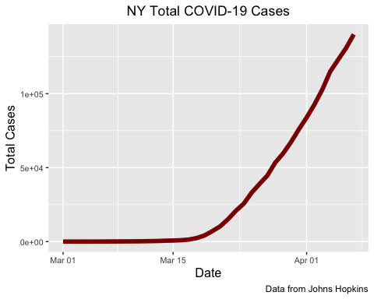

Sadly, the curve has not flattened yet. Recall that this is for all of New York State and is **dominated by cases in New York City**.

We will save the plot as in both the png and jpg formats.

strOutPng <- "plt/Covid-19-Total-Cases-NY.png"  
  
# we want the png to be close to 1024x768...  
ggsave(plt_ny_tot, file=strOutPng, width=9.0, height=6.0,  
 units="in", dpi=113.7778)  
  
strOutJpg <- "plt/Covid-19-Total-Cases-NY.jpg"  
  
# we want the png to be close to 1024x768...  
ggsave(plt_ny_tot, file=strOutJpg, width=9.0, height=6.0,  
 units="in", dpi=113.7778)

# Plot NY COVID Deaths

plt_ny_deaths <- ggplot(new_york, aes(x=date, y=deaths)) +  
 geom_line(colour='darkred', size=2) +  
 xlab("Date") +  
 ylab("Total NY Deaths") +   
 ggtitle("NY Total COVID-19 Deaths") +  
 labs(caption = 'Data from Johns Hopkins') +  
 scale_x_date() +  
 # theme_minimal() +  
 theme(axis.text=element_text(size=8),  
 axis.title=element_text(size=12),  
 plot.title=element_text(hjust = 0.5)) +  
 NULL  
  
print(plt_ny_deaths)

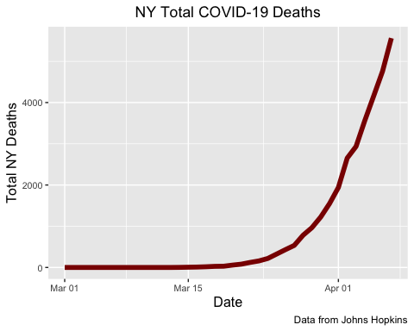

We will save the plot as in both the png and jpg formats.

strOutPng <- "plt/Covid-19-Total-Deaths-NY.png"  
  
# we want the png to be close to 1024x768...  
ggsave(plt_ny_deaths, file=strOutPng, width=9.0, height=6.0,  
 units="in", dpi=113.7778)  
  
strOutJpg <- "plt/Covid-19-Total-Deaths-NY.jpg"  
  
# we want the png to be close to 1024x768...  
ggsave(plt_ny_deaths, file=strOutJpg, width=9.0, height=6.0,  
 units="in", dpi=113.7778)

# Plot COVID New York New Cases

Make a tibble of new cases

new_cases <- diff(tib$cases)  
the_date <- as.Date(tib$date[-1], "%m-%d")  
print(class(the_date))

[1] "Date"

new_cases_tbl <- data.frame(the_date, new_cases)  
print(head(new_cases_tbl))

the_date new_cases  
1 2020-03-02 0  
2 2020-03-03 1  
3 2020-03-04 9  
4 2020-03-05 11  
5 2020-03-06 22  
6 2020-03-07 45

print(tail(new_cases_tbl))

the_date new_cases  
32 2020-04-02 8881  
33 2020-04-03 10100  
34 2020-04-04 12126  
35 2020-04-05 7915  
36 2020-04-06 7792  
37 2020-04-07 9378

plt_ny_new_cases <- ggplot(new_cases_tbl, aes(x=the_date, y=new_cases)) +  
 geom_line(colour='darkred', size=2) +  
 xlab("Date") +  
 ylab("New Cases") +   
 ggtitle("NY Total New COVID-19 Cases") +  
 labs(caption = 'Data from Johns Hopkins') +  
 scale_x_date() +  
 theme(axis.text=element_text(size=8),  
 axis.title=element_text(size=12),  
 plot.title=element_text(hjust = 0.5)) +  
 NULL  
  
print(plt_ny_new_cases)

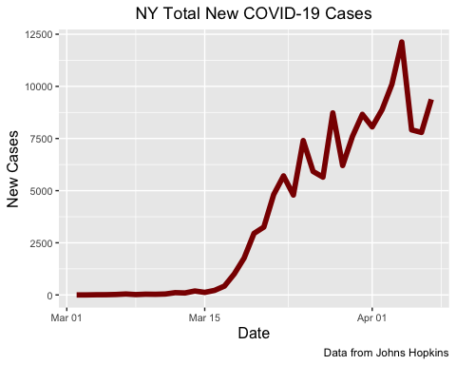

Save the New Cases Plot

strOutPng <- "plt/Covid-19-New-Cases-NY.png"  
  
# we want the png to be close to 1024x768...  
ggsave(plt_ny_new_cases, file=strOutPng, width=9.0, height=6.0,  
 units="in", dpi=113.7778)  
  
strOutJpg <- "plt/Covid-19-New-Cases-NY.jpg"  
  
# we want the png to be close to 1024x768...  
ggsave(plt_ny_new_cases, file=strOutJpg, width=9.0, height=6.0,  
 units="in", dpi=113.7778)