My Super Title

J. R. Minter



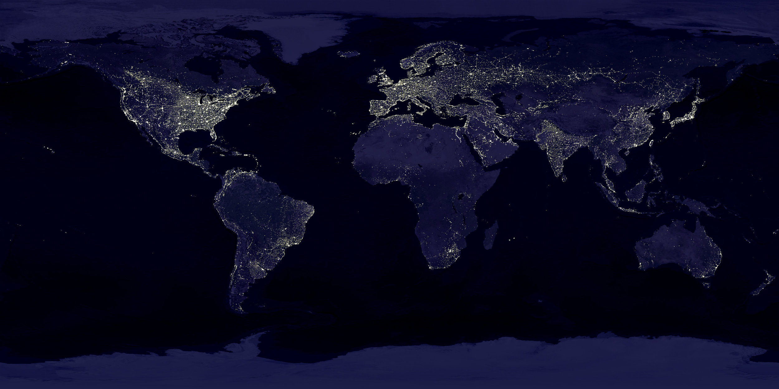

#### A report prepared by John Minter on behalf of **YOUR NAME HERE**.

##### Pagebreak

This report describes…

##### Pagebreak