Analytical Technology Division
Polymer and Colloid Microscopy
Report of Analysis
<DIV ALIGN=right>Date: 04-April-1998 14:15</DIV>

Author: John Minter 2/49/KP/23712/x23407
Contributing Analysts: Roger Button 2/49/KP/23712/x21220
Project: Software verification of cryoTEM Image Analysis
Software
WIMS/MIDB Sample Number(s): 10211
Charge Number: 4CGFS01

Objective
The purpose of this investigation was to validate the image analysis software developed to analyze cryoTEM images. The basic approach was to generate images conformant to a single mode lognormal distribution and to compare the results obtained by image analysis with the input particle size distribution.

Conclusions
We concluded that the image analysis software developed to analyze cryoTEM images faithfully reproduced the input distributions. In the case of the "low-magnification" test, the bin increments were below the resolution of the data so the data only populated alternate bins. Still, the geometric mean ECD was within 2% of the known value, despite an enlarged 95% confidence interval.

Materials and Methods
Test images compliant with a lognormal distribution were generated using the program SIMGRAINS by Roger Button. To generate monodisperse spheres with a geometric mean equivalent circular diameter of 2000 nm and a geometric standard deviation of 1.00 the parameter D_CENTER was set to 1.000 (the radius in microns) and the parameter D_WIDTH was set to 0.000. The scale factor was set to 0.05 microns per pixel. To generate spheres with a geometric mean equivalent circular diameter of 900 nm and a geometric standard deviation of 1.07 the parameter D_CENTER was set to 0.450 (the radius in microns) and the parameter D_WIDTH was set to 0.033829 (this is 0.5*ln(1.07)). Two sets of images were generated. First, a set of 25 images with 50 particles per image (CROWD_FACTOR = 50) were calculated with a scale factor of 0.025 microns per pixel. Then a set of 25 images with 200 particles per image (CROWD_FACTOR = 200) were calculated with a scale factor of 0.05 microns per pixel. The SimGrains output of the particle position and radius were redirected to an text file. Before image processing of the test images,the text output of SIMGRAINS was imported into EXCEL and the area of each particle calculated from the numeric value of the radius. These data were output as a text file and analyzed by the program SUMMAPSD to verify the input distribution. Distributions were plotted and fit to a single mode lognormal distribution using the RS/1 procedure SUMMAPSD. The images were then analyzed using the VISILOG macro CRYO_PSD. This macro analyzes the features (particles) in each image and outputs a text file for each image containing the feature number, centroid coordinates (x and y, in pixels) , area (in pixels), area fraction, equivalent circular diameter, Feret diameter in 36 degree increments, and a shape factor. The C++ program VLPSD was used to prepare a histogram of particle diameters with equally spaced bins of ln(diameter). The increment in ln(diameter) chosen was ln(16th root of 2). Distributions were then plotted and fit to a single mode lognormal distribution using the RS/1 procedure CRYOPSD containing a weighted least-squares fit. .

Results and Discussion
A typical image of monodisperse spheres is shown below:

The results from this analysis are given in the table below:
Analysis of monodisperse circles (Test result LBMN546)
State | Number of Particles | Geometric Mean  Equivalent Circular Diameter  [nm] | Geometric Standard Deviation
Input | 250 | <DIV ALIGN=right>2000.00</DIV> | <DIV ALIGN=right>1.0000</DIV>
Image Analysis | 151 out of 160  features not touching boundaries. | <DIV ALIGN=right>2001.29</DIV> | <DIV ALIGN=right>1.0219</DIV>
A typical image from the "high magnification" test is shown below:

Differential and Cumulative particle size distributions are shown below.
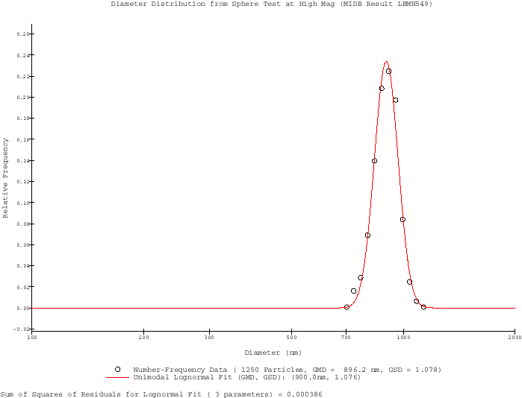

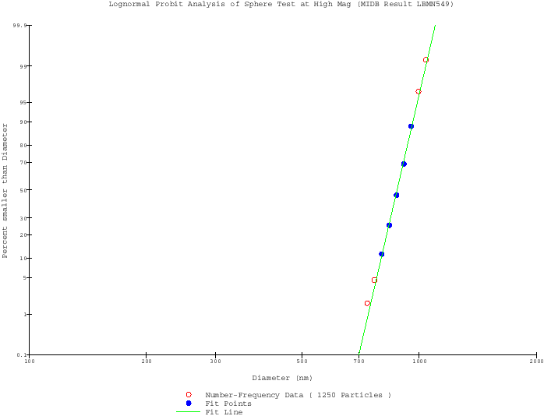Analysis of "high magnification" lognormally distributed circles
State | Number of Particles | Geometric Mean  Equivalent Circular Diameter  [nm] | Geometric Standard Deviation
Input  [LBMN549] | 1250 | 900.0  (894.1 .. 905.9) | 1.076  (1.070 .. 1.083)
Image Analysis  [LBMN550] | 846 out of 865  features not touching boundaries. | 900.7  (887.4 .. 914.2) | 1.082  (1.072 .. 1.099)
Note: the ranges in parentheses are the 95% confidence interval from the weighted least-squares fit.
A typical image from the "low magnification" test is shown below:
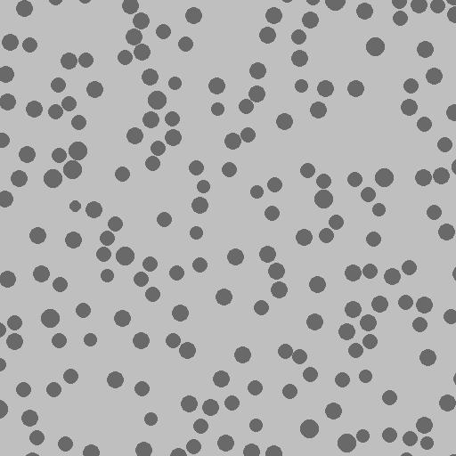
Differential and Cumulative particle size distributions are shown below.
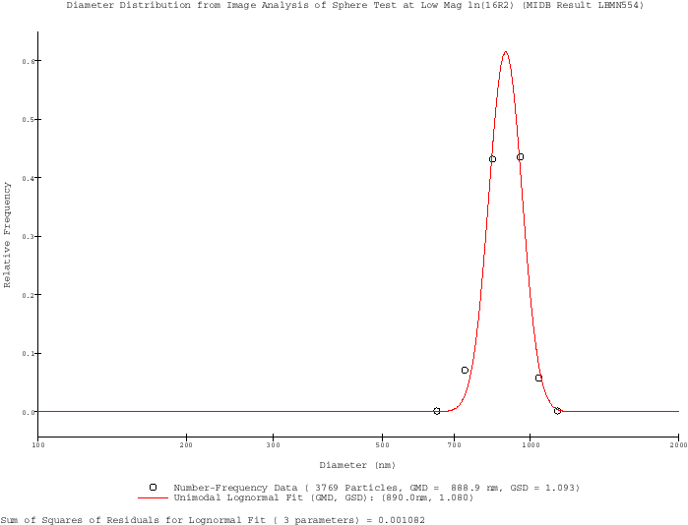
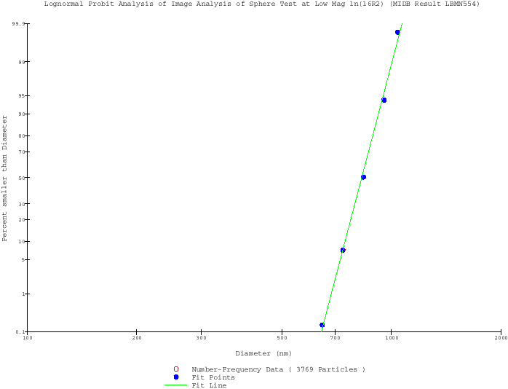
Analysis of "low magnification" lognormally distributed circles
State | Number of Particles | Geometric Mean  Equivalent Circular Diameter  [nm] | Geometric Standard Deviation
Input  [LBMN553] | 5000 | 901.0  (897.5 .. 904.6) | 1.077  (1.073 .. 1.081)
Image Analysis  [LBMN554] | 3769 out of 3990  features not touching boundaries. | 890.0  (872.5 .. 908.0) | 1.080  (1.062 .. 1.136)
Note: the ranges in parentheses are the 95% confidence interval from the weighted least-squares fit. Note also that the low-magnification case is over-sampled.
For additional information or work regarding this report, please contact the responsible analyst. This report may not be duplicated except in its entirety to preserve data integrity.

