**Description for getting the compilation error**

bool exists in the current C - C99, but not in C89/90. And for that "#include <stdbool.h>" needs to be included.

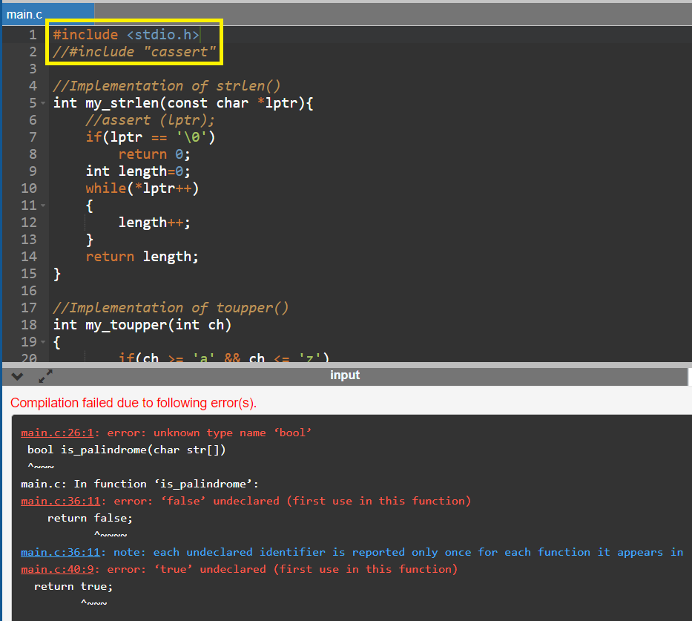

**After including ” #include <stdbool.h> "**

