$100M Offers PDF

Alex Hormozi
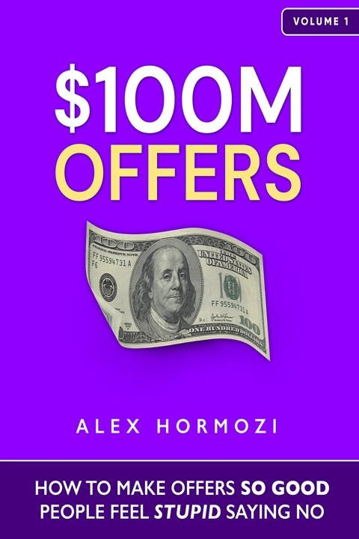


$100M Offers
Transform Your Pricing and Attract More Customers Effortlessly.
Written by Bookey
Check more about $100M Offers Summary Listen $100M Offers Audiobook

About the book
In "$100M Offers," Alex Hormozi reveals transformative strategies for maximizing your pricing and elevating your product's value to levels you've never imagined. Through a series of powerful frameworks, including the Tiny Market Big Money Process and the Unfair Pricing Formula, Hormozi demonstrates how to tap into lucrative niche markets while securing buyers' commitments like never before. Learn to craft irresistible offers using the Scarcity Stack and God-mode Guarantees, ensuring that prospects are eager to pay and act immediately. This book provides you with actionable insights to enhance your business, streamline delivery, and harness the psychological triggers that compel customers to say "yes" without hesitation. With straightforward tactics that yield immediate results, "$100M Offers" is your roadmap to amplifying profits and achieving unprecedented sales success. If you're ready to elevate your business to new heights, it's time to dive in and discover the magic for yourself.

About the author
Alex Hormozi is a prominent entrepreneur, business strategist, and author known for his expertise in scaling businesses and creating compelling offers that drive sales. With a background in electrical engineering and a passion for entrepreneurship, he co-founded Acquisitions.com, where he shares valuable insights and strategies for building wealth. Hormozi gained significant recognition for his previous ventures in the fitness industry, where he successfully scaled multiple companies and generated substantial revenue. Through his book, "$100M Offers," he distills his extensive experience into actionable guidance for entrepreneurs looking to craft irresistible offers that resonate with their target audiences and propel their businesses to new heights.



Try Bookey App to read 1000+ summary of world best books
Unlock 1 00+ Titles, O+ Topics
New titles added every week
kand -$- Leadership & Collaboration 0 Time Management � Relationship & Communication

1ess Strategy 'fl Creativity IQ;) Public
ei Money & Investing
(S Know Yourself
(:j Positive P

� Entrepreneurship � World History
(o Parent-Child Communication � Self-care
ls Mind & Spi




THINKING,
FAST AND SLOW

Howwe make decisions
Insights of world best books

Masteringthearto1power,to ATOMIC HABITS

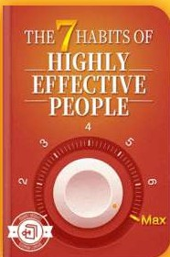
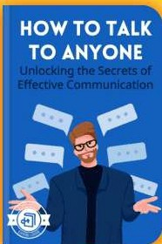
have thestrength toconfront complicatedsituations
'

n

Don
Satire of

















Summary Content List

Scan to Download
Chapter 1 : How We Got Here Chapter 2 : Grand Slam Offers
Chapter 3 : Pricing: The Commodity Problem
Chapter 4 : Pricing: Finding The Right Market -- A Starving Crowd
Chapter 5 : Pricing: Charge What It’s Worth Chapter 6 : Value Offer: The Value Equation Chapter 7 : Free Goodwill
Chapter 8 : Value Offer: The Thought Process
Chapter 9 : Value Offer: Creating Your Grand Slam Offer Part I: Problems &amp; Solutions
Chapter 10 : Value Offer: Creating Your Grand Slam Offer Part II: Trim &amp; Stack
Chapter 11 : Enhancing The Offer: Scarcity, Urgency, Bonuses, Guarantees, and Naming
Scan to Download



Chapter 12 : Enhancing The Offer: Scarcity Chapter 13 : Enhancing The Offer: Urgency Chapter 14 : Enhancing The Offer: Bonuses Chapter 15 : Enhancing The Offer: Guarantees Chapter 16 : Enhancing The Offer: Naming Chapter 17 : ExecutionYour First $100,000

Scan to Download

Chapter 1 Summary : How We Got Here
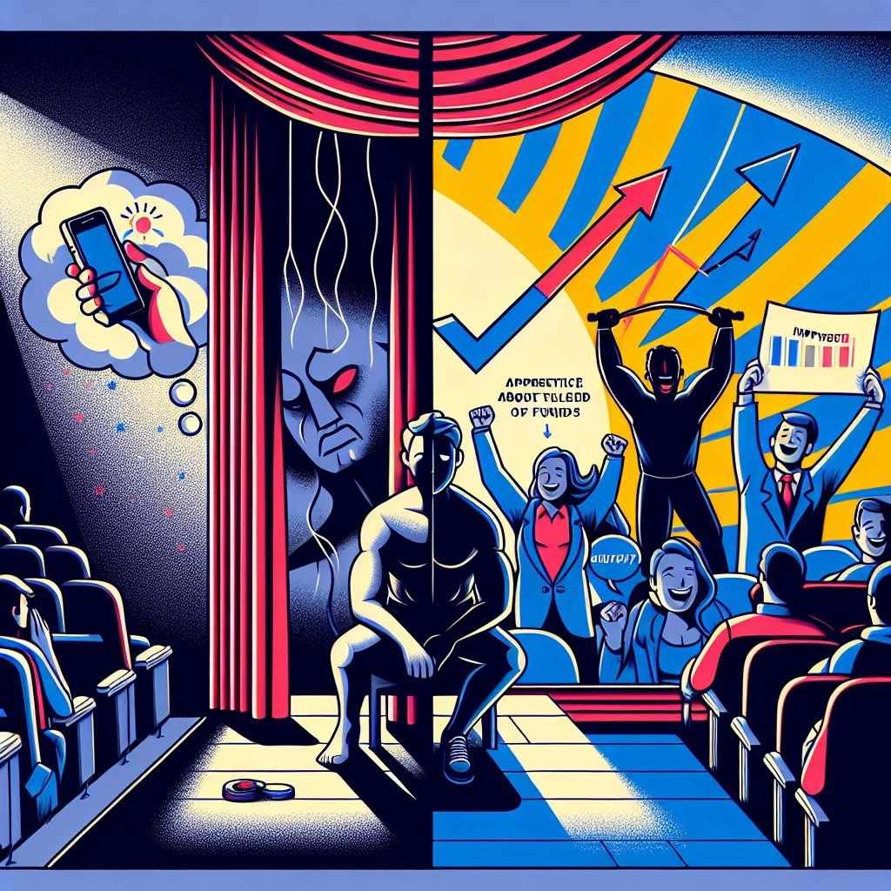

Chapter 1 Summary: From Desperation to Success

Setting the Scene

On Christmas Eve 2016, Alex Hormozi finds himself in a dark theater, unable to enjoy the movie with his girlfriend Leila. Overwhelmed by stress and anxiety, he struggles with life-altering problems that stem from his fledgling business venture.

A Troubling Phone Call

Alex receives a distressing call about the stalling of a

significant fund ($120,000) due to "irregular activity." He is left with only $23,036 in his account, stating his urgency to pay a $22,000 commission to his salesman during Christmas. The emotional weight of his financial crisis and its implications for his employees weighs heavily on him.

Loss and Despair

In the weeks leading up to his troubles, Alex sold all his gyms for a new venture called "Gym Launch." However, he discovers that his business partner had emptied their bank account, leaving him with nothing. Furthermore, he faces personal turmoil, including a family crisis and an accident that adds to his misfortunes.

A Turning Point

Despite his dire situation, Leila’s unwavering support inspires Alex. He resolves to proceed with his plans for launches at six gyms, relying solely on a credit card to fund the venture. To his surprise, the business begins to generate revenue, alleviating his initial fears of bankruptcy.

Rapid Success



In January 2017, Alex's new business strategy pays off with

Scan to Download
$100,117 in revenue. This momentum continues, leading to remarkable growth—reaching $4.4 million a month within a year, and over $120 million in sales by the second year.
Along the way, he contributes to charity and connects with influential figures like Arnold Schwarzenegger.

Reflection and Gratitude

Alex emphasizes that his success evolved from a combination of belief, strategy, and a strong offer. He acknowledges his past mistakes but asserts that mastering the art of making offers transformed his life. He expresses gratitude to his readers for their attention and promises to provide valuable insights throughout the book, with an emphasis on empowering more entrepreneurs to create "magic."

Critical Thinking
Key Point:The transformative power of belief and strategy in entrepreneurial success.
Critical Interpretation:Hormozi’s narrative underscores the belief that personal resolve and strategic
decision-making were crucial to overcoming adversity; however, it’s vital to recognize that personal experience may not universally apply, as the path to success often varies by industry and individual circumstances. Critics argue that reliance on singular narratives may overlook systemic barriers many face in entrepreneurship, suggesting that success stories can sometimes glamorize the hardships without addressing inequality in opportunities (source: "The Myth of the Entrepreneurial Hero" by Scott Shane). Readers should critically evaluate his viewpoint in the context of broader social and economic factors that influence entrepreneurial journeys.


Chapter 2 Summary : Grand Slam Offers

Section | Content
Key Quote | “Make people an offer so good they would feel stupid saying no.” - Travis Jones
Introduction | The author’s pivotal moment at a marketing seminar transformed their understanding of creating irresistible offers.
About the Book | The journey from wantrepreneur to entrepreneur involves discomfort and the realization that trading freedom for security is unfulfilling.
Defining an Offer | An offer is essential for business success: no offer means no business, while a Grand Slam Offer leads to fantastic profit.
Main Problems Addressed | The primary challenges are not enough clients and cash, with traditional models often resulting in unsustainable practices.
Value Proposition for Readers | Readers will benefit from the author's lessons learned, applying methods to significantly increase clients and revenue.
Author’s Intent | Designed to help entrepreneurs without high costs, aiming to build trust and potentially invest in successful individuals.
Structure of the Book | The book serves as a long-term resource with sections on pricing, creating and enhancing offers, and implementation.

Summary of Chapter 2 from "$100M Offers"

Key Quote

“Make people an offer so good they would feel stupid saying no.” - Travis Jones

Introduction

At 23, the author attended a marketing seminar in Las Vegas, feeling anxious and out of place among established business owners. The pivotal moment came when TJ, the organizer, shared a fundamental sales principle that transformed the author’s understanding: creating irresistible offers.

About the Book

The journey from wantrepreneur to entrepreneur often begins with discomfort and the realization that trading freedom for security is unfulfilling. Many entrepreneurs start out wanting to help others, yet face challenges in understanding business mechanics and making a profit.

Defining an Offer

An offer is the cornerstone of business, initiating the exchange of goods or services for payment. The effectiveness of an offer can dictate the success of a business:
- No offer = No business
- Bad offer = Negative profit
- Decent offer = Stagnation
- Good offer = Some profit
- Grand Slam Offer = Fantastic profit and business growth This book guides entrepreneurs on crafting Grand Slam Offers, drawing on the author's extensive experience and failures to create a practical framework for success.

Main Problems Addressed

The primary challenges entrepreneurs face are:
- Not enough clients
- Not enough cash
Traditional models often lead to unsustainable practices where businesses barely break even. The author emphasizes that this book offers alternative solutions to these issues, suggesting actionable steps to enhance value and improve profitability.

Value Proposition for Readers

Readers will learn from the author’s past mistakes without the same pain. By applying the methods outlined in this book, even one component can significantly increase clients and revenue. The author promises the highest return on time invested.

Author’s Intent

The materials provided are designed to help as many entrepreneurs as possible without the costs typically associated with business education. The author aims to build trust with small business owners and eventually invest in those who succeed.

Structure of the Book

The book is designed to be a long-term resource for implementation rather than just a one-time read. The outline includes:
- How We Got Here
- Pricing: How To Charge Lots of Money For Stuff
- Value: Create Your Offer
- Enhancing Your Offer



- Next Steps: Implementation in the Real World

Scan to Download
This section establishes the foundation for practical advice and tools that readers can apply to their own businesses.

Example
Key Point:Crafting an Irresistible Offer as a Business Owner
Example:Imagine you're at a crowded market, eager to sell your handmade jewelry. Instead of simply stating a price, you create a bundle: a free matching bracelet with every necklace purchased. Suddenly, customers perceive greater value—your offer is so enticing they can't resist. This example of adding perceived value showcases the principle of making offers so compelling that refusing feels like missing out on a once-in-a-lifetime opportunity.

Critical Thinking
Key Point:Creating Irresistible Offers
Critical Interpretation:The philosophical underpinning of Hormozi's proposal suggests that the crux of entrepreneurial success lies in the ability to formulate offers that are undeniably appealing to clients. While this perspective emphasizes the tactical advantage of a strong value proposition, one might argue that it oversimplifies the multifaceted nature of business success. Not all entrepreneurs will find that simply having an attractive offer eliminates the complexities of client acquisition or cash flow management. Critics might point to research by Eric Ries in 'The Lean Startup,' which suggests that iterative testing and customer feedback are vital components of
product-market fit—areas that Hormozi's framework may inadvertently downplay in favor of direct offer enhancement. Therefore, while Hormozi’s approach provides a foundational strategy for drawing in clients through compelling offers, it may not serve as a comprehensive solution for the diverse challenges faced within the entrepreneurial landscape.

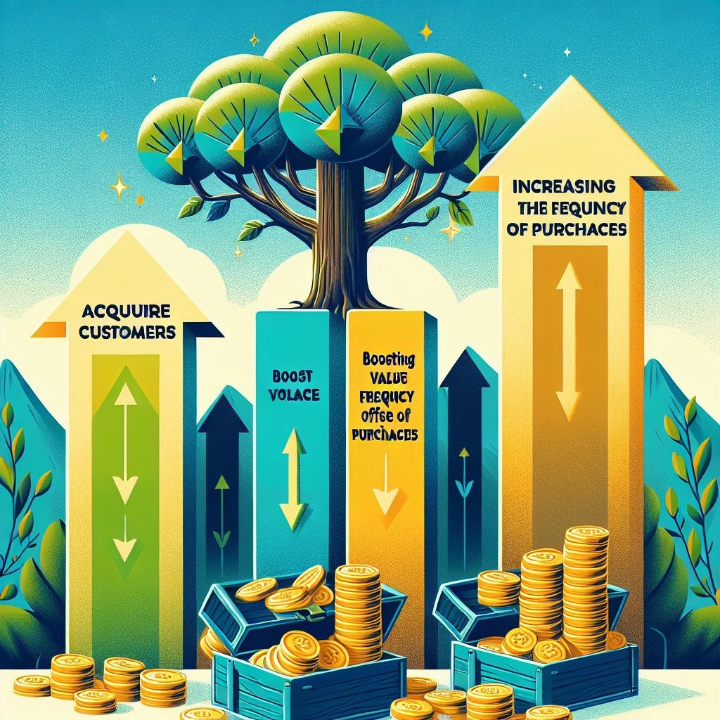
Chapter 3 Summary : Pricing: The Commodity Problem

Chapter 3 Summary: Growth and Grand Slam Offers

Core Principle: Growth or Decline

- The mantra "Grow or Die" emphasizes that if a company isn’t growing, it's deteriorating. Maintenance is an illusion; businesses must continuously grow to keep pace with the market.

Three Fundamental Growth Strategies

- Acquire more customers.
- Boost their average purchase value.
- Increase purchase frequency.

Key Business Concepts

-
Gross Profit
: Revenue minus direct costs associated with acquiring additional customers.

-
Lifetime Value (LTV)
: Total gross profit a customer generates over their entire relationship with a business.

Value-Driven vs. Price-Driven Purchases

Install Bookey App to Unlock Full Text and Audio
- Success hinges on creating a Grand Slam Offer, which
allows businesses to differentiate themselves and focus on value, avoiding the race to the bottom on pricing.
- A commoditized product leads to price-driven purchasing; a
Grand Slam Offer leads to value-driven purchasing.

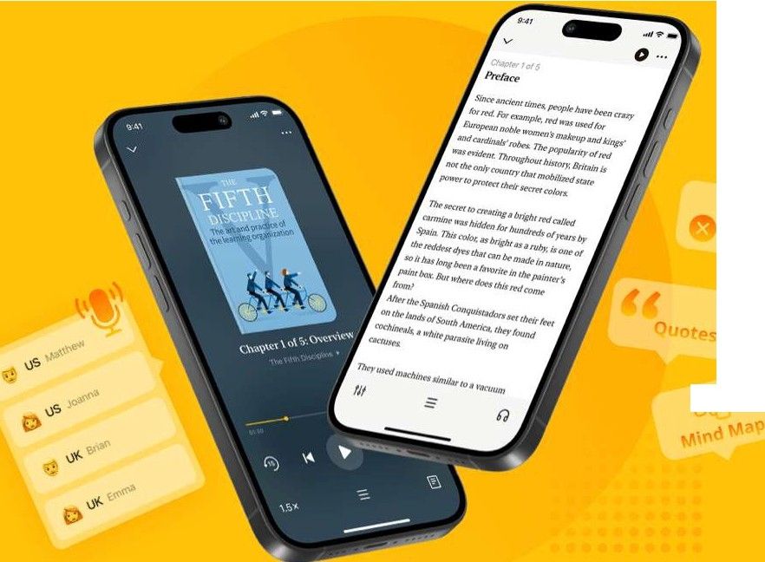
••

Scan to Download

f')I If-,

rP

Why Bookey is must have App for Book Lovers
30min Content
The deeper and clearer interpretation we provide, the better grasp of each title you have.
Text and Audio format
Absorb knowledge even in fragmented time.

-v Quiz
-x
Check whether you have mastered what you just learned.

And more
Multiple Voices & fonts, Mind Map, Quotes, IdeaClips...



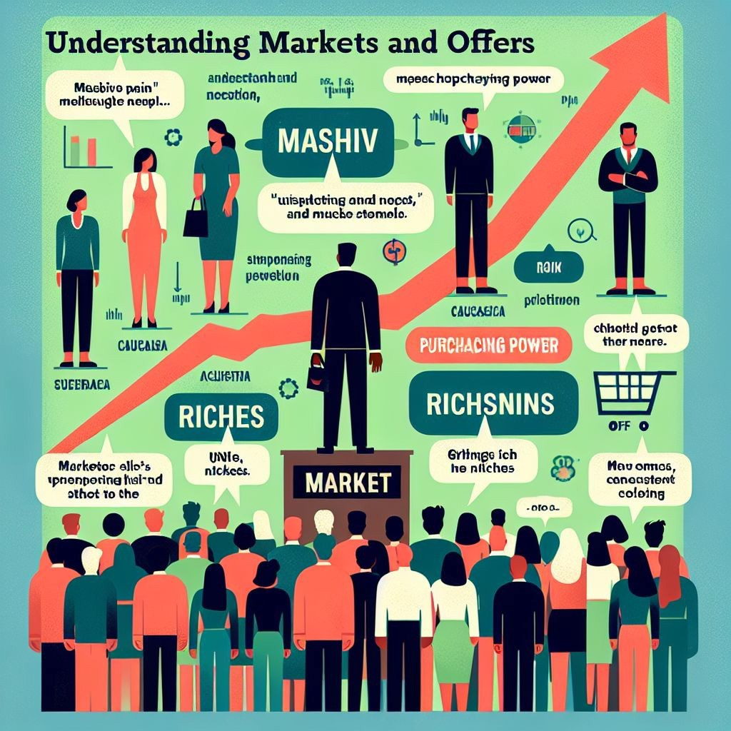
Chapter 4 Summary : Pricing: Finding The Right Market -- A Starving Crowd

Key Takeaways | Description
Market Importance | Choosing the right market is crucial for business success; a great offer cannot compensate for low demand in a declining market.
Starving Crowd Concept | Businesses must find a "starving crowd" with high demand for their solutions; even mediocre products can succeed in such markets.
Indicators for Market Selection | Look for massive pain, purchasing power, ease of targeting, and market growth.
Core Markets | Health, wealth, and relationships always have demand due to human challenges.
Niche Commitment | Once a market is selected, stay committed; hopping between niches may hurt success.
Riches in Niches | Niching down allows for higher pricing and increased perceived value.
Order of Importance | A strong market is more important than a strong offer or persuasive skills; focus on expanding markets with evident pain.
Resilience is Key | Persistence and adaptability are essential; successful entrepreneurs learn from trials rather than abandoning their paths.
Summary Points | Choose your market wisely, commit, and test various offers for success. Skills in market assessment are vital for sustainability.

Understanding Markets and Offers

Key Takeaways from Chapter 4

1.
Market Importance
: The story of Lloyd illustrates that picking the right market is crucial for business success. A great offer in a declining market can't compensate for the lack of demand.
2.
Starving Crowd Concept
: To succeed, businesses must identify a "starving crowd"—a market with high demand for the offered solution. Even mediocre products can thrive in such conditions.
3.
Indicators for Market Selection
:
-
Massive Pain
: Identify markets where the audience has urgent and painful problems.
-
Purchasing Power
: Ensure your target audience can afford your services.

-
Easy to Target
: Choose markets that have identifiable groups or associations for effective outreach.
-
Growing Market
: Opt for a market experiencing growth to benefit from a favorable environment.
4.
Core Markets
: Health, wealth, and relationships always have demand due to inherent human challenges.
5.
Niche Commitment
: Once a market is chosen, commit to it. Jumping from niche to niche can hinder success.
6.
Riches in Niches
: Niching down allows for higher pricing, maximizing potential revenue. Specificity in targeting leads to increased perceived value.
7.
Order of Importance
: Understand that a strong market outweighs a strong offer



and persuasion skills. Success is more likely if you address expanding markets with evident pain.

Scan to Download
8.
Resilience is Key
: Persistence and trial are vital. Effective entrepreneurs learn and adapt rather than abandon their chosen paths.

Summary Points
: Choose a market wisely, commit to it, and don't hesitate to try various offers until success is found. Skills in assessing market viability are essential for long-term growth and sustainability.

Example
Key Point:Identifying the Right Market is Key to Success
Example:Imagine you launch a fitness program aimed at busy professionals. Instead of targeting general fitness enthusiasts, you discover a starving crowd of stressed executives struggling with weight management. By crafting offers that directly address their unique pain points—like time-efficient workouts and nutrition guidance tailored for their hectic schedules—you resonate deeply with them. In a growing market with high demand, your tailored solutions compel them to join, proving that even a decent program can succeed in a ripe market.

Critical Thinking
Key Point:Market Selection is Paramount
Critical Interpretation:Hormozi emphasizes that the selection of a suitable market is a decisive factor for business success; however, it could be argued that product quality also plays a vital role in sustaining long-term customer satisfaction. While Hormozi's perspective on prioritizing market demand aligns with
the practical needs of entrepreneurship, relying solely on market trends may disregard the potential risks associated with oversaturation or changing consumer preferences (Kotler, P., & Keller, K. L. (2016).
Marketing Management). Thus, prospective entrepreneurs should consider balancing market selection with product innovation and quality assurance to ensure sustainable growth.

Chapter 5 Summary : Pricing: Charge What It’s Worth

Chapter 5 Summary: Pricing Strategies and Value Creation

Introduction

In this chapter, Alex Hormozi emphasizes the importance of understanding pricing in relation to the perceived value of services. Using personal anecdotes and observations about the business landscape, he distinctly advocates for premium pricing strategies.

Price to Value Discrepancy

- Value versus Price: Consumers buy based on the belief that they are getting more value than the cost they incur. If perceived value declines, so does their willingness to buy.
- Lowering price to attract customers is often detrimental to business health. Instead, businesses should aim to create

significant value before increasing prices.

Competing on Price

- Many businesses base their prices on competitors, leading to a cycle of "more for less." This often results in insufficient revenue to sustain exceptional service.
- Hormozi argues against this practice, stating that the goal should be maximizing profit, not merely staying competitive. Attempting to be the second-lowest price doesn’t yield strategic benefits.

Virtuous Cycle of Price

- Lowering prices decreases customer investment and perceived service value, attracting less desirable clients.
- Conversely, raising prices enhances clients' emotional investment and perceived value, thereby improving results and satisfaction. This investment allows businesses to thrive and grow.

Higher Price Means Higher Value

- Research demonstrated that consumers often associate

higher prices with higher quality, even when the product remains constant. A higher price can elevate perceived value in the eyes of consumers.

Getting Customers Invested

- Hormozi stresses that pricing should be structured to require a commitment from clients, which in turn increases their engagement and potential success with the service.

Personal Experience with Premium Pricing

- Hormozi shares his journey with Gym Launch where he charged premium prices to deliver substantial value, leading to remarkable results for gym owners. He outlines the metrics of success achieved through his program, reinforcing the superiority of a high-value, high-cost model.

Summary Points

- Charging premium prices is essential for success, enabling businesses to provide exceptional value and facilitate client success.
- Businesses often need to raise their prices to grow, as profit



is crucial for sustaining growth and expanding impact.

Scan to Download
- To command higher prices, businesses must focus on creating and consistently delivering tremendous value to their clients.

Critical Thinking
Key Point:The importance of premium pricing for perceived value and business sustainability.
Critical Interpretation:Hormozi's argument for premium pricing suggests that higher costs correlate with greater perceived value, which can lead to enhanced customer commitment and overall satisfaction. However, this perspective may not universally apply, as market segments can vary significantly. For instance, in highly price-sensitive markets, consumers might prioritize affordability over perceived value, indicating that the interpretation of value can be subjective. Additionally, this principle contrasts with findings from behavioral economics, where consumers may be willing to sacrifice quality for better deals in competitive environments.
Therefore, while Hormozi presents compelling anecdotes and a business-focused perspective, readers should critically evaluate this framework against their market realities and consider alternative pricing strategies that may be more effective in different contexts.

Chapter 6 Summary : Value Offer: The Value Equation

Summary of Chapter 6 from "$100M Offers" by Alex Hormozi

Introduction to Value in Pricing

- Entrepreneurs should aim to charge significantly more for their products and services, moving beyond traditional notions of fairness.
- Successful companies thrive on the disparity between costs and pricing, often charging extremely high amounts for items that cost little to produce.

Understanding Value and Pricing

- It is essential to charge well beyond the cost of fulfillment—sometimes up to a hundred times more if the offered value warrants it.
- The example of a photography business illustrates that a

high price increase can lead to massive profit gains and customer satisfaction.
Perceived Effort & Sacrifice (Goal: Decrease)
: The work and sacrifices required to achieve the outcome.

Strategies to Enhance Value

- Focus more on minimizing the time delay and effort

The Value Equation

1.
Dream Outcome (Goal: Increase)
: The ultimate desire or goal of the prospect. 2.
Perceived Likelihood of Achievement (Goal: Increase)

: The probability that the prospect believes they can achieve
their desired outcome.
3.
Perceived Time Delay (Goal: Decrease)
: The time between purchase and realization of the dream outcome.
4.
Install Bookey App to Unlock Full Text and
Audio




App•Store Editors' Choice

22k 5 star review

Positive feedback

Sara Scholz Fantastic!!! Masood El Tot:Jre F

tes after each book summary erstanding but also make the and engaging. Bookey has ling for me.
I'm amazed by the variety of books and languages A Bookey supports. It's notjust an app, it's a gateway b to global knowledge. Plus, earning points for charity to is a big plus! m

Jose Botfn
Love it! Wonnie Tappl<x
Time saver!

iing habit
>'s design 1al growth
Bookey offers me time to go through the important parts of a book. It also gives me enough idea whether or not I should purchase the whole book version or not! It is easy to use!
Bookey is my go-to app fo summaries are concise, in� curated. It's like having ace right at my fingertips!

Awesome app! Rahul Ma!viya
Beautiful App Alex Wal�

I love audiobooks but don't always have time to listen to the entire book! bookey allows me to get a summary of the highlights of the book I'm interested in!!! What a great concept !!!highly recommended!
This app is a lifesaver for book lovers wit busy schedules. The summaries are spot on, and the mind maps help reinforce wh I've learned. Highly recommend!







Chapter 7 Summary : Free Goodwill
Scan to Download

Scan to Download

Summary of Chapter 7: Enhancing Lives through Generosity

Introduction to Generosity and Fulfillment

The chapter begins with a thought-provoking quote that emphasizes the joy of giving. It suggests that helping others leads to increased fulfillment, longevity, and financial success.

The Call to Action

Alex Hormozi poses a question to readers about their willingness to help a stranger without expecting anything in return. He introduces the *ask* of the chapter: readers are encouraged to leave an honest review of the book to help others find it.

Impact of Your Review



Hormozi outlines the potential positive impacts of leaving a review, including:

Scan to Download
- Supporting more entrepreneurs in sustaining their families.
- Helping employees find meaningful work.
- Facilitating client transformations.
- Contributing to positive life changes.

How to Leave a Review

Practical instructions are provided for different platforms, making it easy for readers to contribute their thoughts in under a minute.

Personal Connection and Closing Remarks

Hormozi expresses gratitude and excitement for readers who engage in this act of kindness. He reinforces the idea of creating value for others and hints at the valuable content to come in subsequent chapters.

Final Note

Readers are left with a sense of community and purpose, encouraging them to share the book with fellow entrepreneurs to foster goodwill.





Chapter 8 Summary : Value Offer: The Thought Process
Scan to Download

Scan to Download

Convergent & Divergent Problem Solving

Convergent problem solving focuses on finding a single solution using known variables and conditions, exemplified by mathematical problems. In contrast, divergent thinking encourages exploration of multiple solutions to a problem, accommodating known and unknown variables, and dynamic conditions.

The Brick Exercise

To cultivate divergent thinking, the "brick" exercise encourages brainstorming various uses for a brick within a 120-second timer. Participants are prompted to consider factors such as size, material, and shape, expanding the potential applications for a brick beyond the obvious.

Example List of Brick Uses



- Paper weight

Scan to Download
- Door stop
- Building material
- Fish tank ornament
- Plant holder
- Trophy
- Rustic decor
- Tool for breaking windows
- Mural material
- Exercise weight
- Wedge for stabilizing
- Pen holder
- Toy for children
- Floatation support
- Currency (gold brick)
- Leaning object stabilizer
- Flagpole holder
- Seat

Key Takeaway

To create attractive and valuable offers, one must utilize divergent thinking to identify various ways to meet customer desires, effectively combining elements to enhance perceived value.

Chapter 9 Summary : Value Offer: Creating Your Grand Slam Offer Part I: Problems &amp; Solutions

Chapter 9 Summary: Creating Irresistible Offers

Struggles of a New Gym Owner

- The author shares his initial struggles in selling gym memberships priced at $99/month, noting strong competition from cheaper options, leading to feelings of inadequacy and frustration.

Discovery of Irresistible Offers

- The author finds inspiration in Dan Kennedy's concept of creating "irresistible offers" that people feel compelled to accept.

Step #1: Identify Dream Outcome

- Transition from selling memberships to focusing on the customers' ultimate goals, such as losing 20lbs in 6 weeks, thus presenting the service as a means to achieve their desired results.
2. Likelihood of Achievement
3. Effort & Sacrifice
4. Time
- A comprehensive understanding of these pain points leads to the identification of more effective solutions.

Step #2: List Problems


- The author emphasizes the importance of identifying customers' pain points and obstacles they face before and after using the service. This involves in-depth detailing of the challenges associated with their weight loss journey, such as confusion in purchasing healthy food, time constraints, and
- Each problem corresponds to four value drivers:
1. Dream Outcome
Value Drivers
feelings of overwhelm.
Install Bookey App to Unlock Full Text and
Audio

Read, Share, Empower
Finish Your Reading Challenge, Donate Books to African Children.

BFOOOR KS.
AFRICA
The Concept
X ml X


This book donation activity is rolling out together with Books For Africa. We release this project because we share the same belief as BFA: For many children in Africa, the gift of books truly is a gift of hope.
The Rule




•" ,
Earn 100 points Redeem a book Donate to Africa
Your learning not only brings knowledge but also allows you to earn points for charitable causes! For every 100 points you earn, a book will be donated to Africa.



Chapter 10 Summary : Value Offer: Creating Your Grand Slam Offer Part II: Trim &amp; Stack

Section | Summary
Chapter Title | Crafting the Grand Slam Offer
Introduction | Apart from offering value, this chapter outlines how to attractively position products/services while ensuring profitability.
Sales to Fulfillment Continuum | Emphasizes the balance between easy sales and complex fulfillment, advocating for demand creation before refining offerings.
Step 4: Create Your Solutions Delivery Vehicles ("The How") | Brainstorm diverse solutions to problems to provide compelling reasons for customers to choose your offer.
Product Delivery Cheat Codes | Enhance creativity in solutions by evaluating attention levels, client effort, delivery methods, and communication frequency.
Step 5: Trim & Stack | Narrow down to high-value, low-cost offerings while focusing on scalable delivery models to maximize profitability.
The Final High Value Deliverable | Summarize identified problems and solutions into attractive bundles, promoting value-based purchasing decisions over price-based ones.
Summary Points | This chapter aims to help businesses create unique offers that stand out based on perceived value, leading into further exploration of psychological techniques in the next chapter.

Chapter 10 Overview: Crafting the Grand Slam Offer

Introduction

This chapter is divided into two crucial parts, focusing on creating a valuable offer as the foundation for a successful

business. The goal is to position your product or service attractively, ensuring a high perception of value while maintaining profitability.

Sales to Fulfillment Continuum

Understanding the balance between sales ease and fulfillment complexity is essential. The ideal scenario is to create a
high-demand product that is also easy to deliver. The author emphasizes generating demand first, then adding complexities to refine the offering.

Step 4: Create Your Solutions Delivery Vehicles ("The How")

This step involves brainstorming diverse solutions to identified problems, focusing on creativity to enhance value. The goal is to offer compelling reasons for customers to choose your service or product.

Product Delivery Cheat Codes

For enhancing creativity in solutions:
- Determine levels of personal attention (one-on-one, small

group, many)
- Assess expected effort from clients (DIY vs. done for them)
- Evaluate delivery methods (in-person, virtual, recorded formats)
- Define responsiveness and communication frequency

Step 5: Trim & Stack

Create a comprehensive list of potential solutions, then narrow down to high-value, low-cost offerings. Focus on scalable delivery models to maintain profitability while maximizing customer satisfaction.

The Final High Value Deliverable

Summarize the identified problems and solutions into compelling bundles that highlight value. The ultimate goal is to deliver unique offers that stand out in the market, thus fostering a value-based purchasing decision rather than a price-based one.

Summary Points

The purpose of this chapter is to develop a unique,



compelling offer that differentiates itself in the marketplace, allowing businesses to attract customers based on perceived value rather than competitive pricing. The next chapter will focus on enhancing the core offer using psychological techniques.

Scan to Download

Example
Key Point:Value over Price
Example:To win customers, imagine presenting your service as a unique solution that fulfills their deepest needs, making the cost seem irrelevant.

Chapter 11 Summary : Enhancing The Offer: Scarcity, Urgency, Bonuses, Guarantees, and Naming

Chapter 11 Summary: The Delicate Dance of Desire

Introduction to Scarcity and Demand

- The chapter begins with an illustrative experience at Arnold Schwarzenegger's charity event, showcasing how exclusive access and pricing strategies influenced donations.
- The idea of creating urgency and scarcity to increase demand is a central theme.

Understanding Supply and Demand

- Marketing aims to shift the supply and demand curve by promoting scarcity, thus increasing desire for products.
- Increasing demand while decreasing perceived supply allows businesses to sell products for higher prices and in greater volumes.

The Nature of Desire

- Desire stems from wanting what is not readily available; it fades once the desire is satisfied.
- Effective marketing strategies involve delaying gratification to build desire.

Case Study of Pricing Strategies

- Two scenarios demonstrate this principle: selling fewer high-ticket items versus many low-ticket ones.
- The focus should be on creating exclusivity and generating pent-up demand to drive future sales.

Hormozi Law

- This law states that delaying the ask can allow for larger future asks, emphasizing the importance of maintaining a balance between supply and demand.

Key Takeaways

- There is an intricate balance between satisfying demand and

maintaining desire.
- Businesses must skillfully navigate this dynamic to encourage ongoing demand and maximize profits.

Enhancing Your Offer

- To boost offer desirability, Hormozi outlines several strategies:
1.
Scarcity
: Limit supply to increase perceived exclusivity and raise prices.
2.
Urgency
: Encourage immediate action to enhance demand.
3.
Bonuses
: Offer additional incentives to make offers more compelling.
4.
Guarantees
: Reduce perceived risk to stimulate demand.
5.
Names
: Utilize branding to generate awareness and desire.



- The upcoming discussion will delve into tactical applications of these principles to capitalize on the fear of missing out (FOMO) through scarcity.

Scan to Download

Chapter 12 Summary : Enhancing The Offer: Scarcity

Section | Summary
Scarcity and Pricing Power | Scarcity enhances pricing power for businesses, as seen with authority figures and celebrities who can charge high fees due to perceived demand.
The Value of Rarity | Understanding Demand: Scarcity increases perceived value.  Consultants' High Fees: Unique expertise allows charging premium rates.
Creating Scarcity | Communicating a fixed supply generates FOMO, motivating purchases.
Types of Scarcity | Limited Supply of Seats/Slots: Maximum number of clients.  Limited Supply of Bonuses: Exclusive bonuses with limited quantities. Never Available Again: Offers that won’t be reproduced.
Implementing Scarcity with Products and Services | Physical Products: Limited releases to drive demand. Services: Various methods to create scarcity, including:  Total Business Cap: Limit number of clients overall. Growth Rate Cap: Restrict new clients weekly.  Cohort Cap: Limit clients per cycle/class.
Using Honest Scarcity | Transparency about capacity encourages quicker customer decisions.
Summary Points | Effective use of scarcity accelerates purchase decisions and enhances demand, leading to increased sales when paired with urgency.

Scarcity and Pricing Power

Scarcity is a powerful force that can significantly increase

pricing power for businesses. Authority figures and celebrities command high fees because of perceived demand versus limited supply, a concept that many business owners struggle to grasp until they experience it firsthand.

The Value of Rarity

1.
Understanding Demand

: The perception of scarcity can make solutions appear more valuable, especially if they promise rapid achievement of goals or significant financial returns.
2.
Consultants' High Fees
: Specialized consultants can charge premium rates due to their unique expertise, allowing clients to bypass costly errors.

Install Bookey App to Unlock Full Text and Audio
Creating Scarcity

To create urgency and encourage purchases, businesses should communicate a fixed supply of products or services. This generates a fear of missing out (FOMO) among potential buyers.


Free Picks ATOMIC HAerrs
c..
>
,
9"0uoh-.,._,••bool<
-��
Getlw,t, .
F',ni&I,.Book.y lo<lay

Acniove •O.day.sdaily g0;11
-
-
V

Ctiant ,..,�
Overview
0 ...

Today's Bookey

j)
------


Iii, \\clcome to Bookey. Toda '
unloek h Y ""<'11
t e book Atomic Habits: An i;.,
& Pron,nWay to BuildGood sy
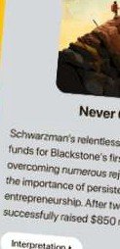
BreakBad One1 Habfts&

lmagfM rou'reSitting ina plane fl .


Atomic Habits
fromLos An
gel11S 10
- rmg
New York Cir 0

Fourst-1obuiciG<>odhllblls to n mystC!riousnnd d y. ue

ba<l000s fndb.,a1c
1urbulence .
un c1ccrablc

' r •
rYou
'}our aJrcmfl'snose shrn
..
more1han 7!• 3. IS
ce1, ., degrees to <he
$-Otllh, Alter frvc hour,;onr
i


. Im Y 1'8, before
•
JI
)Ou ow it, lhr plane fsland"
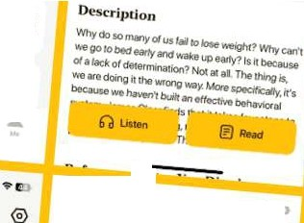
mg.
Noto S{ins
-

r.;>

17:53
I, Hamiah

Oei/yGoals

II

17:25-,,

Library

-...
A



D
..
Q
?e

Q (
larniivPat1ts

'

□ Saved
lcle,ci,,.
N<.11"9

72
°"""
Ongoing
(

(Top 10i of them

is first tor me.How the
makesme feel it's1₁·1c
,•Ith as to match' my ret
happening around,;,:·
�- That's where tt" comes
f rom.

w

""'-2..,.
.,I,_ Downloaded

0 l'lnistrod

History

l/Q!I <
ATOMIC HABIT$
..

0 )

- 103 )
1/7 8oOl(ey,;
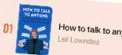

Develop leadership skills

1f7Booi.eyg
Master timema

r • ,C

6183 102 ,
0 t)
►

,3,1.6.(1

mi


World' best ideas unlock your potential

Free Trial with Bookey
•
Download on the
,
II
App Store

GET ITON

Scan to download
- Google Play





Chapter 13 Summary : Enhancing The Offer: Urgency
Scan to Download

Scan to Download

Deadlines, Drive, Decisions

Scarcity relates to quantity, while urgency pertains to time. Establishing a defined deadline creates urgency and encourages action. This chapter introduces four ethical methods to consistently employ urgency in business:

- Cohort-Based Rolling Urgency

By starting new clients at regular intervals (e.g., weekly), you can incentivize immediate sign-ups. Highlight the advantage of joining the next group to encourage quicker decisions.
This strategy is more potent when new clients are onboarded less frequently.

- Rolling Seasonal Urgency

Utilizing real countdown dates for promotions fosters urgency. Clear promotion timelines on landing pages boost



conversions by motivating clients not to miss the opportunity, creating a sense of urgency tied to seasonal themes.

Scan to Download

- Pricing or Bonus-Based Urgency

Highlighting time-sensitive offers or discounts generates urgency around promotions rather than the service itself. Discuss limited-time discounts, bonuses, or exclusive offers to encourage quick decision-making while maintaining integrity.

- Exploding Opportunity

Presenting arbitrage or competitive opportunities that diminish over time pushes prospects to act swiftly.
Emphasize the benefits of acting promptly to take advantage of opportunities that will decrease in value if delayed.

Summary Points

Incorporating deadlines and various forms of urgency will drive action among prospects. The author has successfully utilized these methods and encourages their implementation in business strategies.

Chapter 14 Summary : Enhancing The Offer: Bonuses

Chapter 14: The Power of Bonuses

Introduction

In this chapter, Alex Hormozi emphasizes the significance of bonuses in enhancing the value of offers. The author credits Jason Fladlien for redefining the perspective on bonuses, highlighting their impact on how offers are perceived and sold.

Key Concepts of Bonuses

-
Value Enhancement
: Presenting an offer as a collection of components rather than a single item increases perceived value by stacking bonuses.
-

Psychological Anchoring
: The initial price establishes a reference point, while added bonuses heighten the price-to-value discrepancy, compelling individuals to purchase.

Presenting Bonuses

-
1-on-1 Selling
: During one-on-one sales, ask for the sale first, and if accepted, reveal bonuses afterward for a “wow” experience. If declined, present a bonus addressing their objections to encourage a sale.
-
Utilizing Bonuses
: Each bonus should be carefully communicated, including its relation to customer pain points, how it was created, and the specific benefits it offers.

Bonus Bullets Checklist

- Always offer bonuses.
- Name bonuses with a benefit.
- Explain how each bonus addresses customer issues.

- Provide proof of value.
- Use vivid imagery for potential experiences.
- Assign and justify a price tag.
- Prefer tools and checklists over extensive training.
- Counter specific objections.
- Anticipate future customer needs.
- Ensure bonus value exceeds core offer value.
- Add scarcity and urgency.
- Leverage guarantees as bonuses.

Advanced Bonuses with Other Products

Partner with other businesses to include their products/services as bonuses, enhancing value without additional cost. This approach can create additional revenue streams through referral commissions from these partnerships.

Summary of Recommendations

- Create valuable tools and resources that save time and effort for customers.
- Record all events and interactions for future bonus use.
- Negotiate discounts and commissions with ancillary



businesses to enrich your offers.

Scan to Download

Next Steps

Having established a compelling core offer with effective bonuses, the next focus will be on mitigating risk through strategic guarantees to further encourage purchases.

Chapter 15 Summary : Enhancing The Offer: Guarantees

Reversing Risk through Guarantees

The primary objection in sales is often risk; consumers worry that a product or service won't deliver as promised. To counteract this, offering guarantees can significantly enhance the attractiveness of an offer, with potential conversion rates boosting 2-4 times by improving the quality of guarantees.

Types of Guarantees

1.
Unconditional Guarantees
: The strongest type, allowing customers to try a product/service without risk.
2.
Conditional Guarantees
: Offers specific terms that must be met for a guarantee to apply, often enhancing commitment on the part of the customer.

3.
Anti-Guarantees
: Clearly state that all sales are final. This approach can emphasize the exclusivity and value of the offer.
4.
Implied Guarantees
: Relate to performance-based agreements like revenue sharing, where payment is tied to results.

Stacking Guarantees


Multiple guarantees can be combined for greater effect, such as pairing unconditional and conditional guarantees, or offering different guarantees for multiple outcomes. This approach alleviates risk for the customer while showcasing confidence in the product/service.

Creating Effective Guarantees

Install Bookey App to Unlock Full Text and Audio
To design winning guarantees, identify customer fears and
transform them into guarantees that address those concerns. A guarantee is most effective when it adapts to specific needs and perceptions of your target audience. However, it's crucial that guarantees complement a solid product or service rather



Try Bookey App to read 1000+ summary of world best books
Unlock 1 00+ Titles, O+ Topics
New titles added every week
kand -$- Leadership & Collaboration 0 Time Management � Relationship & Communication

1ess Strategy 'fl Creativity IQ;) Public
ei Money & Investing
(S Know Yourself
(:j Positive P

� Entrepreneurship � World History
(o Parent-Child Communication � Self-care
ls Mind & Spi




THINKING,
FAST AND SLOW

Howwe make decisions
Insights of world best books

Masteringthearto1power,to ATOMIC HABITS



have thestrength toconfront complicatedsituations
'

n

Don
Satire of













Chapter 16 Summary : Enhancing The Offer: Naming

Summary of Chapter 16: Crafting Irresistible Offers

Implicit-Egotism Effect

People are naturally attracted to things that resemble them. Therefore, it’s crucial to design offers that resonate with your ideal customers.

The Importance of Naming Your Offer

A Grand Slam Offer is worthless if nobody knows about it. Proper naming is essential to generate interest and prompt action from your target audience. For instance, “Free
Six-Week Stress Release Challenge” is more appealing than “Float Tank Center Session.”

Understanding Offer Fatigue

Offers can fatigue over time, especially in local markets where marketing to the entire population can be inexpensive. New creative elements (like images and copy) should be regularly introduced to maintain interest. Refreshing the name of an offer helps keep it appealing without changing the offer itself.

Naming Formula Components

1.
Magnetic “Reason Why”
: Create a compelling reason for the offer’s promotion (e.g., “Free,” “88% Off”).
2.
Announce Your Avatar
: Specify your ideal customer (e.g., “Hinsdale Moms”). 3.
Give Them A Goal
: Define the desired outcome or result (e.g., “Celebrity Smile,” “Pain Free”).
4.
Indicate a Time Interval
: Mention the expected timeframe for achieving results (avoiding guarantees).

5.
Complete With A Container Word
: Use a term that implies a bundled system (e.g., “Challenge,” “Blueprint”).

Examples of Effective Naming

-
Wellness
: "Free Six-Week Lean-By-Halloween Challenge"
-
Doctors
: "$2,000-Off Celebrity Smile Transformation"
-
Coaching
: "5 Clients in 5 Days Blueprint"

Managing Offer Variations

To combat offer fatigue, modify the following in order:
- Change the creative (images, videos).
- Change the body copy.
- Change the headline.
- Change the offer duration.



- Change the free/discount component.

Scan to Download
- Change the monetization structure.

Final Thoughts on Naming

Effective naming directly affects conversions. A well-named offer can significantly enhance response rates. Aim to craft a name that attracts the right audience while repelling the wrong one.

Enhancing Your Offer Recap

Congratulations on developing a valuable offer, breaking down your services, enhancing the offer with guarantees, presenting it with urgency, and crafting a compelling name. Prepare for Book II, where strategies for attracting clients and monetizing offers will be further explored.

Chapter 17 Summary : ExecutionYour First $100,000

Chapter 17 Summary: The Journey to $100,000

Overcoming Emotional Hurdles

Alex Hormozi shares a personal moment of achievement when he and his wife, Leila, realized they had hit $100,000 in their personal bank accounts. Hormozi reflects on the tumultuous journey filled with struggle, anxiety, and doubt before reaching this milestone. The moment marked a transition from fear to security, allowing him to release years of pent-up emotions.

Achieving Financial Security

Upon reaching this financial threshold, Hormozi felt a sense of relief rather than happiness. He realized that even with no further income for three years, they could confidently manage their expenses. This achievement was a culmination

of years of hard work and setbacks, finally resulting in significant wealth.

Key Lessons Learned

Hormozi emphasizes that reaching financial success does not follow a specific timeline; persistence and belief in oneself are crucial. He outlines important takeaways for aspiring entrepreneurs to move forward in their business ventures.

In A Nutshell

- Avoid being a commodity in the marketplace.
- Choose a normal or growing market, as niches can lead to riches.
- Understand the importance of charging a premium price.
- Use four core value drivers to justify higher prices.
- Create value offerings through a structured five-step process.
- Stack value to increase profitability.
- Use scarcity to shift demand in your favor.
- Implement urgency to lower buyer hesitation.
- Use strategic bonuses to enhance offer attractiveness.
- Offer creative guarantees to eliminate buyer risk.



- Name your product or service in a way that resonates with the target audience.

Scan to Download
These lessons are foundational for creating a high-margin, de-commoditized offer that appeals to customers, facilitating the journey toward achieving $100,000 or more.

Final Thoughts

Hormozi highlights the importance of acquiring skills, beliefs, and traits necessary for entrepreneurship. He encourages continual learning from experiences and quality sources to achieve excellence. The first book lays the groundwork for creating compelling offers, while future volumes will focus on lead generation and customer acquisition.
Through his writing, Hormozi aims to inspire and guide others on their entrepreneurial journeys, emphasizing the need for innovation to improve the world. He expresses gratitude for the readers' attention and commitment to their personal growth.


••

Scan to Download

f')I If-,

rP

Why Bookey is must have App for Book Lovers
30min Content
The deeper and clearer interpretation we provide, the better grasp of each title you have.
Text and Audio format
Absorb knowledge even in fragmented time.

-v Quiz
-x
Check whether you have mastered what you just learned.

And more
Multiple Voices & fonts, Mind Map, Quotes, IdeaClips...







Best Quotes from $100M Offers by Alex Hormozi with Page Numbers

Scan to Download
View on Bookey Website and Generate Beautiful Quote Images

Chapter 1 | Quotes From Pages 11-18
- Magic will find those with pure hearts, even when all seems lost.
- I literally felt like I was playing dress up. Except the stakes were real. And this was my life.
- I would sleep with you under a bridge if it came to that.
- But things started shaping up. Here’s what happened that month (January 2017), as documented by my old processing records I dug up.
- The skill of making offers saved me from bankruptcy and likely saved my life.
- I can teach you how to build great offers.
- I don’t know who you are (yes, you, the one reading this). But thank you from the bottom of my heart.
- The world needs more entrepreneurs. It needs more fighters. It needs more magic.
Scan to Download



Chapter 2 | Quotes From Pages 19-25

Scan to Download
- Make people an offer so good they would feel stupid saying no.
Chapter 3 | Quotes From Pages 26-34
- Think different.” - Steve Jobs
- Grow or Die” is a core tenet at our companies. We believe every person, every company, and every organism is either growing or dying. Maintenance is a myth.
- If you want to grow, you’ve got to either sell more clients every month... or have them be worth more... That’s it.
- Having a Grand Slam offer makes it almost impossible to lose.
- Your Grand Slam Offer, however, forces a prospect to stop and think differently to assess the value of your differentiated product.
- When you align all the pieces, you can knock it out of the park so well that you win for good.


ffil Scan to Download
Download Bookey App to enjoy
1Million+ Quotes

1000+ Book Sun,n,aries
Free Trial Available!
,
•

'·,�
,.

Download on the
App Store

GET IT ON
Google Play

10:17 |  | 9EI.J | 10:17 | 9 llJ
X | Theme |  | X


Nature
Categories

Saved □

Sky

Abstract
Bookey See all


Personal Management
□
• •
Development & Business

Psychology • Fiction
& Happiness Classics
�
Personal Development See all

life ,r Success


Relationship ll Friendship n

Psychology & Happiness See all





Chapter 4 | Quotes From Pages 35-44

Scan to Download
1.A starving crowd.
- The pain is the pitch.
- Your market matters.
- Don’t make me niche slap you.
- Riches Are In The Niches.
- If your offer doesn’t work, it doesn’t mean you suck. It means your offer sucks.
Chapter 5 | Quotes From Pages 45-54
- Charge as high a price as you can say out loud without cracking a smile.
- If I made you $239,000 extra this year, would you pay me
$42,000?
- Making shit loads of money breaks people’s minds.
- I hope what you’re giving them is worth it.
- Price is what you pay. Value is what you get.” — Warren Buffet
- Those who pay the most, pay the most attention.
Chapter 6 | Quotes From Pages 55-67
Scan to Download



- We question all of our beliefs, except for the ones we really believe in, and those we never think to question.

Scan to Download
- You must abandon any notion you have about 'what's fair.' Every enormous company in the world charges you money for things that cost them nothing.
- If you can make the bottom part of the equation equal to zero, you’re golden.
- Perception is reality. It’s not about how much you increase your prospect’s likelihood of success, or decrease the time delay to achievement, or decrease their effort and sacrifice. That in itself is not valuable. Many times, they will have no idea.
- You can either be right or you can be rich. This book is for getting rich.


ffil Scan to Download
Download Bookey App to enjoy
1Million+ Quotes

1000+ Book Sun,n,aries
Free Trial Available!
,
•

'·,�
,.

Download on the
App Store

GET IT ON
Google Play

10:17 |  | 9EI.J | 10:17 | 9 llJ
X | Theme |  | X


Nature
Categories

Saved □

Sky

Abstract
Bookey See all


Personal Management
□
• •
Development & Business

Psychology • Fiction
& Happiness Classics
�
Personal Development See all

life ,r Success


Relationship ll Friendship n

Psychology & Happiness See all





Chapter 7 | Quotes From Pages 68-69

Scan to Download
- He who said money can’t buy happiness, hasn’t given enough away.
- People who help others (with zero expectation) experience higher levels of fulfillment, live longer, and make more money.
- If you have found this book valuable thus far, would you please take a brief moment right now and leave an honest review of the book and its contents?
- To make that happen...all you have to do is….and this takes less than 60 seconds….leave a review.
Chapter 8 | Quotes From Pages 70-73
- If at first you don't succeed, try, try, try again.
- But life will pay you for your ability to solve using a divergent thought process.
- Every offer has building blocks, the pieces that when combined make an offer irresistible.
Chapter 9 | Quotes From Pages 74-81
- When you are thinking about your dream
Scan to Download



outcome, it has to be them arriving at their destination and what they would like to experience.

Scan to Download
- The more problems you think of, the more problems you get to solve.
- You will solve every problem.
- What would I need to show someone to solve this problem?
- Don’t be fancy. Just get all the problems down then turn them into solutions.


ffil Scan to Download
Download Bookey App to enjoy
1Million+ Quotes

1000+ Book Sun,n,aries
Free Trial Available!
,
•

'·,�
,.

Download on the
App Store

GET IT ON
Google Play

10:17 |  | 9EI.J | 10:17 | 9 llJ
X | Theme |  | X


Nature
Categories

Saved □

Sky

Abstract
Bookey See all


Personal Management
□
• •
Development & Business

Psychology • Fiction
& Happiness Classics
�
Personal Development See all

life ,r Success


Relationship ll Friendship n

Psychology & Happiness See all

Chapter 10 | Quotes From Pages 82-93
- You want them to think to themselves, "I get all this, for only that?" In essence, you want them to perceive tremendous value.
- Create flow. Monetize flow. Then add friction.
- I’d rather do more for every customer and have cash flow coming in, then optimize my business but have zero cash flow coming in after.
- The next step is thinking about all the things you could do to solve each of these problems you’ve identified.
- Just take one step back at a time until you arrive at something that has a time commitment or cost you are willing to live with.
- We went through this entire process to accomplish one objective: to create a valuable offer that is differentiated and unable to be compared to anything else in the marketplace.
- Can you see how much more valuable this is than a gym membership?

Chapter 11 | Quotes From Pages 94-101
- Desire is a contract you make with yourself to be unhappy until you get what you want.
- When demand increases, cut supply.
- The longer you delay the ask, the bigger the ask you can make.
Chapter 12 | Quotes From Pages 102-108
- Scarcity is one of the most powerful and least understood forces to unlock unlimited pricing power.
- The person who needs the exchange less always has the upper hand.
- Fear of loss is stronger than desire for gain.
- It’s better to sell out consistently than over order and fail at creating that scarcity.
- Scarcity is the fear of missing out on something.
- Simply letting people know that you are three-fourths of the way to capacity this week will move people over the edge to buying from you.



- Employ one or multiple methods of scarcity in your business. You will drive a faster purchasing decision from your prospects, and at higher prices.

Scan to Download


ffil Scan to Download
Download Bookey App to enjoy
1Million+ Quotes

1000+ Book Sun,n,aries
Free Trial Available!
,
•

'·,�
,.

Download on the
App Store

GET IT ON
Google Play

10:17 |  | 9EI.J | 10:17 | 9 llJ
X | Theme |  | X


Nature
Categories

Saved □

Sky

Abstract
Bookey See all


Personal Management
□
• •
Development & Business

Psychology • Fiction
& Happiness Classics
�
Personal Development See all

life ,r Success


Relationship ll Friendship n

Psychology & Happiness See all

Chapter 13 | Quotes From Pages 109-113
- Deadlines. Drive. Decisions.
- Scarcity is a function of quantity. Urgency is a function of time.
- Deadlines drive decisions.
- If you wanted to juice it up a little bit...might as well get in on it now so you can start reaping the rewards sooner rather than paying the same and waiting.
- By simply having these...you can point to them and let human beings push themselves over the edge so as not to miss out.
- This creates some fear of missing out on the promotion...while maintaining your integrity — win-win.
- Every second someone delays, they miss out on disproportionate gains.
Chapter 14 | Quotes From Pages 114-120
- It’s all gravy baby
- The reason this works is we are increasing the prospect’s price-to-value discrepancy by increasing the value

delivered instead of cutting the price.
- Psychologically as you continue to add offers, it continues to expand the price to value discrepancy.
- It’s a win-win for everyone.
- Create checklists, tools, swipe files, scripts, templates, and anything else that would take lots of time and effort to create on one’s own, but is easy to use once created.
Chapter 15 | Quotes From Pages 121-131
- You’re gonna like the way you look...I guarantee it.
- The single greatest objection for any product or service being sold is...drum roll...risk.
- Sometimes, but not usually. That being said, you must understand the math.
- You must always hit your guarantee hard, even if you don't have one.
- If you know the key actions someone must take in order to be successful, make those part of the conditional guarantee.
- You can actually stack guarantees.



- Realistically, if someone does everything you asked them to do and doesn’t achieve the result by the time you had said, one of two things usually happens: either you keep working with them until they achieve the desired result, or it gets dropped.

Scan to Download
- Reversing risk is the number one way to increase the conversion of an offer.
- The more specific and creative the guarantee is, the better.
- If a guarantee is used to cover up a poor sales team or a poor product, it will backfire into lots of refunds.


ffil Scan to Download
Download Bookey App to enjoy
1Million+ Quotes

1000+ Book Sun,n,aries
Free Trial Available!
,
•

'·,�
,.

Download on the
App Store

GET IT ON
Google Play

10:17 |  | 9EI.J | 10:17 | 9 llJ
X | Theme |  | X


Nature
Categories

Saved □

Sky

Abstract
Bookey See all


Personal Management
□
• •
Development & Business

Psychology • Fiction
& Happiness Classics
�
Personal Development See all

life ,r Success


Relationship ll Friendship n

Psychology & Happiness See all





Chapter 16 | Quotes From Pages 132-140

Scan to Download
- The goal must be that upon hearing about your offer, your ideal prospects are interested enough to take action.
- Here’s the rub: over time, offers fatigue. And in local markets, they fatigue even faster.
- Over time you can rename the offer to refresh it. This one concept will get you leads forever.
- The shorter and punchier the better. So it's a balance between brevity and specificity.
- Keep trying. Keep striking out. Then try more. You’ll get there.
- Don’t fall victim to lazy naming. Follow the steps here to name your product or service offering and watch the same offer get 2x, 3x, or 10x the response rate.
Chapter 17 | Quotes From Pages 141-146
- The first $100,000 is a bitch, but you gotta do it. I don't care what you have to do—if it means walking everywhere and not eating anything that
Scan to Download



wasn't purchased with a coupon, find a way to get your hands on $100,000. After that, you can ease off the gas a little bit.

Scan to Download
- I felt like this 'struggle' chapter of life was finally over.
- But everyone gets there eventually, as long as you don’t give up. Keep moving forward. Keep getting up. Keep believing it can happen.
- It was the beginning of the next chapter in my life as a business person and entrepreneur.
- Entrepreneurship is about acquiring skills, beliefs, and character traits.


ffil Scan to Download
Download Bookey App to enjoy
1Million+ Quotes

1000+ Book Sun,n,aries
Free Trial Available!
,
•

'·,�
,.

Download on the
App Store

GET IT ON
Google Play

10:17 |  | 9EI.J | 10:17 | 9 llJ
X | Theme |  | X


Nature
Categories

Saved □

Sky

Abstract
Bookey See all


Personal Management
□
• •
Development & Business

Psychology • Fiction
& Happiness Classics
�
Personal Development See all

life ,r Success


Relationship ll Friendship n

Psychology & Happiness See all

$100M Offers Questions
View on Bookey Website

Chapter 1 | How We Got Here| Q&A
- Question
What does the phrase 'Magic will find those with pure hearts' imply about resilience in adversity?
Answer:It suggests that even in dire circumstances,
maintaining a pure heart and staying true to oneself can lead to unexpected solutions or opportunities, highlighting the importance of hope and perseverance.
- Question
How did Leila's support impact the author during his struggles?
Answer:Leila's unwavering belief in the author provided
emotional strength and comfort. Her willingness to stand by him during his lowest moments reinforced the idea that love and support can be transformative, helping one to overcome significant obstacles.

- Question
What decision did the author make on Christmas Day that fundamentally changed his life?
Answer:The author decided to take a leap of faith despite his
financial struggles, launching six new gyms simultaneously, which marked the start of his turnaround and ultimately led to significant financial success.
- Question
What lesson can be drawn from the author’s experience of losing everything?
Answer:It illustrates that loss can be a catalyst for
transformation; sometimes hitting rock bottom forces individuals to seek new paths and solutions that they may not have pursued otherwise.
- Question
What does having a 'Grand Slam Offer' signify in the context of entrepreneurship?
Answer:A 'Grand Slam Offer' represents a compelling and
irresistible value proposition that attracts customers, which in the author's case, became the key to turning his business

around and achieving phenomenal growth.
- Question
Why is the author grateful to the readers of his book?
Answer:He expresses gratitude because readers' attention and willingness to engage with his work give him the opportunity to share valuable lessons and insights that can help others succeed, fostering a sense of community and purpose.
- Question
What mindset shift is suggested by the author's experience of going from bankruptcy to success?
Answer:It emphasizes the importance of resilience,
adaptability, and innovative thinking; rather than succumbing to despair, one can pivot, learn from failure, and aggressively pursue opportunities to rebuild and thrive.
- Question
How does the author's story illustrate the concept of risk-taking in business?
Answer:The author exemplifies risk-taking by investing in
new avenues for his business, even when financially strapped, showcasing that calculated risks can lead to

enormous rewards if paired with a strong strategy and determination.
- Question
What overarching theme does the author communicate about entrepreneurship through his journey?
Answer:The theme of resilience and the power of
belief—both in oneself and from others—shines through, emphasizing that entrepreneurship is not only about business acumen but also about navigating personal challenges with tenacity.
- Question
How can hardship lead to personal and entrepreneurial growth according to the author’s narrative?
Answer:Hardship can serve as a powerful motivator to
innovate and find creative solutions. The author’s journey illustrates that overcoming significant challenges can lead to newfound clarity, purpose, and eventual success.
Chapter 2 | Grand Slam Offers| Q&A
- Question
What is the one secret to sales that changed Alex

Hormozi's life?
Answer:Make people an offer so good they would feel stupid saying no.
- Question
How can aspiring entrepreneurs overcome the discomfort of initiating their business journey?
Answer:By realizing that the discomfort of staying the same
becomes greater than the discomfort of change, leading them to take the leap of faith to become entrepreneurs.
- Question
What are the two main problems most entrepreneurs face according to this chapter?
Answer:1) Not enough clients 2) Not enough cash (excess
profit at the end of the month).
- Question
Why does Hormozi emphasize the importance of crafting a 'Grand Slam Offer'?
Answer:Because it is the lifeblood of a business; a great offer
attracts customers and initiates the process of making money.
- Question

What is the relationship between offers and business success?
Answer:Without an effective offer, there can be no business;
a weak offer leads to negative profits, while a Grand Slam Offer leads to fantastic profits and business success.
- Question
What should one focus on to avoid the common pitfalls of being an entrepreneur?
Answer:Understanding how to create valuable offers that
resonate with clients to avoid merely 'buying themselves a job'.
- Question
What transformation can readers expect from implementing the book's teachings?
Answer:Readers can expect to add more clients and dollars to
their bottom line by effectively crafting and utilizing offers.
- Question
How does Hormozi propose to help entrepreneurs not only avoid his past mistakes but also succeed?
Answer:By sharing actionable frameworks derived from his

experiences, enabling entrepreneurs to learn what works and apply effective strategies immediately.
Chapter 3 | Pricing: The Commodity Problem| Q&A
- Question
What does 'Grow or Die' mean in the context of business?
Answer:It signifies that a business must continuously strive for growth; otherwise, it risks stagnation and eventual decline. Growth is considered essential for survival, reflecting the dynamic nature of markets where failure to grow means falling behind competitors.
- Question
How do you define growth for a business?
Answer:Growth can be defined in three simple terms: acquiring more customers, increasing their average purchase value, and getting them to make more purchases over time.
- Question
Why is maintenance considered a myth in business?
Answer:Maintenance suggests a business can remain

stagnant, but in reality, any lack of growth means falling behind. The market grows consistently, so not keeping pace with growth can lead to decline.
- Question
What constitutes a Grand Slam Offer?
Answer:A Grand Slam Offer is a unique business proposition that differentiates itself from competitors, making it incomparable. It combines strong promotions, an outstanding value proposition, and flexible payment options, allowing businesses to efficiently acquire customers.
- Question
What are the results of implementing a Grand Slam Offer compared to a commoditized offer?
Answer:A Grand Slam Offer can dramatically increase
response rates, conversion rates, and allows businesses to charge premium prices, resulting in significantly higher cash flow from customer acquisition.
- Question
Can you provide an example of how a business increased its profitability through a Grand Slam Offer?

Answer:By shifting from a price-driven offer, which resulted in slim margins and high competition, to a value-driven Grand Slam Offer that guaranteed results and added value (like coaching and best practices), a company transformed its earnings from a basic model to a much more profitable one, illustrating the potential for exponential growth.
- Question
How can you differentiate between price-driven and value-driven business models?
Answer:Price-driven models focus on competing based on
price and are often seen as commodities. In contrast,
value-driven models emphasize unique offers and customer experience, allowing businesses to stand out and reduce price comparisons.
- Question
What is the significance of Lifetime Value (LTV) in business strategy?
Answer:LTV helps businesses understand the total gross
profit a customer can bring over their lifetime. This insight



allows companies to make informed decisions on customer acquisition spending and optimizing their service offerings.

Scan to Download
- Question
Why is it important to focus on the right market for your Grand Slam Offer?
Answer:Targeting the right market is crucial because a
well-crafted offer will not succeed if presented to the wrong audience. Understanding the needs and preferences of your market increases the chance of acceptance and success.
- Question
What role does feedback and iteration play in developing a Grand Slam Offer?
Answer:Continuous feedback and understanding customer
responses to your offers are vital. This process allows businesses to fine-tune their value proposition and ensure the offer remains compelling, addressing market demands effectively.




App•Store Editors' Choice

22k 5 star review

Positive feedback

Sara Scholz Fantastic!!! Masood El Tot:Jre F

tes after each book summary erstanding but also make the and engaging. Bookey has ling for me.
I'm amazed by the variety of books and languages A Bookey supports. It's notjust an app, it's a gateway b to global knowledge. Plus, earning points for charity to is a big plus! m

Jose Botfn
Love it! Wonnie Tappl<x
Time saver!

iing habit
>'s design 1al growth
Bookey offers me time to go through the important parts of a book. It also gives me enough idea whether or not I should purchase the whole book version or not! It is easy to use!
Bookey is my go-to app fo summaries are concise, in� curated. It's like having ace right at my fingertips!

Awesome app! Rahul Ma!viya
Beautiful App Alex Wal�

I love audiobooks but don't always have time to listen to the entire book! bookey allows me to get a summary of the highlights of the book I'm interested in!!! What a great concept !!!highly recommended!
This app is a lifesaver for book lovers wit busy schedules. The summaries are spot on, and the mind maps help reinforce wh I've learned. Highly recommend!



Chapter 4 | Pricing: Finding The Right Market -- A Starving Crowd| Q&A
- Question
What is the critical factor that can make a business successful even if the product or service isn't the best?
Answer:A starving crowd or high demand for the
solution makes a business successful regardless of the offer's quality.
- Question
Why is selecting the right market crucial for an entrepreneur's success?
Answer:Because your market determines the likelihood of
success; a shrinking market can hinder even the best offers and skills.
- Question
What important lesson can be learned from Lloyd's experience in selling to newspapers?
Answer:The importance of recognizing that a declining
market can erode even the strongest offers and skills, necessitating a market shift.

- Question
How does pain play a role in determining the viability of a market?
Answer:The greater the pain your target audience
experiences, the more desperate their need for a solution, making them more likely to purchase.
- Question
What should you consider about your target audience's financial capabilities when selecting a market?
Answer:Make sure your audience has the purchasing power
to afford your services; targeting those who can't pay will lead to business failure.
- Question
What are the four indicators to look for when picking a market?
Answer:1) Massive Pain, 2) Purchasing Power, 3) Easy to
Target, 4) Growing Market.
- Question
Why is commitment to a niche important for success in business?

Answer:Because frequent changes in market focus can prevent you from gaining traction and hinder the development of a strong offer.
- Question
How can niching down your target market increase your income potential?
Answer:By being specific about who you serve, you can
charge significantly higher prices as your product appears to address a specialized need.
- Question
What is the order of importance among market, offer strength, and persuasion skills for business success?
Answer:Starving Crowd (market) > Offer Strength >
Persuasion Skills.
- Question
What mindset should an entrepreneur adopt when their initial efforts in a market don’t succeed?
Answer:They should view failures as learning opportunities
rather than personal shortcomings and remain resilient in trying different offers.

- Question
How can a strong market and a Grand Slam Offer together impact an entrepreneur's future?
Answer:Pairing these two can lead to exceptional financial
success, potentially negating the need for constant future work.
- Question
What are the 'Three Levers on Success' in determining your business outcome according to market conditions?
Answer:The factors are: being in a great market, having a
strong offer, and possessing excellent persuasion skills, in that order of importance.
Chapter 5 | Pricing: Charge What It’s Worth| Q&A
- Question
What does it mean to charge as high a price as possible?
Answer:It means establishing a price point based on the perceived value you deliver, rather than following your competitors or lowering your prices to compete. This concept encourages you to attract clients willing to pay a premium, which can lead to

greater financial success and the ability to provide better services.
- Question
Why do people often assume high prices are illegal or wrong?
Answer:Because many struggle to comprehend how someone
could earn significantly more than them. They may believe there's a shortcut or that something is unethical about the high earning potential. However, it reflects their misunderstanding of value and market dynamics.
- Question
How can one effectively communicate value to clients?
Answer:By clearly articulating the benefits and results of your service or product compared to its cost. For instance, when you can demonstrate that a client's investment will lead to substantial financial gains, it helps to justify the price increase.
- Question
What is a price to value discrepancy?
Answer:It's the gap between what customers pay and what

they believe they receive in value. To maintain customer loyalty, this discrepancy should favor value over price, meaning customers should feel they are getting more worth for their payment.
- Question
What happens when you lower your prices?
Answer:Lowering prices can decrease clients' emotional investment, perceived value, and ultimately their results. It can attract cost-conscious clients who are less satisfied and willing to complain, leaving you with less margin to improve your service.
- Question
Why might charging higher prices be morally right?
Answer:Because premium pricing enables businesses to invest in better services, staff, and client experiences, leading to higher client satisfaction and retention. This ultimately supports the growth of the business and its capacity to help more people.
- Question
How does higher pricing contribute to perceived value?

Answer:When you charge more, clients often assume the quality is superior, which can enhance their experience of your product or service. This can create a perception of exclusivity and quality that draws more customers.
- Question
What personal experience reinforced the author's belief in premium pricing?
Answer:In his Gym Launch business, he transitioned from a
low-priced offer to charging premium rates which allowed him to provide unparalleled support and achieve impressive results for his clients. His strong conviction in the product's effectiveness fostered trust and willingness to pay among clients.
- Question
What is the virtuous cycle of price?
Answer:It's the concept that increasing your prices can lead to improving the quality and perception of your service, which in turn attracts more clients and generates higher profits. This cycle reinforces itself, allowing for further

investment in customer experiences.
- Question
What should businesses prioritize according to the author?
Answer:Businesses should focus on creating tremendous
value and charging accordingly. The aim is to not just survive month-to-month, but to thrive and make a significant impact through their services.
Chapter 6 | Value Offer: The Value Equation| Q&A
- Question
How can I effectively increase the prices of my products or services without losing customers?
Answer:To increase your prices effectively, focus on
delivering exceptional value that significantly outweighs the cost. Understand what your customers truly desire and refine your offerings to align with those desires. Demonstrate high perceived likelihood of achieving desired outcomes and minimize perceived time delays and effort required. For

instance, by enhancing the customer experience and highlighting quick wins, such as emotional milestones during the journey, you can justify higher pricing.
- Question
What is the significance of the Value Equation in pricing strategy?
Answer:The Value Equation is crucial because it comprises
four primary drivers that influence perceived value: Dream Outcome, Perceived Likelihood of Achievement, Perceived Time Delay, and Perceived Effort & Sacrifice. A successful strategy focuses on increasing the top drivers while decreasing the bottom drivers. Achieving balance in these elements allows you to command higher prices while ensuring customer satisfaction.
- Question
Why should I ignore traditional notions of fairness when setting prices?
Answer:Ignoring traditional notions of fairness allows you to

fully capitalize on the value you provide. Many successful companies charge significantly more than their fulfillment costs because they create perceived value that exceeds customer expectations. Customers are more likely to pay a premium for a product if they believe it delivers exceptional outcomes and experiences.
- Question
What examples illustrate how perception drives value when pricing?
Answer:A notable example is the preference for a seasoned
plastic surgeon over a novice, even if both offer the same surgery. The perceived expertise and success rate of the experienced surgeon dramatically affects the patient's willingness to pay. Similarly, a company that simplifies user experience, such as Amazon with one-click purchasing, greatly enhances perceived value and can command higher prices.
- Question
How can immediate emotional wins impact customer retention?

Answer:Immediate emotional wins are crucial because they build trust and reinforce the customer's decision to engage with your service. For example, in a weight loss program, if a customer sees quick initial results, they are more likely to continue on their journey toward the ultimate goal of a bikini body. Fast results keep customers engaged and committed.
- Question
What does it mean to truly understand customer values when marketing?
Answer:Truly understanding customer values means
recognizing their deep-rooted desires and aligning your products or services to fulfill those wishes. Successful marketing channels these emotions effectively, demonstrating how your offerings directly contribute to achieving desirable outcomes, thereby enhancing perceived value and driving sales.
- Question
Can you describe the relationship between effort/sacrifice and perceived value?

Answer:There's a direct inverse relationship: the more effort and sacrifice a customer believes they need to make to achieve their desired outcome, the lower the perceived value of that offer. Conversely, if a service can reduce perceived effort and sacrifice while still delivering results, its overall value increases exponentially, justifying higher prices.
- Question
Why is the distinction between marketing a
'done-for-you' service vs. 'do-it-yourself' important?
Answer:The distinction matters because 'done-for-you' services significantly reduce the perceived effort required by customers, making them more willing to pay premium prices. Customers often associate hands-off services with a higher likelihood of achieving their desired outcomes, leading to a greater perception of value than that of a DIY service.
- Question
How can a business owner articulate their value proposition more effectively?
Answer:A business owner can articulate their value



proposition effectively by clearly addressing the four drivers of value in their communications: magnifying the Dream Outcome, showcasing the Perceived Likelihood of Achievement through testimonials or case studies, minimizing the Perceived Time Delay with immediate results, and reducing Perceived Effort and Sacrifice by providing streamlined services.

Scan to Download
- Question
What advice does Hormozi give regarding the relationship between price and value in the marketplace?
Answer:Hormozi advises that understanding and maximizing
the elements of value will allow you to charge what your product or service is truly worth in the marketplace. By consistently enhancing customer perceptions and delivering exceptional outcomes, you can overcome price objections and capitalize on profitability.

Read, Share, Empower
Finish Your Reading Challenge, Donate Books to African Children.

BFOOOR KS.
AFRICA
The Concept
X ml X


This book donation activity is rolling out together with Books For Africa. We release this project because we share the same belief as BFA: For many children in Africa, the gift of books truly is a gift of hope.
The Rule




•" ,
Earn 100 points Redeem a book Donate to Africa
Your learning not only brings knowledge but also allows you to earn points for charitable causes! For every 100 points you earn, a book will be donated to Africa.



Chapter 7 | Free Goodwill| Q&A
- Question
What is the connection between helping others and personal fulfillment?
Answer:Helping others without expectation leads to
higher fulfillment, longer life, and increased wealth. This suggests that acts of kindness create a positive feedback loop, enriching both the giver and the recipient.
- Question
Why does the author ask readers to leave a review of the book?
Answer:Leaving a review can help entrepreneurs who are
seeking guidance and support. The author believes that through sharing positive experiences, more individuals will be inspired to reach out for help, ultimately leading to transformative changes for many.
- Question
How can a simple action, like leaving a review, make a significant impact?

Answer:A review can catalyze a chain reaction: it aids in attracting more entrepreneurs who potentially will find meaningful work, support their families, and create valuable changes in their lives.
- Question
What does the author mean by 'introducing something valuable'?
Answer:When you share valuable information or resources
with others, they often associate that benefit with you, building goodwill and strengthening relationships. It’s a strategy for fostering connections in the entrepreneurial community.
- Question
What is the overarching message of this chapter?
Answer:The key message emphasizes the importance of altruism and community support: small, simple actions can significantly impact others, and nurturing a spirit of generosity can lead to both personal and communal success.
- Question
How does the quote ‘He who said money can’t buy

happiness, hasn’t given enough away’ relate to the chapter's themes?
Answer:The quote encapsulates the idea that true happiness
stems from giving and helping others without expecting something in return, reinforcing the chapter's focus on the profound benefits of altruism in our lives.
- Question
What action does the author encourage readers to take, and why is it significant?
Answer:The author encourages readers to leave an honest
review because it requires minimal effort but has the potential to create a significant impact on the lives of other entrepreneurs seeking guidance and support.
- Question
Why does the author believe that a book's review makes it more approachable for new readers?
Answer:Reviews serve as social proof, helping potential
readers feel confident in their decision to engage with the book, ultimately leading to a broader reach and more

entrepreneurs benefiting from the content.
Chapter 8 | Value Offer: The Thought Process| Q&A
- Question
What is the essence of divergent thinking according to Hormozi’s explanation?
Answer:Divergent thinking involves generating
multiple solutions to a problem, incorporating various known and unknown variables, and adapting to dynamic conditions, unlike convergent thinking which seeks a single, correct answer.
- Question
What is the 'brick exercise' designed to teach?
Answer:The 'brick exercise' teaches the power of divergent thinking by challenging individuals to identify multiple uses for a single object (the brick), highlighting how one can generate numerous potential solutions or value propositions.
- Question
Why is divergent thinking considered more valuable than convergent thinking in real life?
Answer:Divergent thinking is seen as more valuable because

it allows for creativity and innovation, producing multiple viable answers and solutions compared to the binary right/wrong outcomes of convergent thinking, which is often too limiting.
- Question
What practical steps does Hormozi suggest for utilizing divergent thinking in business?
Answer:Hormozi suggests identifying customers' desires and
then brainstorming various ways to create value with your product or service, effectively leveraging divergent thinking to enhance your offers.
- Question
How can the concept of a brick be applied to create a Grand Slam Offer?
Answer:By identifying various features and benefits of the
'brick' (product), entrepreneurs can create a versatile offer that addresses different customer needs, turning a simple idea into an irresistible proposition.
- Question
How does Hormozi illustrate the concept of convergent vs

divergent thinking through mathematical problem-solving?
Answer:Hormozi uses a mathematical example involving
salespeople and calls, demonstrating convergent thinking by arriving at a definitive answer (number of salespeople needed), contrasting that with divergent thinking which would consider multiple ways to increase sales.
- Question
What motivational quote does Hormozi start with in Chapter 8, and what does it signify?
Answer:Hormozi starts with the quote, 'If at first you don't
succeed, try, try, try again,' signifying the importance of perseverance and the iterative process of thinking and problem-solving in achieving success.
- Question
What mindset is essential for creating valuable offers in business?
Answer:A mindset focused on divergent thinking, which
encourages exploration of multiple possibilities, creativity in

problem-solving, and the willingness to adapt solutions based on customer feedback and varying conditions.
- Question
How does understanding the size, material, and shape of a brick enhance the number of uses for it?
Answer:Considering the brick's size, material, and shape
expands one's perspective on its value, allowing for more creative applications and innovative ways to meet customer needs.
- Question
What are some examples of various 'brick' uses presented by Hormozi?
Answer:Some examples include a paper weight, door stop,
weight for resistance training, rustic decoration, a seat, and even a payment for goods (gold brick), illustrating the versatility of simple objects when viewed from different angles.
Chapter 9 | Value Offer: Creating Your Grand Slam Offer Part I: Problems &amp; Solutions| Q&A
- Question

What is the significance of identifying the Dream Outcome in creating offers?
Answer:Identifying the Dream Outcome is crucial
because it shifts the focus from what you're selling (like a membership) to what people truly want (like losing weight). This change in perspective allows you to create an offer that resonates deeply with your prospects' desires, making it more appealing and compelling.
- Question
How can listing problems help in creating a valuable offer?
Answer:Listing problems helps you understand the specific
challenges your prospects face, allowing you to craft solutions that directly address these pain points. By anticipating every obstacle they might encounter, you can create a more effective, tailored offer that eliminates friction and enhances the likelihood of a sale.
- Question

What is the process to turn problems into solutions?
Answer:To turn problems into solutions, you take each problem and ask, 'What would I need to show someone to solve this problem?' and then reframe it in solution-oriented language. This systematic approach helps clarify your offerings and reinforces how your service can ease the customer's journey toward their goals.
- Question
Why is it important to think about the customer's experience sequence?
Answer:Thinking about the customer's experience sequence
helps you identify all potential obstacles they face at each stage of their journey. This thorough analysis leads to creating comprehensive solutions that not only help customers start their journey but ensure they can continue successfully.
- Question
What does it mean to make an offer so good that people feel stupid to say no?

Answer:It means creating a value proposition that clearly outweighs the cost in the mind of the customer. When your offer effectively solves problems and aligns with their Dream Outcome in an appealing way, it becomes irresistible. The prospect feels they would be missing out significantly by not taking action.
- Question
How does understanding the four value drivers impact your offer creation?
Answer:Understanding the four value drivers—Dream
Outcome, Likelihood of Achievement, Effort & Sacrifice, and Time—enables you to pinpoint exactly what might deter customers from purchasing. By addressing each driver in your solutions, you create a more robust offer that answers potential objections before they even arise.
- Question
What are some practical examples provided for turning problems into solutions?
Answer:Examples include transforming 'cooking healthy



food is hard' into 'how anyone can enjoy cooking healthy meals easily,' or 'buying healthy food is expensive' into 'how to buy healthy food for less than your current grocery bill.' Each example reverses the problem into actionable and appealing solutions.

Scan to Download
- Question
What is the overarching takeaway from this chapter regarding offers?
Answer:The overarching takeaway is that successful offers
are built on a clear understanding of customer dreams and obstacles. By meticulously detailing problems and crafting specific solutions, you create offers that not only attract customers but guide them effortlessly toward achieving their goals.


Free Picks ATOMIC HAerrs
c..
>
,
9"0uoh-.,._,••bool<
-��
Getlw,t, .
F',ni&I,.Book.y lo<lay

Acniove •O.day.sdaily g0;11
-
-
V

Ctiant ,..,�
Overview
0 ...

Today's Bookey

j)
------


Iii, \\clcome to Bookey. Toda '
unloek h Y ""<'11
t e book Atomic Habits: An i;.,
& Pron,nWay to BuildGood sy

BreakBad One1 Habfts&

lmagfM rou'reSitting ina plane fl .


Atomic Habits
fromLos An
gel11S 10
- rmg
New York Cir 0

Fourst-1obuiciG<>odhllblls to n mystC!riousnnd d y. ue

ba<l000s fndb.,a1c
1urbulence .
un c1ccrablc

' r •
rYou
'}our aJrcmfl'snose shrn
..
more1han 7!• 3. IS
ce1, ., degrees to <he
$-Otllh, Alter frvc hour,;onr
i


. Im Y 1'8, before
•
JI
)Ou ow it, lhr plane fsland"

mg.
Noto S{ins
-

r.;>

17:53
I, Hamiah

Oei/yGoals

II

17:25-,,

Library

-...
A



D
..
Q
?e

Q (
larniivPat1ts

'

□ Saved
lcle,ci,,.
N<.11"9

72
°"""
Ongoing
(

(Top 10i of them

is first tor me.How the
makesme feel it's1₁·1c
,•Ith as to match' my ret
happening around,;,:·
�- That's where tt" comes
f rom.

w

""'-2..,.
.,I,_ Downloaded

0 l'lnistrod

History

l/Q!I <
ATOMIC HABIT$
..

0 )

- 103 )
1/7 8oOl(ey,;


Develop leadership skills

1f7Booi.eyg
Master timema

r • ,C

6183 102 ,
0 t)
►

,3,1.6.(1

mi


World' best ideas unlock your potential

Free Trial with Bookey
•
Download on the
,
II
App Store

GET ITON

Scan to download
- Google Play

Chapter 10 | Value Offer: Creating Your Grand Slam Offer Part II: Trim &amp; Stack| Q&A
- Question
What is the significance of over-delivering in the initial stages of a business?
Answer:Over-delivering in the initial stages
establishes a strong foundation of trust and value for your customers. It creates a perception that they are receiving far more than they expected for their investment, which encourages repeat business and referrals. For instance, when Hormozi flew out to help gym owners personally, he ensured they had zero financial or time risks, making the offer compelling and actionable.
- Question
How does the sales to fulfillment continuum impact business strategy?
Answer:The sales to fulfillment continuum serves as a
balancing act between making sales easier and fulfilling those sales efficiently. If you reduce the effort required for

fulfillment, it becomes harder to sell your product. Conversely, if you make the sales process too easy with extensive promises, fulfilling those promises may lead to burnout. Finding the sweet spot maximizes both sales and customer satisfaction.
- Question
What is the importance of creating delivery vehicles in your offer?
Answer:Creating delivery vehicles indicates how you will
solve your clients' problems effectively and uniquely. It allows for innovation and creativity, tailoring the solution to enhance perceived value. For example, offering a live grocery tour, meal prep calculator, or DIY tools enables clients to see varied options that fit their expectations and needs.
- Question
Why should businesses prioritize 'one to many' delivery methods?
Answer:'One to many' delivery methods are essential because

they leverage the highest value at the lowest cost of time and resources. By developing scalable solutions such as templates or online courses, businesses can reach a larger audience without a proportional increase in workload, thus maximizing profit margins and generating sustainable cash flow.
- Question
How does trimming and stacking solutions contribute to a business offer?
Answer:Trimming and stacking solutions help businesses
focus on high-value, low-cost offerings while eliminating less valuable ones. This refines the offer to ensure that each included item enhances the overall value perception and addresses the client’s challenges effectively, leading to a stronger, more compelling offer.
- Question
What steps are involved in creating the ultimate high-value deliverable?
Answer:The steps include: 1) Identifying the client's dream

outcome, 2) Listing problems the client faces, 3) Formulating solutions for those problems, 4) Developing diverse delivery methods for those solutions, and 5) Trimming down to the most effective, high-value, low-cost options, culminating in a unique, irresistible offer.
- Question
How do psychological levers enhance the offer's attractiveness?
Answer:Psychological levers such as bonuses, urgency,
scarcity, guarantees, and strategic naming enhance an offer's attractiveness by creating an emotional connection and perceived value. They foster a sense of urgency and exclusivity, making potential customers feel compelled to act quickly, increasing conversion rates.
- Question
What lesson can be drawn from Alex Hormozi's experience in scaling Gym Launch?
Answer:Hormozi's journey emphasizes that starting with a
strong hands-on approach to over-deliver can create

immediate cash flow. This allowed him to later transition to a scalable business model by teaching others, demonstrating the importance of flexibility and innovation in service delivery.
- Question
What should businesses consider when addressing customer problems?
Answer:Businesses should aim to solve every perceived
problem their customers face. Not addressing even a single obstacle can prevent a sale, as customers often look for comprehensive solutions that alleviate their concerns. Thus, thorough problem understanding leads to a more compelling offer.
- Question
Why is it necessary to differentiate your offer in the marketplace?
Answer:Differentiating your offer is crucial as it reduces the
likelihood of being compared directly to competitors on price points alone, shifting the decision-making process to

value-based assessments. This strategy allows businesses to command premium pricing and establish loyalty, as customers recognize the unique benefits they receive.
Chapter 11 | Enhancing The Offer: Scarcity, Urgency, Bonuses, Guarantees, and Naming| Q&A
- Question
What is the significance of scarcity in marketing according to Hormozi?
Answer:Scarcity creates a sense of urgency and
increases demand by making a product appear more exclusive. Hormozi illustrates this by showing that cutting supply while raising prices leads to higher perceived value and greater profits. The idea is that people desire what they cannot easily obtain, which drives demand.
- Question
How does the 'Delicate Dance of Desire' explain consumer behavior?
Answer:Desire thrives on unmet wants. Hormozi explains
that reducing the availability of a product fuels consumer

desire; if prospects can't immediately acquire something they want, their anticipation and commitment to eventually purchasing it increases.
- Question
Can you give an example of how to maximize profits through supply and demand manipulation?
Answer:Hormozi provides the example of selling two 1-on-1
coaching sessions for $5000 each instead of ten sessions for
$500 each. This leaves 80% unsatisfied, creating pent-up demand, thus allowing for more exclusive selling opportunities and higher prices in the future.
- Question
What does the Hormozi Law state, and how does it apply to sales strategy?
Answer:The Hormozi Law states, 'The longer you delay the
ask, the bigger the ask you can make.' This means that by strategically timing your sales pitch and creating anticipation, you can significantly increase the perceived value of your offer.

- Question
How can understanding supply and demand dynamics prevent business failure?
Answer:By balancing between not satisfying all consumer
desires and not leaving them completely unfulfilled, businesses can maintain a continuous flow of demand. If all demand is satisfied too quickly, it leads to diminished future sales potential.
- Question
What are the key methods to enhance offers according to Hormozi?
Answer:Hormozi outlines several techniques: 1) Utilize
scarcity to limit supply; 2) Implement urgency to encourage quicker decision-making; 3) Offer bonuses to add perceived value; 4) Provide guarantees to alleviate risk; 5) Use
well-chosen names to enhance awareness and stimulate desire.
- Question
How does Hormozi connect the concept of desire to consumer psychology?

Answer:He indicates that desire is generated from a lack of possession; once someone owns something, the desire diminishes. Therefore, by managing how much and how quickly consumers can access a product, businesses can keep the desire alive and potent.
- Question
What lesson can be drawn about consumer exclusivity from Hormozi's experiences at the fundraiser?
Answer:The charity auction showcased how goods can sell
for much more than their perceived value due to an environment of scarcity and exclusivity. The presence of wealthy donors willing to pay high prices reinforced the idea that exclusivity drives higher demand.
- Question
How does Hormozi illustrate the impact of social proof in sales?
Answer:When prospects see others enjoying a product or
experience, their desire intensifies, motivating them to act quickly to avoid missing out. Hormozi emphasizes that this

phenomenon can lead to increased urgency in future sales.
- Question
What overall strategy does Hormozi advocate for maintaining profitability over time?
Answer:The strategy is to carefully manage the relationship
between supply and demand — ensuring that desires are somewhat unmet while also remaining mindful of not leaving prospects completely deprived of offers, thereby maintaining a healthy cycle of interest and engagement.
Chapter 12 | Enhancing The Offer: Scarcity| Q&A
- Question
What is the significance of scarcity in business pricing strategies?
Answer:Scarcity creates an impression of high
demand and limited supply, which can drastically increase the perceived value of a product or service. When customers believe something is scarce or not readily available, they are more motivated to purchase it to avoid missing out.

- Question
How can a business ethically create scarcity?
Answer:A business can create scarcity by setting limits on the availability of products or services, such as offering a fixed number of slots for clients or limited edition products. This strategy is most effective when it truthfully reflects the business's capacity and when it is communicated clearly to potential customers.
- Question
What are some practical examples of creating scarcity in a service-based business?
Answer:1) Setting a cap on total clients (e.g., 'We only accept
25 clients in total'), 2) Establishing a cap on new clients per week (e.g., 'Only accepting 5 new clients this week'), 3) Creating cohort limits (e.g., 'Only 100 clients accepted per quarter'). These clearly defined limits encourage potential clients to act quickly.
- Question
Why might high-profile individuals like doctors or celebrities charge high fees?

Answer:They create a perception of scarcity due to their limited availability and high demand for their time. This results in a higher perceived value for their services, allowing them to command premium prices due to the unique solutions they offer.
- Question
What is 'Honest Scarcity' and how can it be utilized in marketing?
Answer:Honest scarcity involves transparently
communicating your actual capacity to take on clients or customers. Sharing information like 'We are 81% full this week' leverages social proof and urgency, enticing potential customers to act quickly before slots run out.
- Question
How does the fear of missing out (FOMO) affect consumer behavior?
Answer:FOMO is a powerful motivator that can drive
customers to make quicker purchase decisions. When consumers believe that a product or service is limited in

availability, they are more likely to act fast to secure it.
- Question
Why is it essential to maintain the integrity of scarcity tactics?
Answer:Maintaining integrity is crucial because if customers
feel manipulated by false scarcity claims, it can damage trust and harm the brand's reputation. Authentic scarcity, based on real limits, fosters long-term customer relationships.
- Question
How can announcing sold-out products benefit future sales?
Answer:When products sell out, it creates social proof that
others found value in the offering. This anticipation can make customers more likely to buy the next time the offer is available, as they fear missing out again.
- Question
What are the potential economic benefits of hiring specialized consultants, as discussed in the text?
Answer:Hiring specialized consultants can provide a
significant return on investment by solving complex



problems that lead to increased revenues. For example, paying $50,000 to solve a problem that boosts revenue by

Scan to Download
$500,000 a month represents a valuable economic exchange.
- Question
How does understanding supply and demand dynamics influence pricing strategies?
Answer:Comprehending the dynamics of supply and demand
allows businesses to optimize their pricing strategies. By maximizing perceived scarcity and presenting unique value, they can command higher prices for their products or services.



Try Bookey App to read 1000+ summary of world best books
Unlock 1 00+ Titles, O+ Topics
New titles added every week
kand -$- Leadership & Collaboration 0 Time Management � Relationship & Communication

1ess Strategy 'fl Creativity IQ;) Public
ei Money & Investing
(S Know Yourself
(:j Positive P

� Entrepreneurship � World History
(o Parent-Child Communication � Self-care
ls Mind & Spi




THINKING,
FAST AND SLOW

Howwe make decisions
Insights of world best books

Masteringthearto1power,to ATOMIC HABITS



have thestrength toconfront complicatedsituations
'

n

Don
Satire of













Chapter 13 | Enhancing The Offer: Urgency| Q&A
- Question
What role do deadlines play in decision-making?
Answer:Deadlines create urgency and drive decisions by enforcing a time limit on when people can take action, pushing them to act rather than procrastinate.
- Question
How can cohort-based rolling urgency benefit clients signing up for programs?
Answer:Cohort-based rolling urgency enables immediate
participation for those who act quickly, allowing clients to start reaping benefits sooner and ensuring a structured onboarding experience.
- Question
Why is authenticity important when using rolling seasonal urgency in promotions?
Answer:Authenticity is crucial because using misleading or
fake deadlines can lead to a loss of credibility, causing potential customers to distrust the offer.

- Question
What kind of urgency can be created by using pricing or bonus-related strategies?
Answer:By highlighting time-sensitive promotions,
discounts, or bonuses, businesses can generate a fear of missing out without compromising the integrity of their service.
- Question
Explain 'exploding opportunities' and how they drive action.
Answer:Exploding opportunities leverage time-sensitive
chances that deteriorate with delay, encouraging quick decisions by emphasizing the potential loss of value if one waits.
- Question
How does incorporating urgency into marketing strategies affect customer behavior?
Answer:Incorporating urgency prompts customers to take
decisive actions that they might have delayed, significantly increasing conversion rates.

- Question
What is the connection between urgency and consumer psychology?
Answer:Urgency taps into human instincts related to scarcity
and time, motivating consumers to act quickly to avoid missing out on valuable opportunities.
- Question
What can businesses achieve by using the four forms of urgency described in the chapter?
Answer:By implementing cohort-based rolling urgency,
seasonal urgency, pricing urgency, and exploding opportunities, businesses can effectively drive sales and enhance customer engagement.
- Question
Can urgency be applied ethically in marketing?
Answer:Yes, urgency can be used ethically by ensuring that the deadlines and promotional opportunities genuinely exist, fostering trust and respect with customers.
- Question
What are the potential pitfalls of using urgency in

marketing?
Answer:Potential pitfalls include overusing urgency in a misleading way, which can harm customer trust and long-term brand reputation.
Chapter 14 | Enhancing The Offer: Bonuses| Q&A
- Question
Why are bonuses important in an offer?
Answer:Bonuses increase the perceived value of the offer significantly more than the core product or service itself. They expand the price-to-value discrepancy, making the offer seem irresistible and compelling to potential buyers.
- Question
How can bonuses be structured to enhance an offer?
Answer:Bonuses should be specific, with names that highlight their benefits. Each bonus should address potential objections from the prospect, provide proof of its value, and paint a vivid picture of the benefits it brings to the buyer’s life.

- Question
What are the psychological triggers used when offering bonuses?
Answer:Using scarcity and urgency can heighten the appeal
of bonuses, as it encourages prospects to act quickly, fearing they might miss out on something valuable if they hesitate.
- Question
How do you present bonuses in a one-on-one sales scenario?
Answer:Ask for the sale first, then reveal the bonuses after
they agree. This creates a positive surprise and reinforces their decision to buy. If they do not buy initially, present a bonus that addresses their concerns and ask again.
- Question
What types of bonuses create the highest perceived value?
Answer:Tools and checklists are preferred over additional training because they require less effort from the buyer.
Bonuses that solve anticipated problems (before they arise) or are tied to other businesses' products also add substantial perceived value.

- Question
How can you leverage other businesses to enhance your offer?
Answer:By negotiating partnerships with other businesses,
you can include their services/products as bonuses in your offer for free, adding high value at no cost. This creates potential revenue streams through affiliate commissions, while benefiting all parties involved.
- Question
What is a key action step to take when utilizing bonuses?
Answer:Consistently create valuable resources such as checklists and recorded workshops that can serve as bonuses, enhancing the overall offer without additional ongoing investment.
- Question
How do bonuses relate to addressing risks in an offer?
Answer:Bonuses can mitigate perceived risks by providing extra value or guarantees that alleviate concerns clients may have, enhancing trust and increasing conversion rates.
- Question

What mindset should you have when structuring bonuses?
Answer:Think about expanding the perceived value of your
offer and aim to create an abundance mentality. The more value you can stack in your offer, the more irresistible it becomes.
Chapter 15 | Enhancing The Offer: Guarantees| Q&A
- Question
What is the single greatest objection to selling a product or service?
Answer:The single greatest objection is the risk that
the product or service won't perform as promised.
- Question
How can reversing risk make an offer more attractive?
Answer:Reversing risk, typically through guarantees, makes the offer significantly more appealing as it reassures potential customers about the value of their investment.
- Question
What impact can the quality of a guarantee have on sales

conversion rates?
Answer:A high-quality guarantee can increase conversion rates by 2-4 times, highlighting its crucial role in marketing.
- Question
What are the four types of guarantees?
Answer:1) Unconditional 2) Conditional 3) Anti-Guarantee
4) Implied Guarantees.
- Question
How can a strong guarantee impact a business's bottom line despite possible refunds?
Answer:Even if refund rates increase, a well-crafted
guarantee can lead to a net gain in sales, considering the overall increase in customer acquisition.
- Question
What type of guarantee is recommended for enhancing customer commitment and outcomes?
Answer:Conditional guarantees that tie success to specific
customer actions are recommended, as they encourage customers to engage fully with the product.
- Question

Why might customers who only buy due to guarantees underperform?
Answer:Customers solely influenced by guarantees might
lack the motivation or commitment needed to achieve success with the product or service.
- Question
What is a key component in creating effective guarantees?
Answer:A conditional statement that defines the outcome and
what happens if the customer doesn’t achieve that outcome is vital for a powerful guarantee.
- Question
How should businesses approach guarantees in service-based industries?
Answer:Businesses should craft guarantees that align their
own success with that of the customer, such as performance partnerships where providers only get paid upon delivering results.
- Question
What should businesses do if they notice high refund

rates with their guarantees?
Answer:They should analyze their product or service quality and ensure that the guarantees offered are appropriate for what they can realistically deliver.
- Question
What can businesses do to ensure guarantees enhance their offers rather than mask quality issues?
Answer:Businesses should focus on providing high-quality
products and services, using guarantees as a way to enhance customer trust rather than as a crutch for poor performance.
- Question
How important is creativity in formulating guarantees?
Answer:Creativity is essential; a specific and innovative guarantee can more effectively address the fears and concerns of potential customers, leading to higher conversions.
- Question
What is the relationship between guarantees and customer satisfaction?
Answer:Effective guarantees can enhance customer



satisfaction by minimizing their perceived risk and assuring them of support in achieving their goals.

Scan to Download
- Question
How does stacking guarantees work?
Answer:Stacking guarantees involves combining different types of guarantees to create a more compelling offer, such as using both an unconditional refund and a conditional outcome guarantee.
- Question
What is the future direction discussed after completing the guarantee framework?
Answer:The next step involves naming the offer correctly to
enhance marketing effectiveness and ensure better conversion rates across advertising channels.


••

Scan to Download

f')I If-,

rP

Why Bookey is must have App for Book Lovers
30min Content
The deeper and clearer interpretation we provide, the better grasp of each title you have.
Text and Audio format
Absorb knowledge even in fragmented time.

-v Quiz
-x
Check whether you have mastered what you just learned.

And more
Multiple Voices & fonts, Mind Map, Quotes, IdeaClips...



Chapter 16 | Enhancing The Offer: Naming| Q&A
- Question
What is the Implicit-Egotism Effect and how does it relate to offers?
Answer:The Implicit-Egotism Effect suggests we are
drawn to things that resemble us. In the context of offers, this means crafting offers that resonate with our target audience's identities and desires can increase engagement and response.
- Question
Why is naming crucial for my offers?
Answer:Naming is essential because a well-chosen name can capture attention and spark interest. For example, a 'Free
Six-Week Stress Release Challenge' is more enticing than a generic 'Float Tank Session,' illustrating how naming impacts perceptions and response rates.
- Question
How often do offers fatigue, especially in local markets?
Answer:Offers fatigue can happen quickly in local markets because the cost to advertise to the entire population is low,

resulting in frequent exposure. This means businesses need to continually refresh and rename offers to maintain interest.
- Question
What are some effective strategies to refresh a fatigued offer?
Answer:To refresh a fatigued offer, consider changing the
creative materials (images/videos), the body copy, and the offer's headline. You can also vary the duration or the type of discount/free component to regenerate interest.
- Question
Can you provide a formula for creating compelling offer names?
Answer:Yes! An effective offer name should include
components such as a "Magnetic Reason Why" (e.g., Free, 88% Off), an avatar call-out (e.g., Lakeway Moms), a goal statement (e.g., Perfect Smile), a time interval (e.g., 6 Weeks), and a container word (e.g., Challenge or Program). Aim for brevity and clarity.
- Question
What does the phrase 'changing the wrapper' mean in the

context of offers?
Answer:'Changing the wrapper' refers to the practice of altering the presentation or name of an offer while keeping the underlying product or service the same. This can breathe new life into offers and re-engage your audience.
- Question
How can I identify which offer names are effective?
Answer:Trial and error is key. Use multiple variations of your offer names in advertising, track their performance, and observe which ones yield the highest engagement or sales.
Once identified, compare new names against the successful ones as a control.
- Question
What should be the focus when names for offers are not converting?
Answer:If an offer name isn't converting, analyze its
components for potential improvements. Consider changes in creative elements, copy, or even aspects like the length or specificity of the name. Don't be discouraged; refining your

approach is part of the process.
- Question
What is the general rule for modifying offers once they are established?
Answer:Once an offer has traction, avoid making significant
changes unless necessary. Instead, focus on light modifications like changing creative elements or names. Major overhauls should only be a last resort to maintain efficiency.
- Question
How do I ensure that my offer attracts the right prospects?
Answer:To attract the right prospects, ensure your offer name
effectively communicates the value and specifics of what you're providing while repelling those who aren't a good fit. This can involve using specific language that resonates with your ideal customer profile.
Chapter 17 | ExecutionYour First $100,000| Q&A
- Question
What is the significance of reaching the first $100,000 in

personal bank accounts according to Alex Hormozi?
Answer:Reaching the first $100,000 signifies a crucial turning point for Alex Hormozi. It represents moving from constant struggle and financial anxiety to a sense of security and relief. It transforms feelings of failure into the achievement of a long-held dream, allowing for the emotional space to feel happiness and stability. Hormozi emphasizes that this milestone opens new opportunities and marks the beginning of a prosperous chapter in life.
- Question
How does Alex Hormozi suggest one should approach the struggle of entrepreneurship?
Answer:Hormozi suggests embracing the struggle of
entrepreneurship as a necessary path to success. He emphasizes persistence, stating that everyone can achieve their goals as long as they do not give up. He advises to keep moving forward, continue to learn from experiences, and

remain open to evolving skills, beliefs, and character traits necessary for growth.
- Question
What key lessons does Hormozi summarize as important for creating a successful offer?
Answer:Hormozi outlines several important lessons for
creating a successful offer, including: not being a commodity in the marketplace, choosing a normal or growing market, charging appropriately for value, using effective value drivers, creating enticing offers, and effectively communicating risks to buyers. These components are essential for developing a 'Grand Slam Offer' that resonates with customers and leads to increased sales and profitability.
- Question
In what ways does Alex Hormozi express gratitude towards the readers and their investment of time?
Answer:Hormozi expresses profound gratitude by
acknowledging that the readers could have chosen to invest their time elsewhere, yet they invested it in his work. He

emphasizes the value he places on their trust and the hope that the lessons shared in the book yield significant returns for them, further mining the importance of this interaction for both his and the readers' journeys in entrepreneurship.
- Question
How does Hormozi view the role of entrepreneurs in society?
Answer:Hormozi views entrepreneurs as crucial figures
responsible for innovation and creating a better world. He believes that no one else will come to save society, highlighting that it is up to entrepreneurs to take action and make a positive impact through their endeavors. He is dedicated to this mission and encourages others to embrace it as well.
- Question
What mindset and approach does Hormozi recommend for overcoming challenges in entrepreneurship?
Answer:Hormozi recommends a mindset of resilience and
continuous improvement. He emphasizes learning from

experiences, whether good or bad, and being open to evolving one's skills and beliefs. He advocates for a proactive approach where setbacks are seen as opportunities for growth, and encourages entrepreneurs to maintain belief in the possibility of their success.
- Question
What emotional transition does Hormozi describe after achieving financial stability?
Answer:Hormozi describes a powerful emotional transition
from anxiety and fear of failure to a feeling of security and relief after achieving financial stability. This shift allows him to embrace happiness, move forward in life without the weight of constant worry, and recognize the accomplishment as a significant milestone in his entrepreneurial journey.
- Question
What does Hormozi hope readers will achieve after reading his book?
Answer:Hormozi hopes readers will be well on their way to
creating their first Grand Slam Offer or at least have gained



valuable insights that will enhance their existing offers. He aims for his book to provide a high return on time invested and to foster trust between him and the readers, while inspiring them to take action towards entrepreneurship and personal growth.

Scan to Download




App•Store Editors' Choice

22k 5 star review

Positive feedback

Sara Scholz Fantastic!!! Masood El Tot:Jre F

tes after each book summary erstanding but also make the and engaging. Bookey has ling for me.
I'm amazed by the variety of books and languages A Bookey supports. It's notjust an app, it's a gateway b to global knowledge. Plus, earning points for charity to is a big plus! m

Jose Botfn
Love it! Wonnie Tappl<x
Time saver!

iing habit
>'s design 1al growth
Bookey offers me time to go through the important parts of a book. It also gives me enough idea whether or not I should purchase the whole book version or not! It is easy to use!
Bookey is my go-to app fo summaries are concise, in� curated. It's like having ace right at my fingertips!

Awesome app! Rahul Ma!viya
Beautiful App Alex Wal�

I love audiobooks but don't always have time to listen to the entire book! bookey allows me to get a summary of the highlights of the book I'm interested in!!! What a great concept !!!highly recommended!
This app is a lifesaver for book lovers wit busy schedules. The summaries are spot on, and the mind maps help reinforce wh I've learned. Highly recommend!







$100M Offers Quiz and Test

Scan to Download
Check the Correct Answer on Bookey Website

Chapter 1 | How We Got Here| Quiz and Test
- Alex Hormozi experienced financial problems after selling all his gyms for a new venture called 'Gym Launch'.
- Leila’s support had no significant impact on Alex's decision to pursue his business plans during his financial crisis.
- Alex's business strategy led to a revenue of $100,117 in January 2017 and $4.4 million a month within a year.
Chapter 2 | Grand Slam Offers| Quiz and Test
- The author emphasizes that a Grand Slam Offer can lead to fantastic profit and business growth.
- The book suggests that having no offer is not detrimental to starting a business.
- Entrepreneurs reported in the book find immediate and sustainable profits without addressing their value propositions.
Scan to Download



Chapter 3 | Pricing: The Commodity Problem| Quiz and Test

Scan to Download
- The mantra 'Grow or Die' implies that businesses can remain stagnant without consequences.
- A Grand Slam Offer focuses on price-driven purchasing to compete in the market.
- The three fundamental growth strategies include acquiring more customers, boosting their average purchase value, and increasing purchase frequency.


ffil Scan to Download
Download Bookey App to enjoy
1000+ Book Sun,n,aries

with Quizzes
Free Tr-ial Available!
,
•

,
GET IT ON
Download on the
App Store
  - ♦ Google Play
1

10:16 ?Ill ••


< X 1 of 5
X
ScH
The Two·Minute Rule is a quick way to end procrastination, but it only works for two minutes and does little to build long-term habits.

ATOMIC HABITS




Atomic Habits
Four steps 10buildgoodhabits andbreak badones
JamesClear

I) 36 m1n '( 3 keyinsights ::;FWliSh«l

Description
Whydo somanyof us failto lose weight?Why can't we go tobedearly and wakeup early? Is ii because of a lack of determination?Not at all. The thingis, we aredoingit thewrong way. M0<e specifically,it's because wehaven'!bull!aneffective behavioral
�,_... ,. ..,..,.--_,.... i�isti,-. ••-•.,,--'--·-- ,..
bcl Listen I, @ Read
T�
Habit building requires four steps: cue,craving, response, and reward are the pillars of every habit.

M@HI 


Com!ct Answer
OnceyoltveJearned tocarefortheseedof everyhabit,the hrsttwominutesarejust thelnitiationof tormal matters. Ovt!t time,)!Oli'll0<get thetwo•mlnute timellnit andoet better at buildingthehabn.

Continue





Chapter 4 | Pricing: Finding The Right Market -- A Starving Crowd| Quiz and Test
Scan to Download

Scan to Download
- Choosing the right market is crucial for business success and a great offer in a declining market cannot compensate for the lack of demand.
- Once a market is chosen, it is advisable to jump from niche to niche to explore different opportunities and maximize success.
- Health, wealth, and relationships are considered core markets due to their persistent demand stemming from human challenges.
Chapter 5 | Pricing: Charge What It’s Worth| Quiz and Test
- Charging premium prices is unnecessary for business success.
- Lowering prices to attract customers is beneficial for business health.
- Consumers typically associate higher prices with higher quality, regardless of the product's actual quality.



Chapter 6 | Value Offer: The Value Equation| Quiz and Test

Scan to Download
- Entrepreneurs should aim to charge significantly less for their products and services, in accordance with traditional notions of fairness.
- It is essential to charge only up to the cost of fulfillment, avoiding prices much higher than this.
- Reducing perceived waiting times can enhance customer satisfaction, even if the actual service speed is unchanged.


ffil Scan to Download
Download Bookey App to enjoy
1000+ Book Sun,n,aries

with Quizzes
Free Tr-ial Available!
,
•

,
GET IT ON
Download on the
App Store
  - ♦ Google Play
1

10:16 ?Ill ••


< X 1 of 5
X
ScH
The Two·Minute Rule is a quick way to end procrastination, but it only works for two minutes and does little to build long-term habits.

ATOMIC HABITS




Atomic Habits
Four steps 10buildgoodhabits andbreak badones
JamesClear

I) 36 m1n '( 3 keyinsights ::;FWliSh«l

Description
Whydo somanyof us failto lose weight?Why can't we go tobedearly and wakeup early? Is ii because of a lack of determination?Not at all. The thingis, we aredoingit thewrong way. M0<e specifically,it's because wehaven'!bull!aneffective behavioral
�,_... ,. ..,..,.--_,.... i�isti,-. ••-•.,,--'--·-- ,..
bcl Listen I, @ Read
T�
Habit building requires four steps: cue,craving, response, and reward are the pillars of every habit.

M@HI 


Com!ct Answer
OnceyoltveJearned tocarefortheseedof everyhabit,the hrsttwominutesarejust thelnitiationof tormal matters. Ovt!t time,)!Oli'll0<get thetwo•mlnute timellnit andoet better at buildingthehabn.

Continue





Chapter 7 | Free Goodwill| Quiz and Test

Scan to Download
- Helping others leads to increased fulfillment according to Chapter 7 of '$100M Offers'.
- Alex Hormozi encourages readers to leave a review of the book with the expectation of receiving something in return.
- Leaving a review can help support entrepreneurs and facilitate client transformations according to Hormozi.
Chapter 8 | Value Offer: The Thought Process| Quiz and Test
- Convergent problem solving focuses on finding a single solution using known variables and conditions.
- The brick exercise is intended to promote convergent thinking by limiting brainstorming to only a few uses for a brick.
- To create attractive and valuable offers, it is important to utilize divergent thinking to meet customer desires.
Chapter 9 | Value Offer: Creating Your Grand Slam Offer Part I: Problems &amp; Solutions| Quiz and Test
Scan to Download



- The author discovered the concept of 'irresistible offers' from Dan Kennedy.

Scan to Download
- The first step in creating irresistible offers is listing the sales price of your service.
- Each identified problem must have a corresponding solution to create compelling offers.


ffil Scan to Download
Download Bookey App to enjoy
1000+ Book Sun,n,aries

with Quizzes
Free Tr-ial Available!
,
•

,
GET IT ON
Download on the
App Store
  - ♦ Google Play
1

10:16 ?Ill ••


< X 1 of 5
X
ScH
The Two·Minute Rule is a quick way to end procrastination, but it only works for two minutes and does little to build long-term habits.

ATOMIC HABITS




Atomic Habits
Four steps 10buildgoodhabits andbreak badones
JamesClear

I) 36 m1n '( 3 keyinsights ::;FWliSh«l

Description
Whydo somanyof us failto lose weight?Why can't we go tobedearly and wakeup early? Is ii because of a lack of determination?Not at all. The thingis, we aredoingit thewrong way. M0<e specifically,it's because wehaven'!bull!aneffective behavioral
�,_... ,. ..,..,.--_,.... i�isti,-. ••-•.,,--'--·-- ,..
bcl Listen I, @ Read
T�
Habit building requires four steps: cue,craving, response, and reward are the pillars of every habit.

M@HI 


Com!ct Answer
OnceyoltveJearned tocarefortheseedof everyhabit,the hrsttwominutesarejust thelnitiationof tormal matters. Ovt!t time,)!Oli'll0<get thetwo•mlnute timellnit andoet better at buildingthehabn.

Continue





Chapter 10 | Value Offer: Creating Your Grand Slam Offer Part II: Trim &amp; Stack| Quiz and Test

Scan to Download
- The purpose of Chapter 10 in '$100M Offers' is to develop a unique and compelling offer that focuses on competitive pricing.
- Generating demand for a product before making it complex is emphasized as an important strategy in creating a successful business offer.
- In Step 5, the process involves creating a comprehensive list of solutions and selecting only high-value, high-cost offerings to maximize customer satisfaction.
Chapter 11 | Enhancing The Offer: Scarcity, Urgency, Bonuses, Guarantees, and Naming| Quiz and Test
- Marketing aims to shift the supply and demand curve by promoting scarcity, thus decreasing desire for products.
- Hormozi law states that delaying the ask can allow for larger future asks, emphasizing the importance of
Scan to Download



maintaining a balance between supply and demand.

Scan to Download
- To enhance offer desirability, one strategy is to offer additional incentives, such as bonuses, to make offers more compelling.
Chapter 12 | Enhancing The Offer: Scarcity| Quiz and Test
- Scarcity can increase pricing power for businesses.
- Consultants typically charge low fees due to their unique expertise.
- Creating urgency involves communicating a fixed supply of products or services.


ffil Scan to Download
Download Bookey App to enjoy
1000+ Book Sun,n,aries

with Quizzes
Free Tr-ial Available!
,
•

,
GET IT ON
Download on the
App Store
  - ♦ Google Play
1

10:16 ?Ill ••


< X 1 of 5
X
ScH
The Two·Minute Rule is a quick way to end procrastination, but it only works for two minutes and does little to build long-term habits.

ATOMIC HABITS




Atomic Habits
Four steps 10buildgoodhabits andbreak badones
JamesClear

I) 36 m1n '( 3 keyinsights ::;FWliSh«l

Description
Whydo somanyof us failto lose weight?Why can't we go tobedearly and wakeup early? Is ii because of a lack of determination?Not at all. The thingis, we aredoingit thewrong way. M0<e specifically,it's because wehaven'!bull!aneffective behavioral
�,_... ,. ..,..,.--_,.... i�isti,-. ••-•.,,--'--·-- ,..
bcl Listen I, @ Read
T�
Habit building requires four steps: cue,craving, response, and reward are the pillars of every habit.

M@HI 


Com!ct Answer
OnceyoltveJearned tocarefortheseedof everyhabit,the hrsttwominutesarejust thelnitiationof tormal matters. Ovt!t time,)!Oli'll0<get thetwo•mlnute timellnit andoet better at buildingthehabn.

Continue





Chapter 13 | Enhancing The Offer: Urgency| Quiz and Test

Scan to Download
- Scarcity relates to time, while urgency pertains to quantity.
- Cohort-Based Rolling Urgency involves onboarding new clients at regular intervals to create incentive for quick sign-ups.
- Rolling Seasonal Urgency should avoid using real countdown dates for promotions to foster urgency.
Chapter 14 | Enhancing The Offer: Bonuses| Quiz and Test
- Presenting bonuses as part of an offer can enhance its perceived value.
- Bonuses should always be presented before asking for the sale to ensure customers understand their value.
- Partnering with other businesses to include their products as bonuses can enhance the value of offers without additional costs.
Chapter 15 | Enhancing The Offer: Guarantees| Quiz and Test
Scan to Download



- Offering guarantees can enhance the attractiveness of an offer and potentially boost conversion rates by 2-4 times.

Scan to Download
- Conditional guarantees are less effective than unconditional guarantees because they require specific terms to be met for a guarantee to apply.
- Stacking guarantees means offering multiple guarantees to alleviate risk for the customer.


ffil Scan to Download
Download Bookey App to enjoy
1000+ Book Sun,n,aries

with Quizzes
Free Tr-ial Available!
,
•

,
GET IT ON
Download on the
App Store
  - ♦ Google Play
1

10:16 ?Ill ••


< X 1 of 5
X
ScH
The Two·Minute Rule is a quick way to end procrastination, but it only works for two minutes and does little to build long-term habits.

ATOMIC HABITS




Atomic Habits
Four steps 10buildgoodhabits andbreak badones
JamesClear

I) 36 m1n '( 3 keyinsights ::;FWliSh«l

Description
Whydo somanyof us failto lose weight?Why can't we go tobedearly and wakeup early? Is ii because of a lack of determination?Not at all. The thingis, we aredoingit thewrong way. M0<e specifically,it's because wehaven'!bull!aneffective behavioral
�,_... ,. ..,..,.--_,.... i�isti,-. ••-•.,,--'--·-- ,..
bcl Listen I, @ Read
T�
Habit building requires four steps: cue,craving, response, and reward are the pillars of every habit.

M@HI 


Com!ct Answer
OnceyoltveJearned tocarefortheseedof everyhabit,the hrsttwominutesarejust thelnitiationof tormal matters. Ovt!t time,)!Oli'll0<get thetwo•mlnute timellnit andoet better at buildingthehabn.

Continue



Chapter 16 | Enhancing The Offer: Naming| Quiz and Test

Scan to Download
- People are naturally attracted to things that resemble them, making it important to design offers that resonate with ideal customers.
- A well-named offer can have no impact on its conversion rates and interest from the target audience.
- To manage offer fatigue, you should start by changing the offer duration before any other components.
Chapter 17 | ExecutionYour First $100,000| Quiz and Test
- Alex Hormozi felt happiness upon reaching
$100,000 in his personal bank account.
- Achieving financial success follows a specific timeline according to Hormozi.
- Using strategic bonuses enhances the attractiveness of offers as per Hormozi's insights.


ffil Scan to Download
Download Bookey App to enjoy
1000+ Book Sun,n,aries

with Quizzes
Free Tr-ial Available!
,
•

,
GET IT ON
Download on the
App Store
  - ♦ Google Play
1

10:16 ?Ill ••


< X 1 of 5
X
ScH
The Two·Minute Rule is a quick way to end procrastination, but it only works for two minutes and does little to build long-term habits.

ATOMIC HABITS




Atomic Habits
Four steps 10buildgoodhabits andbreak badones
JamesClear

I) 36 m1n '( 3 keyinsights ::;FWliSh«l

Description
Whydo somanyof us failto lose weight?Why can't we go tobedearly and wakeup early? Is ii because of a lack of determination?Not at all. The thingis, we aredoingit thewrong way. M0<e specifically,it's because wehaven'!bull!aneffective behavioral
�,_... ,. ..,..,.--_,.... i�isti,-. ••-•.,,--'--·-- ,..
bcl Listen I, @ Read
T�
Habit building requires four steps: cue,craving, response, and reward are the pillars of every habit.

M@HI 


Com!ct Answer
OnceyoltveJearned tocarefortheseedof everyhabit,the hrsttwominutesarejust thelnitiationof tormal matters. Ovt!t time,)!Oli'll0<get thetwo•mlnute timellnit andoet better at buildingthehabn.

Continue

