Perioperative transcutaneous electrical acupoint stimulation and electroacupuncture for postoperative opioid consumption: a systematic review and meta-analysis of randomised trials
John Ryan Nual Mendoza^{1,2*}, Siv Katrin Peters², Carina Sjöberg¹, Pether Jildenstål¹
¹Department of Health Sciences, Faculty of Medicine, Lund University, Lund, Sweden
²Region Skåne, Sweden
*Corresponding author: John Ryan Nual Mendoza, Department of Health Sciences, Faculty of Medicine, Lund University, Lund, Sweden. Email: john_ryan.nual_mendoza@med.lu.se
[PROVISIONAL – READING COPY for the supervisors, with figures in the text. Not the submission file: BMC wants figures uploaded separately and legends at the end.]

Abstract
Background: Transcutaneous electrical acupoint stimulation (TEAS) and electroacupuncture (EA) are used perioperatively, partly to reduce analgesic requirements. Whether they reduce postoperative opioid consumption by a clinically important amount is uncertain.
Methods: We searched PubMed, CENTRAL, Embase and CINAHL on 21–23 July 2026 for randomised trials in adults having surgery under general anaesthesia. TEAS and EA, and sham and usual-care comparisons, were analysed separately. The primary outcome was all delivered systemic opioid from the end of surgery to 24 hours (intravenous morphine equivalents), with 24-hour pain co-primary; clinical importance required a reduction of at least 10 mg without worse pain in the same trial. Eligible reports needed an English full text, a 24-hour opioid or pain outcome and a confirmed postoperative opioid result, the last added after registration with results known. We used random-effects meta-analysis (REML, Hartung–Knapp), RoB 2 and GRADE.
Results: Forty-four reports of 43 trials (7,703 participants) were included. One TEAS-versus-sham trial (48 participants) reported the primary outcome: mean difference −7.70 mg (95% CI −10.62 to −4.78; low certainty), an interval including a 10 mg reduction. No EA-versus-sham trial reported it. In another trial (60 participants), rest pain at about 24 hours differed by −1.03 points (−1.80 to −0.26; low certainty that pain was not worse). Nausea and vomiting were less frequent with TEAS (risk ratio 0.60, 0.45 to 0.79; nine trials, 2,848 participants; low certainty). Of 180 assessed results, 29% were at high risk of bias.
Conclusions: Perioperative TEAS and EA did not demonstrate a clinically important reduction in first-day systemic opioid consumption, and the registered criterion could not be evaluated: the primary-outcome trial reported no 24-hour pain result. Fewer TEAS recipients had nausea and vomiting (low certainty). Inconsistent opioid reporting, background analgesia and trial conduct limited certainty.
Systematic review registration: PROSPERO CRD420261452908, registered 20 August 2026.
Keywords: Electroacupuncture; Transcutaneous electrical acupoint stimulation; Acupuncture analgesia; Analgesics, opioid; Opioid-sparing; Postoperative pain; Postoperative nausea and vomiting; Systematic review; Meta-analysis

Background
An estimated 312.9 million operations were performed worldwide in 2012 [1], and postoperative pain remains common wherever it has been measured. In a Chinese national registry of 26,193 adults, 48.7% reported moderate-to-severe pain on the first postoperative day and 68% received systemic opioids [2]. In a US national survey, 80% of patients given analgesics after surgery reported adverse effects from them [3]. Opioid sparing is often justified by new persistent opioid use, but those estimates are largely North American and vary with definition and setting, from 5.9–7.2% in US studies to 1.7% in a national Austrian cohort [4–6]. The firmer case is immediate: opioid adverse effects, tolerance and hyperalgesia are dose-related, and guidelines endorse multimodal, opioid-sparing analgesia on that basis [7].
In parts of East Asia, acupuncture is part of publicly funded health care. Taiwan's National Health Insurance has reimbursed Chinese medicine since 1995 [8], and in 2011 about one in four insured people in Taiwan and South Korea used traditional-medicine services [9]; acupuncture is also covered or regulated in Japan, Malaysia, Singapore and India [10–13]. These figures describe service use in general, not how often surgical patients receive electrical acupoint stimulation. The World Health Organization's 2025–2034 strategy calls for integrating evidence-based traditional medicine into national health systems [14]. Acupuncture's surgical use began in China in 1958 [15–17]. Because acupuncture alone seldom provided complete anaesthesia, practitioners there moved to combined acupuncture–drug anaesthesia and then to perioperative stimulation aimed at reducing anaesthetic and analgesic requirements [16, 18, 19]. Reducing drug requirements is therefore not a hypothesis imported from Western anaesthesiology but the role clinicians in China arrived at through their own surgical practice.
Electroacupuncture (EA), delivered through inserted needles, and transcutaneous electrical acupoint stimulation (TEAS), delivered through surface electrodes, are modern forms of this practice, also largely characterised in China. Han Jisheng's laboratory showed that electrical acupoint stimulation releases endogenous opioid peptides in a frequency-dependent pattern [20, 21] and was using a surface-electrode stimulator clinically by the early 1990s [22]. If the effect depends on how stimulation is delivered, timing, number of sessions, cumulative duration, frequency and intensity are plausible sources of variation between trials. Skin penetration also determines what a credible sham can be.
This history shapes how the evidence should be read. In the largest perioperative TEAS synthesis, 66 of 76 trials (86.8%) were conducted in China [23]. Scholarship on decolonising global health describes a tendency to value knowledge from distant, high-income-country institutions over that of the places where a practice is used [24, 25], and acupuncture research has long debated whether trials from China should be trusted [26]. Across 84 Cochrane acupuncture reviews, Chinese-language trials reported larger effects and were more often at high risk of bias for blinding, but high risk of bias did not inflate their effects more than in trials published in other languages [26]. Methodological weaknesses are nonetheless real: inadequate blinding was common in acupuncture trials published in any language [26], and a synthesis of TEAS in gynaecological surgery rated its evidence low to moderate in certainty [27]. Such weaknesses should be judged result by result, not inferred from a trial's country or language.
Existing syntheses have not resolved whether either modality produces opioid sparing of a magnitude that matters. Some pooled heterogeneous modalities [28, 29] or combined EA and TEAS [30], although their sham comparators are not interchangeable. The largest TEAS synthesis reported a 14.6 mg reduction in 24-hour morphine-equivalent consumption from six of its 76 trials, with electrodes applied without current grouped with usual care as controls; against non-acupoint sham stimulation the reported reduction was smaller [23]. Opioid quantities that are not the same estimand are also often converted to a common scale and combined: different time windows, weight-normalised doses, pump volumes, or patient-controlled totals that omit rescue. Total quantity and receipt of additional rescue opioid answer different questions; rescue receipt avoids conversion but depends on each trial's rescue criteria and observation period.
We therefore undertook a systematic review of randomised controlled trials of perioperative TEAS and EA in adults undergoing surgery under general anaesthesia. The registered primary outcome is all delivered systemic opioid from the end of surgery to 24 hours in intravenous morphine equivalents, with co-primary pain at approximately 24 hours. Clinical importance required both a reduction of at least 10 mg, the median clinician-perceived threshold in arthroplasty analgesic trials [31], and pain evidence excluding clinically important worsening [32]. Secondary outcomes included receipt of additional rescue opioid. TEAS and EA were analysed separately, as were sham-controlled and usual-care comparisons. Each candidate opioid result was classified against the registered construct before synthesis, and risk of bias and certainty were assessed for each result and outcome [33, 34]. The review was designed to examine whether protocol characteristics explain variation in effect.

Methods

Protocol and registration
The review was registered with PROSPERO on 20 August 2026 (CRD420261452908), after the searches and initial screening had begun but before final study selection, data extraction and analysis. It is distinct from a broader review by the same team (CRD420251090635), from which only search terminology and known reports were used. Reporting follows PRISMA 2020 [35] (Additional file 1).

Eligibility criteria
We included randomised controlled trials in adults undergoing surgery under general anaesthesia. Eligible interventions were defined by physical method: transcutaneous electrical acupoint stimulation (TEAS), delivered through surface electrodes over acupuncture points, and electroacupuncture (EA), delivered through inserted needles, with at least one session before 24 hours postoperatively. Surface stimulation of acupoints combined with electrodes beside the incision was classed as TEAS. Comparators were sham stimulation (principal), usual care (supportive) and active electrical stimulation (reported separately); comparator class was assigned per result from the source text. Manual, auricular and mixed interventions were excluded. Only reports with an English full text were eligible.
At full text, reports had to include a postoperative opioid result (a named postoperative opioid or an author-defined morphine-equivalent quantity, confirmed in the source) and a 0–24-hour systemic opioid quantity or pain at about 24 hours. Pain, nausea and vomiting and the other secondary outcomes were therefore assessed only in trials that reported a postoperative opioid result. Where eligibility could not be fully confirmed, reports were retained but not pooled: Lee 2011 [36] enrolled participants aged 14–59 years and was held from all pooled analyses; Chen 2016 [37], whose eligibility criteria admitted patients aged 16–80 years, was held in the same way; general anaesthesia was not established in Jin 2023 [38]; and whether Long 2025 [39] used needles or surface electrodes could not be determined. The two outcome requirements were narrower than the registered criteria, which admitted any eligible outcome.

Search and selection
We searched PubMed, CENTRAL, Embase and CINAHL Ultimate on 21–23 July 2026 without date, language or outcome limits (full search strategies and terms for each database in Additional file 2). One further report was identified by citation searching; the citing source was not recorded. Trial registers were not searched, and the database searches were not updated before submission. Before screening, 1,664 duplicates were removed, 12 of them merged by Covidence at import, and 508 records that Covidence's randomised-controlled-trial classifier marked as not randomised trials were excluded without a human check. Titles and abstracts, and then full texts, were screened independently in Covidence by JRNM and SKP (Fig. 1). Disagreements were resolved by consensus between JRNM and SKP, with an AI agent (Codex) supporting the resolution of some conflicts. Excluded reports and reasons are in Additional file 3.
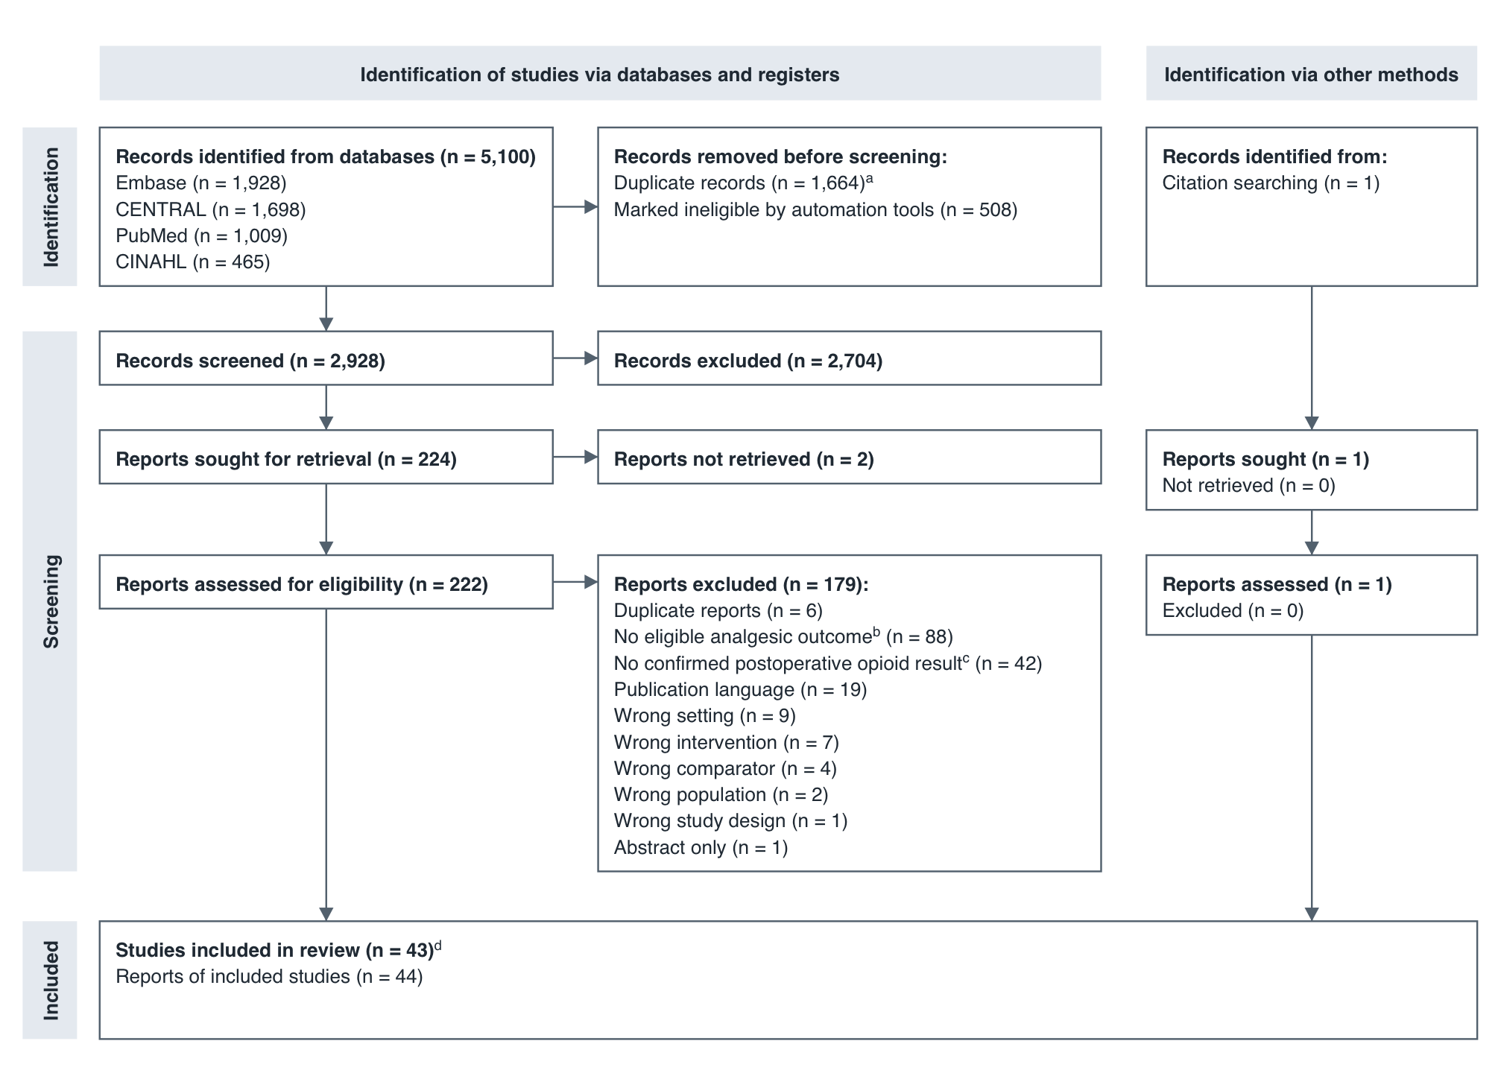
Fig. 1 PRISMA 2020 flow diagram
Database searches were run in July 2026; one further report was identified by citation searching. ᵃ 1,652 duplicates removed in Covidence and 12 references merged by Covidence at import (5,100 references imported as 5,088 records). ᵇ At full text, eligibility required a 24-hour opioid or approximately 24-hour pain outcome, which is narrower than the registered eligibility (see Methods). Reasons for each report are in Additional file 3. ᶜ No named postoperative opioid or morphine-equivalent quantity could be confirmed in the source: none was located in the available report for 27, and for 15 the opioid identity, quantity or timing could not be confirmed (Additional file 3). ᵈ Two reports (Yeh 2010 and Yeh 2011) probably describe overlapping participants and are counted as one study. Adapted from Page et al. [35].

Data extraction
We extracted study, participant, intervention, comparator and outcome data, and stimulation protocols against the Standards for Reporting Interventions in Clinical Trials of Acupuncture (STRICTA) domains [40]. The hospital setting was recorded as stated in each report. Multimodal analgesia was recorded as present when a non-opioid analgesic or a regional or local technique was given routinely to all groups at any time in the perioperative period; drugs given only as rescue were not counted. A second reviewer (SKP) checked the study characteristics, stimulation protocols, hospital setting, analgesic regimens and narrative outcome tables of every report. Arm-level outcome data were independently double-extracted; they were re-checked by the AI assistant against the source reports. Contradictory or uncertain reports were held, analysed only in sensitivity analyses, or left out with an accompanying analysis (Additional file 4). Every extracted value has a recorded source location, and Additional file 5 lists the source of every value entering an analysis. Trial authors were contacted with data queries; none replied.

Outcomes
The primary outcome was cumulative systemic opioid consumption from the end of surgery to 24 hours, in milligrams of intravenous morphine equivalents (IV MME). The co-primary outcome was pain at approximately 24 hours, at rest and on movement, on a 0–10 scale. A registered criterion defined clinical importance as a reduction of at least 10 mg IV MME [31] together with pain evidence from the same trial excluding worsening of 1 point or more [32]. Registered sensitivity thresholds were a reduction of 8 mg [41] and a relative reduction of 30%.
Before synthesis, every candidate opioid result was classified against the registered construct, all delivered systemic opioid over 0–24 hours (Additional file 5). A broader first-day analysis admitted results with incomplete or uncertain capture of systemic opioid, such as patient-controlled analgesia (PCA) totals omitting rescue, and is reported as a sensitivity analysis. Conversion factors are listed in Additional file 6. Intravenous sufentanil was converted at 0.5 mg morphine per µg, a research assumption taken from the midpoint of a chronic-dosing equivalence range, with sensitivity bounds of 0.25 and 1.0; no primary result required it. Opioids without a sourced factor were analysed in native units.
Secondary outcomes included receipt of additional rescue opioid: the proportion of participants given at least one rescue opioid dose. This was analysed separately from rescue amount, time to first rescue and routine receipt of an opioid pump. Other secondary outcomes were opioid consumption at 48 and 72 hours and intraoperatively, pain at other times, nausea and vomiting (composite and separately), quality of recovery (QoR-15 and QoR-40 separately), gastrointestinal recovery, mobilisation, length of stay, satisfaction and adverse events. Harms were summarised descriptively.

Statistical analysis
TEAS and EA were analysed separately, and so were sham, usual-care and active comparisons. Results were pooled with random-effects meta-analysis (restricted maximum likelihood) [42]. Confidence intervals used the Hartung–Knapp method, modified so that they are never narrower than those of the standard method [43, 44]; with only two or three trials they are therefore very wide. Single-trial results are reported on their own. Heterogeneity is reported as I² and τ² [45], and prediction intervals, the range in which the effect of a new trial would be expected to fall, are given for analyses of five or more trials [46]. Each trial contributed one comparison per analysis: several intervention arms were combined, and a shared control arm was counted once. Two reports that probably describe the same participants (Yeh 2010 and 2011) [47, 48] were counted as one trial and not pooled. Each time point was analysed separately. Medians were not converted to means; trials with no events in one arm received a continuity correction of 0.5, and trials with no events in either arm were described but not pooled.
Rescue receipt was seldom reported over a common period, so TEAS-versus-sham trials were pooled over each trial's own follow-up.
Sensitivity analyses removed one trial at a time, removed results at high risk of bias, varied the sufentanil conversion, and used the broader first-day dose analysis. For rescue receipt, they also kept only trials with a stated or a first-day follow-up, and assumed best and worst cases for missing outcomes. The rest-pain and nausea-and-vomiting analyses were also refitted with the trials that the opioid-result requirement had removed. These refits, the broader first-day analysis and the pooling of rescue receipt over differing follow-up were added post hoc, after the primary result was known. The registered meta-regression of stimulation characteristics (timing, repetition, cumulative stimulation, frequency and intensity) needed at least 10 trials per characteristic; no analysis had enough, so the protocols are described instead (Additional file 7). Tests for small-study effects were not done for the same reason, and bias from unreported results was assessed only within trials (RoB 2 domain 5).
No adjustment was made for multiple comparisons: the primary outcome was the single confirmatory question, and all other analyses are supportive or exploratory, interpreted by their precision and GRADE certainty rather than by statistical significance.
Analyses were run in Python and Stata 19.5 and independently recomputed in R 4.5.2 (effects and confidence limits agreed to within 1.4 × 10⁻⁶, and τ² and I² to within 7.3 × 10⁻⁶); later refits were run in R and recomputed in independent re-checks, the last by an AI assistant. One script in Additional file 8 reproduces the final estimates from the distributed inputs.

Risk of bias and certainty of evidence
Risk of bias was assessed with the Cochrane risk-of-bias tool for randomised trials, version 2 (RoB 2) [33] for each result: each outcome, time window, comparison and analysis population was judged separately, including results used only in sensitivity analyses. Certainty was assessed with the Grading of Recommendations Assessment, Development and Evaluation (GRADE) approach [34] for each outcome and comparison, with imprecision judged against the 10 mg opioid threshold and the 1-point pain margin. No body of evidence was upgraded. Assessments were made by JRNM and an AI assistant which were checked and confirmed by a second reviewer (SKP). Results held from synthesis or reported only descriptively were not assessed (Additional files 9 and 10). The four trials added only in the refits of rest pain and nausea and vomiting were not re-assessed; their earlier assessments are listed in Additional file 9.

Use of AI tools
Large language models (GPT-6 Astra, OpenAI, used through the Codex agent; and Claude Opus 5.5, Anthropic) were used in the conduct of this review and are not authors. Under the review team's delegation, they wrote analysis code, supported the resolution of some screening, data extraction, and RoB2/GRADE assessment conflicts and edited language; the checks by a second reviewer are described above. The authors take responsibility for the content.

Results

Study selection
The searches identified 5,100 records, of which 2,928 were screened. Of 224 reports sought from the database searches, 222 were retrieved; with one report found by citation searching, 223 full-text records were assessed, six of which duplicated other records (Fig. 1). Forty-four reports of 43 trials were included [36–39, 47–86]. The most common reasons for exclusion at full text were no 24-hour opioid or pain outcome (88 reports), no confirmed postoperative opioid result (42) and no English full text (19). The full texts of six excluded reports could not be retrieved to confirm their exclusion reasons (Additional file 3). Two reports (Yeh 2010 and 2011) probably describe overlapping participants and are counted as one trial; on that convention the 43 trials randomised 7,703 participants (7,793 across the 44 reports). Eligibility was not fully confirmed for four reports, which were retained but not pooled: Lee 2011 enrolled participants aged 14–59 years, Chen 2016's eligibility criteria admitted patients aged 16–80 years, general anaesthesia was not established in Jin 2023, and the modality of Long 2025 could not be classified.

Study characteristics
Table 1 summarises the included reports. Twenty-eight evaluated TEAS, 15 evaluated EA and one could not be classified (Long 2025). Thirty-five reports came from Asia: China (27), Taiwan (4), Hong Kong (2), Malaysia (1) and Singapore (1). The remaining nine came from the USA (3), Turkey (2), and Brazil, Greece, Poland and the UK (one each). The median trial randomised 88 participants (range 20 to 1,948). Thirty-five reports included a sham arm. Of the other nine, seven compared the intervention with usual care and two with an active electrical comparator and usual care (Oztas 2019, Wu 2016). Sham procedures ranged from electrodes or needles applied without current to low-intensity stimulation. Procedures spanned abdominal, gynaecological, thoracic, cardiac, neurosurgical, breast, thyroid and orthopaedic surgery. Seven reports stated a tertiary setting, 15 named a university or university-affiliated hospital, ten named another hospital, one was multicentre without stating the level of care, and 11 did not state the trial site. Routine multimodal analgesia (a non-opioid analgesic or a regional or local technique given to all groups at any perioperative time) was described in 14 reports, including Szmit 2021, in which every patient received 1 g metamizole before the end of surgery. In eight of these 14 the routine non-opioid was given only before or at the end of surgery, as in Szmit 2021; in six it continued after surgery (Additional file 7). It was conditional on use of an analgesia pump in two reports. No routine non-opioid component was described in 27 reports, and one did not report the regimen. Postoperative opioid regimens, PCA settings and rescue criteria also differed across trials.
Stimulation protocols converged on a few acupoints but varied in delivery. Forty-two reports used at least one of PC6 (30 reports), ST36 (27) or LI4 (25); two TEAS trials combined LI4 with electrodes beside the incision (Szmit 2021, Wang 1997). Alternating frequencies were most common: 2/100 Hz in 16 reports and 2/10 Hz in ten. Stimulation was given postoperatively only in 15 reports, preoperatively only in seven, intraoperatively only in six and across more than one phase in 15; one trial gave it before or after surgery in separate arms (Sim 2002). Twenty-one reports used a single session: nine of 30 minutes, nine continuous through surgery, one through surgery with a pause during microelectrode recording (Fu 2024) and two of 20 or 45 minutes.

Contribution of reports to the analyses
Fig. 2 shows how each report contributed. Although all 44 reports contained postoperative opioid data, only three contributed to the registered primary outcome; the others reported opioid use over a different window, as a weight-normalised dose or pump volume, as rescue receipt, or without separately quantified rescue. Eleven reports contributed to the broader first-day dose analysis, eight to rescue opioid receipt and 12 to nausea and vomiting. Thirty-five reports contributed to at least one main analysis, most to only one or two outcome domains. Nine contributed to no main analysis, mainly because their opioid outcomes were reported in forms that could not be pooled.
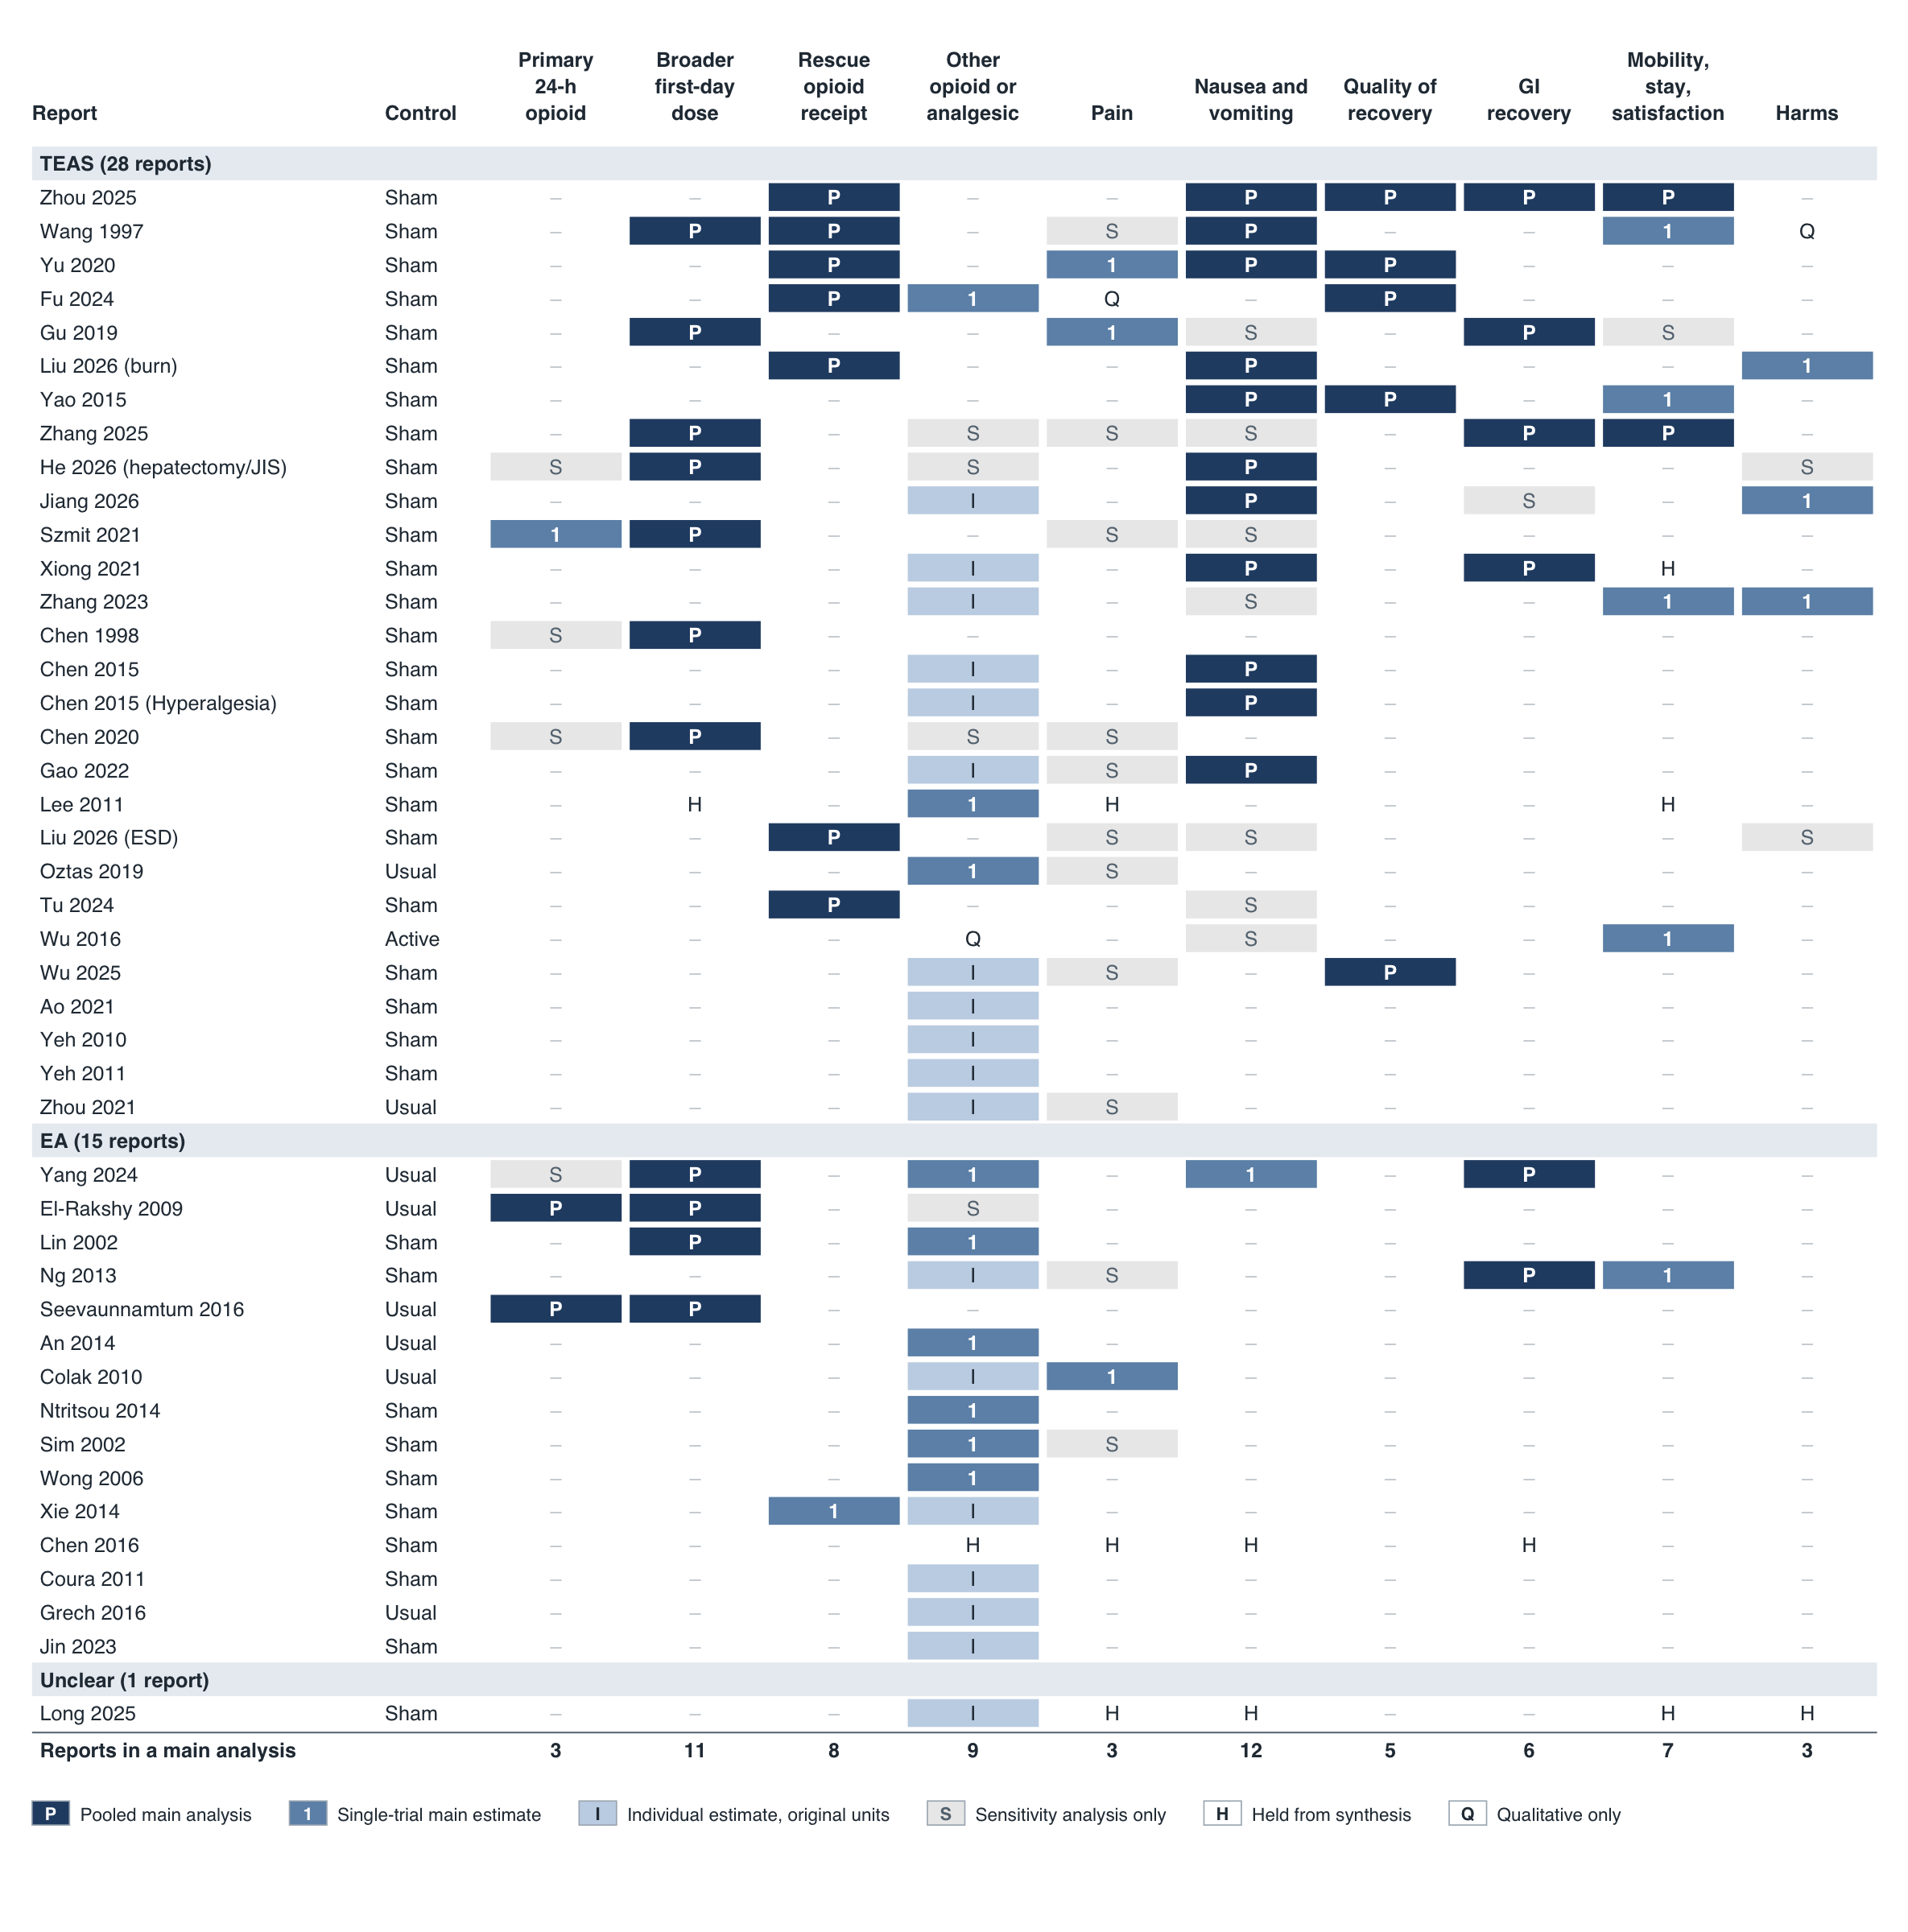
Fig. 2 Contribution of each included report to the analyses
Rows are reports grouped by modality; columns are outcome domains. P, contributed to a pooled main analysis; 1, single-trial main estimate; I, individual estimate in the report's original units, not pooled; S, sensitivity or diagnostic analysis only; H, held from synthesis; Q, qualitative finding only. The control column gives the principal comparator (Active, an active electrical comparator at non-acupoints). The bottom row counts reports in a main analysis for each domain. The broader first-day dose domain is itself a sensitivity analysis of the primary outcome. GI, gastrointestinal.

Risk of bias
Of 180 assessed results, two (1%) were at low risk of bias, 126 (70%) had some concerns and 52 (29%) were at high risk (Fig. 3). High risk always arose from one of two domains. Thirty results were rated high for missing outcome data, usually because participants were excluded after randomisation for surgical complications, conversion to open surgery or neurological events that plausibly relate to pain, opioid use or nausea. Twenty-one were rated high for outcome measurement, when someone who knew the allocation reported or determined the outcome: self-reported pain, nausea or bowel function, patient-initiated opioid doses, or remifentanil titrated by an unblinded anaesthetist. One was rated high for both. No result was at high risk from the randomisation process, deviations from the intended interventions or selective reporting.
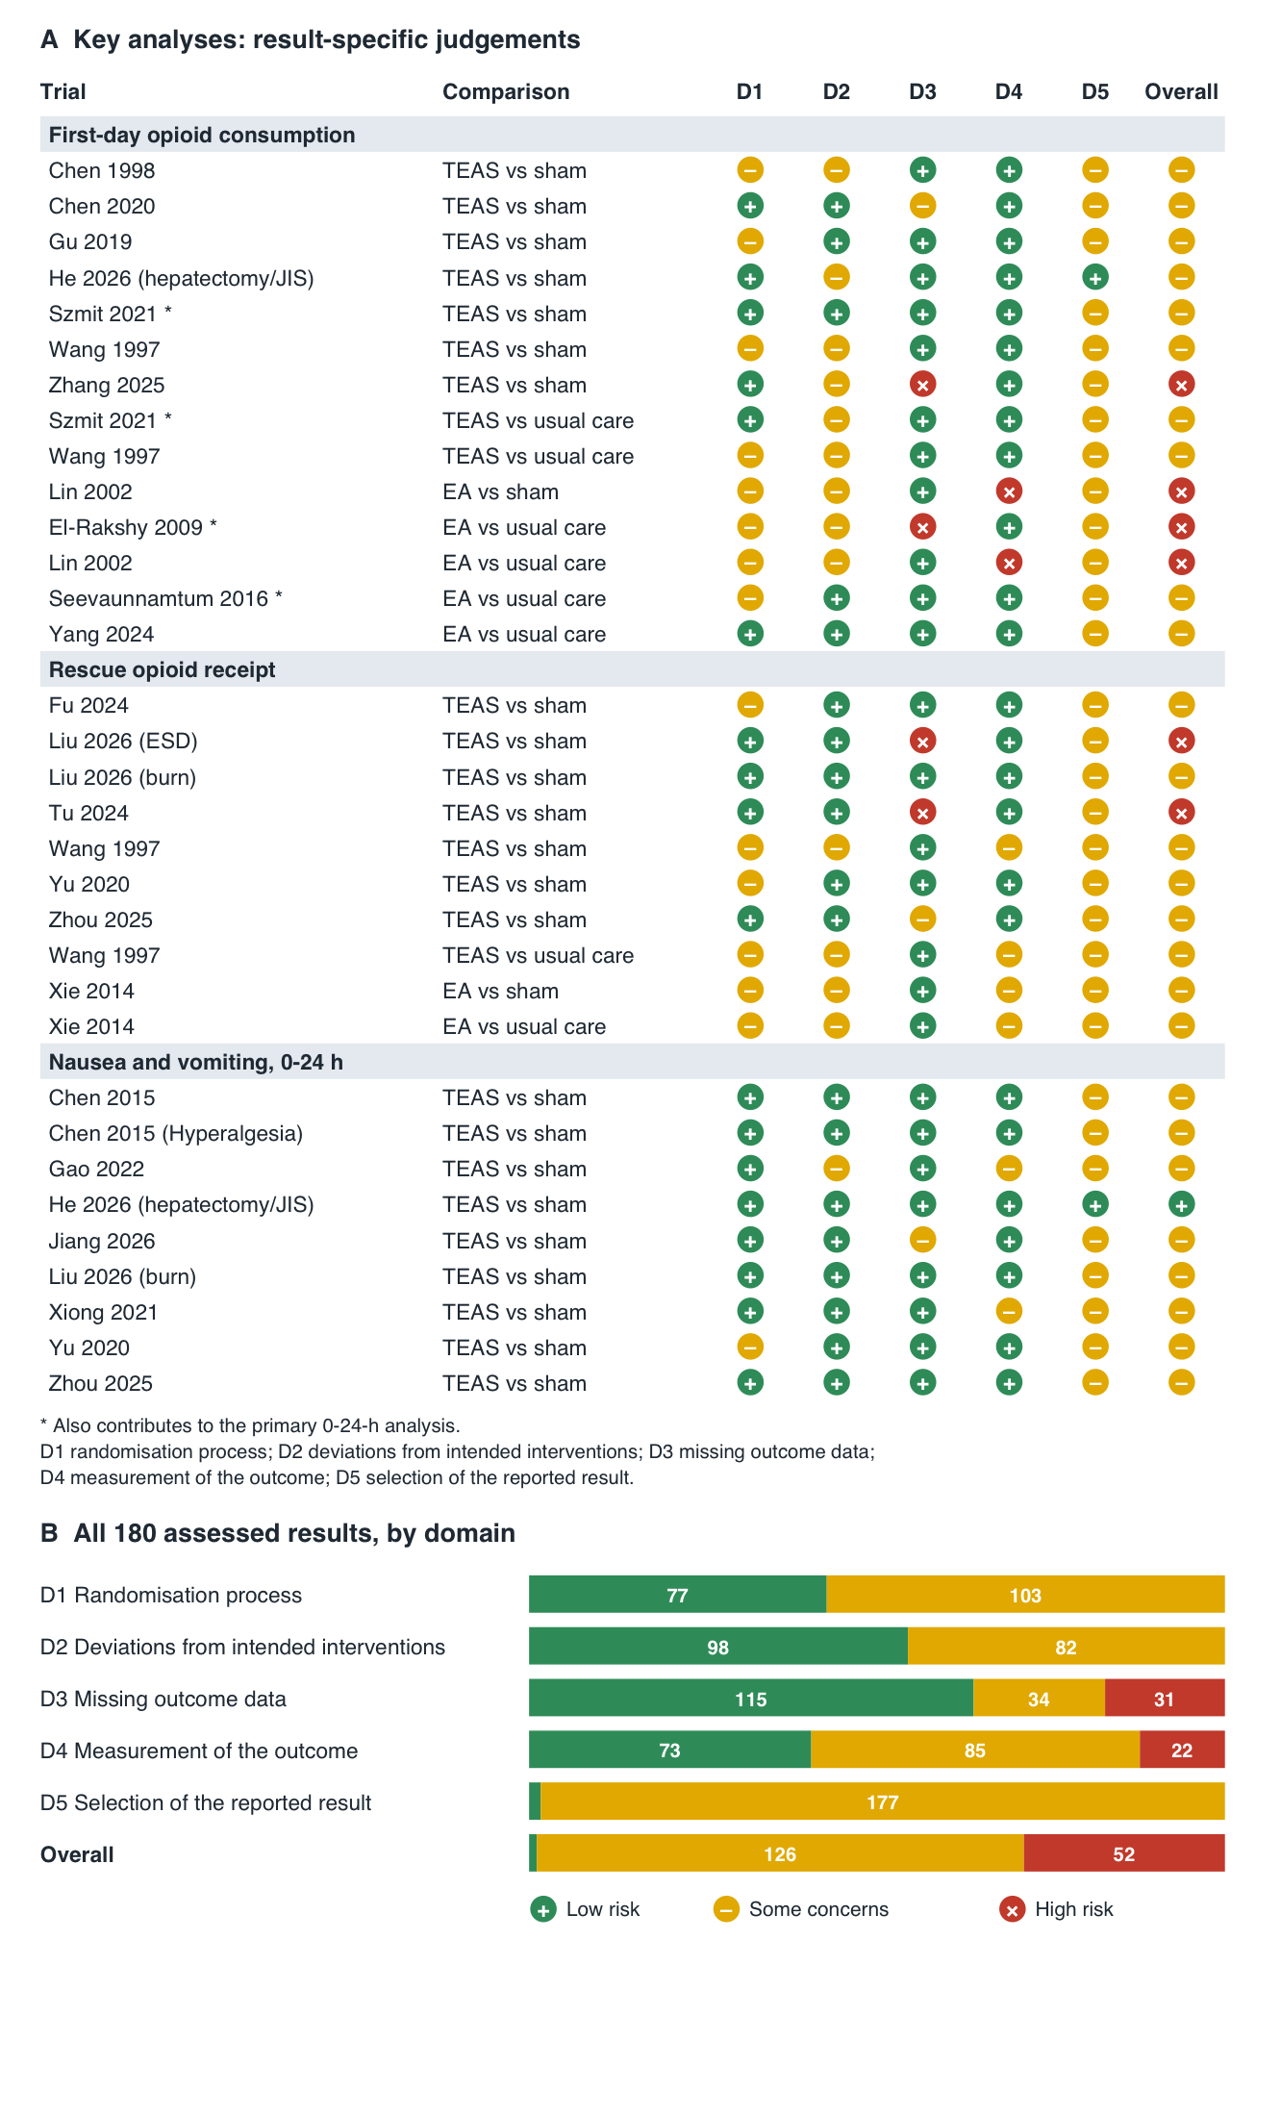
Fig. 3 Risk of bias
(A) Result-specific RoB 2 judgements for the first-day opioid analyses (including the three primary-outcome trials, marked *), rescue opioid receipt and nausea and vomiting over 0–24 hours. (B) Distribution of judgements by domain across all 180 assessed results. D1, randomisation process; D2, deviations from intended interventions; D3, missing outcome data; D4, measurement of the outcome; D5, selection of the reported result.
Most judgements of some concerns arose in two domains. Almost every result (177 of 180) had some concerns for selection of the reported result, usually because a prespecified analysis plan could not be verified for that result; the three exceptions were from He 2026, whose protocol and analysis plan were available. Just over half (103) had some concerns about randomisation, mostly because allocation concealment was not described. In the key analyses, high-risk results came from a few trials: Zhang 2025 and Lin 2002 in the first-day opioid analyses, El-Rakshy 2009 in the primary EA-versus-usual-care analysis, and Tu 2024 and Liu 2026 (ESD) in the rescue analysis. Only one result in these analyses was at low risk (He 2026, nausea and vomiting). Judgements for every result, with rationales, are in Additional file 9.

Primary outcome: systemic opioid consumption over 0–24 hours
One trial supplied an eligible TEAS-versus-sham result (Szmit 2021; 48 participants). The mean difference (MD) in cumulative systemic opioid consumption was −7.70 mg (95% confidence interval [CI] −10.62 to −4.78; low-certainty evidence). The point estimate was smaller than both the 10 mg threshold and the 8 mg sensitivity threshold, but the interval included a 10 mg reduction. The trial did not report pain at approximately 24 hours, so the registered criterion for clinical importance could not be evaluated. No EA-versus-sham result met the primary outcome definition. Wang 1997 was not admitted to this analysis because its report does not establish that its 24-hour hydromorphone quantities include the intramuscular supplemental opioid given to 19 of its 101 participants; supplemental meperidine was converted to hydromorphone equivalents for the report's analysis, but rescue was not itemised. It was therefore analysed in the broader first-day analysis only, as Chen 1998 was.
Against usual care, the same trial gave an MD of −8.00 mg for TEAS (−10.92 to −5.08; 47 participants; low certainty). Two EA trials gave a pooled MD of −6.83 mg (−76.39 to 62.73; 159 participants; I² = 72%; very low certainty); their individual estimates were −1.60 mg (El-Rakshy 2009) and −12.56 mg (Seevaunnamtum 2016).

Co-primary outcome: pain at approximately 24 hours
Only one TEAS-versus-sham trial reported pain at rest at about 24 hours (Yu 2020; 60 participants). Pain was 1.03 points lower with TEAS on a 0–10 scale (95% CI −1.80 to −0.26), so the trial rules out pain being worse by 1 point or more (low certainty: one small trial). Its table and abstract give different standard deviations; with the abstract's, the result was almost the same (−1.03, −1.77 to −0.29). Because this trial did not report the primary opioid outcome, it cannot show whether pain was preserved in the patients whose opioid use fell. Adding back the two rest-pain trials removed by the opioid-result requirement (Liu 2021 and Xing 2022), the MD was −0.21 points (−0.75 to 0.33; three trials, 218 participants), which still rules out a 1-point worsening. No trial reported pain on movement. For EA, one small unblinded trial against usual care (Colak 2010; 30 participants) gave −0.20 points on day 1 (−1.05 to 0.65; very low certainty). Five trials reported pain without saying whether it was at rest or on movement; together they gave −1.66 points (−3.03 to −0.29; 492 participants), but the trials differed greatly (I² = 98%), and a new trial could plausibly find anything from 4.91 points lower to 1.59 points higher (prediction interval).

Broader first-day opioid consumption (sensitivity analysis)
The registered primary outcome is the total of all systemic opioid given in the first 24 hours, including rescue doses. Many trials reported only part of it: most often the opioid delivered by a patient-controlled analgesia (PCA) pump, without the rescue doses given outside the pump, or a total that did not say whether rescue doses were counted. Such results understate or may understate total opioid use, so they could not answer the primary question; this is one of the main reasons only one TEAS-versus-sham trial contributed to the primary outcome. They were pooled in this broader analysis instead: seven TEAS-versus-sham trials (622 participants) gave an MD of −7.22 mg (−14.13 to −0.32; I² = 98%; prediction interval −24.81 to 10.36; very low certainty) (Fig. 4). Lee 2011 was held from this and all other pooled analyses. Without Wang 1997, the estimate was −6.67 mg (−14.53 to 1.18; six trials), and four of the seven leave-one-out intervals included no difference (estimates −5.33 to −8.60 mg). The sufentanil conversion bounds gave −5.14 mg (−11.02 to 0.75) and −10.61 mg (−20.71 to −0.52). Excluding the one result at high risk of bias left six trials and 529 participants (−8.48 mg, −16.64 to −0.32); excluding the two trials whose totals may not capture supplemental opioid (Chen 1998 and Wang 1997) gave −5.07 mg (−12.23 to 2.10; five trials). Three trials in this analysis also reported pain at about 24 hours in the same arms, without stating whether at rest or on movement: Chen 2020 (opioid −14.10 mg; pain −3.06 points), Gu 2019 (−1.57 mg; −0.74 points) and Wang 1997 (−15.00 mg, −31.00 to 1.00; −0.35 points, −1.44 to 0.74). None of these pairs applies the registered criterion, which requires the primary opioid outcome and pain at rest or on movement.
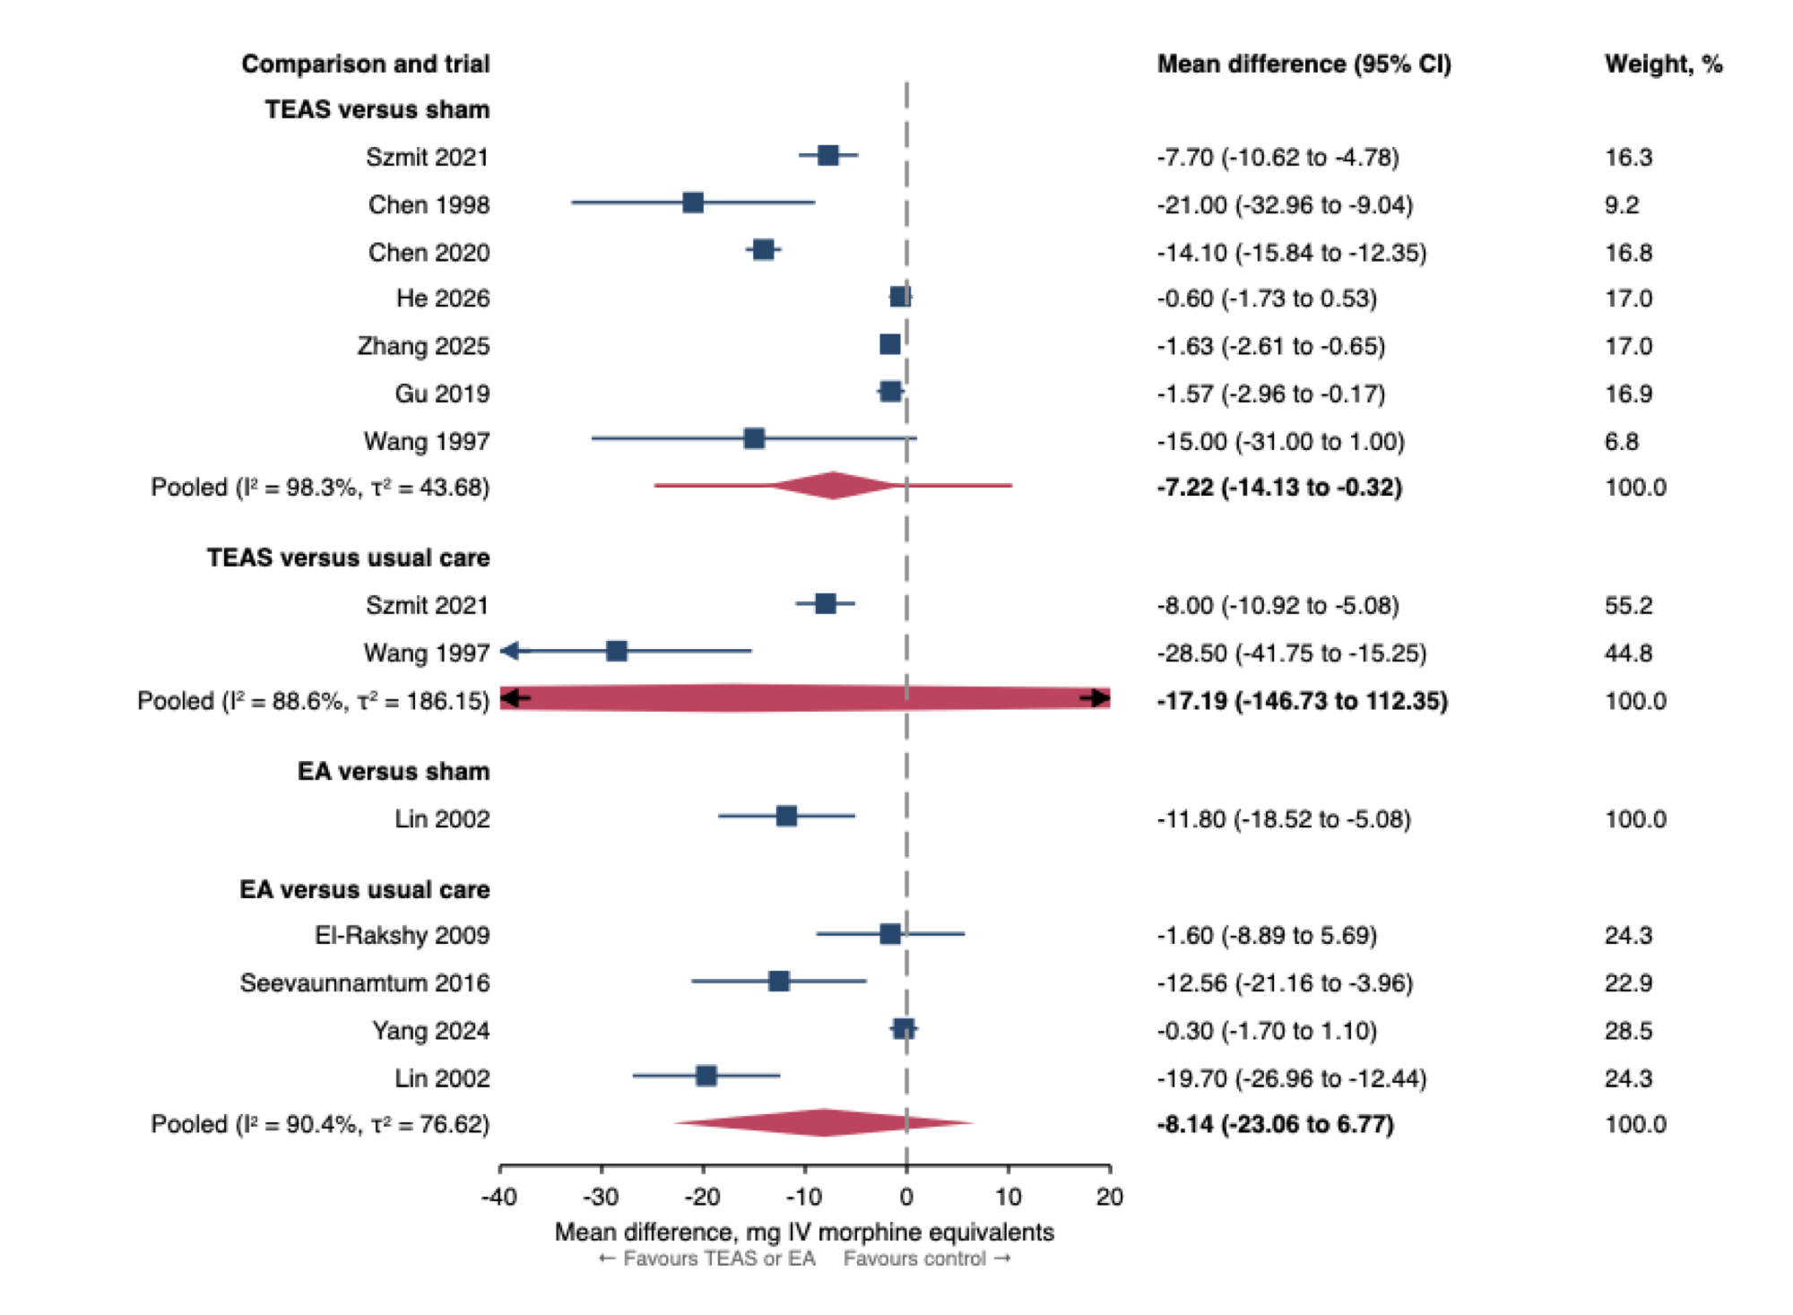
Fig. 4 Broader first-day opioid consumption, by modality and comparator
This is a sensitivity analysis of the primary outcome that admits results with incomplete capture of systemic opioid. Mean differences are in mg intravenous morphine equivalents; negative values favour TEAS or EA. Pooled estimates use random-effects models (REML) with Hartung–Knapp 95% confidence intervals, and weights are calculated within each comparison. Single trials show their own 95% confidence intervals. The line through the TEAS-versus-sham diamond is the 95% prediction interval. Nothing is pooled across comparisons. Szmit 2021, Wang 1997 and Lin 2002 appear twice because their active arms were compared with both sham and usual care. Arrows mark intervals that extend beyond the axis. Lee 2011 is held from all pooled analyses.
Against usual care, two TEAS trials (Szmit 2021 and Wang 1997) gave −17.19 mg (−146.73 to 112.35; 123 participants; I² = 89%; very low certainty). For EA, a single sham-controlled trial at high risk of bias gave −11.80 mg (Lin 2002; −18.52 to −5.08; 75 participants; very low certainty). Four usual-care-controlled trials gave −8.14 mg (−23.06 to 6.77; 414 participants; I² = 90%; very low certainty).

Receipt of additional rescue opioid
Seven TEAS-versus-sham trials, six conducted in China and one in the USA, reported whether participants received rescue opioid (612 participants, 155 events). Fewer participants received rescue opioid with TEAS (risk ratio [RR] 0.51, 95% CI 0.37 to 0.71; I² = 0%; low certainty) (Fig. 5). Follow-up was 6–24 hours, 24 hours, through the first postoperative day, 48 hours and 3 days in five trials, and was not stated in two (Yu 2020 and Fu 2024); the five trials with stated follow-up gave RR 0.51 (0.32 to 0.81). At the observed comparator risk of 34.5%, the pooled ratio corresponds to about 17 fewer participants per 100 receiving rescue opioid (10 to 22 fewer); this illustrates the ratio and is not a standardised risk difference. τ² was estimated as zero, so the prediction interval equals the confidence interval and does not show that effects were consistent.
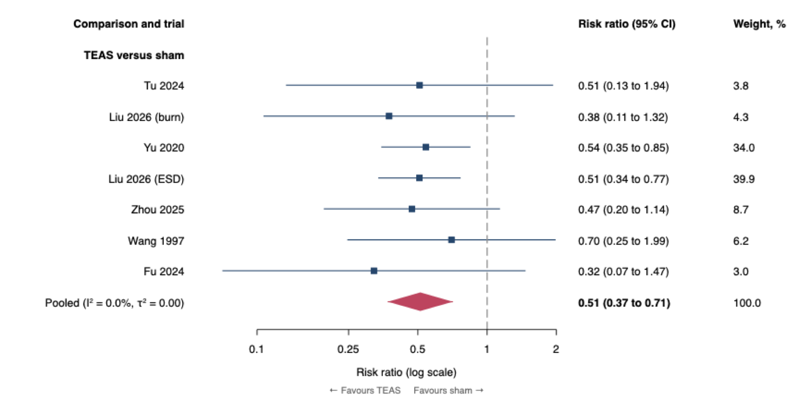
Fig. 5 Receipt of additional rescue opioid, TEAS versus sham
Exploratory analysis of the proportion of participants given at least one rescue opioid dose. Risk ratios are shown on a log scale; values below 1 favour TEAS. Six of the seven trials were conducted in China and one in the USA. Follow-up was 6–24 hours, 24 hours, through the first postoperative day, 48 hours or 3 days, and was not stated in Yu 2020 or Fu 2024, so the pooled estimate is not a 0–24-hour effect. The pooled estimate uses a random-effects model (REML) with a Hartung–Knapp 95% confidence interval. τ² was estimated as zero, so the 95% prediction interval equals the confidence interval and does not show that effects were consistent.
Leave-one-out estimates ranged from 0.50 to 0.52; without Fu 2024, whose printed P values do not match its printed summaries (Additional file 4), the RR was 0.52 (0.37 to 0.74). After excluding the two trials at high risk of bias, the RR was 0.52 (0.32 to 0.84; five trials, 377 participants). The three trials with first-day follow-up gave RR 0.53 (0.12 to 2.42; 276 participants; very low certainty). Assigning rescue opioid to every participant with a missing outcome in the TEAS arm and to none in the sham arm gave RR 0.61 (0.45 to 0.82). Against usual care, Wang 1997 gave RR 0.52 (0.20 to 1.32; 76 participants; very low certainty). For EA, a single trial gave RR 0.17 (0.02 to 1.26) versus sham and 0.14 (0.02 to 1.06) versus usual care (Xie 2014; 40 participants per comparison; very low certainty).

Protocol characteristics
The registered meta-regression could not be performed. The primary TEAS-versus-sham analysis contained one trial and the EA analysis none, and the largest broader-dose analysis had seven trials, below the required 10 per predictor. Stimulation protocols varied widely: preoperative only, intraoperative, repeated postoperative sessions or several perioperative phases, with differing frequencies and intensities (Additional file 7). The data could not show which timing, frequency, intensity or number of sessions was associated with greater opioid sparing.

Other outcomes
For TEAS versus sham, composite postoperative nausea and vomiting over 0–24 hours was less frequent (RR 0.60, 0.45 to 0.79; nine trials, 2,848 participants; I² = 55%; prediction interval 0.32 to 1.12; low certainty). With a comparator risk of 34.1%, this corresponds to about 14 fewer patients per 100 (7 to 19 fewer). Adding the two trials removed by the opioid-result requirement (Zheng 2025 and Lu 2021) gave RR 0.63 (0.51 to 0.77; 11 trials, 3,509 participants). The single trial at low risk of bias showed no clear difference (RR 0.89, 0.52 to 1.53; 159 participants). Vomiting was also less frequent (RR 0.57, 0.40 to 0.81; four trials, 1,863 participants; very low certainty); nausea reported separately did not clearly differ (RR 0.78, 0.22 to 2.78; two trials, 146 participants; very low certainty).
Quality of recovery at approximately 24 hours did not clearly differ (QoR-40: MD 10.19 points, −13.26 to 33.63, two trials; QoR-15: MD 8.47 points, −5.18 to 22.12, three trials; very low certainty). Without Fu 2024, the QoR-15 estimate was 9.64 points (−57.20 to 76.47; two trials). Time to first flatus was −4.70 hours (−9.88 to 0.48; four trials, 369 participants; very low certainty). In one large trial, mobilisation within 24 hours was more frequent with TEAS (RR 1.10, 1.02 to 1.19; 1,838 participants; low certainty).
Adverse events were inconsistently reported, and no difference in harm was established. In Jiang 2026 (587 participants), the RR for any adverse event was 1.14 (0.42 to 3.10; very low certainty); the largest trial (Zhang 2023) reported specific events only. No included report gave a result on persistent opioid use beyond 30 days. Table 2 summarises the main findings and their certainty. Further outcomes and all sensitivity analyses are in Additional file 11.
Table 2 Summary of findings: TEAS or EA versus sham or usual care after surgery
Outcome | Comparison | Trials (participants) | Effect (95% CI) | Certainty
Systemic opioid, 0–24 h (primary) | TEAS vs sham | 1 (48) | MD −7.70 mg (−10.62 to −4.78) | Low
 | EA vs sham | 0 | No eligible result | Not rated
 | TEAS vs usual care | 1 (47) | MD −8.00 mg (−10.92 to −5.08) | Low
 | EA vs usual care | 2 (159) | MD −6.83 mg (−76.39 to 62.73) | Very low
Rest pain, ~24 h (co-primary) | TEAS vs sham | 1 (60) | MD −1.03 points (−1.80 to −0.26) | Low*
 | EA vs usual care | 1 (30) | MD −0.20 points (−1.05 to 0.65) | Very low*
Broader first-day opioid (sensitivity analysis) | TEAS vs sham | 7 (622) | MD −7.22 mg (−14.13 to −0.32) | Very low
 | TEAS vs usual care | 2 (123) | MD −17.19 mg (−146.73 to 112.35) | Very low
 | EA vs sham | 1 (75) | MD −11.80 mg (−18.52 to −5.08) | Very low
 | EA vs usual care | 4 (414) | MD −8.14 mg (−23.06 to 6.77) | Very low
Rescue opioid receipt (exploratory; follow-up 6 h to 3 days)† | TEAS vs sham | 7 (612) | RR 0.51 (0.37 to 0.71); 17 fewer per 100 (10 to 22 fewer)‡ | Low
 | EA vs sham | 1 (40) | RR 0.17 (0.02 to 1.26) | Very low
PONV, 0–24 h | TEAS vs sham | 9 (2848) | RR 0.60 (0.45 to 0.79); 14 fewer per 100 (7 to 19 fewer)‡ | Low
*Certainty that the intervention does not worsen pain by 1 point or more; neither result comes from a trial that reported the primary opioid outcome. Adding the two rest-pain trials removed by the opioid-result requirement gave MD −0.21 (−0.75 to 0.33). †Proportion of participants given at least one rescue opioid dose, over each trial's own follow-up (not stated in two trials); excluding the two trials at high risk of bias gave RR 0.52 (0.32 to 0.84). ‡Illustrative absolute effects at the observed comparator risk (34.5% for rescue, 34.1% for PONV). Reasons for downgrading are given in Additional file 10. CI, confidence interval; EA, electroacupuncture; MD, mean difference; PONV, postoperative nausea and vomiting; RR, risk ratio; TEAS, transcutaneous electrical acupoint stimulation.

Discussion

Principal findings
In 44 reports of 43 randomised trials, the evidence did not demonstrate that perioperative TEAS or EA reduces total systemic opioid consumption over the first 24 hours by a clinically important amount. The registered primary outcome was available from one sham-controlled TEAS trial of 48 participants: a 7.7 mg reduction whose interval included 10 mg (low certainty). That trial reported no pain result at 24 hours, so the registered criterion for clinical importance could not be evaluated. The one TEAS rest-pain result came from a different trial, and the three broader-analysis trials that reported pain in the same arms did not state whether it was at rest or on movement. No sham-controlled EA trial reported the primary outcome. In a sensitivity analysis admitting results with incomplete or uncertain capture of systemic opioid, the TEAS-versus-sham estimate (−7.22 mg) was smaller than the 10 mg threshold; its upper limit (−0.32 mg) only just excluded no difference, and the interval included no difference without Wang 1997 (very low certainty). Fewer patients receiving TEAS had postoperative nausea and vomiting (about 14 fewer per 100; low certainty), and, in an exploratory analysis over differing follow-up, fewer received rescue opioid. The findings do not establish opioid sparing of a size that would matter to patients or clinicians.

Why total dose and rescue receipt diverge
These two findings need not conflict. Total quantity and rescue receipt answer different questions: when most postoperative opioid is delivered by pumps with fixed settings, total quantity may change little even if fewer patients reach the threshold for rescue. Rescue receipt has its own weaknesses. Six of the seven trials were conducted in China, follow-up ranged from 6 hours to 3 days and was not stated in two trials, and rescue criteria differed. Without the two trials at high risk of bias, the estimate was similar (RR 0.52, 0.32 to 0.84), but the follow-up periods still differed. The rescue finding therefore does not confirm opioid sparing; it identifies an outcome that future trials should measure over a fixed window.

Why the evidence is uncertain
The first reason is how opioid use was reported. All 44 reports contained postoperative opioid data, but only three supplied the registered outcome: all delivered systemic opioid over a fixed 24-hour window, in convertible units. The others reported a different window, a weight-normalised dose, a pump volume, a PCA total that omitted rescue, or rescue receipt alone. Trials that randomised 7,703 participants therefore yielded a primary estimate from 48. The broader analysis pooled such quantities and showed near-total heterogeneity (I² = 98%), which probably reflects differences in what was measured as well as in effect.
The second reason is the background analgesia. Routine multimodal analgesia was described in 14 reports, including the single primary TEAS trial, which gave every patient metamizole before the end of surgery; no routine non-opioid component was described in 27. Control-group opioid consumption is a major source of heterogeneity in trials of analgesic adjuncts [87], and trials with less multimodal analgesia than clinical practice may overstate the opioid sparing an intervention would achieve in routine care [88].
The third reason is trial conduct and reporting. Of 180 assessed results, 29% were at high risk of bias, all from missing outcome data or outcome measurement: exclusions after randomisation for complications plausibly related to pain or opioid use, and outcomes reported or determined by someone who knew the allocation. Most other results had some concerns, usually because a prespecified analysis plan could not be verified, and allocation concealment was often not described. A registered protocol with an analysis plan, analysis of all randomised participants and blinded outcome assessment would address most of these.

Comparison with previous reviews
The largest previous synthesis of perioperative TEAS included 76 trials; six of them contributed to its estimate of a 14.6 mg reduction in 24-hour morphine-equivalent consumption, with electrodes applied without current grouped with usual care as controls [23]. Against non-acupoint sham stimulation, it reported a smaller reduction (5.33 mg), with a P value that does not match its interval. Our sham-controlled estimates are smaller and less certain. Three differences in method probably contribute: we analysed sham and usual-care comparisons separately, never pooled TEAS with EA, and did not combine opioid quantities that measured different things. We did not re-analyse the earlier review's trials with our methods, so these explanations have not been tested. An earlier review found less opioid use on day 1 with TEAS but not with EA or manual acupuncture [28], which supports analysing the modalities separately; reviews that pooled acupuncture modalities [29] answer a broader question.
For nausea and vomiting, our estimate (RR 0.60) is similar to those of a Cochrane network meta-analysis of PC6 stimulation, in which noninvasive PC6 stimulation reduced nausea (RR 0.67) and vomiting (RR 0.58) compared with sham, with low certainty [89], and to a review of electrical acupoint stimulation (RR 0.49) [30]. PC6 was stimulated in 30 of the 44 reports. Because PC6 stimulation is also studied as a direct antiemetic, the reduction cannot be attributed to opioid sparing, and its prediction interval (0.32 to 1.12) allows no effect in a new setting.

Patient-reported outcomes
Opioid quantity stands in for what patients experience. The Standardised Endpoints in Perioperative Medicine (StEP) patient-comfort group recommends pain at rest and on movement, supplementary analgesic use, nausea and vomiting, QoR-15 and time to mobilisation, among other endpoints; morphine consumption at 24 hours did not reach consensus [90]. Of the opioid outcomes here, rescue receipt resembles supplementary analgesic use most closely.
The included reports gave these endpoints sparsely. Two gave an eligible result for rest pain (one TEAS and one EA trial) and none for pain on movement at about 24 hours; nine measured quality of recovery with three instruments, with imprecise pooled estimates; and none reported persistent opioid use. Because reports were included only if they reported a postoperative opioid result, these counts describe that selected set, not all trials of TEAS or EA: trials reporting pain or recovery without an opioid result were excluded.

Where the evidence comes from
Thirty-five of the 44 reports came from Asia, 27 of them from China, and six of the seven TEAS rescue trials were conducted in China. This makes the evidence most directly applicable where these interventions are already used, and whether it transfers elsewhere depends on background analgesia, rescue criteria and patient expectations more than on geography. The low certainty arose from features of trial conduct and reporting judged result by result, not from where trials were done.

Strengths and limitations
Modality and comparator were treated as part of the question and never pooled, every candidate opioid result was classified against the registered outcome definition before synthesis, risk of bias was assessed for each result, and the analyses were reproduced independently in R.
The review also had limitations. First, only English full texts were eligible and Chinese-language databases, such as CNKI, Wanfang and VIP, were not searched, although most trials of these interventions are conducted in China. Nineteen reports published in Chinese were excluded, seven of them with English abstracts reporting pain at about 24 hours or an opioid result, and other relevant trials may be missing. Language-restricted reviews of complementary interventions have produced smaller effect estimates than language-inclusive reviews, and Chinese-language acupuncture trials have reported larger effects [26, 91, 92]; a search including these databases might therefore have found larger effects, but this review cannot tell whether such differences would reflect true effects or bias. Second, the primary analysis contained one trial, and the meta-regression and small-study tests were not feasible. Finally, harms were inconsistently reported, so the absence of a difference in harms is not evidence of safety.

Implications for practice and research
For practice, these findings neither support adopting TEAS or EA specifically to reduce postoperative opioid dose nor show that the interventions are ineffective. Where they are already part of routine care, other considerations will guide the decision, including patient preference and the low-certainty evidence of less nausea.
The most useful next trials would report all delivered systemic opioid, including rescue, over a fixed 0–24-hour window with the drugs, routes and conversion basis, together with rescue receipt over the same window, pain at rest and on movement, QoR-15 and nausea and vomiting [90]. They would test stimulation within contemporary multimodal analgesia, register a protocol with an analysis plan, analyse all randomised participants, blind outcome assessment, and describe stimulation to STRICTA standards [40]. Sham-controlled EA trials are the clearest gap. Future syntheses should search Chinese-language databases, ideally with researchers in China.

Conclusions
In the included trials, perioperative TEAS and EA did not demonstrate a clinically important reduction in first-day systemic opioid consumption: the single eligible primary trial's interval included a 10 mg reduction, and that trial did not report the pain result needed to apply the registered criterion. Fewer patients receiving TEAS had nausea and vomiting, with low certainty. Trials that report all delivered opioid and pain over a fixed 24-hour window within contemporary multimodal analgesia, including sham-controlled EA trials, are needed.

List of abbreviations
AI: artificial intelligence
CI: confidence interval
EA: electroacupuncture
ENT: ear, nose and throat
ESD: endoscopic submucosal dissection
GI: gastrointestinal
GRADE: Grading of Recommendations Assessment, Development and Evaluation
IV MME: intravenous morphine milligram equivalents
MD: mean difference
MMA: multimodal analgesia
PCA: patient-controlled analgesia
PCIA: patient-controlled intravenous analgesia
PONV: postoperative nausea and vomiting
PRISMA: Preferred Reporting Items for Systematic Reviews and Meta-Analyses
PROSPERO: International Prospective Register of Systematic Reviews
QoR-9, QoR-15, QoR-40: Quality of Recovery scores with 9, 15 and 40 items
REML: restricted maximum likelihood
RoB 2: Cochrane risk-of-bias tool for randomised trials, version 2
RR: risk ratio
StEP: Standardised Endpoints in Perioperative Medicine
STRICTA: Standards for Reporting Interventions in Clinical Trials of Acupuncture
TEAS: transcutaneous electrical acupoint stimulation
TENS: transcutaneous electrical nerve stimulation

Declarations

Ethics approval and consent to participate
Not applicable. This systematic review synthesised data from published reports; no new human participants, human data or human tissue were involved.

Consent for publication
Not applicable.

Availability of data and materials
The datasets supporting the conclusions of this article are included within the article and its additional files (Additional files 3 to 11).

Competing interests
The authors declare that they have no competing interests.

Funding
This work received no external funding.

Authors' contributions
JRNM conceived and designed the review, ran the searches, screened titles, abstracts and full texts, directed the AI-assisted data verification and analyses, and drafted the manuscript. SKP screened titles, abstracts and full texts and was the second reviewer for study characteristics, stimulation protocols, hospital setting, analgesic regimens, narrative outcome tables, and all risk-of-bias and GRADE assessments. CS and PJ contributed to the design and critically revised the manuscript. All authors read and approved the final manuscript.

Acknowledgements
Not applicable.

References
1. Weiser TG, Haynes AB, Molina G, Lipsitz SR, Esquivel MM, Uribe-Leitz T, et al. Estimate of the global volume of surgery in 2012: an assessment supporting improved health outcomes. Lancet. 2015;385 Suppl 2:S11.
2. Liu Y, Xiao S, Yang H, Lv X, Hou A, Ma Y, et al. Postoperative pain-related outcomes and perioperative pain management in China: a population-based study. Lancet Reg Health West Pac. 2023;39:100822.
3. Gan TJ, Habib AS, Miller TE, White W, Apfelbaum JL. Incidence, patient satisfaction, and perceptions of post-surgical pain: results from a US national survey. Curr Med Res Opin. 2014;30:149-60.
4. Brummett CM, Waljee JF, Goesling J, Moser S, Lin P, Englesbe MJ, et al. New Persistent Opioid Use After Minor and Major Surgical Procedures in US Adults. JAMA Surg. 2017;152:e170504.
5. Frangakis S, Keating SJ, Pisarczyk K, Tuzil J, Menzie AM. New persistent opioid use following surgery among opioid-naïve patients in the USA: a systematic review and meta-analysis of observational studies. Reg Anesth Pain Med. 2026; doi:10.1136/rapm-2025-107296.
6. Bologheanu R, Bilir A, Kapral L, Gruber F, Kimberger O. New Persistent Opioid Use After Surgery. JAMA Netw Open. 2025;8:e2460794.
7. Adams TJ, Aljohani DM, Forget P. Perioperative opioids: a narrative review contextualising new avenues to improve prescribing. Br J Anaesth. 2023;130:709-18.
8. Chang LC, Huang N, Chou YJ, Lee CH, Kao FY, Huang YT. Utilization patterns of Chinese medicine and Western medicine under the National Health Insurance Program in Taiwan, a population-based study from 1997 to 2003. BMC Health Serv Res. 2008;8:170.
9. Huang CW, Hwang IH, Lee YS, Hwang SJ, Ko SG, Chen FP, et al. Utilization patterns of traditional medicine in Taiwan and South Korea by using national health insurance data in 2011. PLoS One. 2018;13:e0208569.
10. Yoshino T, Kashio A, Terasawa Y, Hachiki M, Yoshinaga R, Arita R. The Integration of Traditional Medicine with Conventional Biomedicine: A Narrative Review of the Japanese Perspective. J Integr Complement Med. 2023;29:372-9.
11. Park JE, Yi J, Kwon O. Twenty years of traditional and complementary medicine regulation and its impact in Malaysia: achievements and policy lessons. BMC Health Serv Res. 2022;22:102.
12. Phua SA, Yen ECS, Teo DB, Ng HP, Lim SH. Traditional Chinese Medicine in Singapore: Integrating education, practice, and research in a modern healthcare system. Ann Acad Med Singap. 2026;55:480-4.
13. Nair PMK, Jagwani M, Sharma G, Singh D, Sharma H, Tewani GR. Medical Education, Practice, and Regulation of Acupuncture in India. Med Acupunct. 2022;34:294-8.
14. Wong YMA, Ahn S, Bana A, Dua PK, Eggers R, Kuruvilla S, et al. Policy implications of WHO's Global traditional medicine strategy 2025-2034. Bull World Health Organ. 2025;103:715-21.
15. Han JS. [Research on Acupuncture Anesthesia-analgesia]. Zhen Ci Yan Jiu. 2016;41:377-87. (In Chinese.)
16. Zhou J. [Historical Review About 60 Years' Clinical Practice of Acupuncture Anesthesia]. Zhen Ci Yan Jiu. 2018;43:607-10. (In Chinese.)
17. Liu LG, Fan AY, Zhou H, Hu J. The history of acupuncture anesthesia for pneumonectomy in Shanghai during the 1960s. J Integr Med. 2016;14:285-90.
18. Yuan W, Wang Q. Perioperative acupuncture medicine: a novel concept instead of acupuncture anesthesia. Chin Med J (Engl). 2019;132:707-15.
19. Lu Z, Dong H, Wang Q, Xiong L. Perioperative acupuncture modulation: more than anaesthesia. Br J Anaesth. 2015;115:183-93.
20. Han JS. Acupuncture: neuropeptide release produced by electrical stimulation of different frequencies. Trends Neurosci. 2003;26:17-22.
21. Han JS. Acupuncture and endorphins. Neurosci Lett. 2004;361:258-61.
22. Han JS, Chen XH, Yuan Y, Yan SC. Transcutaneous electrical nerve stimulation for treatment of spinal spasticity. Chin Med J (Engl). 1994;107:6-11.
23. Tan SY, Jiang H, Ma Q, Ye X, Fu X, Ren YF, et al. Effects of transcutaneous electrical acupoint stimulation on early postoperative pain and recovery: a comprehensive systematic review and meta-analysis of randomized controlled trials. Front Med (Lausanne). 2024;11:1302057.
24. Abimbola S, Pai M. Will global health survive its decolonisation? Lancet. 2020;396:1627-8.
25. Pratt B, de Vries J. Where is knowledge from the global South? An account of epistemic justice for a global bioethics. J Med Ethics. 2023;49:325-34.
26. Li J, Hui X, Yao L, Shi A, Yan P, Yao Y, et al. The relationship of publication language, study population, risk of bias, and treatment effects in acupuncture related systematic reviews: a meta-epidemiologic study. BMC Med Res Methodol. 2023;23:96.
27. Tahmasbi F, Sanaie S, Eslami S, Rahimi-Mamaghani A. Application of Transcutaneous Electrical Acupoint Stimulation (TEAS) for Management of Postoperative Pain After Gynecological Surgeries: A Meta-Analysis. Pain Manag Nurs. 2025;26:111-24.
28. Wu MS, Chen KH, Chen IF, Huang SK, Tzeng PC, Yeh ML, et al. The Efficacy of Acupuncture in Post-Operative Pain Management: A Systematic Review and Meta-Analysis. PLoS One. 2016;11:e0150367.
29. Liu J, Li Y, Liu J, Zhang X. Efficacy of Acupuncture in Postoperative Pain-Relieving: A Systematic Review and Meta-Analysis. Pain Manag Nurs. 2025;26:319-29.
30. Lu L, Xie C, Li X, Zhou Y, Yin Z, Wei P, et al. Efficacy and safety of electrical acupoint stimulation for postoperative nausea and vomiting: A systematic review and meta-analysis. PLoS One. 2023;18:e0285943.
31. Laigaard J, Pedersen C, Rønsbo TN, Mathiesen O, Karlsen APH. Minimal clinically important differences in randomised clinical trials on pain management after total hip and knee arthroplasty: a systematic review. Br J Anaesth. 2021;126:1029-37.
32. Myles PS, Myles DB, Galagher W, Boyd D, Chew C, MacDonald N, et al. Measuring acute postoperative pain using the visual analog scale: the minimal clinically important difference and patient acceptable symptom state. Br J Anaesth. 2017;118:424-9.
33. Sterne JAC, Savović J, Page MJ, Elbers RG, Blencowe NS, Boutron I, et al. RoB 2: a revised tool for assessing risk of bias in randomised trials. BMJ. 2019;366:l4898.
34. Guyatt GH, Oxman AD, Vist GE, Kunz R, Falck-Ytter Y, Alonso-Coello P, et al. GRADE: an emerging consensus on rating quality of evidence and strength of recommendations. BMJ. 2008;336:924-6.
35. Page MJ, McKenzie JE, Bossuyt PM, Boutron I, Hoffmann TC, Mulrow CD, et al. The PRISMA 2020 statement: an updated guideline for reporting systematic reviews. BMJ. 2021;372:n71.
36. Lee D, Xu H, Lin JG, Watson K, Wu RS, Chen KB. Needle-free electroacupuncture for postoperative pain management. Evid Based Complement Alternat Med. 2011;2011:696754. doi:10.1155/2011/696754
37. Chen T, Wang K, Xu J, Ma W, Zhou J. Electroacupuncture Reduces Postoperative Pain and Analgesic Consumption in Patients Undergoing Thoracic Surgery: A Randomized Study. Evid Based Complement Alternat Med. 2016;2016:2126416. doi:10.1155/2016/2126416
38. Jin Y, Yu X, Hu S, Liu L, Wang B, Feng Y, et al. Efficacy of electroacupuncture combined with intravenous patient-controlled analgesia after cesarean delivery: a randomized clinical trial. Am J Obstet Gynecol MFM. 2023;5:100826. doi:10.1016/j.ajogmf.2022.100826
39. Long J, Zhang X, Zhang J, Zhou T, Chen W, Li Y. Effect of electroacupuncture intervention before and after operation on perioperative neurocognitive disorders in elderly patients with hip fractures: A randomized controlled trial. Injury. 2025;56:112660. doi:10.1016/j.injury.2025.112660
40. MacPherson H, Altman DG, Hammerschlag R, Youping L, Taixiang W, White A, et al. Revised STandards for Reporting Interventions in Clinical Trials of Acupuncture (STRICTA): extending the CONSORT statement. PLoS Med. 2010;7:e1000261.
41. Steiness J, Hägi-Pedersen D, Lunn TH, Overgaard S, Brorson S, Graungaard BK, et al. Non-opioid analgesic combinations following total hip arthroplasty (RECIPE): a randomised, placebo-controlled, blinded, multicentre trial. Lancet Rheumatol. 2024;6:e205-15.
42. Veroniki AA, Jackson D, Viechtbauer W, Bender R, Bowden J, Knapp G, et al. Methods to estimate the between-study variance and its uncertainty in meta-analysis. Res Synth Methods. 2016;7:55-79.
43. Hartung J, Knapp G. On tests of the overall treatment effect in meta-analysis with normally distributed responses. Stat Med. 2001;20:1771-82.
44. Röver C, Knapp G, Friede T. Hartung-Knapp-Sidik-Jonkman approach and its modification for random-effects meta-analysis with few studies. BMC Med Res Methodol. 2015;15:99.
45. Higgins JP, Thompson SG. Quantifying heterogeneity in a meta-analysis. Stat Med. 2002;21:1539-58.
46. IntHout J, Ioannidis JP, Rovers MM, Goeman JJ. Plea for routinely presenting prediction intervals in meta-analysis. BMJ Open. 2016;6:e010247.
47. Yeh ML, Chung YC, Chen KM, Tsou MY, Chen HH. Acupoint electrical stimulation reduces acute postoperative pain in surgical patients with patient-controlled analgesia: a randomized controlled study. Altern Ther Health Med. 2010;16:10–8.
48. Yeh ML, Chung YC, Chen KM, Chen HH. Pain reduction of acupoint electrical stimulation for patients with spinal surgery: a placebo-controlled study. Int J Nurs Stud. 2011;48:703–9. doi:10.1016/j.ijnurstu.2010.10.009
49. Ao L, Shi J, Bai Y, Zhang S, Gan J. Effects of transcutaneous electrical acupoint stimulation on perioperative immune function and postoperative analgesia in patients undergoing radical mastectomy: A randomized controlled trial. Exp Ther Med. 2021;21:184. doi:10.3892/etm.2021.9615
50. Chen L, Tang J, White PF, Sloninsky A, Wender RH, Naruse R, et al. The effect of location of transcutaneous electrical nerve stimulation on postoperative opioid analgesic requirement: acupoint versus nonacupoint stimulation. Anesth Analg. 1998;87:1129–34.
51. Chen Y, Yang Y, Yao Y, Dai D, Qian B, Liu P. Does transcutaneous electric acupoint stimulation improve the quality of recovery after thyroidectomy? A prospective randomized controlled trial. Int J Clin Exp Med. 2015;8:13622–7.
52. Chen Y, Yao Y, Wu Y, Dai D, Zhao Q, Qiu L. Transcutaneous electric acupoint stimulation alleviates remifentanil-induced hyperalgesia in patients undergoing thyroidectomy: a randomized controlled trial. Int J Clin Exp Med. 2015;8:5781–7.
53. Chen J, Zhang Y, Li X, Wan Y, Ji X, Wang W, et al. Efficacy of transcutaneous electrical acupoint stimulation combined with general anesthesia for sedation and postoperative analgesia in minimally invasive lung cancer surgery: A randomized, double-blind, placebo-controlled trial. Thorac Cancer. 2020;11:928–34. doi:10.1111/1759-7714.13343
54. Fu T, Kang F, Han M, Huang X, Zhu BQ, Kan BF, et al. Intraoperative transcutaneous electroacupoint stimulation on early postoperative fatigue in patients with Parkinson's disease undergoing deep brain stimulation surgery. Heliyon. 2024;10:e30012. doi:10.1016/j.heliyon.2024.e30012
55. Gao W, Zhang L, Han X, Wei L, Fang J, Zhang X, et al. Transcutaneous Electrical Acupoint Stimulation Decreases the Incidence of Postoperative Nausea and Vomiting After Laparoscopic Non-gastrointestinal Surgery: A Multi-Center Randomized Controlled Trial. Front Med (Lausanne). 2022;9:766244. doi:10.3389/fmed.2022.766244
56. Gu S, Lang H, Gan J, Zheng Z, Zhao F, Tu Q. Effect of transcutaneous electrical acupoint stimulation on gastrointestinal function recovery after laparoscopic radical gastrectomy – a randomized controlled trial. Eur J Integr Med. 2019;26:11–7. doi:10.1016/j.eujim.2019.01.001
57. He S, Lv Z, Wang H, Yu N, Tuo X, Wang Y, et al. Acupoint Stimulation After Anesthesia Induction Does Not Decrease Nausea and Vomiting After Hepatectomy: A Multi-Center Double-Blinded Clinical Trial. J Invest Surg. 2026;39:2653912. doi:10.1080/08941939.2026.2653912
58. Jiang X, Zhang Y, Tan J, Zhuang P, Fang A, Yue X, et al. Transcutaneous electrical acupoint stimulation accelerates postoperative gastrointestinal function recovery in patients undergoing non-gastrointestinal laparoscopic surgery: a randomized controlled trial. Complement Ther Clin Pract. 2026;64:102076. doi:10.1016/j.ctcp.2026.102076
59. Liu XM, Qi YX, Zheng JY, Hao SQ, Hao WW, Du Y, et al. Transcutaneous Electrical Acupoint Stimulation Reduces Postoperative Abdominal Pain after Endoscopic Submucosal Dissection: A Single-Center, Prospective, and Randomized Controlled Trial. Chin J Integr Med. 2026;32:720–7. doi:10.1007/s11655-025-3844-7
60. Liu Q, Pan Z, Zhang J, He H, Zhao Y, Yin J, et al. Effect of transcutaneous electrical acupoint stimulation for preemptive analgesia on intraoperative opioid dosage in burn patients: a randomized, double-blind, controlled trial. Perioper Med (Lond). 2026;15:21. doi:10.1186/s13741-026-00656-7
61. Oztas B, Iyigun E. The effects of two different electrical stimulation methods on the pain intensity of the patients who had undergone abdominal surgery with a midline incision: Randomized controlled clinical trial. Contemp Nurse. 2019;55:122–38. doi:10.1080/10376178.2019.1628650
62. Szmit M, Agrawal S, Goździk W, Kübler A, Agrawal A, Pruchnicki P, et al. Transcutaneous Electrical Acupoint Stimulation Reduces Postoperative Analgesic Requirement in Patients Undergoing Inguinal Hernia Repair: A Randomized, Placebo-Controlled Study. J Clin Med. 2021;10:146. doi:10.3390/jcm10010146
63. Tu LD, Li PC, Zhao Y, Feng RZ, Lv JQ. Transcutaneous electrical acupoint stimulation for postoperative nausea and vomiting in patients undergoing craniotomy: A randomized controlled trial. Complement Ther Clin Pract. 2024;54:101824. doi:10.1016/j.ctcp.2023.101824
64. Wang B, Tang J, White PF, Naruse R, Sloninsky A, Kariger R, et al. Effect of the intensity of transcutaneous acupoint electrical stimulation on the postoperative analgesic requirement. Anesth Analg. 1997;85:406–13. doi:10.1097/00000539-199708000-00029
65. Wu H, Wang K, Li G, Meng D, Han J, Wang G, et al. Effects of transcutaneous acupoint electrical stimulation on the imbalance of Th1, Th2, Th17 and Treg cells following thoracotomy of patients with lung cancer. Exp Ther Med. 2016;11:495–502. doi:10.3892/etm.2015.2913
66. Wu S, Lou J, Zou H, Wang W, Zhang Y, Xu Y, et al. Transcutaneous Electrical Acupoint Stimulation (TEAS) Facilitates Postoperative Recovery in Day Lung Cancer Surgery: A Randomized Controlled Trial. J Pain Res. 2025;18:3017–26. doi:10.2147/JPR.S529193
67. Xiong Q, Min S, Wei K, Yang Y, Ma J, Liu D, et al. Transcutaneous Electrical Acupoint Stimulation Combined with Dexamethasone and Tropisetron Prevents Postoperative Nausea and Vomiting in Female Patients Undergoing Laparoscopic Sleeve Gastrectomy: a Prospective, Randomized Controlled Trial. Obes Surg. 2021;31:1912–20. doi:10.1007/s11695-020-05205-9
68. Yao Y, Zhao Q, Gong C, Wu Y, Chen Y, Qiu L, et al. Transcutaneous Electrical Acupoint Stimulation Improves the Postoperative Quality of Recovery and Analgesia after Gynecological Laparoscopic Surgery: A Randomized Controlled Trial. Evid Based Complement Alternat Med. 2015;2015:324360. doi:10.1155/2015/324360
69. Yu X, Zhang F, Chen B. The effect of TEAS on the quality of early recovery in patients undergoing gynecological laparoscopic surgery: a prospective, randomized, placebo-controlled trial. Trials. 2020;21:43. doi:10.1186/s13063-019-3892-4
70. Zhang YF, Li XY, Liu XY, Zhang Y, Gong LR, Shi J, et al. Transcutaneous Electrical Acupoints Stimulation Improves Spontaneous Voiding Recovery After Laparoscopic Cholecystectomy: A Randomized Clinical Trial. World J Surg. 2023;47:1153–62. doi:10.1007/s00268-023-06924-7
71. Zhang Y, Dai Q, Zhang J, Wang J, Zhuang X, Zhang A, et al. Effects of Transcutaneous Electrical Acupoint Stimulation on Postoperative Acute Visceral, Incisional, and Low Back Pain and Recovery in Patients Undergoing Laparoscopic Hysterectomy: A Randomized Controlled Trial. J Pain Res. 2025;18:6477–89. doi:10.2147/JPR.S553932
72. Zhou X, Cao SG, Tan XJ, Liu XD, Li ZQ, Kong LX, et al. Effects of Transcutaneous Electrical Acupoint Stimulation (TEAS) on Postoperative Recovery in Patients with Gastric Cancer: A Randomized Controlled Trial. Cancer Manag Res. 2021;13:1449–58. doi:10.2147/CMAR.S292325
73. Zhou Z, Yang X, Shi M, Huang L, Wu D, Yang H, et al. Efficacy of Transcutaneous Electrical Acupoint Stimulation Applied During the Post-Anesthesia Recovery Period in Improving Postoperative Recovery Quality After Gynecological Laparoscopic Surgery: A Randomized Controlled Trial. Ther Clin Risk Manag. 2025;21:1175–86. doi:10.2147/TCRM.S507856
74. An LX, Chen X, Ren XJ, Wu HF. Electro-acupuncture decreases postoperative pain and improves recovery in patients undergoing a supratentorial craniotomy. Am J Chin Med. 2014;42:1099–109. doi:10.1142/S0192415X14500682
75. Colak MC, Kavakli A, Kilinç A, Rahman A. Postoperative pain and respiratory function in patients treated with electroacupuncture following coronary surgery. Neurosciences (Riyadh). 2010;15:7–10.
76. Coura LE, Manoel CH, Poffo R, Bedin A, Westphal GA. Randomised, controlled study of preoperative electroacupuncture for postoperative pain control after cardiac surgery. Acupunct Med. 2011;29:16–20. doi:10.1136/aim.2010.003251
77. El-Rakshy M, Clark SC, Thompson J, Thant M. Effect of intraoperative electroacupuncture on postoperative pain, analgesic requirements, nausea and sedation: a randomised controlled trial. Acupunct Med. 2009;27:9–12. doi:10.1136/aim.2008.000075
78. Grech D, Li Z, Morcillo P, Kalyoussef E, Kim DD, Bekker A, et al. Intraoperative Low-frequency Electroacupuncture under General Anesthesia Improves Postoperative Recovery in a Randomized Trial. J Acupunct Meridian Stud. 2016;9:234–41. doi:10.1016/j.jams.2016.03.009
79. Lin JG, Lo MW, Wen YR, Hsieh CL, Tsai SK, Sun WZ. The effect of high and low frequency electroacupuncture in pain after lower abdominal surgery. Pain. 2002;99:509–14. doi:10.1016/S0304-3959(02)00261-0
80. Ng SSM, Leung WW, Mak TWC, Hon SSF, Li JCM, Wong CYN, et al. Electroacupuncture reduces duration of postoperative ileus after laparoscopic surgery for colorectal cancer. Gastroenterology. 2013;144:307–313.e1. doi:10.1053/j.gastro.2012.10.050
81. Ntritsou V, Mavrommatis C, Kostoglou C, Dimitriadis G, Tziris N, Zagka P, et al. Effect of perioperative electroacupuncture as an adjunctive therapy on postoperative analgesia with tramadol and ketamine in prostatectomy: a randomised sham-controlled single-blind trial. Acupunct Med. 2014;32:215–22. doi:10.1136/acupmed-2013-010498
82. Praveena Seevaunnamtum S, Bhojwani K, Abdullah N. Intraoperative Electroacupuncture Reduces Postoperative Pain, Analgesic Requirement and Prevents Postoperative Nausea and Vomiting in Gynaecological Surgery: A Randomised Controlled Trial. Anesth Pain Med. 2016;6:e40106. doi:10.5812/aapm.40106
83. Sim CK, Xu PC, Pua HL, Zhang G, Lee TL. Effects of electroacupuncture on intraoperative and postoperative analgesic requirement. Acupunct Med. 2002;20:56–65. doi:10.1136/aim.20.2-3.56
84. Wong RH, Lee TW, Sihoe AD, Wan IY, Ng CS, Chan SK, et al. Analgesic effect of electroacupuncture in postthoracotomy pain: a prospective randomized trial. Ann Thorac Surg. 2006;81:2031–6. doi:10.1016/j.athoracsur.2005.12.064
85. Xie YH, Chai XQ, Wang YL, Gao YC, Ma J. Effect of electro-acupuncture stimulation of Ximen (PC4) and Neiguan (PC6) on remifentanil-induced breakthrough pain following thoracal esophagectomy. J Huazhong Univ Sci Technolog Med Sci. 2014;34:569–74. doi:10.1007/s11596-014-1317-x
86. Yang J, Huang L, Zhu J, Liu S, Ji F, Tian W, et al. Effects of perioperative electroacupuncture on postoperative gastrointestinal recovery after thoracoscopic lung surgery. Explore (NY). 2024;20:450–5. doi:10.1016/j.explore.2023.11.004
87. Doleman B, Sutton AJ, Sherwin M, Lund JN, Williams JP. Baseline Morphine Consumption May Explain Between-Study Heterogeneity in Meta-analyses of Adjuvant Analgesics and Improve Precision and Accuracy of Effect Estimates. Anesth Analg. 2018;126:648-60.
88. Pedersen C, Vilhelmsen FJ, Laigaard J, Mathiesen O, Karlsen APH. Opioid consumption and non-opioid multimodal analgesic treatment in pain management trials after hip and knee arthroplasties: A meta-epidemiological study. Acta Anaesthesiol Scand. 2023;67:613-20.
89. Lee A, Zhang JZ, Xie J, Cheng V, Wong MKH, Yau DKW. Stimulation of the wrist acupuncture point PC6 for preventing postoperative nausea and vomiting: a network meta-analysis. Cochrane Database Syst Rev. 2025;9:CD003281.
90. Myles PS, Wallace S, Boney O, Botti M, Chung F, Cyna AM, et al. An updated systematic review and consensus definitions for standardised endpoints in perioperative medicine: patient comfort and pain relief. Br J Anaesth. 2025;134:1450-9.
91. Moher D, Pham B, Lawson ML, Klassen TP. The inclusion of reports of randomised trials published in languages other than English in systematic reviews. Health Technol Assess. 2003;7:1-90.
92. Pham B, Klassen TP, Lawson ML, Moher D. Language of publication restrictions in systematic reviews gave different results depending on whether the intervention was conventional or complementary. J Clin Epidemiol. 2005;58:769-76.

Additional files
Additional file 1 (.docx). PRISMA 2020 checklist. Completed PRISMA 2020 checklist with the location of each item.
Additional file 2 (.docx). Search strategies. Full search strategies for PubMed, CENTRAL, Embase and CINAHL, with dates and record counts.
Additional file 3 (.xlsx). Included and excluded reports. Every report assessed at full text, whether it was included, and the reason for each exclusion.
Additional file 4 (.xlsx). Source contradictions and their dispositions. Contradictions within source reports and how each affected analysis.
Additional file 5 (.xlsx). Classification of candidate opioid results and analysis inputs. Classification of every candidate opioid result against the registered outcome definition, the source of every value entering an analysis, and the extracted results of Wang 1997, Colak 2010, Fu 2024 and Chen 2016.
Additional file 6 (.xlsx). Opioid conversion register. Opioid conversion factors with their sources and dates, the sufentanil sensitivity bounds and the factor applied to each result.
Additional file 7 (.xlsx). Study and stimulation-protocol characteristics. Full study, participant, analgesic-regimen and stimulation-protocol characteristics of the 44 reports.
Additional file 8 (.zip). Analysis code, reproduction and verification. Analysis scripts (Python, Stata, R), a script that reproduces the final estimates from the distributed inputs, and the record of independent numerical verification.
Additional file 9 (.xlsx). Risk-of-bias judgements. Result-specific RoB 2 judgements for every assessed result, with signalling responses and rationales.
Additional file 10 (.xlsx). GRADE evidence profiles. GRADE evidence profiles for each outcome and comparison, with reasons for downgrading.
Additional file 11 (.xlsx). Additional outcomes and sensitivity analyses. Further outcomes, later time windows, leave-one-out, conversion and other sensitivity analyses, and held results.

Table 1 Characteristics of the included reports
Study | Country | Setting | Surgery | N randomised (analysed) | Age, y | Female, % | Modality | Comparator | Acupoints | Frequency | Timing; sessions | MMA
Ao 2021 [49] | China | University | Gynecologic & Breast | 70 (32/33) | 46/47 | 100 | TEAS | Sham | Bilateral LI4, PC6, ST36 | 2/100 Hz | Pre + Post; 9 × 30 min | No
Chen 1998 [50] | USA | Hospital | Gynecologic & Breast | 100 (25/25) | 43/45/44/44 | 100 | TEAS | Sham; active TENS | ST36 | 2/100 Hz | Post; self-applied every 2–3 h × 30 min | No
Chen 2015 [51] | China | Hospital | Head, Neck & ENT | 84 (41/42) | 38/40 | 100 | TEAS | Sham | Bilateral LI4, PC6 | 2/10 Hz | Pre; 1 × 30 min | No
Chen 2015 (Hyperalgesia) [52] | China | NS | Head, Neck & ENT | 60 (29/30) | 42/41 | 100 | TEAS | Sham | Bilateral LI4, PC6 | 2/10 Hz | Pre; 1 × 30 min | No
Chen 2020 [53] | China | University | Thoracic & Cardiac | 86 (40/40) | 56/56 | 44 | TEAS | Sham | Bilateral LI4, PC6, SI3, TE6 | 2/100 Hz | Pre + Intra + Post; 1 continuous + 4 × 30 min | No
Fu 2024 [54] | China | University | Neurosurgery | 60 (30/29) | 61/62 | 39 | TEAS | Sham | Bilateral ST36, SP6 | 2/10 Hz | Intra; 1 through both stages, paused during microelectrode recording | Yes
Gao 2022 [55] | China | Multicentre | Mixed or unspecified surgery | 1655 (827/828) | 39/39‡ | 97 | TEAS | Sham | Bilateral PC6, ST36 | 2/10 Hz | Post; 2 × 30 min | Yes
Gu 2019 [56] | China | NS | Abdominal & Gastrointestinal | 120 (58/59) | 58/57 | 49 | TEAS | Sham | Bilateral ST36, PC6 | 2/100 Hz | Pre + Intra + Post; 1 continuous + 6 × 30 min | Yes
He 2026 (hepatectomy/JIS) [57] | China | Tertiary | Abdominal & Gastrointestinal | 161 (80/79) | 52/54 | 34 | TEAS | Sham | Bilateral PC6 | 2/10 Hz | Intra; 1, induction to end of surgery | Yes
Jiang 2026 [58] | China | Tertiary | Mixed or unspecified surgery | 614 (296/297) | 51/50‡ | 62 | TEAS | Sham | ST36, PC6, LI4 | 2/10 Hz | Pre + Intra; 1 continuous to end of surgery | Cond.
Lee 2011 [36] | Taiwan | University | Gynecologic & Breast | 49 (10/12) | 42.0 (range 14–59) | 100 | TEAS | Sham; usual care | ST36 | 100 Hz or 3/10/20 Hz (two arms) | Pre + Post; 2 × 30 min | No
Liu 2026 (ESD) [59] | China | University | Abdominal & Gastrointestinal | 129 (58/62) | 65/62‡ | 32 | TEAS | Sham | Bilateral LI4, PC6, ST36, ST37 | 2/100 Hz | Pre + Intra; 1 continuous to end of procedure | No
Liu 2026 (burn) [60] | China | University | Burn & Reconstructive | 88 (43/43) | 42/40 | 22 | TEAS | Sham | LI4, PC6, ST36, SP6 | 2/100 Hz | Pre; 1 × 30 min | No
Oztas 2019 [61] | Turkey | Hospital | Abdominal & Gastrointestinal | 48 (15/16) | 62/56/61 | 32 | TEAS | Active TENS; usual care | ST25, PC6, ST36, LI4 | 2–100 Hz | Post; 6 × 30 min | No
Szmit 2021 [62] | Poland | University | Abdominal & Gastrointestinal | 71 (24/24) | 55/58/61 | 15 | TEAS | Sham; usual care | Bilateral LI4 + 2 peri-incisional points | 2/100 Hz | Post; 30 min every 2 h to 24 h | Yes
Tu 2024 [63] | China | University | Neurosurgery | 120 (57/58) | 45/49 | 54 | TEAS | Sham | Bilateral PC6 | 2/100 Hz | Post; 1 × 30 min | No
Wang 1997 [64] | USA | Hospital | Gynecologic & Breast | 101 (50/25) | 44/44/45/43 | 100 | TEAS | Sham; usual care | LI4 + 2 peri-incisional points | 2/100 Hz | Post; 30 min every 2 h while awake, until oral analgesia sufficed | No
Wu 2016 [65] | China | University | Thoracic & Cardiac | 90 (27/27) | 53/58/56 | 54 | TEAS | Active non-acupoint; usual care | Bilateral LI4, PC6, SI3, SJ6, TE6 | 2/100 Hz | Pre + Post; 6 × 30 min | No
Wu 2025 [66] | China | Tertiary | Thoracic & Cardiac | 100 (50/50) | 49/50 | 70 | TEAS | Sham | LI4, PC6 | 2/10 Hz | Post; 1 × 30 min | Yes
Xiong 2021 [67] | China | NS | Abdominal & Gastrointestinal | 62 (31/31) | 28/27 | 100 | TEAS | Sham | PC6, ST36 | 2/10 Hz | Pre + Intra + Post; 1 continuous + 2 postoperative (duration NR) | Yes
Yao 2015 [68] | China | NS | Gynecologic & Breast | 74 (35/36) | 34/36 | 100 | TEAS | Sham | Bilateral LI4, PC6, ST36, SP6 | 2/10 Hz | Pre; 1 × 30 min | No
Yeh 2010 [47] | Taiwan | Hospital | Orthopedic & Spine | 99 (33/30) | 61/57/63 | 62 | TEAS | Sham; usual care | Bilateral BL40, GB34, HT7, PC6 | 2/100 Hz | Pre + Post; 3 × 20 min | No
Yeh 2011 [48] | Taiwan | Hospital | Orthopedic & Spine | 90 (30/30) | 61/57/63 | 62 | TEAS | Sham; usual care | BL40, GB34, HT7, PC6 | 2/100 Hz | Post; 2 × 20 min | No
Yu 2020 [69] | China | Hospital | Gynecologic & Breast | 60 (30/30) | 49/46 | 100 | TEAS | Sham | GV20, EX-HN3, ST36, PC6 | 2/100 Hz | Pre; 1 × 30 min | No
Zhang 2023 [70] | China | Tertiary | Abdominal & Gastrointestinal | 1948 (922/916) | 59/59 | 60 | TEAS | Sham | BL32, SP6, CV3, CV4 | 2 Hz | Pre + Intra + Post; 1 continuous to 45 min after surgery | Cond.
Zhang 2025 [71] | China | University | Gynecologic & Breast | 108 (45/48) | 52/50 | 100 | TEAS | Sham | Bilateral LI4, PC6, SP6, ST36 | 2/100 Hz | Pre + Intra; 1 continuous to end of surgery | Yes
Zhou 2021 [72] | China | NS | Abdominal & Gastrointestinal | 82 (41/40) | 59/61 | 32 | TEAS | Usual care | LI4, PC6, BL21, BL27, ST36, ST37 | 20/100 Hz | Post; 6 × 30 min | Yes
Zhou 2025 [73] | China | University | Gynecologic & Breast | 100 (48/49) | 44/41 | 100 | TEAS | Sham | Bilateral LI4, PC6, ST36, SP6 | 2/10 Hz | Post; 1 × 30 min | Yes
An 2014 [74] | China | NS | Neurosurgery | 88 (41/40) | 41/39 | 53 | EA | Usual care | LI4, SJ5, BL63, LR3, ST36, GB40 | 2/100 Hz | Intra; 1, induction to end of surgery | No
Chen 2016 [37] | China | University | Thoracic & Cardiac | 92 (46/46) | 56/57 | 26 | EA | Sham | Bilateral LR3, GB34, TE5, LU5 | 2 Hz | Post; 6 × 30 min (every 12 h for 3 days) | Yes
Colak 2010 [75] | Turkey | University | Thoracic & Cardiac | 30 (15/15) | 52/52 | 37 | EA | Usual care | LI4, LI11, ST36, PC6, LR3 | 60 Hz | Post; 7 × 20 min (daily) | No
Coura 2011 [76] | Brazil | Hospital | Thoracic & Cardiac | 32 (13/9) | 63/56 | 36 | EA | Sham | Bilateral LI4, LI11, LR3, ST36, PC6, TE5 | 3/15 Hz | Pre; 1 × 30 min | No
El-Rakshy 2009 [77] | UK | Hospital | Mixed specialties | 107 (42/53) | NR | 90 | EA | Usual care | Operation-specific (GV2, GV4, BL23, BL32, LI4, PC6; or LR3, SP6, LI4, PC6) | 10 Hz | Intra; 1, duration of surgery | No
Grech 2016 [78] | USA | NS | Head, Neck & ENT | 20 (9/9) | 45/52 | 90 | EA | Usual care§ | Bilateral LI4, LI11, ST36 | 10 Hz | Intra; 2 × 30 min | NR
Jin 2023 [38] | China | Tertiary | Gynecologic & Breast | 174 (53/52) | 31/31/30 | 100 | EA | Sham | Bilateral ST36, SP6 | 2 Hz or 20/100 Hz (two arms) | Post; 4 (6, 12, 24, 48 h), duration NR | No
Lin 2002 [79] | Taiwan | NS | Gynecologic & Breast | 100 (25 per arm) | 39/41/38/42 | 100 | EA | Sham; usual care | Bilateral ST36 | 2 Hz or 100 Hz (two arms) | Pre; 1 × 20 min | No
Ng 2013 [80] | Hong Kong | University | Abdominal & Gastrointestinal | 165 (55/55) | 67/67/69 | 40 | EA | Sham; usual care | ST36, SP6, LI4, TE6 | 100 Hz | Post; up to 4 × 20 min (daily) | No
Ntritsou 2014 [81] | Greece | NS | Urologic | 75 (35/35) | 67/66 | 0 | EA | Sham | Bilateral LI4, ST36 | 100 Hz intra; 4 Hz post | Intra + Post; 2 × 30 min | Yes
Seevaunnamtum 2016 [82] | Malaysia | Tertiary | Gynecologic & Breast | 64 (32/32) | 48/49 | 100 | EA | Usual care | Bilateral PC6, LI4 | 2 Hz | Intra; 1, duration of surgery | No
Sim 2002 [83] | Singapore | NS | Gynecologic & Breast | 90 (30/30) | 47/46/45 | 100 | EA | Sham | Bilateral ST36, PC6 + incision-line needles | 2 Hz (acupoints); 100 Hz (incision) | Pre or Post (separate arms); 1 × 45 min | No
Wong 2006 [84] | Hong Kong | Tertiary | Thoracic & Cardiac | 27 (13/12) | 65/65 | 24 | EA | Sham | LI4, GB34, GB36, TE8 | 60 Hz | Post; 14 × 30 min | Yes
Xie 2014 [85] | China | NS | Thoracic & Cardiac | 60 (20/20) | 53/55/54 | 28 | EA | Sham; usual care | PC4, PC6 | 2/20 Hz | Pre + Intra; 1 continuous to end of surgery | No
Yang 2024 [86] | China | Hospital | Thoracic & Cardiac | 180 (90/90) | 53/56 | 68 | EA | Usual care | Bilateral PC6, ST36, ST37 | 15 Hz | Pre + Post; 3 × 30 min | Yes
Long 2025 [39] | China | University | Orthopedic & Spine | 60 (27/26) | 76/72 | 45 | Unclear | Sham | GV20, PC6, ST36, SP6 | 2/100 Hz | Pre + Post; 2 × 30 min | No
Reference numbers follow each report. Setting as stated in the report: Tertiary, stated tertiary hospital(s); Multicentre, level not stated; University, university or university-affiliated hospital; Hospital, other named hospital; NS, trial site not stated. MMA, routine multimodal analgesia in all groups (a non-opioid analgesic or regional/local technique given by protocol at any perioperative time; rescue drugs not counted); Cond., non-opioid only within a PCIA used if needed; NR, not reported (absence of a description is not taken as opioid-only care). N, number randomised (analysed in intervention/control arms as reported; Wang 1997, both active arms combined/sham). Age: mean by arm in report order (Chen 1998: acupoint, sham, non-acupoint and dermatomal arms; Wang 1997: PCA only, sham, low and high intensity); ‡ median. Female: percentage of participants in the denominators the report gives for sex (analysed participants except Grech 2016, randomised; Jiang 2026, counts as printed; El-Rakshy 2009, from the text, which conflicts with its table). Comparator: Sham, inert or sub-sensory sham; Usual care, no stimulation; Active, electrical stimulation at non-acupoints. §Labelled "sham (control)" in the report, but no sham procedure is described. Acupoints use WHO standard codes. Frequency: a/b Hz denotes alternating (dense-disperse) stimulation. Timing: Pre, preoperative; Intra, intraoperative; Post, postoperative; sessions × duration where reported. EA, electroacupuncture; ENT, ear, nose and throat; TEAS, transcutaneous electrical acupoint stimulation; TENS, transcutaneous electrical nerve stimulation. Full characteristics are in Additional file 7.

