TASK 1
CAMERA 1
camera matrix left
[1678.435592347326, 0, 342.9566750991285;
0, 1681.497378894579, 283.8306476045657;
0, 0, 1]
distortion matrix left
[-0.4099022197771052
-3.07245286106378
-0.001219386650755467
-0.003035720838675977
41.52599117247595]

CAMERA 2
camera matrix right
[1710.102370081143, 0, 315.1291187789068;
0, 1713.964351741807, 250.845819849757;
0, 0, 1]
distortion matrix right
[-0.4788104510406055
-0.9411823233204554
0.0006441849284121036
0.003574448062106206
25.35880156931097]

TASK 2

Rotation
[0.99989629564382, -0.0002872074927716673, 0.01439845372332044;
1.231731930994076e-05, 0.9998178055476596, 0.01908809990925838;
-0.01440131265024648, -0.01908594303979452, 0.9997141236234645]
Translation
[-20.30818326354131;
-0.0211919627040026;
4.674500475756695]
Essential
[0.0002476147655983392, -4.67324433910948, -0.1104132365296127;
4.381551213157632, -0.3889433805712597, 20.36968321247573;
0.02093962262729236, -20.30448931170405, -0.3873394996157055]
Fundamental
[1.693748260424144e-09, -3.190797902107096e-05, 0.007788235017331002;
2.990339790318582e-05, -2.649643943957106e-06, 0.223832401920846;
-0.007256734099548239, -0.2263602530127546, 1]

TASK 3

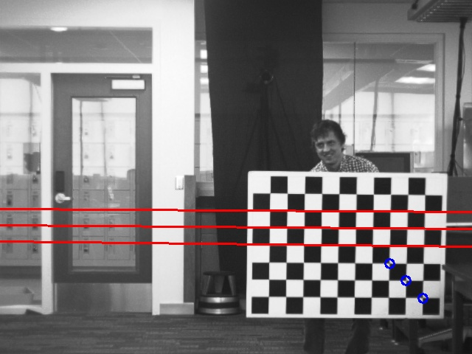

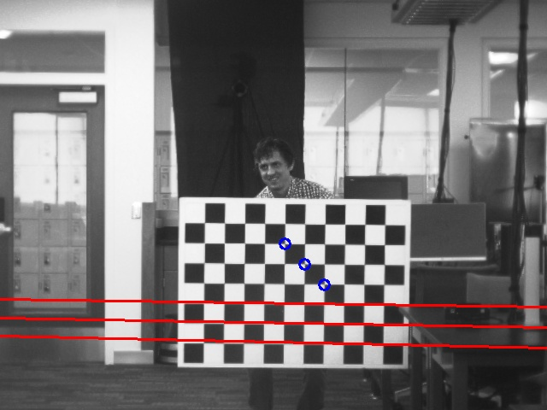

TASK 4
Original Images
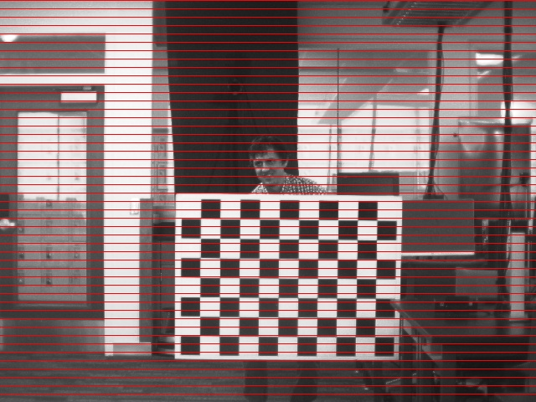
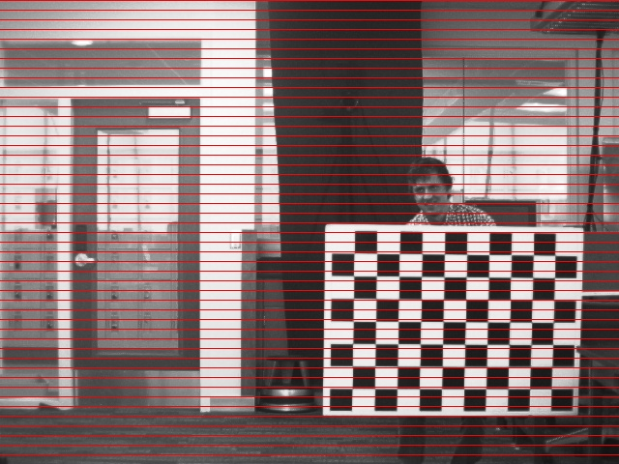

Rectified Image

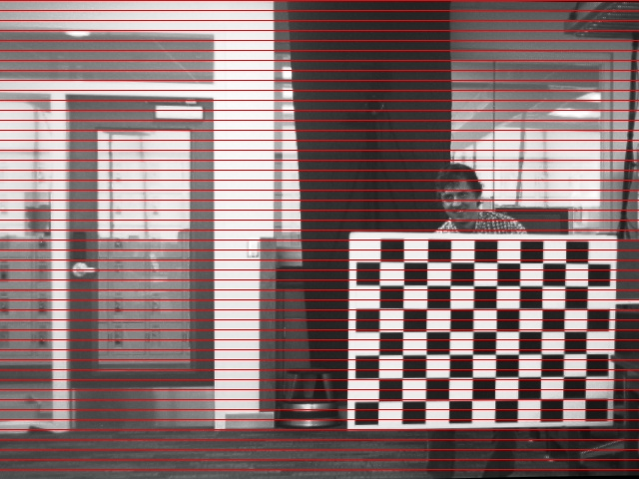
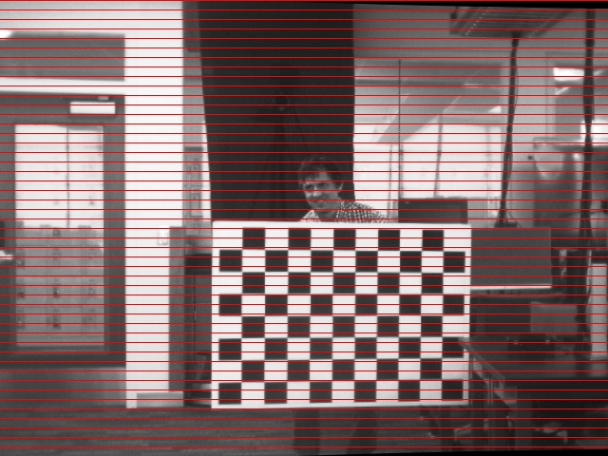

Absolute Difference

