Justin Roberts
HMWK 7

Task 1:

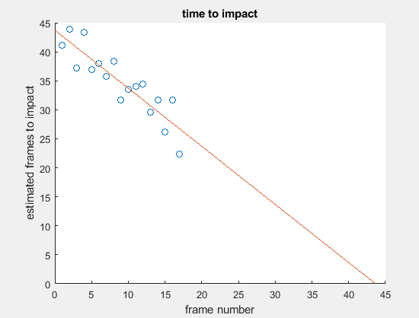
The estimated impact frame was 44. An ROI traced out the can on the first frame and feature points were automatically generated using the traced out ROI as a reference. The feature points were tracked using optical flow. The distance between several pairs of points was calculated to get ratios of X(prime)/X = a for each pair of points. ‘A’ was then used to calculate time to impact for each point pair and averaged to get the final time to impact.

Task 2:

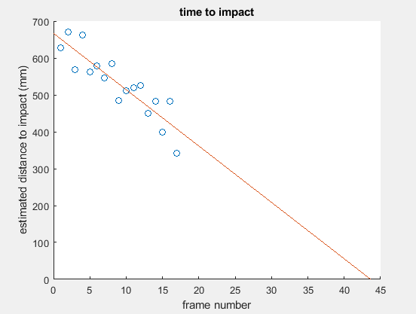

This graph was generated simply by multiplying estimated frames to impact (from task 1) by the image sequence rate of 15.25 mm. The estimated initial distance from the can was 670 mm.

Task 3
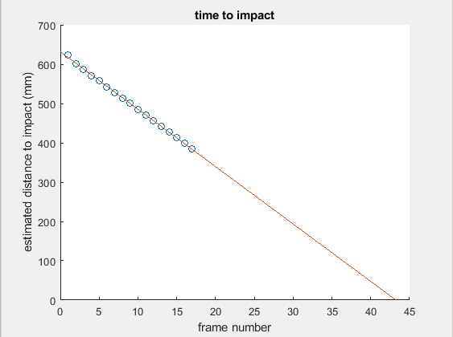
An initial ROI was used to trace out the can. It was then referenced to find the corners of the can. The corners were then tracked using optical flow and the distance between them was calculated. The distance was used together with the focal length to get distance. Focal length was taken from the camera parameters. The estimated frame number to impact was 43.

