# Software Projects Milestone 3

# Concept Design Model

## Group Number: 24

## Concept Name: Smart inventory shelves

## Use Cases

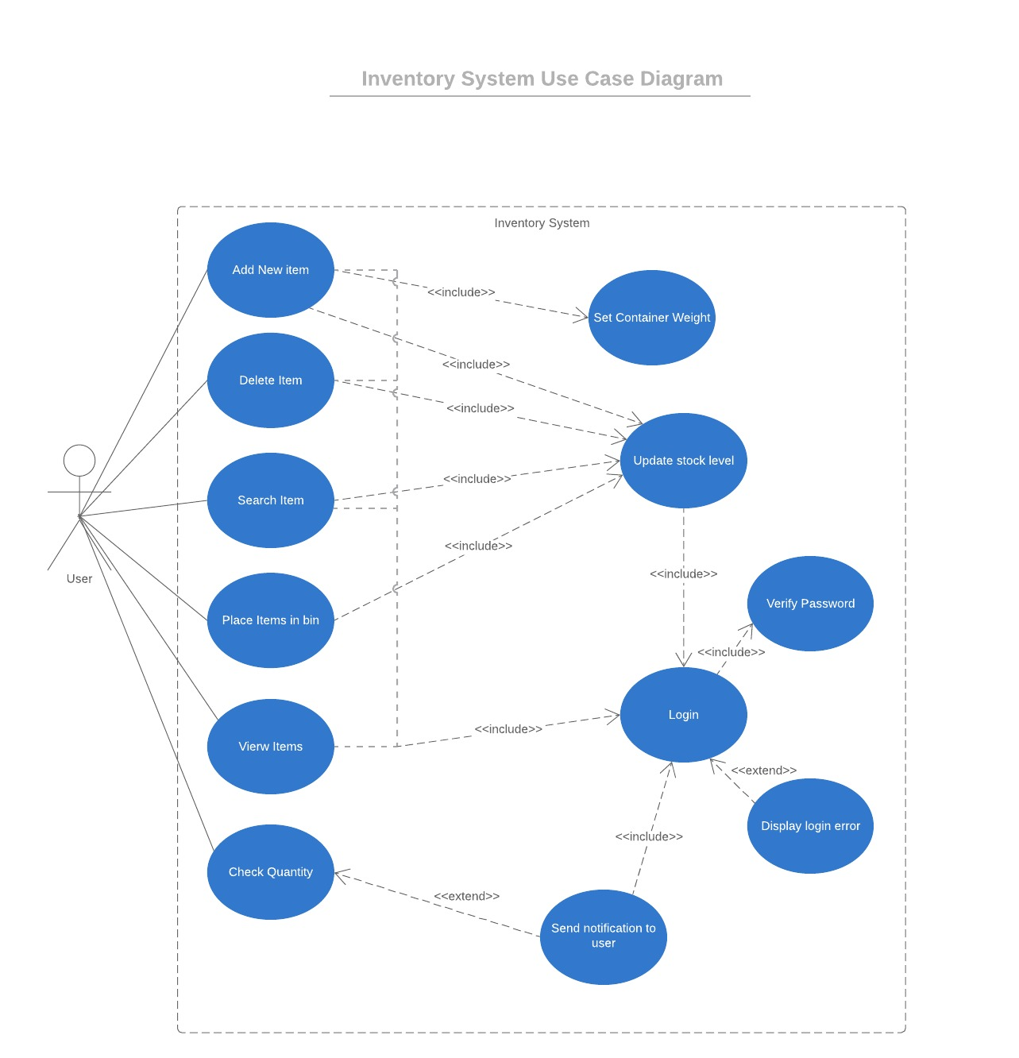

## Sequence Diagram

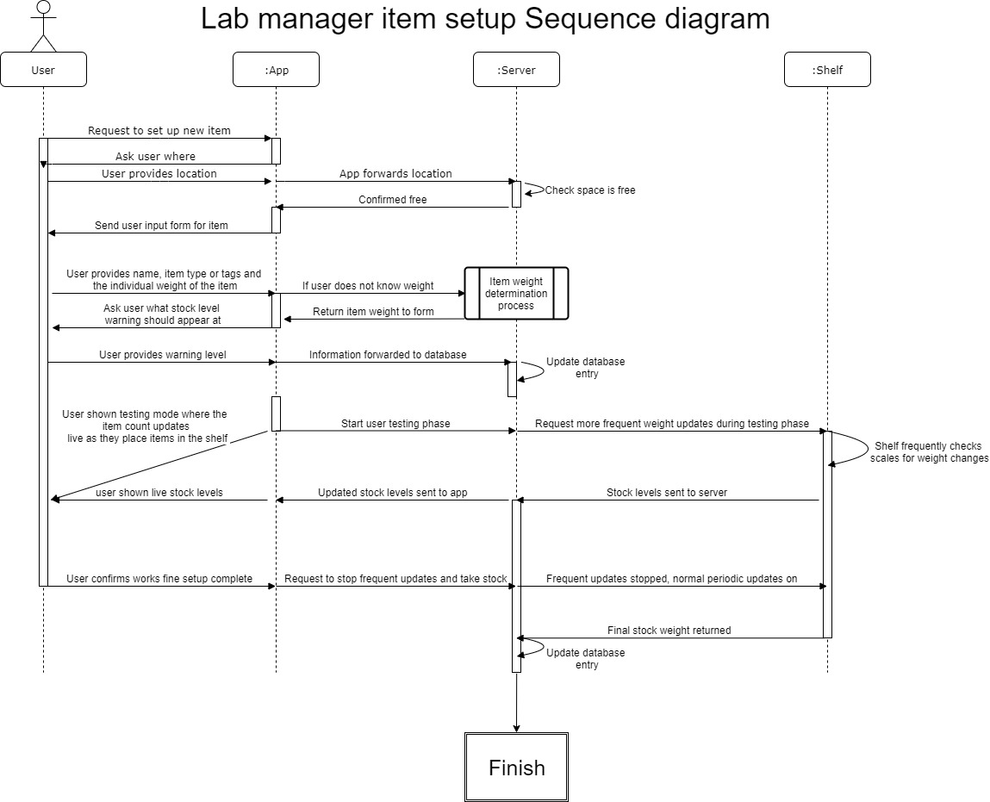

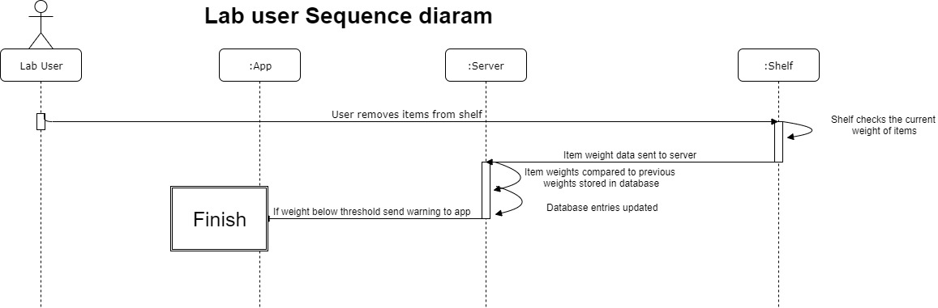

## Determining the weight of loose/ individual items (calibration)

1. App prompts user to ensure the bin is empty
2. user does so and confirms.
3. app requests zeroed shelf data data to be written to the database from the weight sensor via the arduino on the shelf.
4. arduino sends that data and it is written to the database.
5. webserver forwards confirmation of the write to the app.
6. app requests the user place a single item in the bin.
7. user complies, clicks ok.
8. New weight data requested from weight sensor
9. weight written to database
10. app requests user places 5 items in the bin
11. repeat steps 8-9
12. server performs calculation to find average weight of item.
13. Testing phase where the bin is frequently 'checked' and the current stock level is displayed in the app with the user able to add and remove items and see the stock level change in real time.
14. Finish.

## Activity Diagram

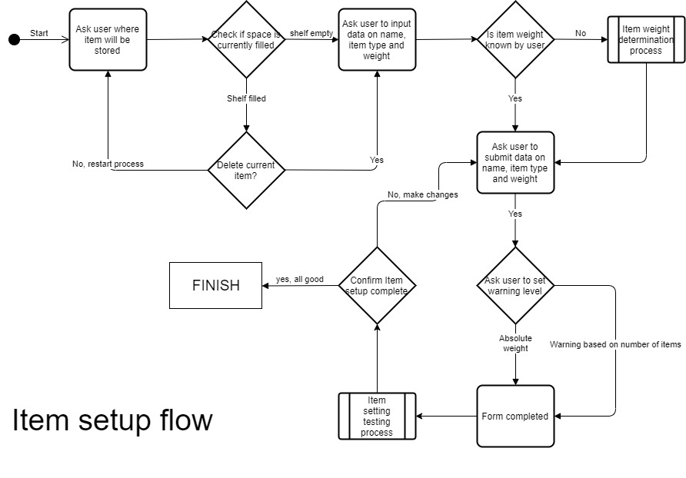

## Open Questions about this concept

* The order of prompts when setting up items and calibrating their weight and the best methods to do so.
* Specific features of the item input form, such as tags for different kinds of items
* Ability to recover data on items previously stored on shelf
  + Or set up templates for common item types to save time.

Whether some copies of data should be stored locally on the app as well as the web server.

* How to get an Arduino to speak nicely to a web server