## High-Fidelity Technical Prototype

You should present evidence that you constructed high-fidelity technical prototypes that you as a team used to test a technology (e.g. a database, web vs mobile app etc) that might be suitable for your project. This section should also describe how the prototype was used by the team to improve the concept.

Database:

The database system we will be using is MySQL due to its scalability, exhibiting the ability to handle deeply embedded applications with a footprint of only 1MB to running massive data warehouses holding terabytes of information. This is valuable to our concept of an inventory system because it has unlimited potential in terms of how much may be stored using it. We will also be able to set up a MySQL database with either a web app or mobile app, depending on which route we go down for the final build. We will all have experience with this database system when the building phase of the project takes place, so it makes sense for us to use it over other options.

Web Vs Mobile App:

We are currently planning on building a mobile app to pair with our inventory system that allows the user to add, check and keep track of stock levels within the physical inventory system. It is understood that this process may prove difficult, so we have opted for a Web App as a backup if we’re unable to create a mobile app in the given time frame. We will be using Java in JavaFX to build this app. JavaFX builds on top of JDK 13 and is a standalone component. There are 2 different options for developing JavaFX applications, using the JavaFX SDK or a build system like maven or gradle. We plan on using the JavaFX SDK from Eclipse.

Hardware:

For the hardware it is likely that we will use a variation of load cells, an HX711 amplifier and an Arduino to link everything and send data to our database. The HX711 is specially made for amplifying the signals from load cells and reporting them to another microcontroller. The load cells plug into this board, and this board tells the Arduino what the load cells measure. Load cells are specially shaped metal parts that have strain gauges glue to them. The strain gauges are resistors that change their resistance when bent. When the metal part bends, the resistance of the load cell changes which is what the HX711 measures accurately.

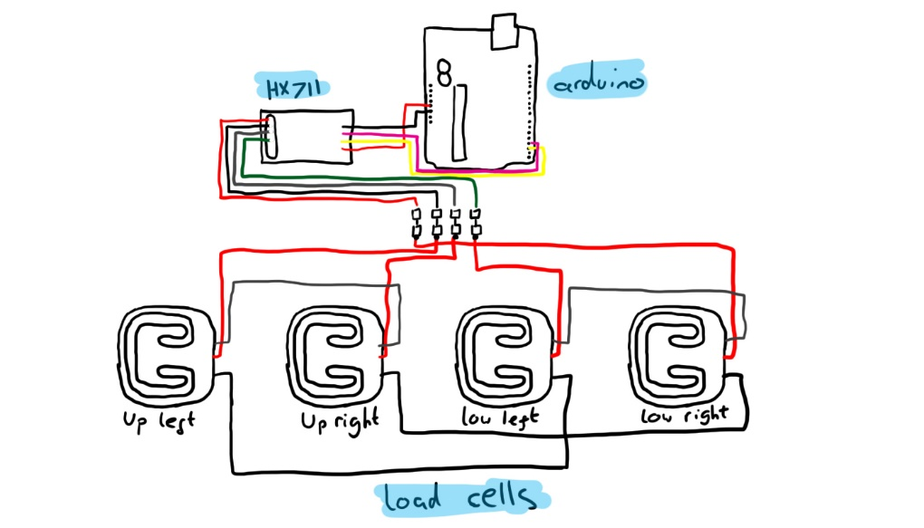There are a lot of examples online of setups like this or similar with code snippets for calibration and setup which we will refer to when setting ours up. To the right is a rough sketch for the setup of the weighing system.

Login System:

If we choose to build a login system for the app or web app, it will most likely be done using MySQL to store the user information. A prototype has been set up for saving user input details to a database and hashing the password for security using bcrypt. This prototype has been setup using node and express for web use, however the processes are similar and this understanding will translate over into an app scenario. Below, a code snippet was taken from the register section which shows how the user inputs are saved and input to a database.

