YAMANTRACKER / TECHNICAL DOCUMENTATION

Technical System Documentation
YamanTracker
Personal Finance Management System
Architecture, service communication, data ownership and principal workflows
Prepared from the current application source tree
28 October 2026 | Version 1.0
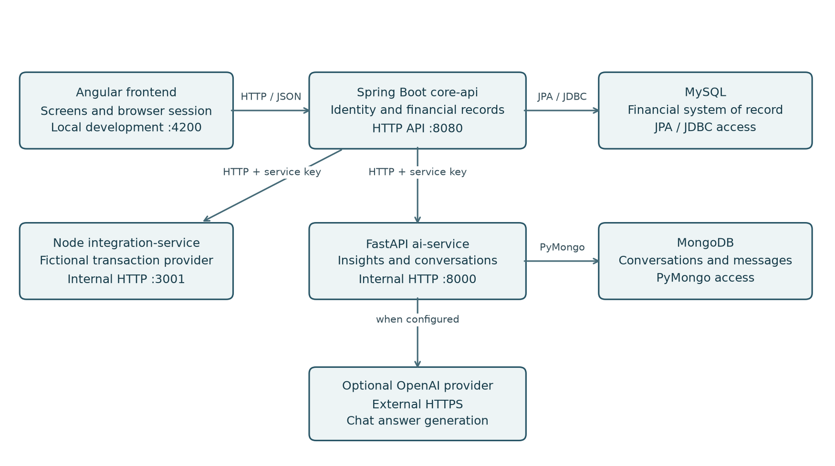
Four application components with separate financial and conversation storage.
The system combines an Angular user interface, a Spring Boot financial API, a Python insights and conversation service, and a Node transaction integration service. Spring Boot coordinates user-facing operations and remains the authority for financial records.
Audience: project stakeholders, technical reviewers and developers who need a mid- to high-level understanding of the implemented system.

YAMANTRACKER / TECHNICAL DOCUMENTATION

Document guide
This document explains the architecture and business flows implemented in the inspected repository. It describes configured behavior and source responsibilities; it does not assert that a particular deployment is running or that external infrastructure has been provisioned.

CONTENTS
1. Purpose and functional scope 3
2. System architecture 4
3. Frontend architecture 5
4. Core API and domain organization 6
5. Communication and interface design 7
6. Identity and security model 8
7. Persistence and data ownership 9
8. Financial workflows and reporting 10
9. Banking and statement imports 11
10. Insights and assistant conversations 12
11. Reliability and architectural limits 13
12. Runtime configuration and deployment 14
Appendix A. Source navigation 15
Appendix B. Service sources and terminology 16

Reading approach
Read the architecture and communication sections together to understand the service boundaries. The financial and banking sections explain where information is created and transformed. The final source map identifies the principal implementation locations without reproducing code listings.

Level of detail
The focus is component responsibilities, data movement, security boundaries, persistence and operational dependencies. Endpoint families and representative source locations are included where they clarify the design. Implementation walkthroughs, command sequences and individual method explanations are outside the intended level.

YAMANTRACKER / TECHNICAL DOCUMENTATION

1. Purpose and functional scope
YamanTracker helps an individual organize income and expenses, review monthly financial performance, define category budgets and discuss a supplied financial summary through an assistant interface. A user account provides the ownership boundary for financial records and conversations.
Capability | Implemented behavior
Identity and account | Registration, sign-in, session restoration, sign-out, display-name updates and password changes.
Financial organization | User-owned income and expense categories, with one-time default category initialization.
Transactions | Create, browse, filter, update and delete financial transactions; track their manual or imported source.
Monthly reporting | Income, expenses, savings, category breakdowns, daily spending, recent records and budget utilization.
Budgets | Monthly limits and alert thresholds for expense categories, with calculated utilization states.
Banking workflows | Simulated account connection and synchronization, plus reviewed CSV statement imports.
Insights and conversations | Deterministic financial insights and persistent GENERAL or FINANCE chat conversations.

Product boundaries
The banking integration supplies fictional records. The displayed demo account balance is simulated, and synchronization does not establish a live bank connection. The assistant explains supplied information and cannot execute payments, transfers or account actions.
Primary implementation: frontend application routes; core-api domain packages; ai-service API routes; integration-service provider.

YAMANTRACKER / TECHNICAL DOCUMENTATION

2. System architecture
Figure 1. Request initiators, service boundaries and storage ownership.
The application has four separately runnable components connected through request-response HTTP. The browser uses the Spring API as its application entry point. Spring handles identity and financial operations, and calls the specialized Python and Node services when the workflow needs them.
Component | Architectural responsibility
Angular frontend | Presentation, navigation, forms, browser session state and display of financial responses.
Spring Boot core-api | Financial domain rules, authentication, authorization, relational persistence and service coordination.
FastAPI ai-service | Aggregate analysis, chat orchestration and owner-scoped conversation persistence.
Node integration-service | Authentication of internal callers and normalization of fictional provider records.

MySQL is accessed by Spring. MongoDB is accessed by Python. Node returns provider data for Spring to validate and persist. These boundaries keep financial ownership decisions in the core API while allowing the auxiliary services to have narrower responsibilities.
Architecture evidence: Spring outbound clients, Python routers and Mongo repository, Node routes, and Angular HTTP services.

YAMANTRACKER / TECHNICAL DOCUMENTATION

3. Frontend architecture
The frontend is an Angular application organized into feature screens, shared components and core services. Its routed screens include authentication, dashboard, transactions, categories, budgets, bank connections and account settings. The assistant is implemented as a shared interface component.
Frontend area | Purpose
Feature components | Render a business screen, collect user input and coordinate screen-specific operations.
Core HTTP services | Centralize application API calls for authentication, transactions, categories, budgets, dashboard, banking and chat.
State and reactivity | Use Angular signals and RxJS to manage the current user, selected reporting period, loading states and returned data.
Route guards | Control navigation according to restored session state; server authorization remains the enforcement boundary.
HTTP interceptor | Apply request lifecycle handling, initialize missing CSRF protection and respond to expired authentication.

Request routing and refresh
The frontend calls relative /api/v1 paths. During local development, the Angular proxy forwards /api traffic to Spring on port 8080. This preserves a same-origin browser interaction while the API runs as a separate process.
Successful financial mutations increment an application revision signal. The dashboard observes this revision and reloads the relevant data. It also reacts to reporting-period changes. Session and period checks prevent late responses from populating a screen for a different user or month.

Session-aware presentation
The browser restores the current session through the backend and maintains a safe user profile in memory. Authenticated financial responses disable Angular transfer caching. The assistant retrieves persisted message history after a completed turn so the screen reflects the conversation store.
Source areas: src/app/features, src/app/core/services, core/interceptors, core/guards and shared/components/ai-assistant.

YAMANTRACKER / TECHNICAL DOCUMENTATION

4. Core API and domain organization
The Spring Boot core API is the financial authority and the central coordinator for user-facing operations. Its packages follow business capabilities: auth, user, category, transaction, budget, dashboard, bank, insights and chat.
Layer | Responsibility
Controllers | Expose versioned HTTP routes, validate request structure and pass the authenticated identity to domain operations.
Services | Apply ownership and business rules, calculate derived results and coordinate database or outbound service work.
Repositories and entities | Represent relational records and implement persistent access through Spring Data JPA and Hibernate.
JDBC support | Manage bank connection and statement-preview support records through JdbcTemplate.
Outbound clients | Translate selected domain data into internal requests and validate Python or Node responses.
Security and error handling | Authenticate requests, enforce browser protection and return controlled public error responses.

Ownership and consistency
Controllers resolve user identity from validated authentication. Services load resources within that ownership boundary and verify category relationships before writes. Database foreign keys, uniqueness rules and checks reinforce these application-level rules.
Financial writes use relational transactions. Selected owner-level locks serialize operations that could otherwise conflict, including category initialization, imports and account changes. Mock provider retrieval finishes before per-record import transactions begin, so a network delay does not hold the import database transaction open.

Account management
Display-name changes update the owned profile. Password changes verify the current password, reject reuse, replace the stored hash and increment the account token version. The browser cookie is cleared and older issued tokens fail the subsequent version check.

YAMANTRACKER / TECHNICAL DOCUMENTATION

5. Communication and interface design
Application components communicate through HTTP requests and structured JSON responses. The main exception is CSV upload, which uses multipart form data. Internal Python and Node calls are initiated by Spring and complete within the user-facing request flow.
Connection | Contract and purpose
Browser → Spring | Relative /api/v1 routes; JSON for application operations; multipart for statement uploads. Browser authentication uses a cookie and protected writes include a CSRF header.
Spring → Python | HTTP with X-Internal-API-Key. Insights use a monthly aggregate contract. Conversation routes additionally receive a trusted X-Owner-Id from Spring.
Spring → Node | GET /internal/mock-transactions with a separate internal key. Node returns a transactions envelope containing normalized fictional records.
Spring → MySQL | JPA/Hibernate and JDBC connections for financial data and import support records.
Python → MongoDB | PyMongo operations for owner-scoped conversations and their messages.
Python → OpenAI | Optional external HTTPS request through the configured SDK provider for chat generation.

Public API organization
The core route families cover /auth, /users, /categories, /transactions, /budgets, /dashboard, /insights, /bank-connections and /chat under /api/v1. Controllers define the HTTP boundary; frontend services define how the interface consumes it.

Contracts at service boundaries
Internal financial amounts are decimal strings. Spring uses BigDecimal and Python converts the strings to Decimal, preserving financial precision. Public financial responses encode numeric values, while the Node normalized amount contract also uses decimal strings. Both sides validate contracts rather than trusting arbitrary upstream JSON.
The current assistant interface consumes persistent conversation routes. The standalone insights endpoint exists in the core API; the inspected frontend does not directly call it.

YAMANTRACKER / TECHNICAL DOCUMENTATION

6. Identity and security model
Spring authenticates end users and establishes the owner identity used by financial controllers. Passwords are stored using BCrypt hashing. A successful login creates a signed JWT and places it in an HttpOnly browser cookie; the response body contains a safe profile and session lifetime.
Control | Effect
JWT verification | Validate the signature and required claims, including issuer, audience and expiry. Confirm that the subject identifies an existing user.
Token version | Compare the token version with the user record. A password change increments this value, invalidating earlier tokens.
Browser cookie | Use an HttpOnly cookie to keep the authentication credential outside JavaScript-readable browser state.
CSRF protection | Use the readable XSRF-TOKEN cookie and X-XSRF-TOKEN request header for browser mutation protection.
Owner-scoped access | Filter financial records by the authenticated owner. Python conversation queries combine conversation ID and trusted owner identity.
Internal credentials | Use separate shared keys for Spring-to-Python and Spring-to-Node traffic. These authenticate services rather than end users.

Session lifecycle
The frontend initializes CSRF protection, submits login credentials and later restores the session through /auth/session. Sign-out clears the browser credential and rotates CSRF state. It clears that browser session; password changes provide token-version invalidation across earlier issued sessions.

Environment boundary
The local profile permits the HTTP development cookie named finance_session. Production defaults use the Secure __Host-finance_session cookie and require HTTPS delivery. Header-only Bearer authentication is also supported with an explicit mechanism policy. Requests combining cookie and Authorization credentials are rejected.
Security evidence: SecurityConfiguration, BrowserCredentials, JwtConfiguration, TokenService, UserService and the Angular auth interceptor.

YAMANTRACKER / TECHNICAL DOCUMENTATION

7. Persistence and data ownership
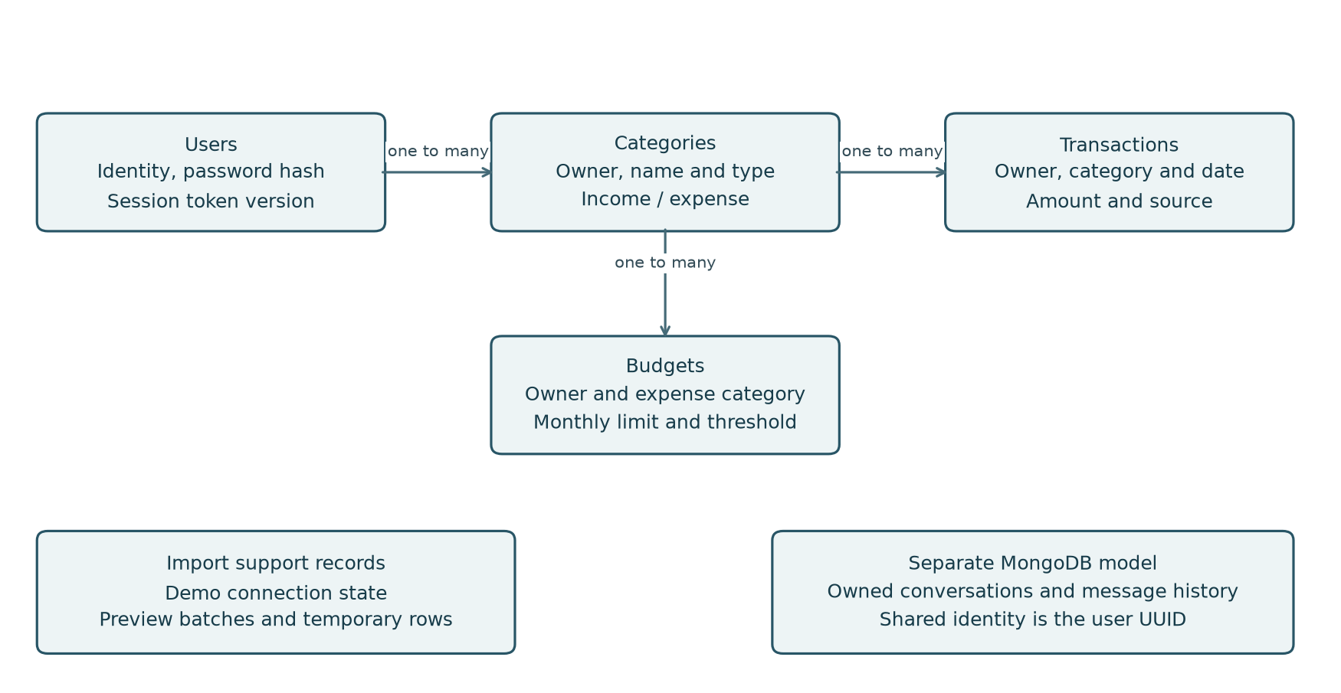
Figure 2. Principal financial relationships and supporting storage groups.
The financial model is relational. Each category belongs to a user; transactions reference the owner and category; budgets reference an owned expense category. Composite relationships prevent a transaction or budget from using a category with a different owner or incompatible type.
Data group | Stored information and lifecycle
Users, categories, transactions, budgets | Durable identity and financial records in MySQL. Imported transactions retain a source and external identifier.
Category initialization | A per-user marker records one-time default-category setup independently of later category edits or deletions.
Bank and statement support | Demo connection state, statement preview batches and temporary rows support reviewed imports.
Conversations and messages | MongoDB stores conversation ownership, mode, optional reporting period, message content and timestamps.

Schema management
Seven MySQL Flyway migrations establish and evolve the schema. Both local and production profiles use Hibernate validation, so migrations own schema changes. The MySQL database and credentials must exist before the API starts. Switching a connection does not transfer records from an earlier datastore.
Money is stored as fixed-precision decimal data. MySQL UUIDs use CHAR(36), financial dates use DATE, and instant timestamps use UTC DATETIME(6). Indexes support owner/date lookups, category grouping, reporting periods and expiry processing.

YAMANTRACKER / TECHNICAL DOCUMENTATION

8. Financial workflows and reporting

Recording and organizing transactions
The user submits a category, transaction type, positive amount, description and date. Spring validates the request, checks that the category is owned by the user and matches the transaction type, then commits the record. Transaction source identifies manual entry, mock-provider import or CSV statement import.
Transaction browsing supports filtering, pagination and ordering. Category names are normalized for uniqueness within an owner and type. A category already referenced by a transaction or budget cannot be deleted or changed to an incompatible type.

Monthly dashboard
01 Angular requests a selected month and year from the core dashboard endpoint.
02 Spring derives the owner from the authenticated request and builds the monthly date interval.
03 Repositories aggregate income and expenses by category and day, and retrieve recent records.
04 The service calculates savings, combines budget utilization and returns a structured dashboard response.
05 Angular updates its screen state and charts, discarding responses that no longer match the user or selected period.
The monthly interval includes the first day of the selected month and excludes the first day of the next month. Net savings equal total income minus total expenses. Savings rate is net savings divided by income, expressed as a percentage; it is unavailable when income is zero.

Budget utilization
A budget is unique for an owner, expense category and month/year. Spending is derived from matching expense transactions. Remaining amount is the monthly limit minus spending. Status is SAFE below the alert threshold, WARNING at or above the threshold, and EXCEEDED when spending reaches or exceeds the limit. Exact amount comparisons determine status before display rounding.
Spring and MySQL calculate the dashboard and budget results. These operations do not depend on Python or the external chat provider.

YAMANTRACKER / TECHNICAL DOCUMENTATION

9. Banking and statement imports

Simulated account synchronization
The bank interface maintains a demo connected/disconnected state in the core database. A connected account can request synchronization. Spring calls the internal Node provider, validates the returned normalized records and imports them for the authenticated user. The demo balance and account identity are simulated presentation values.
01 The frontend submits a synchronization request to Spring.
02 Spring confirms that the demo account is connected and fetches records from Node using an internal key.
03 Node validates and normalizes fictional provider data, including transaction direction, amount, date and category hint.
04 Spring maps hints to owned categories, skips existing owner/source/external-ID matches and commits valid new records.
05 Spring returns imported, skipped, failed and processed counts, records the sync time and the frontend refreshes its state.

Reviewed CSV workflow
CSV statements follow a direct frontend-to-Spring workflow. The user uploads a file, maps columns, reviews parsed rows and selects category assignments. Spring stores a short-lived preview and confirms transactions from those retained rows, rather than accepting replacement amounts from the confirmation request.
Uploads are limited to 1 MiB and 1,000 data rows. Preview batches expire after 30 minutes. Confirmation verifies ownership, expiry, row selection and category type. A repeated confirmation returns its stored result. Confirmation or cancellation removes staged row content; scheduled cleanup handles expired previews and aged receipts.

Duplicate handling
Imported external identifiers are unique within owner and source. CSV reference values are used when available; otherwise the file fingerprint and row position support repeat-file detection. This cannot prove every overlap between differently structured exports. Deleting an imported transaction can allow that external record to be imported again.

YAMANTRACKER / TECHNICAL DOCUMENTATION

10. Insights and assistant conversations

Deterministic insights
For an insights request, Spring builds the authenticated user’s monthly summary from MySQL and sends selected aggregates to Python. The Python engine evaluates savings, spending concentration and budget conditions and returns observations and suggested actions. The insights endpoint does not require an external model call.

Persistent chat flow
01 The browser creates or selects a GENERAL or FINANCE conversation through Spring.
02 Spring reads owned conversation metadata from Python using an internal key and trusted owner header.
03 For FINANCE, Spring rebuilds the current summary for the conversation’s stored reporting period; GENERAL omits financial aggregates.
04 Python loads recent context, obtains an answer and saves the user and assistant messages in MongoDB.
05 Spring validates the returned response and the frontend reloads persisted history for display.

Provider behavior and data boundary
Python attempts the configured OpenAI provider for chat when credentials and model settings are available. FINANCE can fall back to the rule-based explanation. GENERAL returns an unavailable response when the provider cannot supply an answer. The interface receives complete HTTP responses rather than streamed tokens.
Spring supplies financial totals, expense-category aggregates and budget usage. The financial summary excludes raw transaction lists and account credentials. The OpenAI provider constructs its prompt from the question, selected context and supplied summary, uses no action tools and does not grant database access to the model.
MongoDB stores the conversation mode, reporting period where relevant and message history. Owner-filtered access protects conversations. Finance values are refreshed for each turn so earlier dialogue is not treated as the authoritative source of current balances or spending.

YAMANTRACKER / TECHNICAL DOCUMENTATION

11. Reliability and architectural limits
Concern | Current behavior and implication
Outbound service calls | Dedicated clients use connection and response timeouts, validate response size and content, and disable redirect following for internal credentials.
Relational consistency | Financial changes use database transactions, owner locks where required, foreign keys, checks and uniqueness rules.
Import isolation | Mock records are processed with per-record transactions. A failed row can be reported without undoing previously committed rows.
Conversation persistence | Standalone MongoDB message writes use best-effort compensation, not a multi-document transaction. An outage can leave an uncertain outcome.
Uncertain chat submissions | The frontend reconciles by retrieving history. It avoids automatic retries of message submissions because there is no general message idempotency key.
Error responses | Spring maps failures to controlled application errors. Internal response bodies and nested exception text are not blindly forwarded to the browser.
Health reporting | Health routes provide basic liveness. They do not demonstrate that all downstream dependencies are ready for every workflow.

Dependency boundaries
Core financial reporting remains within Spring and MySQL. A Python, MongoDB or model outage affects its corresponding insight or conversation capability; Node availability affects mock synchronization. These boundaries help identify the affected feature, although the application does not implement a distributed transaction across services.

Privacy and operational limits
Logging settings suppress sensitive request-body and database-bind diagnostics, and public responses exclude password hashes. External chat output remains generated content that may be inaccurate. Concurrent messages can share an earlier history snapshot. Capacity, backup policies, deployment availability and disaster recovery depend on the operating environment and are not established by source configuration alone.

YAMANTRACKER / TECHNICAL DOCUMENTATION

12. Runtime configuration and deployment
Each application component runs as its own process. The declared stack uses Angular 22, Java 25 with Spring Boot 4.1.1, FastAPI on Python, and Node 24 with Express. Local defaults use ports 4200 for Angular development, 8080 for Spring, 8000 for FastAPI and 3001 for the integration service.
Configuration group | Operational meaning
Spring database | DB_URL, DB_USERNAME and DB_PASSWORD select the MySQL database and application account. The local URL defaults to personal-financedb.
Spring identity | JWT_SECRET_BASE64 supplies the signing key. The production cookie requires HTTPS; the local profile explicitly permits HTTP development.
Python connection | AI_SERVICE_BASE_URL selects FastAPI. Spring AI_INTERNAL_API_KEY must match Python INTERNAL_API_KEY.
Node connection | INTEGRATION_SERVICE_BASE_URL selects Node. INTEGRATION_INTERNAL_API_KEY must match in the two processes.
Python persistence and provider | MONGODB_URI and MONGODB_DATABASE select conversation storage. OPENAI_API_KEY and OPENAI_MODEL configure the optional chat provider.

Runtime preparation
Provision the databases and application accounts, provide secrets through the process environment or an appropriate secret store, then start the dependent application services. Spring does not automatically load the root environment file. Python loads its service environment file, and Node’s npm startup scripts load its service environment file.

Deployment boundary
Docker Compose currently defines MySQL and MongoDB with persistent volumes and loopback host bindings; it does not package all application processes. Angular’s development proxy forwards /api to Spring. A deployed static frontend or SSR host needs an equivalent reverse-proxy route and HTTPS configuration. The included SSR server renders Angular but does not implement an active API proxy.
Production configuration requires an explicit database URL, keeps Hibernate in validation mode and leaves migrations responsible for schema changes. Actual hosting, network exposure, TLS, backups and secret provisioning must be confirmed for the chosen environment.

YAMANTRACKER / TECHNICAL DOCUMENTATION

Appendix A. Source navigation
Paths are relative to the personal-finance-system repository. These locations provide the primary evidence for the architecture and workflows described above.
Area | Principal source locations
Frontend structure | frontend/personal-finance-ui/src/app/app.routes.ts  frontend/personal-finance-ui/src/app/features/  frontend/personal-finance-ui/src/app/layouts/
Frontend communication | frontend/personal-finance-ui/src/app/core/services/  frontend/personal-finance-ui/src/app/core/interceptors/auth.interceptor.ts  frontend/personal-finance-ui/proxy.conf.json
Dashboard state | frontend/personal-finance-ui/src/app/features/dashboard/dashboard.store.ts  frontend/personal-finance-ui/src/app/core/services/finance-changes.ts
Assistant interface | frontend/personal-finance-ui/src/app/shared/components/ai-assistant/  frontend/personal-finance-ui/src/app/core/services/ai-chat.ts
Core domain | core-api/src/main/java/core_api/auth/  core-api/src/main/java/core_api/user/  core-api/src/main/java/core_api/category/  core-api/src/main/java/core_api/transaction/  core-api/src/main/java/core_api/budget/  core-api/src/main/java/core_api/dashboard/
Security and errors | core-api/src/main/java/core_api/security/  core-api/src/main/java/core_api/error/
Imports and clients | core-api/src/main/java/core_api/bank/  core-api/src/main/java/core_api/integration/  core-api/src/main/java/core_api/insights/  core-api/src/main/java/core_api/chat/

YAMANTRACKER / TECHNICAL DOCUMENTATION

Appendix B. Service sources and terminology
Area | Principal source locations
Python API and configuration | ai-service/app/main.py  ai-service/app/api/  ai-service/app/core/config.py
Insights and chat | ai-service/app/services/insight_engine.py  ai-service/app/services/chatbot_service.py  ai-service/app/services/openai_chat_provider.py  ai-service/app/schemas/
Conversation storage | ai-service/app/core/mongodb.py  ai-service/app/services/conversation_repository.py
Node provider | integration-service/src/server.js  integration-service/src/app.js  integration-service/src/routes/mock-transactions.js  integration-service/src/middleware/internal-auth.js  integration-service/src/services/
Schema and runtime | core-api/src/main/resources/db/mysql/  core-api/src/main/resources/application.properties  core-api/src/main/resources/application-local.properties  core-api/src/main/resources/application-prod.properties  docker-compose.yml
Frontend hosting | frontend/personal-finance-ui/angular.json  frontend/personal-finance-ui/src/server.ts

Terminology
API: the HTTP interface exposed by an application. DTO or contract: the structure exchanged across a boundary. JWT: the signed identity credential used by Spring. CSRF: protection against unauthorized browser-originated mutations. JPA/Hibernate: Java entity persistence and relational mapping. Flyway: versioned schema migration management. Idempotency: repeated submission producing the same intended effect. System of record: the authoritative store for a domain.
Documentation baseline: inspected working-tree application sources as of 28 October 2026. Infrastructure descriptions distinguish configured behavior from an observed running deployment.

