Grocery Tracker and Recommendation Generator
Machine Learners

Team Member | Role
Joan Rocha | UI/UX Design & Testing
Chuheng Xiao | AI/ML Engineer
Katy Bohanan | Back-End/ML Systems Engineer

GitHub Link → LINK

1. Overall System Architecture Diagram
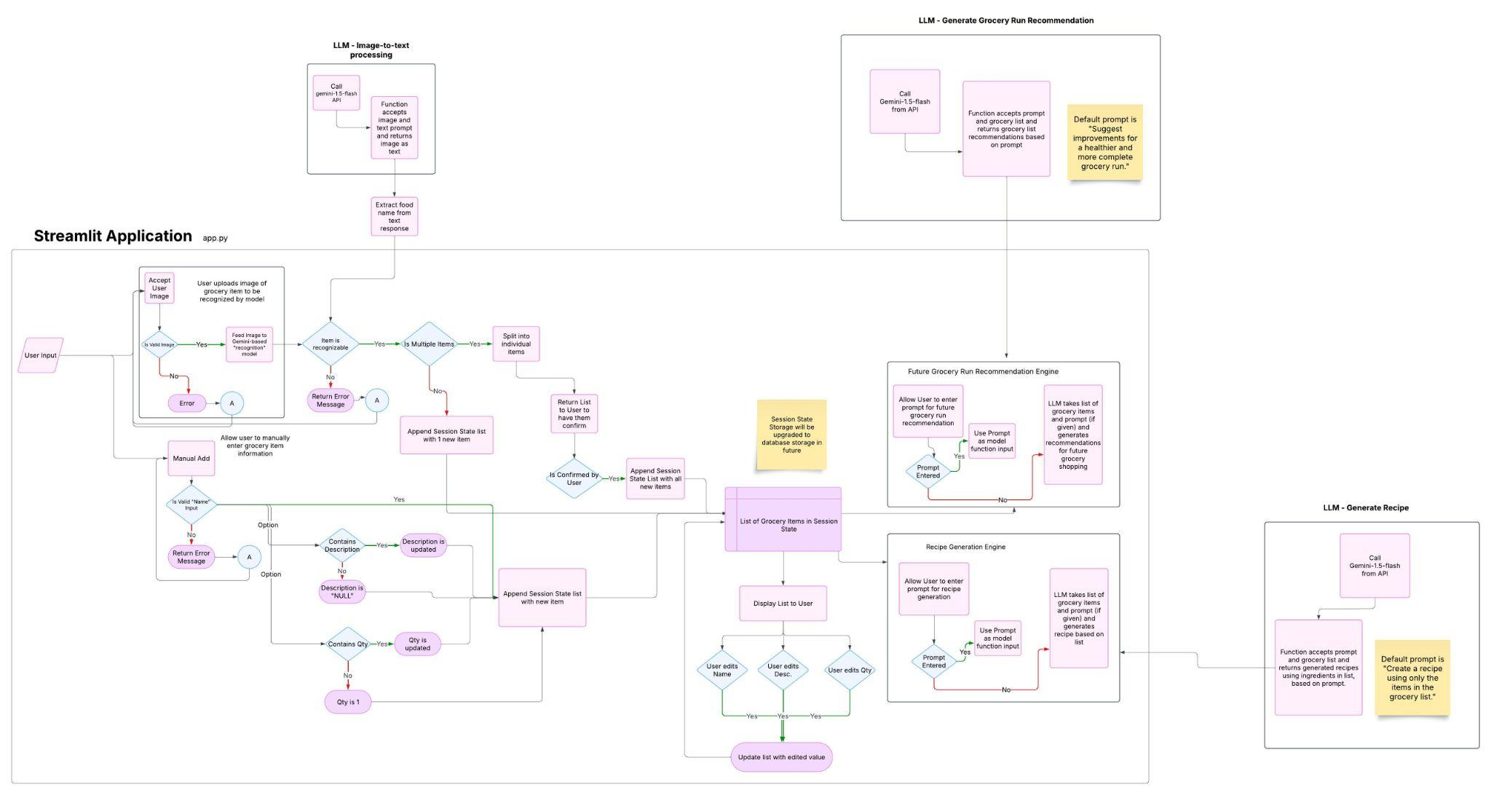
This diagram illustrates our Streamlit-based application, which processes grocery images using an LLM-powered image-to-text system to extract item names and store them in a session state. Users can edit item details before generating AI-driven grocery recommendations or recipes based on available ingredients. The system leverages prompt-based LLM models to enhance grocery runs and meal planning, with future plans for database storage integration.

2. AI/ML Model Diagram 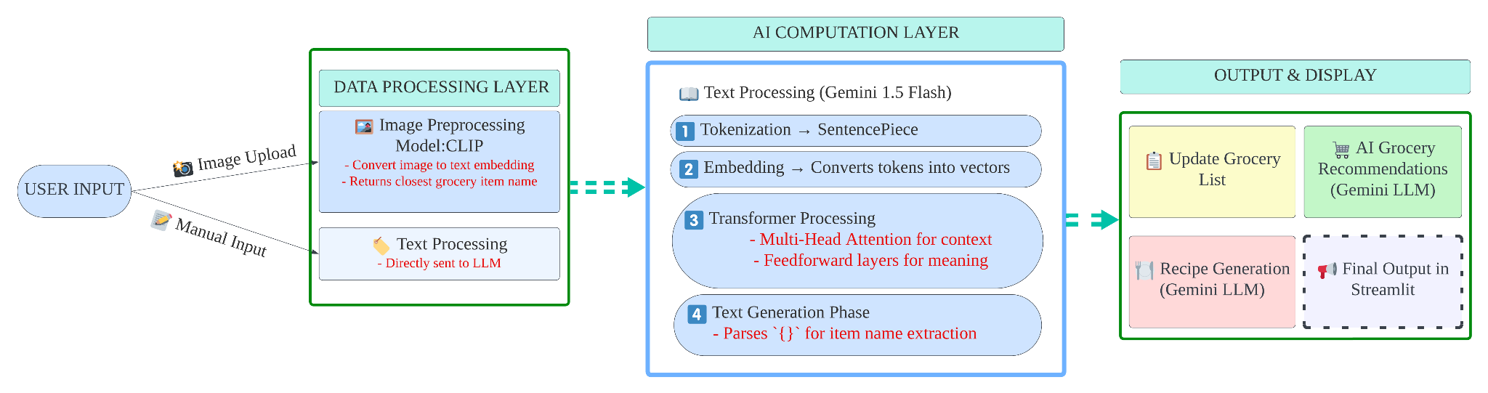
This diagram illustrates the flow of user inputs (images or text) through the AI system, where CLIP converts images into embeddings, and Gemini 1.5 Flash processes both images and text to recognize grocery items, generate recommendations, and create recipes. The architecture includes key components such as tokenization, embedding generation, and transformer-based attention for text understanding, with outputs displayed via a Streamlit interface.

3. Application Interface (UI/UX) Wireframe:
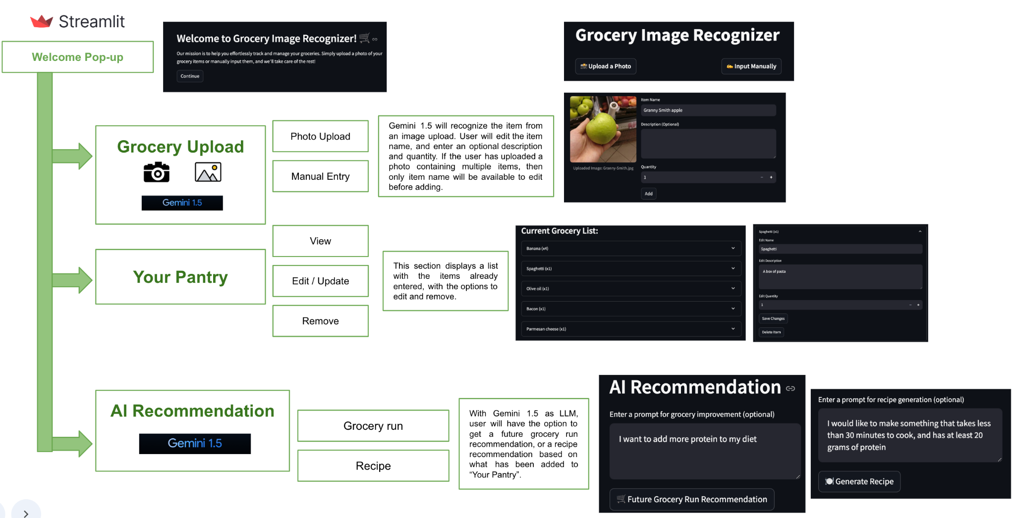
This diagram shows the pipeline of a grocery management application built using Streamlit for the frontend and Gemini 1.5 for AI-powered recommendations. Users can upload groceries via Photo Upload or Manual Entry, manage their pantry by viewing, editing, or removing items, and receive AI Recommendations for grocery runs or recipes based on their stored items. Gemini 1.5 enhances the recommendation system, while Streamlit provides an intuitive and interactive user interface for seamless grocery tracking and decision-making.

