Jose Rodriguez
CSD 325 Module 4 Assignment
June 28, 2026
This document includes the original flowchart for the starting sitka_highs.py program and the revised flowchart after adding the menu, lows graph, loop, and exit message.

Original Program Flowchart
The original program reads the CSV file, collects dates and high temperatures, and displays one red graph for the high temperatures.
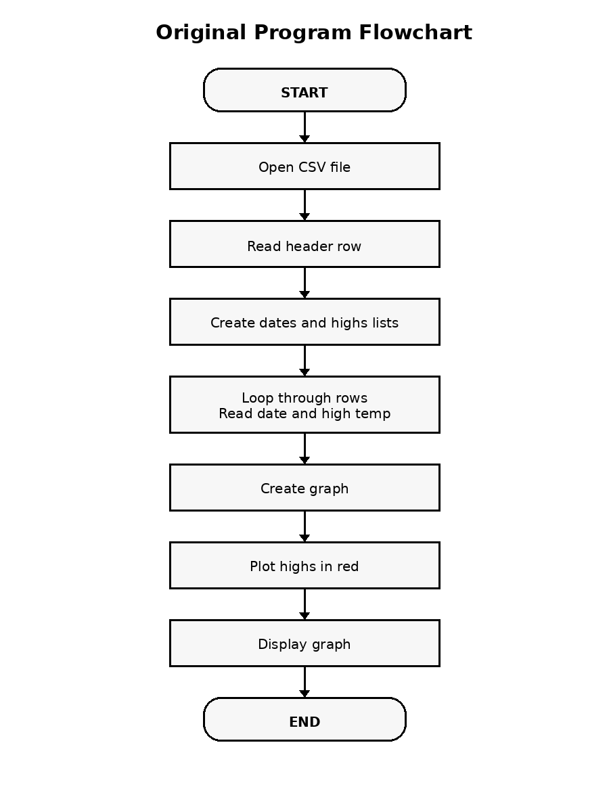

Revised Program Flowchart
The revised program reads both high and low temperatures, displays a menu, lets the user choose highs or lows, and repeats until the user selects Exit.
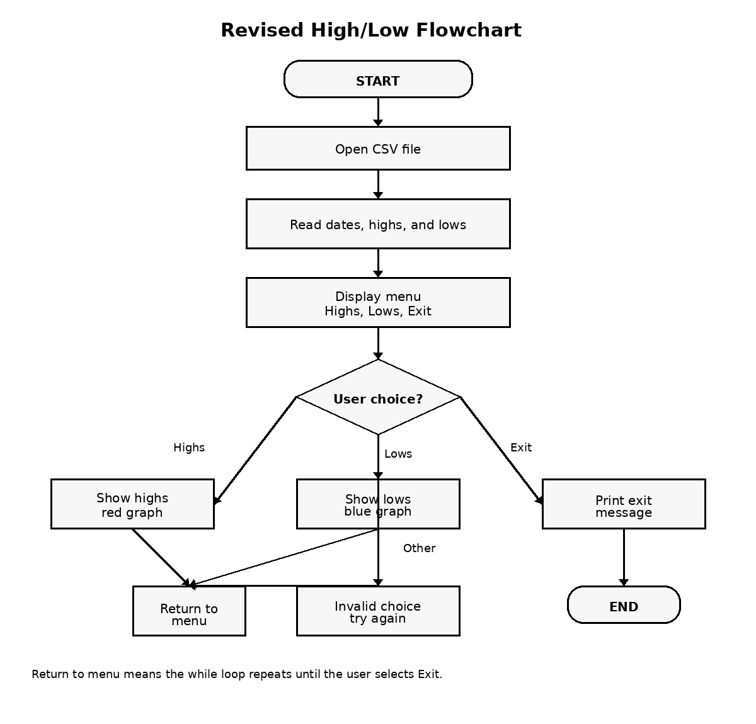

Program Changes Documented
- Added a menu with options for High Temperatures, Low Temperatures, and Exit.
- Added a lows list to store low temperature values from the CSV file.
- Created a show_highs() function to display high temperatures in red.
- Created a show_lows() function to display low temperatures in blue.
- Added a while loop so the menu continues until the user exits.
- Added an exit message when the user chooses Exit.

