Jose Rodriguez
CSD 325
Module 8.2 Assignment
JSON Practice
7/13/2026

Screenshot of the original/updated output
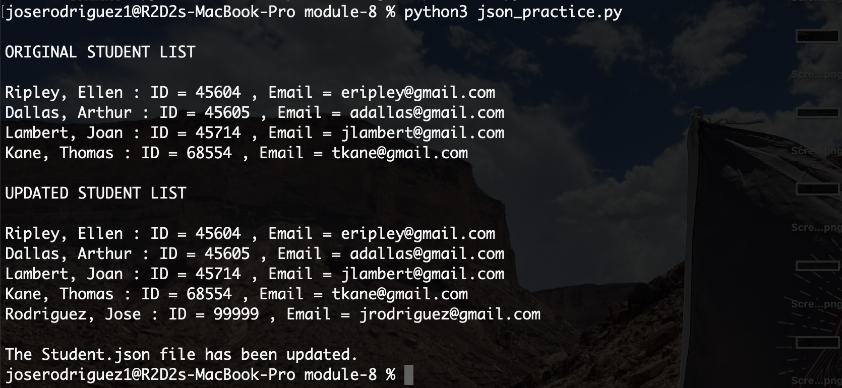

Screenshot showing Student.json changed
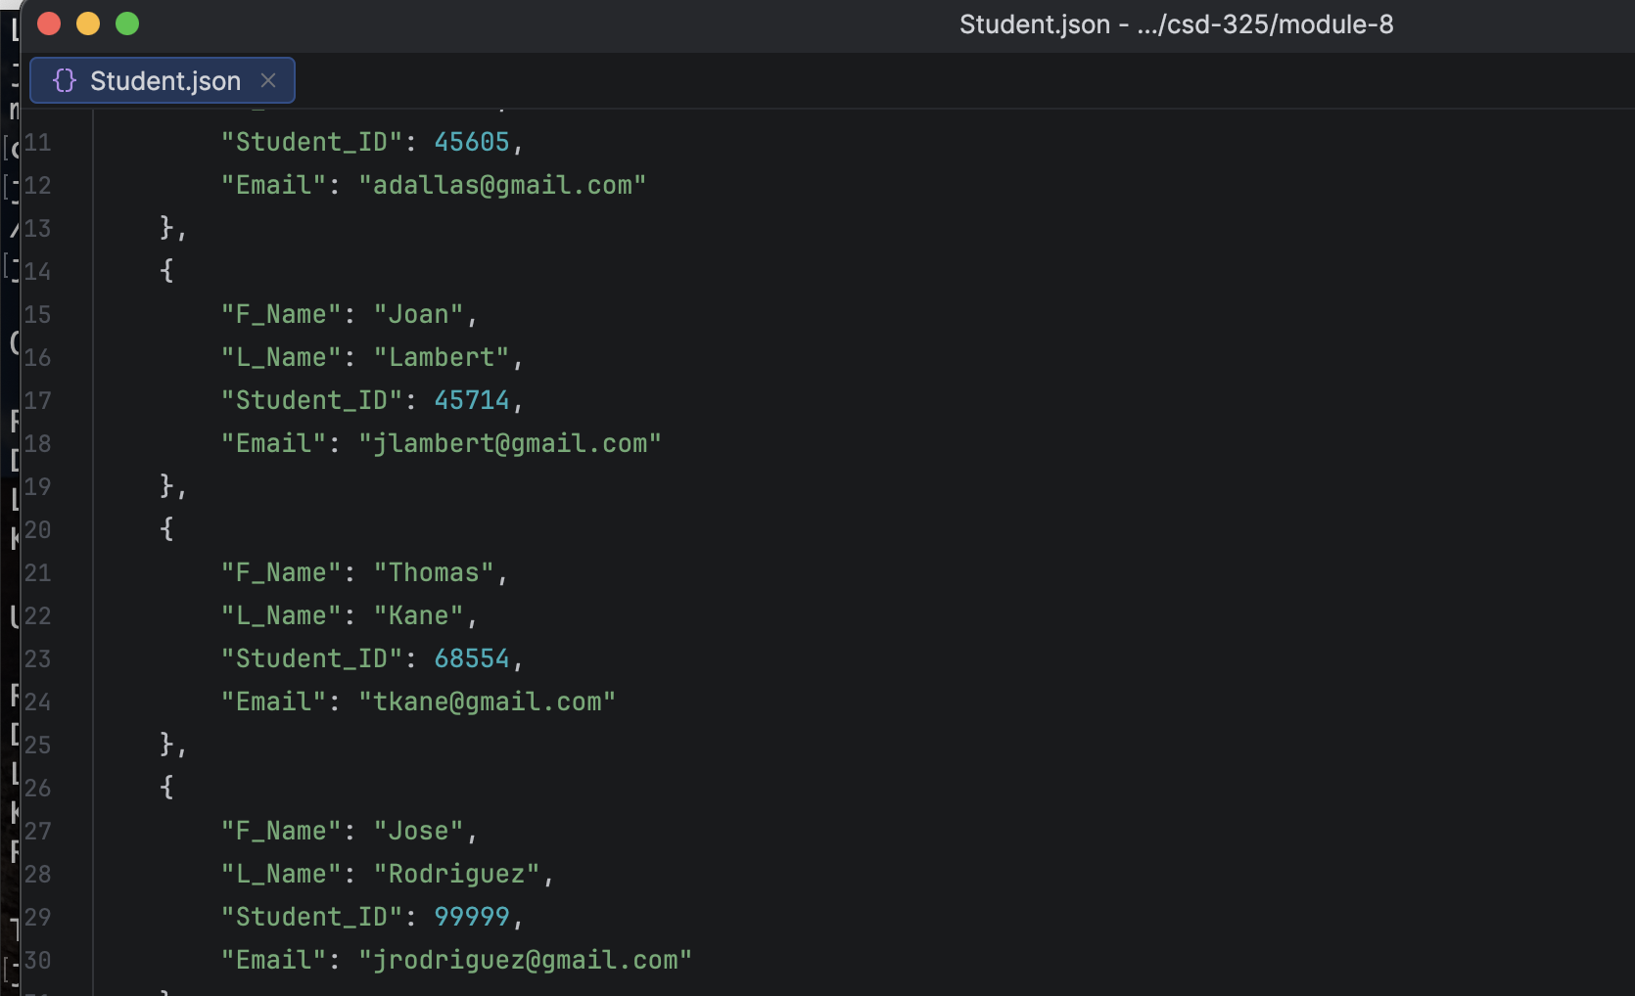
Flowchart
