Jose Rodriguez
7/26/2026
Module 10.2 Assignment

Here is the screenshot of the unchanged code.
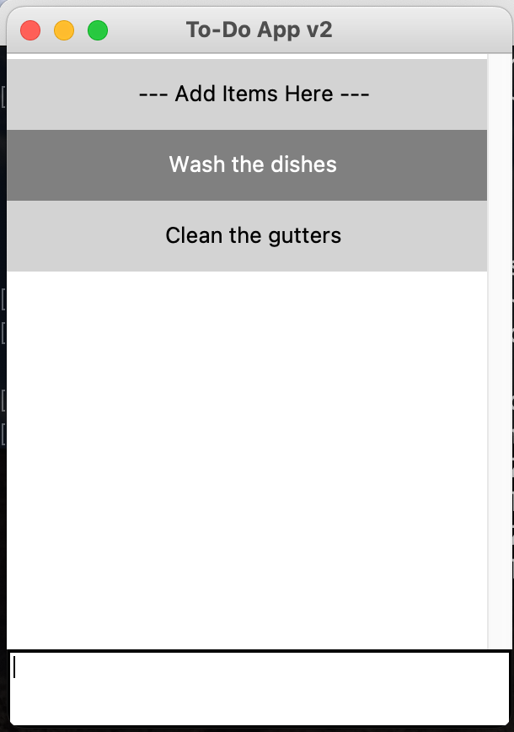

Here is the screenshot after changes have been made to the code.
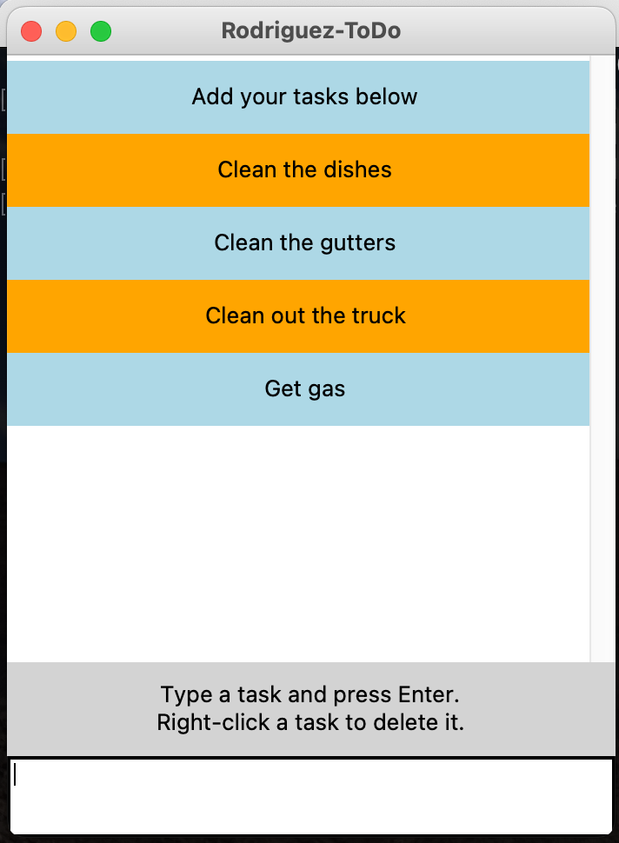

Here is the screenshot of deleting a task.
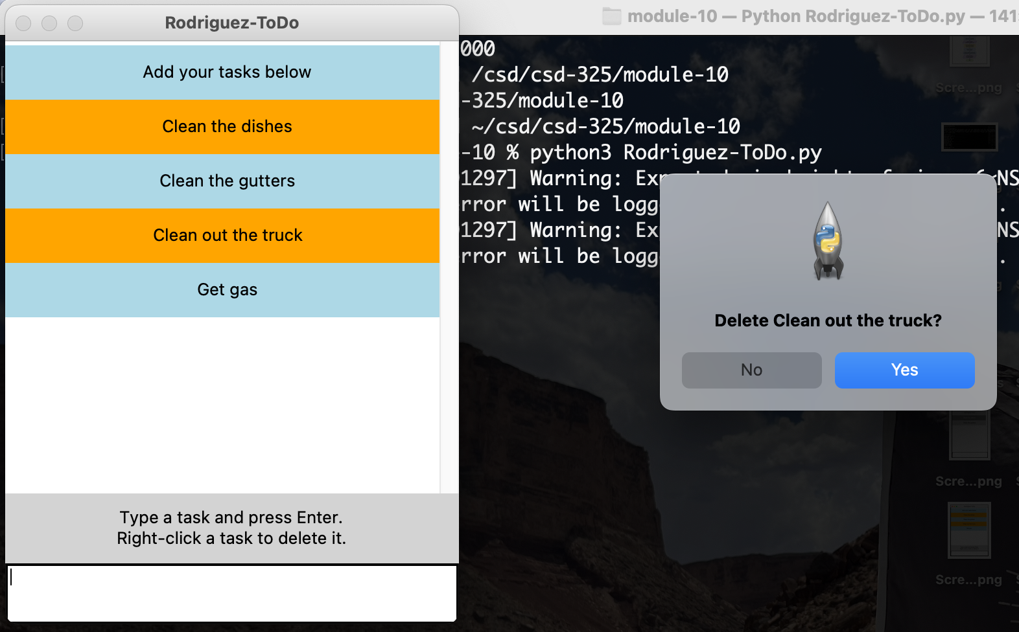

Here is the screenshot of the ToDo list after the task has been deleted.
