Jose Rodriguez
8/2/2026
Module 11.2 Assignment
Django Basics

Django Server Installation Test
I installed Django, created the demo project, and started the development server. The Django installation page confirmed that the server was running successfully at 127.0.0.1:8000.
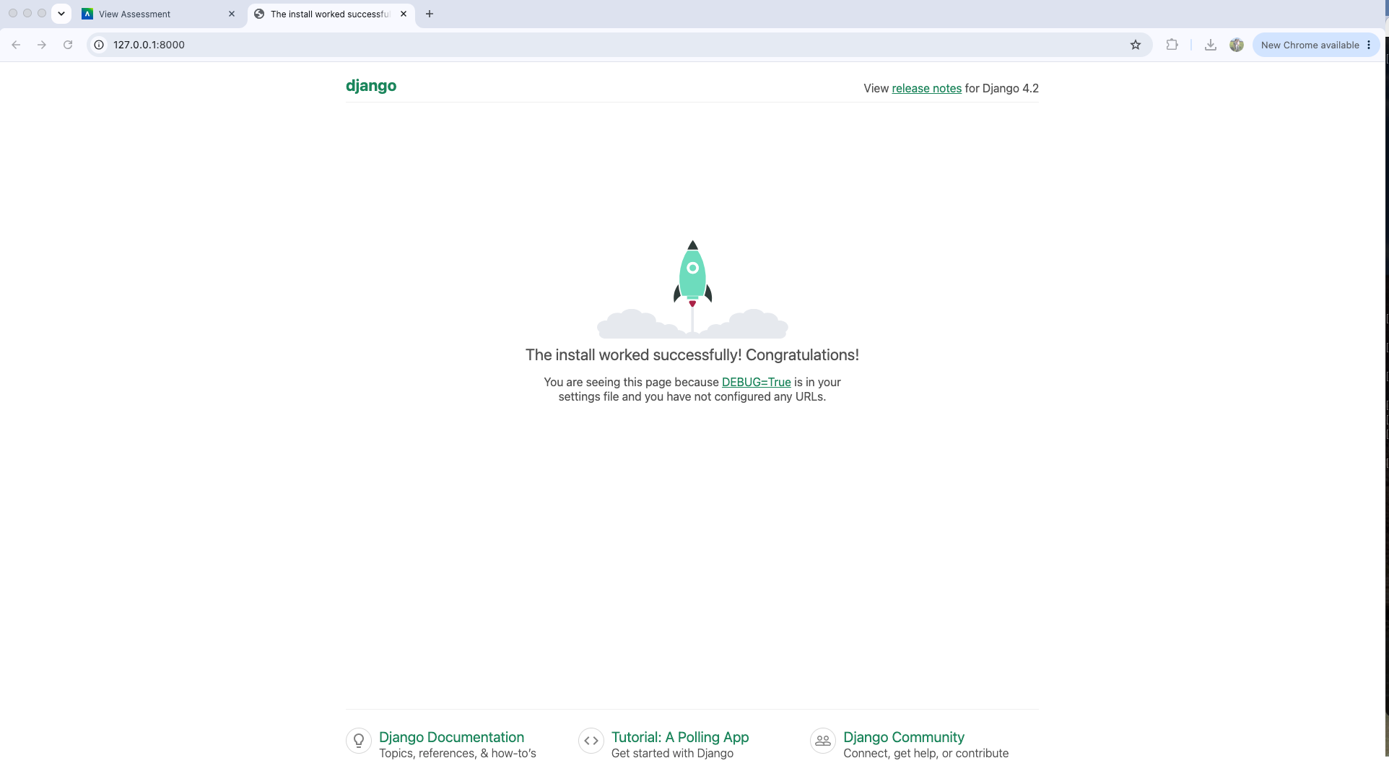

Modified Django Application
I created a Django application named rodriguez and connected it to the main project URL. I modified the HttpResponse so the local website displays “Rodriguez says Hello!”
