Jose Rodriguez
CSD 325 Module 3 Assignment
Cho-Han Flowchart
The flowchart below models the main execution path for the modified Cho-Han program. It shows the bet validation, dice roll, 2 or 7 bonus rule, CHO/HAN decision, 12 percent house fee, and game loop.
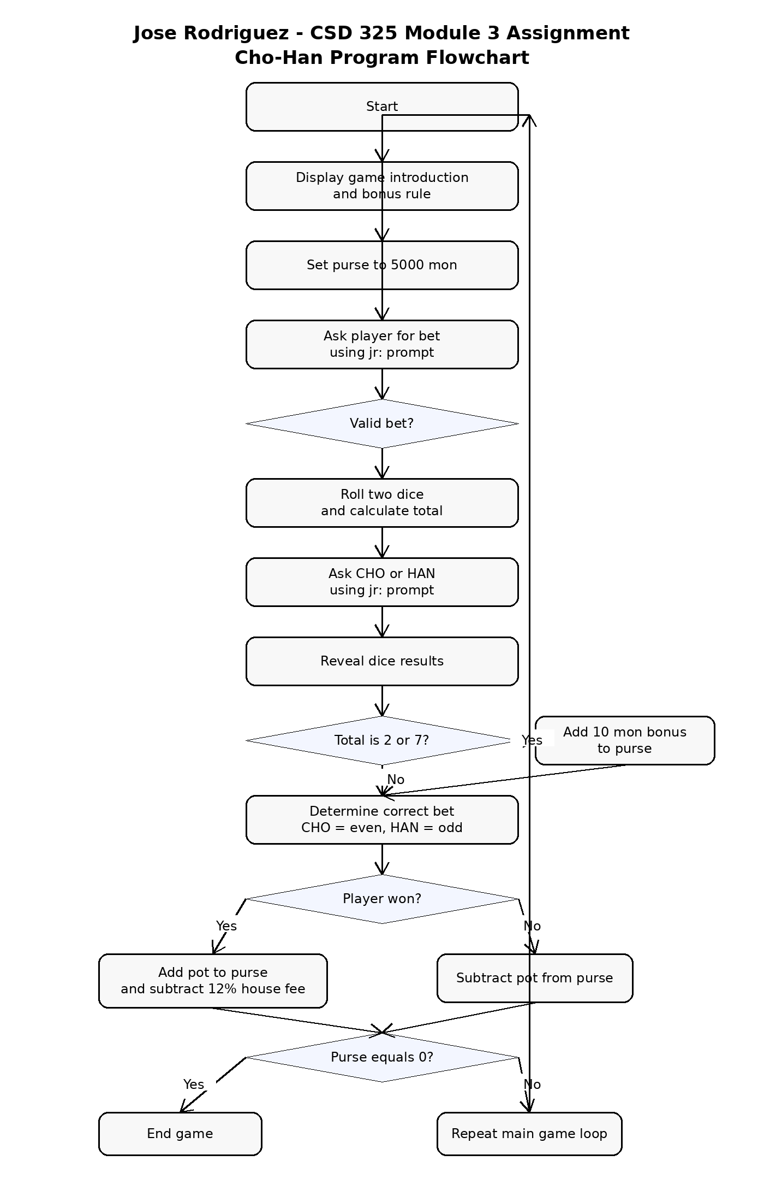
Assumptions: The flowchart focuses on the main game logic and the required assignment changes. Input validation loops are summarized to keep the diagram readable.

