Jose Rodriguez
7/13/2026
Module 7.2 Assignment

Original City and Country Function


Initial Passing Unit Test
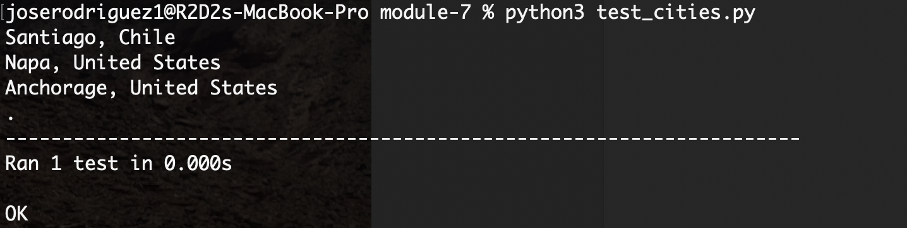

Failed Test After Population Became Required
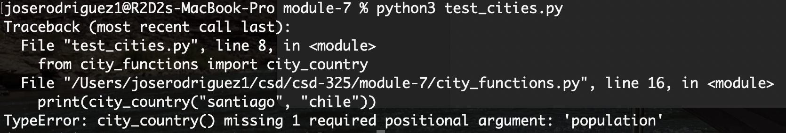

Passing Test After Population Became Optional
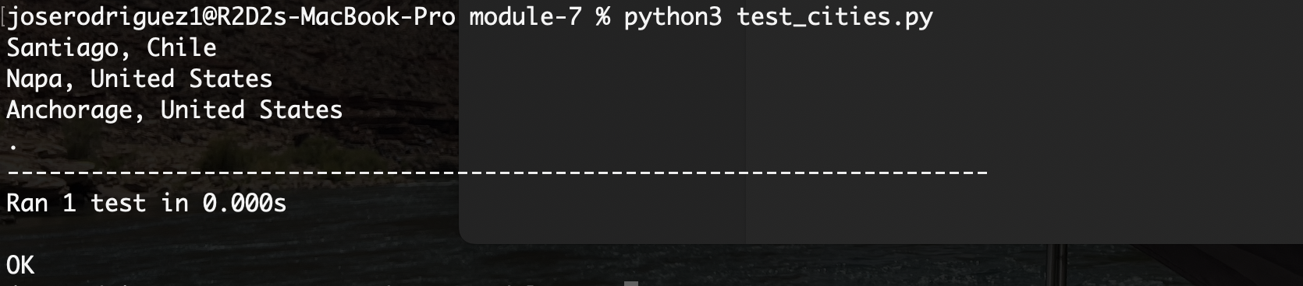

Failed Test After Language Became Required
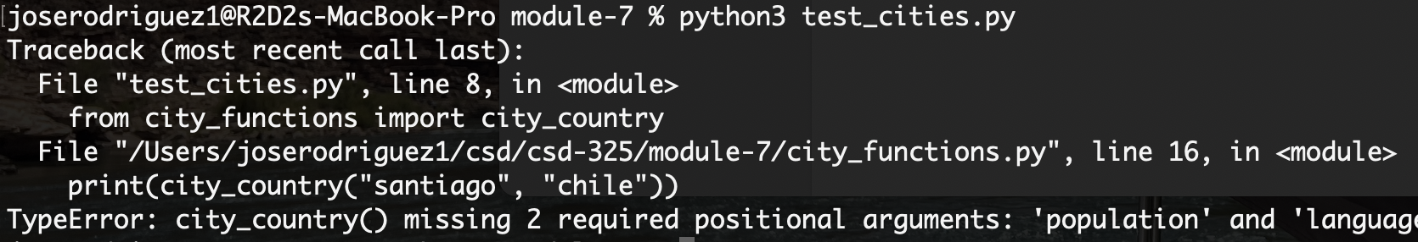
Passing Test After Language Became Optional
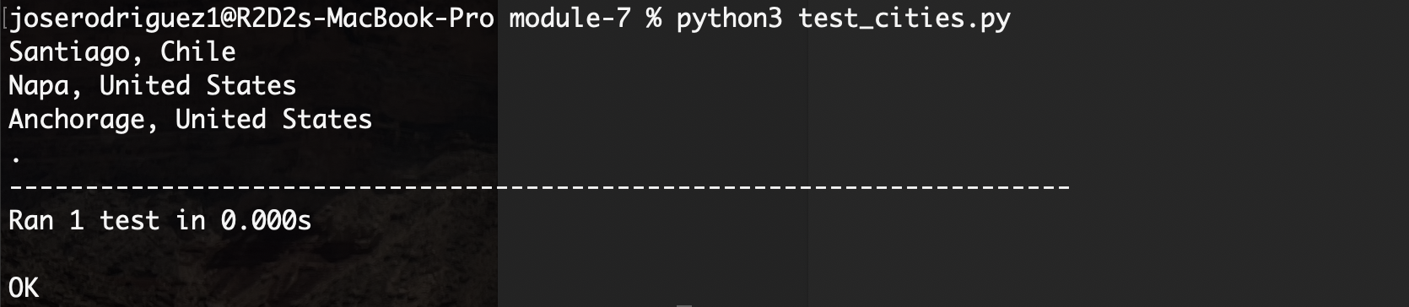

Final Program Output
