Jose Rodriguez
8/17/2026
CSD-340 Mod 1.2 Assignment
GitHub Repository Setup

GitHub Repository Link
https://github.com/jrod818/csd-340.git

Screenshot of GitHub Repository
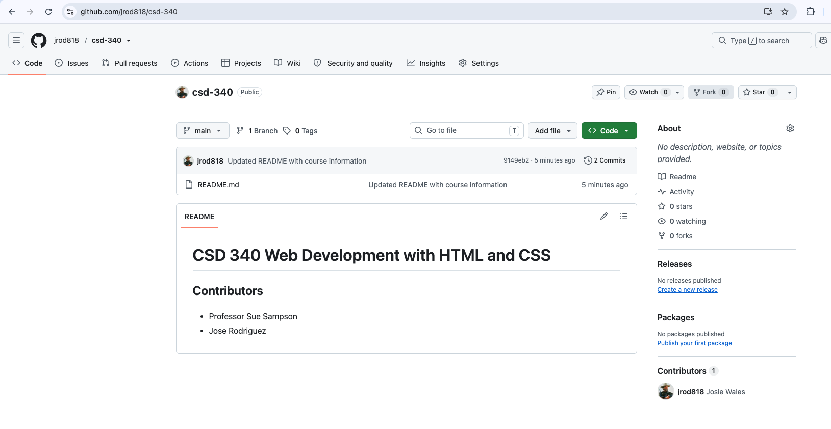

Screenshot of Local Directory
