Jose Rodriguez
August 16, 2026
CSD-340 Mod 1.3
Building a Web Page Exercise, Part 1

Initial HTML Validation
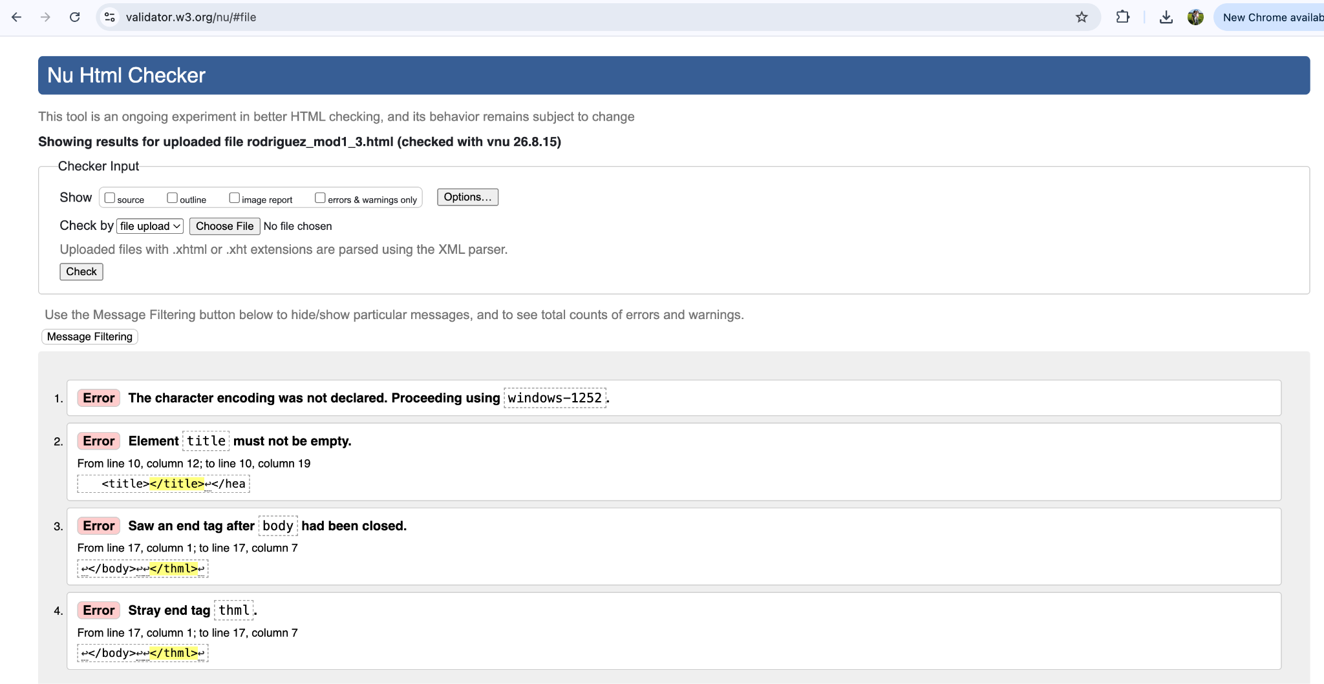
Final HTML Validation
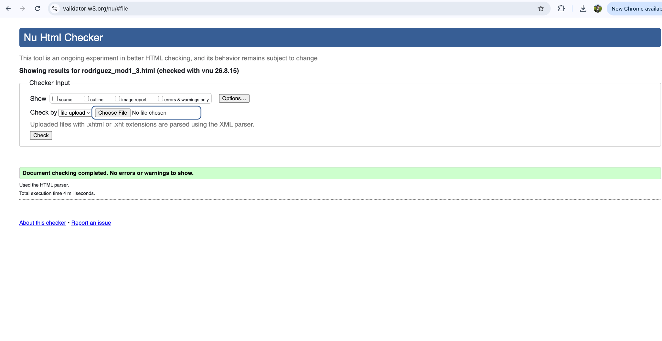
Completed Web Page