Jose Rodriguez
8/23/36
CSD-340 Module 3.2
GitHub Pages Assignment
HTML Validation
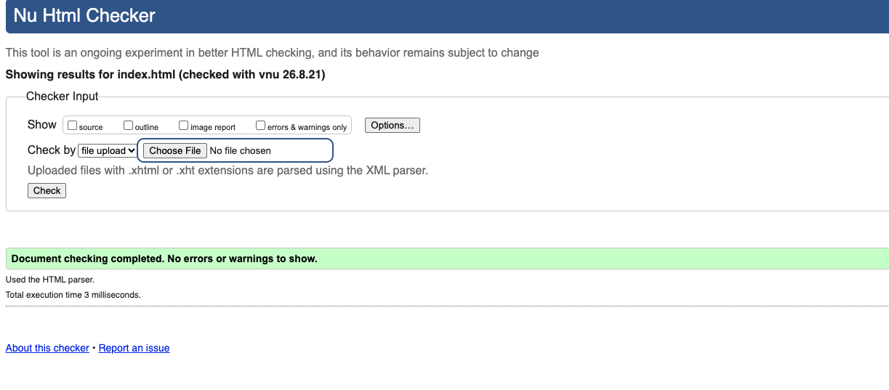

CSS Validation
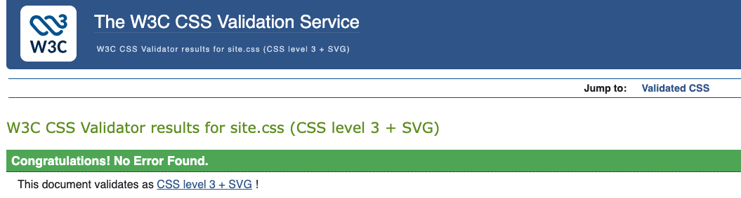

GitHub Pages Landing Page
