Jose Rodriguez
8/17/2026
CSD-402 Module 1.3 Assignment

Java Version
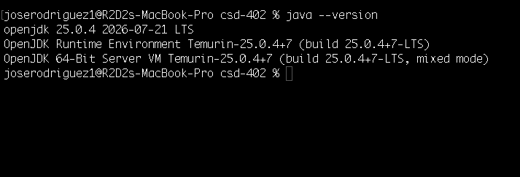
Javac Version
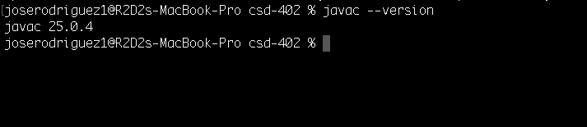
HeatWater.java running successfully
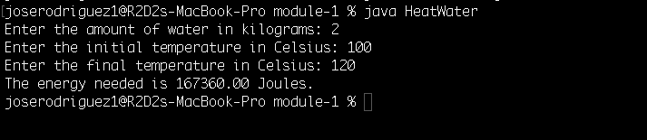
JavaFX test window