Jose Rodriguez
10/25/2026
CSD-420 – Module 1.3 Assignment

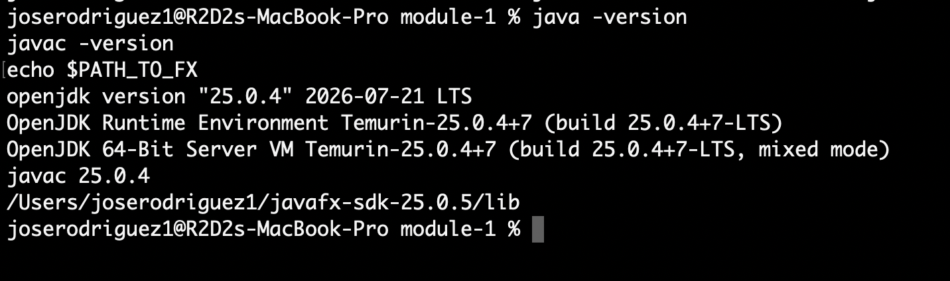
Screenshot of Java and JavaFX configuration

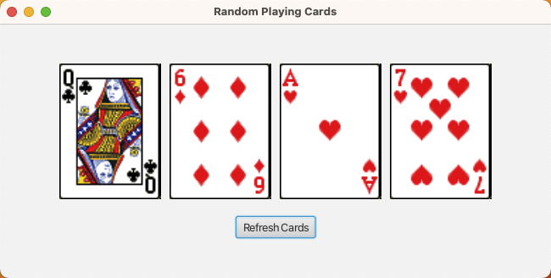
Screenshot of the four playing cards

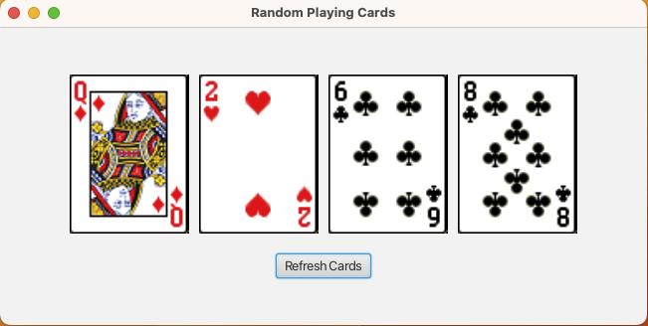
Screenshot after clicking Refresh Cards

