Jose Rodriguez
11/8/26
CSD420 Module 3.2

Screenshot of the output of the program
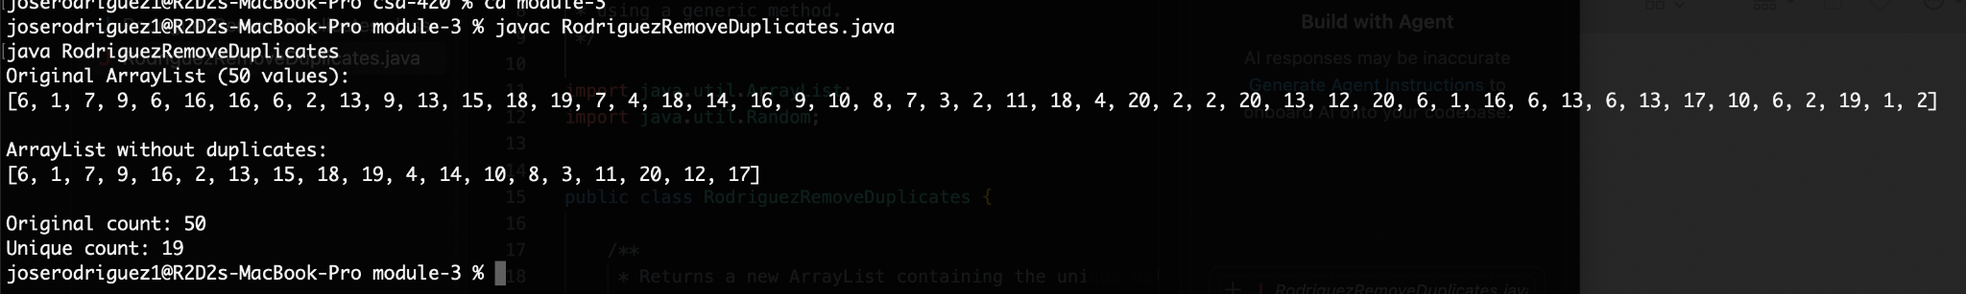

Screenshot of the documentation


