**Web Technologies – Section 1 – Spring 2023**

**Graded Homework One.**

Please follow the instructions provided below to construct a web page.

Please create a sub-folder inside your Web tech repository folder. I will provide each of you with a code – please use this code to name the sub-folder. For instance, if the code provided to you is “gs1907”, then, your sub-folder will be named as “gs1907”. The homework and all related files must be placed inside this folder. Push the entire sub-folder (gs1907) to the GitHub server. Once uploaded, you can test to make sure you can access this homework and it appears the way you designed it. The URL to use is: https://<username>.github.io/<web-tech-repository>/<coded subfolder>/homework1.htm

Here, <username> is your github user name (for example, gshankar425).

<web-tech-repository> is the name of your repository for this class (example, webtech2023).

<coded-subfolder> is for example, gs1907.

“homework1.htm” is the name of the homework file. PLEASE DO NOT CHANGE THIS NAME.

For example, entire URL in my case will look like:

<https://gshankar425.github.io/webtech2023/gs1907/homework1.htm>

**(Construction - 13 points):** Please use “homework1.htm” (do not rename this file) to build and stylize the page as shown below. Please use internal CSS to stylize the page. Points assigned is shown in parenthesis.

* (1) The title of the web page must be changed to say “Web Tech – Section 1 – HW1”
* (1) The heading “Web Tech –Spring 2023 – Homework One” must be marked up using h1 tag.
* (1) The paragraph must be marked with p tag (1)
* (2) The image “table.jpg” must be inserted just before the first line of the paragraph, inside the p tag.
* (3) Create a hot-spot in the image using the coordinates (6,10, 54,129) so that the first column (the entire first column) in the table image is linked to <https://en.wikipedia.org/wiki/Table_(information)>
* (1) The two subtitles “What is a Table?” and “A Sample Table” must be marked up using the h3 tag. (2)
* (3) Construct a table with 3 rows and 2 columns. Please refer to figure below for the content of each row and column in the table.
* (2) The values in the right column must be hyperlinked to the “inclass” work done in each of sessions 7, 8, and 9.

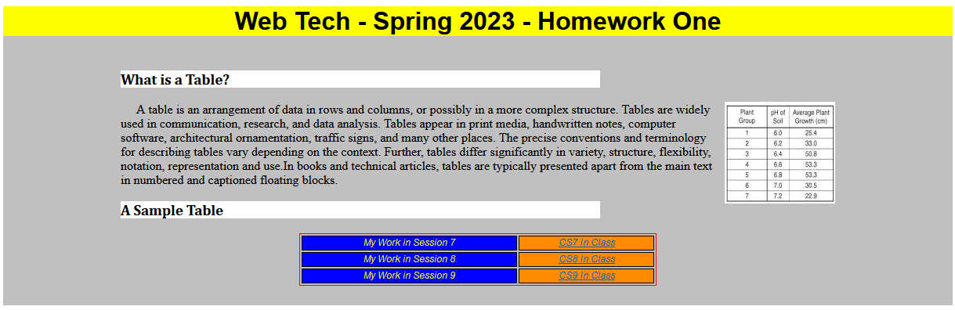

25px

25px

150px

150px

200px

200px

**(Styles- 22 points)**

* (1) The h1 must be centered on the page and use the Arial font. The h3 must be aligned left and use Cambria font.
* (2) The entire rest of the content (not including the page header that uses h1) must have a silver color background
* (1) The heading must have a yellow color background.
* (2) The silver area between the left edge and the content must be 150px. The silver area between the right edge and the content must be 150px. The silver area between the top and bottom edges and the content must be 25px each. These are shown in the figure above using white textboxes. You may ignore these boxes for your formatting purposes.
* (2) The white space to the left and right of the silver area must be 200px. This too is shown in the figure above. The white space to the top (above the yellow section) is 50px (not shown in figure) and bottom has no white space below the silver section.
* (2) The paragraph must be in the default font, default (black) color. The first line must be indented 20px (as seen in the figure).
* (1) The image must be set to the right side with the paragraph text flowing around it. It must have a 5px space between the text and the image on the left side.
* (2) The two sub-headings in h3 must have a white background. The background must cover only the text and must not extend too far outside the text to the right. Just about approx. half the width of content area. There is a red-line drawn to show you what the width of the content area is so that you can gauge one-half that width.
* (5) The sample table width must be 50% of the width of the page and must be centered on the page. It uses Arial that is italicized. The size of the font is 12px. The font must be centered in the table.
* (3) The left column of the table must have a blue background. The right column a dark-orange background. The font color of the left column must be yellow. The right column font must be black.

**Part 2 of Homework 1 (worth 15 points).**

1. (7) Create an external stylesheet that is linked to your “index.htm” and the “toc.htm” pages. This stylesheet must define two things: (1) the background for both pages must have a grey color (any variation of grey is fine) and (2) the <h1> tags in both pages must have Arial font, navy color, and must be centered on the pages. Attach this style sheet to the two pages.
2. (8) Change your TOC page so that the content is listed using a table with two columns. The left column specifies the session number (CS1, CS2, etc.) and the right column is the hyperlink to the work completed in class.