1. **Background/Motivation:**

I found inspiration in Physarum Polycephalum, a plasmodial slime mold *without a brain*. It was first shown to solve complex mazes, then successfully recreate the Tokyo subway system that efficiently connects the densest population areas that researcher applied extensive engineering knowledge to design.[1,2] Such peculiar and impressive feats were achieved in the absence of a brain by the food-seeking drive of the slime mold: it expands to cover its surroundings, allowing identification of nutrient locations; then, it retracts into the most efficient network of veins to connect the food sources, transport digestive fluid to these locations, and finally, transport the digested nutrient to the rest of the mold through the optimized network. For the work on the Tokyo subway system, researchers placed nutrients at locations representing high population density, and thus “tricked” the slime mold to carry out the design work. In our proposed simulation, we propose to simulate this system with a biased random walk with the randomness innate with natural foraging as brownian noise and the chemical gradient provided by a nutrient source by adding a force vector to the random walk that is chosen by the distance away from and the intensity of an nutrient source.

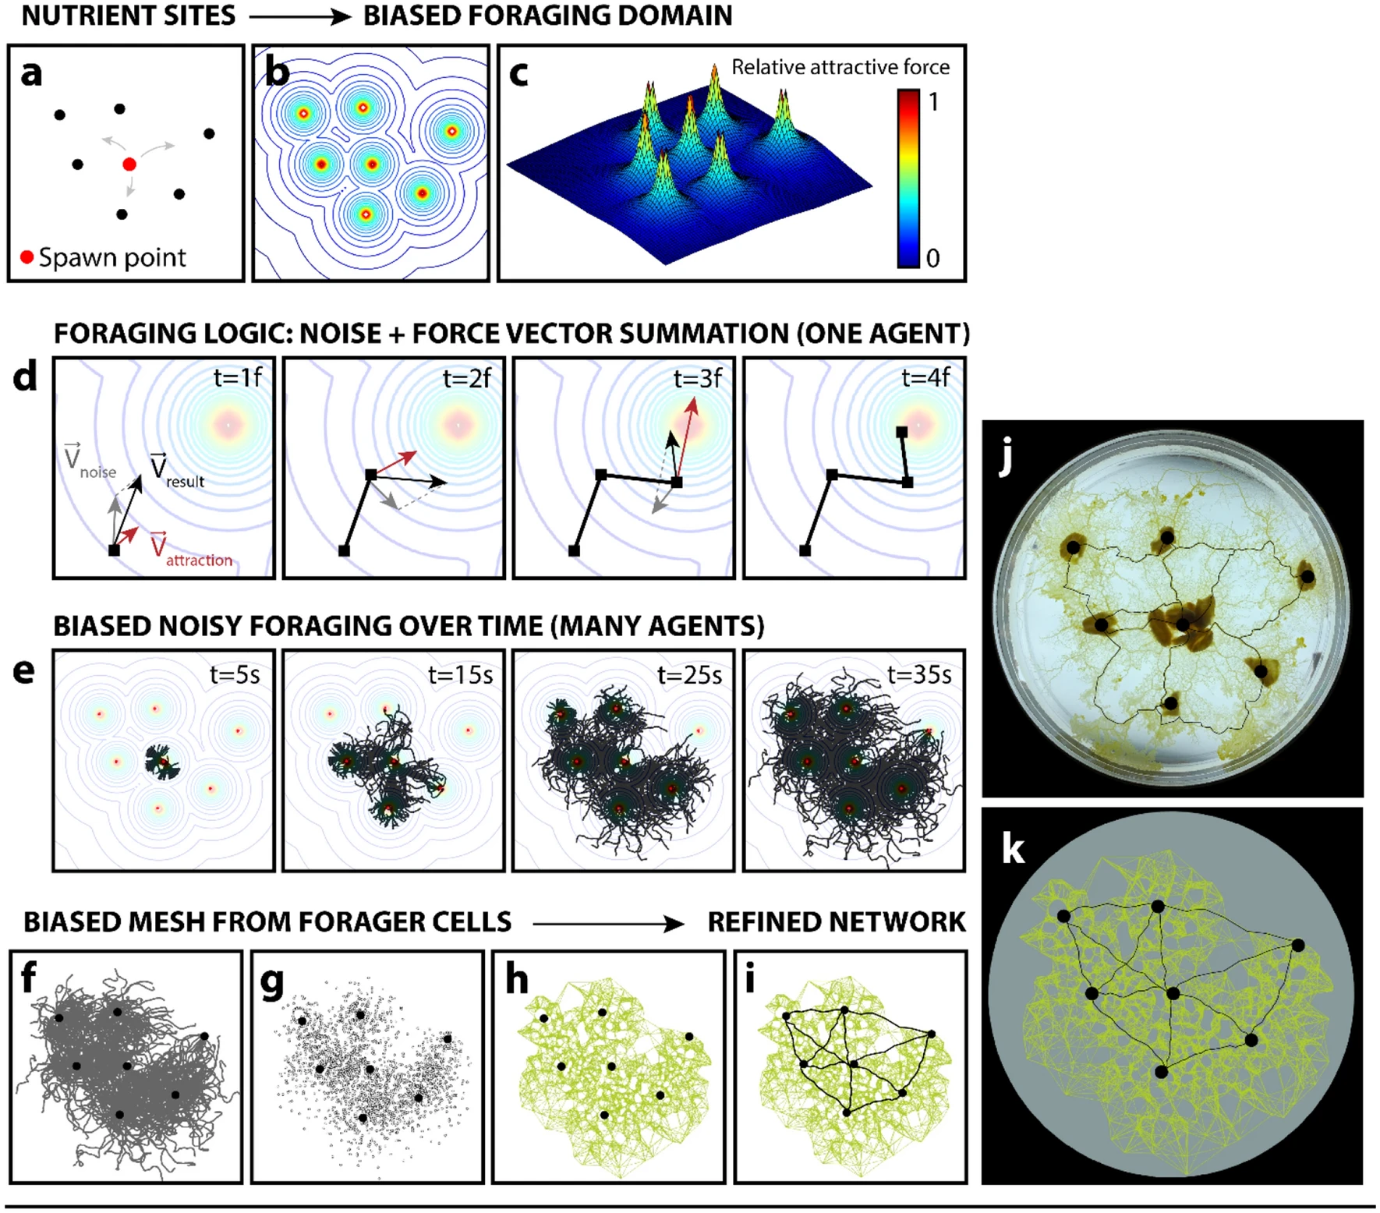

Kay, R., Mattacchione, A., Katrycz, C. *et al.* Stepwise slime mould growth as a template for urban design. *Sci Rep* 12, 1322 (2022). <https://doi.org/10.1038/s41598-022-05439-w>

1. **Objectives:**

* 1. Model several random walkers trajectories that move in response to chemoattractant on 2D surface (like the agar slimes Justin has)
  + Set strength of noise and attraction
  + Asymmetric nutrient sources on ends
  + Use imageJ to stack images and see changes??
* 2. Network morphology/structure metrics:
  + Find nodes (areas where trajectories overlap/connect)
  + # of neighboring nodes (connectivity)
  + Branch lengths
* 3. Treat network connections as springs (thicker veins are stronger springs) and see how system responds to applied stress or strain

For model:

* Have persistence, can use ABP model from class as a starting point and change it from 2 parameter to 3 (x,y, and theta)
* Sqrt(2DdtW)
  + dt is time step
  + dx = sqrt(2Ddt)*cos(theta)*W + V(d)*cos(theta)dt
    - D is diffusion coeff
    - d is distance
    - V is vector
  + Same for Y but with y terms and additional term for attraction to top
  + d(theta) = sqrt(2DRdt)*Wtheta
  + Or can do as in paper and do sum of both direction vectors

How does it differ?

* Replace point attractants with line attractants with a variety of lines with variable
  + distance away from each other
  + relative angle (how many degrees from parallel)
  + size
  + intensity (both between the lines and within within one line)

Things to put into consider:

* Vein thickness?
* Number of random walkers
* Randomness of walk (noise vector)
  + Constant force?
* Chemoattractant (attraction vector)
  + Strengthens with proximity to nutrients, some kind of exponential decay

General info:

* Veins are paths of random walks in model with chemoattractant

1. **Pseudocode:**

* **Prior to Objective 1 import data and sources are to be defined.**
* **(x,y,theta) and A,D, corresponding equations for dx,dy and dtheta.**
* **Objective 1 is to be established by defining the random walker trajectories in the 2D surface**
* **Define the num walks,noise,chemical potential of the chemo attractant, attractive forces of the surface.**
* **Account for mean square values,standard deviation and outliers.**
* **Account for vein thickness.**
* **Account for a solid range of num walks 10 to 100 to 1000 to 10000**
* **Make note of any correlation between defined variables(vein thickness, noise, chemical potential forces, surface properties.**
* **Define regions into quadrants to account for the asymmetrical areas on the surface.**
* **Objective 2 will focus on the regions of overlap of the ABP when the diffusive and ballistic regime meet at a point when the motions of both sets of particles reach their average value or steady state value.**
* **The velocity is worn off at this point and the change in angle then matches/signals the area of overlap on the overall diffusion path from the starting point of the surface.**
* **We can define this by defining the interval using the mean square displacement in the 2D equation.**
* **Defining the time step from the starting point, change in the num steps and the official number of num steps as well as the num walks desired in the simulation.**

**References**

[1]. Nakagaki, T., Yamada, H. & Tóth, Á. Maze-solving by an amoeboid organism. *Nature* **2000**, ***407***, 470.

[2]. Tero, et al., Rules for Biologically Inspired Adaptive Network Design. *Science* **2010**, *327*, 5964, 439-442.

[3]. Kay, R., Mattacchione, A., Katrycz, C. *et al.* Stepwise slime mould growth as a template for urban design. *Sci Rep* 12, 1322 (2022). <https://doi.org/10.1038/s41598-022-05439-w>