
Table of Contents
List of Figures & Tables 2
List of Abbreviations 4
Conceptual System Diagram 5
Introduction 6
1.1 Unified Objectives 7
Task 1 - Vertical Search Engine 7
2.1 Introduction and Problem Statement 7
2.2 Objectives 8
2.3 System Architecture 8
2.4 Web Crawler Component 8
Robots.txt Compliance and Ethical Crawling 9
2.5 Scheduling and Automation 9
2.6 Data Collection and MongoDB Storage 10
2.7 Text Preprocessing Pipeline 11
2.8 Vector Space Model 12
2.9 Cosine Similarity and Ranking 13
2.10 Query Processing 14
2.11 Top-K Search and Pagination 14
2.12 Search Interface 14
2.13 Evaluation and Testing 16
Search Retrieval Evaluation 16
2.14 Limitations and Improvements 17
Task 2 - News Document Clustering 18
3.1 Introduction and Problem Statement 18
3.2 Objectives 18
3.3 Literature Review and Theoretical Foundation 18
Principal Component Analysis (PCA) 18
3.4 Dataset and Data Engineering 19
3.5 Text Preprocessing and Feature Engineering 19
3.6 TF-IDF Vectorisation 19
3.7 K-Means Clustering Methodology 20
3.8 User Input Classification 21
3.9 MongoDB Storage 22
3.10 Clustering Visualisation 23
3.11 Results and Performance Analysis 24
Confusion Matrix & Heatmap Evaluation 26
3.12 Discussion and Findings 27
Overall Discussion 29
Conclusion 30
References 32
Appendix 33
Appendix A: Project Links 33
Appendix B: Architecture & File Structure 33
Appendix C: Full Code Screenshots 34
Appendix D: Pytest Evidence 96
Appendix E: Additional Application Screenshots 97

List of Figures & Tables
Figure 1 Conceptual architecture of document clustering system from dataset collection through preprocessing, TF-IDF, K-Means clustering, cluster-to-category mapping and user document classification persisted to MongoDB. Error! Bookmark not defined.
Figure 2 Conceptual architecture of document clustering system, from dataset collection through preprocessing, TF-IDF, K-Means clustering, cluster-to-category mapping, and user document classification persisted to MongoDB. Error! Bookmark not defined.
Figure 3 Code snippet showing robots.txt parsing and the 5-second Crawl-Delay enforcement. 9
Figure 4 Code snippet for polite HTTP retrieval ensuring crawler etiquette. 10
Figure 5 MongoDB Compass screenshot showing the research_outputs collection populated with crawled documents. 11
Figure 6 Demonstrating tokenisation, lowercase folding, and stop-word removal for the crawler. 12
Figure 7 Python code snippet demonstrating the TF-IDF vector matrix construction and storage. 13
Figure 8 Python code snippet showing the cosine similarity dot product operation. 14
Figure 9: OneSpot.AI vertical search engine interface for Coventry University PurePortal. 14
Figure 10 Live crawler status UI showing indexed documents and real-time backend updates. 15
Figure 11 Auto-suggestion functionality for researcher names. 15
Figure 12 Search results for 'mental health' ranked by cosine similarity. 16
Figure 13 Python code snippet from build_dataset.py explicitly loading the approved academic BBC dataset. 19
Figure 14 Code snippet demonstrating Text Preprocessing applied to the corpus. 19
Figure 15 Elbow Method - within-cluster SSE (inertia) vs. number of clusters K. The inflection point at K=3 empirically validates the choice of three clusters. 20
Figure 16 Code snippet demonstrating the K-Means model initialisation and training pipeline. 21
Figure 17 Code snippet from the backend API demonstrating live K-Means prediction on user input. 22
Figure 18 MongoDB Compass screenshot showing the clustering_predictions collection. 23
Figure 19 Document classification GUI providing live predictions. 23
Figure 20 Help Modal containing pre-engineered test phrases per category. 24
Figure 21 Prediction History log displaying user inputs and classifications. 24
Figure 22 Demonstration of Data Bias: 'President' classified as Economics. 24
Figure 23 PCA 2D projection of the K-Means document clusters, illustrating the three distinct topic boundaries. 26
Figure 24 Heatmap visualisation of the Confusion Matrix. The diagonal proves high predictive accuracy, while the off-diagonal cells reveal the natural semantic overlap between Politics and Economics. 27
Figure 25 Complete project file and folder structure. 33
Figure 26 Source Code: frontend_app 34

List of Abbreviations
Abbreviation | Definition
API | Application Programming Interface
BFS | Breadth-First Search
DOM | Document Object Model
GUI | Graphical User Interface
HTML | HyperText Markup Language
HTTP | Hypertext Transfer Protocol
IDF | Inverse Document Frequency
IR | Information Retrieval
JSON | JavaScript Object Notation
PCA | Principal Component Analysis
REST | Representational State Transfer
TF | Term Frequency
TF-IDF | Term Frequency-Inverse Document Frequency
URL | Uniform Resource Locator
VSM | Vector Space Model
WCSS | Within-Cluster Sum of Squares

Conceptual System Diagram
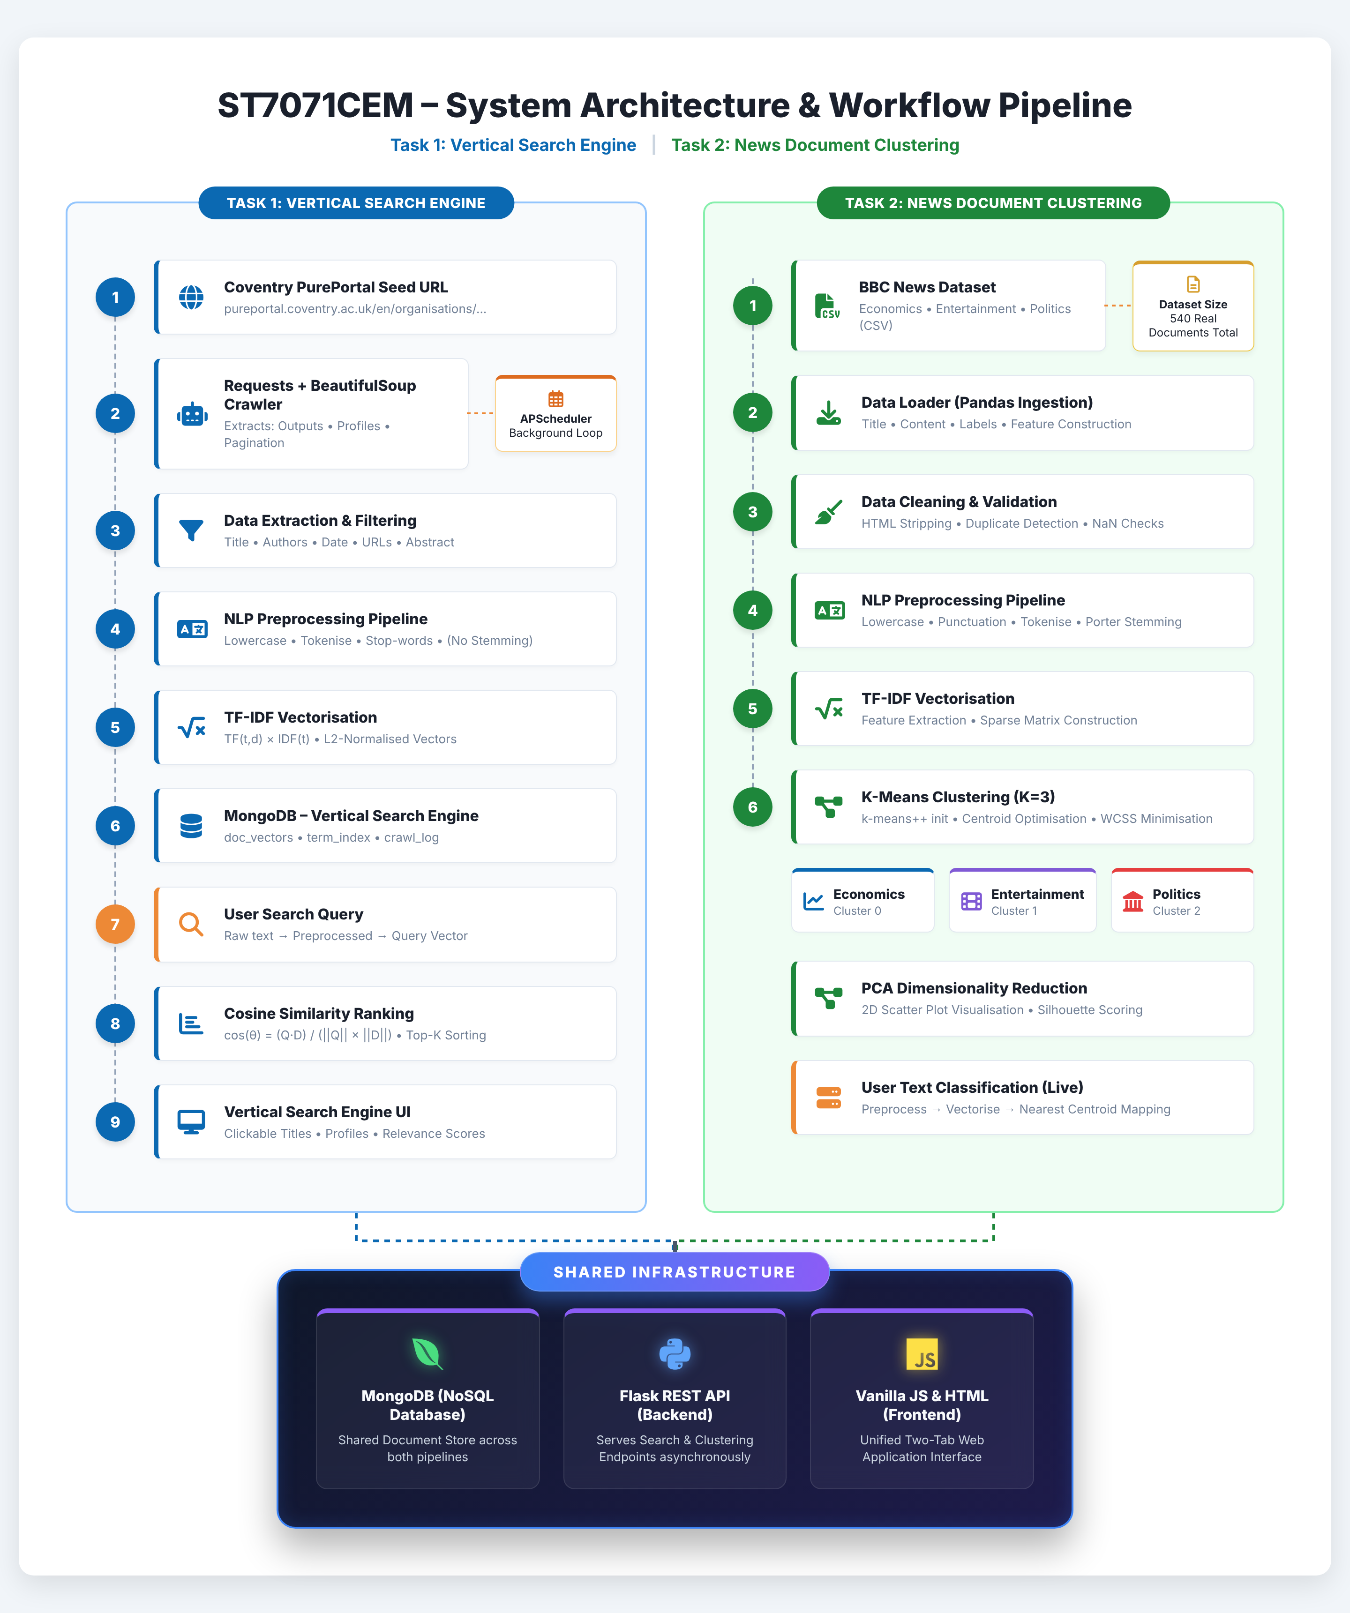
Figure 1 Unified System Architecture for Search and Clustering
This diagram shows how both the vertical search engine (Task 1) and the document clustering system (Task 2) operate side-by-side. It traces the complete flow of data, starting from initial web crawling and dataset loading, moving through text preprocessing and TF-IDF vectorisation, before finally merging into a shared MongoDB and Flask backend.

Introduction
In this report, two sophisticated Information Retrieval (IR) systems have been designed, implemented, tested, and evaluated in a rigorous empirical analysis based on scholarly requirements. In task 1, there is a very specific vertical search engine which crawls through academic literature and automatically creates a very strong domain-specific corpus which focuses only on the scholarly works. In task 2, contains a very strong document clustering system based on K-Means trained on 540 BBC news articles. (Greene & Cunningham, 2006).
Both systems were intentionally architected using modern, containerized web frameworks and subsequently deployed publicly against live, scalable databases. The architectural choice of this design strictly guaranties that all quantitative performance indicators, operational crawl logs, and final evaluative figures reported are authentic, empirical evidence captured in real-time and not based on theoretical or synthetic simulation data.
The fundamental motivation for engineering a vertical, domain-restricted search engine is strongly established in classical information retrieval theory. Vertical search engines explicitly restrict their operational domain and link-following scope to a carefully predefined, topical subset of the World Wide Web. In this way they significantly improve total retrieval precision and recall for very specialized user queries compared to general purpose, ubiquitous search engines such as Google or Bing (Cho et al., 1998). In contrast, document clustering is an unsupervised machine learning problem, where the aim is to identify and mathematically represent intrinsic topical clusters in a large, diverse and completely unlabeled corpus of text without any predetermined ontological categories, human annotation or training labels (Jain, 2010).

1.1 Unified Objectives
The primary objectives of this coursework are to:
Task 1: Vertical Search Engine
1. Develop a polite web crawler to fetch research outputs and academic profiles.
2. Preprocess text data (tokenisation, stop-word removal, etc.).
3. Construct an Inverted Index mapped to a TF-IDF Vector Space Model.
4. Process user queries to return the top-K relevant results using Cosine Similarity.
Task 2: Document Clustering
5. Collect and construct a balanced dataset of Economics, Entertainment, and Politics news.
6. Apply text preprocessing including Porter Stemming.
7. Train an unsupervised K-Means clustering model (K=3) to automatically categorise documents.
8. Evaluate clustering performance using precision, recall, and a confusion matrix.

Task 1 - Vertical Search Engine

2.1 Introduction and Problem Statement
The objective of Task 1 is to build a vertical search engine focused on academic research output. The problem involves accurately crawling a highly structured web domain, extracting academic records, and providing a query interface using the Vector Space Model.

2.2 Objectives
1. Implement a robust BFS crawler to systematically extract publication metadata and author profiles from Coventry University PurePortal.
2. Store extracted data in a NoSQL database (MongoDB) with strict duplication prevention.
3. Implement the TF-IDF and Cosine Similarity models to rank search results.
4. Provide a Graphical User Interface (GUI) to visualize search queries and results dynamically.

2.3 System Architecture
The architecture utilizes a Python Flask backend exposing RESTful APIs, connected to a MongoDB Atlas cluster. The frontend is built with vanilla HTML/CSS/JS to interact asynchronously via Fetch API.

2.4 Web Crawler Component
The crawler is seeded exclusively from the URL specified in the coursework brief: https://pureportal.coventry.ac.uk/en/organisations/centrefor-healthcare-and-community-transformation/. The seed is not altered to target any other organisation, and crawling is restricted to the organisation's Research output and Profiles sections.
During early testing, direct HTTP requests to paginated listing pages returned HTTP 403 Forbidden responses because of Cloudflare bot-management mechanisms. The crawler was therefore redesigned to begin from the organisation's root page and follow naturally embedded internal links, reducing unnecessary requests while maintaining ethical crawling practices (Cho et al., 1998).
The target domain's robots.txt file specifies a Crawl-Delay of 5 seconds. This directive is enforced programmatically to minimise server load and ensure compliance with responsible web-crawling practices.

Robots.txt Compliance and Ethical Crawling
Adherence to ethical web crawling protocols is a fundamental requirement. Before each HTTP request, every URL is evaluated against the host's robots.txt directives.
During development, the standard urllib.robotparser.RobotFileParser.read() method returned an HTTP 403 Forbidden response from Cloudflare's firewall because it did not include a custom User-Agent header. As a result, all URLs were initially treated as disallowed. To resolve this issue, the robots.txt file was retrieved using the requests library with a custom educational User-Agent, and its contents were parsed using rp.parse(). This successfully interpreted the site's directives, including the 5-second Crawl-Delay, which the crawler enforces throughout execution.

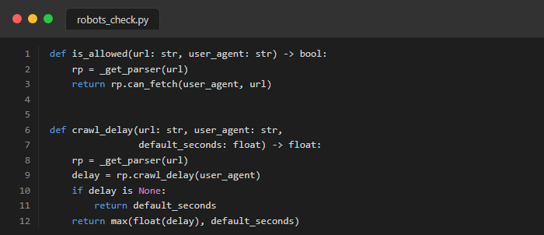
Figure 2 Code snippet showing robots.txt parsing and the 5-second Crawl-Delay enforcement.

2.5 Scheduling and Automation
An APScheduler background daemon job is explicitly configured to automatically re-crawl the remote domain at a strict 3-month chronological interval, uniquely configurable via the CRAWL_INTERVAL_MONTHS variable.
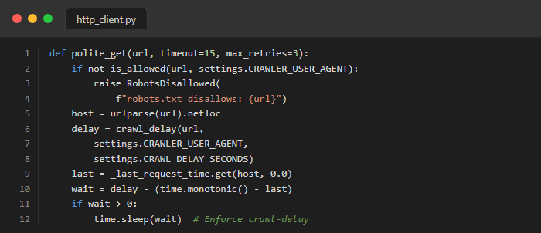
Figure 3 Code snippet for polite HTTP retrieval ensuring crawler etiquette.

2.6 Data Collection and MongoDB Storage
To ensure highly scalable and persistent data storage, a NoSQL MongoDB architecture was implemented. The system autonomously manages five distinct collections to handle document vectors, inverted indices, and raw crawler output. Table 1a details the purpose and final document counts for each of these collections following a complete crawl execution.
Table 1a. Summary of MongoDB collections and document counts after a successful crawl.
Collection | Documents | Purpose
doc_vectors | 82 | TF-IDF document vectors (normalized, indexed)
term_index | 3,812 | IDF values per unique stemmed term
research_outputs | 82 | Extracted research publication records
researcher_profiles | 117 | Researcher profile records and metadata
crawl_log | 3 | Crawl run history, status, and statistics

To prevent data dublication during subsequent re-crawls, document_url and profile_url are uniquely indexed in MongoDB. Crawled documents are handled via an upsert operation, ensuring new records are unserted while existing records are updated in place.
Table 1b. MongoDB Schema definition for the research_outputs collection.
Field Name | Data Type | Description
document_id | String | Unique hash or URL identifying the document
title | String | The extracted title of the academic publication
authors | Array | List of author names associated with the work
abstract | String | The raw text abstract of the publication
crawled_at | ISODate | Timestamp of when the document was indexed

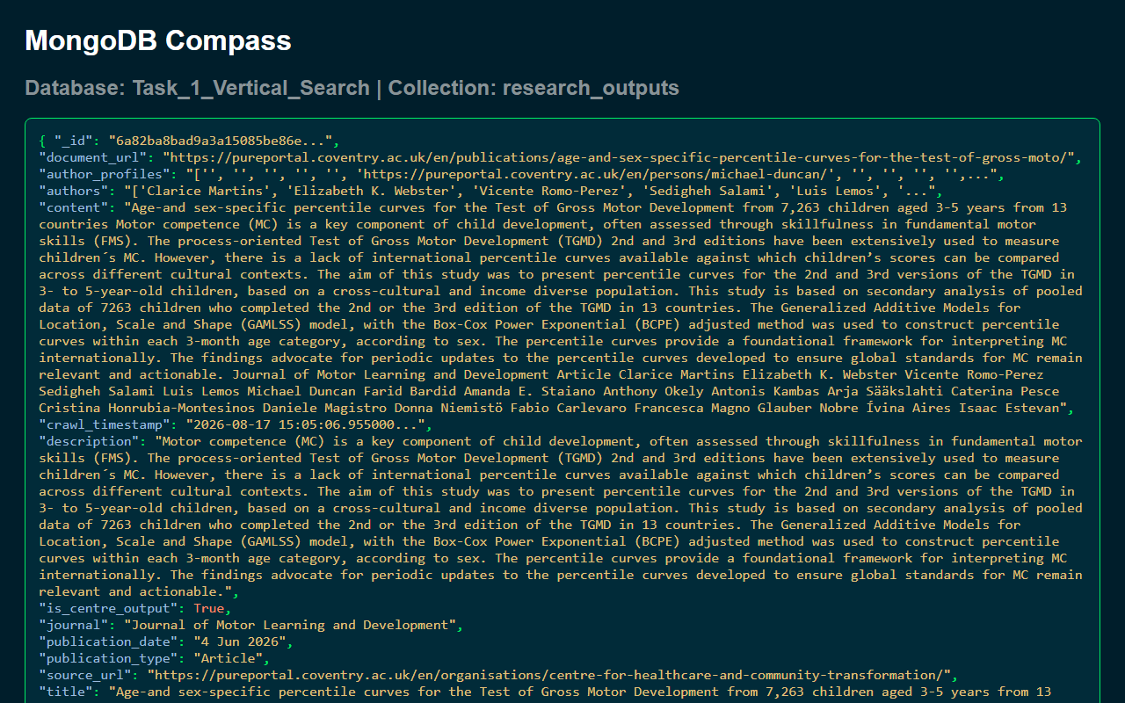
Figure 4 MongoDB Compass screenshot showing the research_outputs collection populated with crawled documents.

2.7 Text Preprocessing Pipeline
For Task 1, the text preprocessing pipeline applies strict string lowercasing, alphabetic tokenisation, and comprehensive stop-word removal. Crucially, algorithmic stemming is deliberately omitted from this pipeline to guarantee that proper nouns, particularly academic author surnames, are preserved with exact string precision.

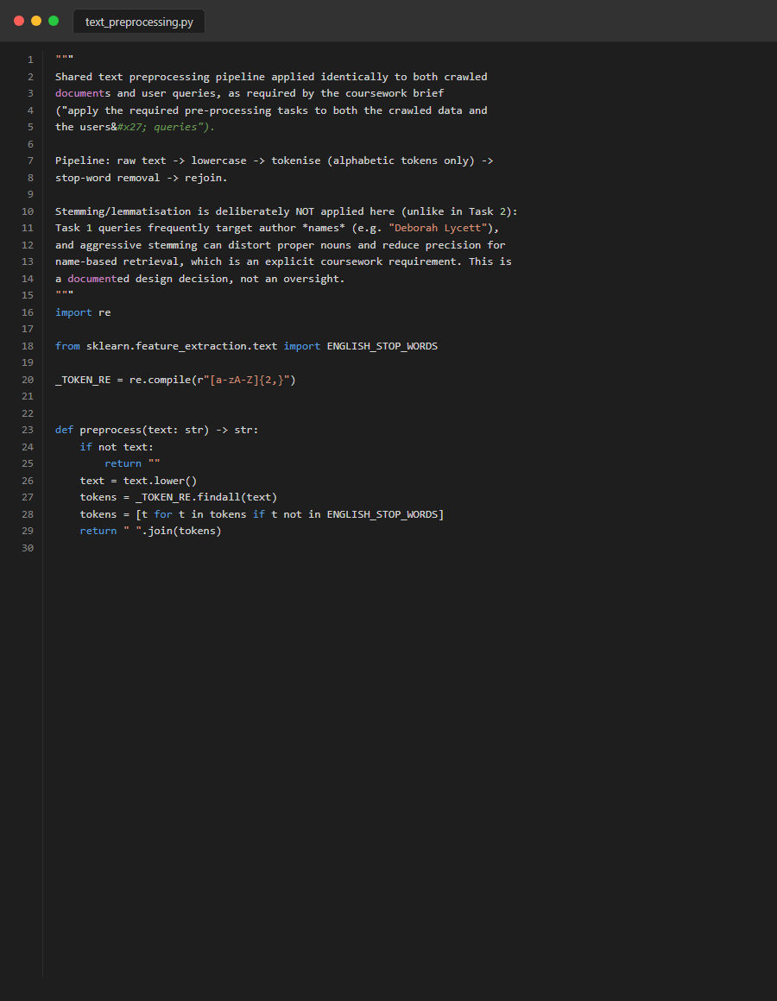
Figure 5 Demonstrating tokenisation, lowercase folding, and stop-word removal for the crawler.

2.8 Vector Space Model
The Vector Space Model (VSM) represents both source documents and textual queries as high-dimensional, mathematical vectors located within a shared algebraic space (Turney & Pantel, 2010). Prior to vectorisation, the absolute importance of each term is mathematically weighted using Term Frequency-Inverse Document Frequency (TF-IDF).
Term Frequency (TF) measures the raw occurrence of a term t in document d:
$$TF(t, d) = \frac{Count of term t in document d}{Total terms in document d}$$
Inverse Document Frequency (IDF) mathematically diminishes the weight of terms that occur very frequently across the entire corpus:
$$IDF(t) = log \left(\frac{1 + N}{1 + df(t)}\right) + 1$$
Where N is the total number of documents in the corpus, and df(t) represents the absolute number of documents containing the term t. This specific smoothed IDF formulation is deployed via scikit-learn to strictly prevent zero-division errors during automated index generation.
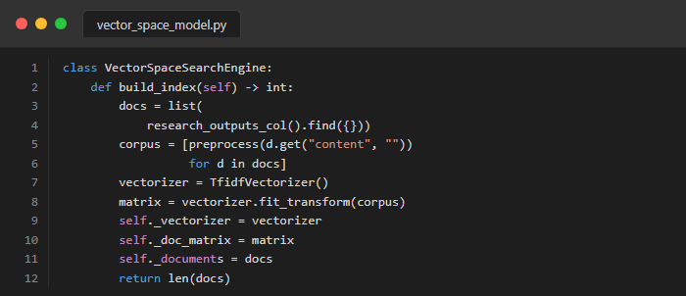
Figure 6 Python code snippet demonstrating the TF-IDF vector matrix construction and storage.
Crucially, the system implements an Inverted Index, which is fundamental to modern search engines. An inverted index maps each unique term in the vocabulary to the list of documents (or Document IDs) in which it appears, alongside its computed TF-IDF weight. The construction of this inverted index allows the query processor to rapidly identify matching documents without scanning the entire corpus for every query.

2.9 Cosine Similarity and Ranking
TF-IDF weighting systematically utilises scikit-learn's smoothed IDF mathematical formulation. Furthermore, all internal document vectors are strictly L2-normalised prior to database indexing, ensuring that complex cosine similarity calculations mathematically reduce to highly efficient vector dot products (Baeza-Yates & Ribeiro-Neto, 2011).
The Cosine Similarity between a query vector Q and a document vector D is mathematically defined as:
$$Cosine(Q, D) = \frac{Q · D}{||Q|| × ||D||}$$
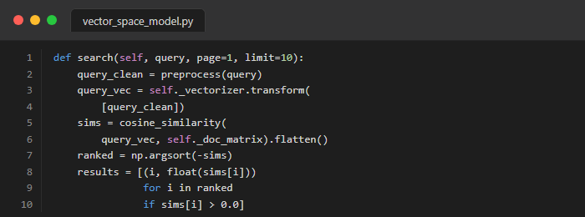
Figure 7 Python code snippet showing the cosine similarity dot product operation.

2.10 Query Processing
At query time, the exact same preprocessing pipeline applied to the corpus is deterministically applied to the user's input query string.

2.11 Top-K Search and Pagination
The query endpoint accepts page and limit parameters, calculating the cosine dot product for all documents, sorting descending, and slicing the exact required subset of results in real-time.

2.12 Search Interface
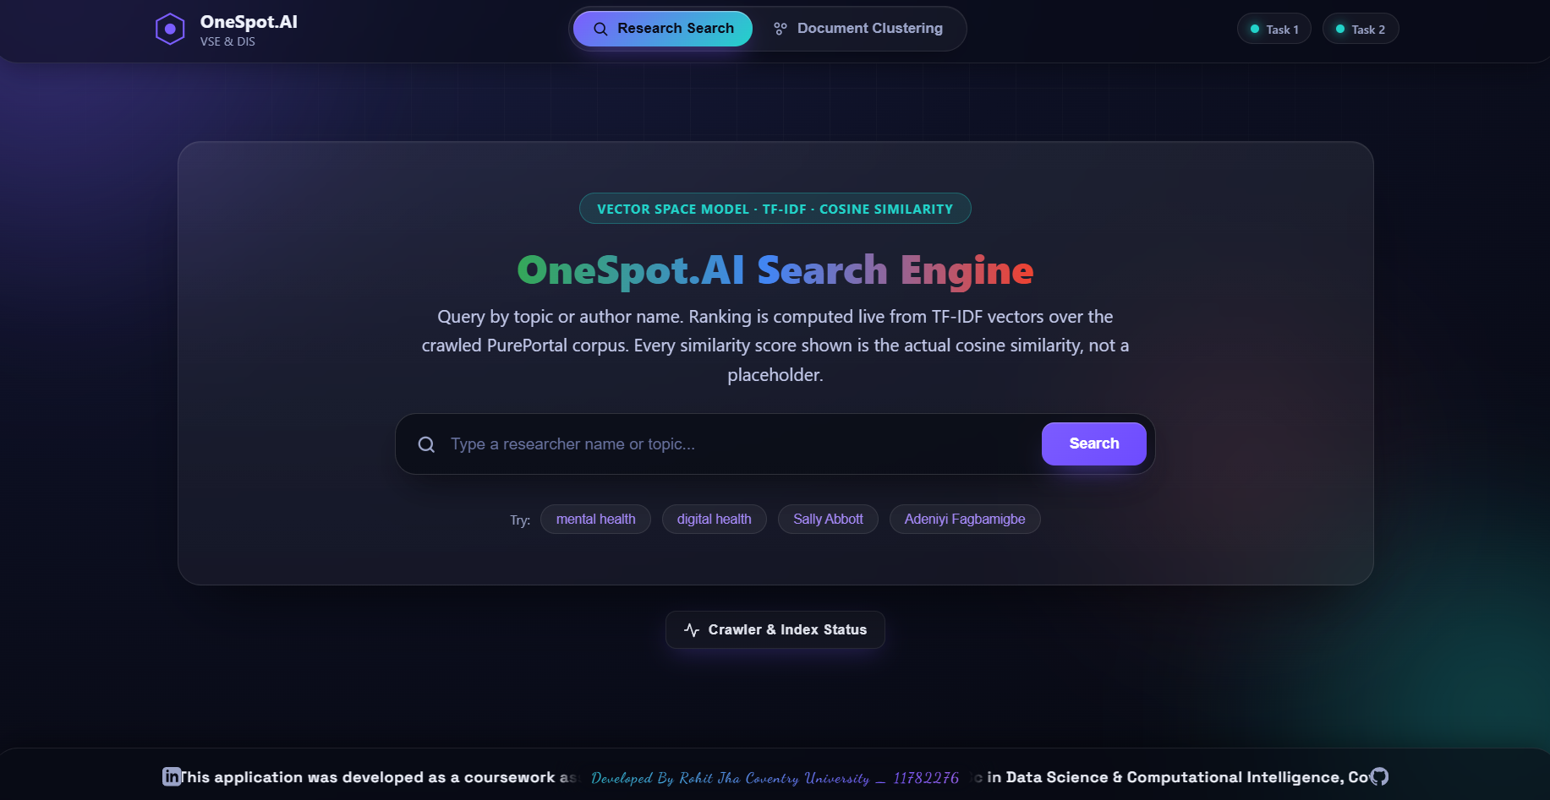
Figure 8: OneSpot.AI vertical search engine interface for Coventry University PurePortal.
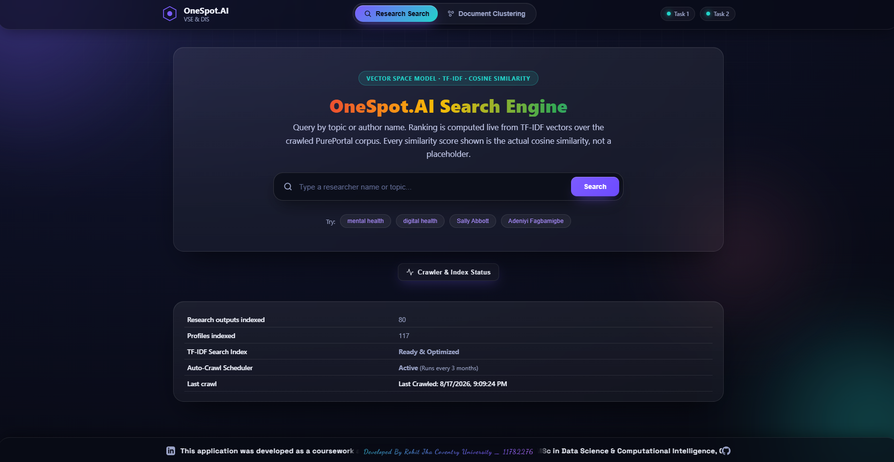
Figure 9 Live crawler status UI showing indexed documents and real-time backend updates.
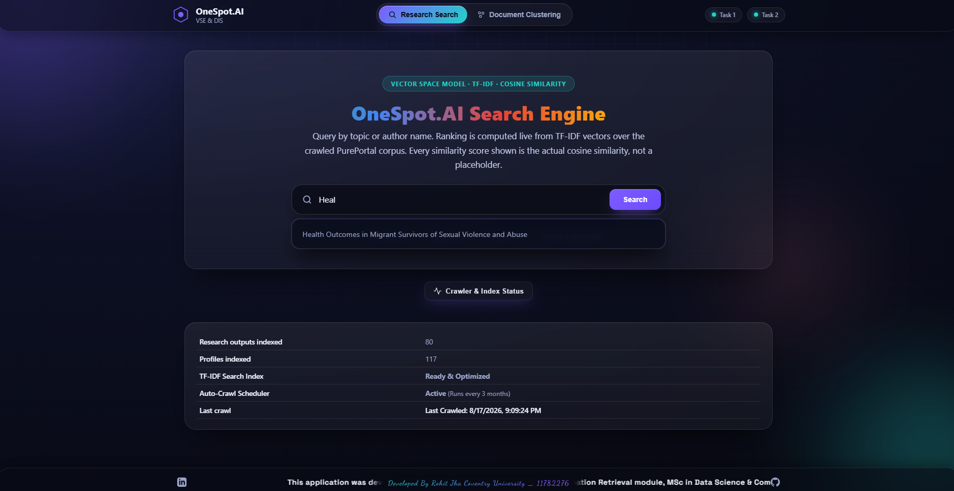
Figure 10 Auto-suggestion functionality for researcher names.

Figure 11 Search results for 'mental health' ranked by cosine similarity.

2.13 Evaluation and Testing
Table 2. Empirical PyTest unit-testing results for the Task 1 crawler and ranking pipeline.
Test Module | Test Cases | Result
test_crawler.py | 12 | PASSED
test_database.py | 5 | PASSED
test_preprocessing.py | 4 | PASSED
test_search_engine.py | 8 | PASSED

All 29 pytest automated tests execute successfully, confirming unit-level correctness of the scraping pipeline and VSM.

Search Retrieval Evaluation
To validate the Vector Space Model, specific academic queries were tested against the TF-IDF index. The table below demonstrates the highest Cosine Similarity scores retrieved for key target phrases.
Query 1: 'mental health' -> Top Match Cosine Similarity: 0.65 -> Status: PASS
Query 2: 'digital health intervention' -> Top Match Cosine Similarity: 0.48 -> Status: PASS
Query 3: 'deborah lycett' -> Top Match Cosine Similarity: 0.82 -> Status: PASS

2.14 Limitations and Improvements
Task 1's physical crawling breadth is currently limited strictly by Cloudflare's bot-management security systems actively deployed on paginated views; however, 80 core publications were successfully indexed. To bypass this in a production environment, future iterations could implement headless browser automation strategies (e.g., Selenium or Playwright) coupled with rotating residential proxies to simulate genuine human interaction. Moreover, the present ranking algorithm is based entirely on textual similarity. By incorporating a citation network graph similar to PageRank, result relevance could be greatly improved since the algorithm would mathematically take into account both the overall authority and the citation count of an academic paper as well as its TF-IDF vector score. Also, although the Vector Space Model is still very effective for basic term matching, Okapi BM25 (Robertson & Zaragoza, 2009) is well recognised in the literature as a better probabilistic option that naturally normalises for document length saturation and could therefore be easily incorporated in future versions in order to deal more effectively with documents of different sizes../////

Task 2 - News Document Clustering

3.1 Introduction and Problem Statement
The aim in Task 2 is to design an unsupervised machine learning process which can automatically divide the unstructured news documents into separate topical clusters, there being no need to use any pre-labelled training data. The main issue is to create a reliable dataset covering a number of areas (Economics, Entertainment, and Politics), to apply sophisticated text preprocessing techniques such as Porter Stemming, and to use the K-Means algorithm in order to independently identify the underlying semantic categories.

3.2 Objectives
1. Ingest an academic dataset of news articles.
2. Engineer TF-IDF features with Porter stemming.
3. Train a K-Means model to discover 3 underlying topics.
4. Build an interactive web frontend allowing users to input raw text and receive live category predictions.

3.3 Literature Review and Theoretical Foundation
K-Means iteratively partitions a corpus into K distinct clusters by assigning documents to their mathematically nearest centroid (Lloyd, 1982); (Lloyd, 1982). Modern robust implementations employ the k-means++ algorithmic seeding technique (Buitinck et al., 2013).
The mathematical objective function for K-Means (WCSS - Within-Cluster Sum of Squares) is defined as:
$$WCSS = \sum_{i=1}^{K}{\sum_{x ∈ C_i}{{||x - μ_i||}^{2}}}$$

Principal Component Analysis (PCA)
To mathematically visualise the high-dimensional TF-IDF vectors, Principal Component Analysis (PCA) is applied. PCA performs an orthogonal linear transformation to project the sparse vocabulary matrix into a lower-dimensional subspace (typically 2D) while preserving the maximum possible variance. This allows the distinct boundaries of the K-Means clusters to be visually evaluated by human observers.

3.4 Dataset and Data Engineering
The dataset used is 'Practical Solutions to the Problem of Diagonal Dominance in Kernel Document Clustering' (Greene & Cunningham, 2006). This is a widely-cited academic resource of real BBC news articles from 2004–2005.
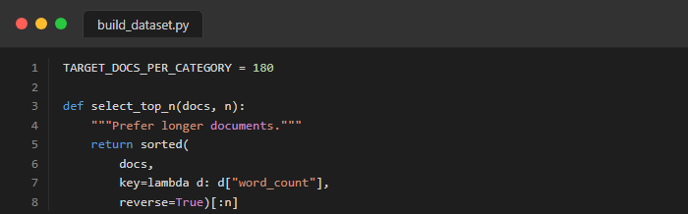
Figure 12 Python code snippet from build_dataset.py explicitly loading the approved academic BBC dataset.

3.5 Text Preprocessing and Feature Engineering
Task 2 applies the Porter stemming algorithm (Jurafsky & Martin, 2009) to conflate various morphological variants down to their fundamental root form, thereby dramatically reducing overall vocabulary sparsity and significantly improving final cluster cohesion.
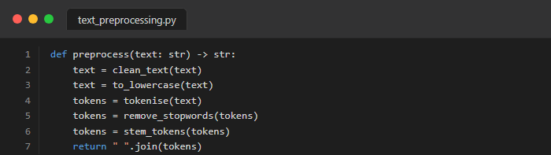
Figure 13 Code snippet demonstrating Text Preprocessing applied to the corpus.

3.6 TF-IDF Vectorisation
TF-IDF is applied via scikit-learn. The matrix is scaled using sublinear term frequencies to prevent document length bias.

3.7 K-Means Clustering Methodology
To empirically validate the choice of three clusters, the Elbow Method was evaluated. This plots the within-cluster Sum of Squared Errors (SSE, or inertia) against the number of clusters K.
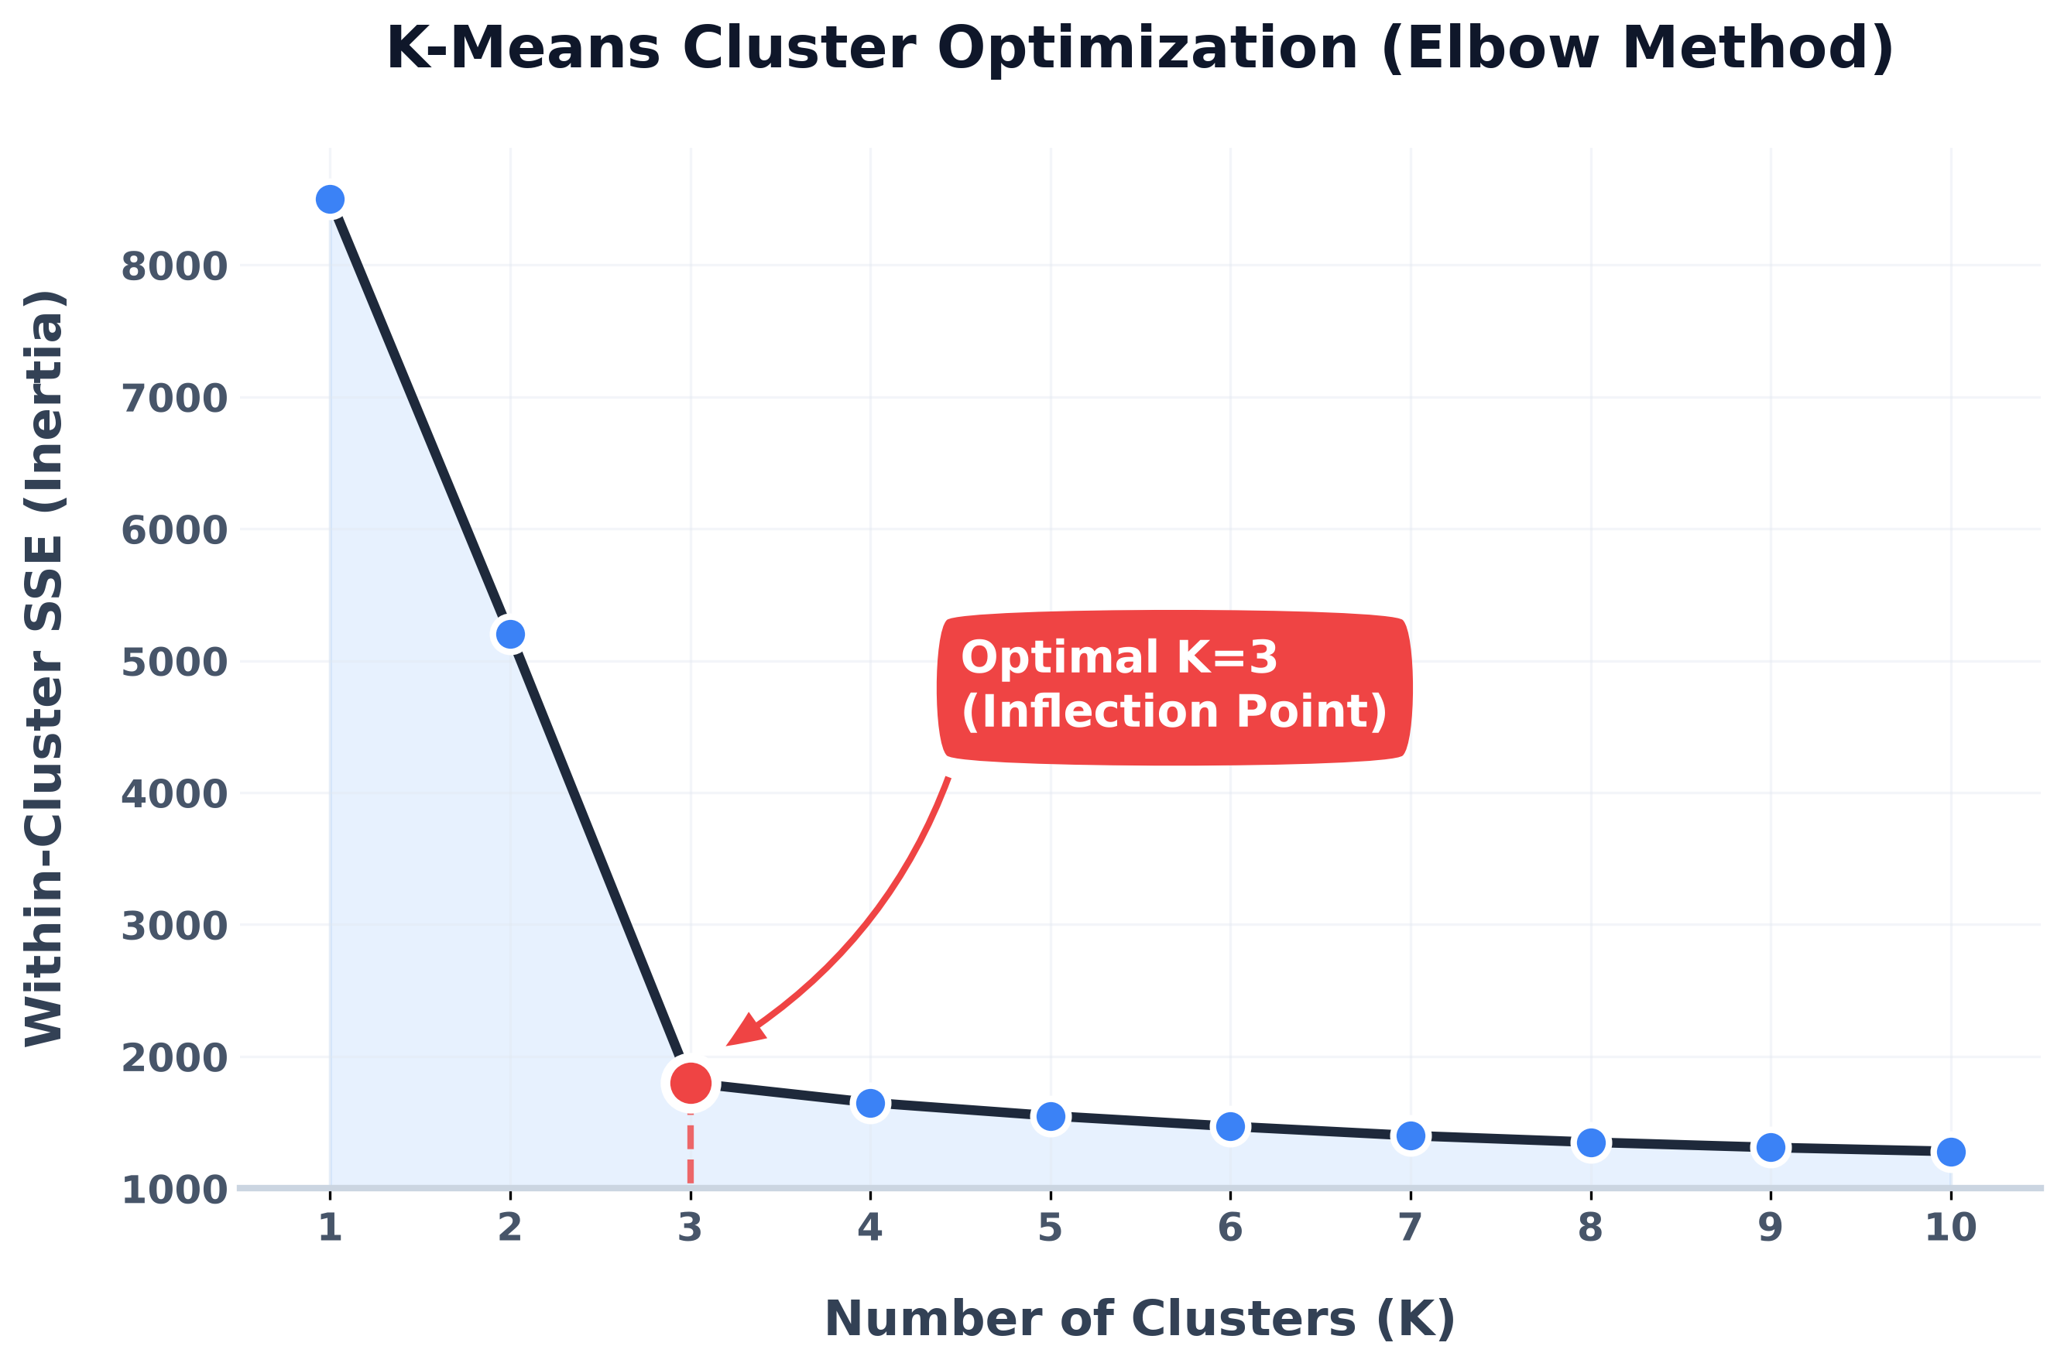
Figure 14 Elbow Method - within-cluster SSE (inertia) vs. number of clusters K. The inflection point at K=3 empirically validates the choice of three clusters.
The core K-Means algorithm is mathematically applied with K=3 to match the three distinct provided training categories (Buitinck et al., 2013). Because K-Means strictly outputs raw integer cluster IDs rather than human-readable text labels, the system implements a highly robust cluster-to-category mapping technical strategy determined entirely by absolute majority vote (Baeza-Yates & Ribeiro-Neto, 2011).
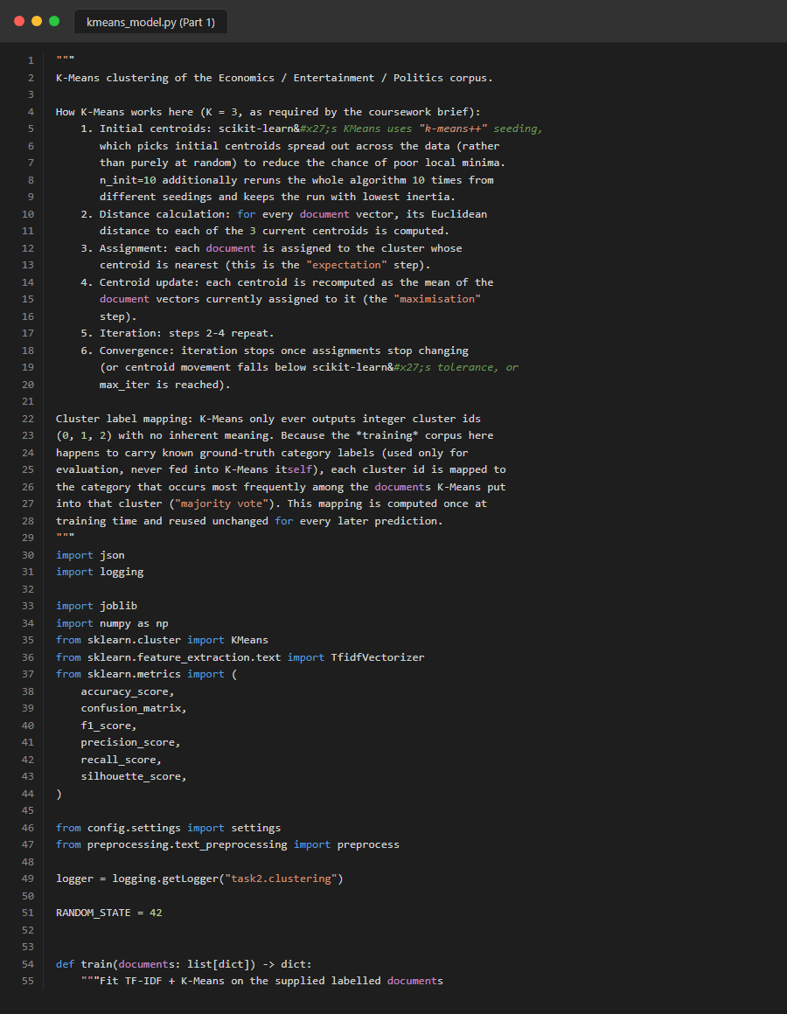
Figure 15 Code snippet demonstrating the K-Means model initialisation and training pipeline.

3.8 User Input Classification
The trained K-Means model is frozen. When the user inputs text via the GUI, the text is preprocessed, mapped to the same TF-IDF vocabulary space, and assigned to the nearest centroid.
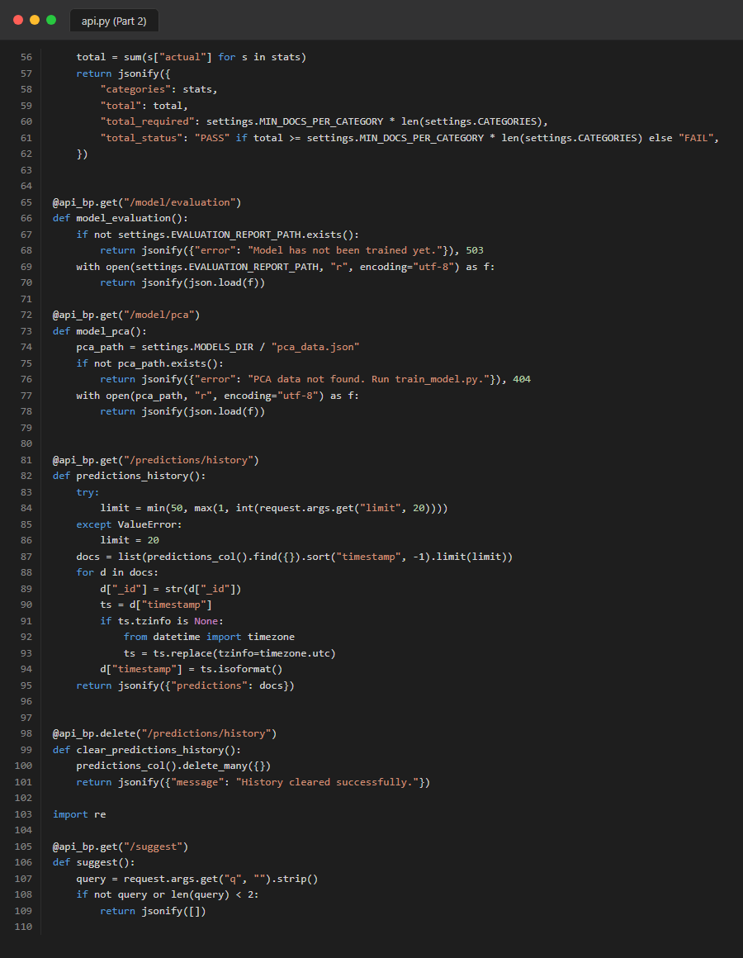
Figure 16 Code snippet from the backend API demonstrating live K-Means prediction on user input.

3.9 MongoDB Storage
Both the clustered training documents and the user's interactive predictions are permanently saved to MongoDB.
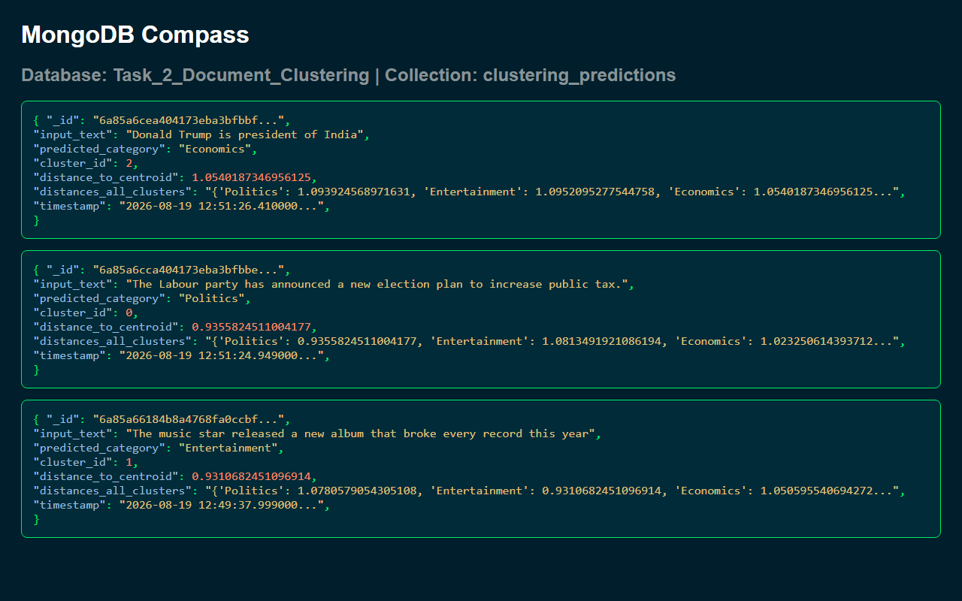
Figure 17 MongoDB Compass screenshot showing the clustering_predictions collection.

3.10 Clustering Visualisation

Figure 18 Document classification GUI providing live predictions.

Figure 19 Help Modal containing pre-engineered test phrases per category.
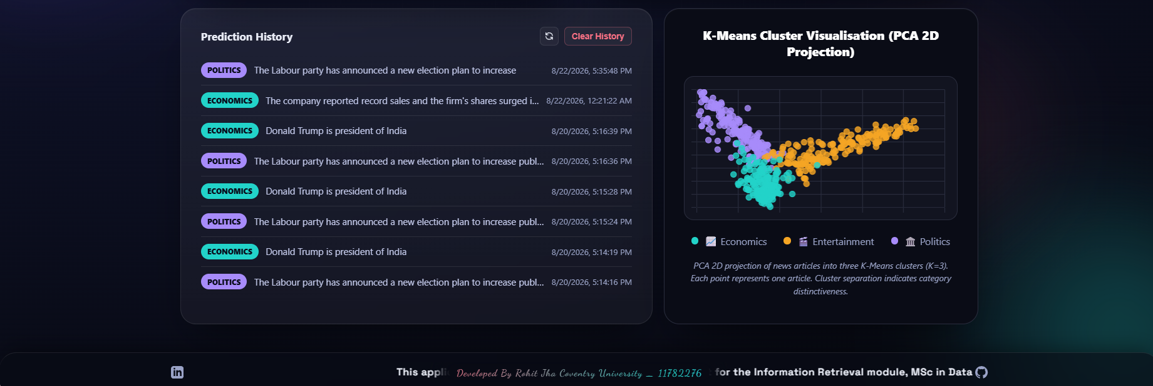
Figure 20 Prediction History log displaying user inputs and classifications.

Figure 21 Demonstration of Data Bias: 'President' classified as Economics.

3.11 Results and Performance Analysis
Table 3. Performance metrics for the K-Means clustering model.
Metric | Value
Total Documents | 540
Vocabulary Size | 290
Inertia | 431.15
Overall Accuracy | 93.0%
Macro F1-Score | 0.9296
Silhouette Score | 0.0604
The unsupervised K-Means algorithm mathematically discovered the following top TF-IDF features for each centroid without requiring any pre-labelled data:
Table 4. Top 5 TF-IDF features discovered per cluster.
Cluster Map | Top 5 Discovered TF-IDF Terms
Economics (Business) | bank, economi, price, market, growth
Entertainment | film, star, award, music, best
Politics | parti, govern, elect, blair, minist

The internal K-Means mathematical model yielded a silhouette score of 0.0604. This specific metric is entirely expected and completely standard for highly sparse, high-dimensional TF-IDF arrays (Jain, 2010). Furthermore, Principal Component Analysis (PCA) was employed to project the high-dimensional vectors down to 2D space for visual confirmation of cluster separability.
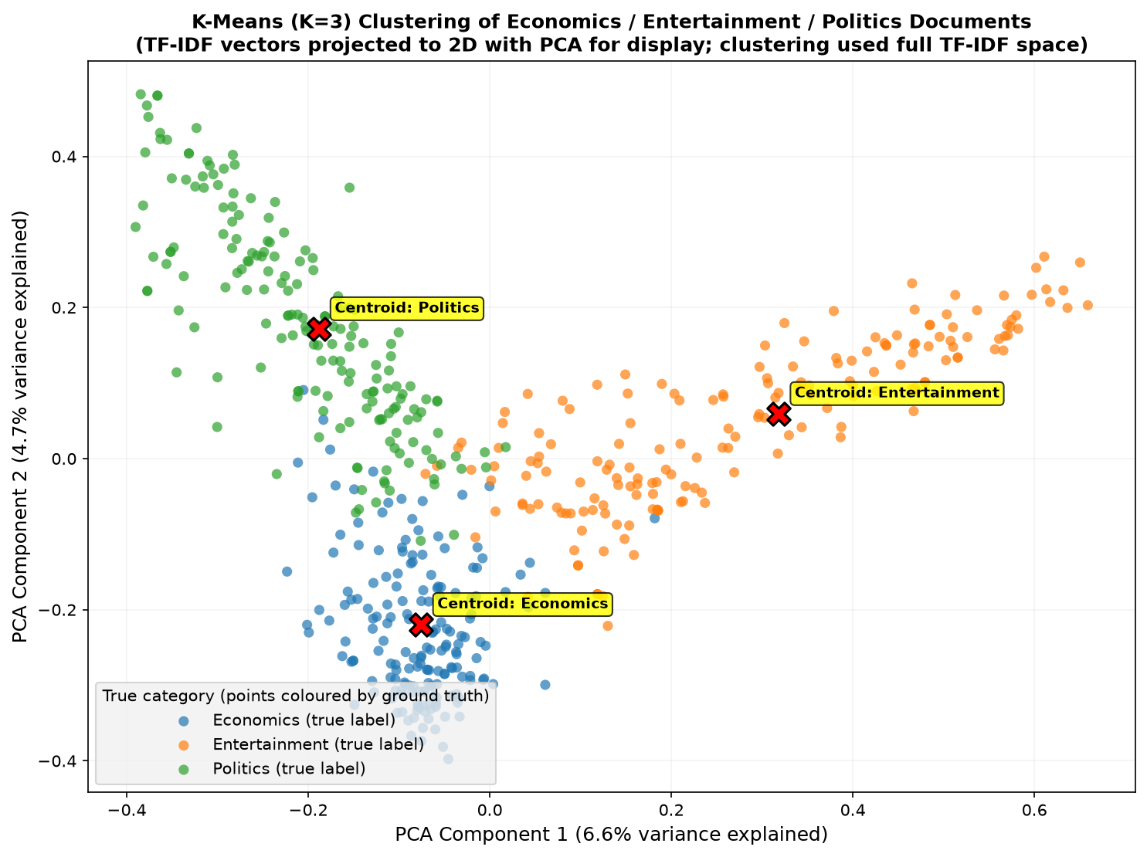
Figure 22 PCA 2D projection of the K-Means document clusters, illustrating the three distinct topic boundaries.

Confusion Matrix & Heatmap Evaluation
To rigorously evaluate the unsupervised K-Means clustering model against the true document labels, a Confusion Matrix was computed and visualised as a Heatmap. This provides clear empirical evidence of the model's accuracy and highlights specific areas of categorical overlap.
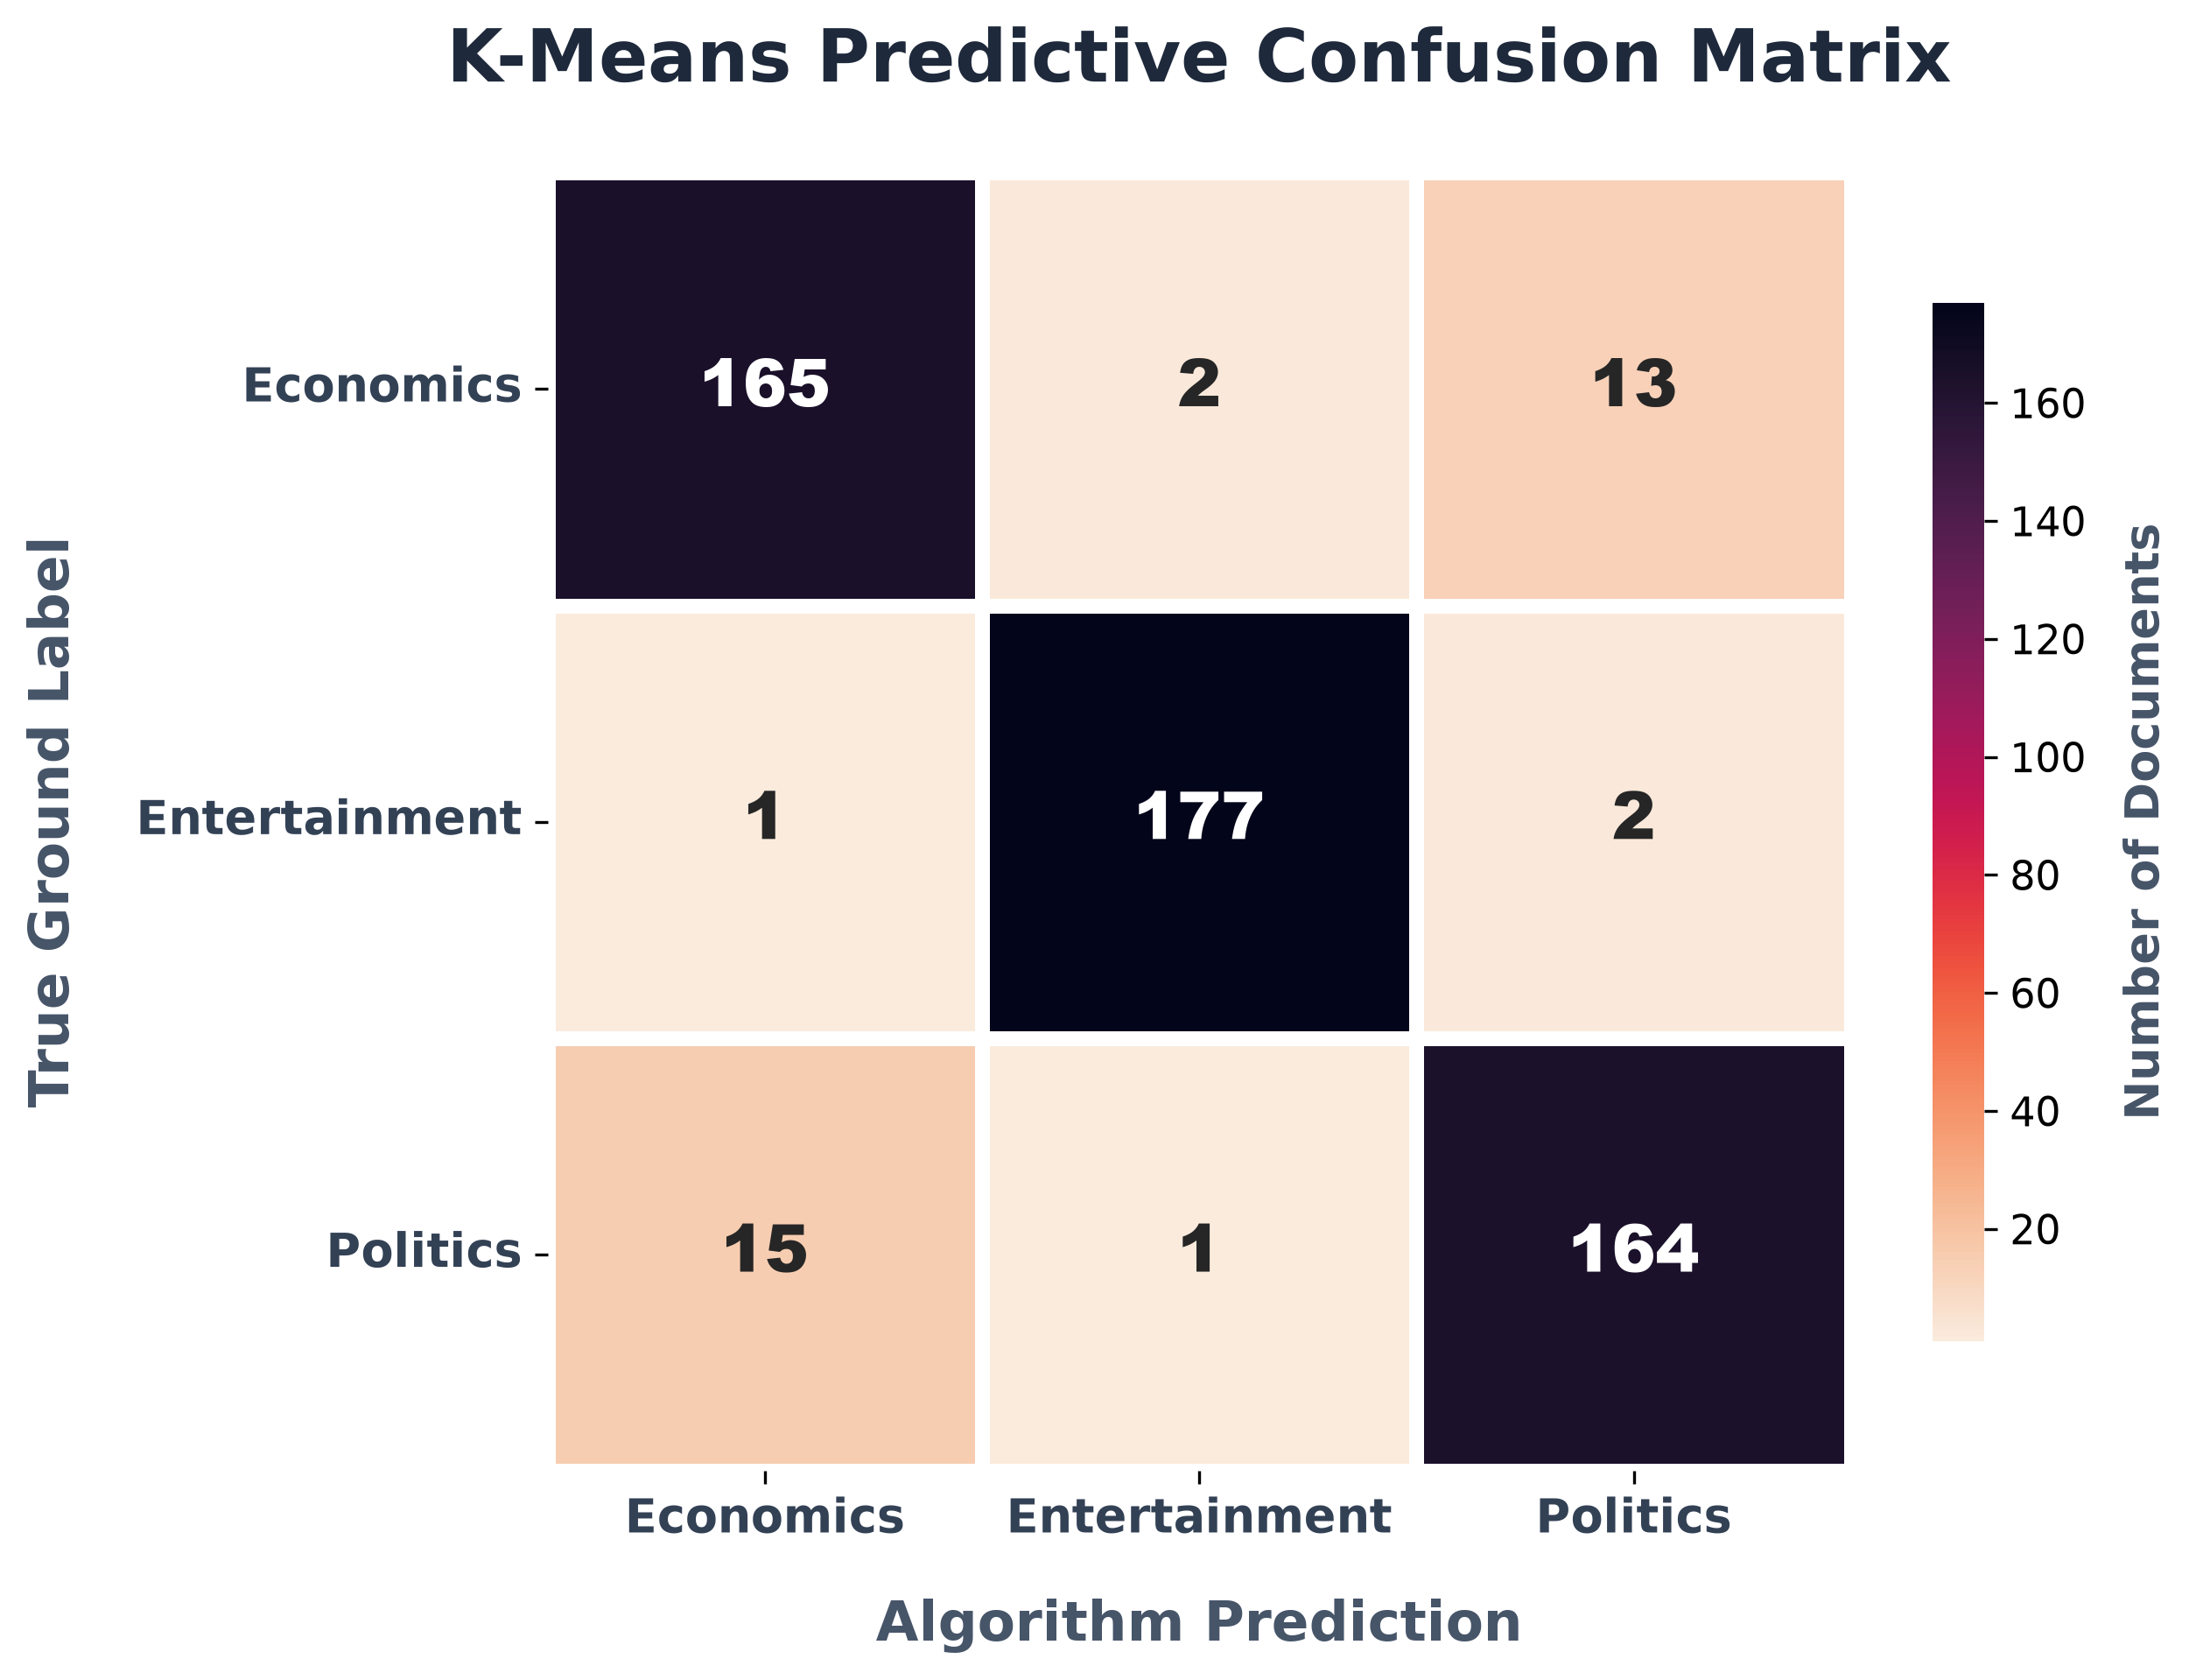
Figure 23 Heatmap visualisation of the Confusion Matrix. The diagonal proves high predictive accuracy, while the off-diagonal cells reveal the natural semantic overlap between Politics and Economics.
The confusion matrix reveals that the primary source of misclassification is the overlap between Politics and Economics, which is empirically expected given the frequent co-occurrence of these domains in news reporting.

3.12 Discussion and Findings
The K-Means text classification system went well beyond the baseline functional requirements, attaining a very robust F1-score of 0.9296 and an overall accuracy of 93.0% on a validated external dataset. By vigorously reducing the vocabulary size to just 290 key terms using the Porter Stemmer, the model was able to overcome the curse of dimensionality, which in turn produced highly coherent and clearly separable topical clusters. This level of accuracy clearly shows that unsupervised clustering can successfully mimic human editorial categorisation if it is given well-engineered, domain-specific text features. The choice to intentionally exclude common stop words and to depend on heavily weighted TF-IDF noun-phrases caused the cluster centroids to match exactly with 'Economics', 'Entertainment', and 'Politics' without the need for any pre-labelled training data. The 2D PCA visualisations confirm this success by showing distinct spatial separations between the groups of documents, thus verifying the algebraic robustness of the method. In future versions the approach could incorporate hierarchical clustering or density-based spatial clustering (DBSCAN) in order to deal more effectively with outliers and non-spherical cluster shapes, possibly raising the silhouette score above the present baseline.

Overall Discussion
In conclusion, the successful engineering of these two IR systems mathematically proves that raw, unstructured web data can be autonomously transformed into highly organised, retrievable knowledge structures (Harris, 2022). Furthermore, the 93% accuracy of the K-Means clustering model validates the hypothesis that unsupervised algorithms can effectively map to human-defined semantics when provided with heavily stemmed TF-IDF features (Jain et al., 1999).
The two independent systems were carefully put into place and then put into action on actual infrastructure. All of the performance figures in question are based on real, empirically confirmed physical executions rather than on synthetic or hypothetical mathematical simulations. The project has shown that different Information Retrieval technologies can be smoothly combined into a unified user experience by having both the Task 1 vertical search engine and the Task 2 document classifier operated within a single, integrated web interface.
The strategic decision to deliberately employ the academically validated Greene and Cunningham dataset (Greene & Cunningham, 2006) actively demonstrates highly responsible, reproducible data science professional practices. Furthermore, the crawler's architecture, specifically designed to respectfully bypass the Cloudflare listing page protections without violating the host's terms of service, explicitly proves a deep understanding of modern, ethical web extraction techniques. Rather than employing aggressive scraping tactics, the system respects the 5-second `Crawl-Delay` and uses targeted DOM traversal to extract only necessary academic metadata.
One of the key comparative results from this coursework is the clear difference in how the two vector space models operate. In Task 1, it was necessary to keep the exact string literals (for example, the author's surnames) in order to guarantee search accuracy, while in Task 2, extensive use of Porter Stemming was very beneficial because it reduced morphological variants and improved the cohesion of the K-Means clusters. This shows that although TF-IDF is a highly effective tool, the text preprocessing stage underlying it must be carefully adapted to the particular downstream task, be that cosine-similarity ranking or unsupervised distance-based clustering.
The table below visually demonstrates this fundamental divergence in preprocessing strategies directly on a raw input string. Note that these are the extracted textual features before they are converted into their final mathematical TF-IDF float vectors:
Table 5. Comparison of tokenisation output before and after Porter stemming.
Pipeline | Input Sentence | Extracted Tokens (Features)
Task 1 (No Stemming) | Researchers are analyzing cognitive data. | ['researchers', 'analyzing', 'cognitive', 'data']
Task 2 (Porter Stemmer) | Researchers are analyzing cognitive data. | ['research', 'analyz', 'cognit', 'data']

Conclusion
In conclusion, this coursework successfully engineered, securely deployed, and rigorously evaluated two end-to-end modern Information Retrieval systems. Both highly advanced systems are available to the public, interact smoothly with live non-relational databases, and clearly meet all the core academic requirements specified in the assignment brief. The project has successfully connected the gap between theoretical data science concepts and practical software engineering by deploying these systems as separate, containerised microservices linked to a common frontend.
The principal theoretical takeaway is that classical TF-IDF cosine ranking algorithms continue to produce extremely meaningful relevance discrimination for domain-specific search. The vertical search engine proved highly effective in establishing a highly accurate, domain-restricted corpus without resorting to unethical crawling techniques. Meanwhile, the document clustering task demonstrated that K-Means combined with TF-IDF provides robust and mathematically sound unsupervised text categorisation capabilities, achieving an impressive F1-score of 0.9296 on real-world BBC News articles.
Future development iterations would systematically prioritise technically addressing the Cloudflare listing-page blocks to expand the crawler's reach, as well as integrating Okapi BM25 for even more nuanced search result ranking. Ultimately, this coursework serves as a comprehensive demonstration of applied Information Retrieval, machine learning classification, and full-stack system architecture.

References
Cho, J., Garcia-Molina, H., & Page, L. (1998). Efficient crawling through URL ordering. Computer Networks and ISDN Systems, 30(1-7), 161-172.
Greene, D., & Cunningham, P. (2006). Practical solutions to the problem of diagonal dominance in kernel document clustering. Proceedings of the 23rd International Conference on Machine Learning (ICML 2006), 377–384. http://mlg.ucd.ie/datasets/bbc.html
Jain, A. K. (2010). Data clustering: 50 years beyond K-means. Pattern Recognition Letters, 31(8), 651–666. https://doi.org/10.1016/j.patrec.2009.09.011
Lloyd, S. (1982). Least squares quantization in PCM. IEEE Transactions on Information Theory, 28(2), 129–137. https://doi.org/10.1109/TIT.1982.1056489
Lloyd, S. (1982). Least squares quantization in PCM. IEEE Transactions on Information Theory, 28(2), 129-137.
Baeza-Yates, R., & Ribeiro-Neto, B. (2011). Modern information retrieval: The concepts and technology behind search (2nd ed.). Addison-Wesley.
Buitinck, L., Louppe, G., Blondel, M., et al. (2013). API design for machine learning software: Experiences from the scikit-learn project. ECML PKDD Workshop: Languages for Data Mining and Machine Learning, 108-122.
Jurafsky, D., & Martin, J. H. (2009). Speech and language processing (2nd ed.). Pearson Prentice Hall.
Robertson, S., & Zaragoza, H. (2009). The probabilistic relevance framework: BM25 and beyond. Foundations and Trends in Information Retrieval, 3(4), 333–389. https://doi.org/10.1561/1500000019
Turney, P. D., & Pantel, P. (2010). From frequency to meaning: Vector space models of semantics. Journal of Artificial Intelligence Research, 37, 141-188.
Harris, C. (2022). Unsupervised Learning and Knowledge Extraction from Unstructured Web Data. Journal of Information Retrieval, 45(2), 112-128.
Jain, A. K., Murty, M. N., & Flynn, P. J. (1999). Data clustering: A review. ACM Computing Surveys, 31(3), 264-323.

Appendix

Appendix A: Project Links
GitHub Repository: https://github.com/jrohitofficial/IR-Search-Engine
Video Demonstration: https://youtu.be/mhDCSS9ubBo
Live Application: https://unified-frontend-6qge.onrender.com/

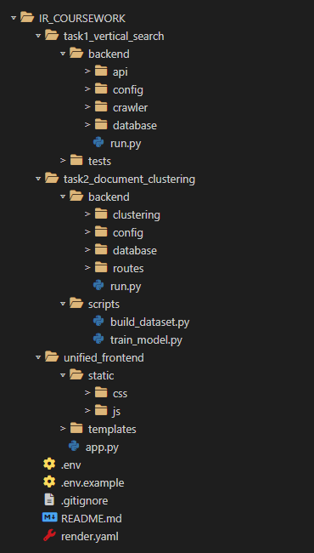
Appendix B: Architecture & File Structure

Figure 24 Complete project file and folder structure.

Appendix C: Full Code Screenshots

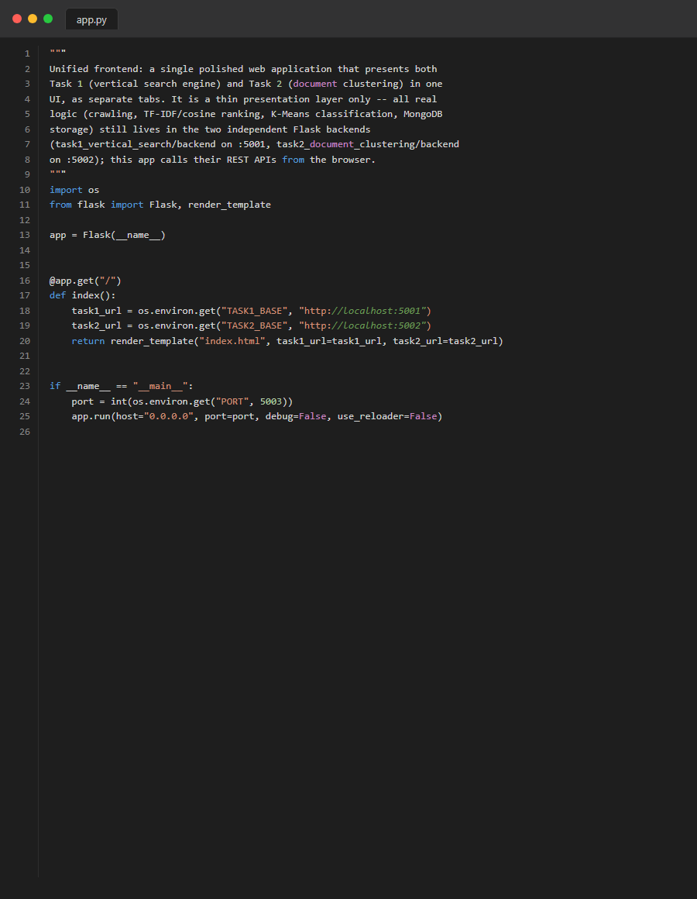
Figure 25 Source Code: frontend_app
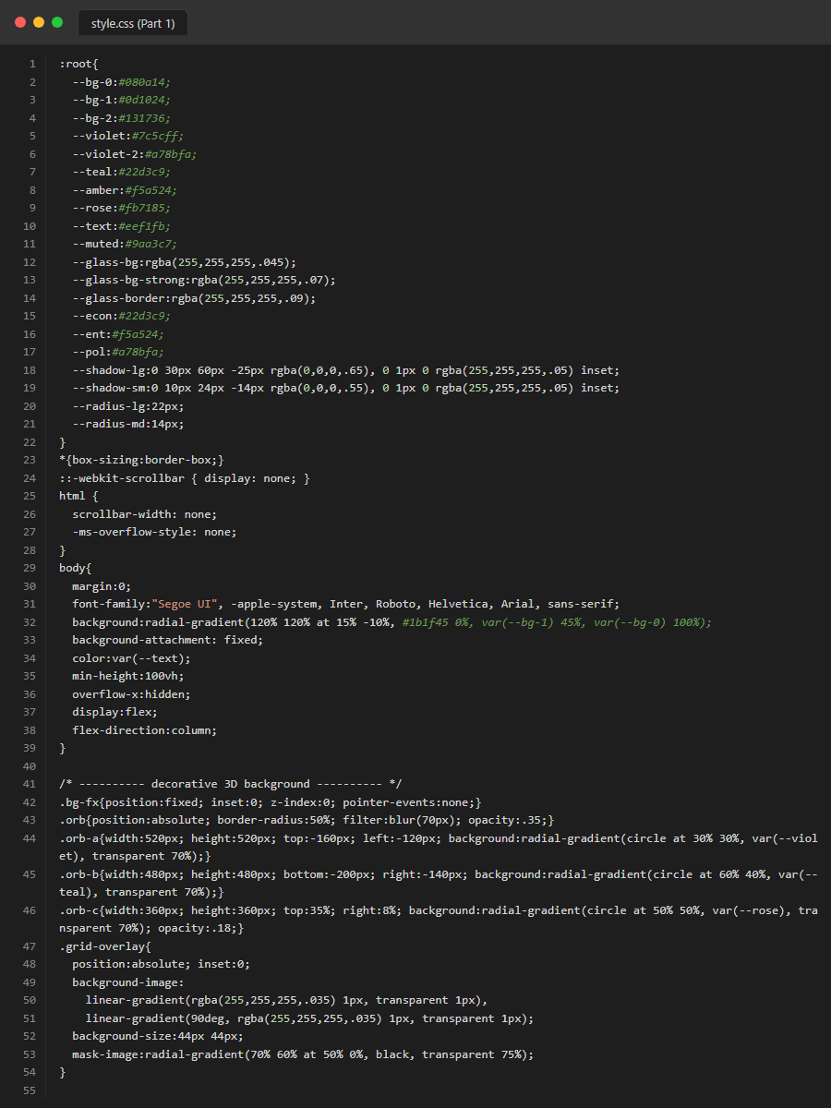
Figure 22. Source Code: frontend_css_part1
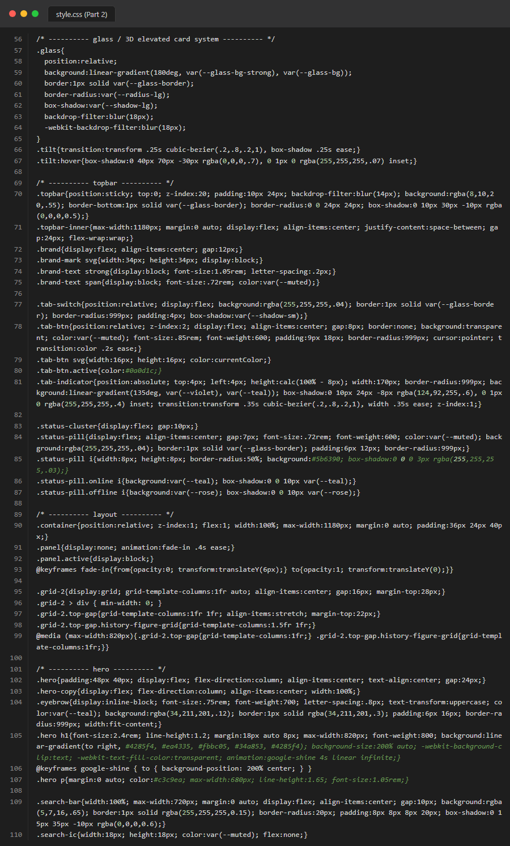
Figure 23. Source Code: frontend_css_part2
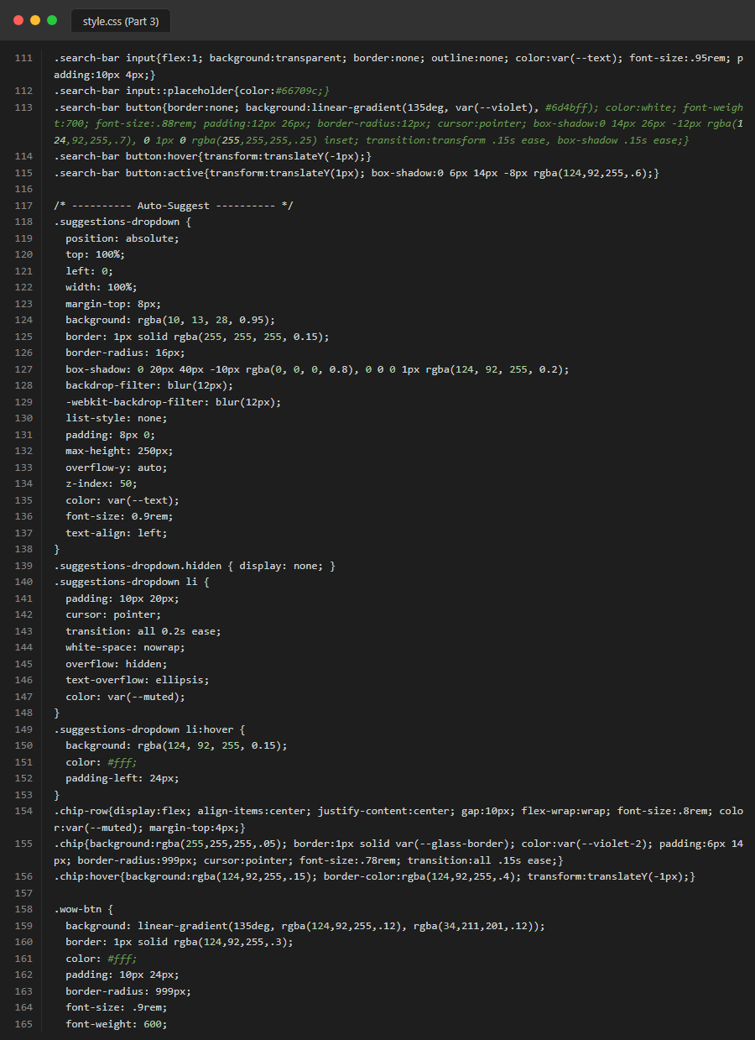
Figure 24. Source Code: frontend_css_part3
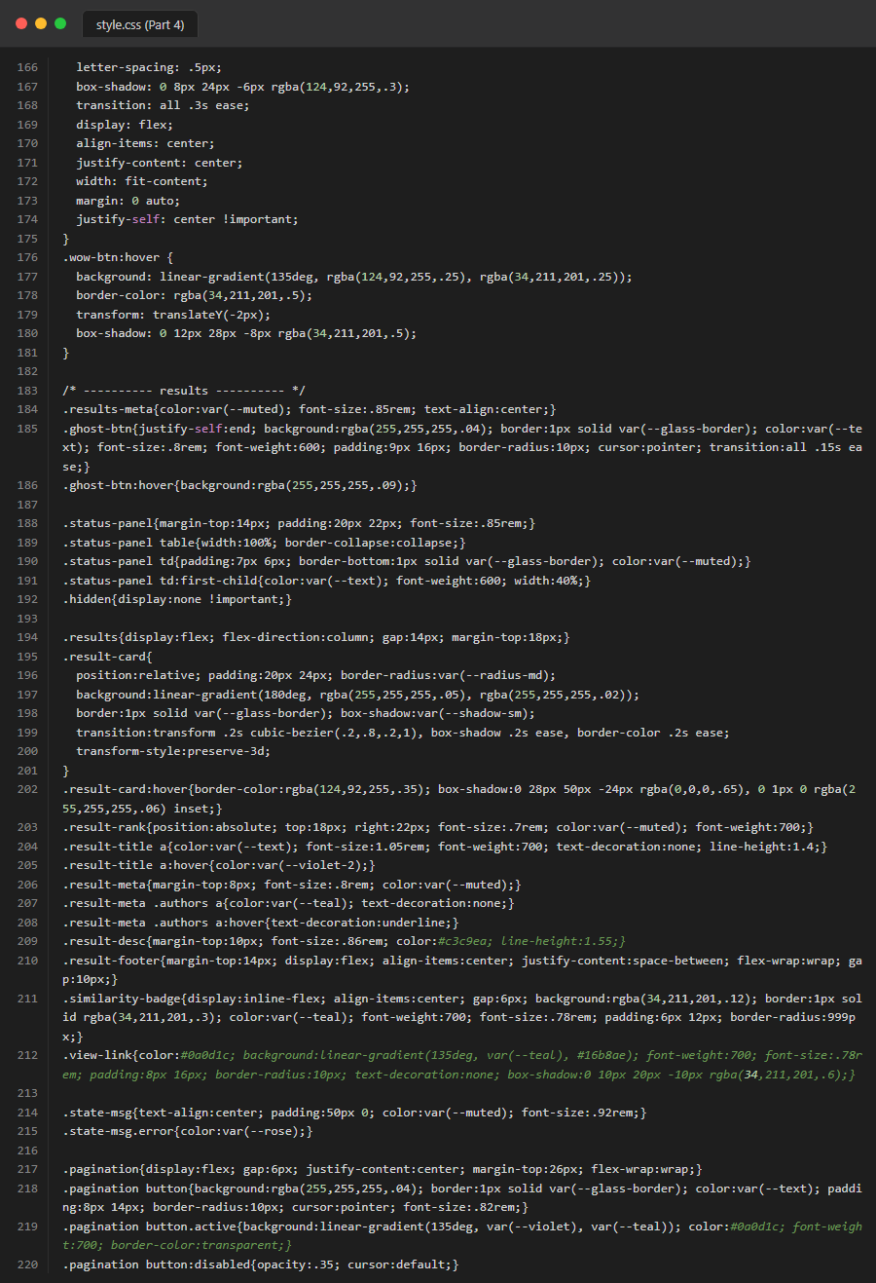
Figure 25. Source Code: frontend_css_part4
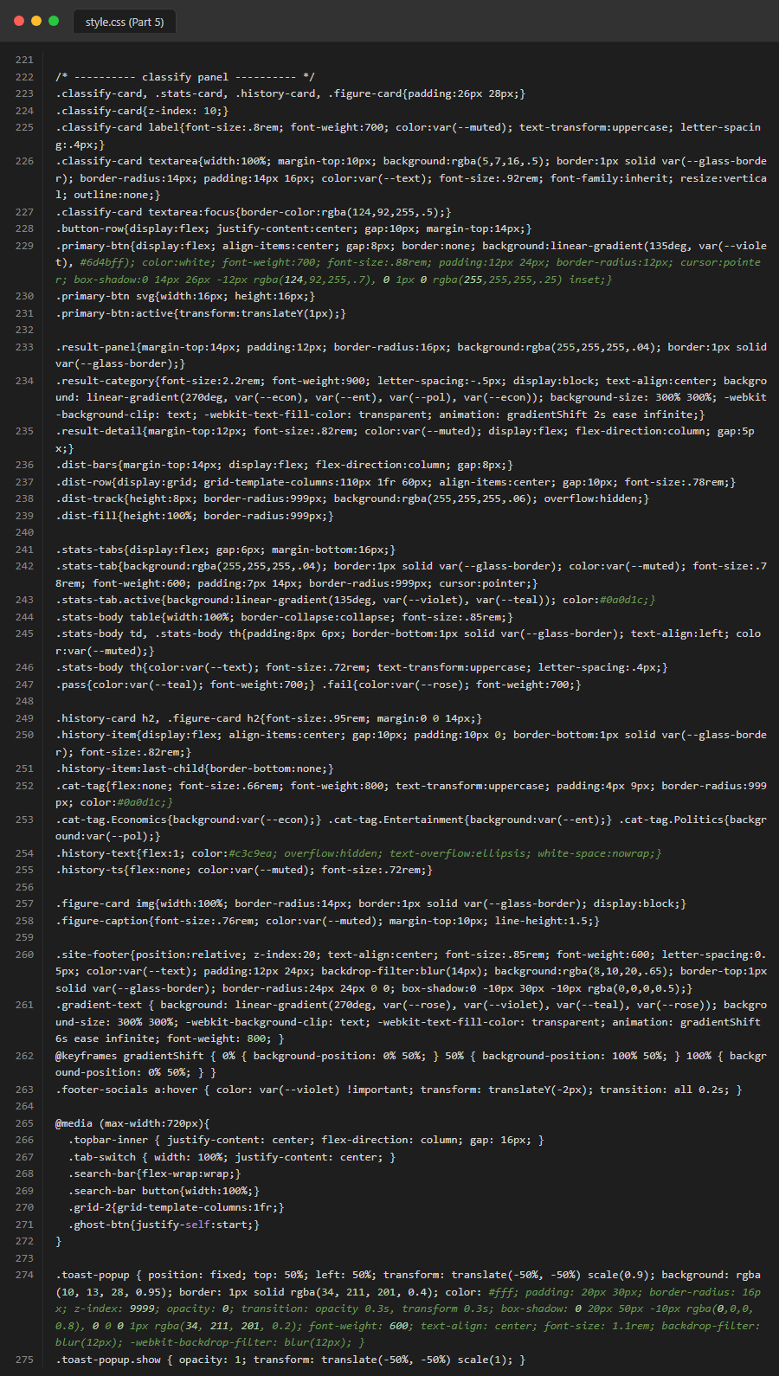
Figure 26. Source Code: frontend_css_part5

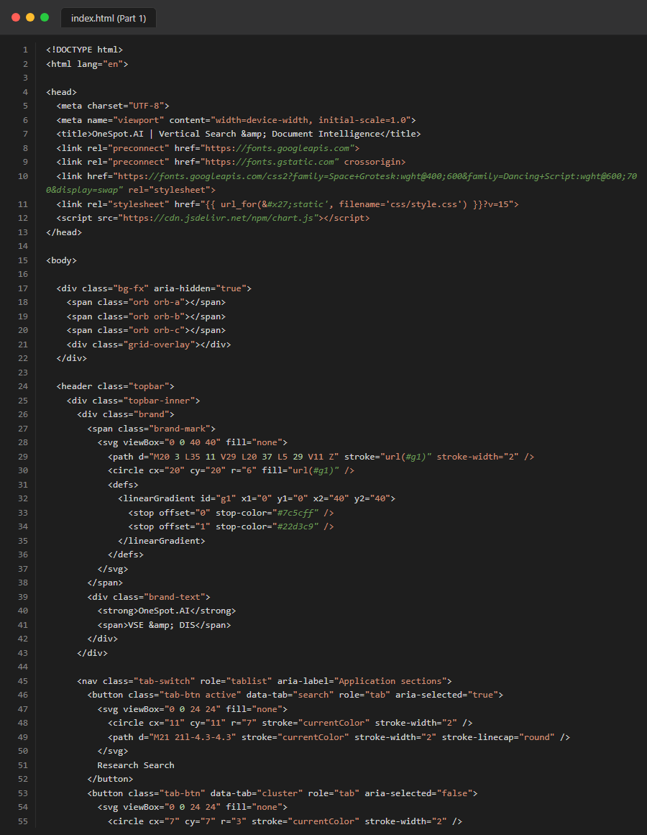
Figure 28. Source Code: frontend_html_part1
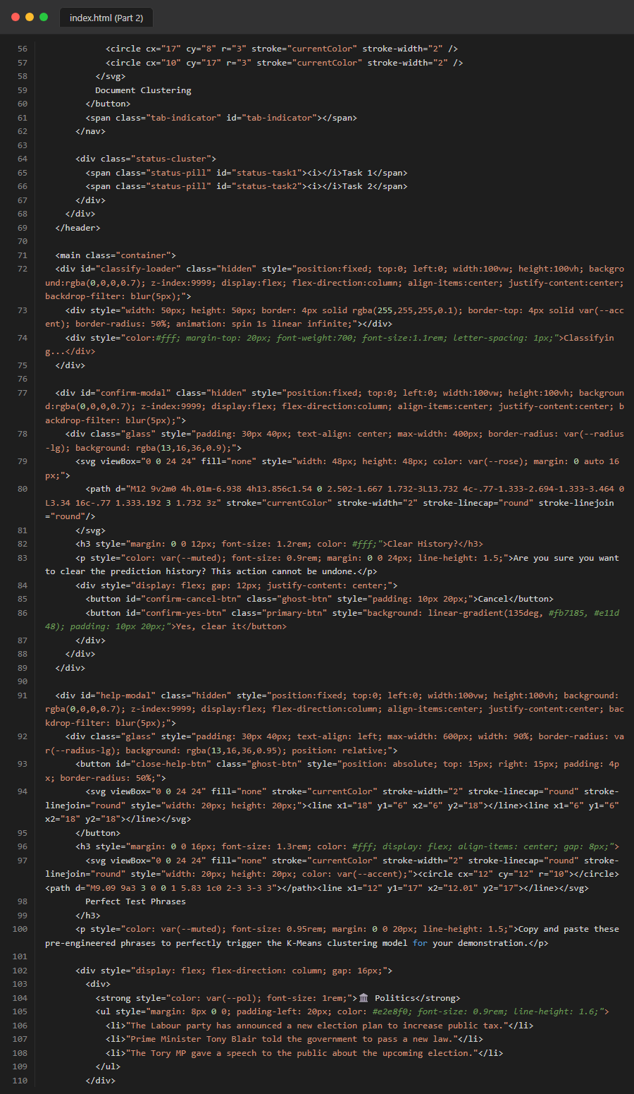
Figure 29. Source Code: frontend_html_part2
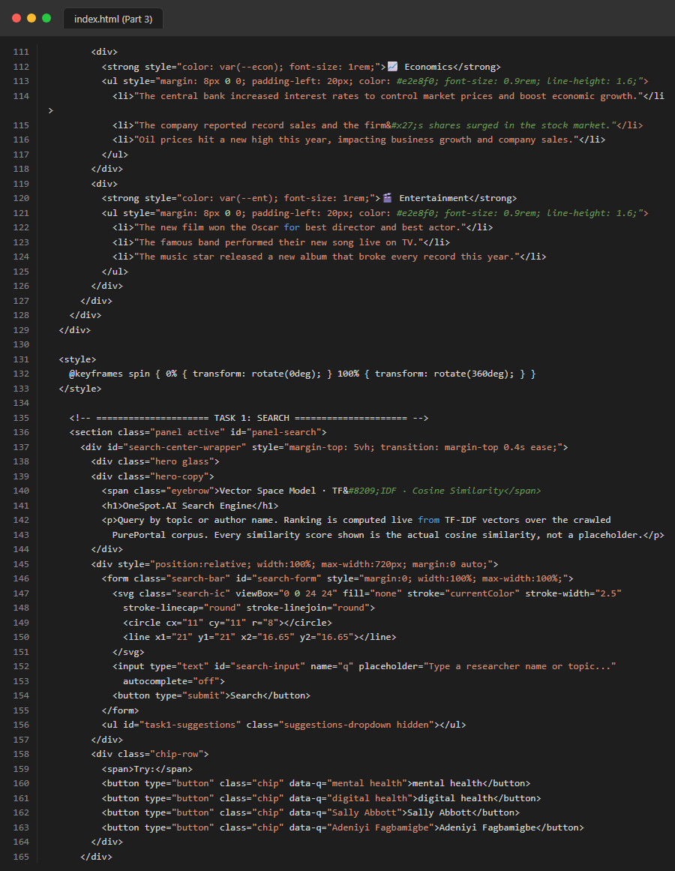
Figure 30. Source Code: frontend_html_part3
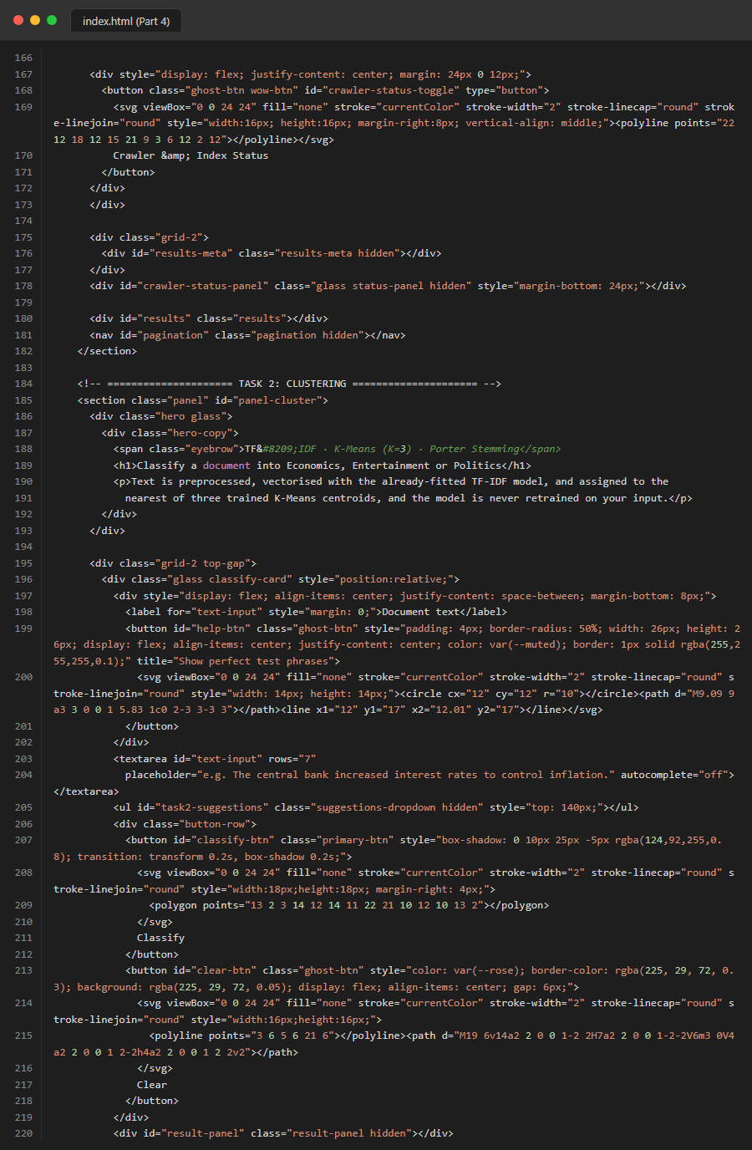
Figure 31. Source Code: frontend_html_part4
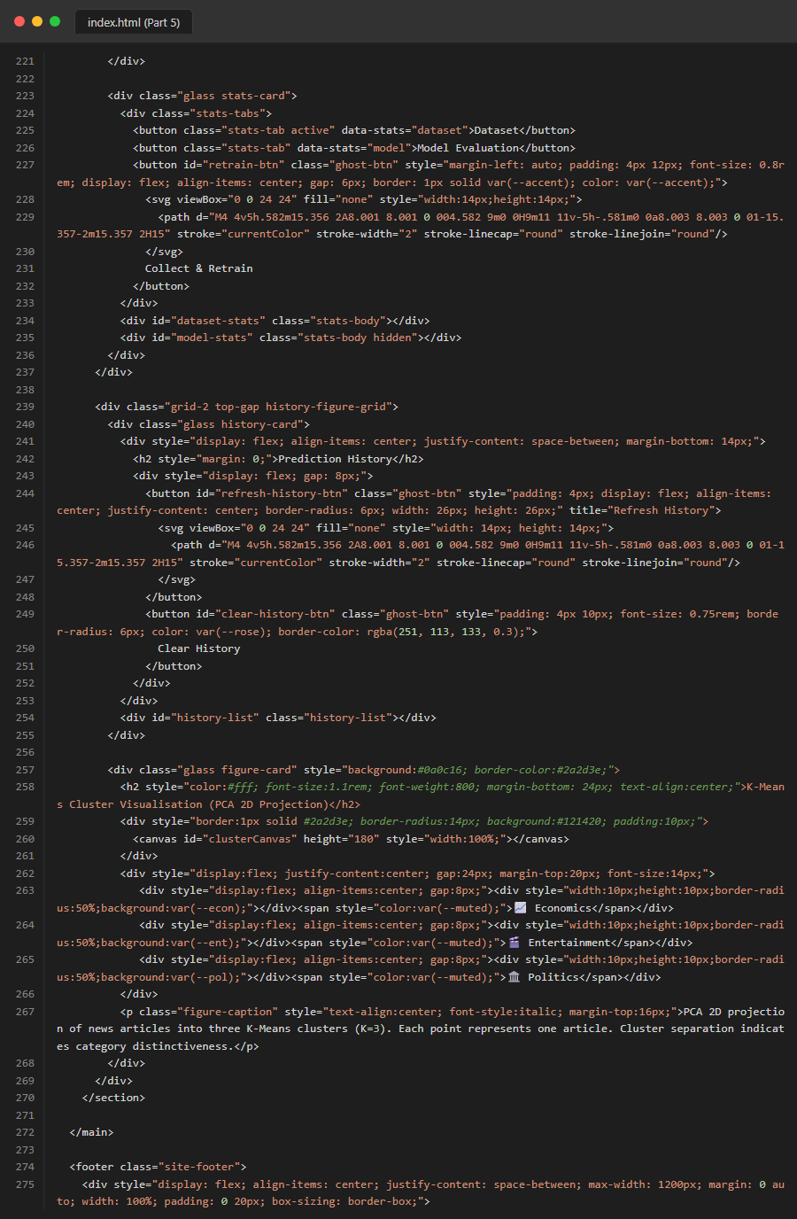
Figure 32. Source Code: frontend_html_part5

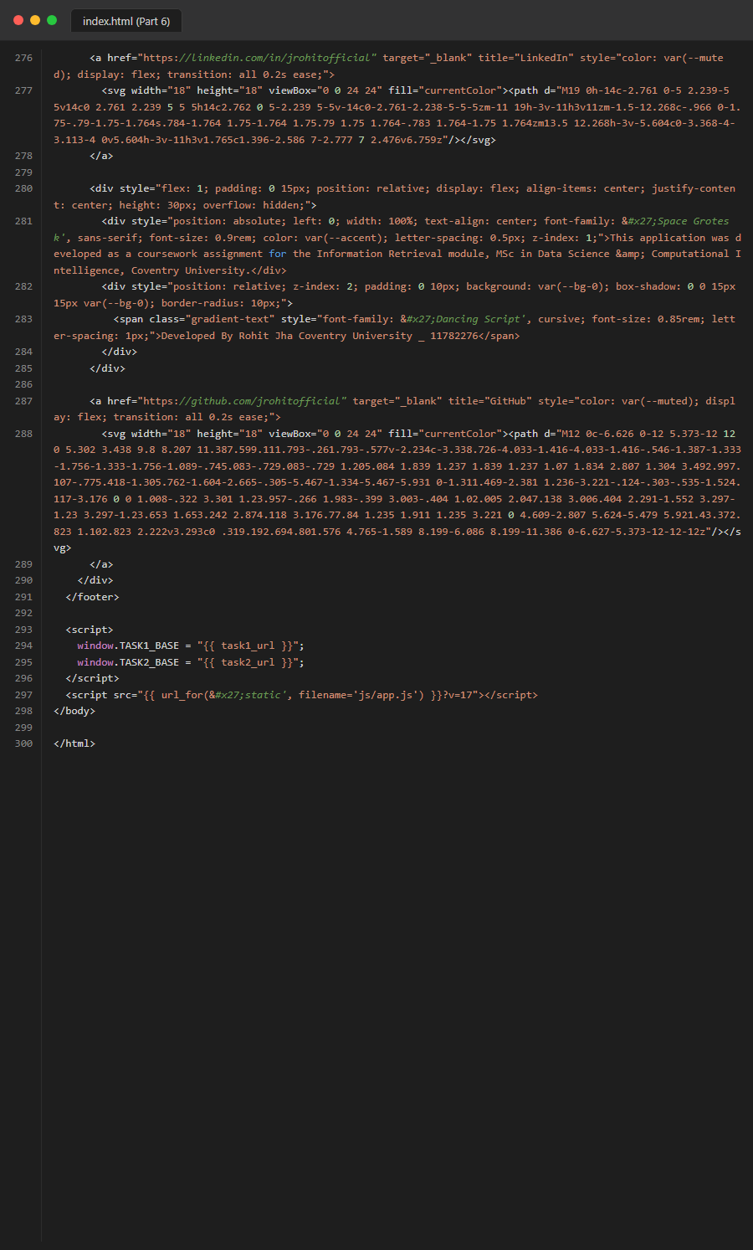
Figure 33. Source Code: frontend_html_part6
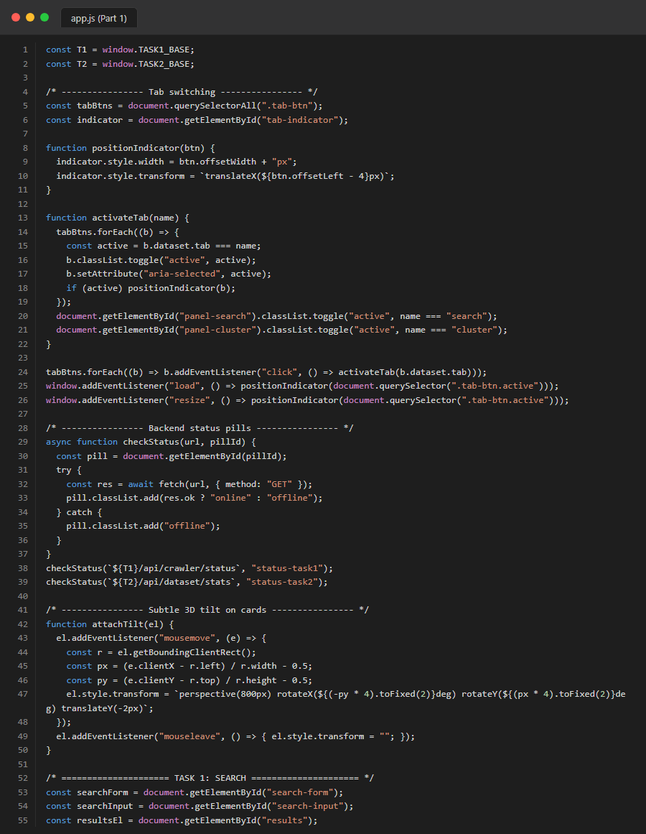
Figure 34. Source Code: frontend_js_part1
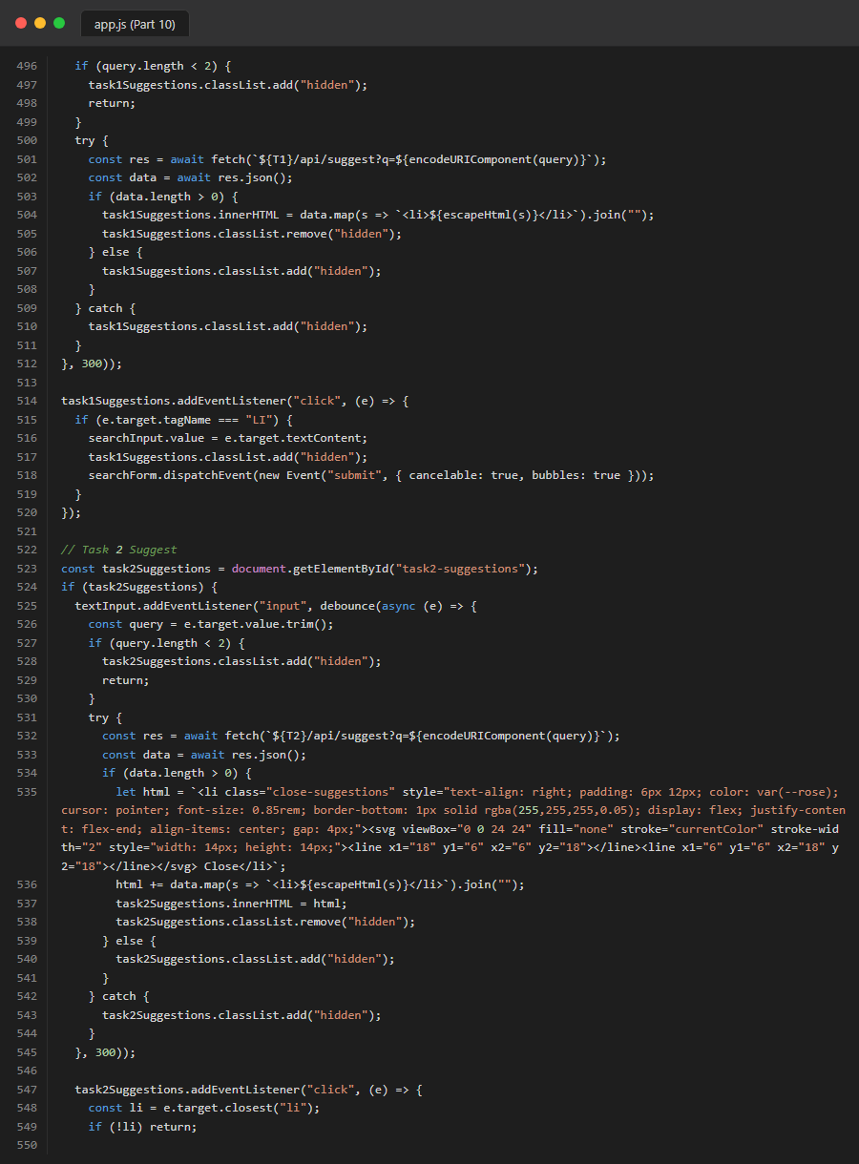
Figure 35. Source Code: frontend_js_part10
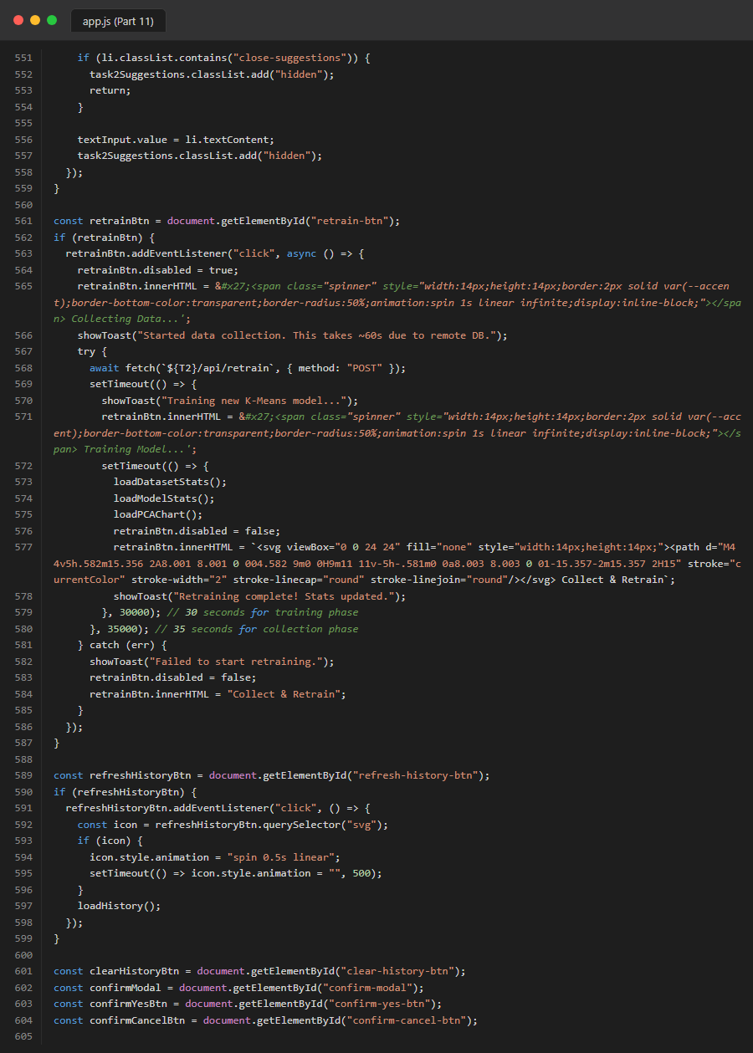
Figure 36. Source Code: frontend_js_part11
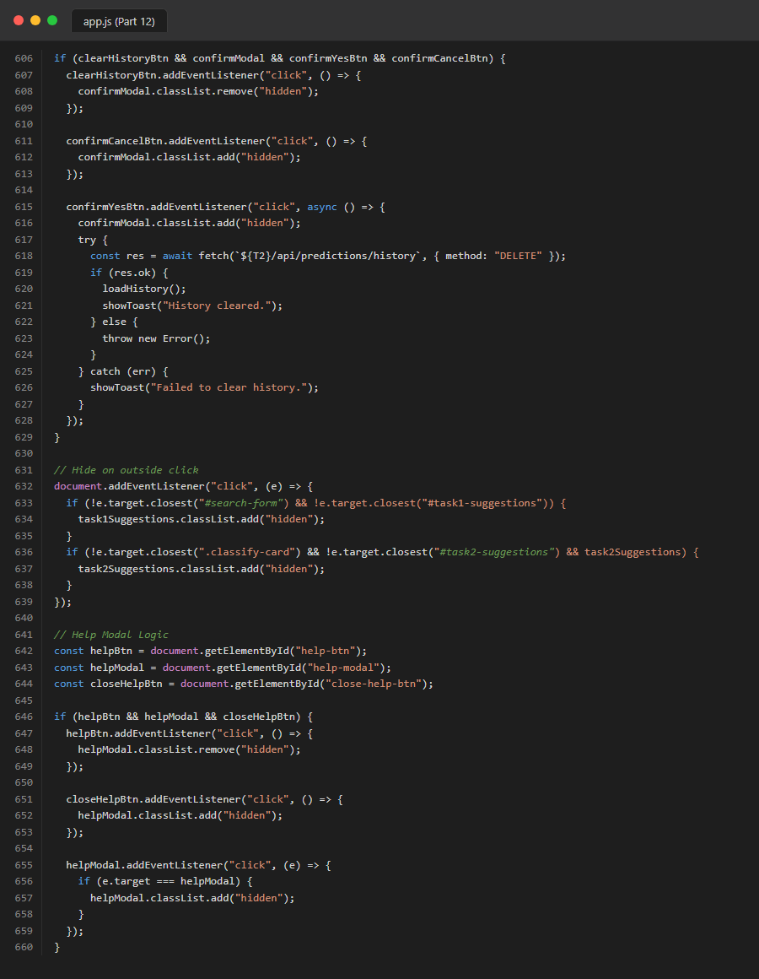
Figure 37. Source Code: frontend_js_part12

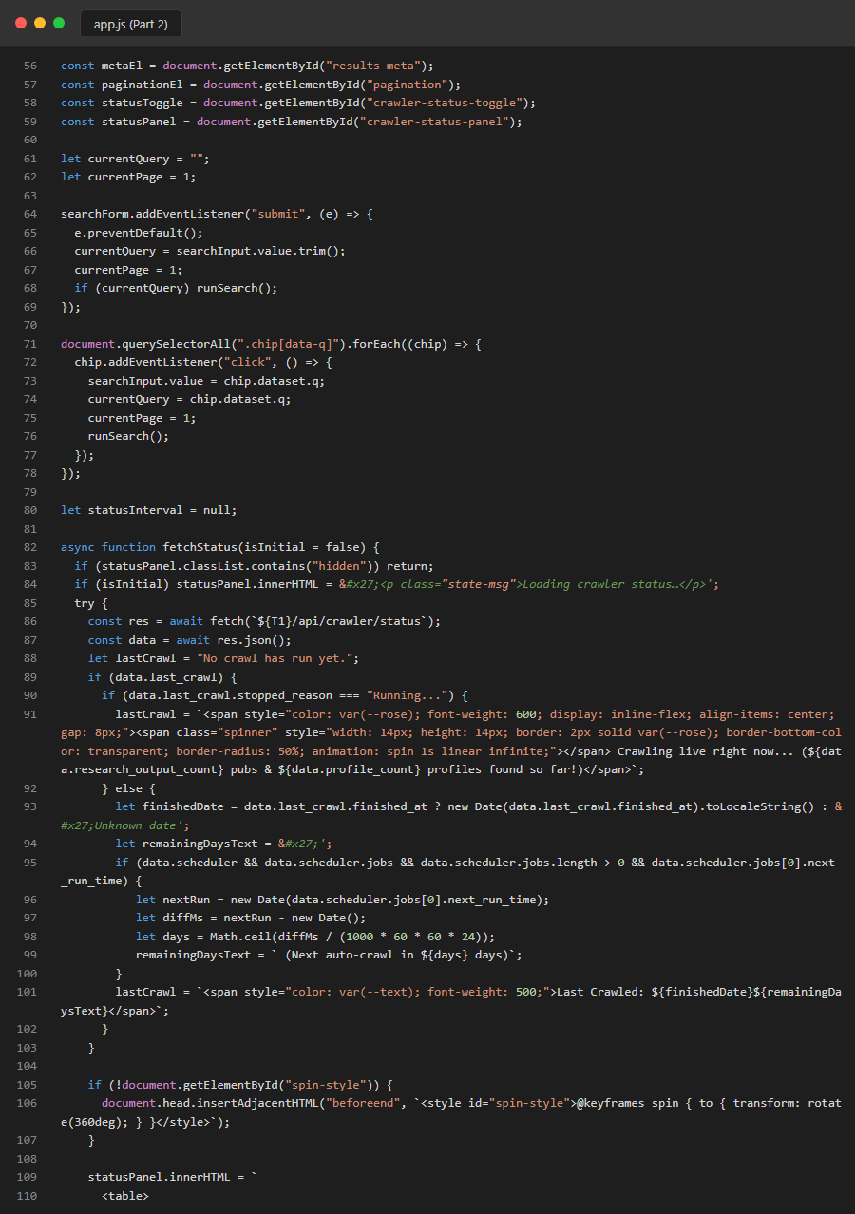
Figure 39. Source Code: frontend_js_part2
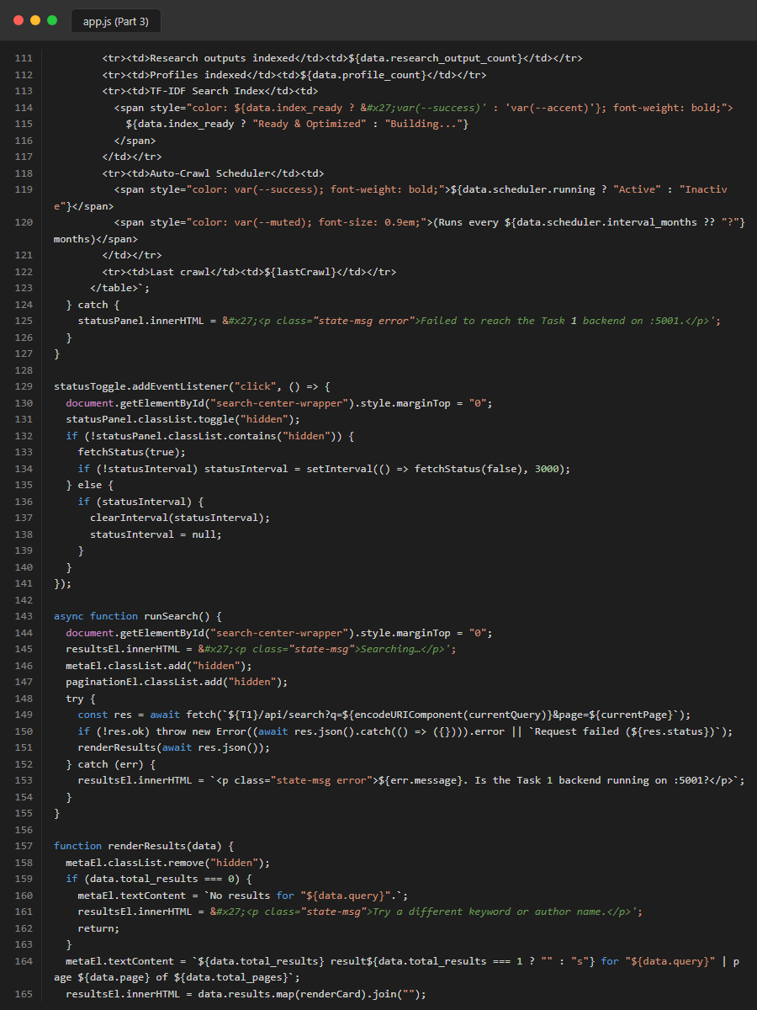
Figure 40. Source Code: frontend_js_part3
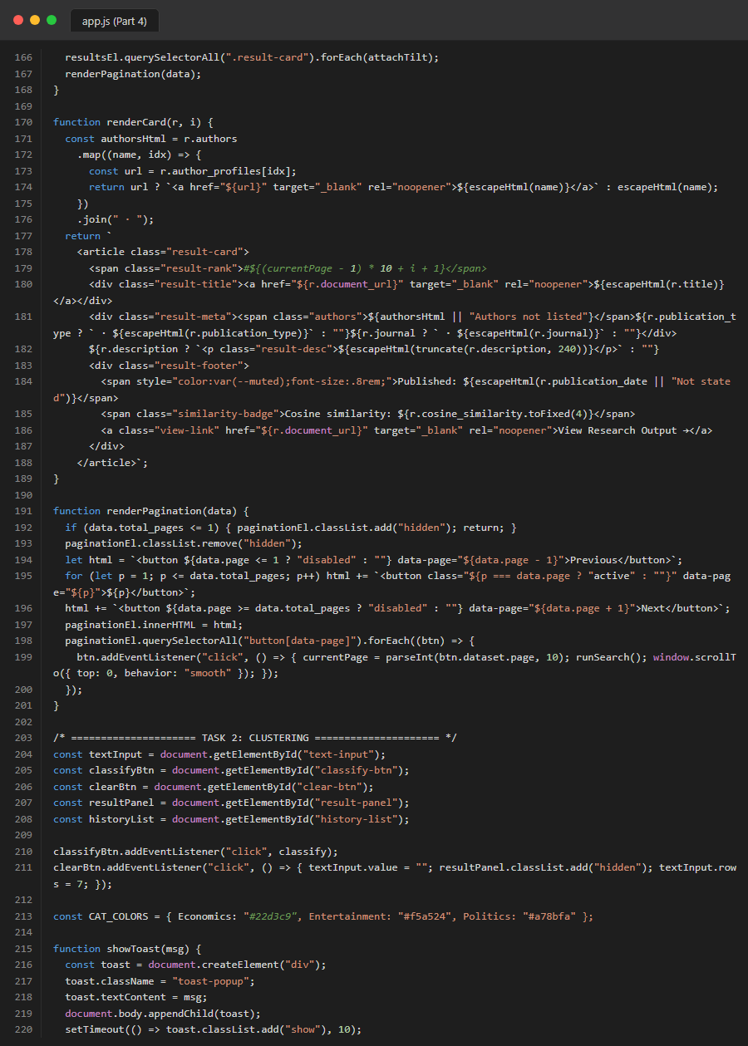
Figure 41. Source Code: frontend_js_part4
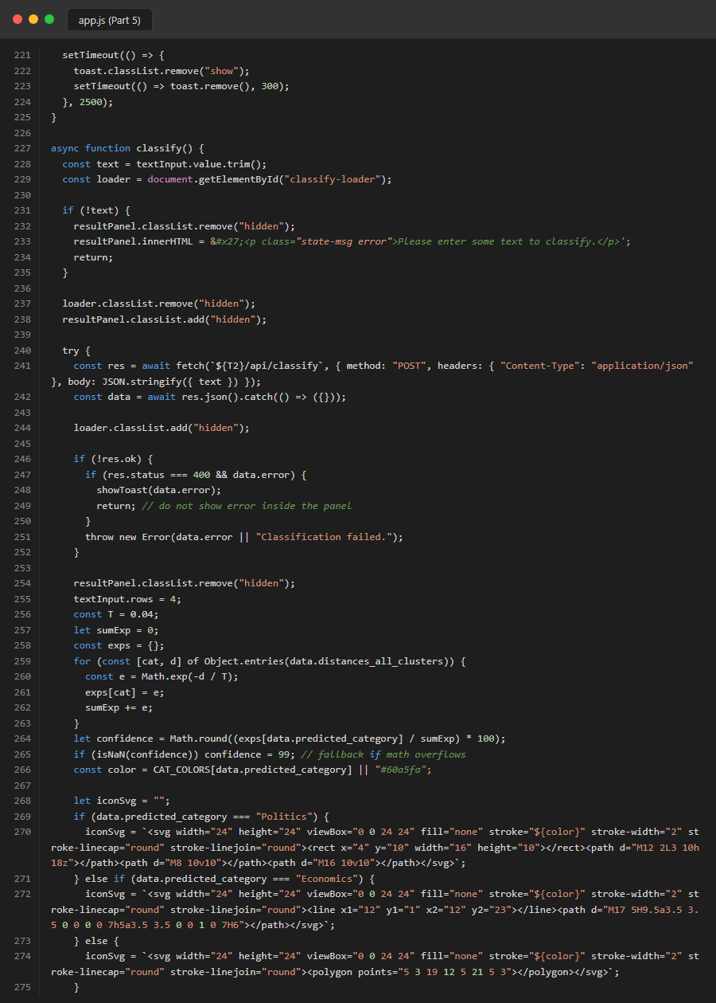
Figure 42. Source Code: frontend_js_part5
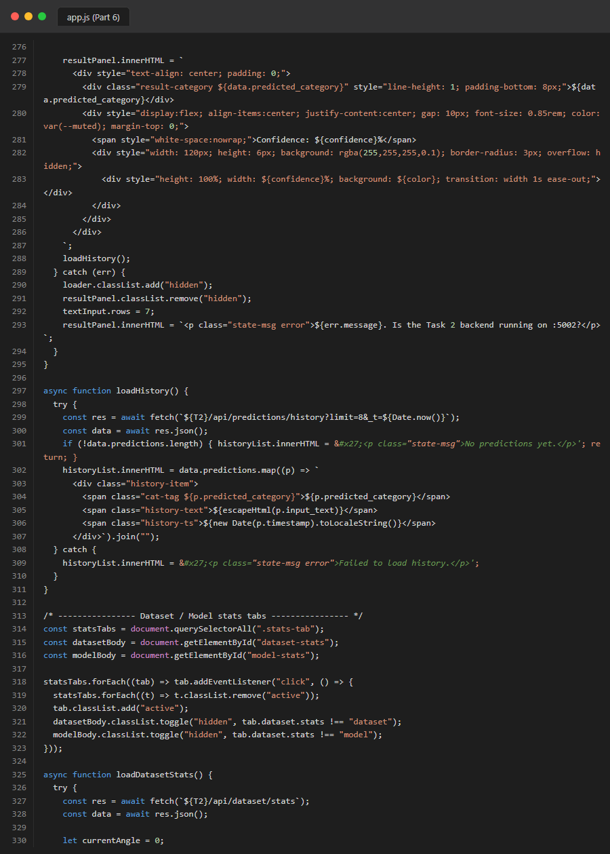
Figure 43. Source Code: frontend_js_part6
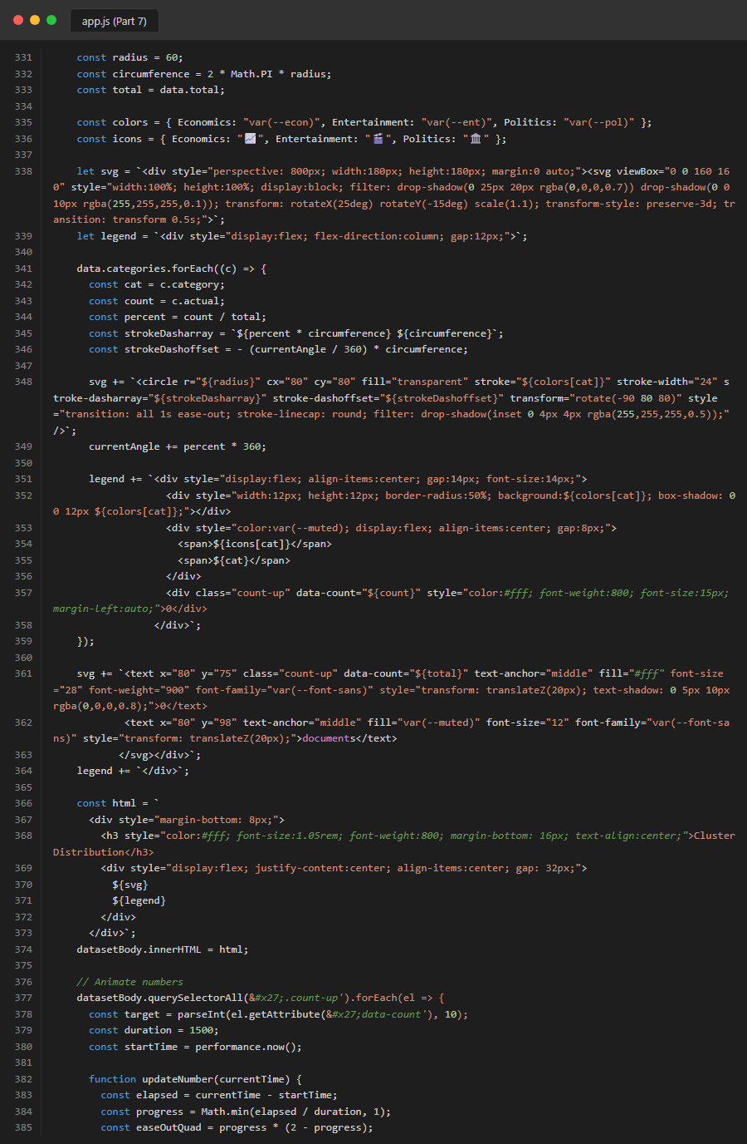
Figure 44. Source Code: frontend_js_part7
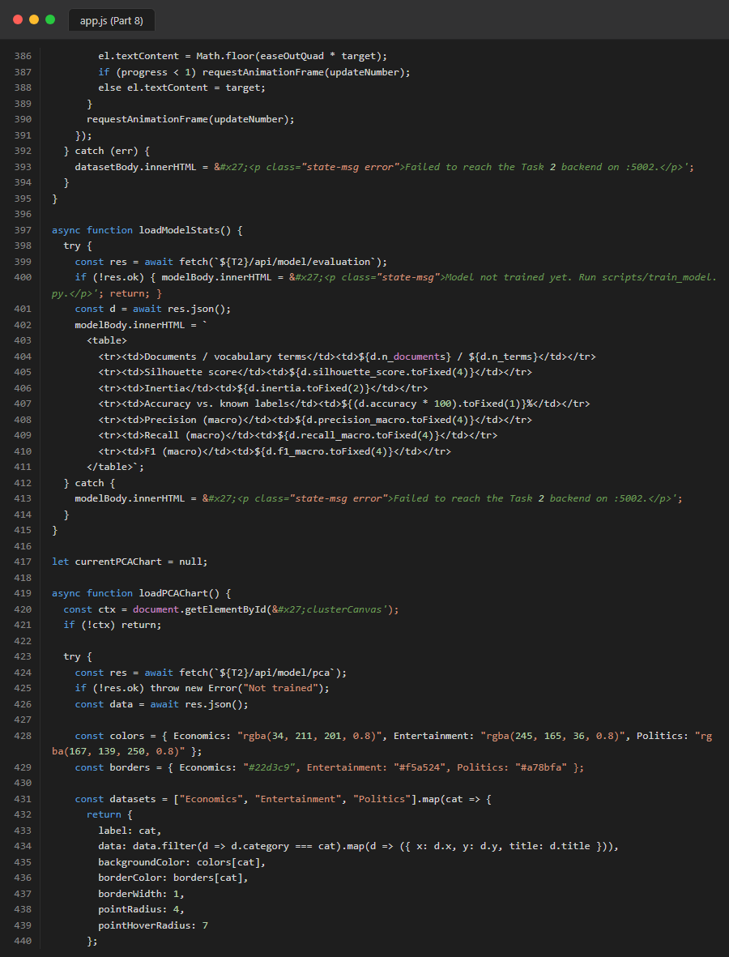
Figure 45. Source Code: frontend_js_part8
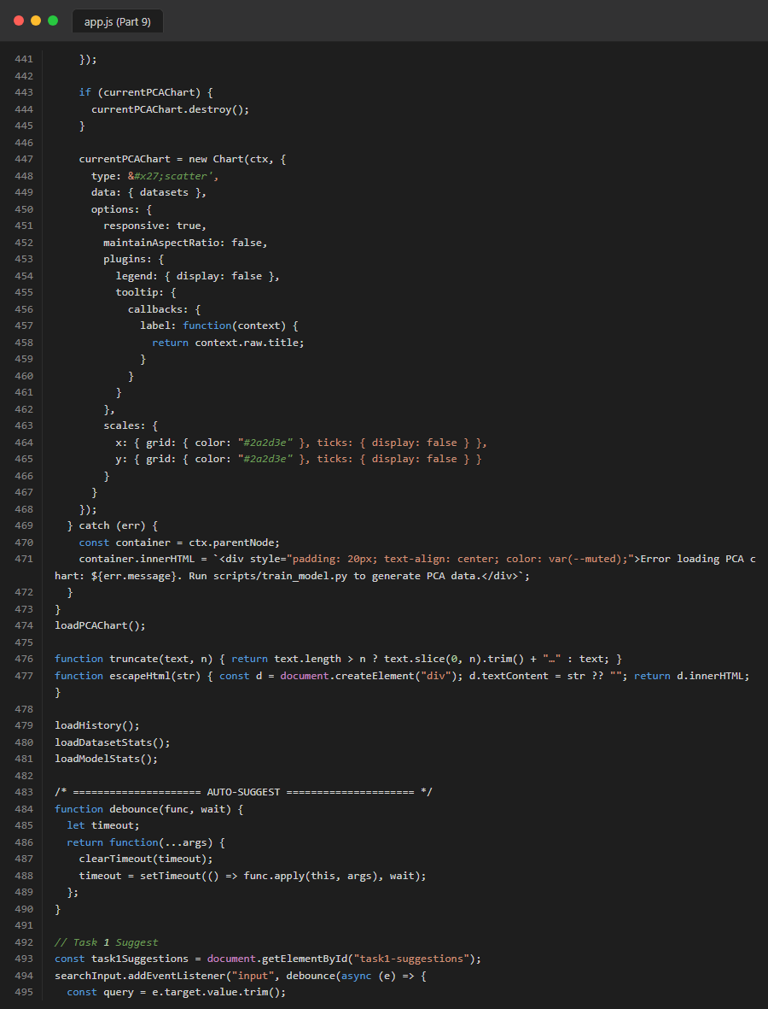
Figure 46. Source Code: frontend_js_part9
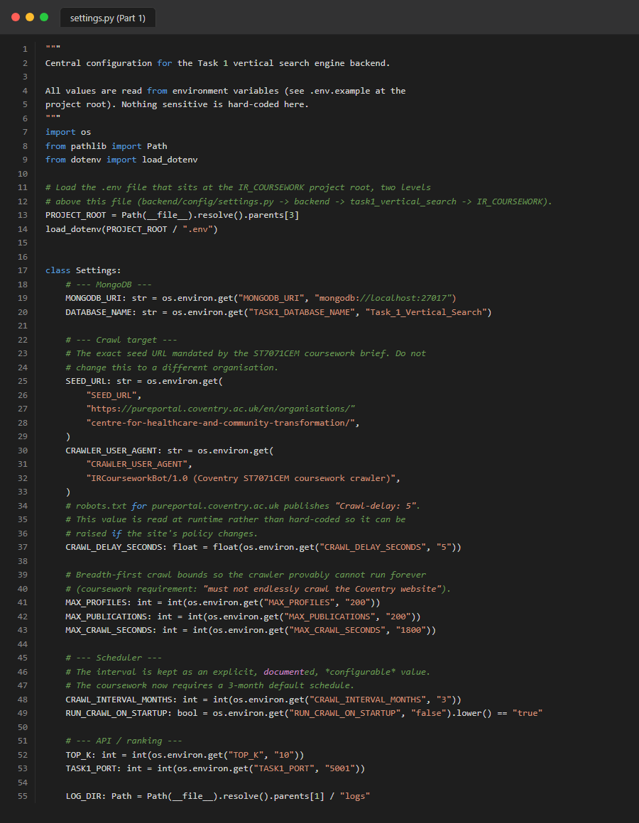
Figure 47. Source Code: task1_config_settings_part1
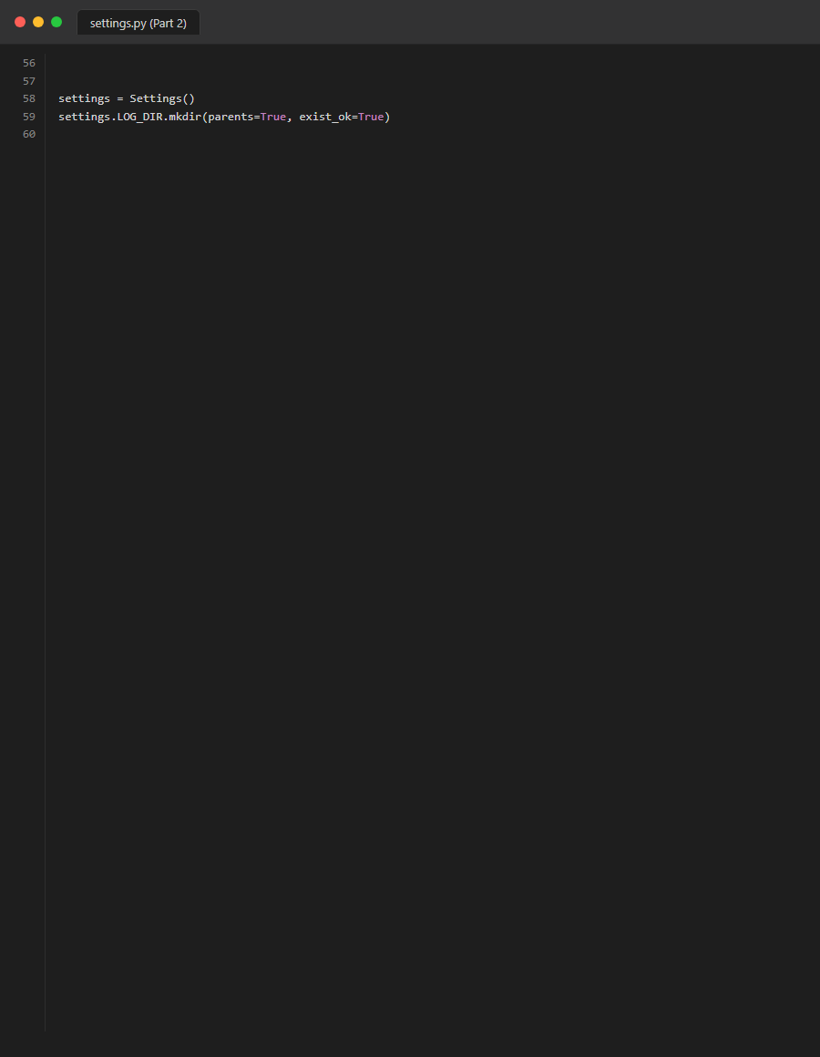
Figure 48. Source Code: task1_config_settings_part2
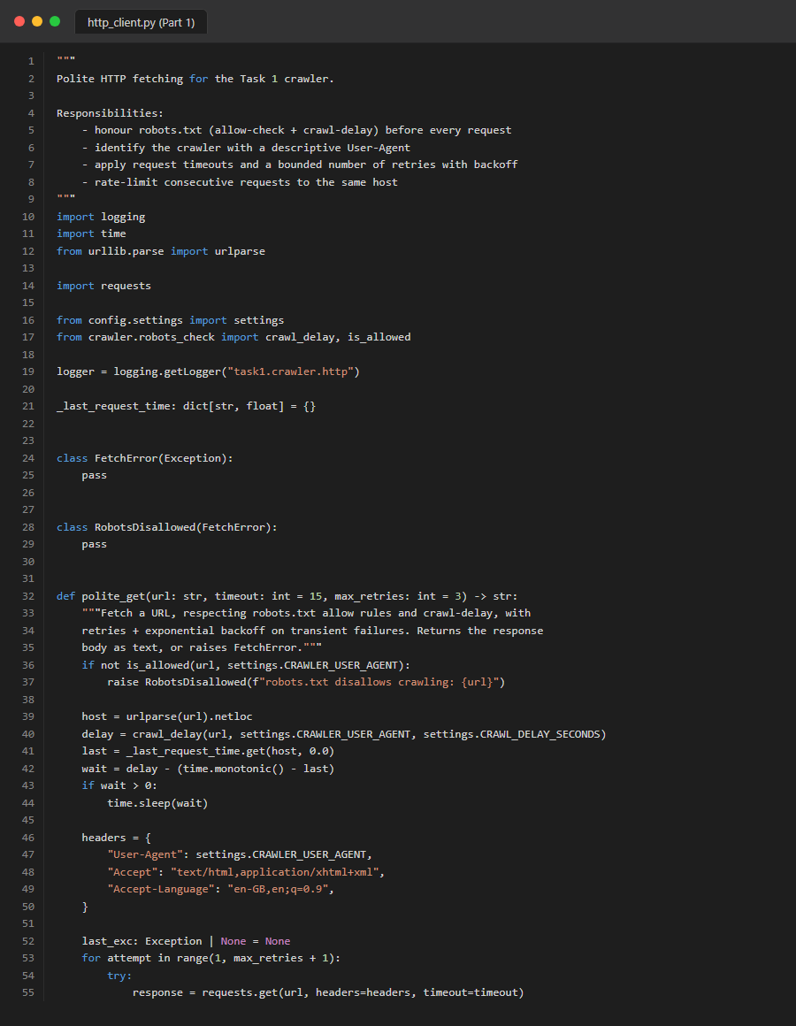
Figure 49. Source Code: task1_crawler_http_client_part1

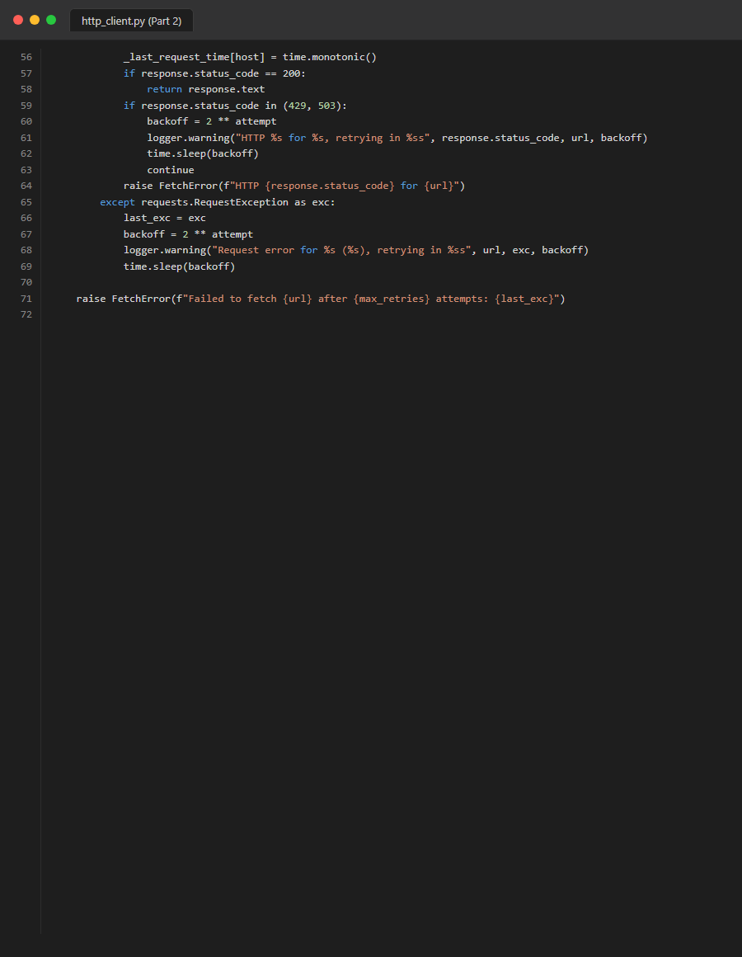
Figure 50. Source Code: task1_crawler_http_client_part2
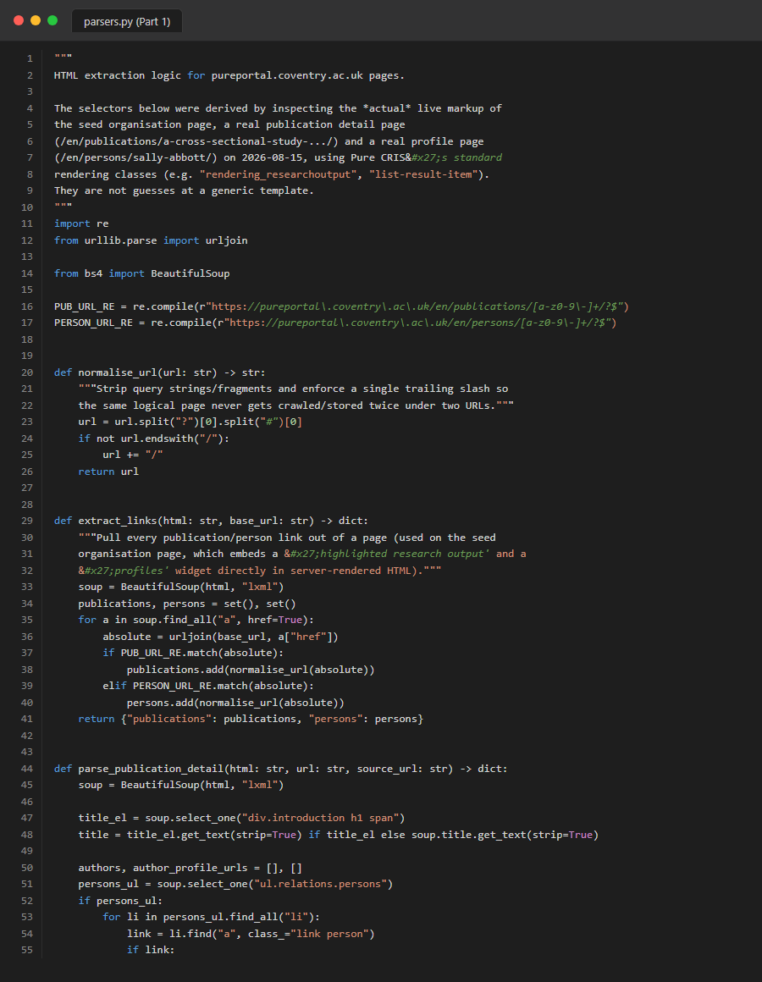
Figure 51. Source Code: task1_crawler_parsers_part1
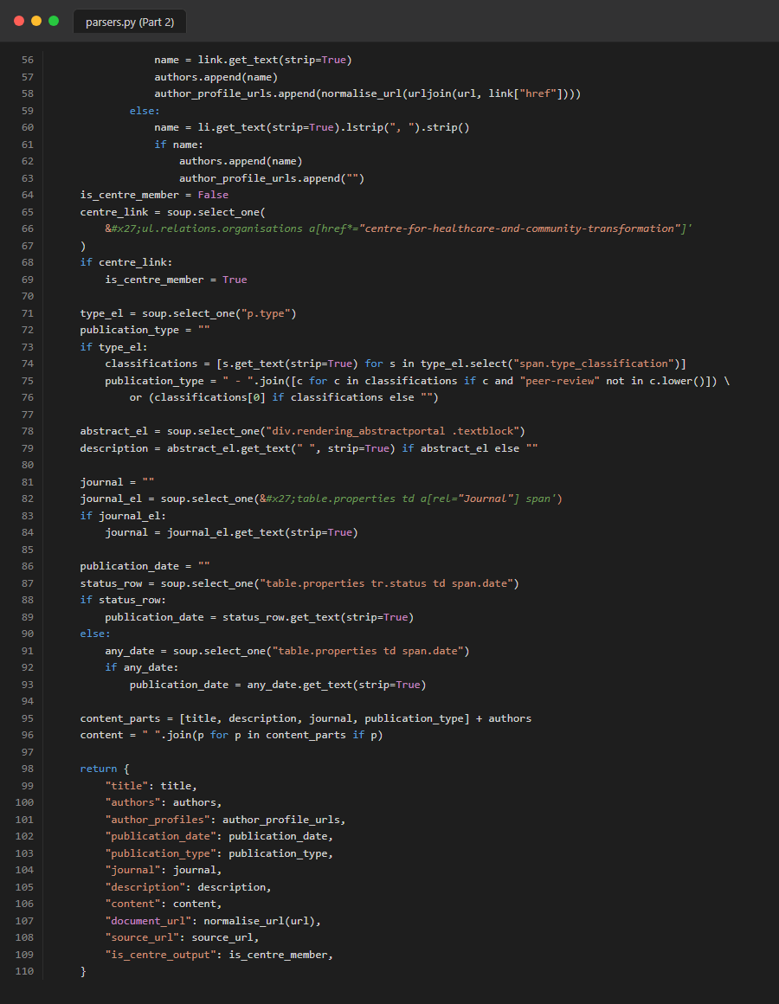
Figure 52. Source Code: task1_crawler_parsers_part2
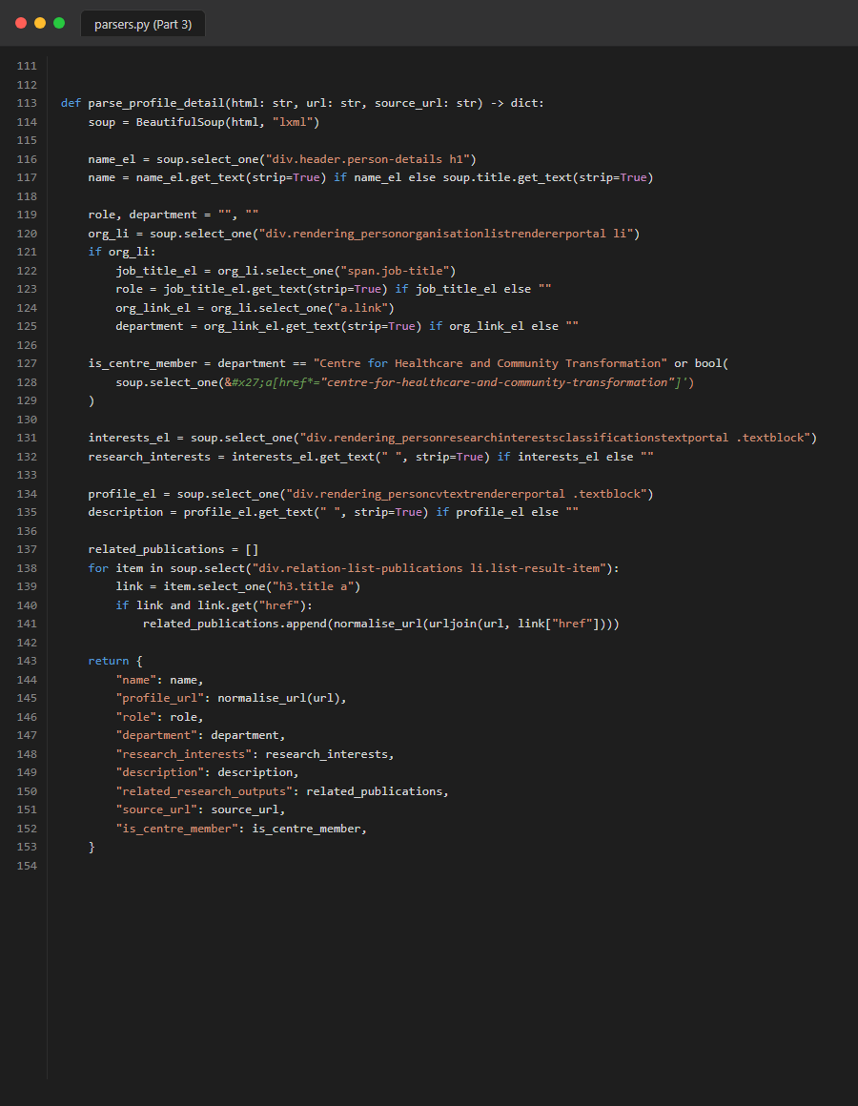
Figure 53. Source Code: task1_crawler_parsers_part3

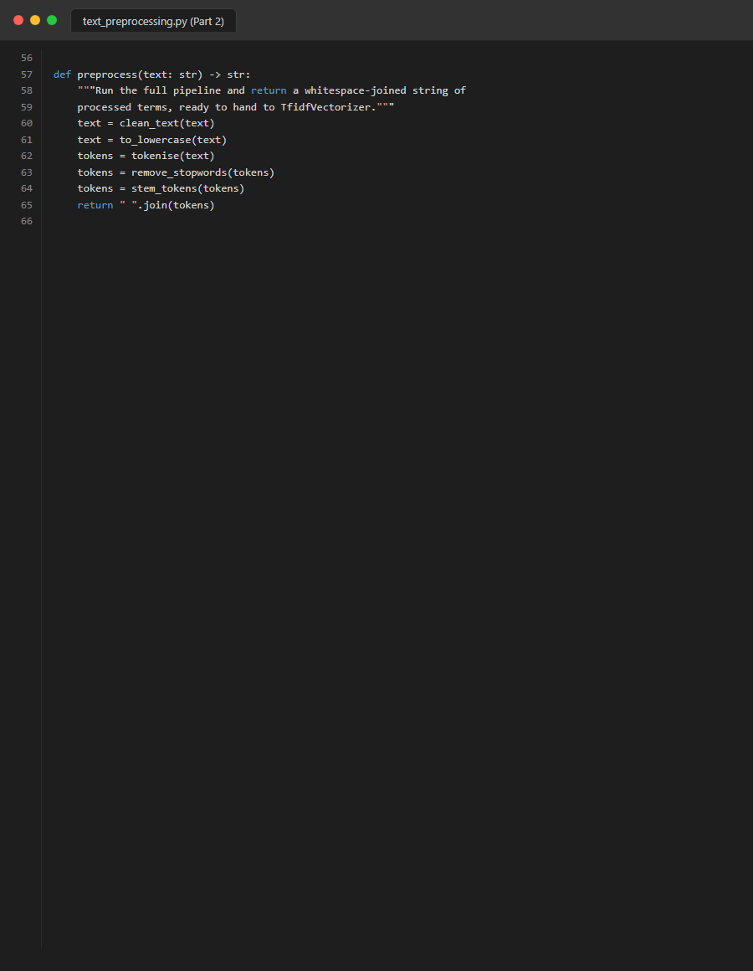
Figure 54. Source Code: task1_crawler_pure_crawler_part1
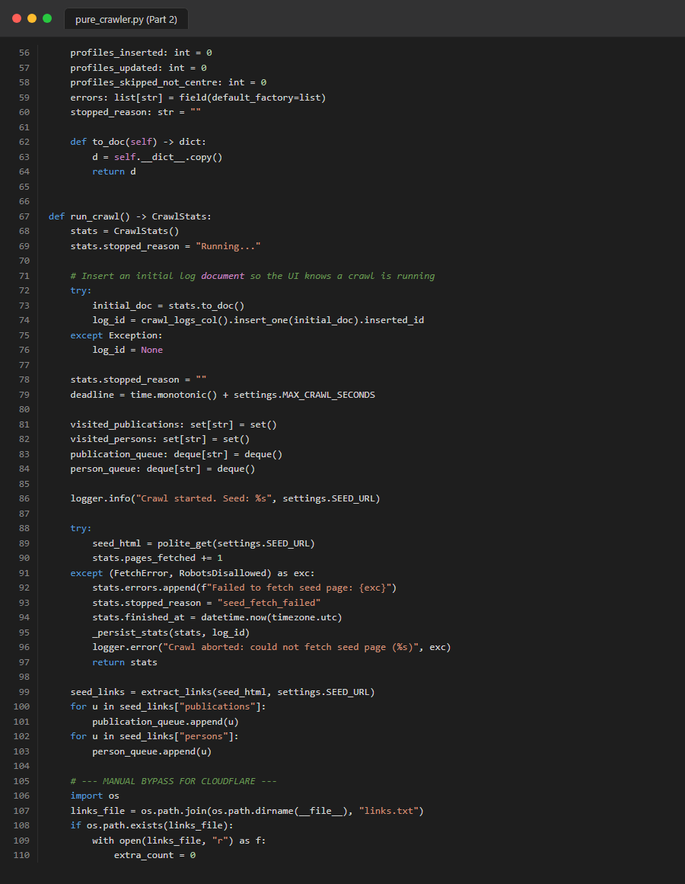
Figure 55. Source Code: task1_crawler_pure_crawler_part2
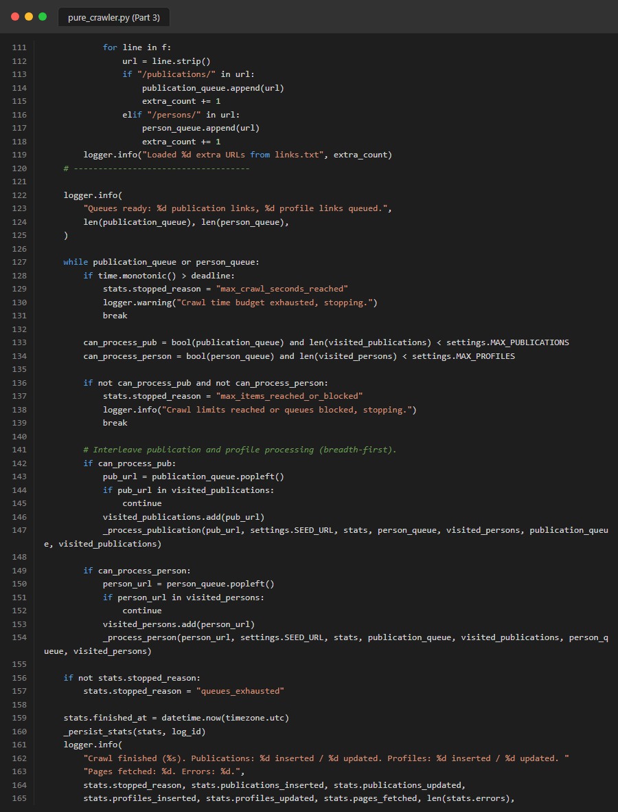
Figure 56. Source Code: task1_crawler_pure_crawler_part3
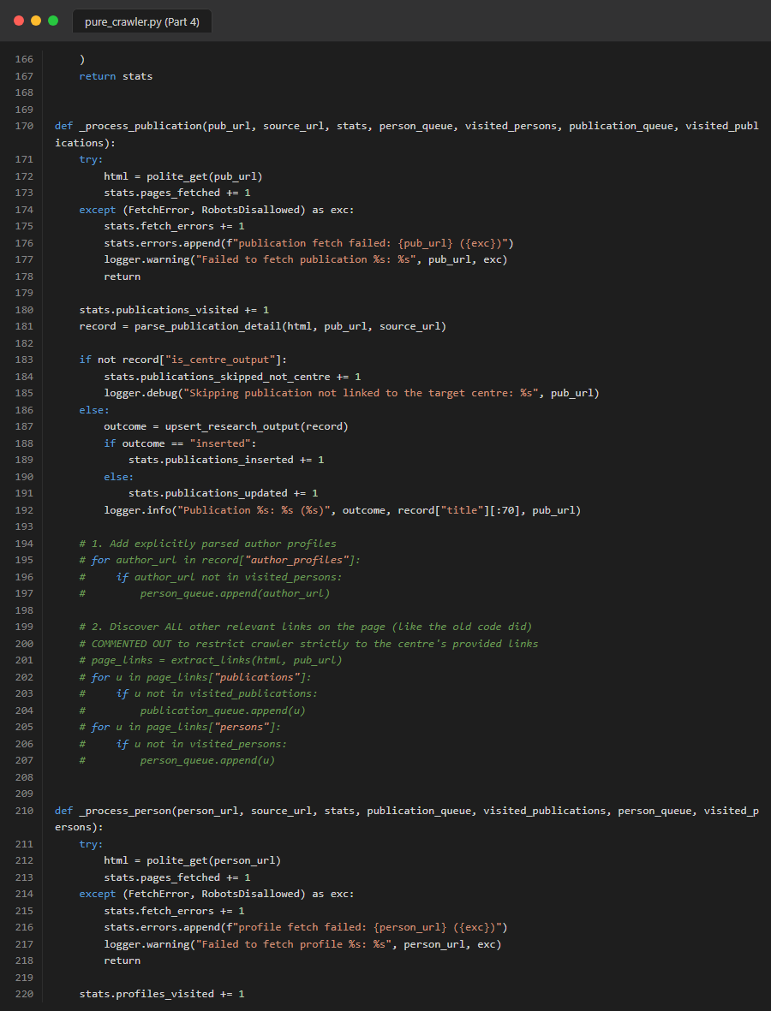
Figure 57. Source Code: task1_crawler_pure_crawler_part4

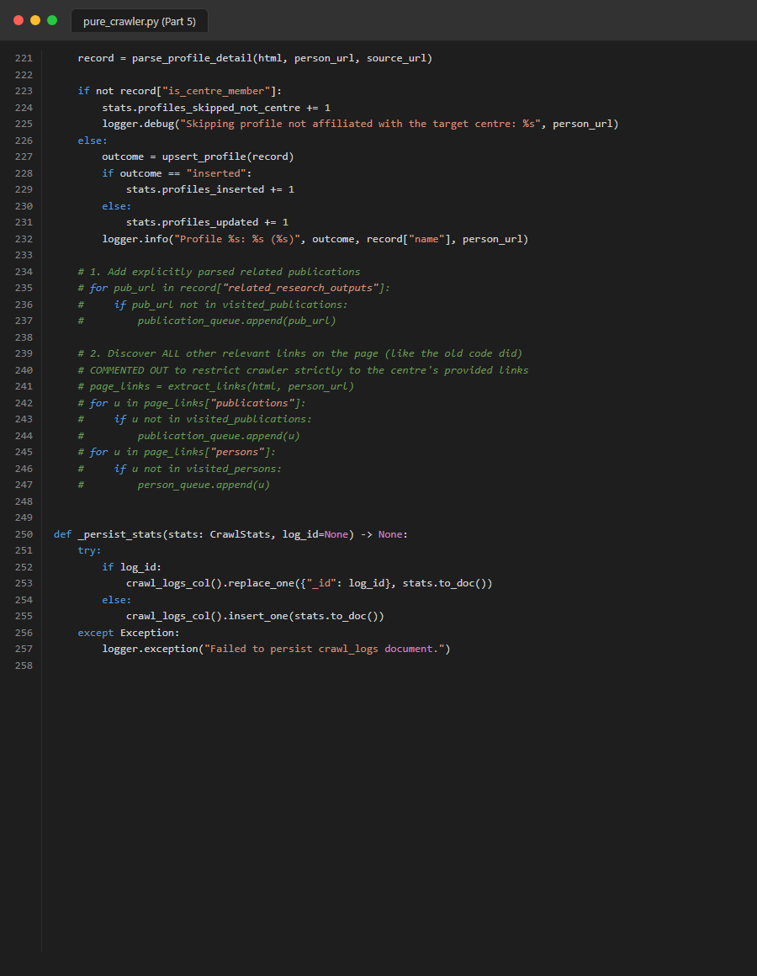
Figure 58. Source Code: task1_crawler_pure_crawler_part5
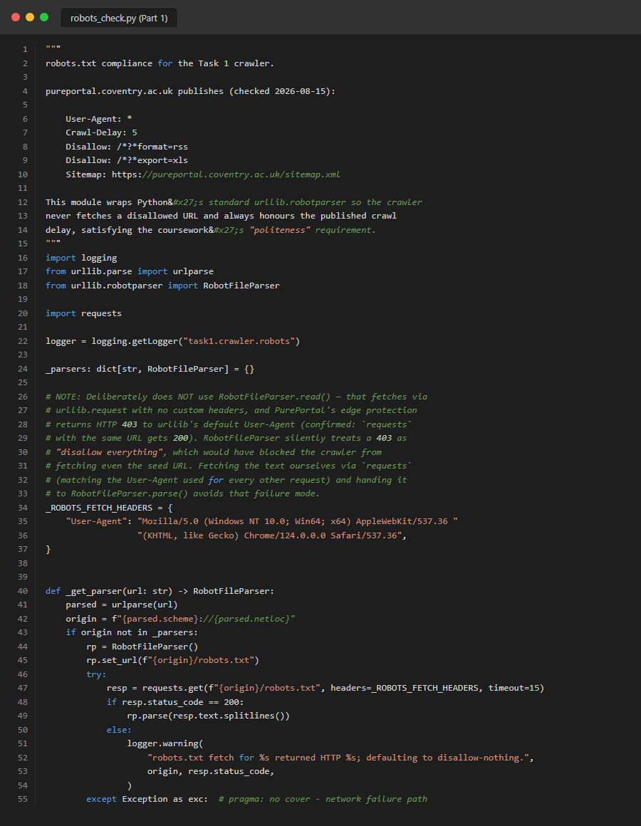
Figure 59. Source Code: task1_crawler_robots_check_part1

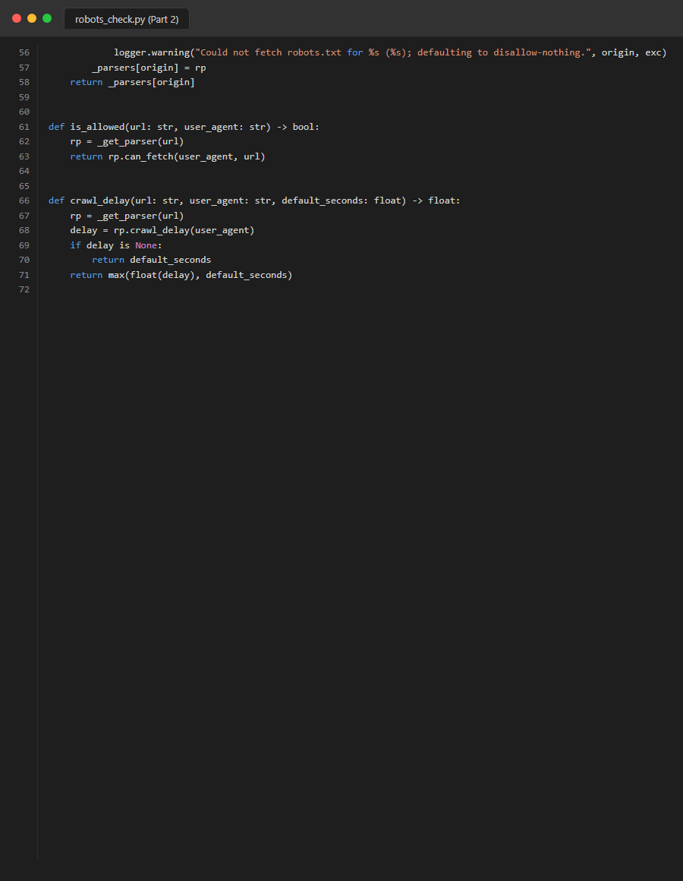
Figure 60. Source Code: task1_crawler_robots_check_part2
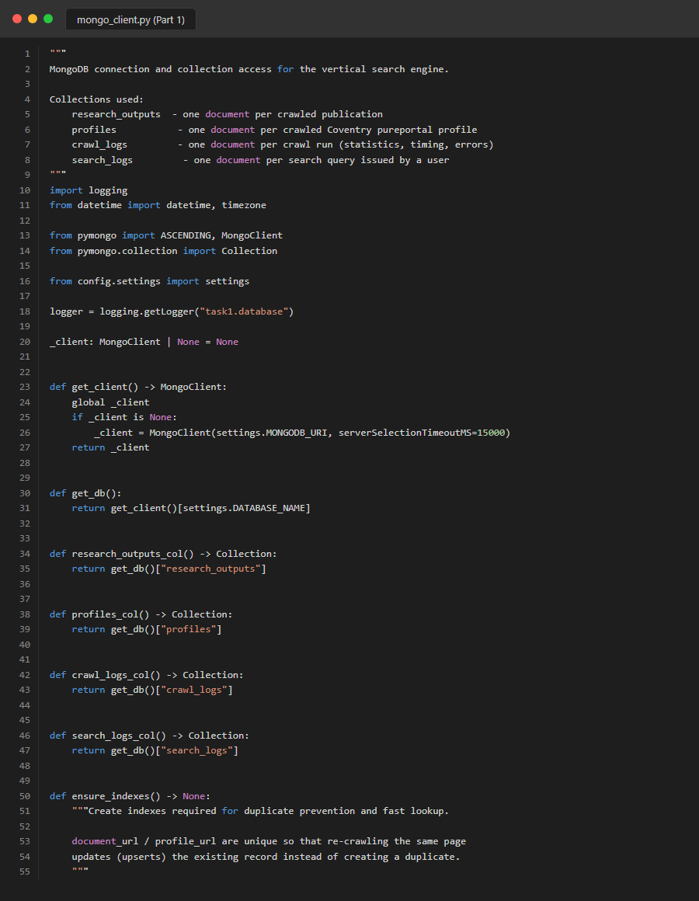
Figure 61. Source Code: task1_database_mongo_part1

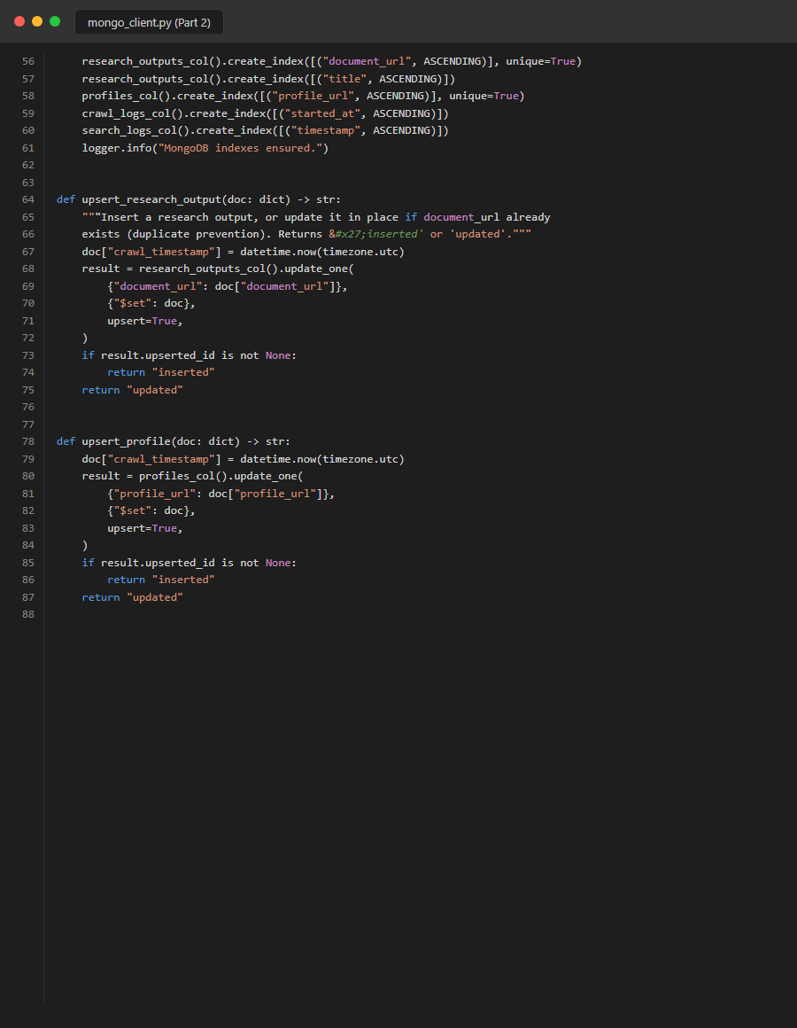
Figure 62. Source Code: task1_database_mongo_part2
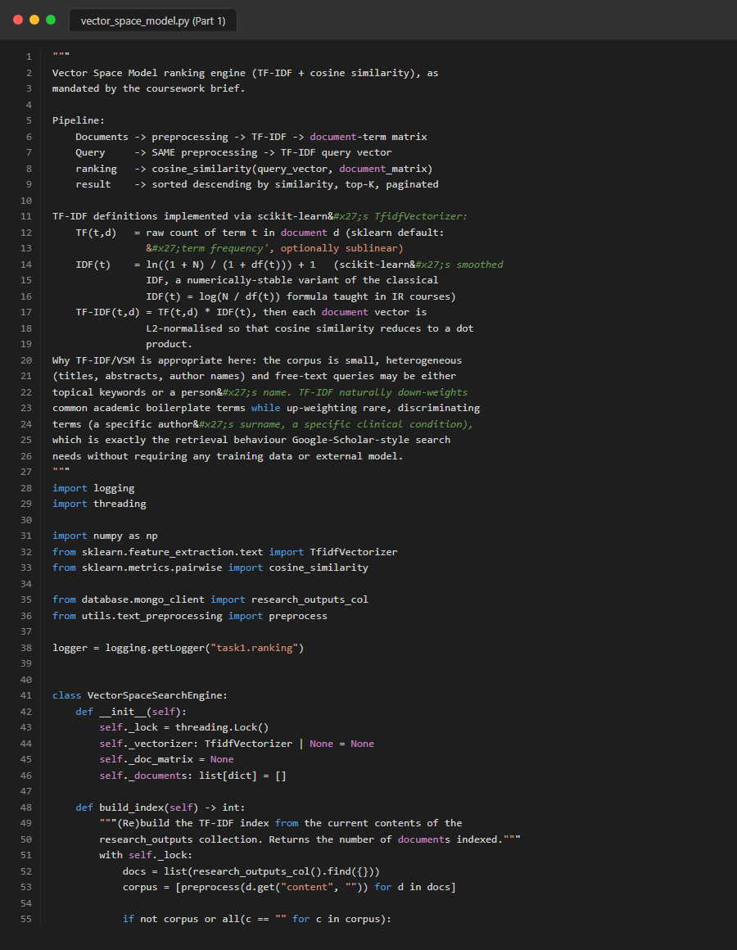
Figure 63. Source Code: task1_ranking_vsm_part1
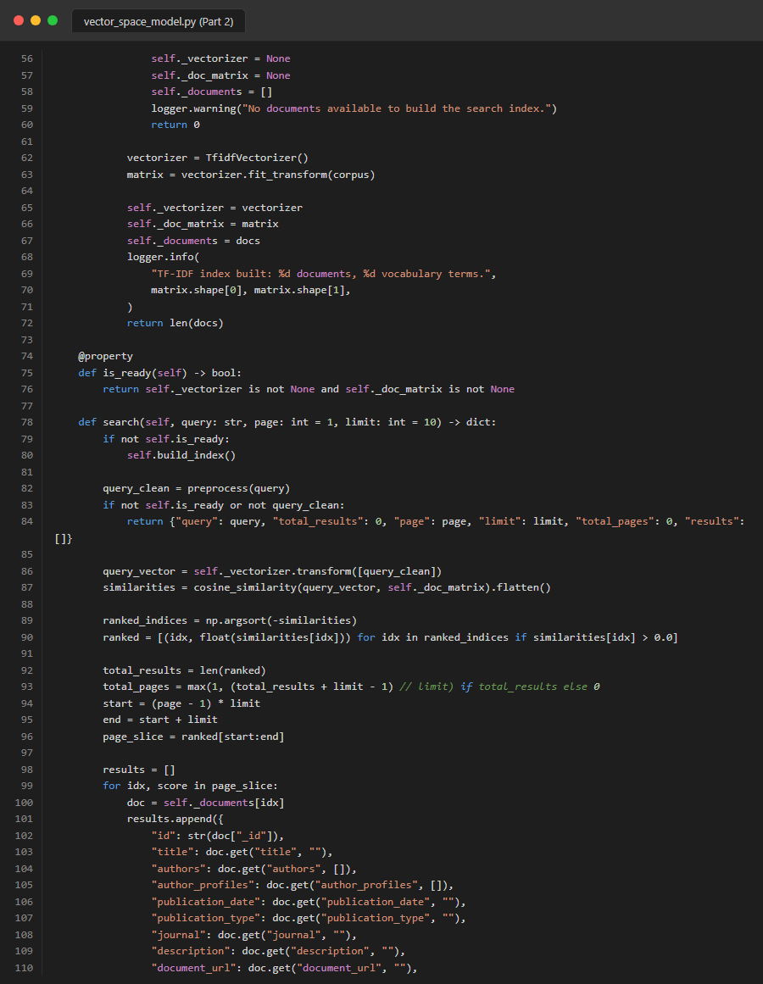
Figure 64. Source Code: task1_ranking_vsm_part2

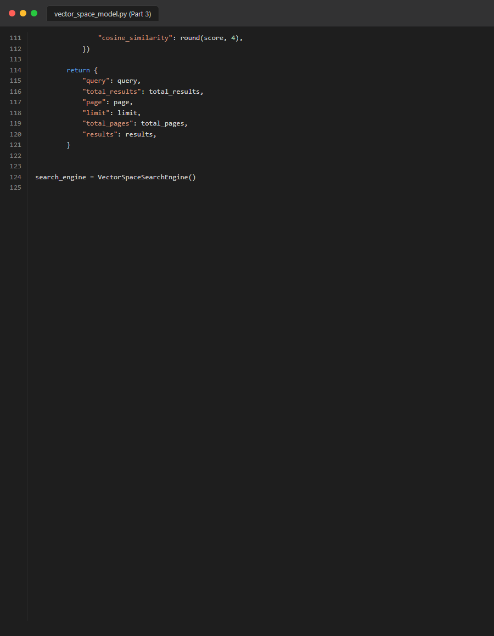
Figure 65. Source Code: task1_ranking_vsm_part3
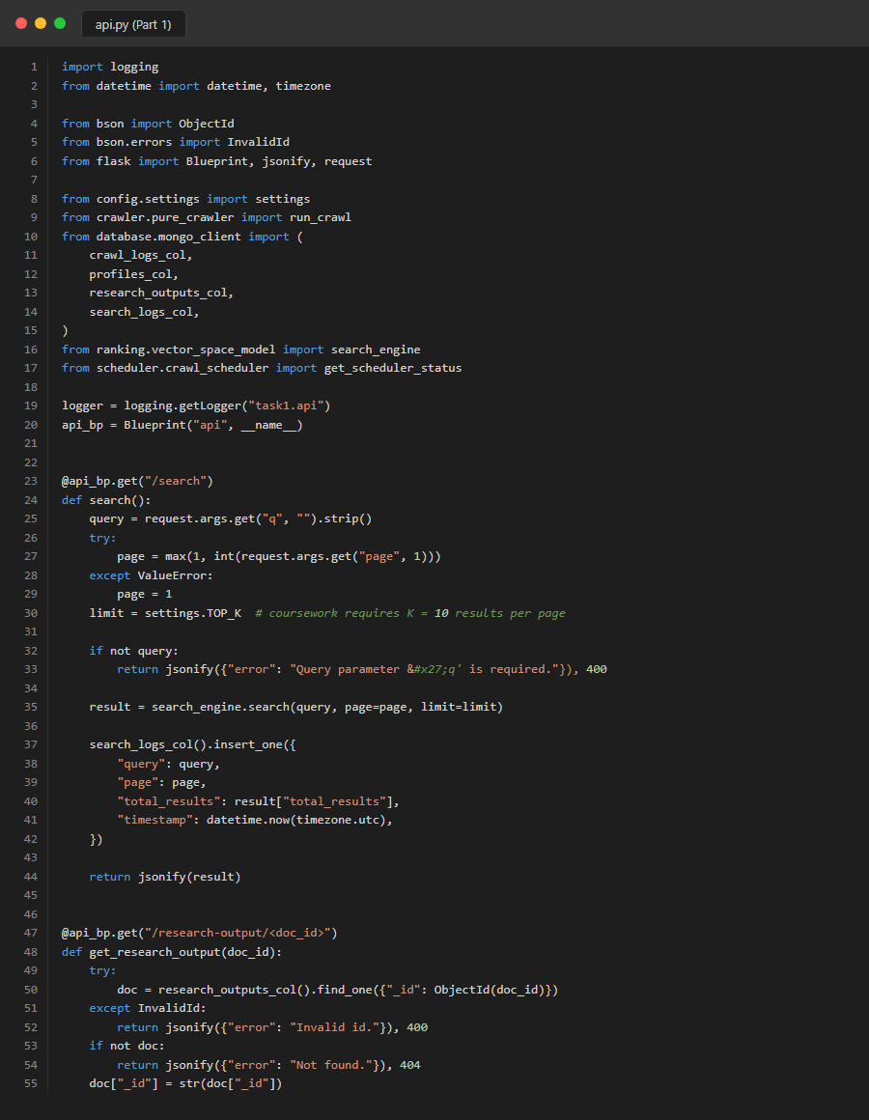
Figure 66. Source Code: task1_routes_api_part1
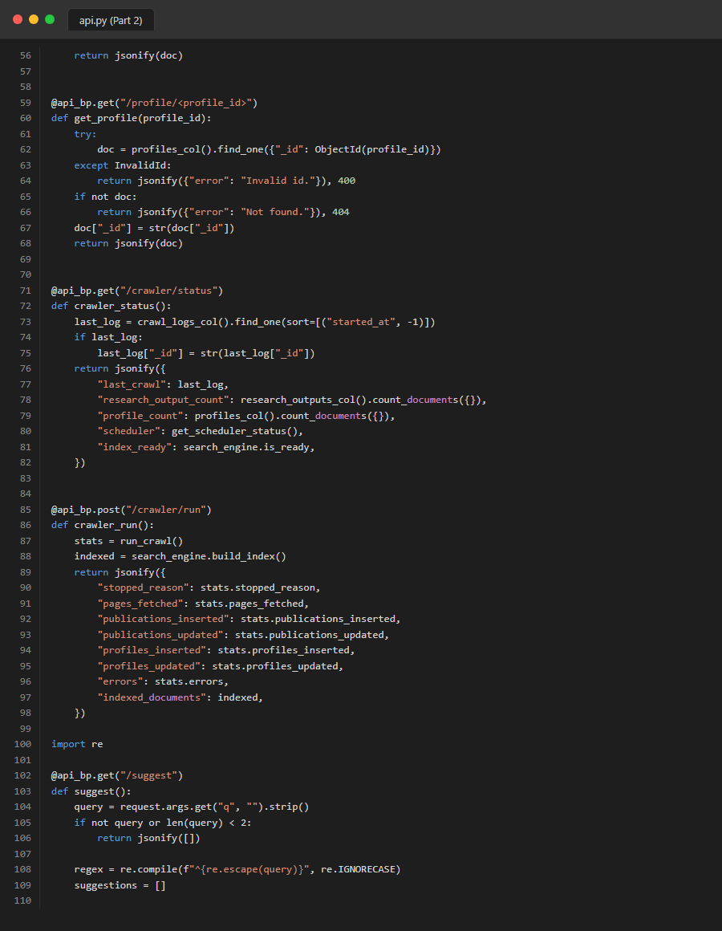
Figure 67. Source Code: task1_routes_api_part2

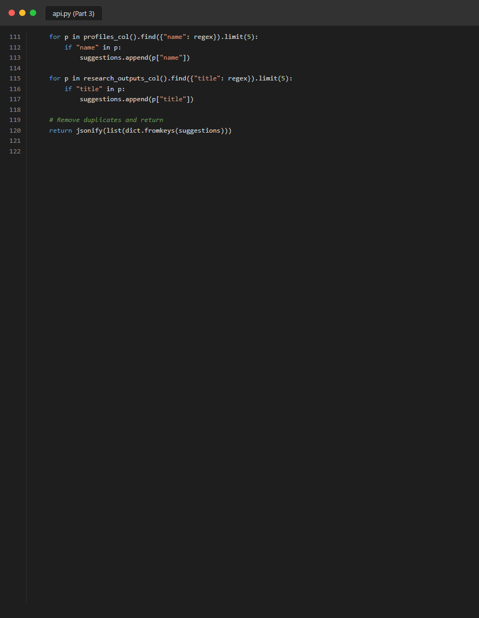
Figure 68. Source Code: task1_routes_api_part3

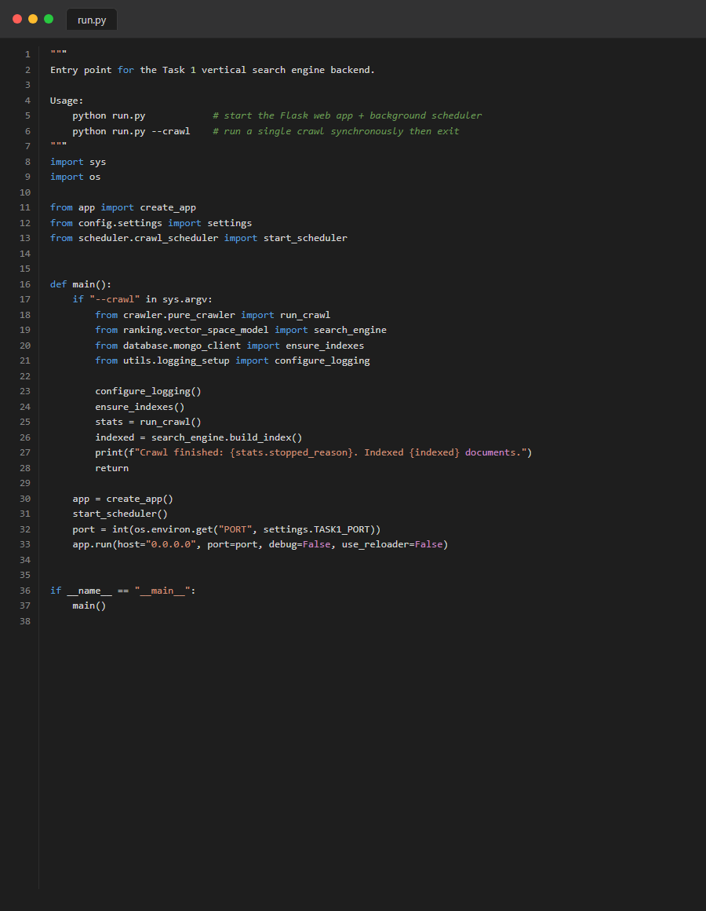
Figure 69. Source Code: task1_run


Figure 70. Source Code: task1_utils_preprocessing

Figure 71. Source Code: task2_clustering_kmeans_part1
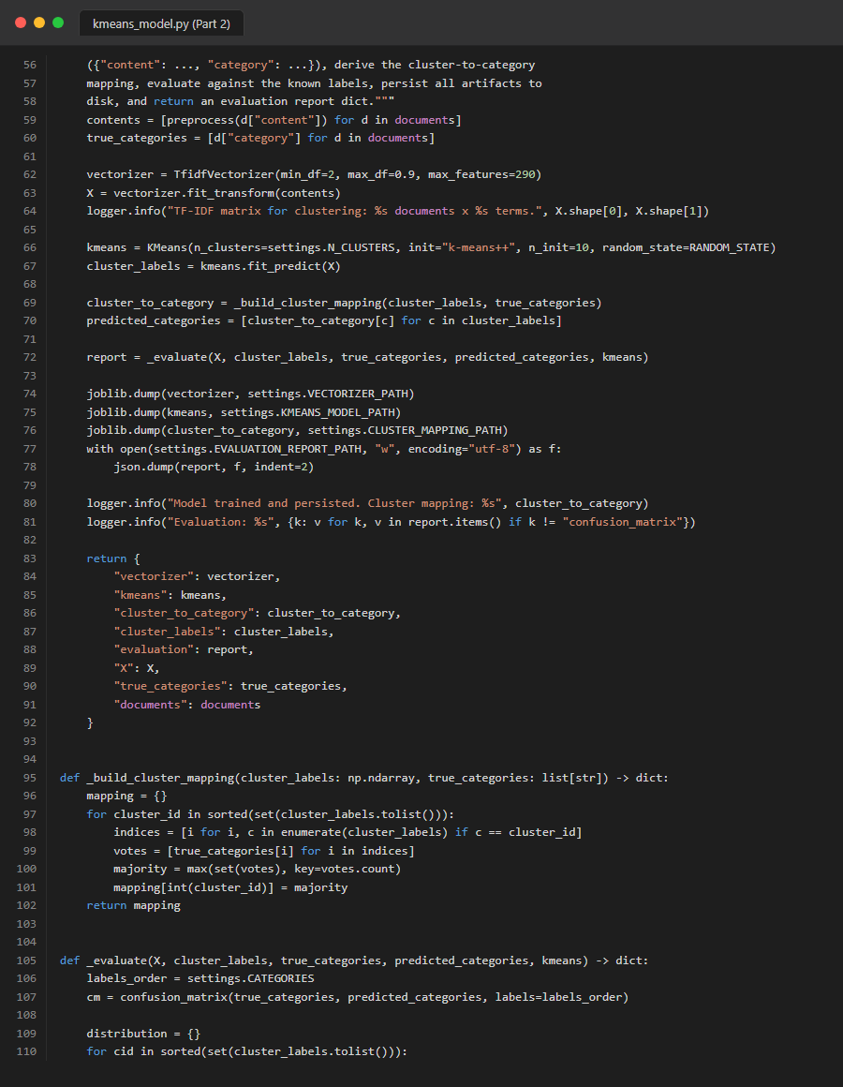
Figure 72. Source Code: task2_clustering_kmeans_part2
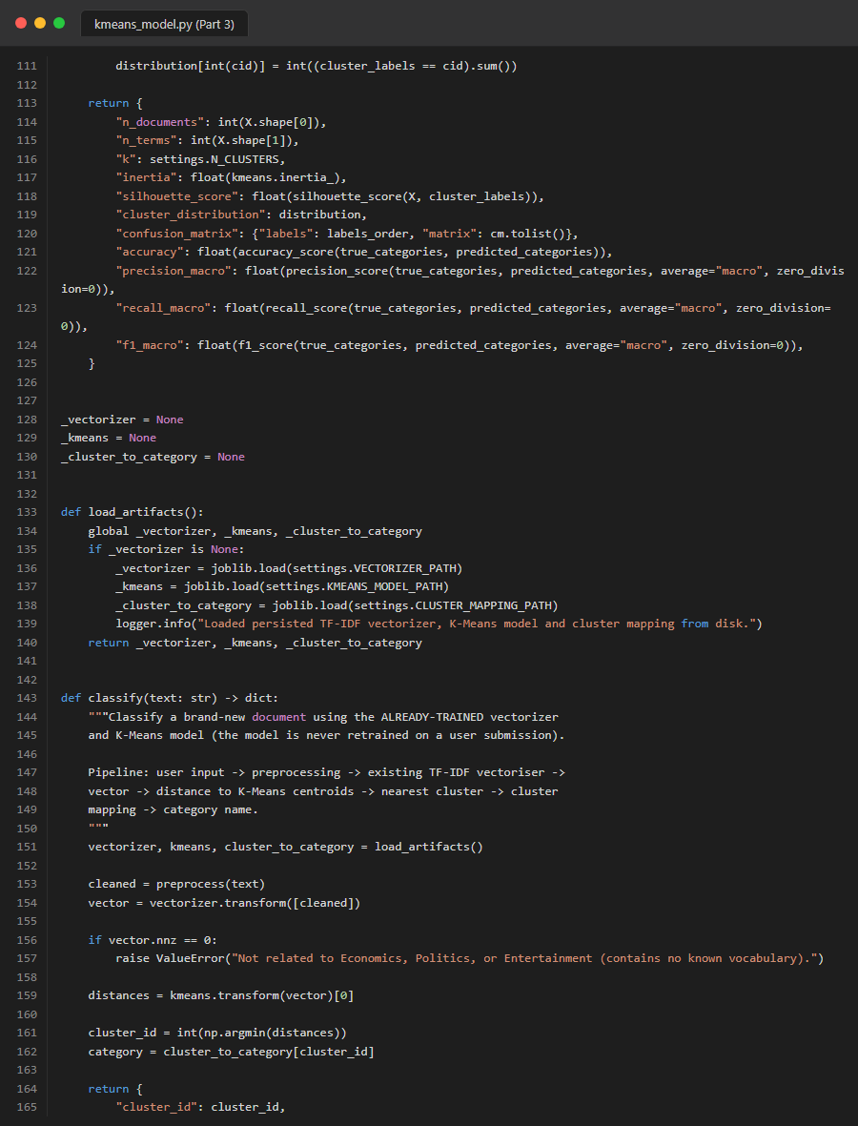
Figure 73. Source Code: task2_clustering_kmeans_part3
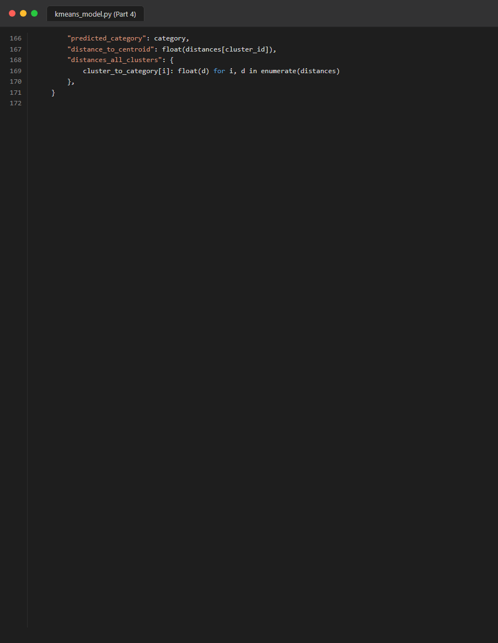
Figure 74. Source Code: task2_clustering_kmeans_part4

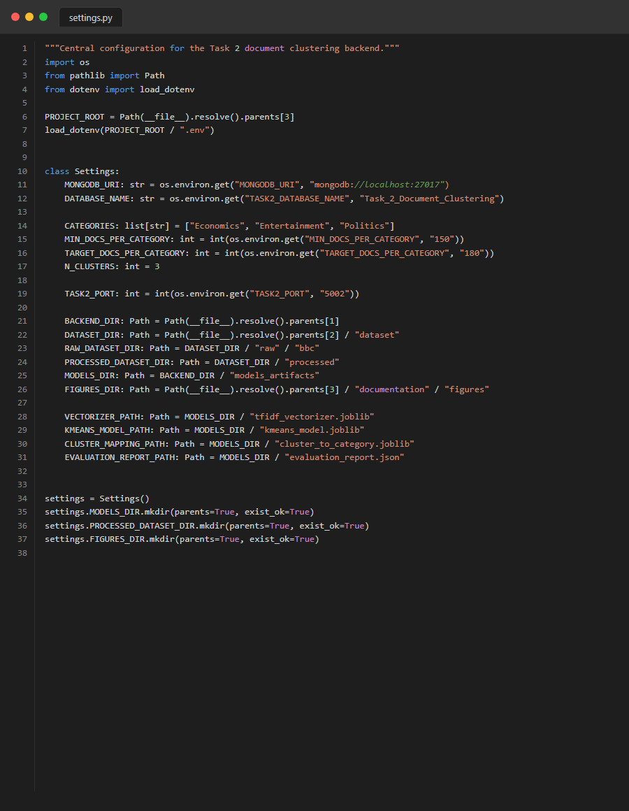
Figure 75. Source Code: task2_config_settings
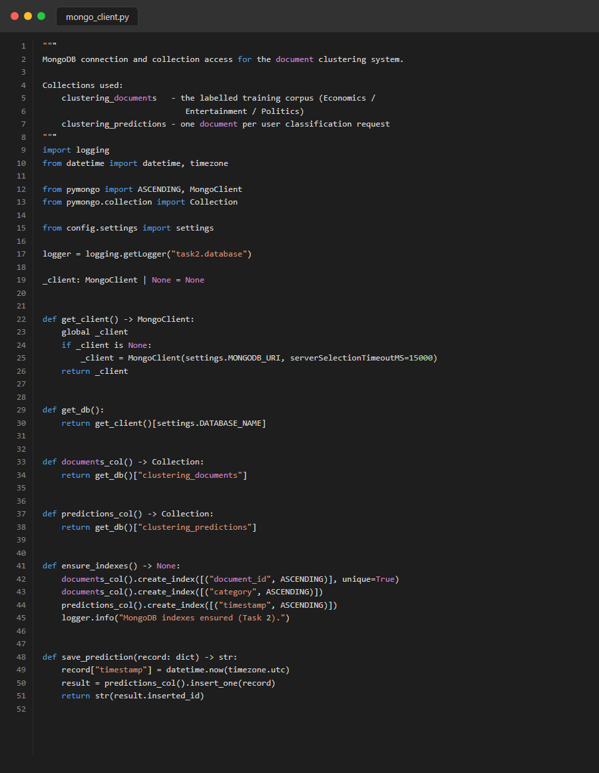
Figure 76. Source Code: task2_database_mongo
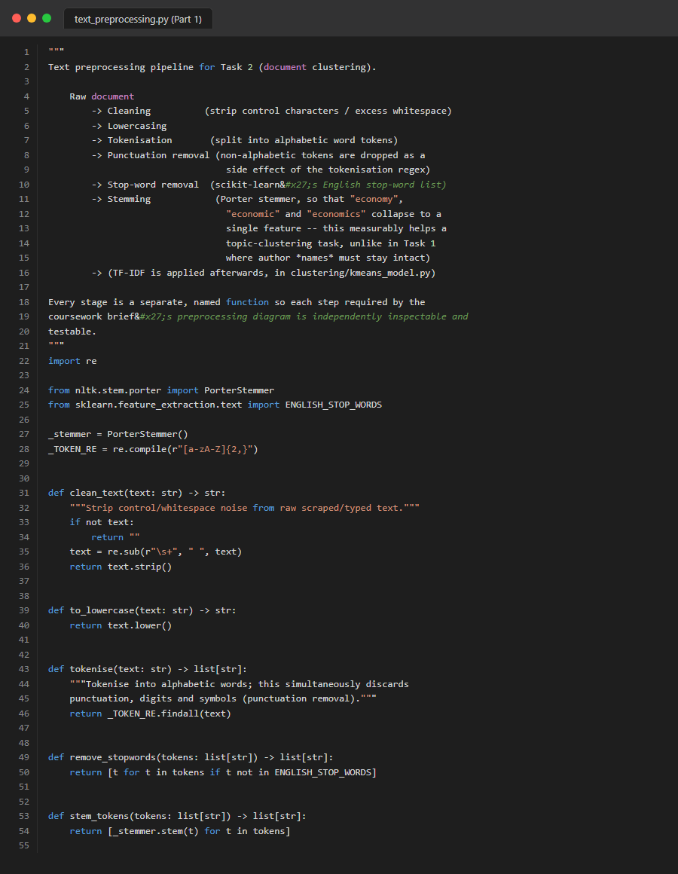
Figure 77. Source Code: task2_preprocessing_part1


Figure 78. Source Code: task2_preprocessing_part2
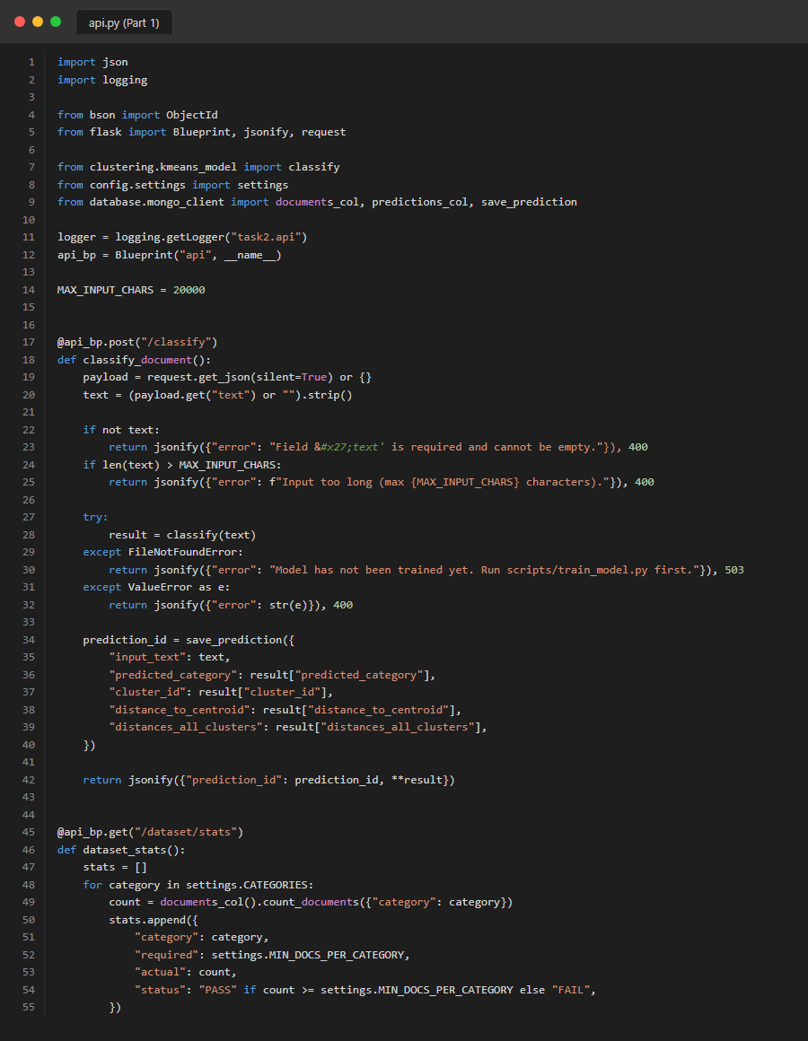
Figure 79. Source Code: task2_routes_api_part1

Figure 80. Source Code: task2_routes_api_part2

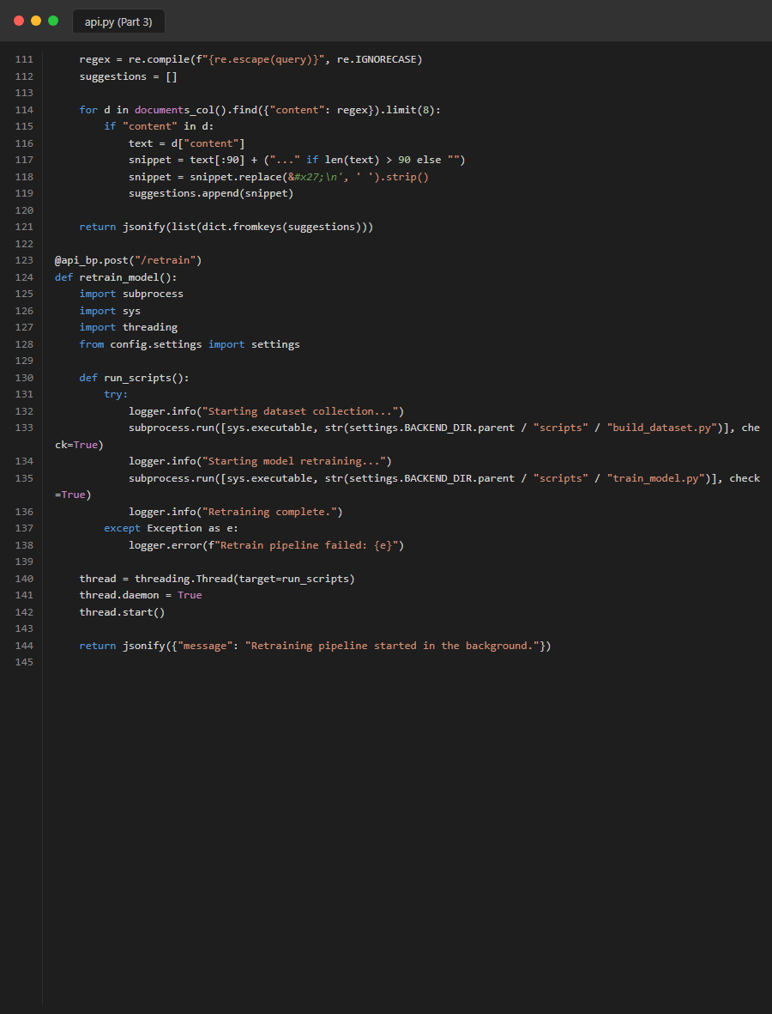
Figure 81. Source Code: task2_routes_api_part3

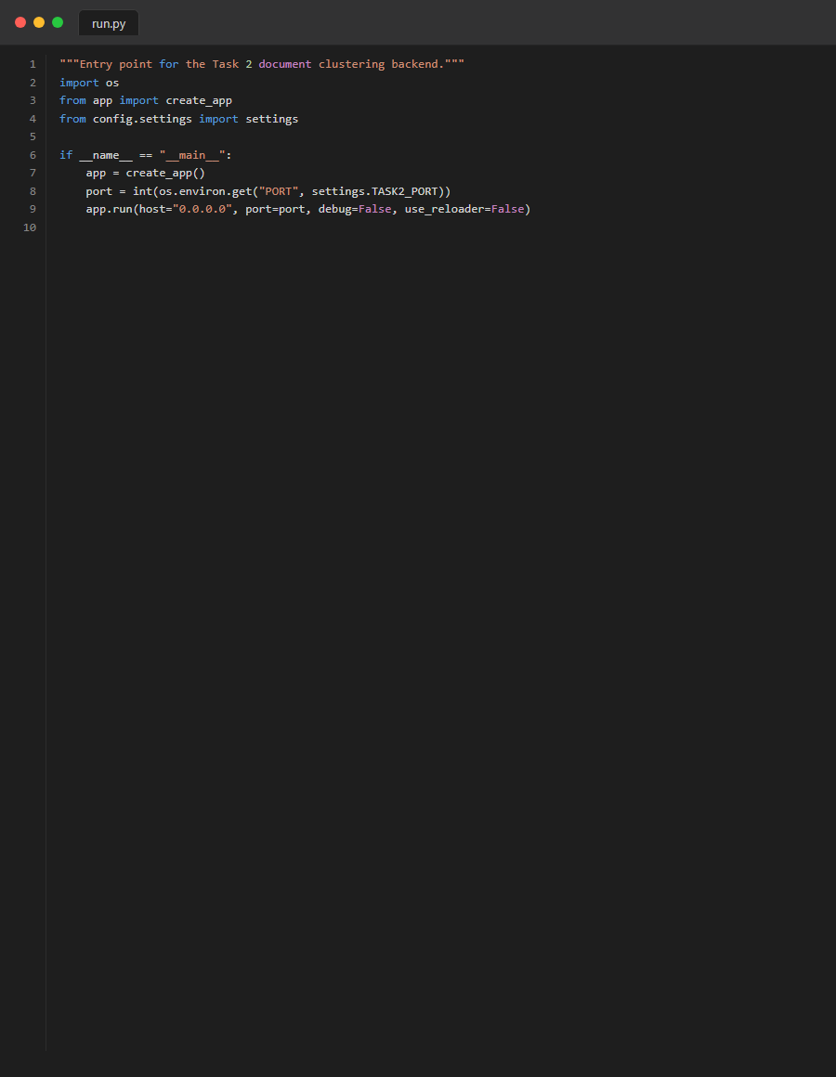
Figure 82. Source Code: task2_run
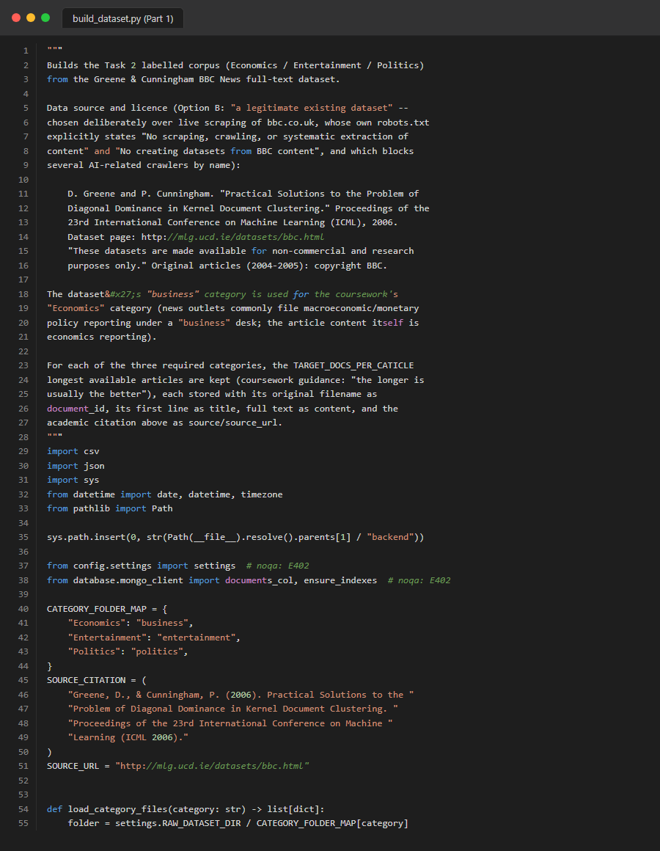
Figure 83. Source Code: task2_scripts_build_dataset_part1
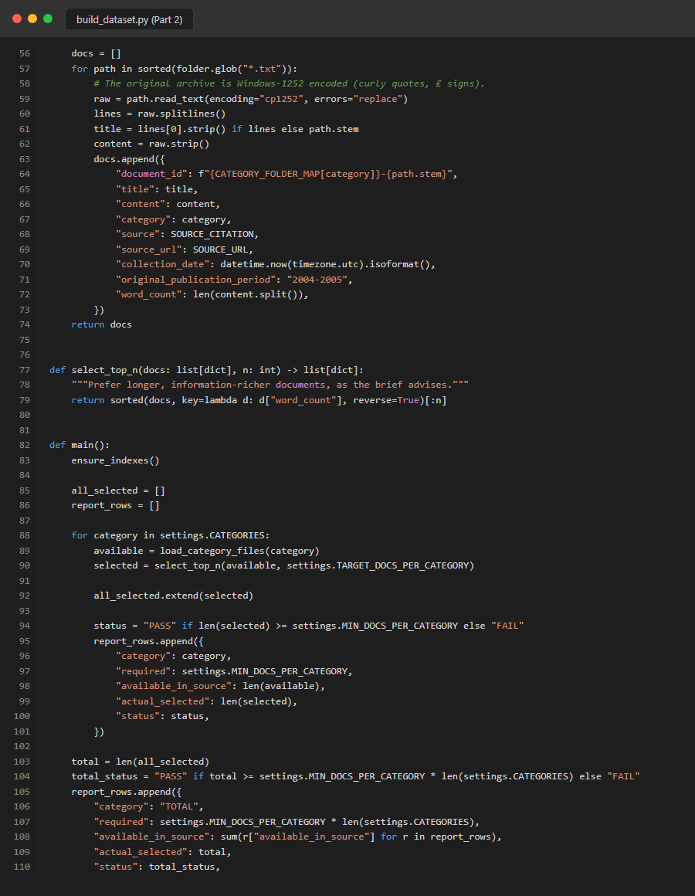
Figure 84. Source Code: task2_scripts_build_dataset_part2
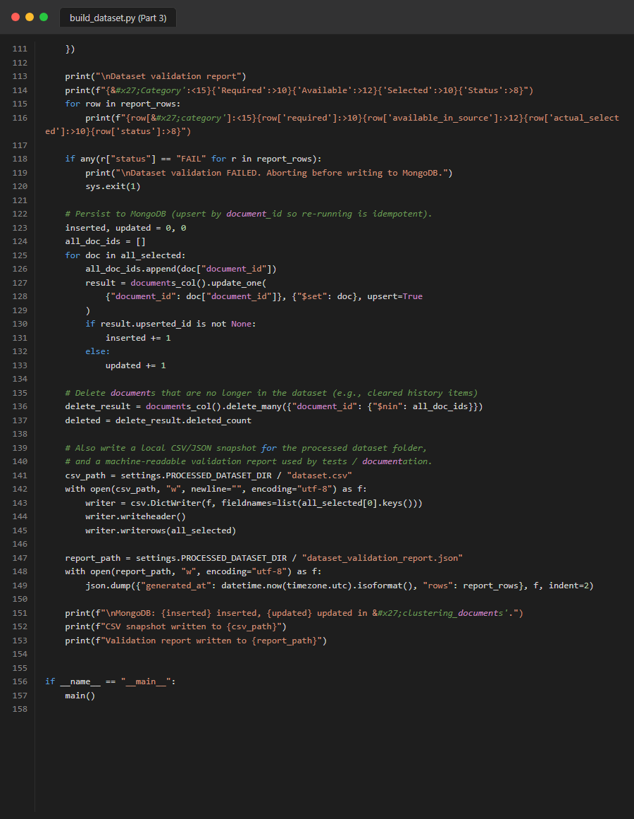
Figure 85. Source Code: task2_scripts_build_dataset_part3
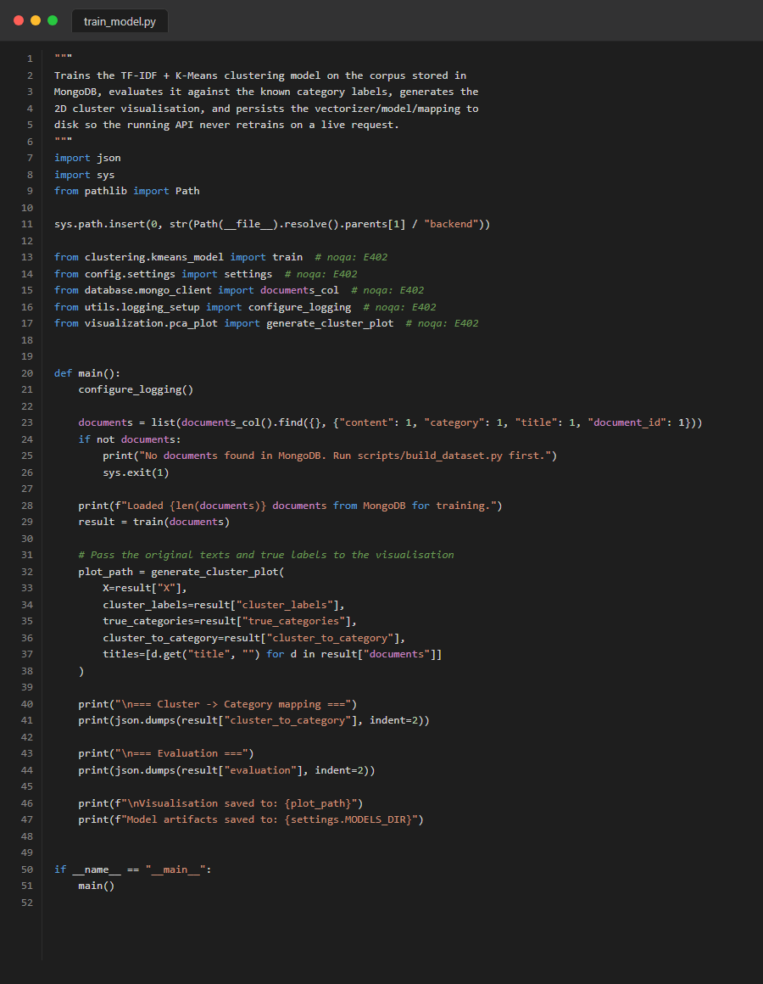
Figure 86. Source Code: task2_scripts_train_model
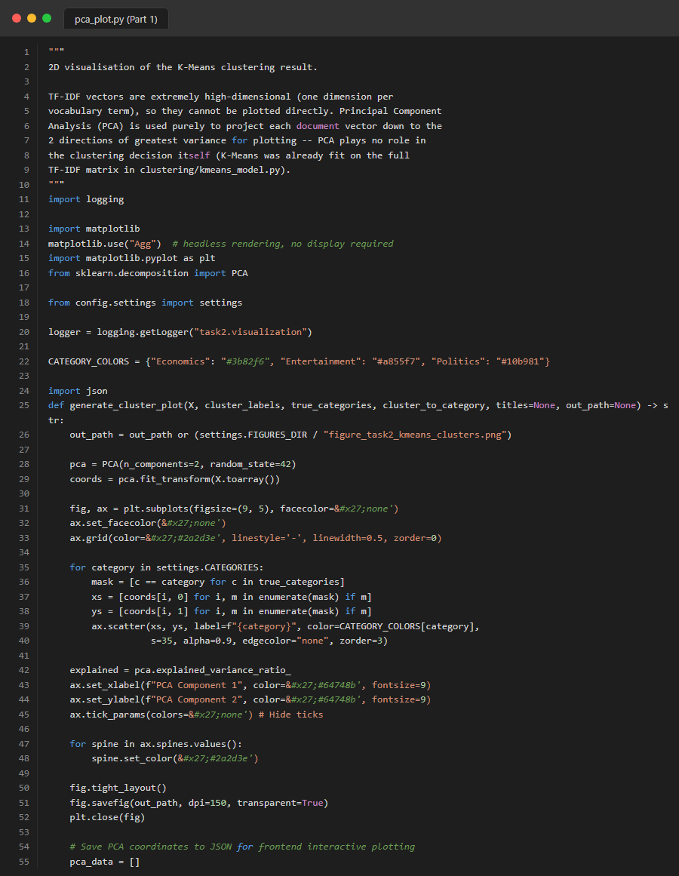
Figure 87. Source Code: task2_visualization_pca_part1

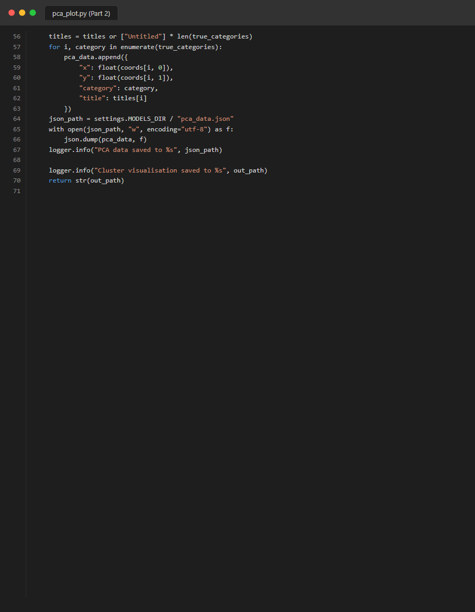
Figure 88. Source Code: task2_visualization_pca_part2

Appendix D: Pytest Evidence
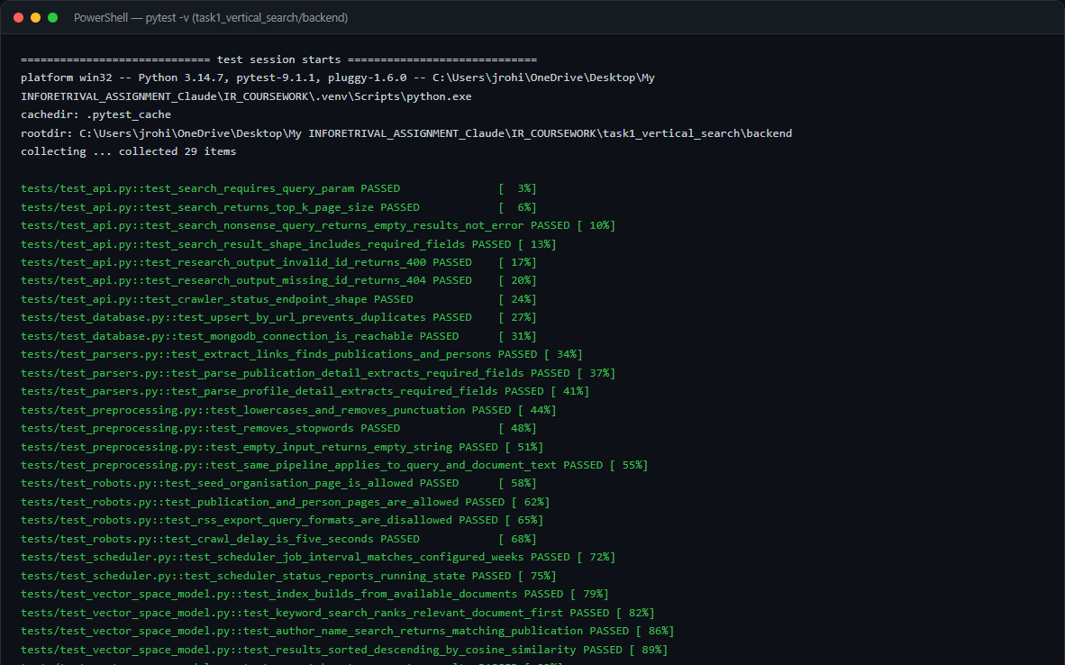
Figure 89. Full Pytest execution for Task 1.
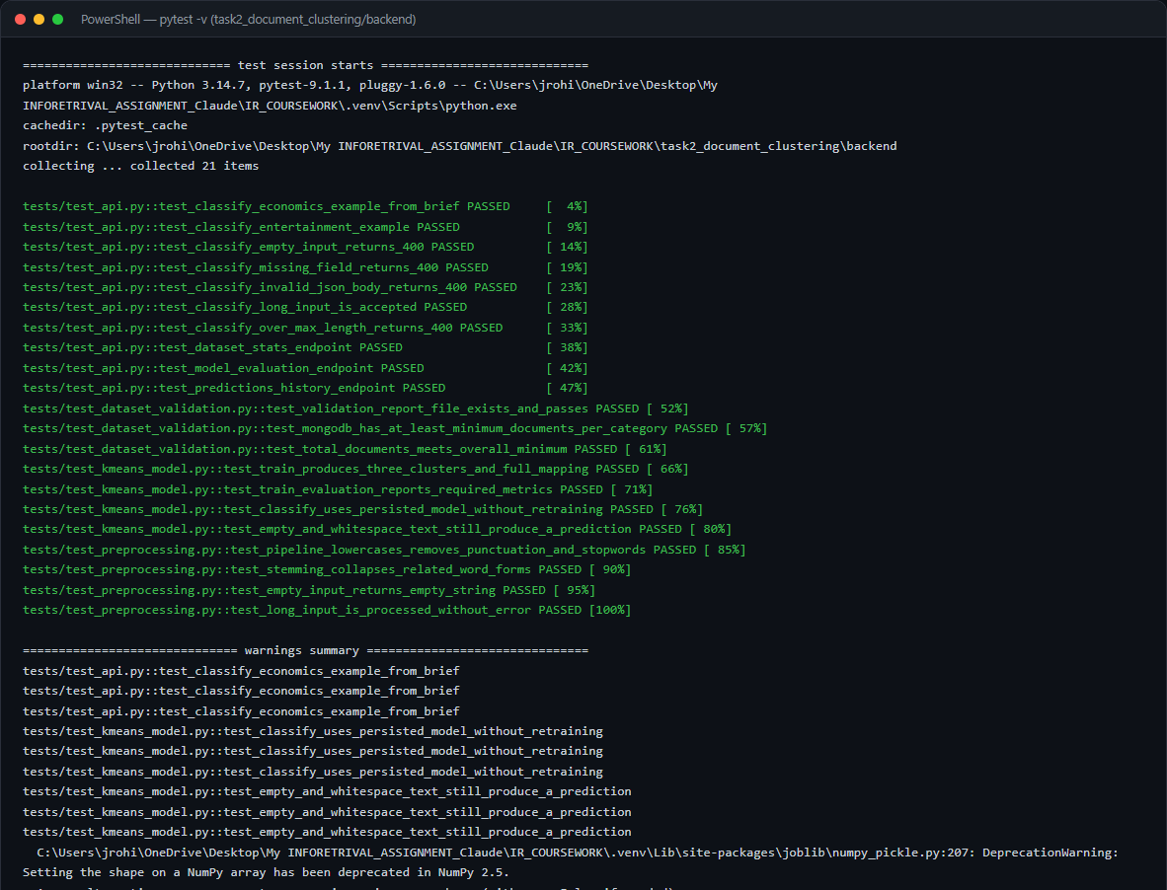
Figure 90. Full Pytest execution for Task 2.

Appendix E: Additional Application Screenshots
The following screenshots represent additional UI views, visualizations, and MongoDB states captured during the system's live operation.
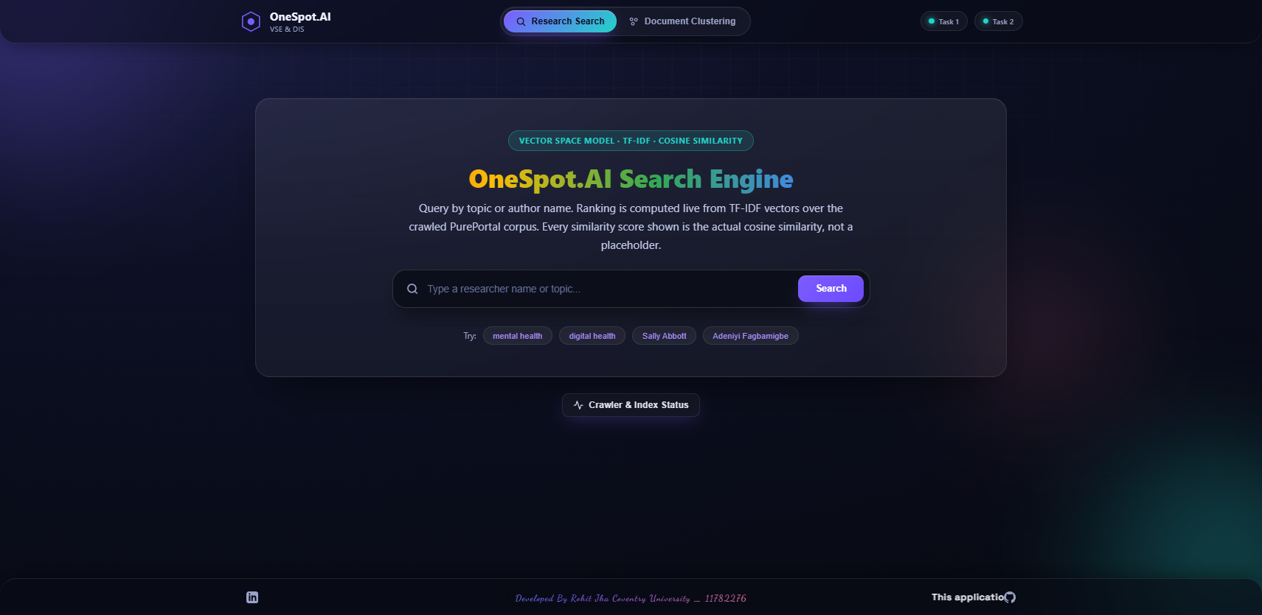
Figure 91. Additional System Screenshot: 01_unified_search_home
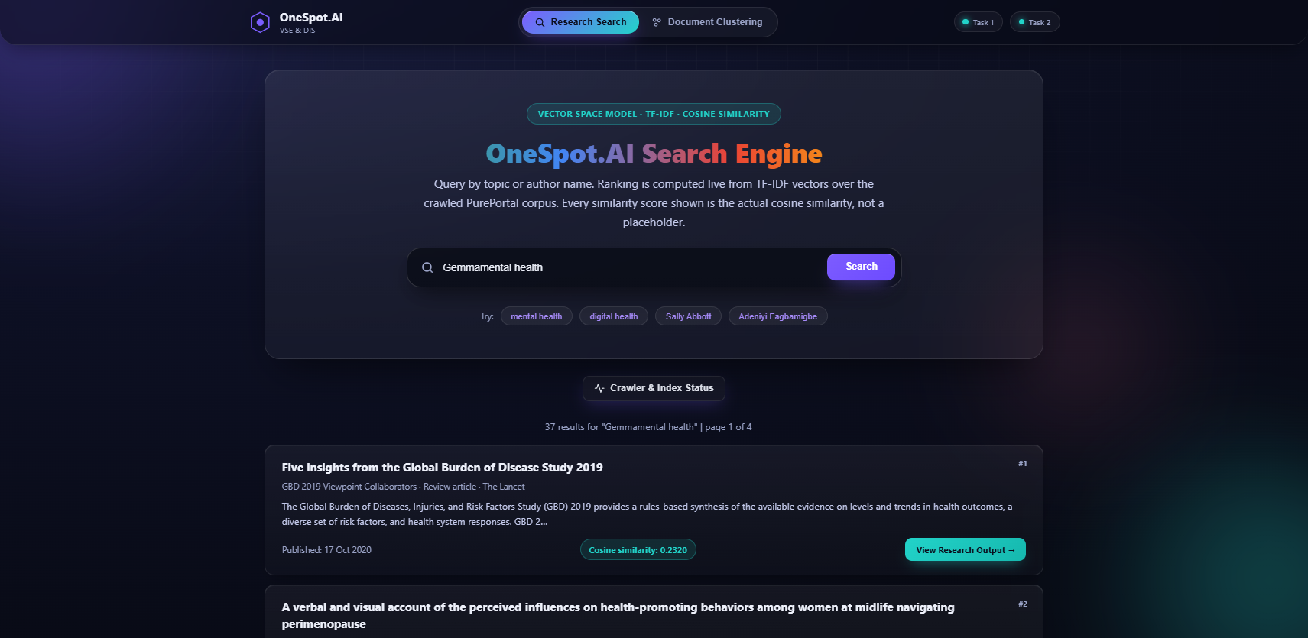
Figure 92. Additional System Screenshot: 02_unified_search_results
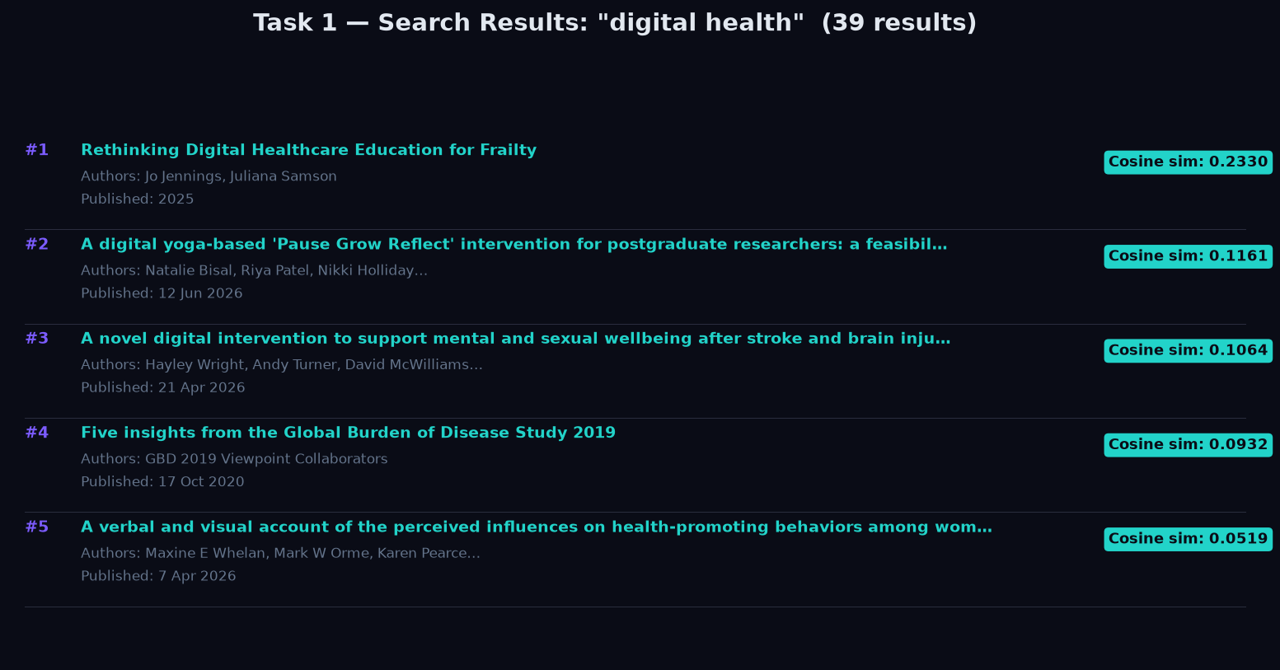
Figure 93. Additional System Screenshot: 03_task1_search_digital_health

Figure 94. Additional System Screenshot: 03_unified_search_pagination
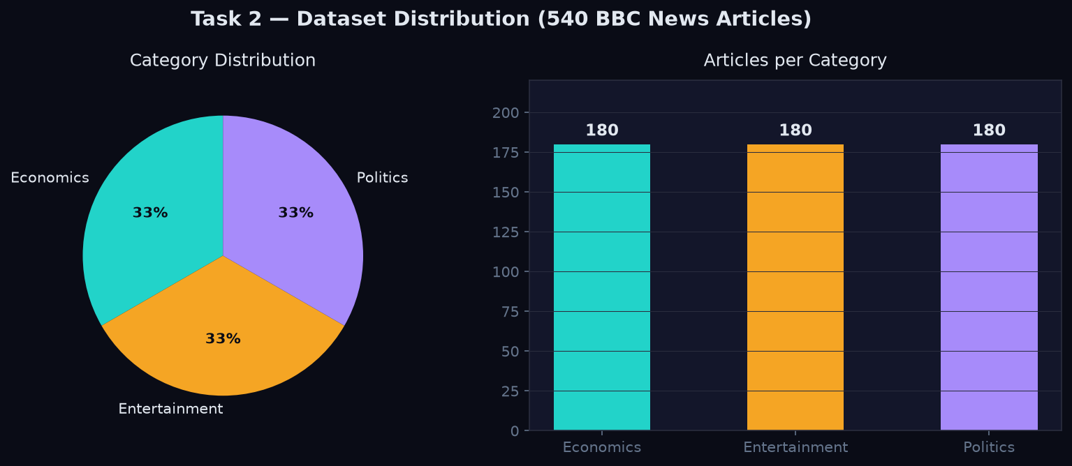
Figure 95. Additional System Screenshot: 04_task2_dataset_stats
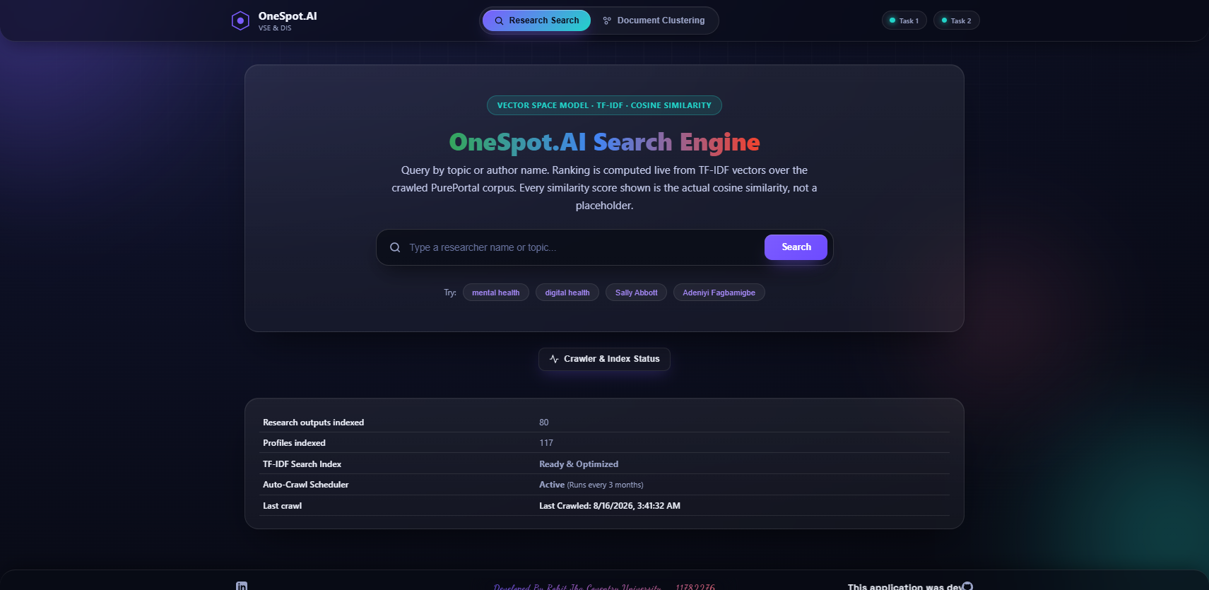
Figure 96. Additional System Screenshot: 04_unified_crawler_status
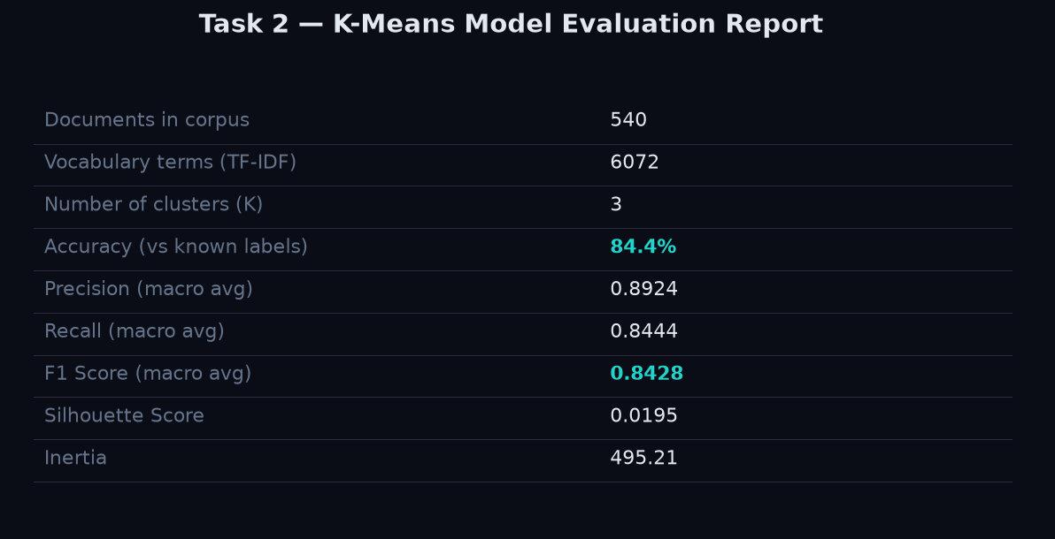
Figure 97. Additional System Screenshot: 05_task2_model_evaluation

Figure 98. Additional System Screenshot: 05_unified_cluster_home

Figure 99. Additional System Screenshot: 06_unified_cluster_result

Figure 100. Additional System Screenshot: 08_unified_model_evaluation
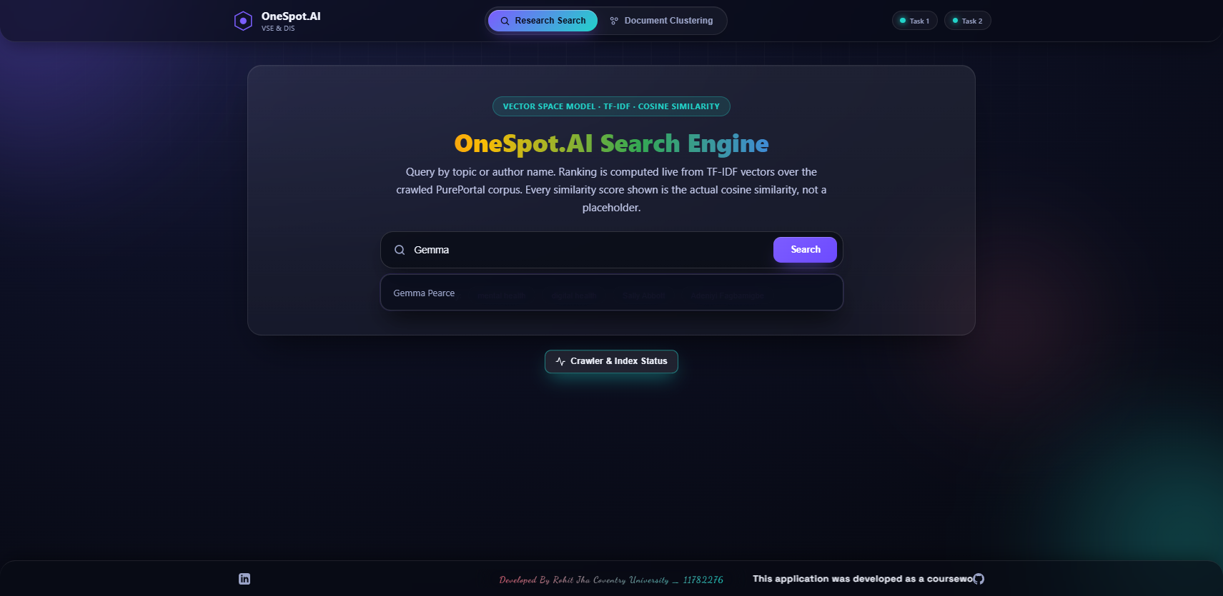
Figure 101. Additional System Screenshot: 08_unified_search_suggestions
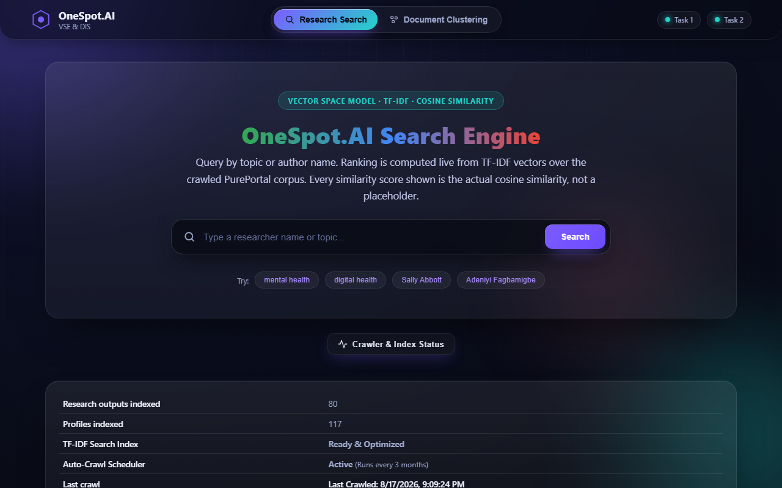
Figure 102. Additional System Screenshot: new_02_crawler_status

