MBTA-APP ReadMe File

# Overview

The application read the MBTA developers API. It uses Version 3 because version 2 has been deprecated and there is no longer a public API key. The application does not require and API Key as long as you do not go over a 1000 request a day.

The Application uses java to read the MBTA API then the Spring boot application has two REST Calls and a JSP user inter face

# Technical Architecture

* Springboot 1.5.9
* Jackson is use to convert the JSON into Java Objects
* Google Simple Json

# Rest Calls

## Stops

* /stops/{lat}/{lon}/{limit}
* lon - Longitude
* lat - Latitude
* **@param** limit - number of stop
* **@return** List<StopByLocation> This return a StopByLocation list which only has the properties associated with the stop

## Sample URL http://localhost:8080/stops/42.349/-71.082/10

|  |
| --- |
| [  {  "stopId": "70239",  "routeId": "Green-E",  "arrivalTime": null,  "departureTime": "2017-12-06T16:53:28-05:00"  },  {  "stopId": "70154",  "routeId": "Green-B",  "arrivalTime": null,  "departureTime": "2017-12-06T16:52:00-05:00"  },  {  "stopId": "70155",  "routeId": "Green-B",  "arrivalTime": null,  "departureTime": "2017-12-06T16:51:59-05:00"  }, |

## MBTA Object

* / mbta/{lat}/{lon}/{limit}
* lon - Longitude
* lat - Latitude
* **@param** limit - number of stop
* **@return** List<StopByLocation> This return a StopByLocation list which only has the properties associated with the stop

## Sample URL http://localhost:8080/ mbta/42.349/-71.082/1

|  |
| --- |
| // 20171206165752  // http://localhost:8080/mbta/42.349/-71.082/1  [  {  "type": null,  "id": null,  "attributes": {  "track": null,  "status": null,  "stop_sequence": null,  "schedule_relationship": "UNSCHEDULED",  "direction_id": 1,  "departure_time": "2017-12-06T16:57:57-05:00",  "arrival_time": null  },  "relationShips": {  "schedule": {  "data": null  },  "stop": {  "data": {  "type": "stop",  "id": "70154",  "attributes": null,  "relationShips": null  }  },  "trip": {  "data": {  "type": "trip",  "id": "1061_1",  "attributes": null,  "relationShips": null  }  },  "vehicle": {  "data": {  "type": "vehicle",  "id": "10016",  "attributes": null,  "relationShips": null  }  },  "route": {  "data": {  "type": "route",  "id": "Green-C",  "attributes": null,  "relationShips": null  }  }  }  }  ] |

# JSP Call

## URL http://localhost:8080/getStops

## Initial Page load

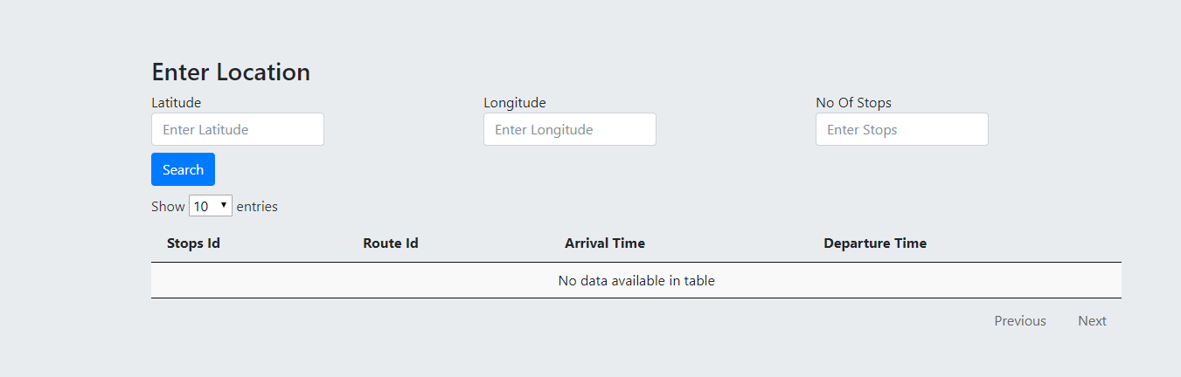

After Search

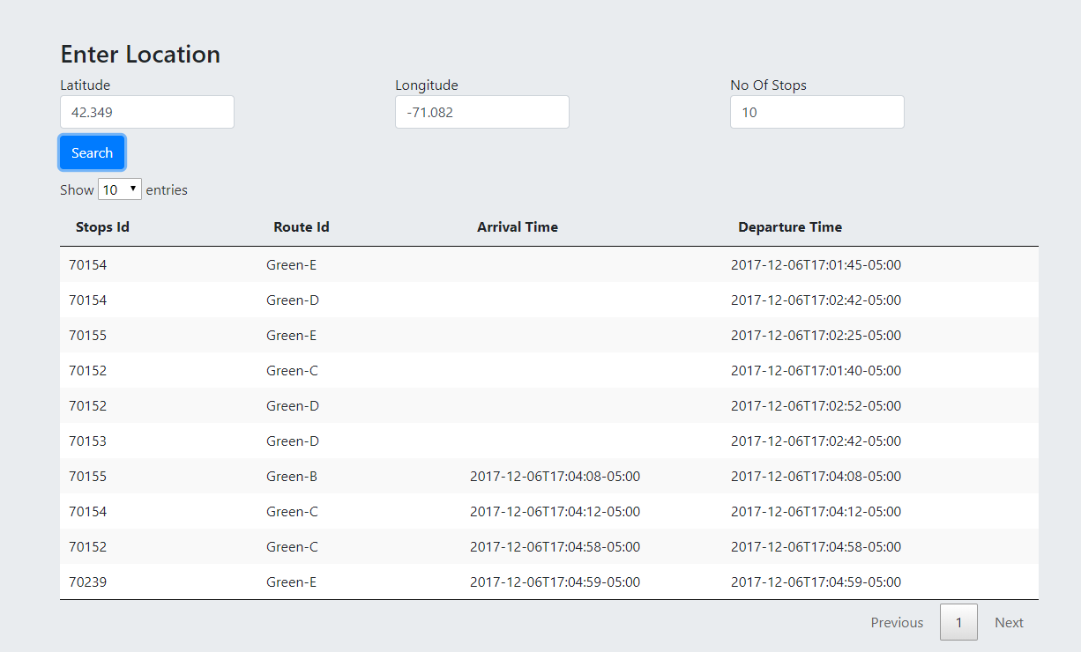

Note there is no validation on this page

I added limit to reduce the number of records because early in the morning you get them all.

The date could be formatted better also.

# Run Application

The application uses maven

If you are using Maven, you can run the application using mvnw spring-boot:run. Or you can build the JAR file with mvnw clean package. Then you can run the JAR file:

java -jar target/mbta-app-0.1.0.jar