**Law School Help Desk**

***a comprehensive guide***

Last updated: June 2019

***Table of Contents***

1. **Introduction**
   1. What to Do Here
2. **Accounts**
   1. Account Lookup
   2. Locked Accounts
3. **Passwords**
   1. Forgot/Change
   2. Clearing Out Old Passwords
4. **Wifi**
   1. Connecting
      1. Mac
      2. PC
      3. Mobile
   2. Troubleshooting
      1. Mac
      2. PC
5. **Printers**
   1. Adding
      1. Mac
      2. PC
      3. Clinics and General Info
   2. Troubleshooting
      1. Mac
      2. PC
6. **General Troubleshooting**
   1. Know when to Google
7. **Phone Calls**
   1. Types of calls
      1. On-Campus Assistance
      2. Off-Campus Assistance
      3. Telemarketers
   2. Phone Functions
8. **Testing Software**
   1. Installation
9. **Miscellaneous**
   1. Signing for Packages
   2. Keeping Tabs on People
   3. Time Entry
   4. Helpful Flowcharts
10. **Introduction**
    1. *What to Do Here*

Working at the Help Desk is, for the most part, a fairly easy job. There are times where you will need to think on the fly to solve problems, but generally you will just be connecting students to the printers and explaining where to find them.

There is a lot of downtime where you will be sitting at the desk waiting for someone to come in with a problem. During this time feel free to read a book, do homework, watch a movie, write a guide on how to do this job, or whatever else keeps you entertained. Just try to look productive to whoever walks by and be ready to immediately help anyone who comes in. If you are using headphones, keep one ear free so you can hear the phone ring or anyone talking to you.

When someone does come in, you should be the first person that interacts with them and asks what they need help with. From there, it is up to you to solve their issue as best you can. This guide should help you with some of the more common issues people need resolved and give you the tools to solve some of the more unique ones.

If you encounter a problem that you are unable to solve, don’t be afraid to ask Bao or someone else for help. Just make sure you watch and learn from how they solve it. Its ok to not know how to fix everything, just make sure to learn from those situations.

Overall, this work study job is one of the best. Sure, it can be a little stressful sometimes dealing with computer illiterate individuals, but the appreciation and gratitude people shower you with for just getting their printer to work make along with the casual office environment make this a great place to work.

1. **Accounts**
   1. *Account Lookup*

Generally, the first thing you should do when someone comes in unable to print or connect to the network is check their account. Most of the time their password has expired, or they changed it recently. To look up an account you will need to be logged into the computer at your desk.

1. **Press WINDOWS + R on the keyboard to open the Run window.**
2. 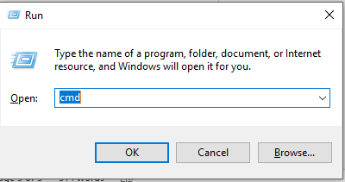**Enter “cmd” to quickly open command prompt.**
3. **Enter in “net user username /domain” to pull up the information about a specific user. (You can abbreviate /domain to /do)**
4. **From the information available you can see when their password was last changed, if their account is locked, and the groups they are in. Make sure to never tell students what their student ID number is.**

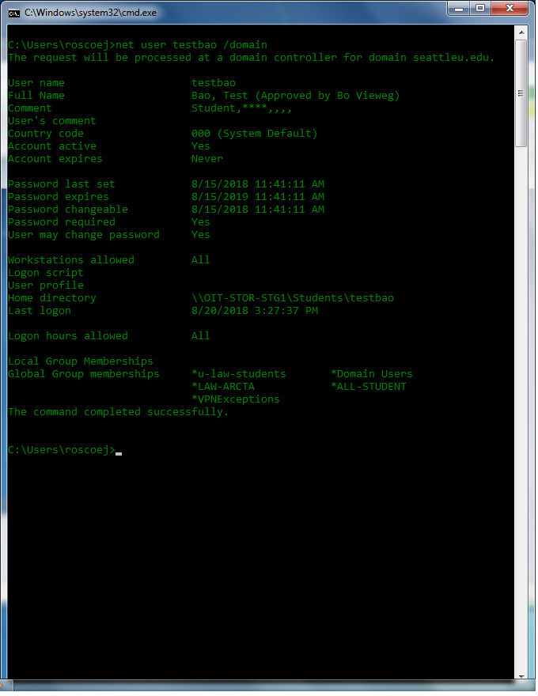

If an account is locked it will say so here.

* 1. *Locked Accounts*

If an account is locked, they will be unable to print,connect to the wifi or access their email or SUonline page. Write down their username and ask Bao or Loren to unlock the account. Make sure they don’t have any old passwords saved on their phone or other devices. Sometimes their phone will try to connect to the wifi with an old password automatically which will quickly lock out their account.

1. **Passwords**
   1. *Forgot/Change*

Hopefully, OIT’s new password policies will reduce the number of people who come in needing to reset or change their password because they forgot it. It used to be passwords expired every 3 months, now they last indefinitely. Someone will still manage to forget theirs, and when that’s the case you need to have them reset it.

1. **(Optional) Try to find their password. Check their Keychain (MAC) / CredentialsManager (PC) and web browser for saved seattleu credentials.**
2. **Plug them into ethernet or have them use their phone to navigate to** [**https://pwreset.seattleu.edu**](https://pwreset.seattleu.edu) **and use the link provided on the site to reset their password.**
3. **If all else fails, you can ask Bao to manually reset their password for them.**
   1. *Clearing Out Old Passwords*

Once someone’s password has been changed, they will need to update it on all their devices. Usually the Wifi will prompt you for a new password, but the printers will need new credentials. For PCs follow the steps in **5.1.2** to reconnect them to the printers. For MACs, simply delete the password from their keychain and then follow the steps in **5.1.1** for printing a test page.

1. **Wifi**
   1. *Connecting*
      1. *Mac*
2. **Click the wifi icon in the top right of their screen.**
3. 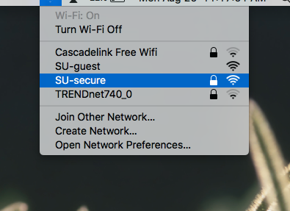**Select SU-secure from the list of availible networks.**
4. 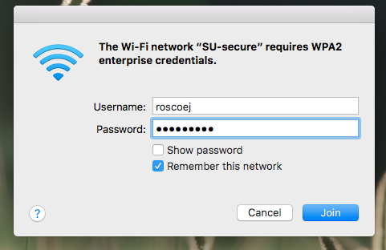**When prompted have them enter in their SU username and password.**
   * 1. *PC*
5. **Click the wifi icon in their taskbar.**
6. 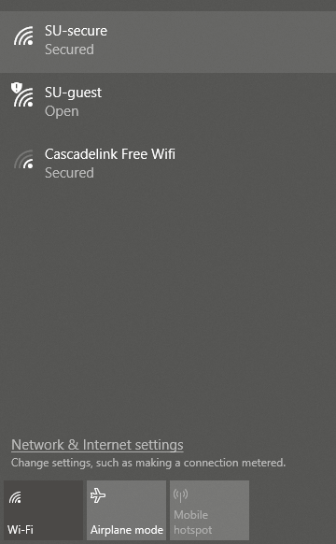**Select SU-secure from the list of availble networks.**
7. **When prompted have them enter in their SU username and password.**
   * 1. *Mobile*

Depending on the phones OS, the steps to connect to SU-secure will vary. Below is the generic approach to take.

1. **Navigate to the phone’s settings and find the Wifi setting.**
2. **Select SU-secure from the availible connections.**
3. **(If needed) EAP method: PEAP**
4. **(If needed) Phase 2 authentication: None**
5. **(If needed) CA Certificate: unspecified**
6. **Identity: just SU username or full email**
7. **(If needed) Anonymous Identity: leave blank**
8. **Password: SU password**
9. **(If needed) Trust the certificate**
   1. *Troubleshooting*

If someone is unable to connect to the wifi, the first thing to check is their account’s status. Make sure they are in the right groups and their account is unlocked. If they are connected but not receiving any internet, make sure that they are not using any VPNs. If they are, they might need to temporarily disable them to use the network. As always, try restarting the machine. If they are able to connect to the Guest network, ask Bao about their account status.

* + 1. *Mac*

Open up the network settings panel and tweak some of the options. Try switching the DNS servers to the ones below or some others, like Google’s or Cloudflare’s.

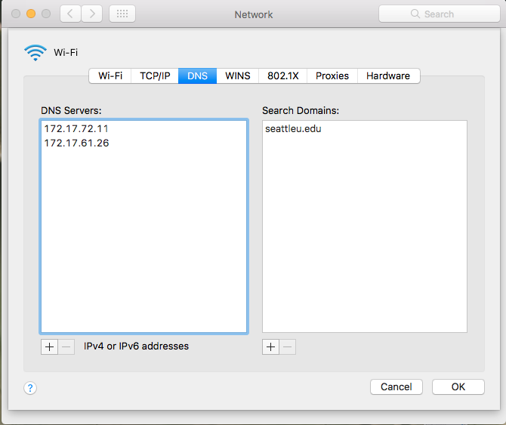

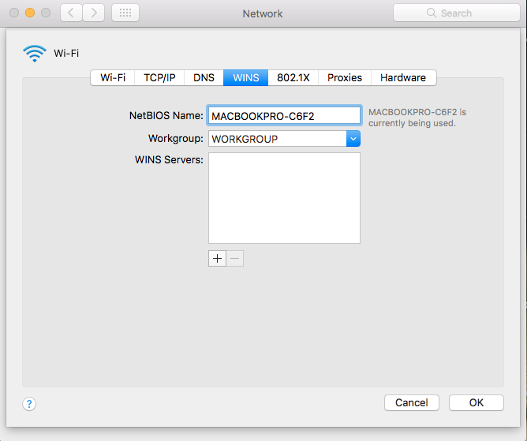

Change their NetBIOS name to their seattleu username

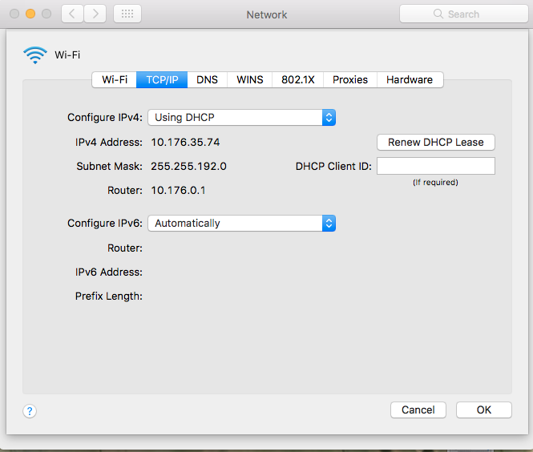

Renew the DHCP Lease

* + 1. *PC*

Right-click the wifi icon and run the troubleshooter. Follow any steps it reccomends. Restart if that fails.

**5. Printers**

5.1 *Adding*

5.1.1 *Mac*

About 70% of the students seem to own Macbooks, so you should get familiar with this section.

1. **Make sure the machine is connected to SU secure wifi. In order to connect and use the printers they cannot be on any other wifi network.**
2. 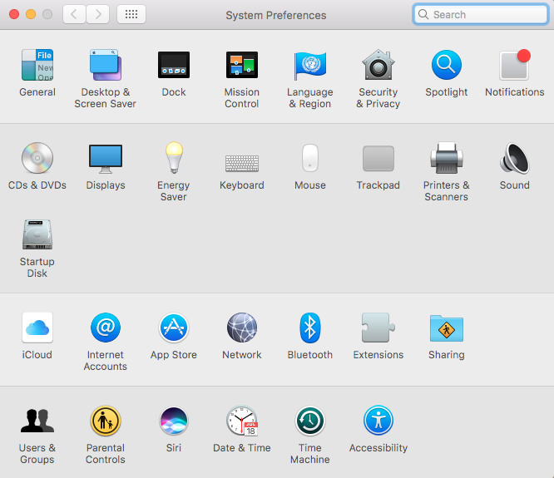**Open up System Prefences and select Printers & Scanners**
3. 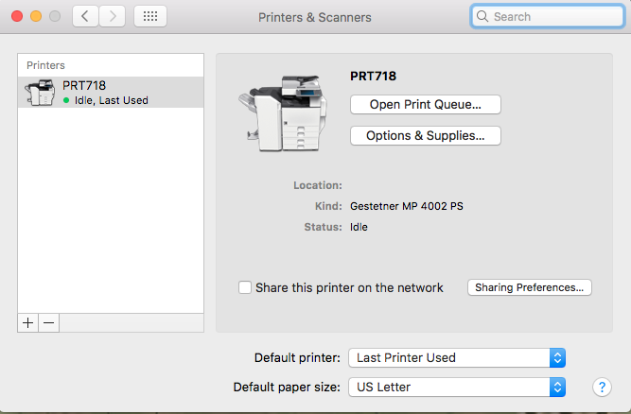**Click the plus at the bottom of the printer list to open up the Add a Printer menu.**
4. **Cmd-Click, Double Click, 2 Finger Click, whatever works on the top bar. Select Customize Toolbar.**

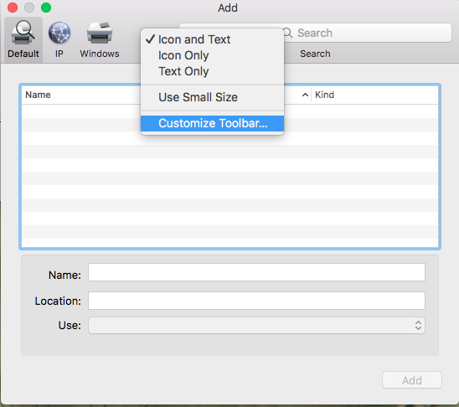

1. 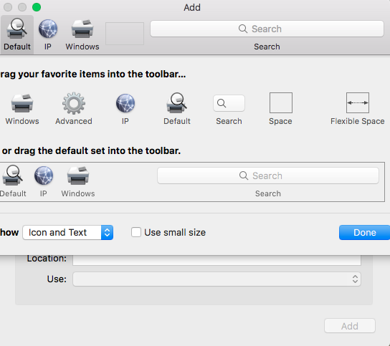**Drag the Advanced gear into the top bar and select it.**
2. **There are three standard printers to add: DDC, LIB3, LIB4. Fill out the fields verbatim. *Do not* put the students actual username and password in place of ‘username:password’. Also note fplawstudnts001 *is not* fplawstudents001.**

Type: *Windows printer via spools*

Device: *Another Device*

URL:

* *username:password@fplawstudnts001.seattleu.edu/****DDC***
* *username:password@fplawstudnts001.seattleu.edu/****SLLHLIB3***
* *username:password@fplawstudnts001.seattleu.edu/****SLLHLIB4***

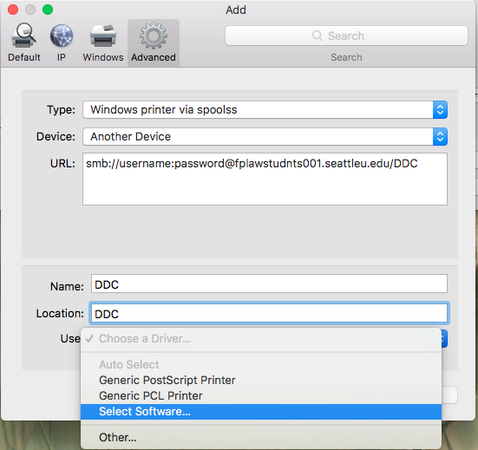Name:

* DDC
* LIB3
* LIB4

Location:

* DDC
* LIB3
* 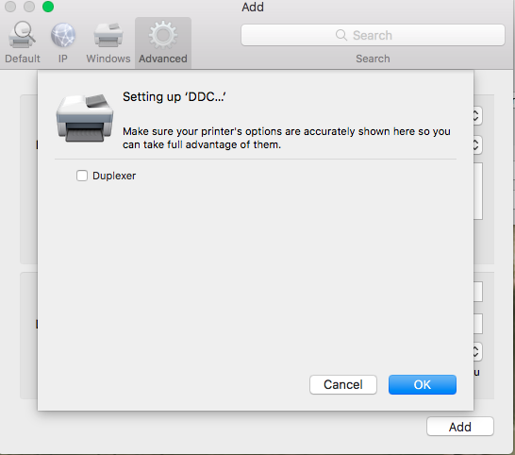LIB4

Use: *Select Software -> Search “pcl” select HP Laserjet Series PCL 4/5*

1. **Click next and check the Duplexer box.**
2. **After adding all 3 printers, open the print queue for the DDC and print a test page.**
3. **In the box that pops up have the student enter in their SU username (first part of their email) and SU password**
4. **Once the test page prints they are good to go.**

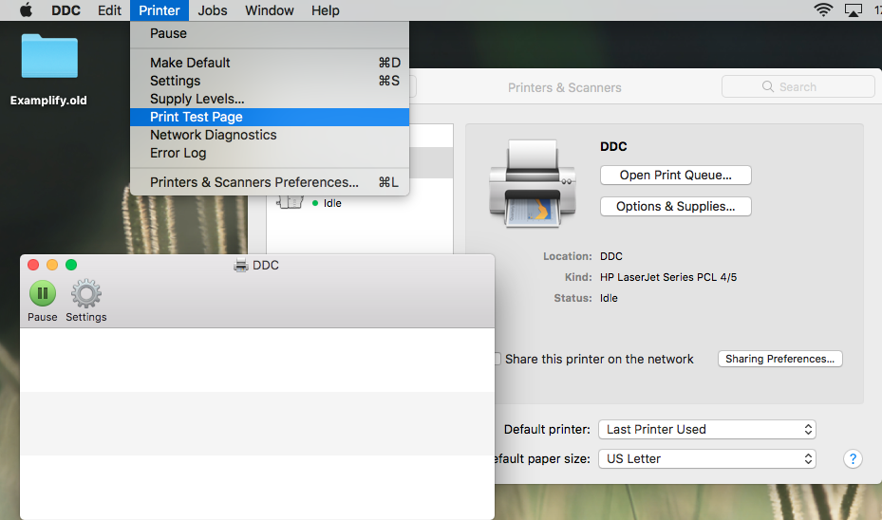

5.1.2 *PC*

1. **Make sure the machine is connected to SU secure wifi. In order to connect and use the printers they cannot be on any other wifi network.**
2. **Hit the [Windows Key] + [R] at the same time to open up the Run box.**
3. **In the box type** *//fplawstudnts001* **and hit enter**
4. **A dialog box should pop up. In the username box type** *seattleu* **followed by the student’s SU username. In the password box have the student enter their SU password and hit enter.**
5. **A File Explorer window should pop up. Right click the DDC, LIB3, and LIB4 and hit connect for each. The LIB printers might take a little while to connect but after all three are installed, the student is good to go.**

5.1.3 *Clinics and General Info*

Some students take special classes that allow them access to a set of printers called the Clinic Printers. Depending on what clinic they are in, they will need to be connected to either Clinic1 or Clinic2. For PC, in the run box type: //law-clinic/*either Clinic 1 or 2* and then follow step 4. For Mac, use the URL:

*username:password@law-clinic.seattleu.edu/Clinic 1 or 2*

The DDC is located on the first floor of the library, which is on the second floor of the building. As soon as they walk in, it will be down the hall on the right.

Library 3 and 4 are on the second floor of the library.

Students get $37.50 worth of printing credits for the year. If they run out they can add more money at the business office on the second floor at the cost of $0.05 a page. They will be given a yellow recipt that they bring to you, which you in turn give to Bao, Loren, or Kyle to add.

5.2 *Troubleshooting*

5.1.1 *Mac*

Generally, if someone cannot print they either:

1. Have an old password stored in their keychain
2. Are out of money
3. Are trying to print with the wrong page size

First, clear out their keychain and print a test page. Make sure the printer is not paused and they are trying to print in 8.5 x 11.

Next, Have Bao, Loren, or Kyle check their balance and account permissions.

If they still cannot print, delete and re-add the printers.

5.1.2 *PC*

Follow the same flow as Mac, but instead of deleting password, try to connect to //fplawstudnts001. If the password is wrong, it will prompt for a new one.

1. **General Troubleshooting**

6.1 *Know when to Google*

The key to being good at this job is accepting you don’t know everything, but being able to find solutions to problems on the fly. Theres not one best way to do this, but I suggest appearing like you know what you are doing while looking up the problem symptoms online. A good rule of thumb is spend about 3-5 minutes trying to fix it yourself before asking Bao for help. When she comes out, watch what she does to fix it so you know what to do next time.

1. **Phone Calls**

7.1 *Types of Calls*

There are generally three types of calls you will receive at the desk. Always answer the phone by indentifying that you are the Law School Help Desk.

7.1.1. *On-Campus Assistance*

These are usually calls by professors that need help connecting their computer to the projector. Either try to talk them through how to do it, or send a media person to their classroom.

7.1.2. *Off-Campus Assistance*

These are require a bit more effort and are for a variety of issues. Take time to listen to their problem and then try to help them solve it. It is ok if it takes you 20 minutes to solve the problem, just don’t get exasperated with them.

7.1.3. *Telemarketers*

Hang up.

7.2 *Phone Functions*

You will get a lot of calls asking for Bao or someone else. If they are in the office, you can put them on hold by pressing the horizontal phone button to the right of the phone screen and letting whoever they are trying to reach know. Alternatively, you can transfer the call to them by pressing the transfer button (sorry no pictures of buttons yet but it is also on the right) and then typing in the target’s 4 digit extension. Once they answer the phone there will be an option on the screen to complete the transfer.

1. **Testing Software**

8.1 *Installation*