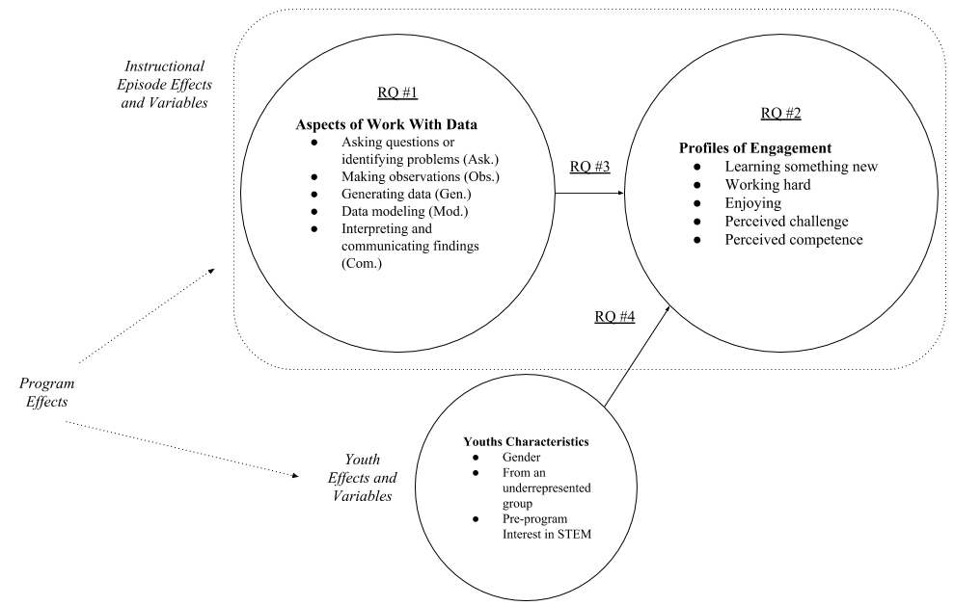

Figure 1. A conceptual framework for this study and research questions.

.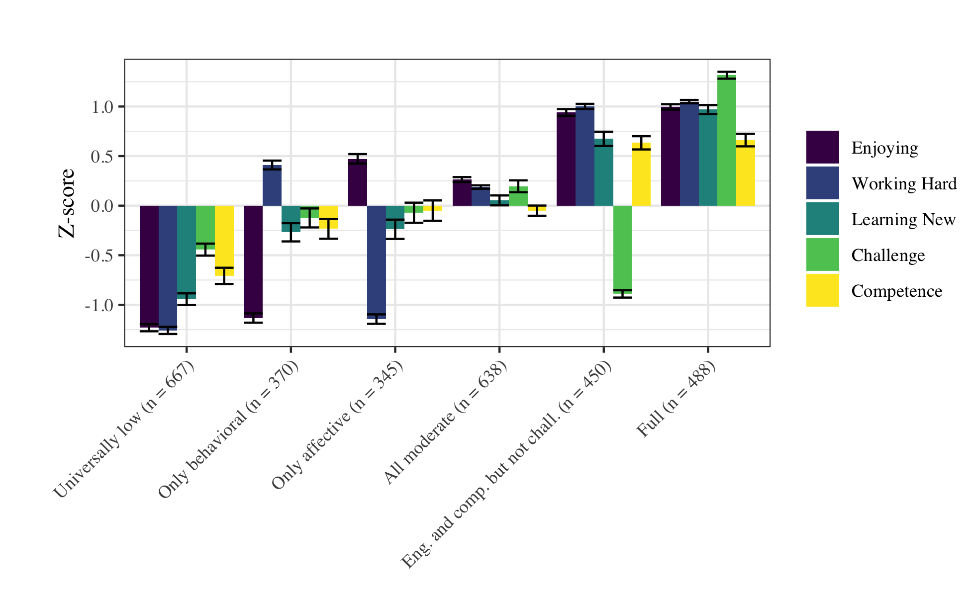

Figure 2. The six profiles of engagement (with variable values standardized)

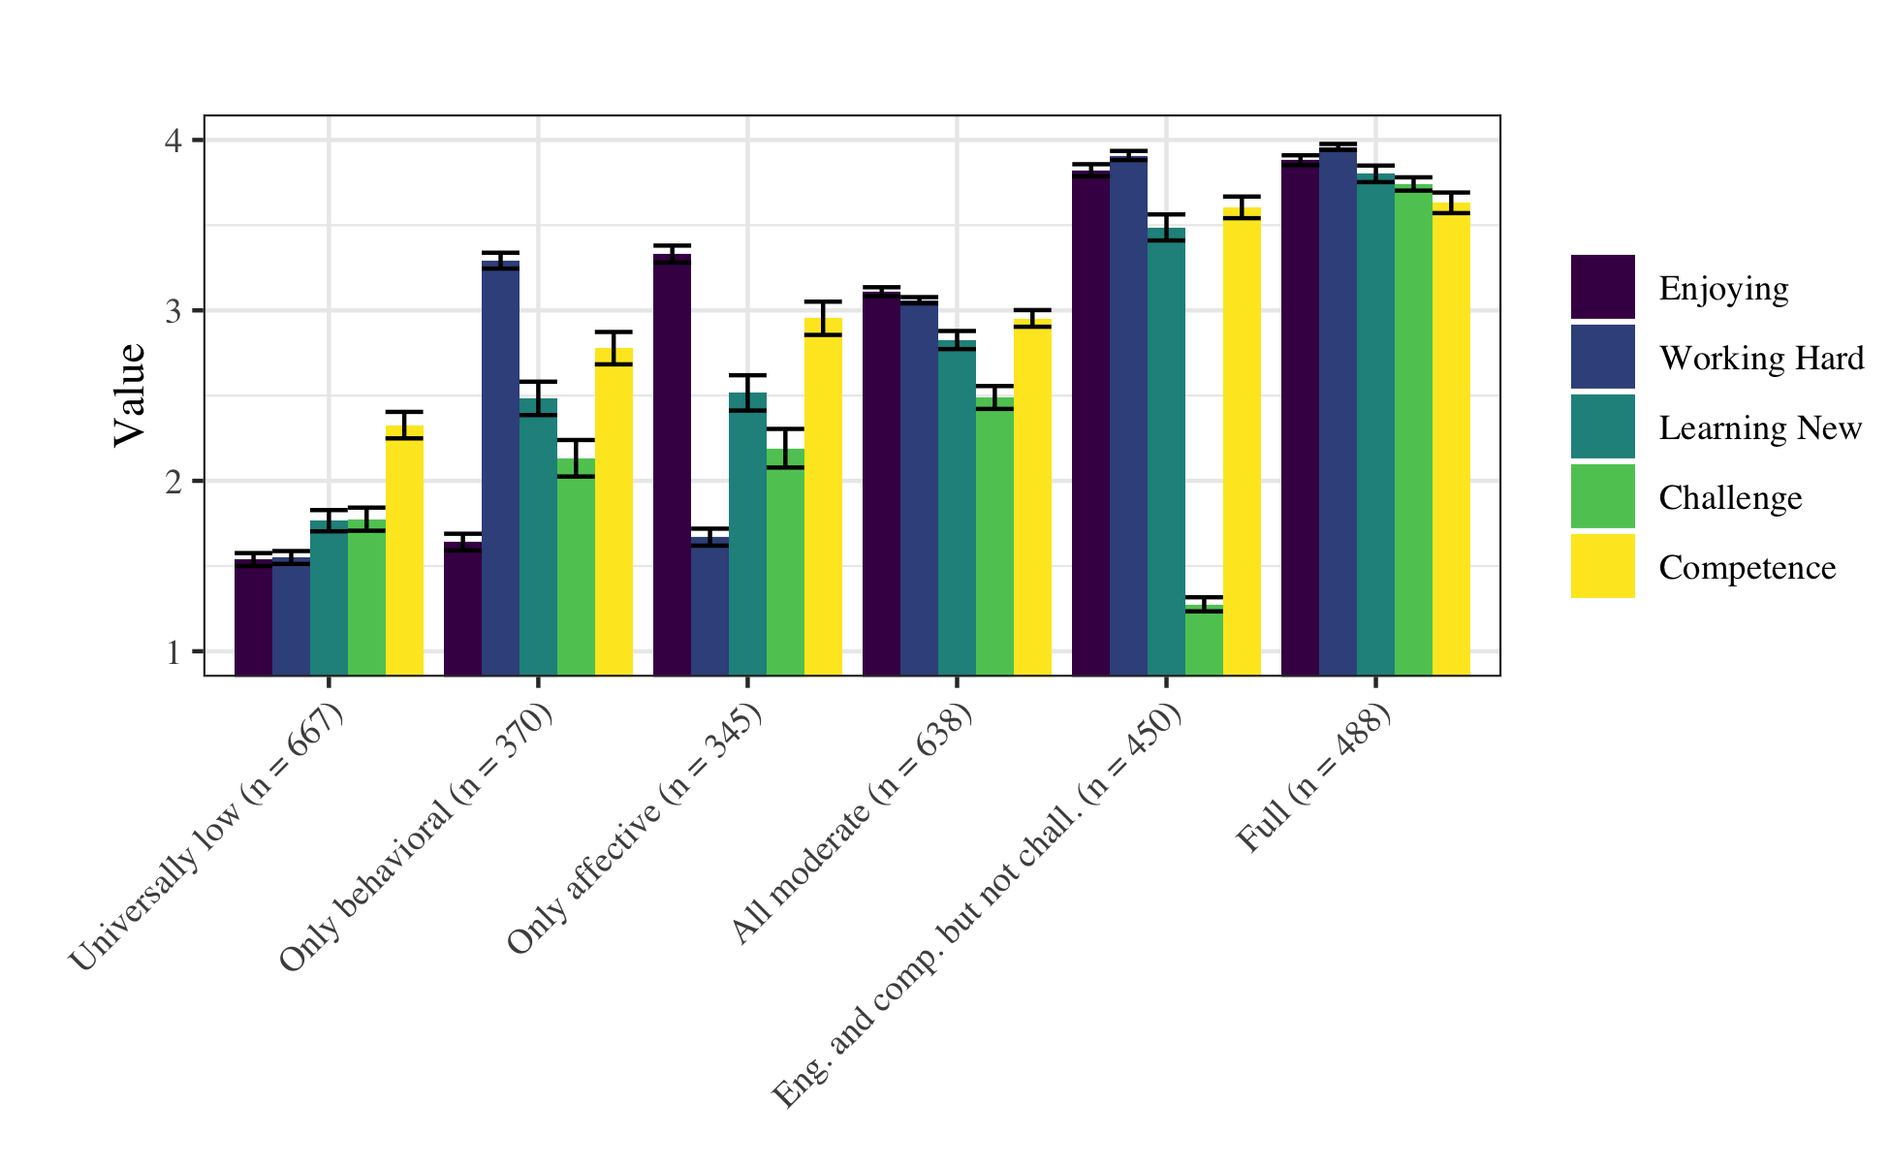

Figure 3. The six profiles of engagement (with raw variable values)



Figure 4. Sources of variability for the six engagement profiles at the instructional episode, youth, and program levels.