Distance from Start | Description
0.0 | Start on the Alum Cave Trail. Almost immediately cross a bridge over the West Prong of the Little Pigeon River.
0.1 | Continue on the trail, now along Alum Cave Creek. The trail gradually climbs up a wide, scenic pathway, occasionally crossing
0.6 | Fun spots to splash in the creek abound around this section. Pick one and cool off in warmer weather!
1.3 | Cross a bridge and then climb up the stairs through Arch Rock. This is an optional point at which to turn-around and return to the start.
1.4 | Cross a footlog and enter a different part of the hike, one where you will ascend more steeply (though the trail remains moderately steep here).
1.9 | Reach inspiration point, a rocky prominence and scenic overlook — and a great point to pause or return back to the start, though the bluffs are only a bit further.
2.2 | Steep climb up stairs. Almost there!
2.25 | Alum Cave Bluffs. Rest, soak in the views, and get ready for the return hike (almost all downhill!). The trail to Mount LeConte continues past the bluffs.
4.5 | Trailhead.

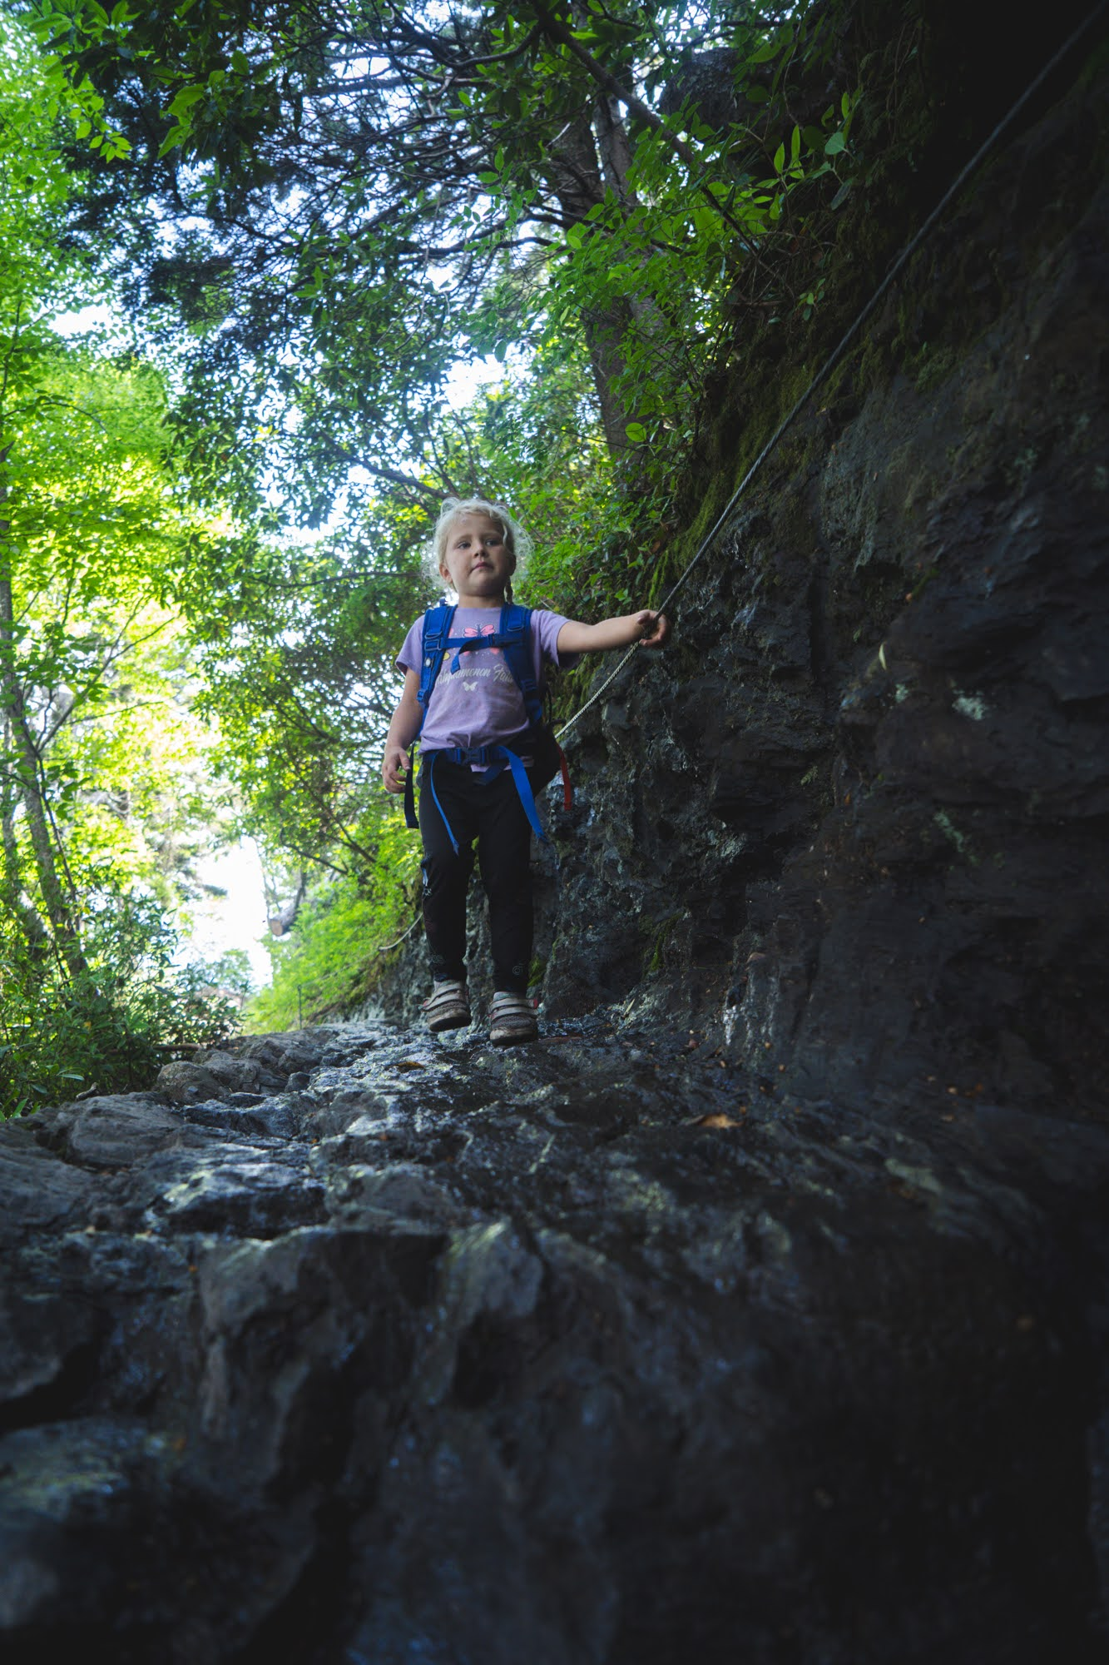

**insert trail-28-figure-02**

