Another gem among Knoxville city parks. The trail starts at a large parking area near the restroom building and walks towards the river. It follows the river past open fields, trees, and bushes that are practically impossible for kids not to explore. The trail cuts up toward the greenway and hikes past Indian burial mounds and the old (many large) houses along the path before returning to the start. In mild weather, it is a fantastic spot to hang up a hammock, go fish, have a picnic, or toss a frisbee or a football. Good for kids of all walking ages; alternate ways to access the greenway make it easy to create a shorter loop.
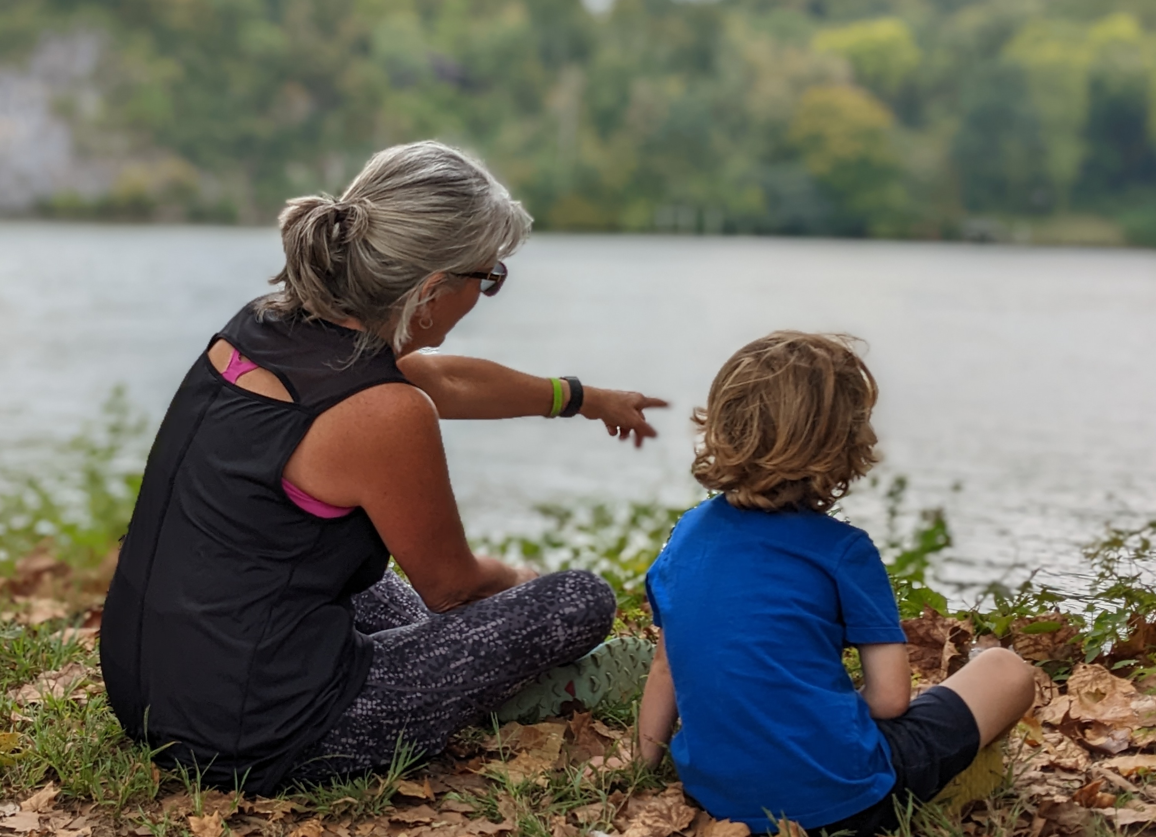
**insert trail-07-figure-01**

