Distance from Start | Description
.3 | Find a bench to play on
1.0 | Bridge crossing!

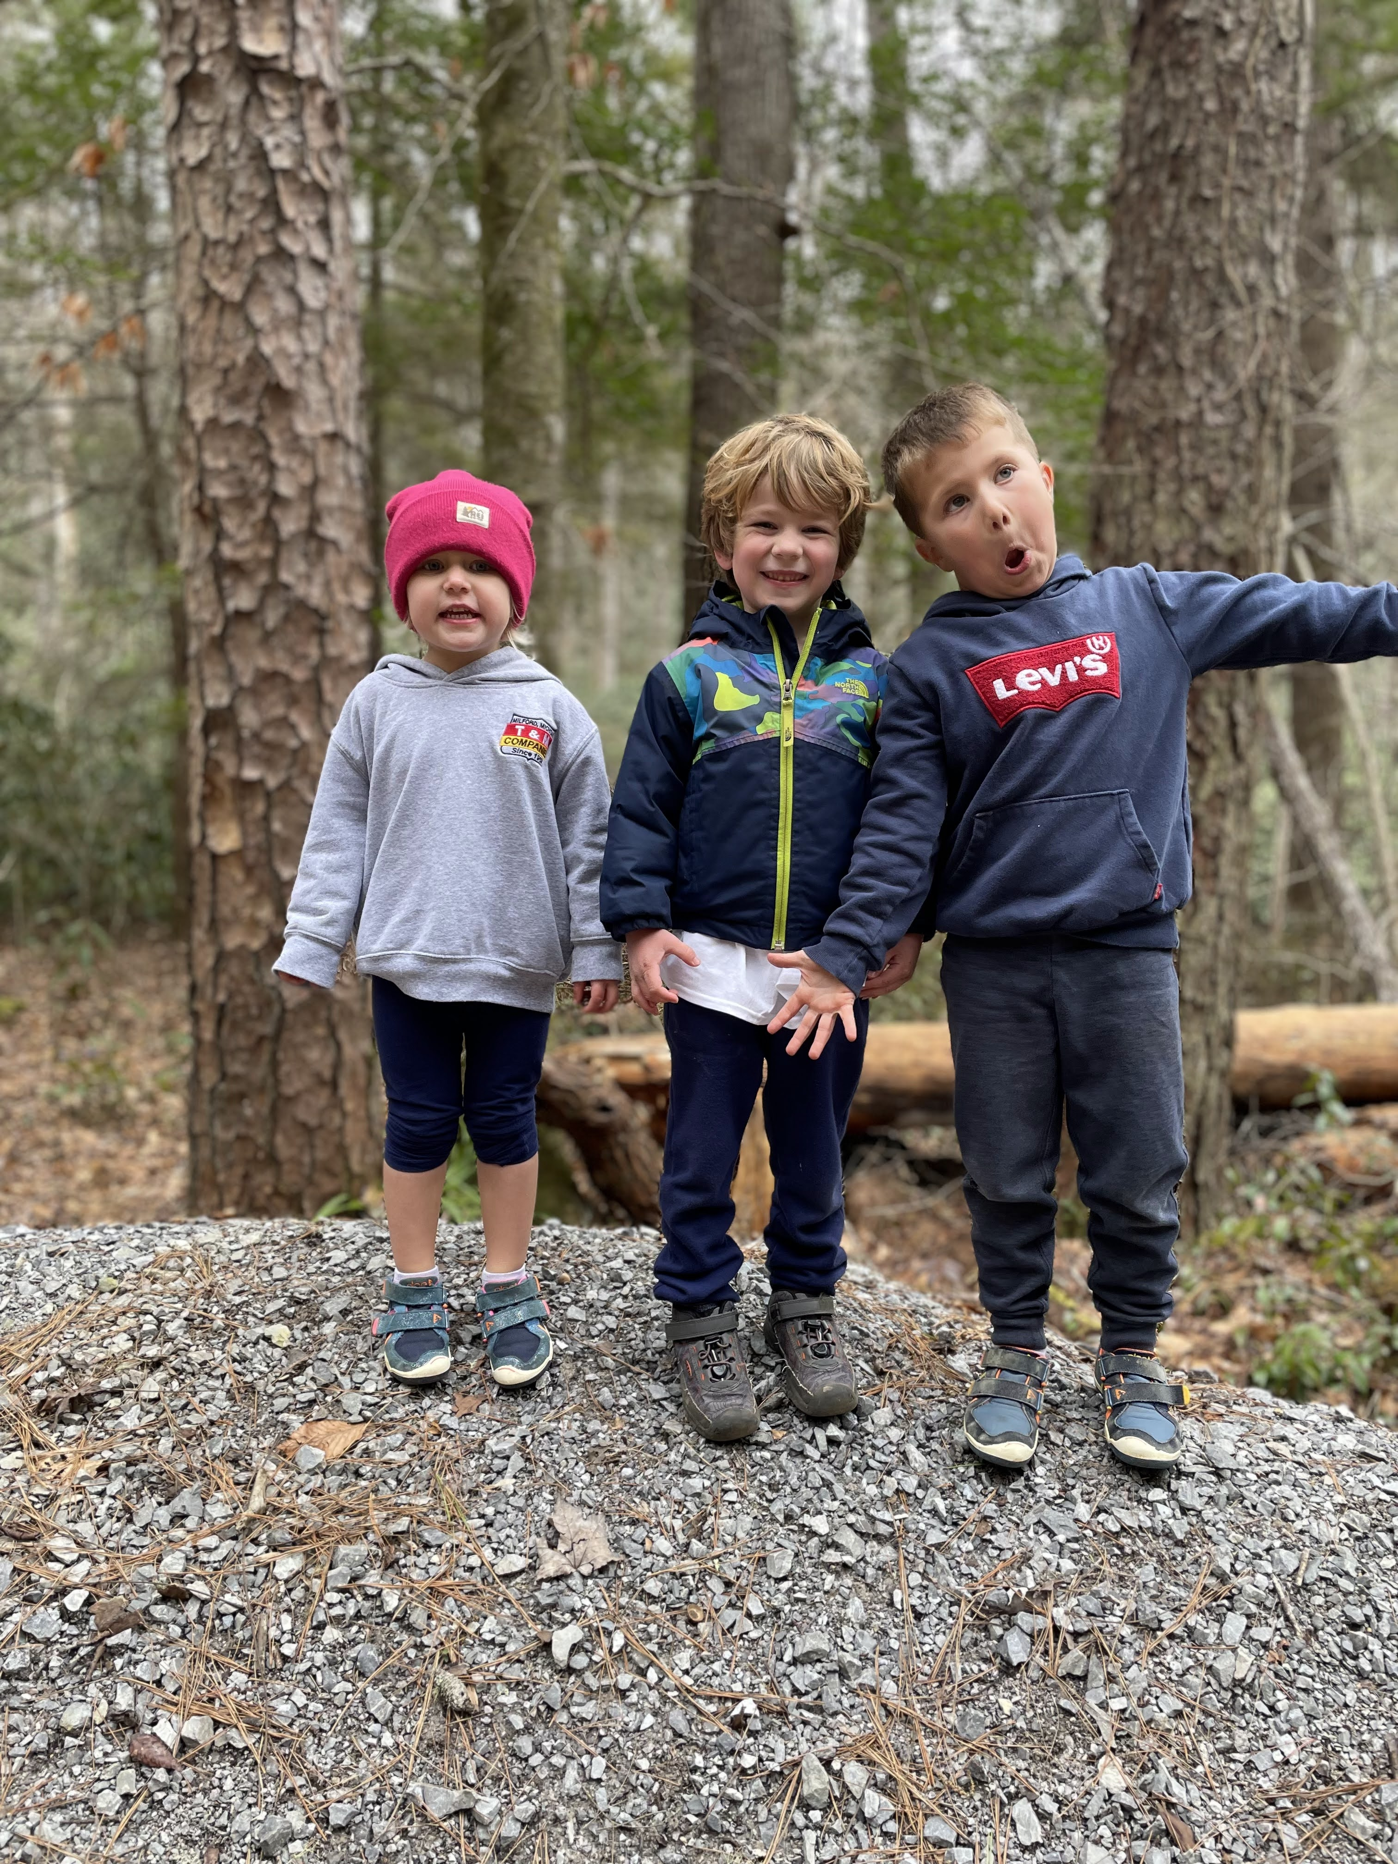
**insert trail-23-figure-02**

