Unreal! This trail features rope ladders, wooden ladders, gigantic sandstone walls, a scenic overlook, a trail that traverses *up* a river, and boulders you crawl over and through. It's spectacular and challenging. A memorable trail that exemplifies what makes the Cumberland Plateau region such a worthy complement to the Great Smoky Mountains National Park. Younger children may be able to hike the first half (traveling counterclockwise from the trailhead); you can walk the road back to the trailhead. The second half of the trail contains more challenging (but very beautiful) sections. Still, it's hard — probably the most difficult for most in this book.
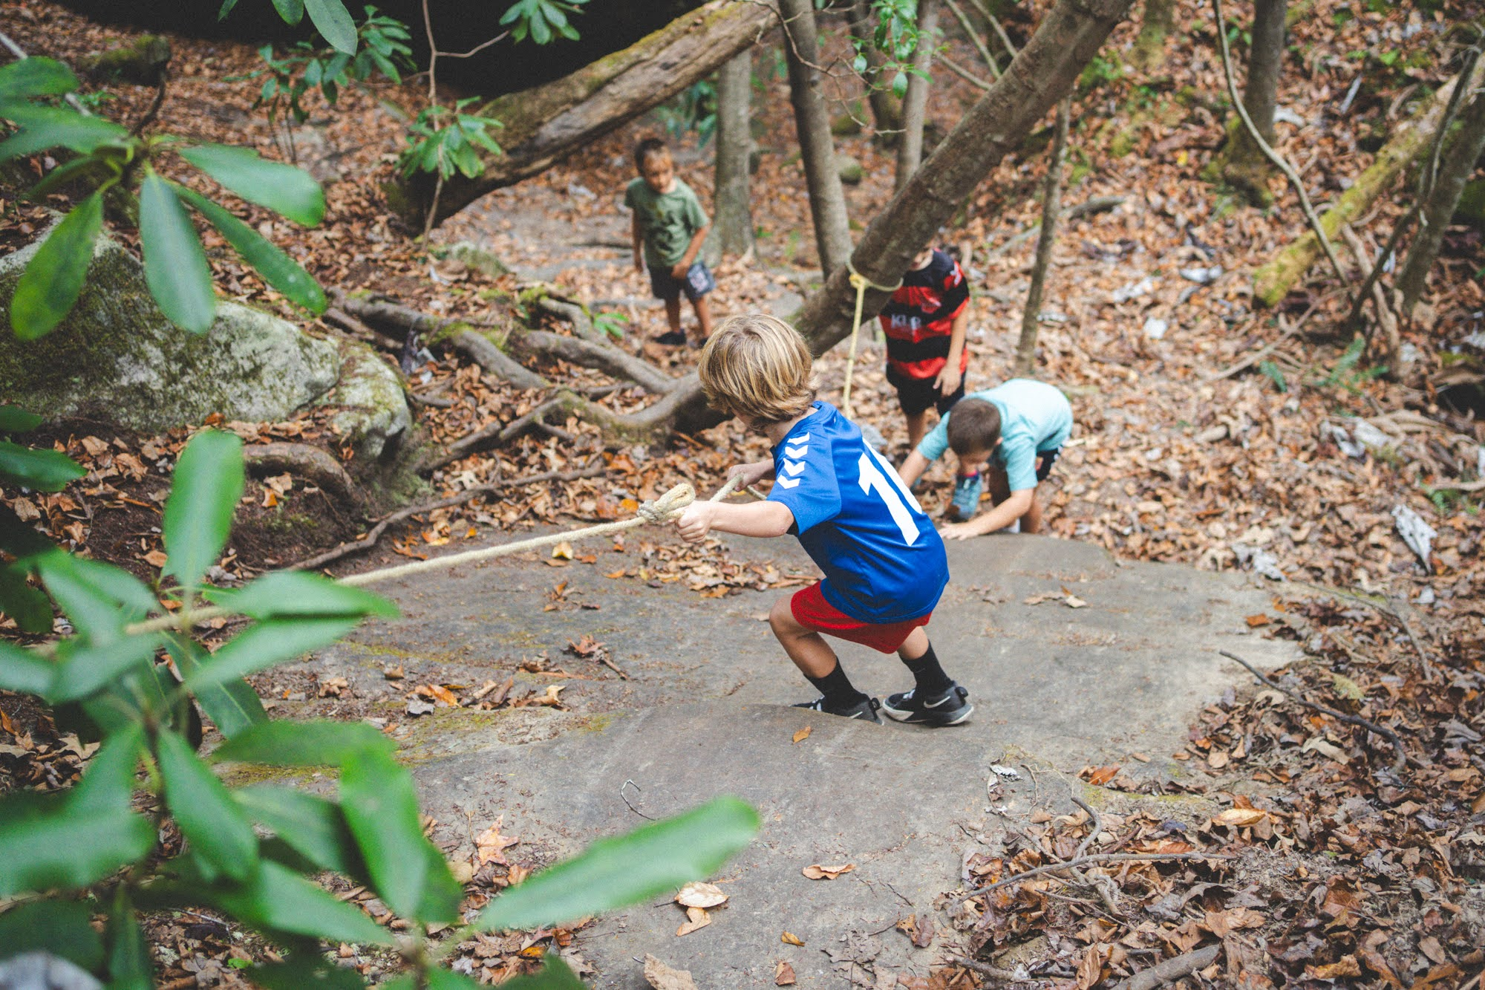
**insert trail-18-figure-01**

