Distance from Start | Description
.3 | Find a bench to play on
1.0 | Bridge crossing!

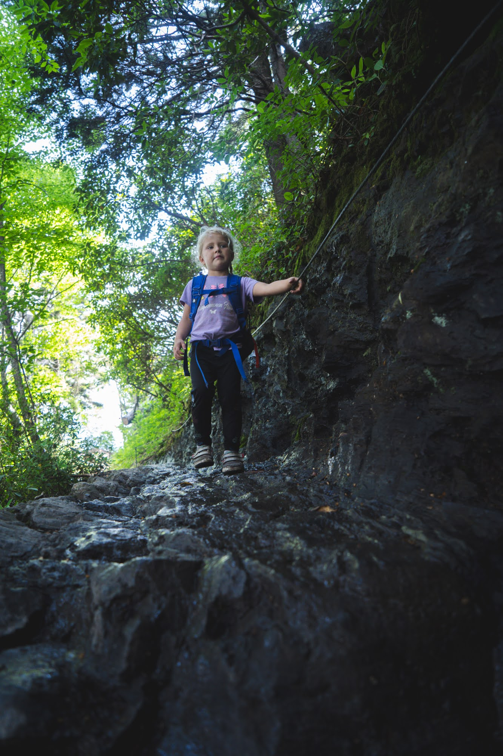

**insert trail-28-figure-02**

