
1. Project Student Upload Page
Follow the below steps
- Log in using Institute User.
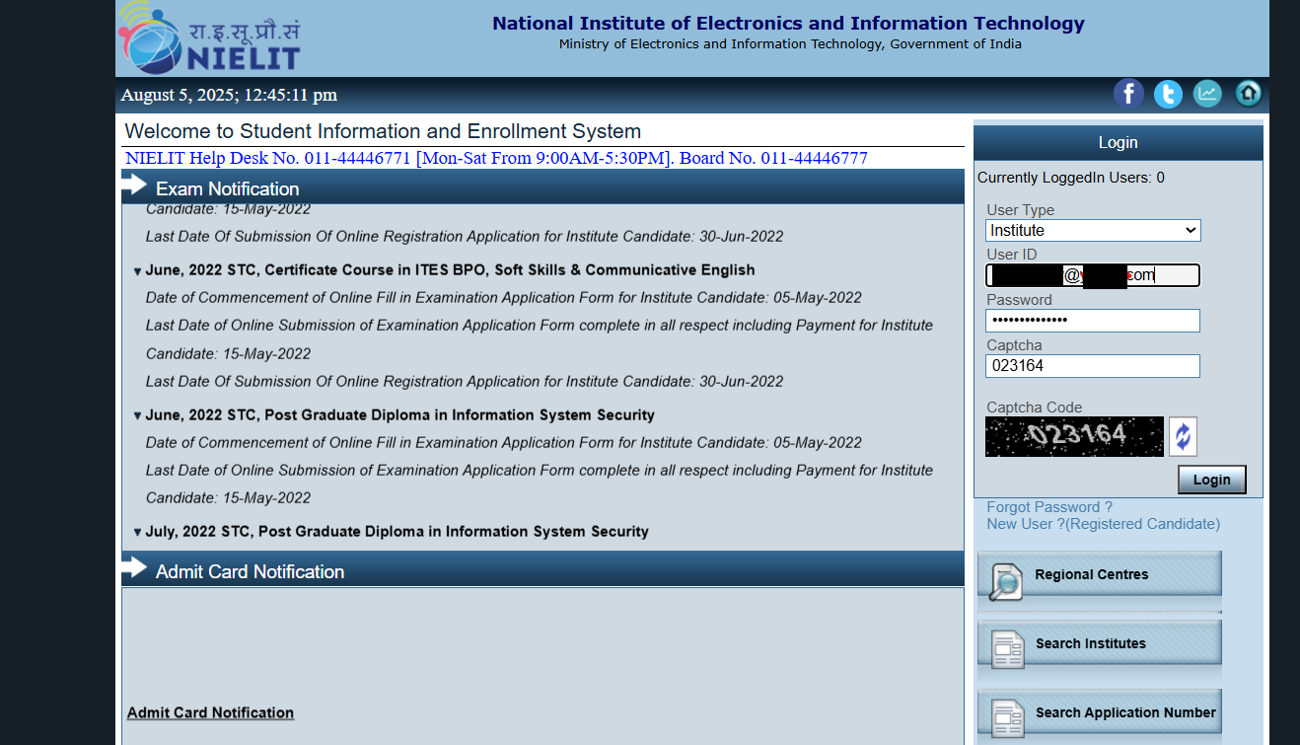
Figure 1.1: NIELIT Student Portal Home Page
- After successful login, User’s dashboard will be displayed as shown below.
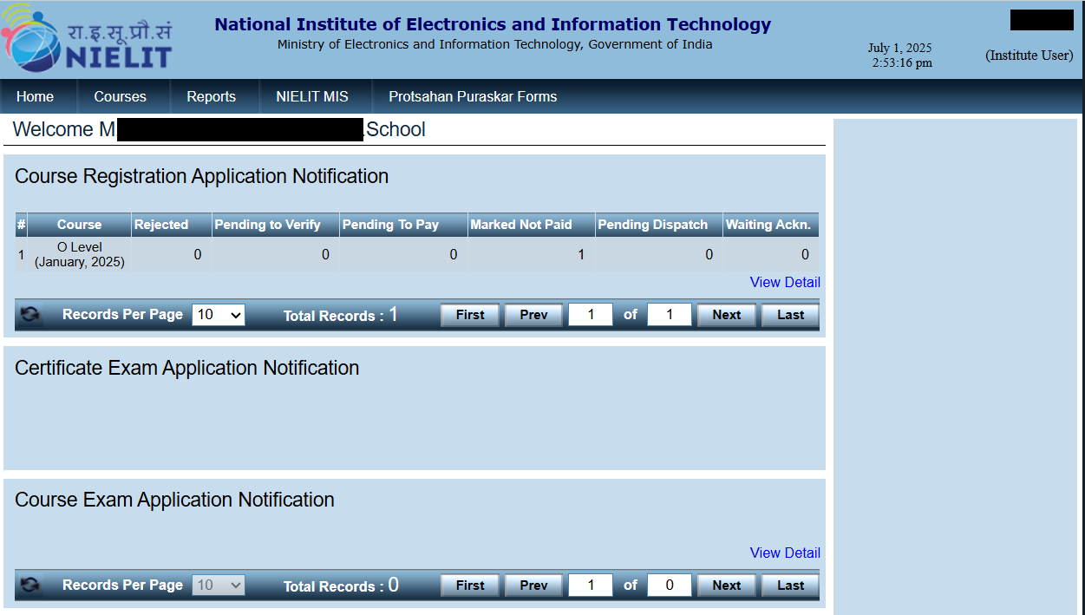
Figure 1.2: NIELIT Institute Login
- Go to “Courses” -> “Upload Project Student Data” menu item.
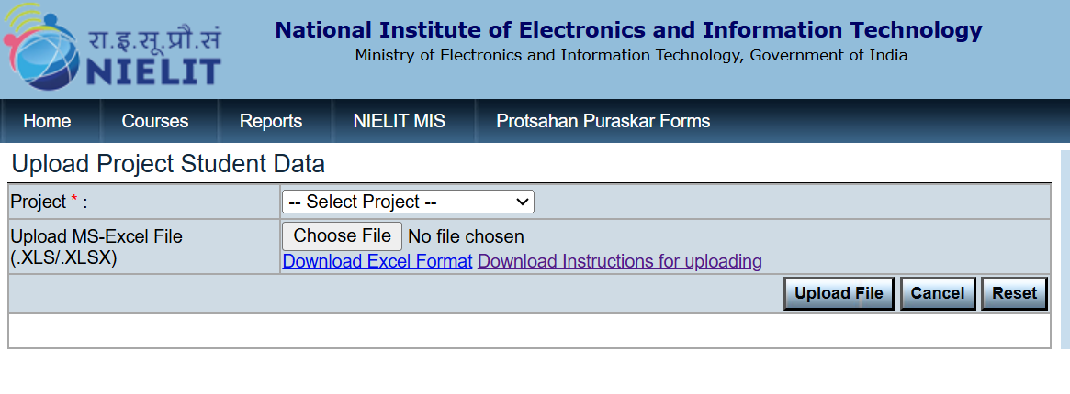
Figure 1.3: Upload Project Student Data Home Page

- Now, Select the Project for Data Upload.
Important: You must first download the Excel Format from the provided link and enter data exactly as per the existing fields. Do not rename, reorder, or alter any columns—any deviation may result in incorrect or rejected data.
Additionally, you must download the Instruction File and strictly follow every guideline mentioned. Failure to follow these instructions will lead to processing errors and invalid uploads.
Then click on ‘Browse’ and Choose the Respective .XLS /.XLSX file to be uploaded.
- Then click on “Upload File”.
IN CASE ALL DATA IS VALID and according to FORMAT specified.
Successful Count = No. of total rows, with 0 failures.
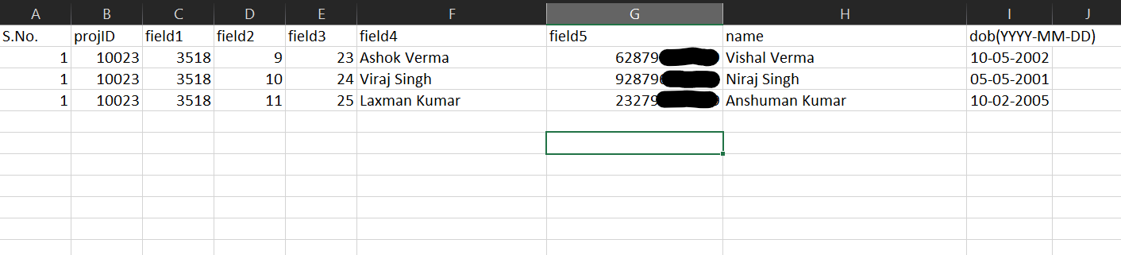
Figure 1.4 Valid Data Sheet
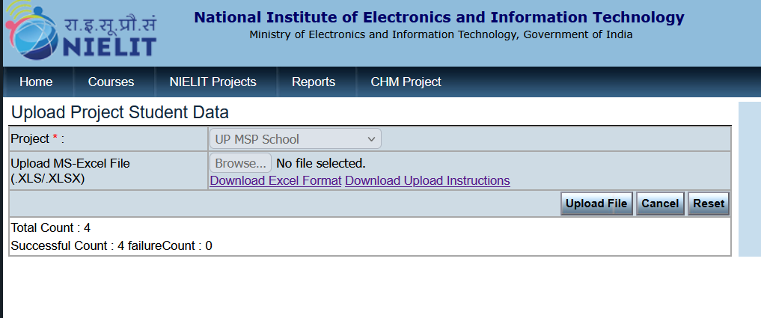
Figure 1.5: Upload Project Student Data page, showing the successful uploading of data

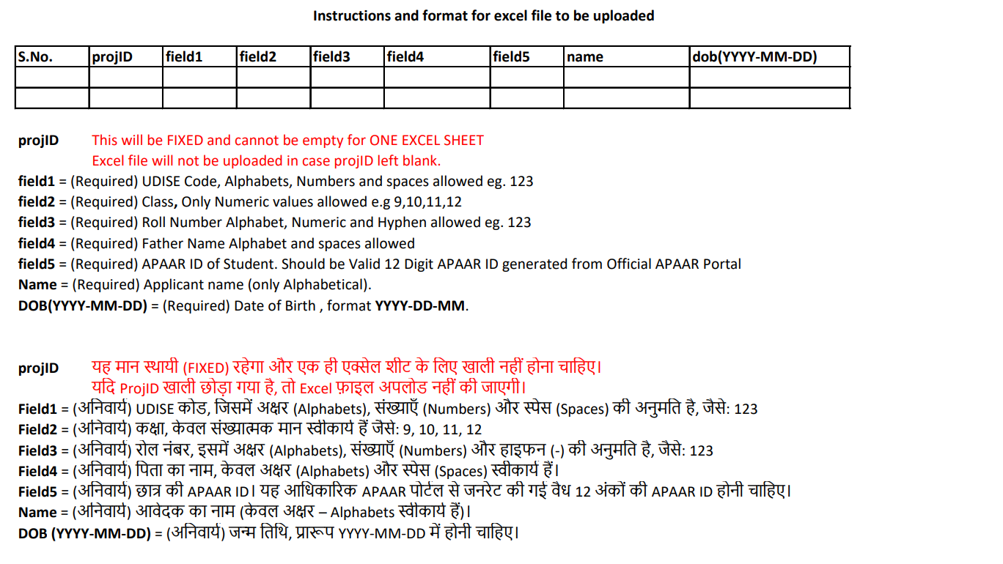
Figure 1.6: Instructions to Upload Excel File.
In case, Entered data is invalid, Alerts will be shown, each alert is explained below, with its reason.
- Please choose .XLS/.XLSX extension file: File other than Excel Format .xls/.xlsx is selected, kindly upload .xls/.xlsx file only.
- Kindly upload Excel File with correct fields only: Excel File uploaded but fields are not in proper format or not according to the mentioned format (See ‘Download Instructions for uploading’).
or sheet is empty or some Columns values are invalid.
- Project ID mismatch in uploaded data. : The Project ID in the uploaded file does not match the selected Project from the dropdown, is either missing, or varies across rows. The Project ID must be identical for the entire column.
- UDISE Code and Accreditation Code do not match for UP Project. : If ‘UP School’ Project is selected, the sheet must have same UDISE Code and Accreditation Code
- Inconsistent Values for Field1: values differ in field1(UDISE Code) column, or is empty. It must be same throughout the column.
- Inconsistent Values for Field5: values differ in field5(ACCR code) column, or is empty. It must be same throughout the column.
- Conditions Not Defined. Please contact NIELIT Head Office: Project not present in criteria. Kindly Contact Head Office for this issue.
- One or more Accreditation Number entered does not exist in Database: Accreditation number of Institute mentioned in sheet does not exist.
- UDISE Code and Accreditation Code do not match for UP Project : In case of UP Project, field1 (UDISE Code) and field5 (Accreditation Code) are incorrect.
- Missing Values Found Error. Please Check and Reupload : Empty Sheet uploaded or some critical fields missing.
- Errors in uploaded file, Kindly check Date Format and Other fields: if the sheet uploaded, have Dates in incorrect format.
If no Alerts are shown, but data has still errors, Failure Count number will increase, the count represents rows failed.
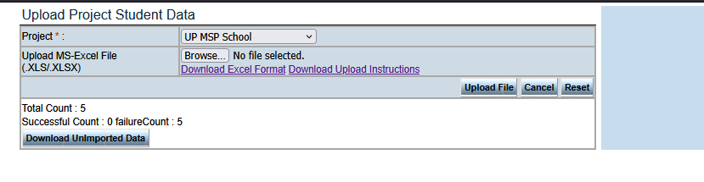
Figure 1.7: Incorrect Data, is collected in Unimported Data.
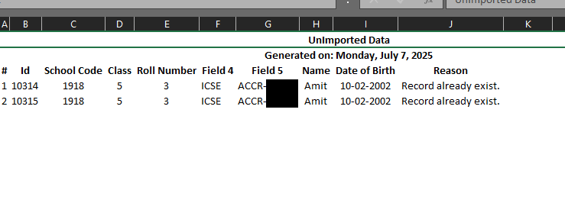
Figure 1.8 Unimported Data Sheet with Errors.
. After every upload, please click “Reset” button , to upload the next sheet.

2. Student Registration Page
Step 1. On selecting ‘Through Institute’, the user will be prompted with an option ‘Whether student belongs to Project’ (Yes/No)
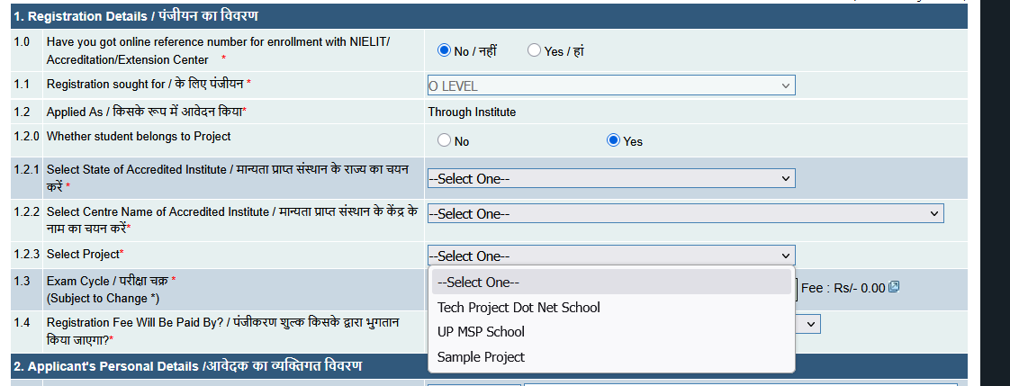
Figure 2.1 Registration Page demonstrating Project Dropdown.

Step 2. On Choosing Yes in Step 1, He will be given “Select Project” option (Dummy Projects are given here for Demonstrative Purposes)
Step 3. User can choose a Project and Fill data accordingly.

Form Preview Page
All the data filled on the Registration page will be shown here.
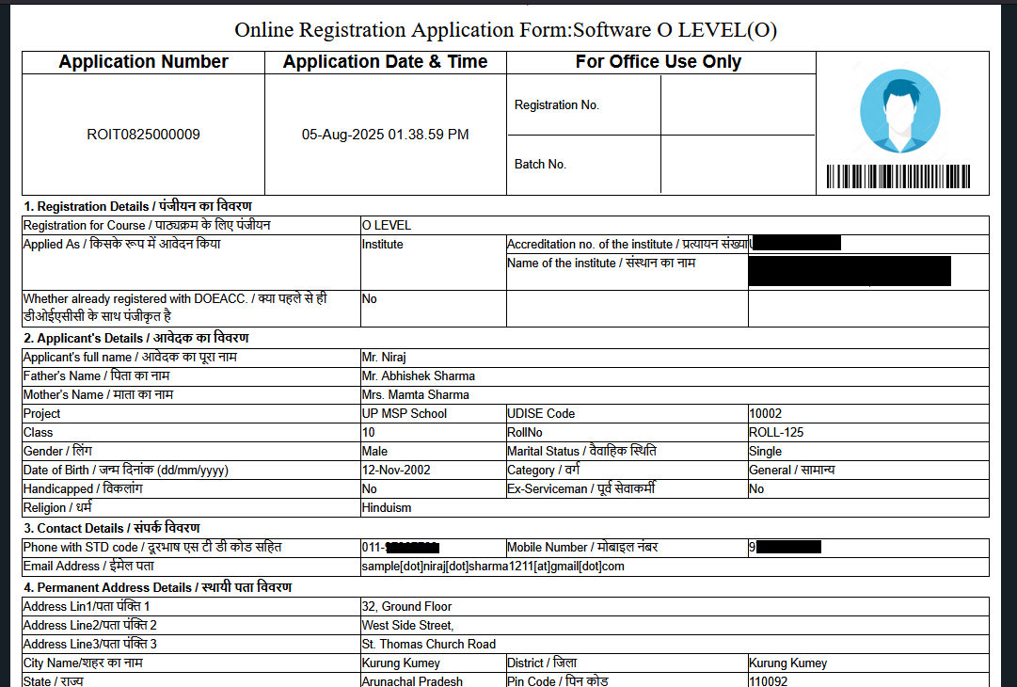
Figure 2.2 Form Preview page, showing entered data of Candidate

Submit Page
After Clicking on Final Submit button, the user is forwarded to Payment Details page, where Application number of user is generated.

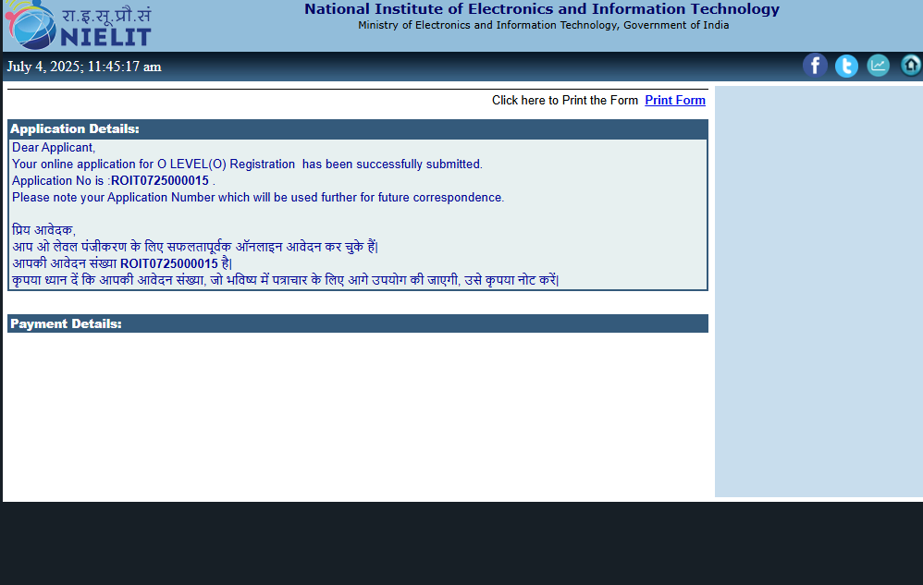
Figure 2.3 Payment Details Page

