Josh Pavoncello

Chris Enck

Type Checker

Project Documentation

**Work Distribution:**

Chris Enck: Wrote second half of the type Check methods, prepared the project documentation, prepared, tested, debugged, and took pictures of test cases.

Josh Pavoncello: Wrote first half of the type check methods for the AST, tested, debugged, prepared the readme.txt, and commented the code.

**Test Input/Results:**

# testArray.csx

# Tests/TestCasesAndResults/ArrayResults.png../TypeChecker/Tests/TestCasesAndResults/ArrayTest.png

# TestExpr.csx

# Tests/TestCasesAndResults/ExprResults.png../ExprTest.png

# TestForLoop.csx

# Tests/TestCasesAndResults/ForLoop1Results.pngTests/TestCasesAndResults/ForLoop1Test.png

# TestForLoop2.csx

# Tests/TestCasesAndResults/ForLoop2Results.png../TypeChecker/Tests/TestCasesAndResults/ForLoop2Test.png

# TestFunctionCall2.csx../TypeChecker/Tests/TestCasesAndResults/FunctionCall2Results.png../TypeChecker/Tests/TestCasesAndResults/FunctionCall2Test.png

# TestFunctionCall3.csx../TypeChecker/Tests/TestCasesAndResults/FunctionCall3Results.png../TypeChecker/Tests/TestCasesAndResults/FunctionCall3Test.png

# TestFunctionCall4.csxTests/TestCasesAndResults/FunctionCall4Results.pngTests/TestCasesAndResults/FunctionCall4Test.png

# TestFunctionCall.csx

# ../TypeChecker/Tests/TestCasesAndResults/FunctionCallResults.png../TypeChecker/Tests/TestCasesAndResults/FunctionCallTest.png

# TestIfElse1.csx

# Tests/TestCasesAndResults/IfElse1Results.pngTests/TestCasesAndResults/IfElse1Test.png

# TestIfElse2.csx../TypeChecker/Tests/TestCasesAndResults/ifElse2Results.png../TypeChecker/Tests/TestCasesAndResults/IfElse2Test.png

# TestIncrementDecrement.csxTests/TestCasesAndResults/IncrementDecrementResults.png../TypeChecker/Tests/TestCasesAndResults/IncrementDecrementTest.png

# TestReadPrint2.csx

# Tests/TestCasesAndResults/ReadPrint2Results.png../TypeChecker/Tests/TestCasesAndResults/ReadPrint2Test.png

# TestReadPrint.csxTests/TestCasesAndResults/ReadPrintResults.png../TypeChecker/Tests/TestCasesAndResults/ReadPrintTest.png

# Test1.csx

# Tests/TestCasesAndResults/Test1Results.png

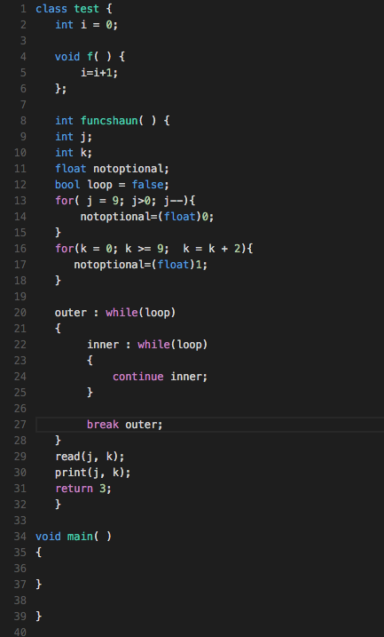

# TestTypeCast.csxTests/TestCasesAndResults/TypeCastResults.png../TypeChecker/Tests/TestCasesAndResults/TypeCastTest.png

# TestWhileLoop.csxTests/TestCasesAndResults/WhileLoop1Results.png../TypeChecker/Tests/TestCasesAndResults/WhileLoop1Test.png

# TestWhileLoop2.csx

# Tests/TestCasesAndResults/WhileLoop2Results.png../TypeChecker/Tests/TestCasesAndResults/WhileLoop2Test.png