Simcav

Julio M. Rodríguez-García

Simcav is a PC program to simulate laser cavities. It is able to calculate a stable cavity for some conditions given by the user. It also provides common functionalities, such as drawing the cavities, calculate beam sizes and provide stability ranges.

The program front-out is a graphical interface: all options are activated with mouse/keyboard.

## Version

This program was written in:

Python 3.4.3

Using the modules:

Matplotlib 1.5.0

Numpy 1.9.3

Pickle

Itertools

**Warning:** There was a command change (not backwards compatible) from Matplotlib 1.4 to Matplotlib 1.5, so this program will throw errors when trying to plot with Matplotlib 1.4.

## Installation

SimCav is portable and does not require installation to work. Just double click the shortcut called “SimCav 4.7”.

## Supported files

SimCav can save designed cavities, or open previously saved ones. The format of the files is “.sc”, to which the information is stored using python's [pickle](https://docs.python.org/3.5/library/pickle.html).

## SimCav layout

SimCav layout is divided in three main sections well differentiated.

**Left frame** is fixed and it always shows the cavity elements on top, and an option for stability calculation at the bottom.

**Right frame** is used to display the buttons used to add optical elements, or to show the cavity calculation tool.

**Central frame** is used to display the cavity and stability plots. Which one is shown can be choose by clicking on the corresponding button at the top of the frame.

A **toolbar on top** provides access to the program functionalities.

A **status bar at the bottom** prompts important messages to the user.

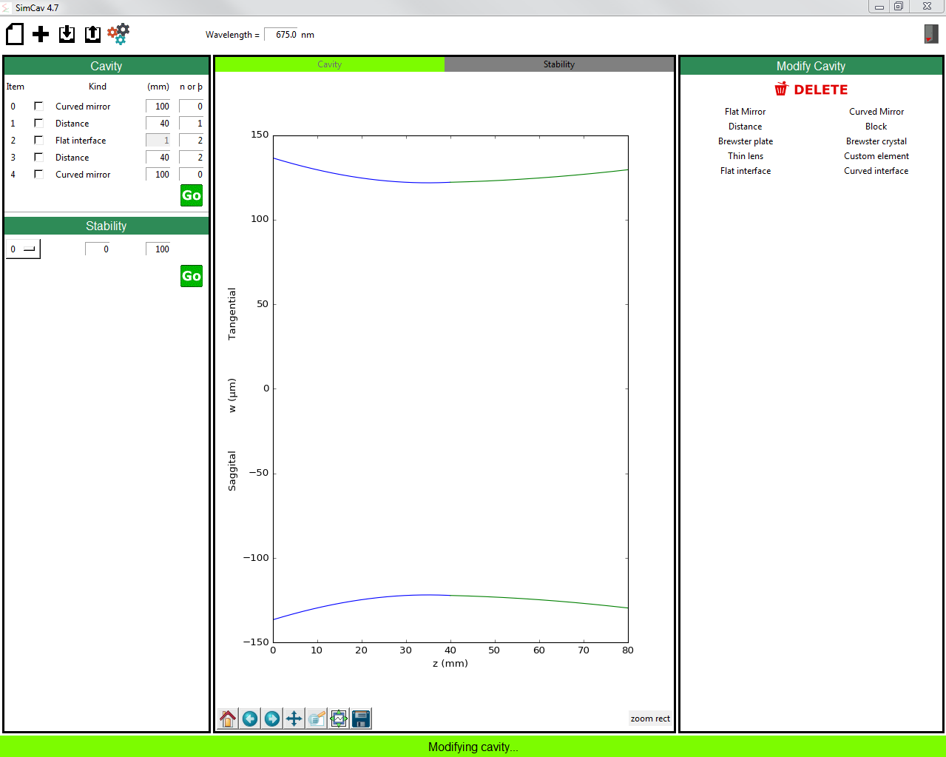

## Building your first laser cavity

SimCav is ready as from start to create a new laser cavity. You can come back any time to this configuration pressing the button “New” in the toolbar: 

Adding optical elements is as easy as clicking on the desired elements in the “Modify cavity” frame at right. The clicked elements are automatically added to the cavity, and shown in the “Cavity” frame at left.

The elements can be deleted by checking their checkbox and clicking the “Delete” button. Several elements may be deleted at the same time.

Elements can also be inserted before an already added element, by selecting the checkbox of the element before which the new element will be inserted, and then clicking on the element to insert.

With the exception flat mirrors, all the elements require one or two parameters to be set before the cavity can be successfully drawn. These parameters can be chosen by writing in the text boxes placed by each element.

Once all cavity elements are set, clicking the “GO” button will draw the cavity if it is stable. If not, a message saying so will be shown in the status bar.

## Checking stability

The stability of the cavity when varying a particular parameter can be calculated using the stability tool under the cavity elements. Select the element to analyse in the dropdown menu and fix the limits of variation of the main parameter. Clicking “GO” will show the stability plot. The stability is computed from 0 (no stability) to 1 (maximum stability), and it is drawn for both tangential and sagittal components.

At this point variations in a second parameter are not supported.

## Cavity elements

* Flat mirror: No need of extra parameters.
* Curved mirror: First parameter: curvature radius (in millimetres). Second parameter: Tilting angle from the vertical plane.
* Distance: This element corresponds to free space. First parameter: distance in millimetres. Second parameter: refractive index. Attention: this is the refractive index of the medium the cavity is immersed in. Therefore it is typically air, and its value is 1 by default.
* Block: Element to model intracavity crystals or other elements with different refractive index than that of the free space. It includes modelling of input and output interfaces (making it different from Distance element).
* Brewster plate and Brewster crystal: Both elements correspond to crystals at Brewster's angle from the optical axis. Brewster plate is a rectangular prism while Brewster crystal is a rectangular rhombohedrum. Longitudinal faces of the Brewster crystal are parallel to the optical axis of the cavity. First parameter: length of the element. Second parameter: refractive index.
* Thin lens: First parameter: focal length. Second parameter: Tilting angle from the vertical plane.
* Custom element: Allows the user to define a custom element with the 4 ABCD parameters. This feature is experimental.
* Flat and curved interfaces: First parameter is the radius of curvature (disabled in the case of flat interface). Second parameter: refraction index of the medium after the interface. Please note that *distance elements* should have the correct refractive index set.

## Calculating a cavity

SimCav’s strong point is the automatic calculation of laser cavities. Once all elements desired to compose the cavity are chosen, SimCav can calculate all the possible combinations, within user defined limits, that produce a stable cavity.

To use this feature, click on the “Calculation” button: 

The calculation frame will be shown at the right. The variation of the parameters can be input in the first two boxes, and the number of points to compute between the limits, in the last box.

SimCav offers several conditions that the cavity must fulfil in order to be considered a solution. Unless every condition is fulfilled, the cavity will not be considered a solution even if it is stable.

The conditions to be used at the moment are:

* Beam size at the first element. SimCav was designed with SDLs in mind, where this is usually the position of the gain medium, and mode matching with the pump laser must be achieved.
* Beam waist at a chosen (thick) element. Very useful for intracavity uses, since the cavity can be designed to fulfil the photon density requirements.
* Cavity total distance. In case there are space limitations, the total length of the cavity can be specified.

Once the calculations are finished, a new window will open with the stable solutions. The solutions are displayed in rows. Clicking on the green cells (corresponding to the conditions) will export that particular solution to the cavity design in the main program for easy plotting.

**Warning:** the more elements to vary and the more points to compute, the longer it will take to process the calculation.

**Warning:** the results shown are limited to a thousand.