Jon-Ross Presta

Final Project

The dataset that I chose to visualize is a record of the outcome of all NFL plays from 2009 to 2018. I found this data by first using Google’s dataset search engine, which took me to a former Kaggle competition that used this dataset. I chose this dataset because I’m a huge fan of football, and I figured that with my knowledge of the game and my exploratory skills, I might be able to come up with some interesting observations. The second dataset that I used was something that I put together myself. Tableau’s method of autogenerating latitude and longitude for city names was missing over half of all the city names, so I put together a dataset mapping each team to its home stadium’s coordinates. I chose this so that I could take advantage of geographical insights as well. There are preconceived notions about how certain areas of the country or certain teams play the game in a certain style, and I wanted to graphically examine whether or not these ideas were true.

**Summary of Data:**

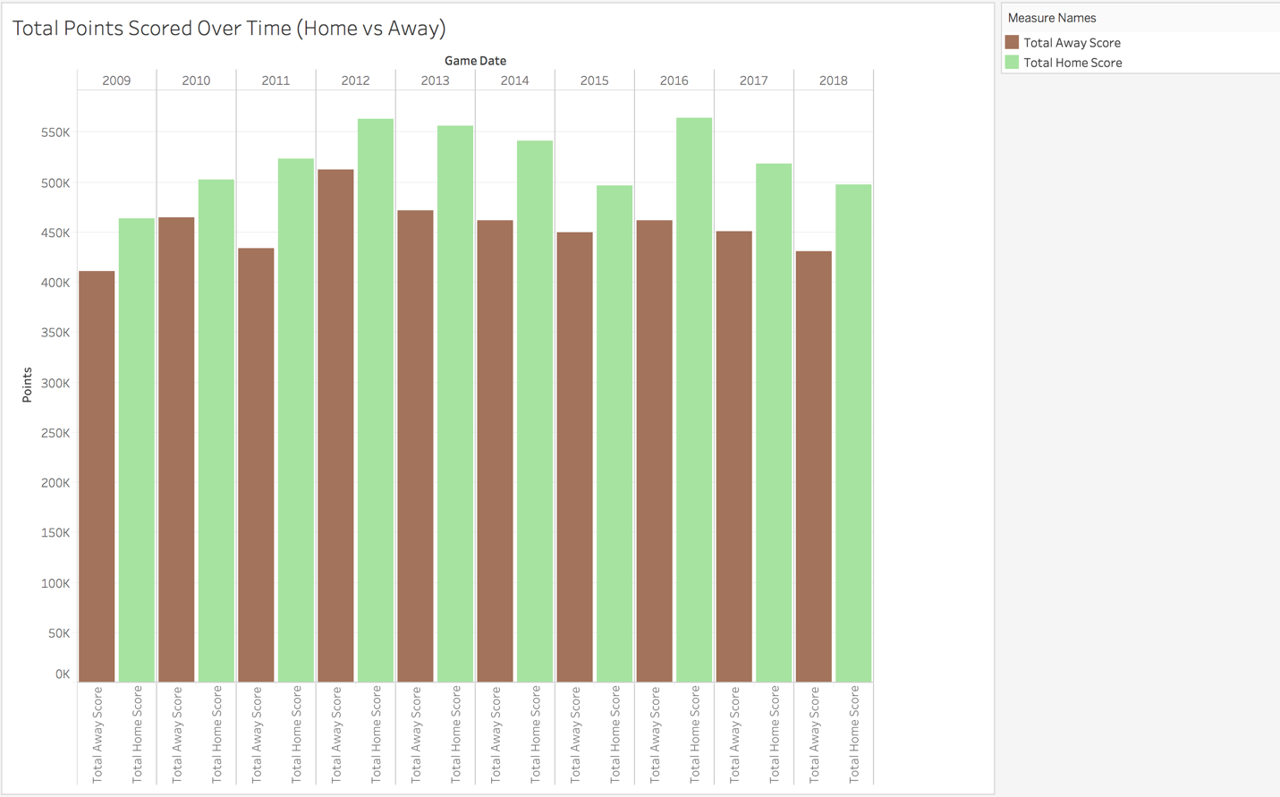

This chart shows the progression of total points scored over the years, splitting up the points between points by the home team and points by the away team.

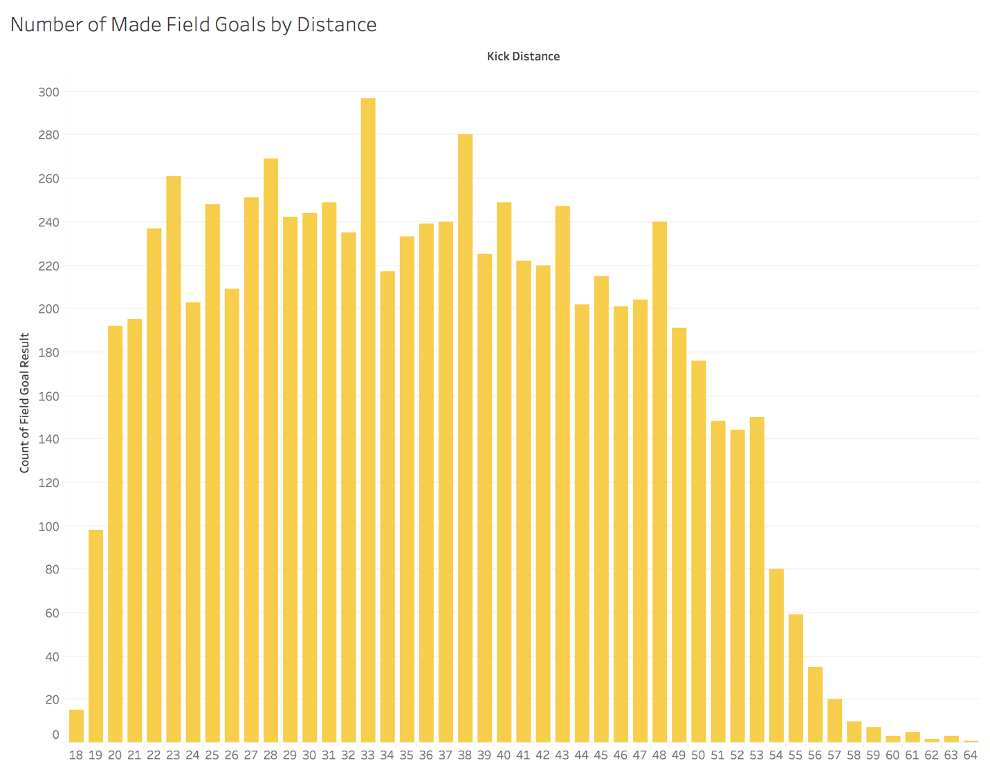

This chart describes what distance field goals are made from throughout the entire timespan.

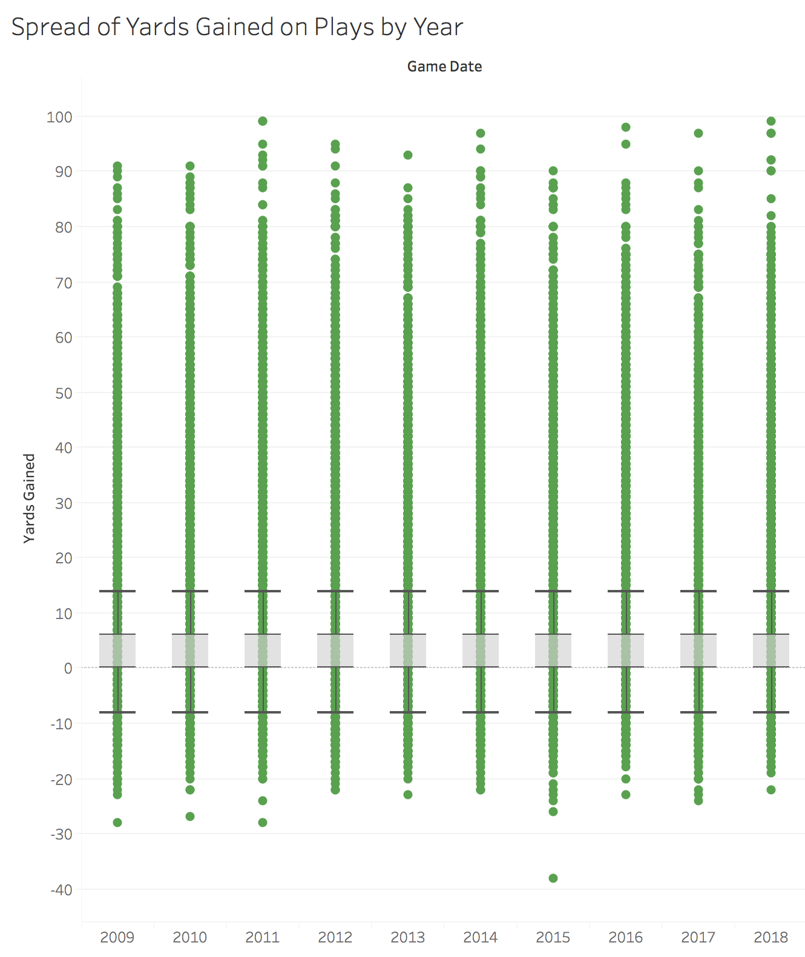

This chart displays the distribution of yards being acquired per play throughout the years.

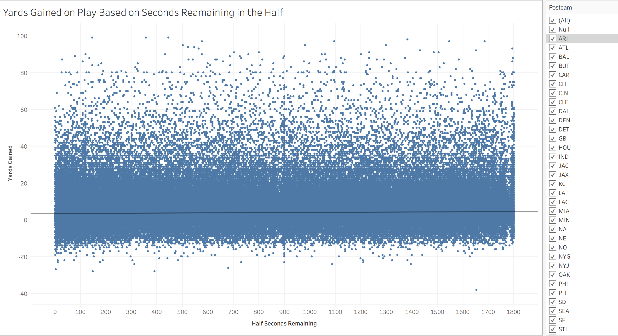

This chart displays the amount of yards gained on a play based on how many seconds are left in the half when this play was run. There is also a regression line. This chart is interactive, in the sense that one is able to filter these scatter points based on what team ran the play.

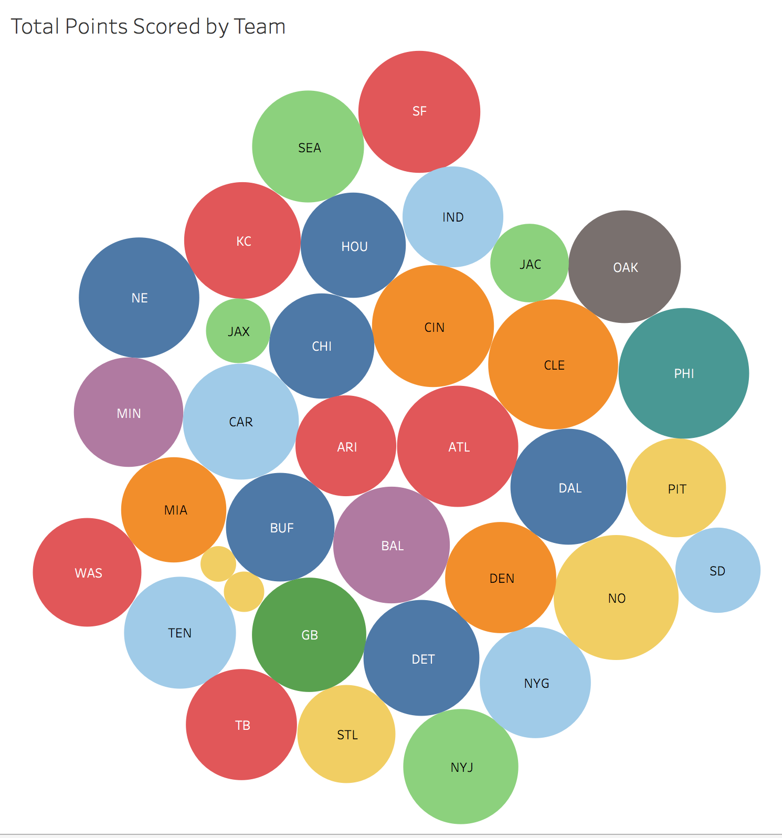

This chart depicts the total amount of points scored by each given team.

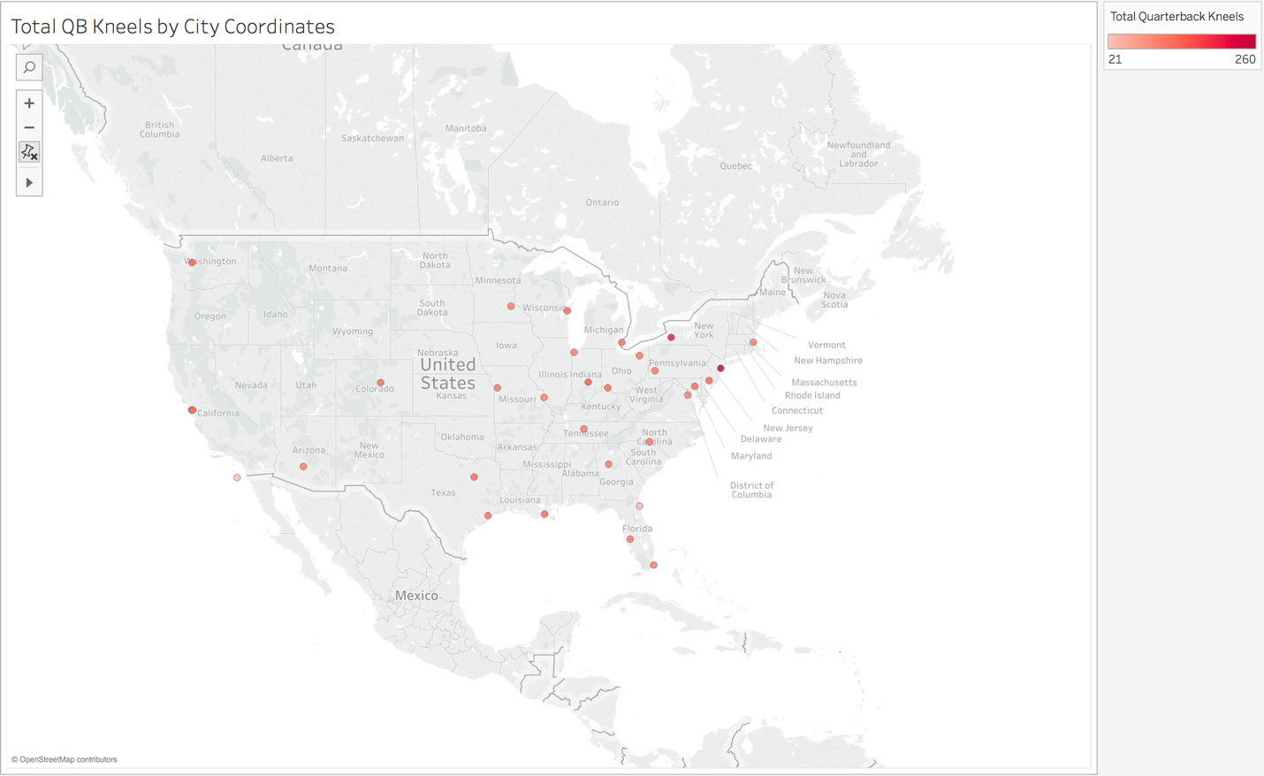

This chart shows the total number of quarterback kneels, based on where the game was played.

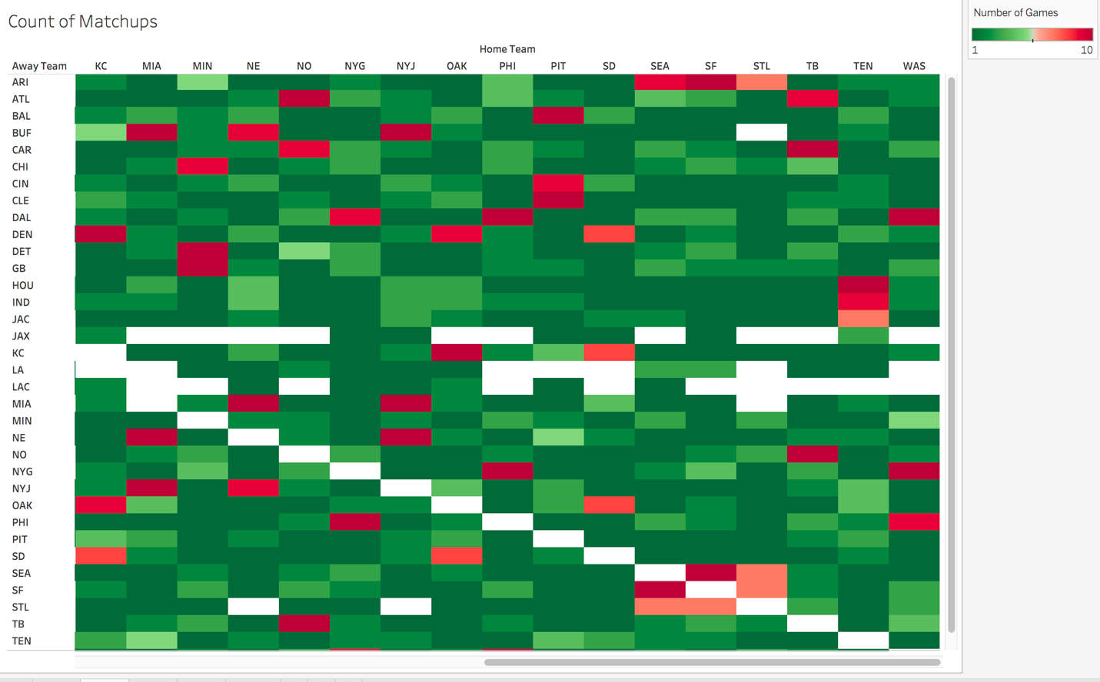

This chart depicts the number of times that the column team has played at the row team’s stadium.

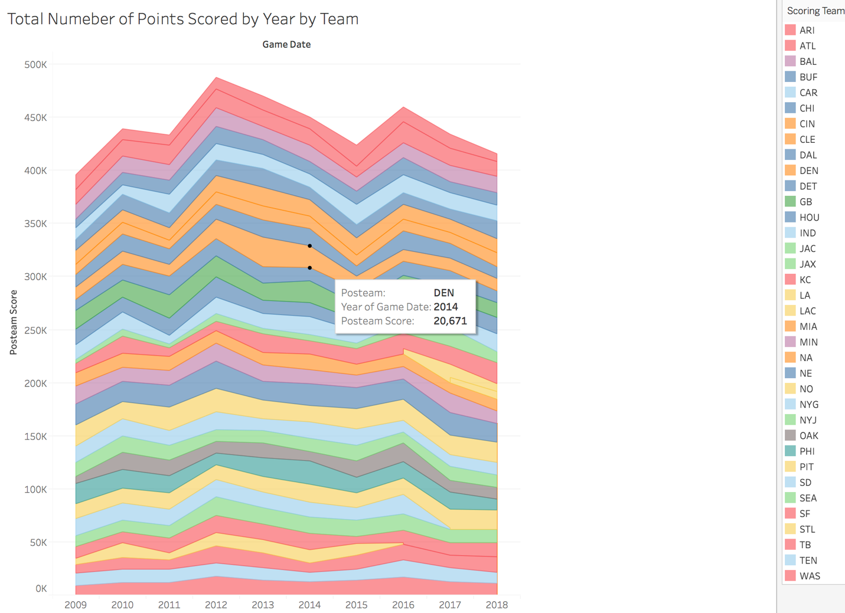

This chart explains the changes in scoring over the years, broken up by team.

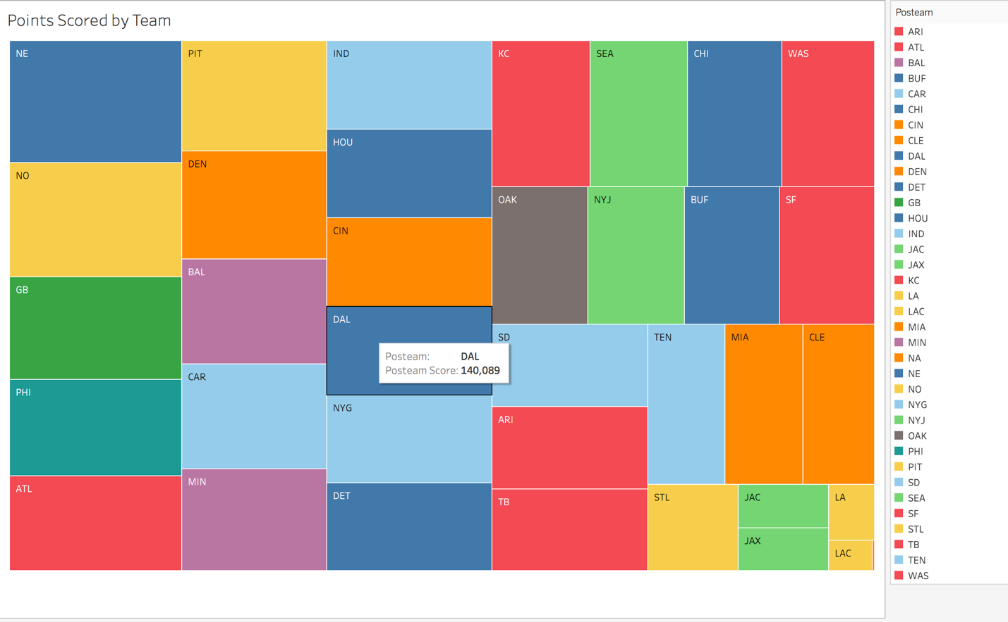

This chart is a different way of visualizing the amount of points scored by each team.

**Storyline**

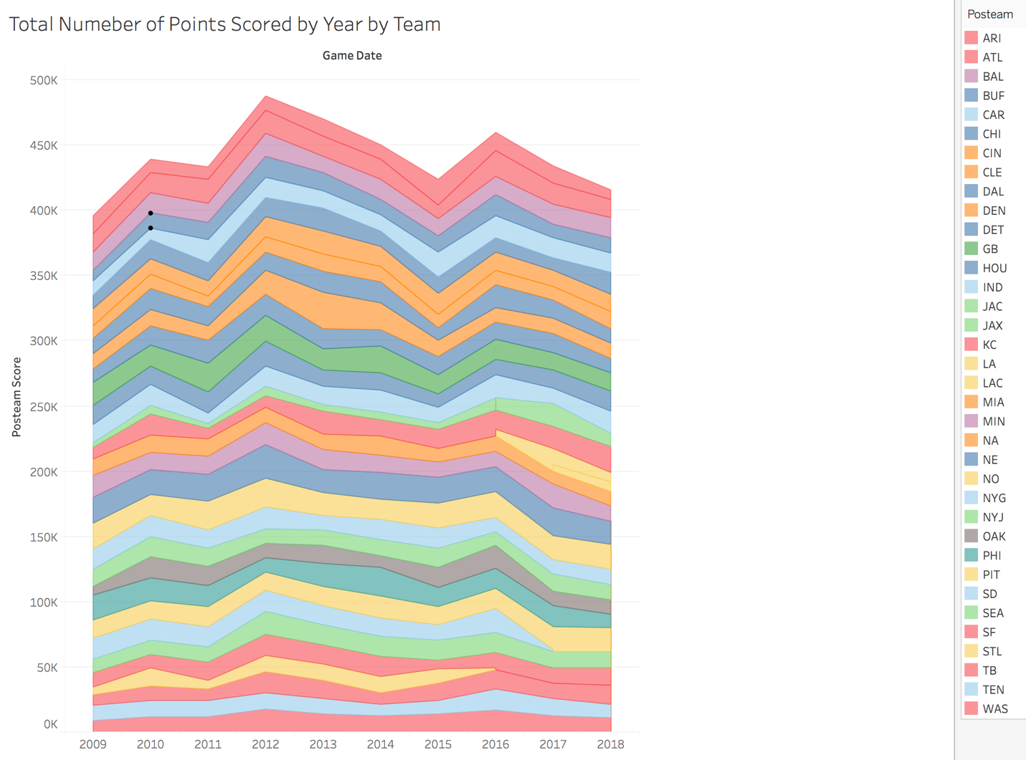

It is a widely-held belief that scoring in the NFL is at an all-time high and that defenses are terrible. People are of the belief that almost the entire league is geared towards quarterbacks and throwing the football and scoring lots and lots of points. This is in contrast to how football used to be played, when it was all about running the ball and defenses were brutal. One would expect that over the previous ten years the total scoring in the league would be almost monotonically increasing. However, here we see that there was a peak back in 2012, and there have been several down years since then. What is also interesting to me is that there is not a single team that appears to be the highest scoring team in the league throughout this whole timespan. Alternatively, there do appear to be teams who are consistently scoring very little. In conclusion, scoring is not constantly increasing year over year, good teams have a hard time staying good consistently, and bad teams tend to stay bad.

**Results/Summary/Conclusion**

Several widely-held opinions regarding the NFL were examined in my plots, with varying results. The biggest takeaway was that overall scoring is not incredibly high like people tend to think. Particularly last year, the Chiefs and Rams were two very high-scoring teams and they met on a nationally televised game and put up so many points that people (including myself) declared the end of defense in football. There have been many rule changes as well in the NFL that promote scoring, so it’s interesting to see that defenses have adapted to these rule changes in order to go back to more typical total scoring numbers. The plots showing the yards gained for each play also confirm this idea that defense is not any worse now than it was before in terms of yards allowed per play. In addition, these graphs were able to show that the teams that have a reputation for being bad teams do perform pretty poorly in terms of total points scored.

**Link to Github:**

<https://github.com/jrpresta/NFL_viz>

**Citations:**

<https://www.kaggle.com/maxhorowitz/nflplaybyplay2009to2016#NFL%20Play%20by%20Play%202009-2018%20(v5).csv>