**Social Networks**

**Project Abstract**

**Spring 2019**

Yash Goel

Sakada Lim

John Reynolds

Jing Xa

**Hypothesis:**

There is a large incentive to “cheat” around financial announcements such as non-farm payrolls, fed minutes, central bank policy, natural resource data, etc. The individuals familiar with this information have an incentive to leak the information to “financial agents” who can then act on this data before before its publicly announced. We can verify this hypothesis fast and cheaply by measuring the gains that a “financial agent” could make by prepositioning in the securities most impacted by the announcements. If there is no measurable difference between an agent who his prior knowledge of an event relative to an agent who could acquire then we can refute the hypothesis. If we can show there are gains to be made from acting on the knowledge beforehand then we can attempt to identify the scope of products and timings of optimal prepositioning.

**Background:**

While most insider trading headlines and enforcement activity center around stock trading, the insider market for macro trading/investing goes relatively unnoticed. Macro investing centers trading and investing in financial products that are impacted by macro economic events. These will include Interest Rate Futures, Foreign Exchange, Equity Futures, and Commodity Futures(Oil, Gold, Natural Gas, Crops, LiveStock, etc). Investors can tap into Futures Markets anywhere in the world to easily place bets on anticipated directional changes in any of the before mentioned contract types.

The largest price movements are typically centered around Central Bank Policy Updates and US Non-Farm Payrolls. Non-Farm Payrolls are released the first friday of every month at exactly 8:30 am (EST) and will provide the change in US Employment for the prior month. It is viewed as the most important number of economic outlook. Later in the month the Federal Reserve releases monthly FOMC minutes which outline current Federal Reserve Monetary Policy. FOMC minutes are released at exactly 2:00pm on one Wednesday of the Month.

There has long been suspicions that the important economic numbers and Fed Policy minutes are being leaked. Helping to fuel the suspicions is the cottage industry of economic forecasting firms run by academic economists. There are strong ties between academic economists and current Federal Reserve Officials, due the the large number of Economists who rotate between academia and the Fed. Questions have been raised as to whether trading firms paying for the forecasting services are actually paying for a forecast with large uncertainty or are they paying for access to economists who have strong ties the the Federal Reserve.

**Scenario:**

Its Friday, February 1st, 2019 at 6:45 am in Chicago, Non-Farm payrolls for January will be released in 45 minutes (7:30 am central time , 8:30 am eastern time). X is a trader at PFP Trading (“Profits First PAL Trading”) in Chicago. X gets a message from the contact at BLS and it simply says 304. X’s knows 45 minutes before the rest of the market that the actual number is almost 2x the market consensus of 165K jobs added. This is a big beat, so X expects Bonds will sell off and Equity Futures will explode upward. Because the number is so strong X positions PFP by selling a large block of the UBM9 Future on the CME. This is the UltraBond future and it will have the greatest price change due to this news. Below is a graph of the actual days events, produced from CME Trade Tick data on the UBM9, UltraBond contract.

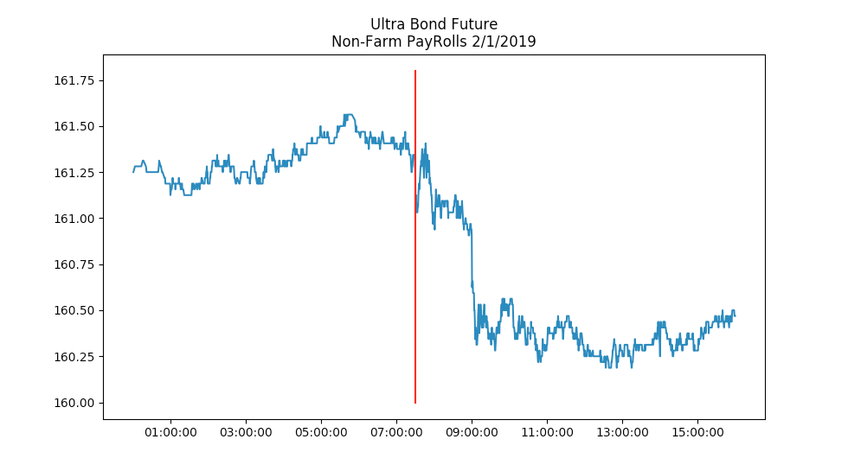

X starts selling 2000 UBM9 contracts at 6:45am (central time) at a price of 161.34375 (161 11/32) . PFP is now short 200 contracts. Now X sits and waits and because it's a big number they will close out the number 30 minutes after release. The number comes out (indicated in graph by the vertical red line, 7:30 am central time) and the market does its zigzag and sells off hard. PFP closes out the position at an average price of 160.3125 (160 10/32). PFP has made 33 ticks on the trade for a profit of $2.062 Million (2000 contracts * 33 ticks * 31.25 $/tick).

**Potential Path of Work:**

1. Catalogue recent tick level price movements in a number of futures contracts to measure the price ranges for various economic events.
2. Measure potential profit that can result from knowing information beforehand.
3. Create forecast models of what prior information models will look like. This can be tricky because all agents have the same information at release of the number, but corrupted agents have had more time to analyze the number and more time to guarantee execution.
4. Measure market drift before the announcement at different intervals. For example in the hour before the Feb 1, 2019 number, the market started drifting down. Produce a forecast of the premarket drift and use that forecast as a predictor of the economic number/after release price action. European and Asian Trading hours will also be examined.
5. Time permitting a graph can be constructed showing the ties between current Government Officials (Federal Reserve, US Treasury) , Academic Economists and Employees at Major Investment Firms.
6. The study will be carried out using Tick level (a.k.a. Every single message) Trade Data for the CME Futures NQ, ES, UB, ZB, TY, EU for the period 2018 to 2019. NQ is the Nasdaq Future, ES is the S&P 500 Future, UB, ZB, TY are Interest Rate Futures covering 30 to 10 year products, EU is the Euro vs US Dollar. The CME trades daily starting 6:00 pm Sunday night, until 5:00 pm the following evening, stops for a one hour switch over and resumes again at 6:00pm and stops on Friday Night at 5:00pm. Futures were picked, because they are they requires the lowest amount of capital, the most liquid, least expensive and most available instruments to trade. In addition economic calendars will be sourced for the timing and market expectations of each economic announcement.

**Potential Products:**

The software and reporting produced by this project can also form the basis of a business which explicitly and accurately ties economic events to tick price action. There is currently no readily available service that ties “news” to market price action.

**References:**

**About the FOMC**

[**https://www.federalreserve.gov/monetarypolicy/fomc.htm**](https://www.federalreserve.gov/monetarypolicy/fomc.htm)

**ECB report says investors may be profiting from leaked US Data**

[**https://www.ft.com/content/9776a710-109c-11e6-91da-096d89bd2173**](https://www.ft.com/content/9776a710-109c-11e6-91da-096d89bd2173)

**Fed worried 2010 leak amounted to “insider trading”**

[**https://www.reuters.com/article/us-usa-fed-leaks-idUSKCN0UT2FD**](https://www.reuters.com/article/us-usa-fed-leaks-idUSKCN0UT2FD)

**Questions about a leak at Federal Reserve escalate to insider trading probe**

[**https://www.wsj.com/articles/questions-about-leak-at-federal-reserve-escalate-to-insider-trading-probe-1443650303**](https://www.wsj.com/articles/questions-about-leak-at-federal-reserve-escalate-to-insider-trading-probe-1443650303)

**Banks on Fed Staffer email list get “accidental” leak of minutes**

[**https://www.bloomberg.com/news/articles/2013-04-11/banks-on-fed-staffer-e-mail-list-get-accidental-leak-of-minutes**](https://www.bloomberg.com/news/articles/2013-04-11/banks-on-fed-staffer-e-mail-list-get-accidental-leak-of-minutes)

**Richmond President Lacker Resigns After Leaking Confidential Fed Deliberations**

<https://www.forbes.com/sites/antoinegara/2017/04/04/richmond-fed-president-lacker-resigns-after-admitting-to-2012-leak-and-cover-up/#5e6473ed20fb>

**A Possible leak of survey data draws federal attention**

<https://www.nytimes.com/2004/03/17/business/a-possible-leak-of-survey-data-draws-federal-attention.html>

**More evidence Thomson Reuters data may be leaking out earlier than its meant to**

<https://finance.yahoo.com/news/more-evidence-data-thomson-reuters-205803500.html>