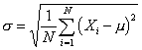

µ is mean or average
σ is standard deviation

