Analysis Report Template

Student Full Name | Joel Da Costa | Student ID No. | W2154055
Case Study Title
Case Study (A): Predicting Clients Loan Status. [Total 43 Marks]
Research Question: Does machine learning have the potential to assist banker and finance analysts in predicting which client can be approved a loan?

Task (1) – Domain Understanding: Classification
The financial risk analysts decided that classification modelling is required. Indicate in the table below for each of the listed
variables in your data which ones you should RETAIN and can be included in the classification modelling of loan approval status, and the variables you should DROP (REMOVE). Justify your decision logically and/or by research (for any research, include in-text citation using
the Harvard style) [3 Marks]
Variable Name | RETAIN or DROP | Brief justification for retention or dropping with in-text citation.
ID | Drop | Identifying variable does not assist in model and could bring noise to  the dataset
Sex | Drop | Large data missingness, cannot be used for modelling or even  imputation
Age | Retain | Usable demographic variable that can be useful in modelling as well  as showing eligibility in real world cases of loan approval
Education Qualifications | Drop | Large informative information that cannot assist the dataset,  ‘unknown’ values don’t assist in informative information
Income | Retain | Usable affordability variable that directly assists in the loan approval  status
Home Ownership | Retain | Variable is often an indicator of repayment stability, can be used for  modelling.
Employment Length | Retain | Huge indicator that determines the stability of loan repayments, very  useful for modelling
Loan Intent | Retain | Once encoded this variable will be useful, it also gives relevant context  to the applications, which is reasoning toward loan acceptance
Loan Amount | Retain | Relevant affordability indicator and highly import in approval  decisions.
Loan Interest Rate | Retain | High relevancy to lending opportunities
Loan-to-Income Ratio (LTI) | Retain | Lenders use this indicator to calculate loan amount  (HomeOwners Alliance, 2018)
Payment Default on File | Retain | Great usage for this variable, indicates credit risk
Credit History Length | Retain | Relevant credit profile indicator
Loan Approval Status | Retain | This is the classification target
Maximum Loan Amount | Retain | This is the regression target
Credit Application Acceptance | Drop | This variable is clearly data leakage and cannot be used for modelling
References
HomeOwners Alliance. (2018). What Percentage Of Income Should Go To Your Mortgage? - HomeOwners Alliance. [online] Available at: https://hoa.org.uk/advice/guides-for-homeowners/i-am-buying/how-much-can-i-afford/.

Task (2) – Exploring and Understanding Your Dataset
With the aid of your Final Python Notebook 1, for your RETAINED input variables and your class “Target” variable, produce 1)basic descriptive stats and 2)variable scale type, then 3)plot the distribution of your target variable. (Paste the three screenshots of code OUTPUTS ONLY for evidence of these elements).
[2 Marks]

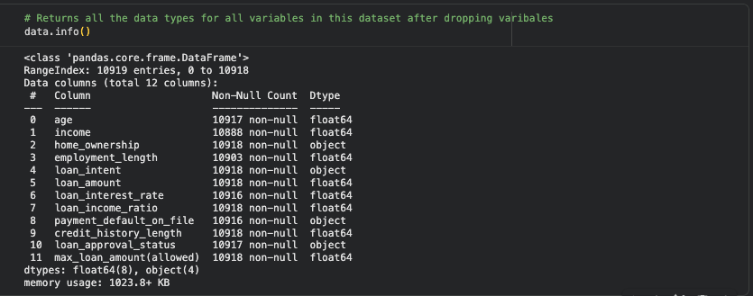
Figure 1 - Data types

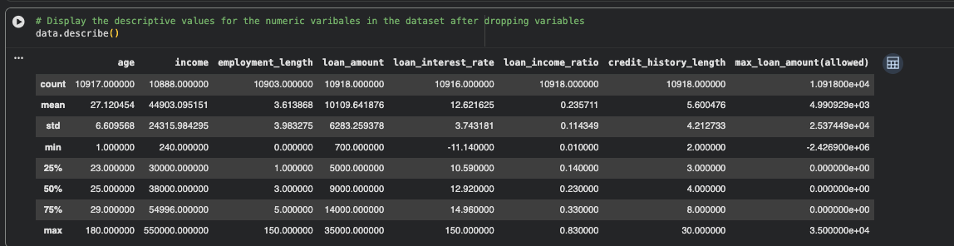
Figure 2 - Descriptive stats

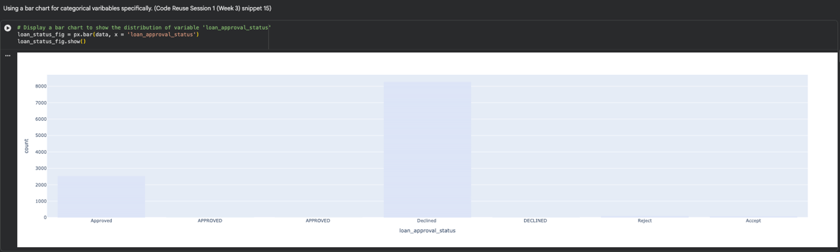
Figure 3 - Plot for target variable

Task (3) – Data Preparation: Cleaning and Transforming your data
a) With the aid of your Final Python Notebook 1, when you first explored your retained variables in the loan dataset, you may have found some issues. 1) Report any issues you found in your retained dataset variables. Based on the issues you found in your data, 2)suggest a suitable possible method to fix each of these issues and 3)provide your justification for using your suggested fix method. Use the table below to organise your findings and analysis, and add more rows if needed
[4 Marks]
 | Variable Name | Issue found | Proposed fix | Justification for used fix method
1 | age | Extreme/Impossible values | Used a filter to return appropriate values | The retained age variable had values like age -30 and age 180, the fixing introduced reliable age data
2 | employment_length | Extreme/Impossible values | Used a filter to return appropriate values | The variable had extreme values of 123 and 130 years of employment, impossible values that had to be dropped
3 | loan_interest_rate | Extreme/Impossible values | Used a filter to return appropriate values | This variable had values like -11.14 and 200 which are extremely impossible values for a bank to provide.
4 | max_loan_amount(allowed) | Extreme/Impossible values | Used a filter to return appropriate values | This variable had minus values as well as value 12467989660, which is an impossible value for a bank to provide
5 | age | Data missingness | Imputed data for the missing values by calculating mean of the dataset | The dataset cannot have missing data, the best option was to impute the data as the missingness was low
6 | income | Data missingness | Imputed data for the missing values by calculating mean of the dataset | The dataset cannot have missing data, the best option was to impute the data as the missingness was low
7 | employment_length | Data missingness | Imputed data for the missing values by calculating mean of the dataset | The dataset cannot have missing data, the best option was to impute the data as the missingness was low
8 | loan_interest_rate | Data missingness | Imputed data for the missing values by calculating mean of the dataset | The dataset cannot have missing data, the best option was to impute the data as the missingness was low
9 | loan_approval_status | Irregular data values | Mapped the irregular data to numeric values | Data had instances that meant related in meaning but not in labels, this label encoding fix ensures that data can easily find relations
10 | payment_default_on_file | Irregular data values | Mapped the irregular data to numeric values | Data had instances that meant related in meaning but not in labels, this label encoding fix ensures that data can easily find relations
11 | All Remaining | Dropped the remaining missing variables | Dropped the remaining missing data | The remaining data was dropped, After numeric encoding many indexes have a NaN variable, this is not useful and is dropped by dropna()
⋮ | ⋮ | ⋮ | ⋮ | ⋮

Task (3) – Data Preparation: Cleaning and Transforming your data
b) With the aid of Python packages and your Final Python Notebook 1, implement your suggested fixes of issues in the previous Task 3-a in your final Python Notebook1.
1) Show evidence (before and after) of implementing your suggested fix to the problems you identified for your dataset in Task 3-a.
To show your evidence, paste screenshots of your relevant code OUTPUTS ONLY (Do not paste the code).
2) Indicate and annotate the issue and the fix in each of your provided evidence screenshots.
[4 Marks]
Output screenshot of the issue before the fix | Output screenshot after fixing the issue

Before
1 – 4
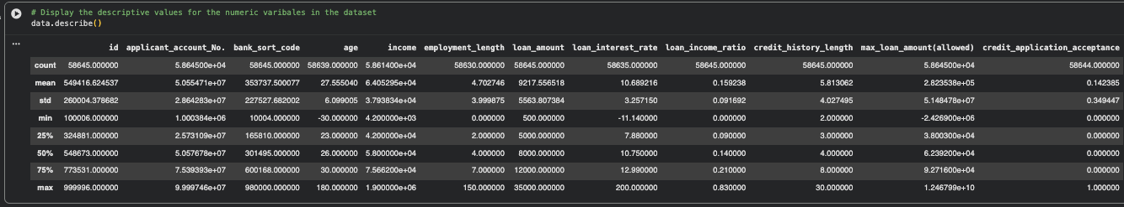
Figure 4 - Age, employment_length, loan_interest_rate, max_loan_amount(allowed) before value outlier removal

Fix
1 – 4
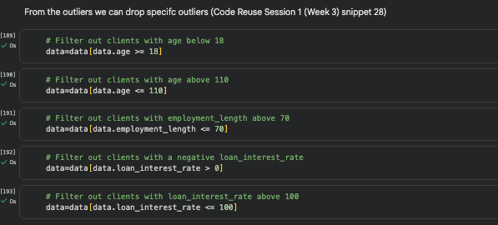
Figure 5 - Filter Age, employment_length, loan_interest_rate, max_loan_amount(allowed)

After
1 - 4
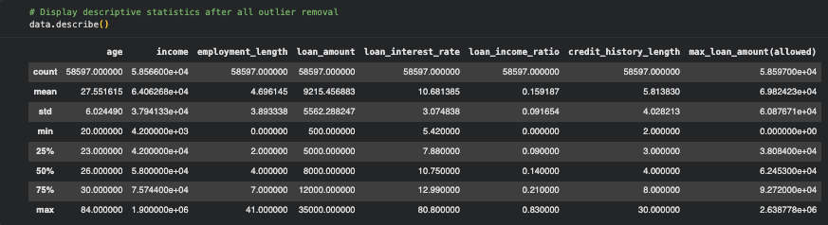
Figure 6 - Age, employment_length, loan_interest_rate, max_loan_amount(allowed) after value outlier removal
Before
5 – 8
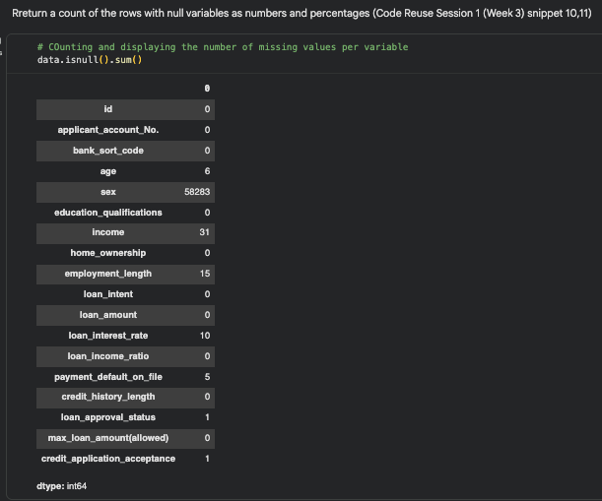
Figure 7 - Age, income, employment_length, loan_interest_rate before data imputation
Fix
5 - 8
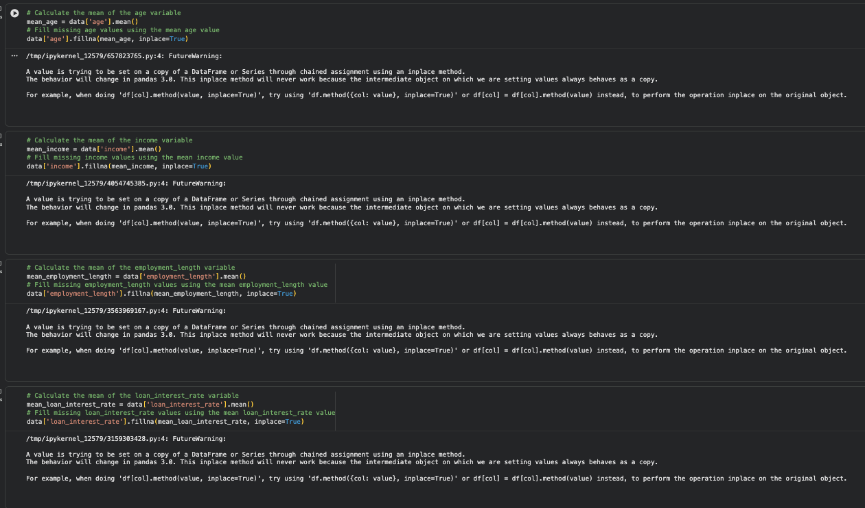
Figure 8 - Age, income, employment_length, loan_interest_rate imputation fix

After
5 - 8

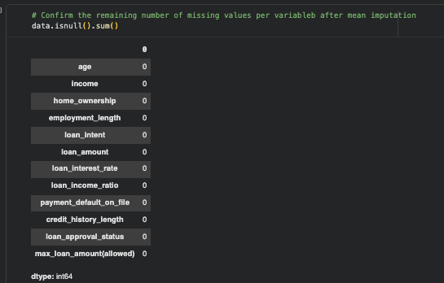
Figure 9 - Age, income, employment_length, loan_interest_rate after imputation fix
Before
9 – 10
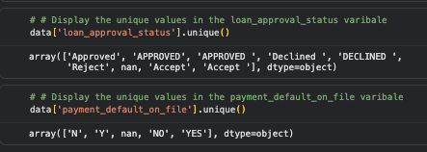
Figure 10 - loan_approval_status, payment_default_on_file before categorical fix
Fix
9 – 10
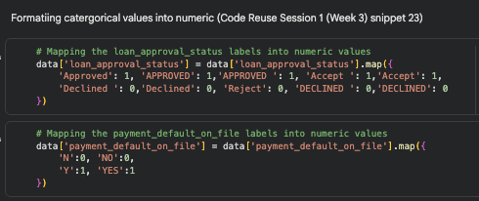
Figure 11 - loan_approval_status, payment_default_on_file categorical fix
After
9 - 10
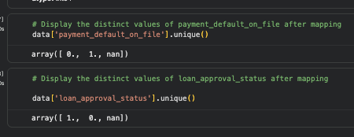
Figure 12 - loan_approval_status, payment_default_on_file qfter categorical fix

Before
11
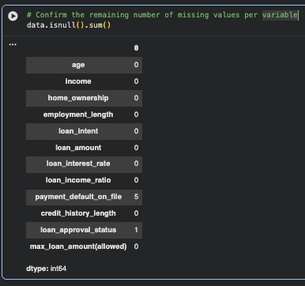
Figure 13 - payment_default_on_file, loan_approval_status before removing NaN values

Fix
11
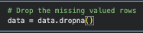
Figure 14 - payment_default_on_file, loan_approval_status removing NaN values
After
11
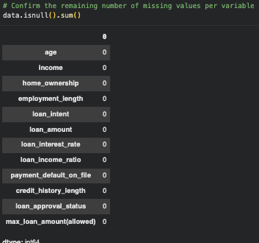
Figure 15 - payment_default_on_file, loan_approval_status after removing NaN values

Output screenshot of the issue before the fix | Output screenshot after fixing the issue

Task (4) – Classification Modelling of Clients Loan Approval Status
a) In your Final Python Notebook 2, you built THREE different models to predict loan approval status: Logistic Regression (LR), K Nearest Neighbour (KNN) and Naïve Bayes (NB). These algorithms are a mix of parametric and non-parametric algorithms.
1) Note down the type of each algorithm (parametric vs non-parametric),
2) name any learnable parameters, and
3) list any strategic hyperparameters for each algorithm which you want to consider tuning. Organise your answer in the table below:
[3 Marks]
Algorithm Name | Algorithm Type | Learnable Parameters | Some Strategic Hyperparameters
Naïve Bayes (NB) | Parametric | nb.class_prior – the prior probabilties  nb.thea_ - the mean of each fearure  nb.var_ - the variance of each feature | priors
Logistic Regression (LR) | Parametric | logreg.intercept_ The intercept (bias)  logreg.coef_ The coeffiecients (weights) | max_iter
K-Nearest Neighbour (KNN) | Non-parametric | None as KNN is a lazy learner | n_neighbors

Task (4) – Classification Modelling of Clients Loan Approval Status
b) With the aid of your Final Python Notebook 2, use the training–test split approach with your retained applicable input features only and the target output feature to build your predictive classification models.
[3 Marks]
i. Screenshot
1) the list of all feature names used for building your classification models and the corresponding
2) data shape function output. (Paste screenshots of the relevant code output only; do not paste the Python code).

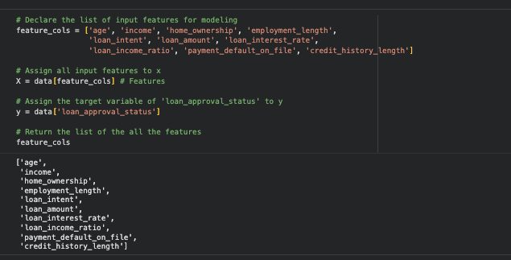
Figure 16 - List of all the feature names for fearure_cols

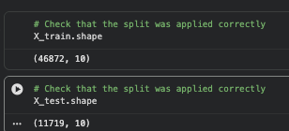
Figure 17 - The dimensions of the dataset

ii. In less than 150 words, research and justify (defend) your choice of the training-test split ratio and provide an in-text citation.

The training test split of 80/20 was chosen for this task, the main factor of its popularity however in the literature by (Vrigazova,2021), it was found that an 80,20 split could still preserve accuracy for classification methods especially for decision tress.

As stated the 80/20 is seen as common practises in machine learning research (Sivakumar, 2024) and it offers a good balance by offering enough data for both training and testing.
References
Vrigazova, B. (2021) ‘The proportion for splitting data into training and test set for the bootstrap in classification problems’, Business Systems Research, 12(1), pp. 228–242. doi:10.2478/bsrj-2021-0015.

Sivakumar, M., Parthasarathy, S., & Padmapriya, T. (2024). Trade-off between training and testing ratio in machine learning for medical image processing. PeerJ. Computer science, 10, e2245. https://doi.org/10.7717/peerj-cs.2245

iii. Provide as evidence the code block line and code output from your Final Python Notebook 2 that ensures two conditions:
1) all your models were tested on the same test instances (clients) in your dataset;
2) the labels ratio of approval Status “Accept” to “Reject” is the same in the training and test subsets.
3) State the training-test split function parameters in your code line that are responsible for meeting both conditions.
4) In less than 150 words, research and justify (defend) your decision to implement both conditions in your Python Notebook 2 notebook with in-text citations where possible.

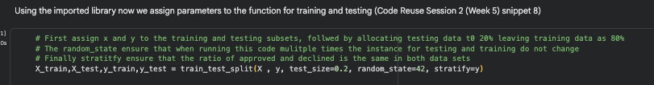
Figure 18 - Proof showing all models are on the same test instances

Both conditions are implemented across the 3 classification models, firstly stratify ensures that the parameters of the approved and declined classes are kept and preserved in their original training and test sets , the data split will be generated consistently for the models. Next was the fixed random seed (random_state= 42), which was executed to ensure that when testing is ongoing the dataset stays split the same throughout.
References with in-text citation
Task (5) – Evaluating your Loan Approval Status Classification Models
Your finance team provided the following success criteria to guide you when evaluating and selecting your best model: “When evaluating your model's performance, which addresses your first research question (a). The model is expected to misclassify clients’ applications. Thus, the model should aim to predict as many “Reject” status for clients as many as possible to decrease the risk of future defaulted loan payments. However, the model should demonstrate that its high “Reject” prediction rate is mainly due to a larger number of correctly detected (predicted) rejected loan applications.”

a) With the aid of Final Python Notebook 2, for each of your models (Logistic Regression LR, Naive Bayes NB and K-Nearest Neighbours KNN)
1) paste the test confusion matrix,
2) the classification report and
3) the AUC-ROC curve graphs
as screenshots from the output of your Python code.
[3 Marks]

1) Screenshot of the test confusion matrix for (NB, LR, and KNN); make sure you title each matrix with its algorithm name

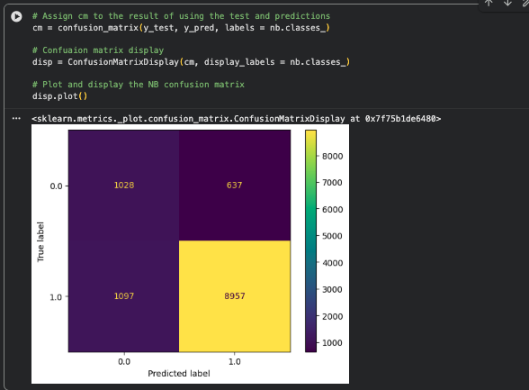
Figure 19 - NB confusion matrix
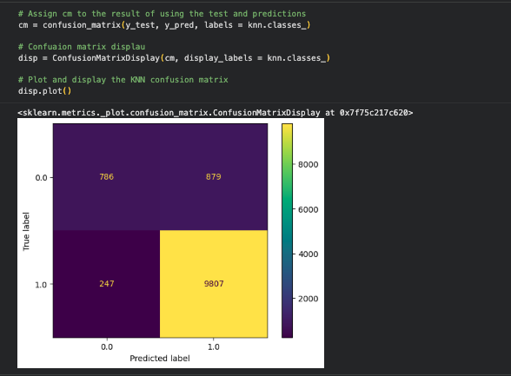
Figure 20 - KNN confusion matrix
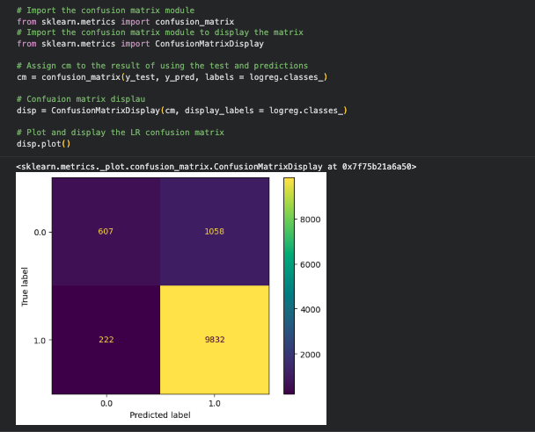
Figure 21 - LR confusion matrix

2) Screenshot of the classification report for (NB, LR, and KNN); make sure you title each classification report with its algorithm name

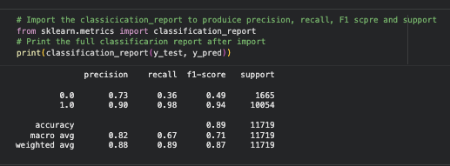
Figure 22 - LR classification report
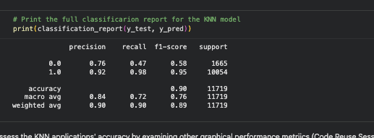
Figure 23 - KNN classification report
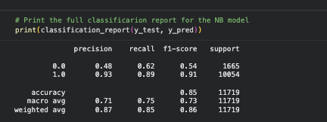
Figure 24 - NB classification report

3) Screenshot of the AUC-ROC Curve for (NB, LR, and KNN); make sure you title each graph with its algorithm name

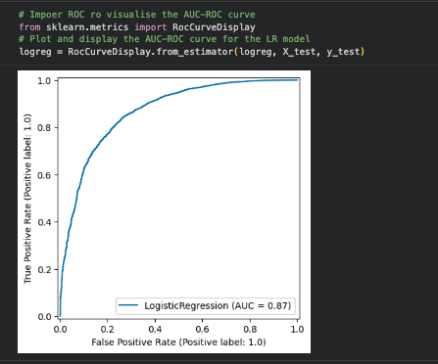
Figure 25 - LR AUC
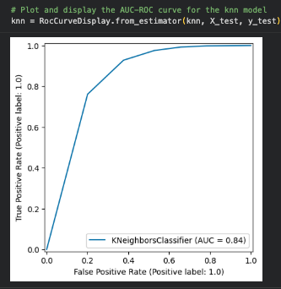
Figure 26 - KNN ROC
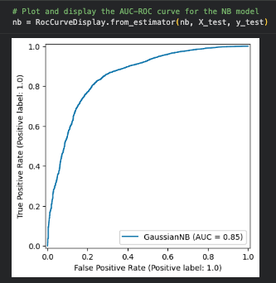
Figure 27 - NB ROC

Task (5) – Evaluating your Loan Approval Status Classification Models
b) Five different classification evaluation metrics are calculated in your Final Python Notebook 2.
1) State which evaluation metric/metrics to “USE or “DO NOT USE” to closely interpret the above success criteria.
2) For justification, explain how closely your choice of “USE” or “DO NOT USE” for a metric interprets the given success criteria.
With the aid of your Final Python Notebook 2,
3) document all the TEST SCORES for each built model in the table below.
[7 Marks]
Metric | 1) USE or DO NOT USE | 2) Justification for choosing “USING” or “NOT USING” this metric in relation to the success criteria | Model | 3) Metric Test Score
Accuracy | DON’T USE | Accuracy is extremely misleading, based on its definition it would assume correctness however model would fail on imbalanced dataset | NB | 0.85
 |  |  | LR | 0.89
 |  |  | KNN (k=5) | 0.9
Recall | USE | Recall measure the actual declines applications the model identifies, this is the success criteria | NB | 0.62
 |  |  | LR | 0.36
 |  |  | KNN (k=5) | 0.47
Precision | USE | The precision measure the declined predictions that are actually declined, this address the criteria | NB | 0.49
 |  |  | LR | 0.73
 |  |  | KNN (k=5) | 0.76
F1-score | USE | F1 score is the mean of precision and recall and it offers the best data based on the success criteria | NB | 0.54
 |  |  | LR | 0.49
 |  |  | KNN (k=5) | 0.58
AUC-Roc | DON’T USE | AUC measures how a model differentiates between class at different thresholds, it doesn’t really adhere to the success criteria | NB | 0.85
 |  |  | LR | 0.87
 |  |  | KNN (k=5) | 0.84

Task (5) – Evaluating your Loan Approval Status Classification Models
c) Suggest a single best approval status classification model based on the ‘USED’ performance metrics scores you identified in Task (5-b). In less than 100 words, briefly describe how well your best model satisfies the needs of your finance team.
[2 Marks]
Based on the USED performance metrics the best model to use for predicting loan approval status was KNN with K = 5. KNN achieves the highest F1 score for the Declined class which means there is a strong balance between the recall and precision. It also does adhere to the success criteria by catching a meaningful proportion of declined applications, which in terms of finance team’s requirements is fulfilled.

Task (5) – Evaluating your Loan Approval Status Classification Models
d) To enhance your selected best model/s performance (from Task 5-c), tune some of its possible hyperparameters, which you indicated in Task (4-a) for that specific algorithm. With the aid of Final Python Notebook 2, Re-train and test the best algorithm again with GridSearchCV
[5 Marks]
i. With the aid of your Final Python Notebook 2,
1) Paste into this report the line of code which shows evidence of specifying a parameters grid and applying the GridSearchCV function to rebuild your selected best model.
2) Then, document the estimated best hyperparameters for the optimised model.

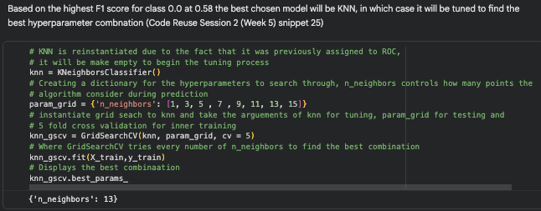
Figure 28 - Evidence of GridSearchCV

Best Hyperparameters = {‘n_neighbors’: 13}

ii. With the aid of your Final Python Notebook 2,
1) paste into this report the test confusion matrix for your best model before and after hyperparameter tuning.
2) Also, document the new score/s of the “USED” performance metric/s of your choice to interpret the success criteria indicated in Task (5.b) before and after tuning.
3) Comment on whether the tuning of hyperparameters of your best model improved its positive predictive ability in line with the success criteria.

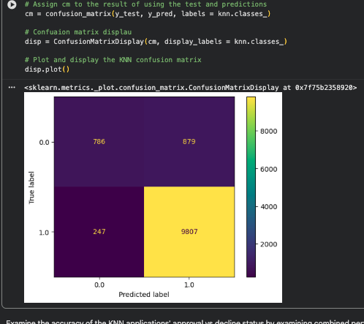
Figure 29 - KNN before tuning (KNN = 5)
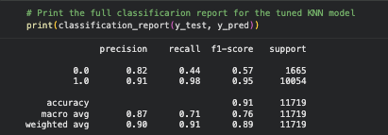
Figure 30 - KNN after tuning
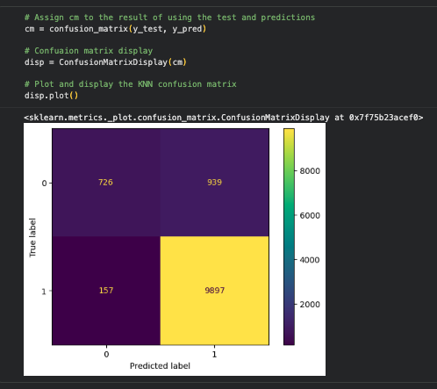
Figure 31 - KNN after tuning (KNN = 13)

Figure 32 - KNN after tuning
K=13 as the optimal number of neighbour, tuning has improved greatly as can be seen in the precision in the declined class which increased to 0.82 which now means there is a larger chance of declined status being correct, this is inline with the success criteria set by the finance team.

