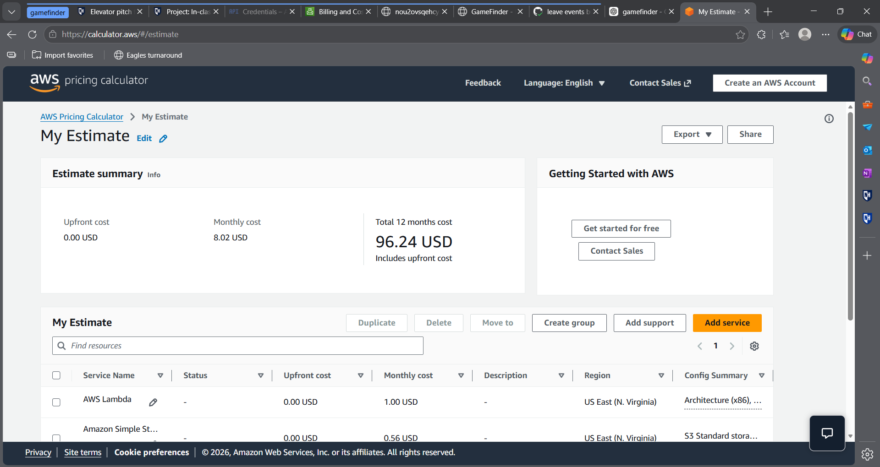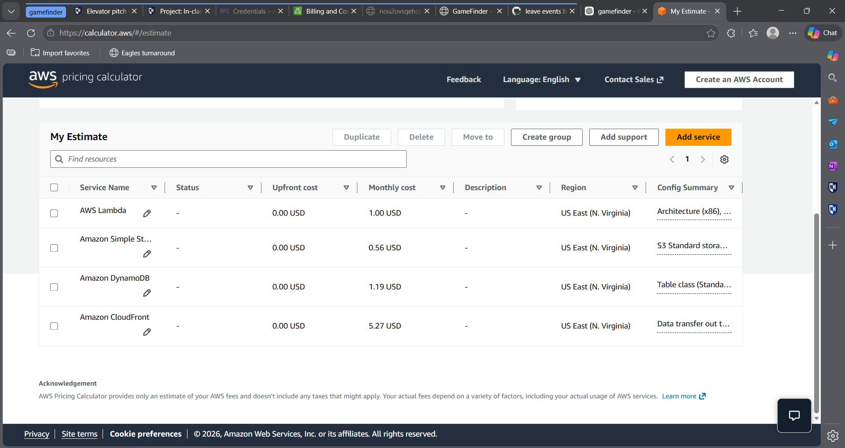
I used the AWS Pricing Calculator to estimate costs at scale, assuming around one million users. The total monthly cost is about $8. This is low because the application uses serverless services like Lambda and DynamoDB, which only charge based on usage. CloudFront is the largest cost because it handles delivering the frontend to users.
This shows the system is cost-efficient and scalable without requiring always-running servers.

