**Environment:** I’m running and have been working on this project on a CentOS Linux 7.8 system via MobaXterm.

**Purpose**: This document will show an example of how the program is run.

**Background:** This project was written for an Operating System course. There will be many areas of improvement in this program. I had previous experience writing code in C, but many of the concepts, libraries, and methods were new to me and was done within a pretty narrow window of time.

Refer to the “*READ ME.txt*” document for more information.

1. Initially I upload and compile the program fsaccess.c and created the necessary files.

* “file.data” is used as the mounted file system.
* “examplefile” will be used as the file we will copy into the file system and afterwards back out.

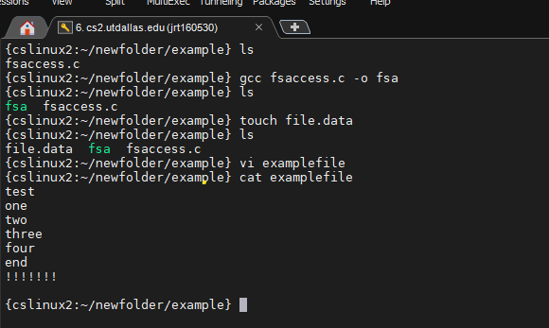

1. Run the compiled program named “fsa”. Upon running the program, the user will be prompted with a list of commands.

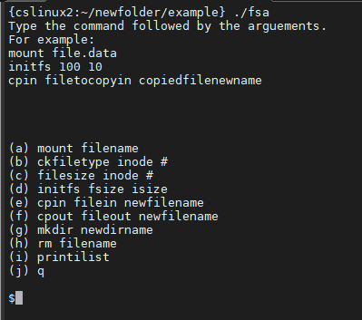

1. The first thing that needs to be done is to mount the file system. In this example, “file.data” is our file system.

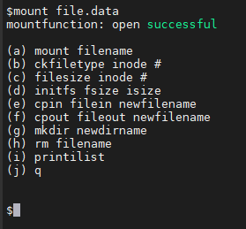

1. After the file system is mounted, initialize the filesystem memory size (fsize) and size of ilist (isize).

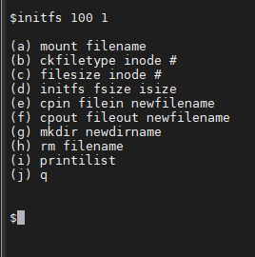

1. After the file system is initialized, we can check the ilist with “printilist”, copy files in, copy files out, and quit and reopen the program to the saved file system (after we remount, with the same mount command above). In the proceeding pictures we will show these examples.

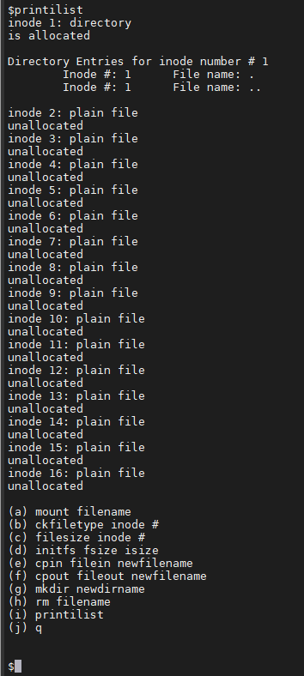

File “examplefile” copied in. I gave it the name “filein”.

I then used “pintilist” to show the update ilist.

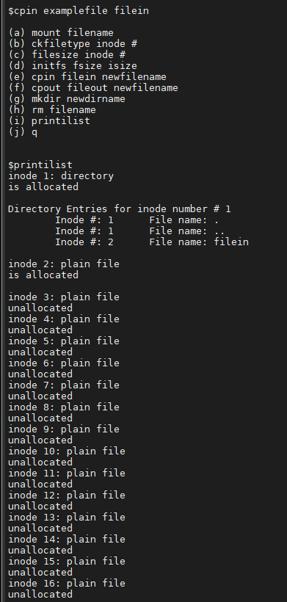

“mkdir dir1” to make a directory name dir1 and then “printilist” to show results. We will continue to use “printilist” in this fashion.

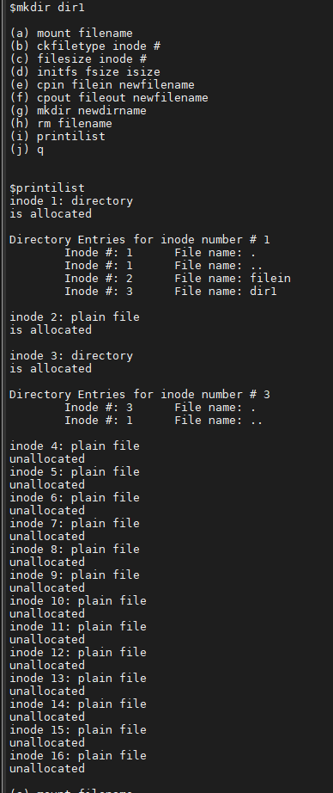

“cpin examplefile /dir1/fileindir1” copies a file into the newly created directory. Program only uses absolute path names.

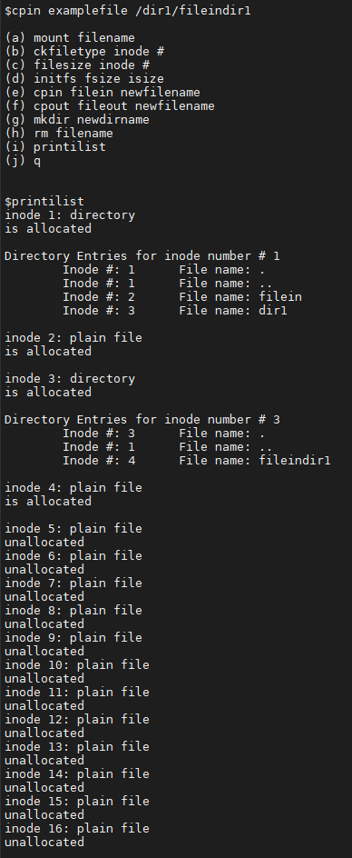

Next we issued “cpout” commands. The files copied out will be shown later after we remove files.

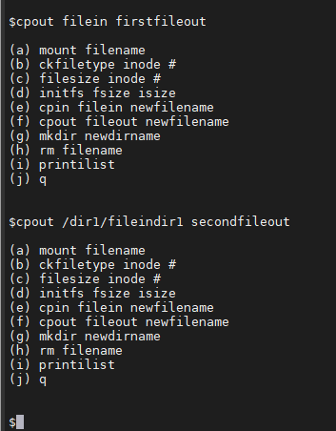

Printilist before files are removed using “rm filename”

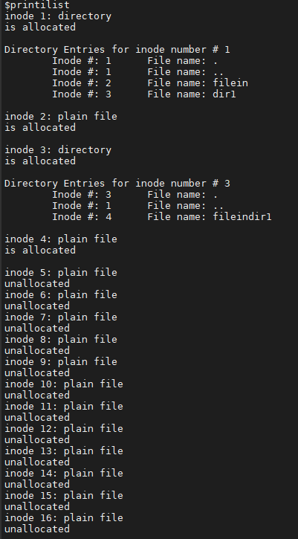

“rm filein”. Printilist now shows inode#2 is unallocated and directory no longer holds entry for file.

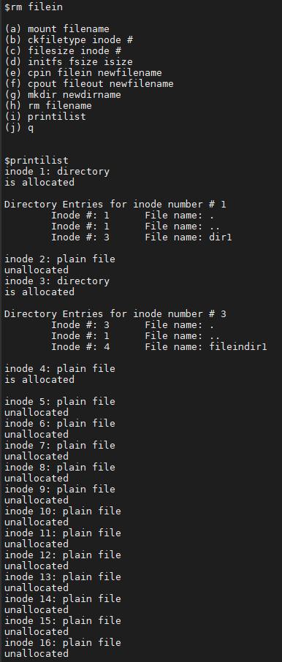

“rm /dir1/fileindir1” with the updated ilist.

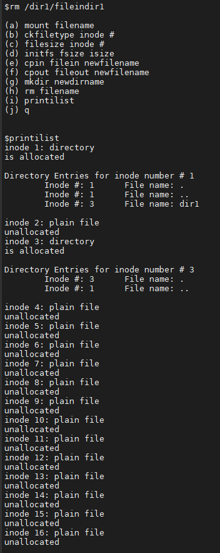

“mkdir /dir1/dir2”

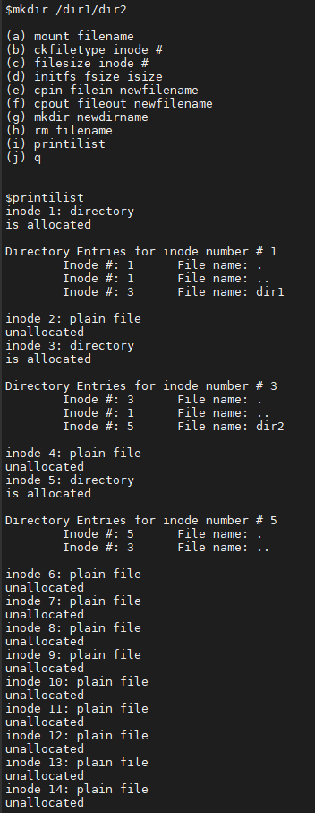

“cpin examplefile /dir1/dir2/file4”

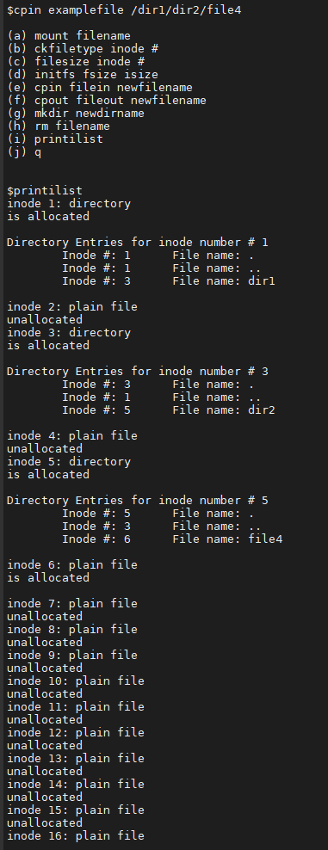

“rm /dir1/dir2/file4”

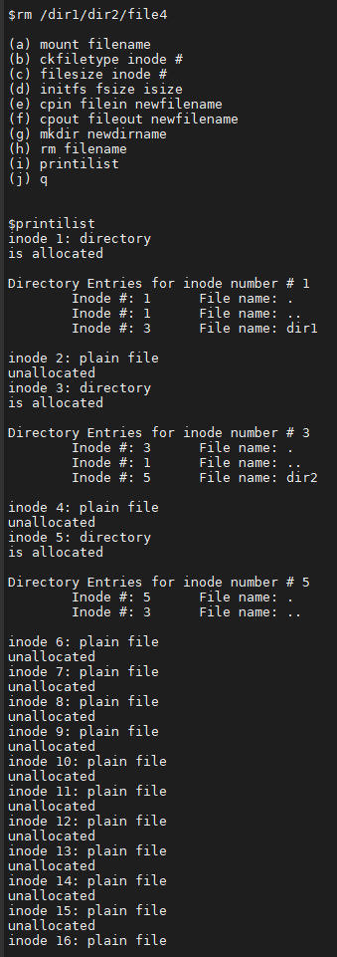

“q” for quit and then we concatenate the files we previously copied out from the v6 file system.

