|  |
| --- |
| Sensor-based behavioural monitoring setup to support dementia care |
| Abstract:  Mobility plays a critical role in enhancing quality of life among people with dementia.  Mobile and wearable technology offers a promising alternative to questionnaire-based methods for measuring out-of-home mobility continuously, passively and remotely using location data from device sensors.  This work presents a mobility monitoring system developed to accommodate a wide variety of mobile/wearable devices and calculate a broad set of spatial, temporal and frequency-based mobility metrics. Additionally, we present a sensor-based implementation of the mobility measurement approach employed by established life space assessments.  Data is collected using a smartwatch, smartphone and custom application based on open source resources. A set of algorithms is developed to extract trajectories, features and mobility assessment results from raw location data. The system is evaluated in pilot study with 5 healthy volunteers, and using data from a series of 6 case studies including people with dementia. Results demonstrate that the system performs adequately and minimal data pre-processing, is comparable with subject perceptions …[TBC when all results are final].  Sensor-based mobility monitoring could greatly benefit dementia care, offering new/important opportunities for proactive and personalised care approaches. |
| July 2018 |

# Introduction (motivation) [1]

The ageing of the population and consequent rise in prevalence of conditions such as dementia presents a great challenge to society. New care approaches are needed to overcome the increasing disparity between available resources and the growing demands on our healthcare systems. Many interesting opportunities are presented by smart mobile and wearable technologies. Our personal devices are capable of generating rich data throughout everyday life from on-board and connected sensors, and provide a convenient and familiar platform through which to offer various forms of support via applications. For dementia, smart technology has been used to… *[get key references from earlier literature review, examples include detection of ADL’s; wandering; falls; support with managing ADL’s/memory support, stimulating activities, etc.]*. Leveraging the functionality of mobile technologies will become even more relevant as today’s highest adopters age. It is therefore already important now to examine how personal devices and the data these generate can be used to support dementia care.

One interesting avenue is mobility monitoring, specifically out-of-home (or global) mobility, which describes the extent to which an individual moves within their environment by any means. Both increasing age and cognitive impairment are associated with reduced mobility (Rosso, Taylor, Tabb, & Michael, 2013; Shoval et al., 2011). This is of great concern regarding quality of life for people with dementia, since mobility is intrinsically linked to social engagement, functional capacity, affective state and caregiver burden, and a decisive factor for active aging (Rosso et al., 2013; J. Y. Tung et al., 2014a; Webber, Porter, & Menec, 2010; Werner et al., 2012). Several factors may be at play when cognitive impairment leads to reduced mobility, such as concerns about safety, usual activities becoming too cognitively demanding, and depressive symptoms (e.g. reclusiveness and apathy). Reduced mobility can present a dangerous feedback loop by inhibiting social engagement and stimulation, thereby aggravating the cognitive decline and depressive symptoms that contribute to further mobility reduction. This underscores the importance of maintaining mobility among the elderly and especially the cognitively impaired.

Traditionally, out-of-home mobility has been assessed using instruments such as the Life Space Questionnaire (Stalvey, Owsley, Sloane, & Ball, 1999) or similar LSA (University of Alabama at Birmingham Study of Aging Life‐Space Assessment) (Baker, Bodner, & Allman, 2003). This approach is limited by its reliance on patients’ memory and subjective perceptions of the distances they cover, which is especially problematic among people with cognitive impairment. Furthermore, questionnaires require input from both patients (interviewee) and healthcare professionals (interviewers). Mobile phones and wearable sensors offer a promising alternative for out-of-home mobility measurement, since these are typically equipped with location sensors and carried with users as they move throughout their wider environment.

The aim of this work is to develop a system for measuring mobility using sensor data generated by personal devices such as smartphones and wearables among people with mild-to-moderate dementia. Specifically, we focus on the analysis of location, activity and step count data commonly available from smart, mobile devices to derive a set of measures describing an individual’s mobility in terms of both the extent to which they leave their home and their general activity level.

## Related work

Within healthcare, sensor-based mobility monitoring has been investigated for chronic diseases, mental health, and among the elderly, looking both at physical activity related mobility and out-of-home mobility (Allet, Knols, Shirato, & de Bruin, 2010; Boissy et al., 2011; Canzian & Musolesi, 2015; Hirsch, Winters, Clarke, & Mckay, 2014; Noury, Quach, Berenguer, Bouzi, & Teyssier, 2012). These works describe a variety of metrics for out-of-home mobility measurement, which can be categorised as spatial, temporal or frequency-based. Spatial measurements, often termed *life space,* include geographical areas or distances covered, such as the area of the minimum convex polygon (MCP) enveloping a specified quantile of GPS coordinates, distances from home (action range), or total distance covered. Temporal measurements include time spent at or out of home, or visiting places of interest. Frequency-based measure include counts within a given period, such as the number of trips out of home or places visited per day or week. Certain *lifespace* measures can be calculated from raw GPS data, whereas other metrics require knowledge of a home location, and some require knowledge of GPS trajectories, that is, the series of stays (also stops or visits) and moves within the location data. [Physical activity data…]

Several studies have started to examine sensor-based mobility measurement among people with cognitive impairment and dementia over the last decade. A number of these works employ specialised GPS kits to monitor mobility among participants with mild cognitively impaired and Alzheimer’s dementia. This is the case in the *SenTra* project, which examines mainly temporal and frequency-based metrics (SHOVAL et al., 2011; Wettstein et al., 2015), and alternatively in work by Tung et al. focusing primarily on life space (J. Tung, Semple, Woo, & Hsu, 2011; J. Y. Tung et al., 2014b). These works have provided important evidence on associations between mobility and cognitive impairment and demonstrated the potential for automatic monitoring, however all use specialised GPS kits rather than everyday devices such as smartphones. In a more recent study (from 2018), smartphones and smartwatches are employed to collect data for mobility measurement among people with dementia (Zylstra et al., 2018). The authors describe the system architecture in detail, with less focus on data analysis, including only two metrics: step count and distance from home. It is therefore of interest to build upon this work with a focus on data analysis by using a similar technical setup to investigate a broad collection of the mobility metrics presented in this section. Furthermore, the many mobility metrics calculated in the works discussed here, while highly relevant, are not directly comparable to related paper-based clinical assessments for out-of-home mobility. Based on the current progress, we therefore summarise two important goals for further development to be addressed in this work:

* Describe a set of tools/algorithms for calculating a broad range of mobility metrics including spatial, temporal and frequency-based, to be applied to sensor-data collected from generic smart devices (rather than a specialised system)
* Present an approach for automatic, remote monitoring of out-of-home mobility that relates directly to current questionnaire-based alternatives

*[scope of paper]*

# Methods: Technical Setup (System Overview)

Location data is required for measuring out-of-home mobility and can be recorded using smartphones’ on-board GPS sensors. Step-count and activity data were also included to support the goal of creating a generic and versatile set of tools for mobility measurement in a wide range of potential applications, since these are both ubiquitous and relevant data streams. The devices used in this study are Google Nexus 5 smartphones and Sony SmartWatch 3 smartwatches, running Android OS v6.0.1. and Android Wear operating systems respectively. Both devices record location and step count, whereas activity types are recorded on the phone only.

A custom-built application (app) was used to securely collect, store and transfer data. The app is an adapted version of that described in (Stopczynski et al., 2014), which is publicly available under the OpenSensing github organization at github.com/organizations/OpenSensing. The app uses Google API’s to access sensor data (*LocationListener*, *ActivityRecognitionApi* and *SensorManager*). New users are registered through a web-portal where they create a front-end username and password, and are assigned a back-end pseudonym. The custom app is then accessed from Google Play and installed on both paired devices. Watch data is uploaded to the phone, where all data is continuously collected, encrypted and stored locally on the phone. Only when a Wi-Fi connection is available are encrypted data files uploaded to a server over HTTPS. To ensure security, two virtually separate servers are employed: an anonymous raw data server and an identity server with user pseudonyms. Data is then decrypted and transferred to a database for analysis as required by an authorised user (researcher with administrator rights). An overview of the technical setup and data flow is provided in Figure 1.

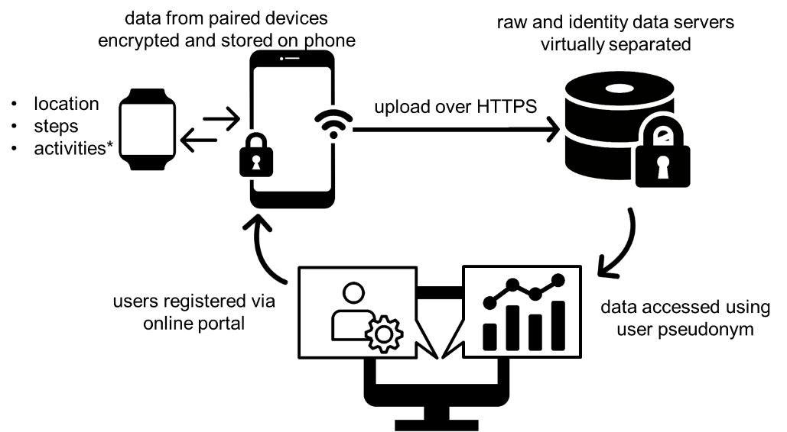

Figure 1. System Overview

# Methods: Mobility Feature Extraction

The raw location data for each user comprises merged watch and phone data including timestamp, latitude, longitude, and accuracy in meters. The sampling frequency is irregular and, besides periods of missing data e.g. due to signal loss, readings are spaced between a few milliseconds and ~5 minutes apart. The only pre-processing applied was to filter the data according to accuracy, with an upper limit of 25 meters. The inputs required to calculate the mobility metrics include the set of coordinate pairs, GPS trajectories (a series of stays and moves), and a known home location. The following sections describe how these inputs are obtained, followed by a description of the metrics calculations.

## Extracting inputs: calculating GPS trajectories and home centroid from location data

Many temporal and frequency-based measures require GPS trajectories describing how the person stays at or moves between locations. This requires analysis of the raw location data to extract “stay” and “move” events, and identification of locations (“points of interest” or “hotspots”) in the dataset.

*Refer to the methods used elsewhere e.g. Cuttone, Zheng, etc. and justify our approach.*

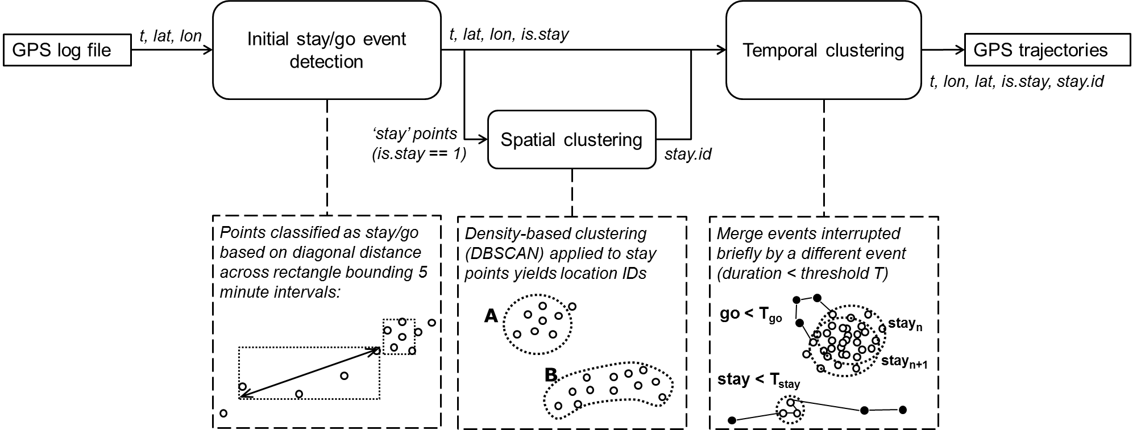

#### Initial stay detection

Adapted from (Andrienko, Andrienko, Raimond, Symanzik, & Ziemlicki, 2013). Not dependent on evenly spaced readings.

#### Spatial clustering (DBSCAN)

good fit: unsupervised, any shape, can handle outliers.

#### Temporal clustering (filtering)

Can be user-specified to fit the application (as with first step)

#### Home detection

Detect “home” position (mode, update) > is.home > distance to home

#### Output…

## Calculating mobility metrics (or features)

The set of mobility metrics was selected by combining various other selections used in literature for similar purposes (Canzian & Musolesi, 2015; Ireland, Mcbride, Liddle, & Chenery, 2013; J. Y. Tung et al., 2014b; Wettstein et al., 2014), ensuring that different types of measures are included (i.e. spatial, temporal and frequency or count based). An overview of the included mobility metrics is provided below.

|  |  |
| --- | --- |
| *Minimum convex polygon* | Area of the smallest possible convex polygon constructed around the data, also referred to as the “mobility envelope”. This is calculated by applying the R function chull to a subset of points for which the distance to the centroid falls within a 99% quantile. |
| *Action range* | Straight-line distance between home and the most distal point of a journey, sometimes referred to as *home range*. The R function distGeo (Karney, 2013) is used to calculate the geodesic distance between the home centroid and all other points in the dataset. For each stay and move event in the GPS trajectory, the action range variable is then calculated as the maximum of these distances. Both the maximum and mean per day are included. |
| *Distance covered* | The geodesic distance between consecutive stays centroids. Both the maximum and total per day are included. |
| *Time spent out* | Sum of durations for all events excluding stays at home |
| *Time spent moving between locations* | Sum of durations for all move events |
| *Number of places visited* | Count of unique places visited (including home). This requires location ID’s, so that a single place is only counted once even when visited multiple times per day. |
| *Number of trips* | Count of all moves in the GPS trajectories |

*To add: Demonstrative result of all stays on a map along with various metrics (one for each of: spatial mobility, temporal mobility, frequency mobility, activity, steps)*

## Activity (TBC)

Step-count: (step count totals are better from watch, but the data is too erratic to see patterns. Phone offers better “real time” patterns, but is less reliable in terms of how it is used to pick up step counts on a micro level.)

* total per day from more reliable device (watch where possible)
* patterns based on windows (NOTE: For most participants this is not an effective method, since the data is too erratic. There are exceptions like P10. This also shows something about the validity of the approach, since it shows the spread of data across the day.)

Activity patterns:

* look at foot, bike, vehicle, still
* approach options:
  + threshold applied to interval between readings
  + look at most frequent in bins

# Evaluation

The mobility monitoring solution was evaluated using data from two experiments. The first experiment served as a small pilot study (N = 5) to test the stay detection module and selected metrics. The second experiment compared results from life-space mobility assessments with corresponding sensor-based measurement for a group of six participants within the target group of people with dementia.

## Pilot test

The pilot study included five healthy participants recruited from the research institution where this work has been carried out […not sure what details are necessary]. Participants used the mobility monitoring system while simultaneously logging their movements for a period of one week. A log sheet was provided with 15-minutes intervals and columns for “stay”, “move” and the stay location or mode of travel respectively.

The data was used to visually inspect the results of the trajectory extraction algorithm to confirm whether these appeared feasible, e.g. if stay events are confined to a small area and moves correspond to sequences of points out of these areas. Timelines of stays and moves were then compared for log sheets and algorithm results to gauge the level of agreement between the two signals.

The metrics *time outside of home* and *number of places visited* were both compared between logged and algorithm results. These were selected because they cover different types of information (time and count) and thus require information about both durations and location identification, and because these could be easily obtained using the log sheets.

## Relating sensor-based monitoring to standard clinical assessments

This part of the evaluation used a subset of data from a series of case studies involving people with early-stage dementia. In the case studies, participants used the mobility monitoring setup for a period of 8 weeks and completed a batch of assessments prior to and post their participation period, including for life-space mobility based on the LSA format. The subset of data used for this evaluation included the last four weeks of location data and the post-study LSA results. This matched the LSA approach of asking subjects to answer mobility questions for a typical week based on the previous four weeks. Location data was used to calculate mobility zone entries in the same format as the LSA results, and the two sets of results were compared for each participant.

*Incorporate the section below from “method” section of previous version where it was part of the metrics calculation.*

A sensor-based implementation of standard life-space mobility assessments was developed as an extension to the metrics commonly calculated from location data. This offers an objective, automatic and remote alternative to existing mobility monitoring practices that are well accepted but less efficient. Life-space mobility assessments typically ask subjects whether they have moved from their home outward along a series of mobility levels (concentric areas of increasing radii). The Life Space Questionnaire (Stalvey et al., 1999) includes 9 levels ranging from moving from the bedroom to other rooms in their home up to travel out of their home state, with the first 3 levels being within their property or building (e.g. courtyard, parking space). The more recent LSA instrument (Baker et al., 2003) includes 5 levels ending with travel out of town, and with only the first two being within their property. This also includes questions regarding how often per week (four levels) a life space range is entered, generating a frequency-distance matrix.

Based on target group and purpose, it was not considered relevant to monitor levels greater than “out of town”. The information available from GPS trajectories calculated in section 3.1 does not offer a spatial resolution high enough to detect indoor movement or to distinguish between a front porch and a driveway (which will differ substantially from home to home). We therefore include four levels, here termed *mobility zones* (MZ), which are outlined in Table [REF]. The four frequency levels from the LSA are used: daily, 4-6, 1-3 or <1 times per week.

|  |  |  |
| --- | --- | --- |
| MZ | DH | Description |
| 1 | up to 50m | Area immediately surrounding their home, e.g. garden, parking area or post-box |
| 2 | 50m-1km | Neighbourhood |
| 3 | 1-10km | Outside of their immediate neighbourhood but within their town/city |
| 4 | >10km | Out of town |

Mobility zone entries are detected using the *action range* variable, which is available for all stays and moves and can be easily assigned to one of the four mobility zone intervals. A binary (true/false) value is calculated per day for each mobility zone, i.e. answering whether the subject entered that zone at all that day. These results are then summarised as the number days per week that each mobility zone was entered.

# Results

This section describes the results from evaluating three main modules of the mobility monitoring solution - trajectory extraction, metrics calculation, and automatic standard assessment.

## Pilot test

* Trajectory extraction
* Metrics. #places, time out of home
* Activity bout extraction

Description: comparison between log sheets (red) and algorithm (blue) results for GPS trajectories (stays and moves) for two days from one participant.

Notes: While the results are similar in terms of the approximate time spent moving or stopped, there are some differences regarding the number of moves and event timing.

Some misalignment is expected, since the logs were in 15-minute intervals and participants were not expected to provide a higher resolution than this, nor to fill in logs immediately as moves occurred when inconvenient, possibly introducing memory inaccuracies.

The examples show the algorithm detecting an unlogged stay (top) and two unlogged moves (bottom). Since all three cases are short events of under 15 minutes, this could be due to a mismatch between the participant’s perception of what constitutes a stay/move and the algorithm parameters.

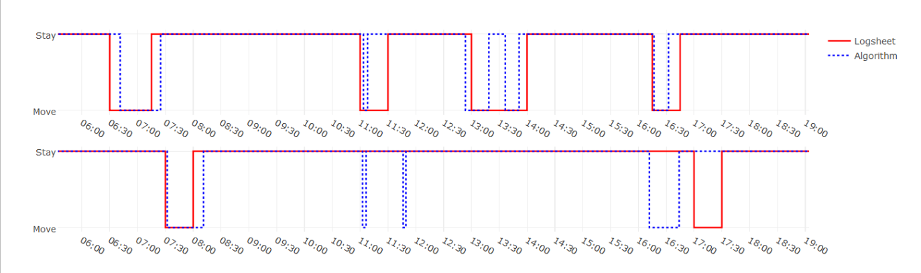

#### Compare time outside of home

Description: paired results from log sheets (solid line) and algorithm (dotted line) for the total time spent out of home each day for all participants (represented by different colours).

Notes: Good agreement (besides day four of the darker green). Could include a numeric result here for the total time difference between the two sources (per participant for whole week).

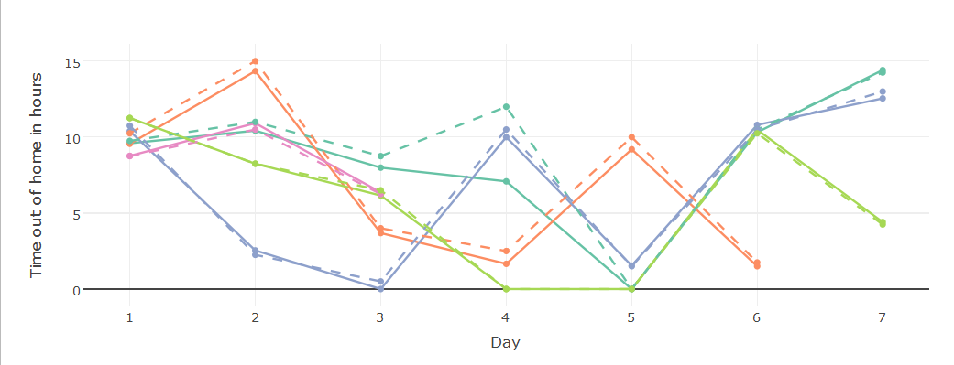

#### Compare #places

Description: total count of unique places visited per day including home for participants 1-4 calculated from log sheets and sensor data.

Notes: agreement ok; one cause of disagreement is different perceptions of a “visit”, some participants were not sure if waiting for a bus was visiting a place, even where the wait for the bus was a long duration.

*since this was added after the pilot was carried out, participants were not instructed to log the place id’s, therefore may need to check with them for any uncertainties*

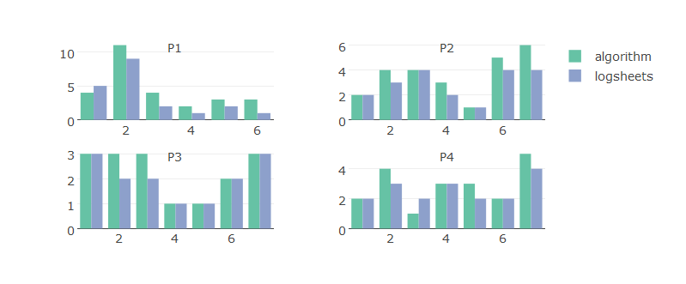

## Relation to standard assessments

#### Life space assessment

Description: plot per participant showing mobility assessment results (questionnaire) and sensor-based alternative. Y-axis show the 4 different “mobility zones” (categorically), and the marker size reflects the number of occurences.

*Note: a couple small changes are needed in the algorithm, which may make it easier to detect the very close zone, so these results will change.*

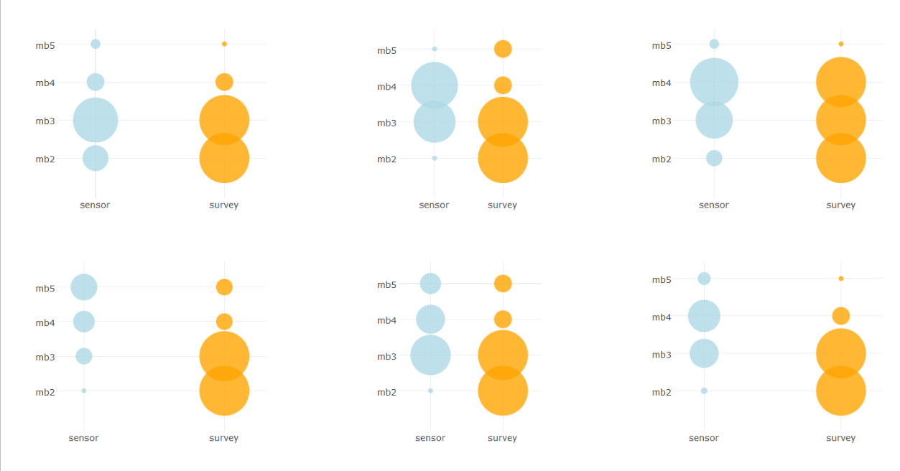

#### Physical activity assessment

# Discussion

* Comments on success/performance of the developed solution.
* Implications for dementia care: how might these measures be applied to improve care?
* Early intervention (and other P4 characteristics, e.g. which metrics fit best the individual QoL needs etc)
* Goal-oriented approaches (customise which places are detected etc)
* Examine pattern consistency as a useful tool for cognitive rehabilitation (literature references – Hysse?)
* For research, ie to supplement or replace self reports when testing interventions etc
* Future work:
* Long term monitoring and pattern analysis (cite examples of approaches to be used)
* Addition of activity if not included here
* Clinical Implementation

# Conclusion

References

Allet, L., Knols, R. H., Shirato, K., & de Bruin, E. D. (2010). Wearable systems for monitoring mobility-related activities in chronic disease: a systematic review. *Sensors (Basel, Switzerland)*, *10*(10), 9026–9052.

Andrienko, G., Andrienko, N., Raimond, O., Symanzik, J., & Ziemlicki, C. (2013). E XTRACTING S EMANTICS OF Individual P LACES FROM, (c).

Baker, P. S., Bodner, E. V., & Allman, R. M. (2003). Measuring Life-Space Mobility in Community-Dwelling Older Adults. *Journal of the American Geriatrics Society*, *51*(11), 1610–1614.

Boissy, P., Brière, S., Hamel, M., Jog, M., Speechley, M., Karelis, A., … Duval, C. (2011). Wireless inertial measurement unit with GPS ( WIMU - GPS ) – Wearable monitoring platform for ecological assessment of lifespace and mobility in aging and disease. In *IEEE Engineering in Medicine and Biology Magazine* (pp. 5815–5819).

Canzian, L., & Musolesi, M. Trajectories of Depression: Unobtrusive Monitoring of Depressive States by means of Smartphone Mobility Traces Analysis, Proceedings of the 2015 ACM International Joint Conference on Pervasive and Ubiquitous Computing - UbiComp ’15 § (2015). New York, New York, USA: ACM Press.

Hirsch, J. A., Winters, M., Clarke, P., & Mckay, H. (2014). Generating GPS activity spaces that shed light upon the mobility habits of older adults : a descriptive analysis. *INTERNATIONAL JOURNAL OF HEALTH GEOGRAPHICS*, 1–14.

Ireland, D., Mcbride, S., Liddle, J., & Chenery, H. (2013). Towards Quantifying the Impact of Parkinson ’ s Disease Using GPS and Lifespace Assessment (pp. 564–569).

Karney, C. F. F. (2013). Algorithms for geodesics. *Journal of Geodesy*, *87*(1), 43–55.

Noury, N., Quach, K. A., Berenguer, M., Bouzi, M. J., & Teyssier, H. (2012). A feasibility study of using a smartphone to monitor mobility in elderly. *2012 IEEE 14th International Conference on E-Health Networking, Applications and Services, Healthcom 2012*, (Figure 3), 423–426.

Rosso, A. L., Taylor, J. A., Tabb, L. P., & Michael, Y. L. (2013). Mobility, disability, and social engagement in older adults. *Journal of Aging and Health*, *25*(4), 617–637.

Shoval, N. ., Wahl, H.-W. ., Auslander, G. ., Isaacson, M. ., Oswald, F. ., Edry, T. ., … Heinik, J. . (2011). Use of the global positioning system to measure the out-of-home mobility of older adults with differing cognitive functioning. *Ageing and Society*, *31*(5), 849–869.

SHOVAL, N., WAHL, H.-W., AUSLANDER, G., ISAACSON, M., OSWALD, F., EDRY, T., … HEINIK, J. (2011). Use of the global positioning system to measure the out-of-home mobility of older adults with differing cognitive functioning. *Ageing and Society*, *31*(05), 849–869.

Stalvey, B. T., Owsley, C., Sloane, M. E., & Ball, K. (1999). The Life Space Questionnaire: A Measure of the Extent of Mobility of Older Adults. *Journal of Applied Gerontology*, *18*(4), 460–478.

Stopczynski, A., Sekara, V., Sapiezynski, P., Cuttone, A., Madsen, M. M., Larsen, J. E., & Lehmann, S. (2014). Measuring Large-Scale Social Networks with High Resolution. *PLoS ONE*, *9*(4), e95978.

Tung, J., Semple, J., Woo, W., & Hsu, W. (2011). Ambulatory Assessment of Lifestyle Factors for Alzheimer’s Disease and Related Dementias. *AAAI Spring Symposium …*, 50–54.

Tung, J. Y., Rose, R. V., Gammada, E., Lam, I., Roy, E. A., Black, S. E., & Poupart, P. (2014a). Measuring life space in older adults with mild-to-moderate Alzheimer’s disease using mobile phone GPS. *Gerontology*, *60*(2), 154–162.

Tung, J. Y., Rose, R. V., Gammada, E., Lam, I., Roy, E. A., Black, S. E., & Poupart, P. (2014b). Measuring life space in older adults with mild-to-moderate Alzheimer’s disease using mobile phone GPS. *Gerontology*, *60*(2), 154–162.

Webber, S. C., Porter, M. M., & Menec, V. H. (2010). Mobility in older adults: A comprehensive framework. *Gerontologist*, *50*(4), 443–450.

Werner, S., Auslander, G. K., Shoval, N., Gitlitz, T., Landau, R., & Heinik, J. (2012). Caregiving burden and out-of-home mobility of cognitively impaired care-recipients based on GPS tracking. *International Psychogeriatrics / IPA*, *24*(11), 1836–1845.

Wettstein, M., Wahl, H.-W., Shoval, N., Auslander, G., Oswald, F., & Heinik, J. (2014). Cognitive status moderates the relationship between out-of-home behavior (OOHB), environmental mastery and affect. *Archives of Gerontology and Geriatrics*, *59*(1), 113–121.

Wettstein, M., Wahl, H.-W., Shoval, N., Oswald, F., Voss, E., Seidl, U., … Landau, R. (2015). Out-of-home behavior and cognitive impairment in older adults: findings of the SenTra Project. *Journal of Applied Gerontology : The Official Journal of the Southern Gerontological Society*, *34*(1), 3–25.

Zylstra, B., Netscher, G., Jacquemot, J., Schaffer, M., Shen, G., Bowhay, A. D., … Schenk, A. K. (2018). Extended, continuous measures of functional status in community dwelling persons with Alzheimer’s and related dementia: Infrastructure, performance, tradeoffs, preliminary data, and promise. *Journal of Neuroscience Methods*, *300*, 59–67.