**Project Algorithm Report**

**Project Team: (A)lways (I)nebriated**

Justin Drouin; jdrouin@csu.fullerton.edu  
Timothy Bui; timothybui98@csu.fullerton.edu

Anthony Lam; [Anthonylam2445@csu.fullerton.edu](mailto:Anthonylam2445@csu.fullerton.edu)

Michael Burdi; maburdi@csu.fullerton.edu

The bots tile count is 174, which is currently incorrect.

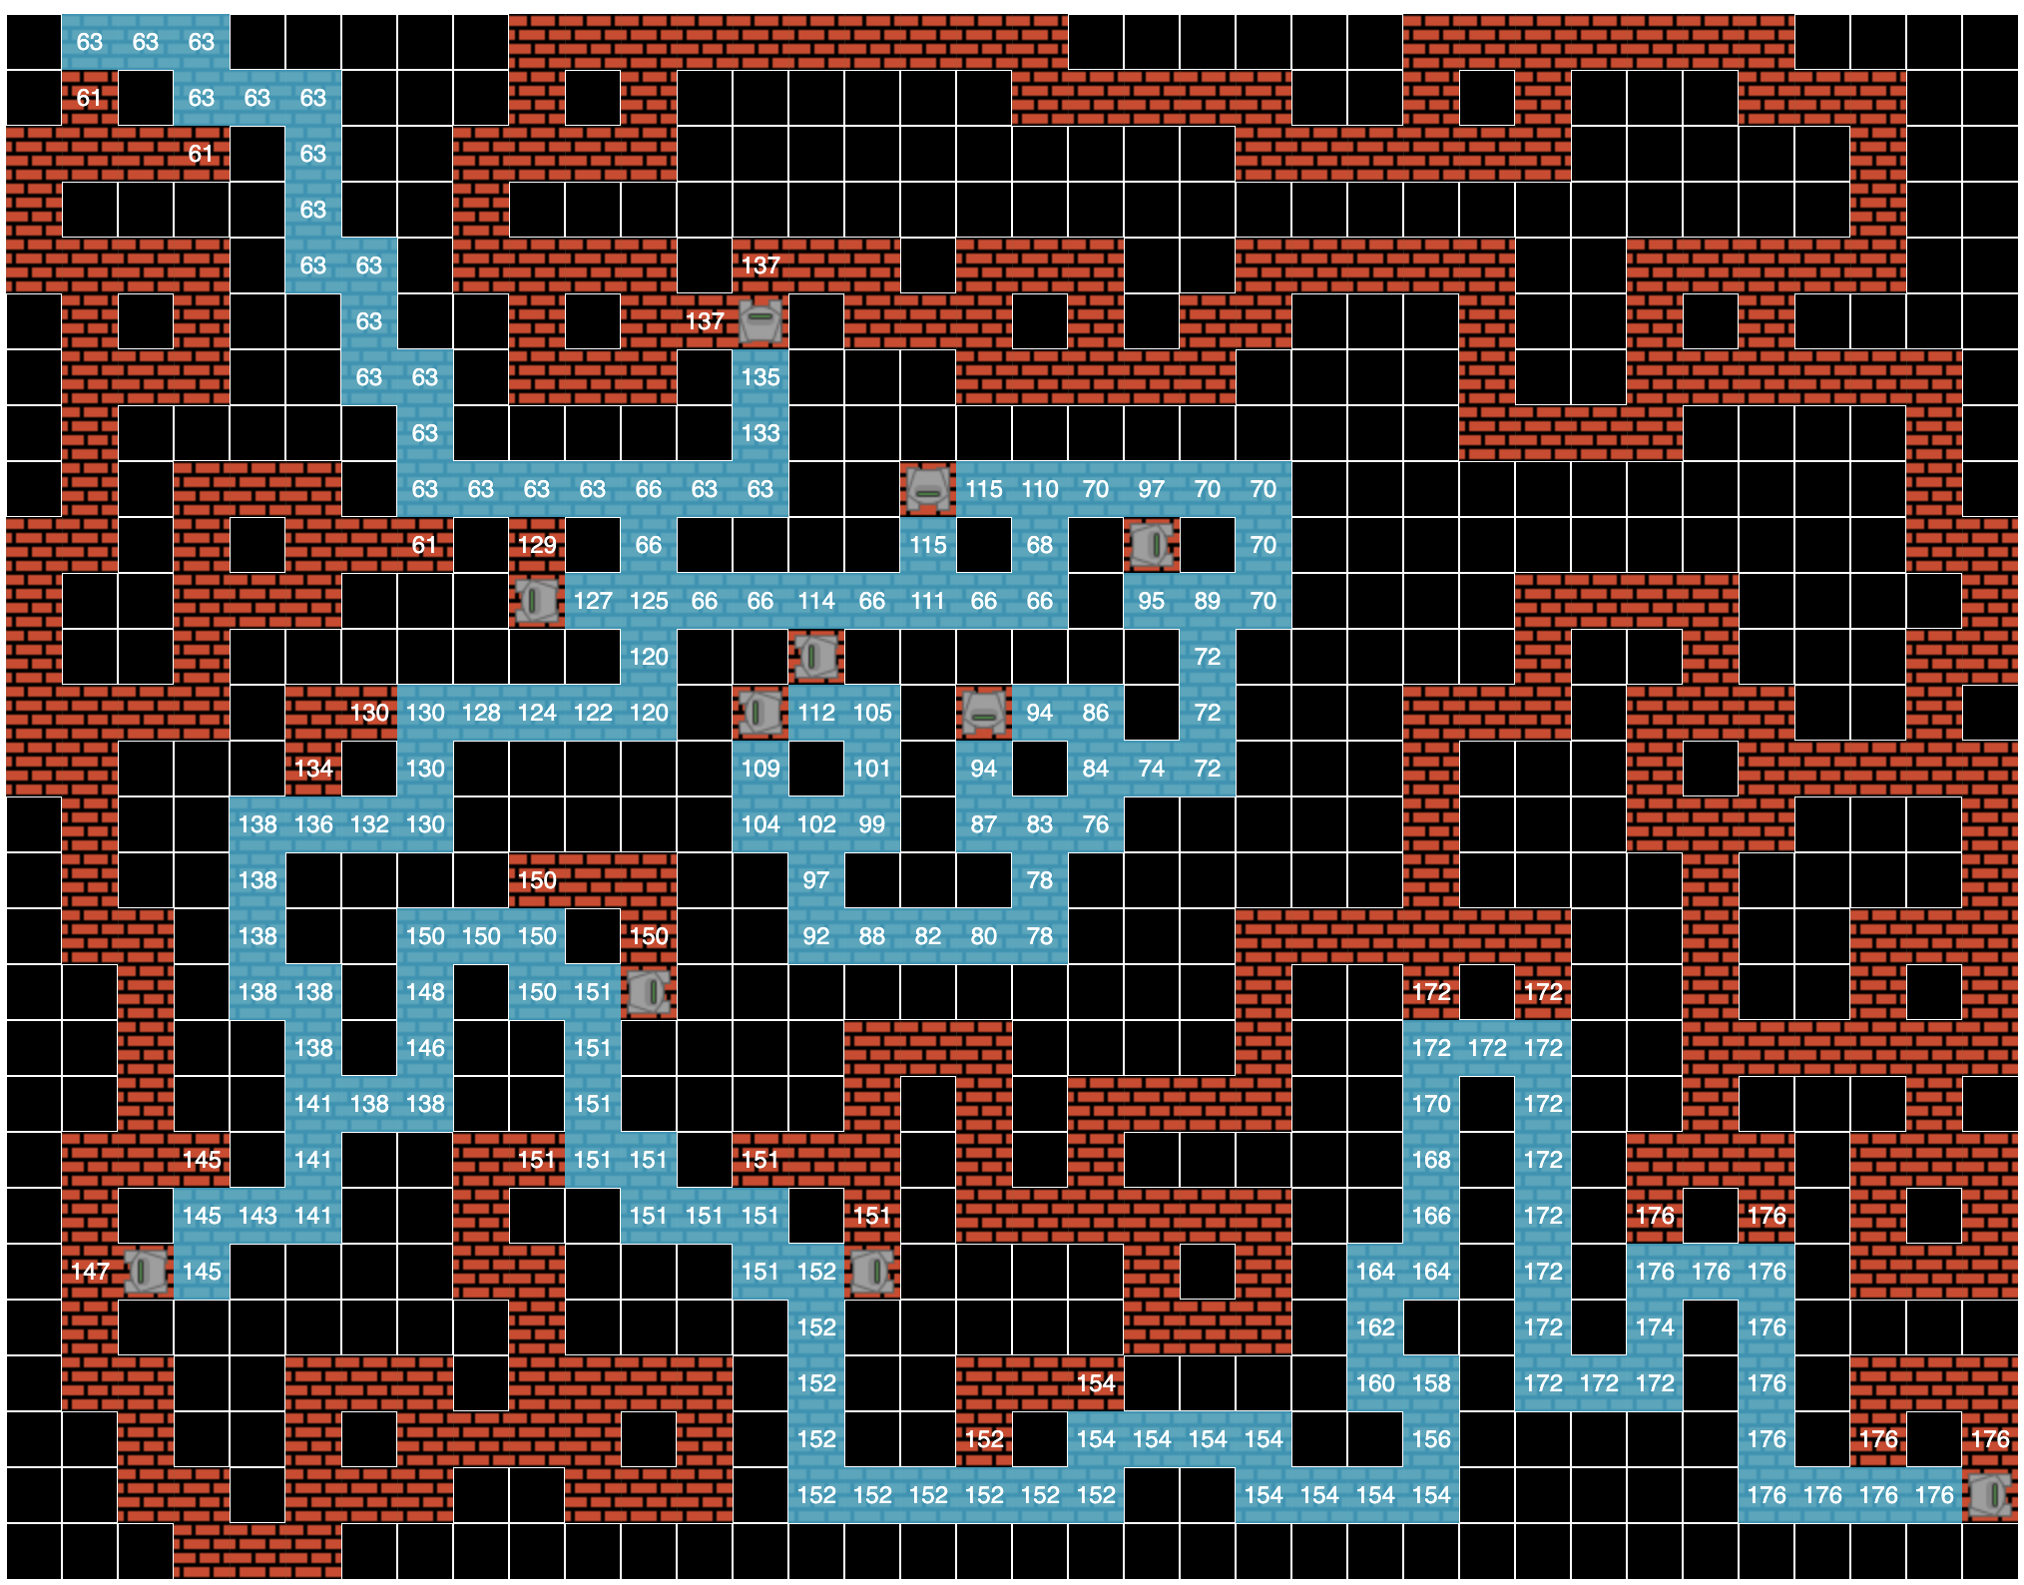

Your algorithm's major data structures, briefly (ie, how you did it internally):

The bot utilizes 3 different lists in lisp, an open list, closed list and best path list. The Hn, Fn, Gn functions are used to get the respective value for the A* search. A neighbors list is also used to maintain cell neighbors. The function get-tile-type is used to get the tile type of any cell so the bot knows if it can move there or not. The bot currently does not backtrack as it should but instead ‘jumps’ to the new path when it reaches a dead end. The best path is not indicated yet either yet, which will be set with green circles.