HABS – Halfluck Automated Brewing System
An open-source Brewbot for Arduino.
(cc) rob@halfluck.com

Source Code Files:
HABS.pde --> Main Sketch
manualmode.pde --> Manual Mode Sketch
automode.pde --> Auto Mode Sketch
cipmode.pde --> CIP (Cleaning In Place) Sketch
setupmenu.pde --> Setup Menu Sketch

Hardware Requirements :

1 x Arduino Based Microcontroller (ATmega328P Chip)
1 x 4x20 LCD & Serial Board
2 x Temperature Sensors (DS18B20)
4 x Push Buttons (Normally Open)
4 x Solid State Relays (SSR)
1 x Heater Element
1 x Float Switch
2 x Perastaltic Pumps
1 x Low RPM Motor

Arduino Pinouts

Digital 0 RX for Serial
Digital 1 TX for Serial & LCD
Digital 2 Button 1
Digital 3 Button 2
Digital 4 Button 3
Digital 5 Button 4
Digital 6 Float Switch
Digital 7 DS18B20 Temp Sensor Data
Digital 8 Speaker
Digital 9 SSR (HLT/KETTLE ELEMENT)
Digital 10 SSR (PUMP 1 HLT to MASHTUN)
Digital 11 SSR (PUMP 2 MASHTUN to HLT/KETTLE)
Digital 12 SSR (MASH STIRRER MOTOR)
Digital 13
Digital 14/Analog
Digital 15/Analog
Digital 16/Analog
Digital 17/Analog
Digital 18/Analog
Digital 19/Analog
Auto Mode

Automode can be selected by pressing "Button 1" on the main menu

Step 1 Countdown Timer
Step 2 Check Water is in the Vessel
Step 3 Heating Vessel to Strike Temp
Step 4 Doughing-In
Step 5 Saccharification Rest
Step 6 Mash Out
Step 7 Stir after adding Mash Out water

Step 8 Mash Out Rest

Step 9 Vorlauf

Step 10 Fill Kettle
Step 11 Bring Kettle to Boil
Step 12 Boil Kettle
Step 13 Add Hops / Wirlfloc / Yeast Nutrient
Step 14 End of Boil Rest

Setup Menu

Setup Menu can be selected by pressing "Button 4" on the main menu

When you first upload the sketch to your Arduino, the default values are usually 255
You will need to update these values before your first "Auto Mode" run.
Each of the below settings are saved on the EEPROM and will survive a power off.

Once in the setup menu, to change variables the buttons are as follows

Button 1 is UP
Button 2 is DOWN
Button 3 is SAVE
Button 4 is NEXT

The User Definable Setup Menu options are as follows:

Test Mode (Default 0, Set to 1 to Enable)

When test mode is enabled you can skip thru each step in AutoMode by pressing button 2

Countdown Timer (Default 0)

Set Between 1-255 for delay at start of Automode
Incriments are in 10 Minute e.g. 2 would be 20 Minutes.

Check Float (Default 0)

Set to 1 if you have a float switch installed.

Strike Temp (Default 70)

Desired Strike Temperature for the water to reach before "Doughing in"
Usually a couple of degrees higher than Desired Mash Temp

Desired Mash Temp (Default 67)

This is the Temperature you wish to maintain during your mash.

Mash Length (Default 60)

How long in Minutes to mash for.

Mash Out Temp (Default 76)

What temperature to raise the mash to at the end of the mash cycle.

Boil Temp (Default 99)

What Temperature to class as the start of the boil.

Boil Length (Default 90)

How long in minutes to boil for.

Hop Addition 1 (Default 60)

When to trigger the alarm for the first hop addition.

Hop Addition 2 (Default 15)

When to trigger the alarm for the second hop addition.

Hop Addition 3 (Default 5)

When to trigger the alarm for the third hop addition.

End Of Boil Rest Time (Default 5)

How Long in minutes to rest after the boil.

HABS Layout

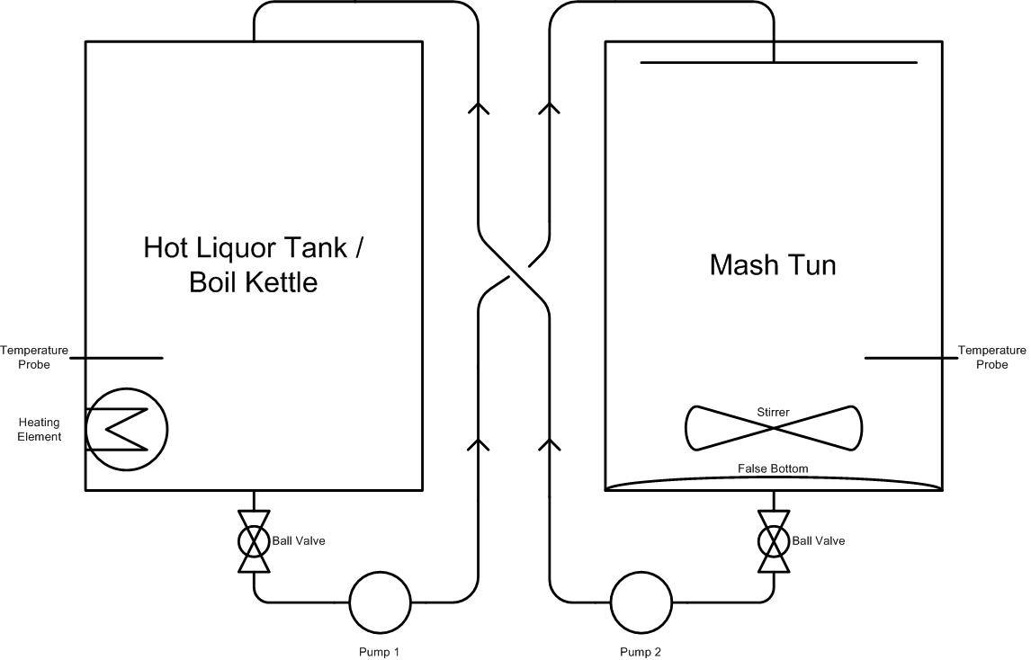

Temperature Sensor (DS18B20) Wiring Diagram

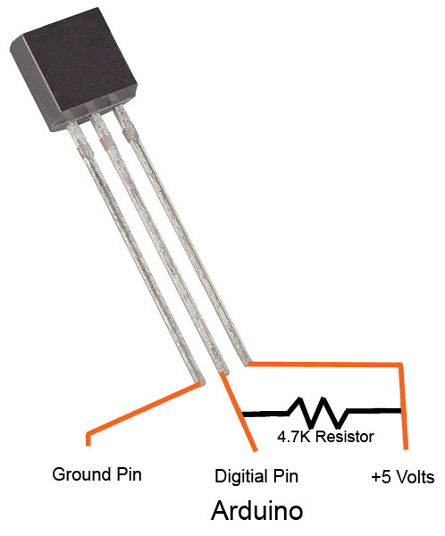

Solid State Relay (SSR) Wiring Diagram

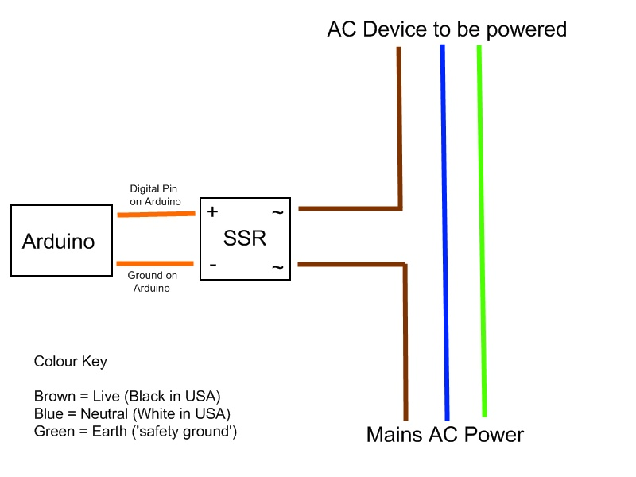

LIFE SAFETY WARNING! [disclaimer]
This information is provided for the use of parties as they see fit!
I am not responsible for the application of this information by any party, including those lacking sufficient skill or knowledge to perform these steps safely and any hazard created is the SOLE responsibility of the user.

I am more than happy to answer any questions or document this further if required
rob@halfluck.com

