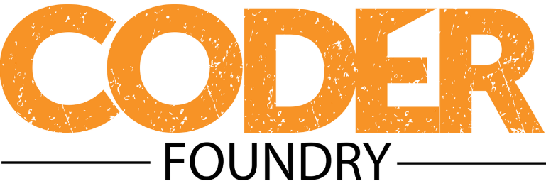

# Master Class Coding Exercises

## JavaScript / jQuery

Complete the following exercises using JavaScript/jQuery. If you are able, spend some time dressing them up visually. While by no means a requirement, it will help you become more comfortable working with CSS. Consider taking advantage of a CSS framework like Bootstrap (which we use extensively at Coder Foundry) to help you with visual presentation. You might spend some time browsing the Bootstrap documentation at getbootstrap.com, and exploring various Bootstrap templates and themes, such as those available at wrapbootstrap.com.

1. Write a program that accepts a series of at least 5 numbers from the user and performs the following actions:
   1. Determine which number is the least
   2. Determine which number is the greatest
   3. Determine the mean of the numbers
   4. Determine the sum of all the numbers
   5. Determine the product of all the numbers
2. Write a program that calculates the factorial of a number. The factorial of a non-negative integer *n* is the product of all positive integers less than or equal to *n*. (i.e. 5! = 5 x 4 x 3 x 2 x 1 = 120).
3. Write a program that accepts two numbers between 1 and 100 from the user. The program then iterates through all numbers from 1 to 100, printing numbers in ascending order to the screen. For each number that is a multiple of the first number input by the user, print "Fizz" instead of the number. For each number that is a multiple of the second number input by the user, print "Buzz" instead of the number. For numbers that are multiples of both numbers, print "FizzBuzz" instead of the number.
4. Write a program that determines whether a word is a Palindrome (the same backward as it is forward – “radar” for example). Display the result to the user.