Below are all the required documents to help you successfully complete the scenario-based tasks. These include a set of templates (for risk assessment, scenario briefs, SWOT analysis, security improvement, performance optimization, compliance roadmap, and a unified action plan), an example report with fictitious data, and several diagrams in Markdown format. You can use these documents to structure your analysis and document your findings during group activities.

## 1. Risk Assessment Template

RISK ASSESSMENT TEMPLATE

Scenario/Project Name: **__________**___

Risk Factor:

* Description: **______________**_
* Detailed Explanation: **__________**

Impact:

* Potential Effects: **____________**_
* Financial/Operational Impact: **________**___

Likelihood:

* ( ) Low ( ) Medium ( ) High

Mitigation Strategy:

* Proposed Actions: **____________**__
* Implementation Details: **__________**__

Responsible Party:

* Assigned Team/Person: **__________**__

Timeline for Mitigation:

* Target Date: **______________**_

Additional Comments/Notes:

## 2. Scenario Brief Template

SCENARIO BRIEF TEMPLATE

Scenario Title: **______________**__

Scenario Description:

* Provide background and context:

Key Data Points:

* Data 1: **________________**
* Data 2: **________________**
* Data 3: **________________**

Impact:

* Describe the consequences on the organization:

Visual Aids/Diagrams:

* [Insert diagram or reference to included diagram if applicable]

Additional Notes:

## 3. SWOT Analysis Template

# SWOT Analysis Template

| **Strengths** | **Weaknesses** |
| --- | --- |
| - List internal advantages (e.g., robust infrastructure, strong vendor support) | - List internal challenges (e.g., skill gaps, outdated systems) |

| **Opportunities** | **Threats** |
| --- | --- |
| - List external opportunities (e.g., emerging cloud technologies, new markets) | - List external risks (e.g., regulatory changes, competitive pressure) |

*Instructions: Fill in each quadrant with relevant points that apply to your scenario analysis.*

## 4. Security Improvement Template

SECURITY IMPROVEMENT TEMPLATE

Scenario Title: **______________**__

Security Issue/Gap:

* Specific Issue: **_____________**
* Detailed Description: **___________**

Root Cause Analysis:

* Causes: **_______________**
* Contributing Factors: **___________**

Impact Analysis:

* Consequences: **______________**
* Affected Areas (e.g., data integrity, service availability):

Proposed Improvement/Remediation:

* Specific Steps: **_____________**
* Process/Configuration Changes: **________**__

Tools/Resources Needed:

* Required Tools (e.g., Azure Security Center, Azure Sentinel): ___

Implementation Timeline:

* Target Date(s): **_____________**

Responsible Team/Person:

* Assigned To: **______________**__

Follow-Up Actions:

* Scheduled Audits/Tests: **__________**__

Additional Comments/Notes:

## 5. Performance Optimization Template

PERFORMANCE OPTIMIZATION TEMPLATE

Scenario Title: **______________**__

Performance Issue:

* Specific Problem: **____________**___
* Detailed Description: **___________**

Root Cause Analysis:

* Identified Bottlenecks: **__________**___
* Contributing Factors: **___________**

Impact Analysis:

* Operational Impact: **____________**_
* Customer/Service Impact: **__________**__

Proposed Optimization Strategies:

* Strategy 1: **______________**___
* Strategy 2: **______________**___
* Strategy 3: **______________**___

Tools/Resources Needed:

* Required Tools (e.g., Azure Monitor, Application Insights): ___

Performance Metrics:

* Key Metrics to Monitor: **__________**__
* Target Improvements: **____________**

Implementation Timeline:

* Expected Completion Date: **________**

Responsible Team/Person:

* Assigned To: **______________**__

Additional Comments/Notes:

## 6. Compliance Roadmap Template

COMPLIANCE ROADMAP TEMPLATE

Scenario Title: **______________**__

Compliance Gaps:

* Gap 1: **________________**_
* Gap 2: **________________**_
* Gap 3: **________________**_

Impact Analysis:

* Consequences of Non-Compliance: **________**

Proposed Remediation Steps:

* Step 1: **________________**
* Step 2: **________________**
* Step 3: **________________**

Timeline for Remediation:

* Milestones & Target Dates: **_________**

Tools/Resources Needed:

* Required Resources (e.g., automated compliance tools, audit software):

Responsible Team/Person:

* Assigned To: **______________**__

Follow-Up Actions:

* Scheduled Reviews/Checks: **_________**

Additional Comments/Notes:

## 7. Unified Action Plan Template

UNIFIED ACTION PLAN TEMPLATE

Scenario/Project Name: **____________**

Key Risk Areas Identified:

* Cost Overruns: **______________**
* Security Gaps: **______________**_
* Vendor Lock-In: **_____________**
* Performance Issues: **____________**_

Integrated Mitigation Strategies:

* Strategy 1 (Cost): **____________**___
* Strategy 2 (Security): **___________**
* Strategy 3 (Vendor): **____________**_
* Strategy 4 (Performance): **__________**__

Overall Action Plan:

* Combined Steps: **_____________**
* Interdependencies: **____________**

Expected Outcomes:

* Benefits/Improvements: **__________**___

Timeline:

* Milestone 1: **______________**__
* Milestone 2: **______________**__
* Overall Target Date: **____________**

Responsible Parties:

* Assigned Teams/Persons: **__________**_

Monitoring & Review:

* Key Metrics: **______________**__
* Review Schedule: **____________**

Additional Comments/Notes:

## 8. Example Report Document (Fictitious Data)

EXAMPLE REPORT: COST OVERRUNS IN AZURE MIGRATION

Scenario Title: Cost Overruns in Azure Migration – Company Alpha

Background:  
Company Alpha migrated its legacy systems to Azure expecting a 20% cost reduction. However, the project experienced a 30% budget overrun due to hidden expenses.

Key Findings:

* **Hidden Fees:** Data egress fees were 15% higher than anticipated.
* **Integration Delays:** Integration of legacy systems with Azure took 25% longer than planned, resulting in increased labor costs.
* **Resource Misallocation:** Over-provisioning of compute instances led to inefficient use of resources.

Impact:

* The budget overrun strained financial resources.
* Delayed project timelines affected product launch dates.
* Customer satisfaction was impacted due to prolonged migration timelines.

Mitigation Strategies Proposed:

1. **Enhanced Cost Forecasting:** Incorporate detailed cost models including potential hidden fees.
2. **Improved Integration Planning:** Allocate additional time and resources for legacy system integration.
3. **Resource Optimization:** Implement auto-scaling and regular cost audits using Azure Cost Management.

Conclusion:  
The report recommends a comprehensive review of cost models and integration processes before future migrations. Implementing robust monitoring and optimization tools is crucial for mitigating similar risks.

## 9. Diagrams in Markdown

### Diagram 1: Cost Overrun Flowchart

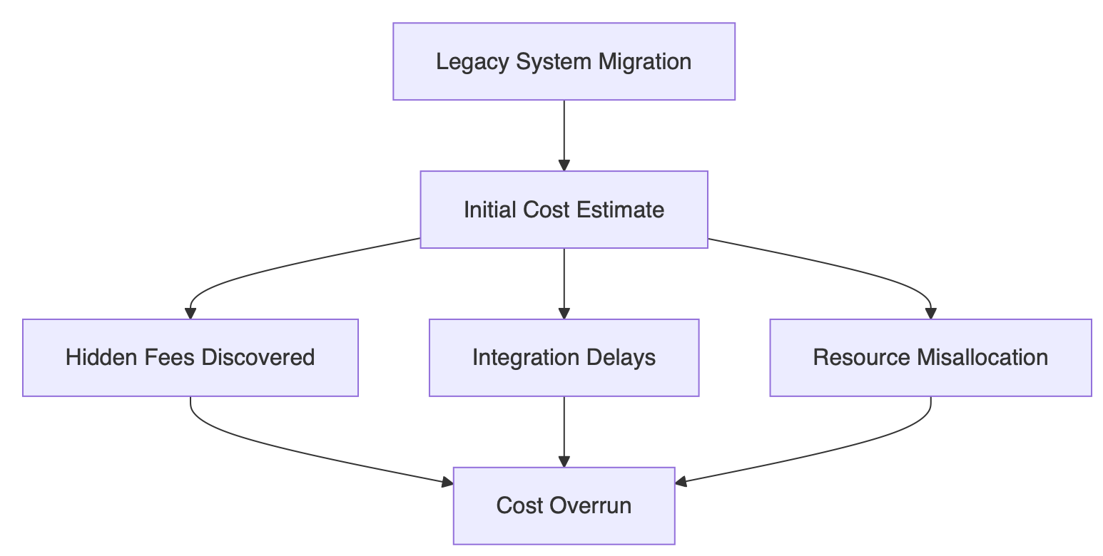

### Diagram 2: Vendor Lock-In vs. Multi-Cloud Strategy

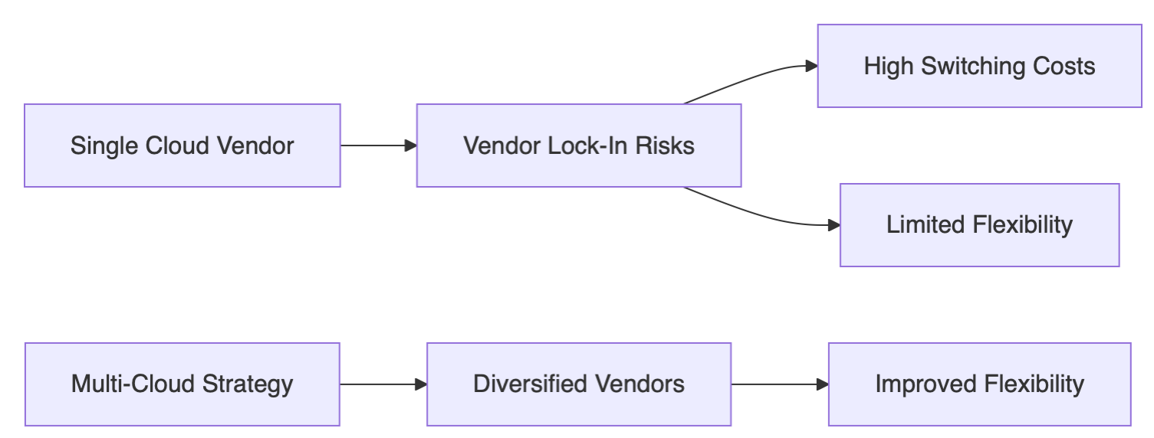

### Diagram 3: Risk Impact Summary Chart

