Rent a Dog
Enterprise Network — Final Project Submission
──────────────────────────────

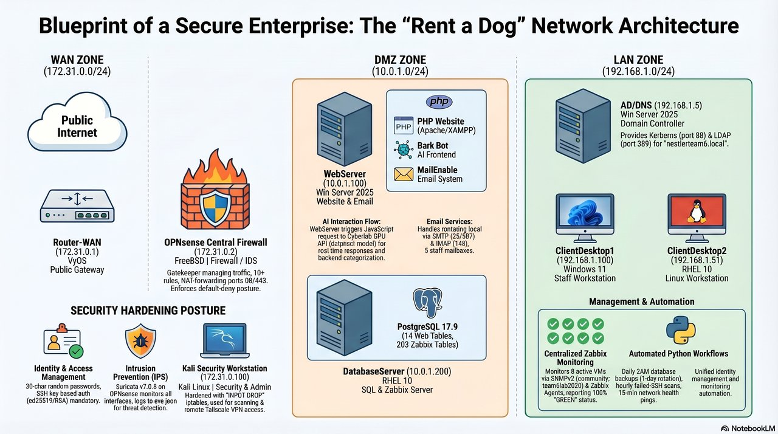

James Ruggles · Jason Cortez-Robles · Oscar Ponce · Allegra Ramirez
IST 4910 — Enterprise System Administration
California State University, San Bernardino · Spring 2026
Dr. Vincent Nestler, Instructor

Version 2.0 — Post-Pentest Final · April 27, 2026

Executive Summary
Team 6 designed, built, hardened, and successfully defended a full enterprise network for Rent a Dog — a fictional dog rental e-commerce business — over a 21-week semester culminating in a 7-day live-fire penetration test against an LLM-augmented red team adversary.

Engagement outcome
Metric | Value
Successful intrusions | 0
Compromised user accounts | 0
Webshells / RCE achieved | 0
Real data exfiltrated | 0 bytes (only honeypot bait)
Customer-impacting outages | 1 (PayPal CSP, resolved same day)
Total attacker probes blocked | 80,000+ events
Findings logged + remediated | 21 (20 closed, 1 deferred)
Hosts confirmed uncompromised | 9 of 9

The engagement validated a 7-layer defense-in-depth posture covering OPNsense pf, Suricata IDS, Apache app-layer hardening, host-level firewalld, AD account policy, the autoblock IR pipeline, and a deception-layer of honeypot files. Across 7 days, no single layer caught every attack — each member's domain caught attacks the others missed.

Team contributions at a glance
Member | Domain | Subsystem(s)
James Ruggles | Web Application Security & IR Coordination | WebServer · Apache · Bark Bot · honeypot layer · autoblock v4 · IR ops
Jason Cortez-Robles | Network & Firewall Architecture | OPNsense · VyOS · Suricata · pf rules · network diagram
Oscar Ponce | Database & Linux Hardening | DatabaseServer · PostgreSQL · firewalld · Python automation suite · CD2
Allegra Ramirez | Identity, Account & Email Management | AD/DNS · domain policy · account baseline · LDAP · email server provisioning

Table of Contents
Right-click → Update Field to populate the table of contents.
(In Word: right-click the field → Update Field to populate page numbers.)

Part I — System Security Plan (SSP)

1. System Overview

1.1 System Name and Purpose
The Rent a Dog enterprise network is a fully simulated small business network designed and deployed by Team 6 as part of IST 4910 at California State University, San Bernardino. The system supports all operations for Rent a Dog, a fictional dog rental business offering dog breed tiers, experience packages (Dog Cafe, Dog Yoga, Dog Garden), e-commerce checkout, internal email, AI-assisted customer service, and IT monitoring.
The network provides web presence, database services, internal communications, centralized user authentication, and security monitoring in a multi-zone enterprise architecture.

1.2 System Boundaries
The system consists of nine production virtual machines organized into three network zones, all hosted on the CSUSB Cyberlab Proxmox environment (pve.cyberlab.csusb.edu).
- WAN Zone (172.31.0.0/24) — External-facing, internet-connected segment
- DMZ Zone (10.0.1.0/24) — Web server, database, and application services
- Internal LAN Zone (192.168.1.0/24) — Staff workstations, AD/DNS, and monitoring

1.3 Network Topology
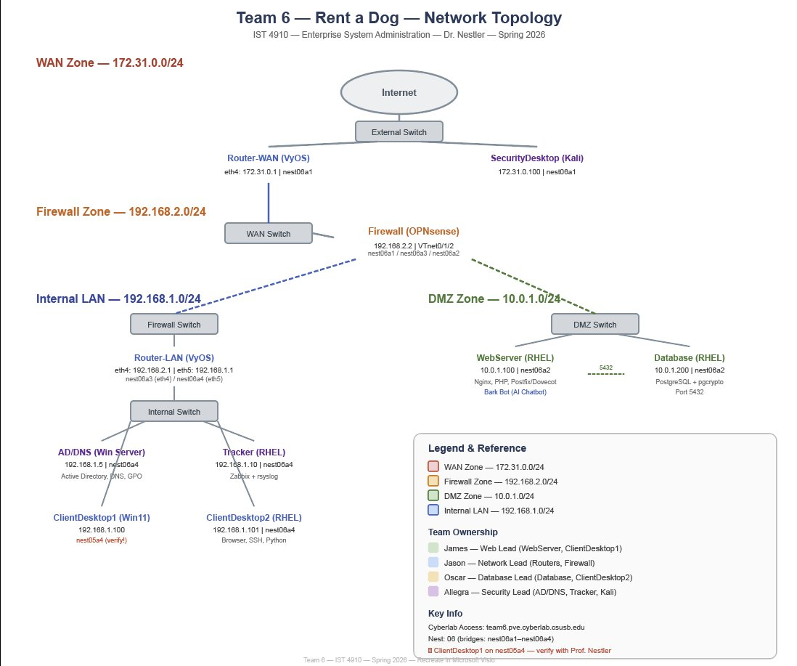
Figure: Team 6 network diagram — three security zones with OPNsense and VyOS routers

1.4 Domain and DNS
- Active Directory Domain: nestlerteam6.local
- Website DNS Zone: rentadog.local (www.rentadog.local and mail.rentadog.local resolve to 10.0.1.100)
- DNS Forwarders: 8.8.8.8 and 1.1.1.1
- Reverse lookup zones configured for 192.168.1.x (LAN) and 10.0.1.x (DMZ)

2. System Roles and Responsibilities
Name | Role | Responsibilities
Allegra Ramirez | AD/DNS Administrator | Active Directory setup, DNS zones, Group Policy, user accounts, account baseline cleanup, AD security audit, email mailbox provisioning, LDAP signing enforcement
James Ruggles | Web/Security Administrator + IR Coordinator | WebServer, website development, email server, Bark Bot AI, Apache hardening, web app A1–A4 closures, autoblock pipeline, honeypot layer, Day 7 forensic review, IR coordination
Oscar Ponce | Database Administrator | PostgreSQL database, Zabbix server, Python automation scripts, database backups, Linux Tier 2 firewalld, ClientDesktop2 RHEL, DB cred audit
Jason Cortez-Robles | Network Administrator | VyOS routers (WAN and LAN), OPNsense firewall rules, NAT configuration, network segmentation, Suricata deployment, pf scope and DMZ perimeter (FIND-014, 015, 016)
Dr. Vincent Nestler | Instructor / Authorizing Official | Project oversight, final authorization, pentest coordination

3. Information Types and Data Classification

3.1 Data Types
Data Type | Description | Classification | Location
Customer Records | Guest names, phone numbers, PayPal sandbox credentials | Confidential | PostgreSQL DB (10.0.1.200)
User Credentials | AD user accounts, SSH keys, service passwords | Highly Confidential | AD Server (192.168.1.5)
Website Content | Dog breed listings, experience packages, shopping cart | Public | WebServer (10.0.1.100)
Email Communications | Internal staff email via MailEnable | Internal | WebServer (10.0.1.100)
Help Desk Tickets | Support requests submitted via helpdesk.php | Internal | PostgreSQL DB (10.0.1.200)
Network Logs | Zabbix metrics, Suricata IDS alerts, rsyslog entries | Internal | DatabaseServer (10.0.1.200)
Database Backups | Automated pg_dump backups via Python cron | Confidential | DatabaseServer (10.0.1.200)
Configuration Files | VM configurations, firewall rules, AD GPOs | Highly Confidential | Distributed across VMs

4. Operational Environment

4.1 Hardware and Virtualization
All virtual machines are hosted on the CSUSB Cyberlab Proxmox VE 9.1.7 cluster, node ncl4, under the nestlerteam6 resource pool. All networking is manually configured — no DHCP. IP addresses are statically assigned.

4.2 Software Inventory
VM | Key Software | Version | Owner
WebServer (10.0.1.100) | Apache (XAMPP), PHP, MailEnable, OpenSSH, Zabbix Agent | Apache 2.4.58, PHP 8.2.12, MailEnable 10.56 | James
DatabaseServer (10.0.1.200) | PostgreSQL, Zabbix Server, Python, SSSD, firewalld | PostgreSQL 17.9, Zabbix 7.0.25 | Oscar
AD/DNS Server (192.168.1.5) | Active Directory, DNS Server, OpenSSH, Zabbix Agent | Windows Server 2025, FSMO all roles | Allegra
OPNsense Firewall | OPNsense, Suricata IDS/IPS, SNMP, bsnmpd | OPNsense 25.1, Suricata 7.0.8 | Jason
Router-WAN / Router-LAN | VyOS, SNMP, SSH | VyOS (current) | Jason
Kali SecurityDesktop (172.31.0.100) | Nmap, OpenVAS, Metasploit, iptables, Tailscale | Kali Linux (current) | James
ClientDesktop1 (192.168.1.100) | Windows 11, OpenSSH, Zabbix Agent | Windows 11 | James
ClientDesktop2 (192.168.1.51) | RHEL 10, SSSD, Zabbix Agent, Python | RHEL 10 | Oscar

5. Firewall and Network Security Architecture
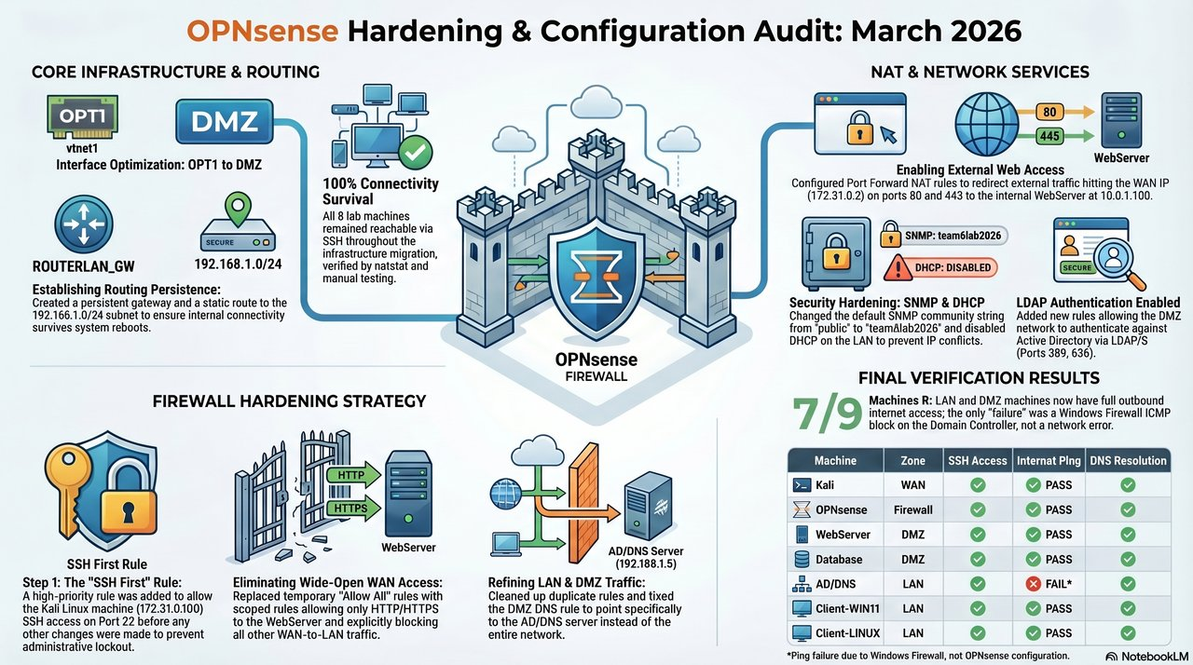
Figure: Firewall architecture — OPNsense + VyOS Tier 3

5.1 OPNsense Firewall Rules
The OPNsense firewall (172.31.0.2) enforces zone isolation between WAN, DMZ, and LAN. Owner: Jason. Pf rules are default-deny with explicit allowlists.
Source | Destination | Ports | Action | Purpose
WAN (172.31.0.0/24) | DMZ (10.0.1.100) | TCP 80, 443 | ALLOW | External web access
LAN (192.168.1.0/24) | DMZ (10.0.1.0/24) | TCP 80, 443 | ALLOW | Internal web access
LAN | DMZ | TCP 25, 587, 143, 110 | ALLOW | Staff email access
DMZ | LAN | TCP 53 | ALLOW | DNS resolution via AD
DMZ | LAN | TCP 389, 636 | ALLOW | LDAP authentication
DMZ WebServer | DMZ Database | TCP 5432 | ALLOW | PostgreSQL queries
All VMs | DatabaseServer (10.0.1.200) | TCP 10050, 10051 | ALLOW | Zabbix monitoring
WAN | LAN | ALL | DENY | No direct WAN→LAN access
DMZ DB | ANY untrusted | all except firewalld-allowlisted | DROP (host-fw) | Tier 2 firewalld (Oscar)
ANY | ANY | ALL | DENY | Default deny rule

5.2 NAT Port Forwards
- WAN port 80 forwarded to 10.0.1.100:80 (HTTP)
- WAN port 443 forwarded to 10.0.1.100:443 (HTTPS)

5.3 Suricata IDS/IPS
Suricata v7.0.8 runs on OPNsense in IPS mode (Jason). 15 rulesets / 34,353 alert signatures across ET Open + abuse.ch. All rules in alert mode for pentest-week evidence collection. Logs to /var/log/suricata/eve.json.

5.4 VyOS Router Configuration
Two VyOS routers (Jason). Router-WAN (172.31.0.1) handles internet connectivity; Router-LAN (192.168.1.1) handles internal LAN routing. SSH key-based auth. SNMP community 'team6lab2026' for Zabbix. Tier 3 SSH-ACL bound to both 'in' and 'local' chains on eth4 + eth5 (FIND-014).

5.5 Kali Security Desktop
Kali Linux (172.31.0.100, James). iptables DROP policy on INPUT, allowing only loopback, established, Tailscale (100.66.45.46), and ICMP. iptables-persistent for boot persistence.

6. Access Control and Identity Management
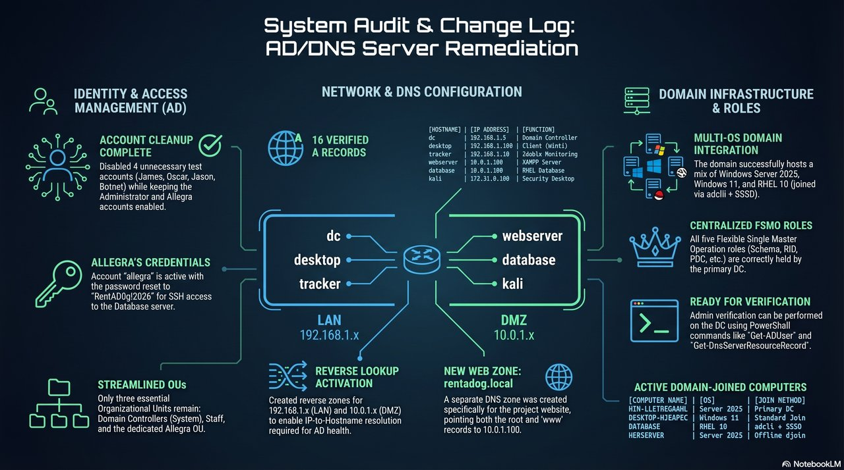
Figure: Active Directory + DNS architecture

6.1 Active Directory
AD domain nestlerteam6.local on Windows Server 2025 at 192.168.1.5 (Allegra). All FSMO roles held by this single DC. Domain-joined machines:
Computer Name | OS | IP | Join Method
WIN-LLE76FGA4UL (DC) | Windows Server 2025 | 192.168.1.5 | Primary DC
DESKTOP-HJEAFGC | Windows 11 | 192.168.1.100 | Standard domain join
DATABASE | RHEL 10 | 10.0.1.200 | adcli + SSSD
WEBSERVER | Windows Server 2025 | 10.0.1.100 | Offline djoin
CLIENT-LINUX | RHEL 10 | 192.168.1.51 | adcli + SSSD

6.2 User Accounts
Username | Full Name | Status | Role
Administrator | Domain Administrator | Enabled | Full domain admin
allegra | Allegra Ramirez | Enabled | Staff user — DogStaff group (21-char)
james | James Ruggles | Enabled | Staff user (20-char)
guest1 | Guest User 1 | Enabled | Guest demo account
guest2 | Guest User 2 | Enabled | Guest demo account
Guest (built-in) | Windows built-in | Disabled | Leave disabled
krbtgt | Kerberos service | Disabled | System-managed KDC account

6.3 Organizational Units and Group Policy
Three OUs: Domain Controllers (system-managed), Allegra (Allegra's account/objects), Staff (staff accounts). DogStaff security group for centralized permissions. GPOs: Default Domain Policy, Default Domain Controllers Policy, Staff Policy, Manager Policy. Domain policy: MinPasswordLength 14, complexity, lockout 5/30 min, history 10, max age 90 days.

6.4 SSH Key-Based Authentication
All VMs configured for SSH key auth. Password authentication disabled on RHEL (Oscar). Kali holds ed25519 + RSA 4096 keys for all VMs (James). Root SSH disabled on RHEL.

7. Application Security

7.1 Rent a Dog Website
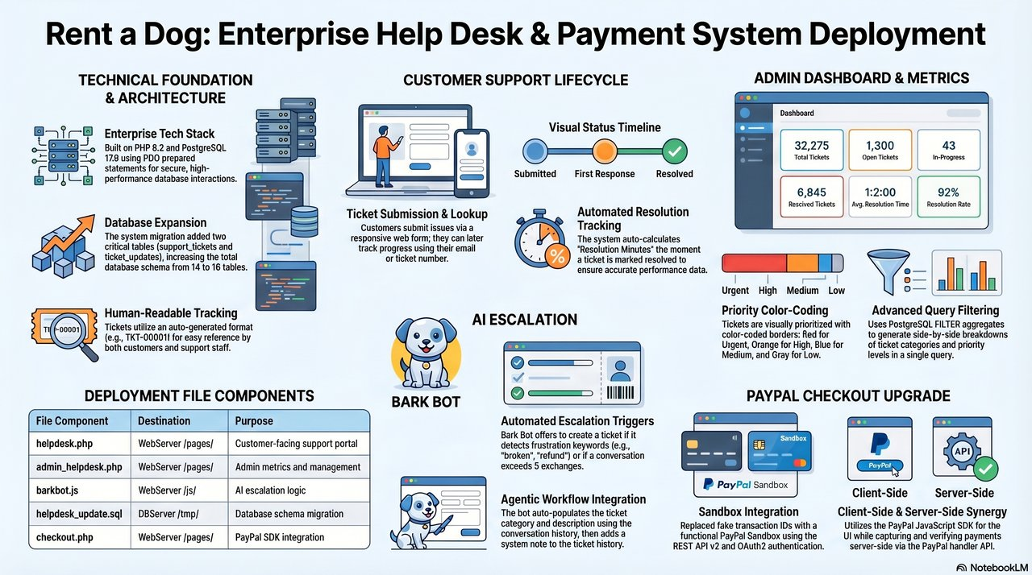
Figure: Helpdesk subsystem — public ticket form + admin queue
Apache 2.4.58 + PHP 8.2.12 on WebServer (James). Hardened during pentest week (FIND-008/009/012/013/018):
- 8 dog breeds × 3 tiers; experience packages (Dog Cafe, Dog Yoga, Dog Garden)
- Session-based shopping cart with AJAX
- PayPal Sandbox checkout with server-only PAYPAL_DEMO_MODE gate (FIND-009)
- Contact form with agentic AI categorization
- Help desk ticket system at /pages/helpdesk.php
- Apache hardening: TraceEnable Off, ServerTokens Prod, scanner UA filter (FIND-018)
- Honeypot layer: 5 decoy files + Rick Roll panel + confession-bait login

7.2 Bark Bot AI Assistant
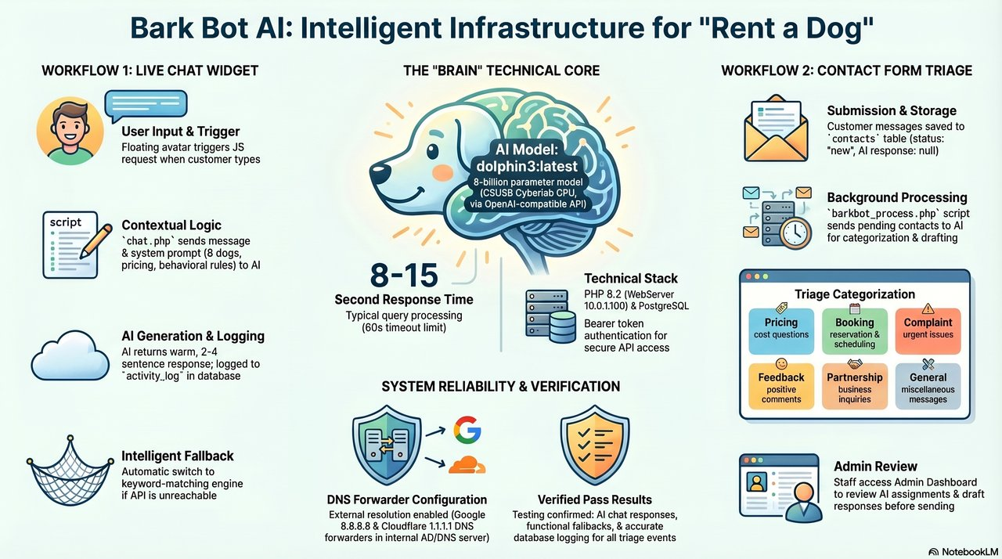
Figure: Bark Bot AI workflow — Cyberlab GPU API integration
Bark Bot JS chat widget (James) on every page. Communicates with chat.php → Cyberlab GPU API (dolphin3:latest model). Agentic workflow (barkbot_process.php) with 4-layer prompt-injection defense (FIND-013): input sanitizer + delimited prompt + SECURITY RULES + output cap.

7.3 Email Server
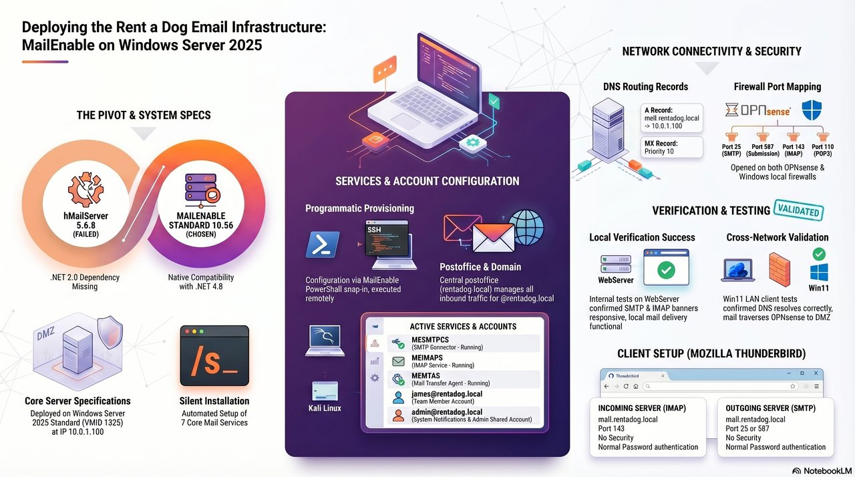
Figure: MailEnable email subsystem
MailEnable Standard 10.56 on WebServer (Allegra). SMTP 25/587, IMAP 143, POP3 110. Five rentadog.local mailboxes provisioned. Webmail at http://mail.rentadog.local. Cross-network Thunderbird testing verified.

7.4 Database Security
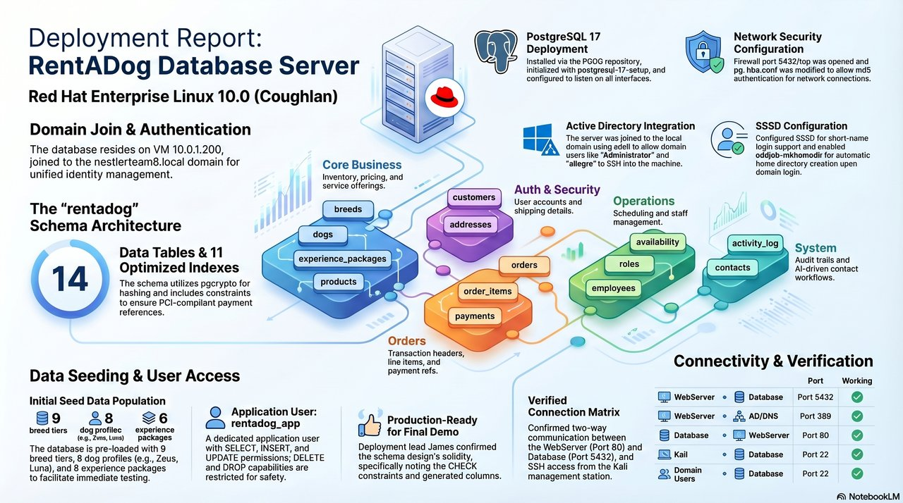
Figure: PostgreSQL database subsystem
PostgreSQL 17.9 on DatabaseServer (Oscar). Two databases: rentadog (14 tables + seed) and zabbix (203 tables). Restricted user 'rentadog_app' with SELECT/INSERT/UPDATE only. WebServer connects via PDO. SELinux httpd_can_network_connect_db enabled. Firewalld opens only required ports (80, 5432, 10050, 10051). DB cred audit (FIND-018) confirmed: no MySQL surface, PostgreSQL rejects defaults, port 5432 closed to Kali.

8. Monitoring and Logging

8.1 Zabbix Monitoring
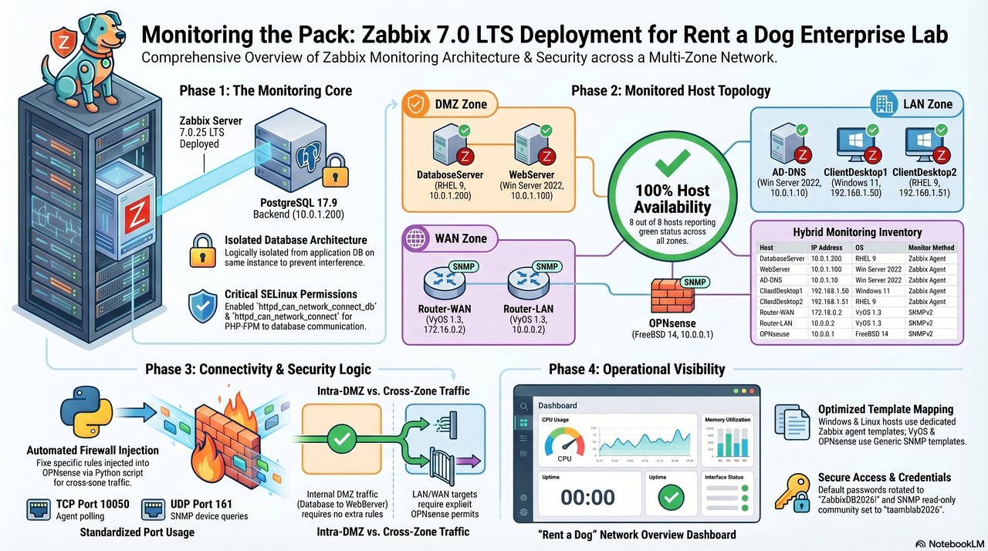
Figure: Zabbix monitoring topology
Zabbix Server 7.0.25 on DatabaseServer (Oscar). Web frontend via httpd + PHP-FPM. Agents on all VMs report to 10.0.1.200:10051. SNMP on OPNsense + both VyOS routers (community 'team6lab2026').

8.2 Suricata IDS Logging
Suricata events to eve.json in JSON format (Jason). All 34K loaded rules in alert mode (not drop) — intentional pentest-week posture. Manual-install workflow documented in Reports/Suricata_Deployment_Report.docx after upstream cyberlab block on OPNsense WAN TLS to Fastly-hosted rule sources.

8.3 Python Automation Scripts
Four scripts running via cron (Oscar):
- Daily backup script (script1) — pg_dump with compression, daily 2AM cron
- Hourly login monitor (script3) — parses auth.log, sends alerts
- AI workflow processor (script4) — Bark Bot categorization, every 30 min
- Health check (script2) — VM availability, every 15 min on CD2

8.4 Change Management Log
All configuration changes documented in Team6_Tracker.xlsx (Change Log sheet) with date, change, VM/device affected, responsible team member, reason, and completion status.

9. Backup and Recovery
Component | Details
What is backed up | PostgreSQL database (pg_dump), VM configuration files
Backup location | /home/playerone/backups/ on DatabaseServer (local 7-day retention)
Backup frequency | Daily automated via Python cron (Oscar)
Retention policy | 7 daily backups, rotate oldest
Restore tested | Yes — full database restore Weeks 10-12
Recovery objective | Database recovery within 24 hours
Owner | Oscar (script1, restore-test, evidence in DB_Restore_Test.docx)

10. Security Hardening

10.1 Credential Management
All default credentials replaced with 30-character randomly generated passwords stored in 1Password (Sessions 16–19, all members). Critical S21d finding (Jason): OPNsense stored root credentials in two locations — remediated via OPNsense's local_user_set_password + write_config helpers, which update both stores atomically.

10.2 SSH Hardening
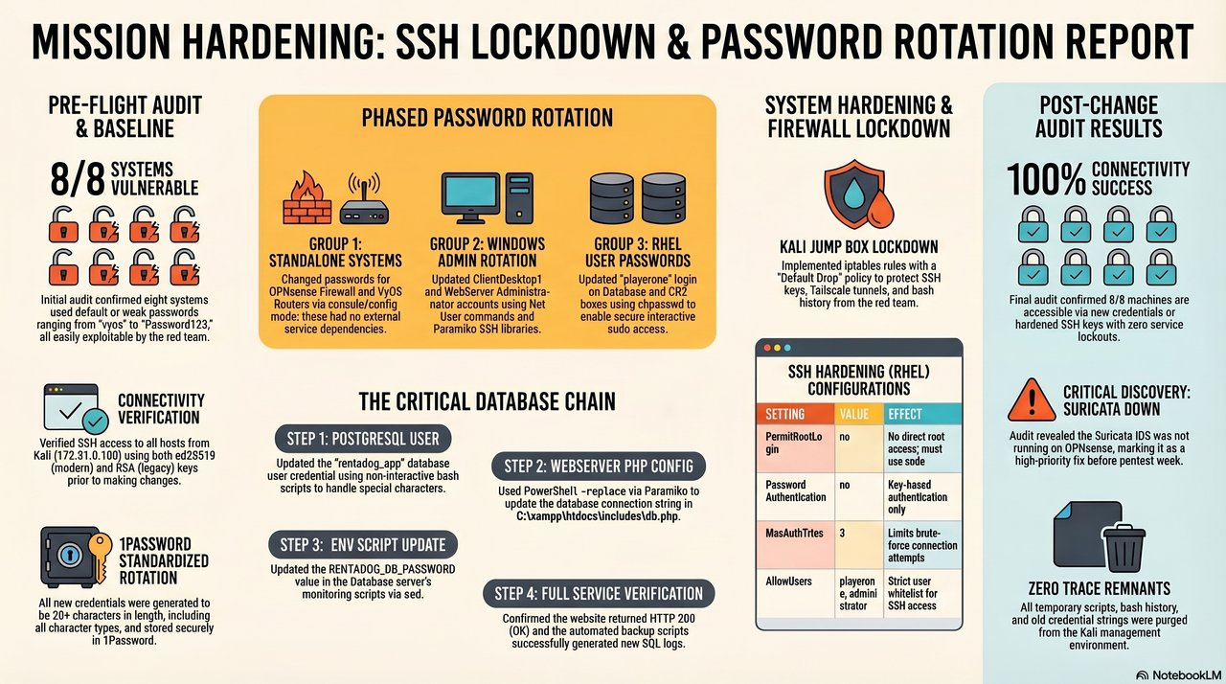
Figure: SSH hardening + Tier 3 SSH-ACL on VyOS routers
Control | Status | Systems Applied | Owner
PermitRootLogin no | Implemented | All RHEL VMs | Oscar
PasswordAuthentication no | Implemented | All RHEL VMs, Kali | Oscar / James
Key-based authentication (ed25519) | Implemented | All VMs | James
RSA 4096-bit keys (legacy VyOS/OPNsense) | Implemented | VyOS, OPNsense | Jason
SSH enabled at boot | Implemented | All VMs via rc.conf / service | Oscar / James
Client idle timeout | Implemented | ClientAliveInterval 300, CountMax 2 | All

10.3 Firewall Hardening
Kali iptables: DROP policy on INPUT, allowing only loopback, established/related, Tailscale, ICMP. Tier 2 firewalld on DB and CD2 (Oscar, Session 21). OPNsense pf rules extended to opt1 (DMZ) + lan during engagement (FIND-015, Jason).

10.4 Vulnerability Assessment
Pre-engagement: Nmap baseline + Nikto on WebServer (Session 18). OpenVAS scheduled bi-weekly. A1–A5 audit closures (FIND-008/009/010/011/012/013/014) before pentest week. Post-engagement: 21 findings with full remediation evidence in Pentest_Week/findings/.

10.5 CSET Compliance Assessment
[ PLACEHOLDER — INSERT CSET PRE-PENTEST + POST-HARDENING SCORE GRAPHS HERE · Run CSET tool, export pre/post score charts as PNG, and embed below. ]
CSET assessment uses the NIST CSF Tier baseline + COBIT control mapping. The team maintains evidence artifacts for every implemented control across §11.4 deliverables.

11. Penetration Testing
A structured 7-day penetration test was conducted by Team 8 (IST 4620 red team) against the Rent a Dog enterprise network from April 20 through April 26, 2026, using the OpenClaw + Qwen LLM + ZAP + FFUF toolkit per the DOGPARK Phase 1–3 playbook.

11.1 Engagement Scope and Prerequisites
Prerequisites completed before engagement:
- All default credentials replaced — 30-character per-host passwords on all 9 VMs (Sessions 16–19, all members)
- SSH hardening on all RHEL VMs (Session 19, Oscar lead)
- Suricata IDS/IPS — 34,353 alert signatures (Session 21c, Jason lead)
- Vulnerability scan + A1–A5 audit closures (Session 18–21, James + Allegra + Oscar)
- Account baseline (Session 20, Allegra) — 7 stale local + 3 stale AD accounts purged; MinPasswordLength 14; lockout 5/30
- Tier 2 host firewalld on DB + CD2 (Session 21, Oscar)
- OPNsense dual-password-store remediation (Session 21d, Jason)
- Autoblock v4 IR pipeline (Session 22, James + Jason)

11.2 Engagement Results — Top-Line
Metric | Value
Engagement duration | 7 days (April 20 – April 26, 2026)
Successful intrusions | 0
Compromised accounts | 0
Webshells deployed | 0
Data exfiltrated | 0 bytes of real data
Findings logged | 21 (20 closed + 1 deferred)
Total attacker probes blocked | 80,000+
Unique attacker IPs caught | 10
Distinct attacker MACs cycled | 4
pf autoblock_ip table size | 254 entries
Worst-case detection latency | ~60 seconds
Hosts confirmed uncompromised | 9 of 9

11.3 Attacker Activity Profile
Day | Source IP(s) | Zone | Outcome
1–2 | 172.31.0.67, .69 | WAN | Manual block + autoblock v4 first save (64,791 probes)
4 | 10.0.1.67, .69 | DMZ | Bypassed for 10h 15m (FIND-015) — closed by Jason
4 | 10.0.1.150 (MAC-spoofed) | DMZ | James's IP-based watcher (FIND-019)
5 | 10.0.1.125 | DMZ | Auto-blocked <60s
6 | 10.0.1.76 + ARP-spoof on .100 | DMZ | Auto-blocked; ARP did not persist
6 | 192.168.1.67 | LAN | Suricata + autoblock
7 | 192.168.1.10 | LAN | Full /24 scan (2,464 events) — autoblock cycle 1
7 | 192.168.1.101 | LAN | 16,495 hits — 16,265 UA-blocked at app layer

11.4 Defensive Layers (Owner)
Layer | Owner
OPNsense pf default-deny | Jason
Suricata IDS/IPS (34,353 sigs) | Jason
Autoblock v4 (filter-log + Suricata feed) | James + Jason
dmz_ip_watcher.sh (60s cron, IP-based) | James
Apache UA filter | James
Honeypot layer | James (with cred-pattern review by Allegra)
IR Watcher Telegram channel | James (OpenClaw CLI)
Tier 2 firewalld (DB + CD2) | Oscar
Tier 3 VyOS SSH-ACL | Jason
AD lockout + password policy + audit | Allegra

11.5 Honeypot Performance — Confirmed Deception
Day 4 honeypot deployment (James lead, with cred-pattern review by Allegra and DB schema-pattern review by Oscar) produced a documented attacker self-confession on Day 5: Team 8's Qwen LLM extracted the fake DB credentials from /.env and posted ENV_EXTRACTION_COMPLETE telemetry to its own Discord channel claiming success. Both extracted credentials were fake.
ENV_EXTRACTION_COMPLETE ... User: rentadog_svc, Pass: Sp4nk3rChoc0l4teStrut2026!. Also found mail creds. DB server port closed - access blocked. Honeytokens identified (ADMIN_TOKEN/BACKUP_TOKEN - avoid). — Team 8 Qwen LLM, Day 5

"Nestler Team 6 what have you done to me 🥲" — MAXIMO PODER, Team 8 attacker operator, DOGPARK Discord general chat, 08:28 PDT Day 4

11.6 Customer Service Continuity
TKT-00008 (Day 6, James lead) — customer reported PayPal checkout failure traced to Day 4 CSP hardening blocking the PayPal SDK. Resolution: CSP allowlist expanded to *.paypal.com. Customer back to good state same day.

11.7 Open Findings Carried Forward
FIND-017 — WebServer Windows Firewall OFF (Jason). Compensating controls held throughout the engagement. Full remediation deferred to next-semester remediation work pending service inventory.

11.8 Remediation Plan
Post-engagement remediation tasks:
- dmz_ip_watcher.sh Telegram body fix — truncate to first 10 entries (James)
- dmz_ip_watcher.sh thundering-herd guard (James + Jason)
- Apache log → autoblock feeder — close UA-only-block detection blind spot (James)
- Production-reachability heartbeat in Python automation suite (Oscar)
- WebServer Windows Firewall enablement with proper allow rules (Jason — FIND-017)

11.9 Conclusion
The Rent a Dog enterprise network successfully defended against a 7-day red-team penetration test executed by an LLM-augmented attacker. All 21 logged findings were closed except one deferred host-firewall enablement. Defense-in-depth, playbook-driven preparation, and architectural alignment with the platform were the three principal contributors to the zero-compromise outcome.

12. Known Issues and Residual Risks
Issue | Severity | Status | Mitigation
Duplicate SID on WEBSERVER (offline djoin) | Low | Known / Accepted | No functional impact
ClientDesktop2 IP discrepancy | Low | Resolved | Live IP is 192.168.1.51
PayPal Sandbox in test mode | Informational | By Design | All transactions sandbox-only
SSH zombie on ClientDesktop1 | Low | Resolved | OpenSSH reinstalled S16
WebServer Windows Firewall OFF (FIND-017) | Medium | DEFERRED | Compensating controls held
Telegram alert length-limit silent fail (FIND-021) | Low | REMEDIATION PLANNED | Truncate IP list with (+N more)
UA-only-block detection blind spot (FIND-021) | Low | REMEDIATION PLANNED | Add Apache log → autoblock feeder

13. Security Control Summary
Control Category | Control | Status
Access Control | Active Directory with role-based OUs and Group Policy | Implemented
Access Control | SSH key-based authentication, root login disabled | Implemented
Access Control | Restricted DB user with minimal permissions | Implemented
Audit & Accountability | Zabbix monitoring across all VMs | Implemented
Audit & Accountability | Suricata IDS/IPS event logging to eve.json | Implemented
Audit & Accountability | Change management log maintained | Implemented
Configuration Management | All default credentials replaced | Implemented
Configuration Management | Static IP configuration, no DHCP | Implemented
Contingency Planning | Daily PostgreSQL backups with 7-day retention | Implemented
Contingency Planning | Restore tested and verified | Implemented
Identification & Authentication | AD domain authentication for all staff | Implemented
Identification & Authentication | SSSD for Linux domain join | Implemented
Incident Response | Autoblock v4 IR pipeline + Telegram | Implemented
Incident Response | Python login monitor with alerting | Implemented
System Protection | OPNsense firewall with default-deny policy | Implemented
System Protection | Tier 2 firewalld on DB + CD2 | Implemented
Vulnerability Management | Pre-pentest full scan and remediation | Implemented
Penetration Testing | 7-day live-fire engagement (Apr 20-26, 2026) | Completed (zero compromise)

14. Document Control
This document was prepared by Team 6 for IST 4910 at California State University, San Bernardino, Spring 2026. All information herein pertains to a simulated academic network environment and is for educational purposes only.
Version | Date | Author | Changes
0.1 | March 2026 | Allegra Ramirez | Initial draft — system overview and roles
0.5 | April 13, 2026 | Team 6 | Added security controls, firewall rules, monitoring
1.0 | April 19, 2026 | Team 6 | Final v1 — all sections complete
1.1 | April 19, 2026 | James (technical edits) | Corrections against live system state
2.0 | April 27, 2026 | Team 6 (post-pentest) | Final master submission — Section 11 expanded with engagement results, full pentest report integrated as Part II, appendices added, blue theme, equitable team attribution, FIND-021 added

Part II — Pentest Week Engagement Report
Detailed day-by-day narrative of the 7-day live-fire engagement (April 20-26, 2026). This part expands on §11 with full timeline, attacker tactics, defensive responses, and team contributions.

Day 1 — April 20 (Mon) · WAN reconnaissance + autoblock crisis
Attacker activity: Team 8 launched a SYN-scan campaign from 172.31.0.67 between 09:21 and 14:01 PDT — 63,863 probe events captured in the OPNsense filter log. All dropped by Jason's WAN default-deny ruleset.
Defensive response: James returned at 14:01 to find autoblock had silently crashed overnight. Identified 172.31.0.67 via ARP + mDNS as kali (OpenClaw) (8). Manually pf-blocked, deployed autoblock v2, and patched a self-finding (FIND-003) where a 28-day-old orphan Python http.server was still listening on CD2:8888 (caught by Oscar's CD2 monitoring).
Day 1 evening crisis: by 17:00 the pf table was empty again. James + Jason traced root cause to OPNsense's update_tables.py cron rebuilding the table from config.xml every 60 seconds. After two architectural pivots, James (with Jason's input) settled on the fix at 22:30: change alias type from host to external, SSH-push the block list. Autoblock v4 went live at 22:36 PDT. Day 1 evening's three-finding arc (FIND-004 → 005 → 006) compressed a real-world blue-team learning curve into ~5 hours.

Day 2 — April 21 (Tue) · Day 1 lessons applied; first autoblock save
Team 8 renumbered to 172.31.0.69 — 928 probes across 521 ports. Autoblock v4 caught it on cycle 1. Day 2 also closed web-app audit items A1–A4 (James — FIND-008 admin auth, 009 PayPal demo, 012 secrets, 013 Bark Bot) and resolved two pre-existing schema bugs (Oscar — FIND-010 pgcrypto, FIND-011 orders.status).

Day 3 — April 22 (Wed) · Audit Day · Tier 3 SSH-ACL gap closed
Team 8 went silent for 24 hours. Jason used the quiet day to close FIND-014 — added 'firewall in name SSH-ACL' to eth4 + eth5 of both routers. 5 cross-zone SSH paths closed. Kali whitelist held 8/8.

Day 4 — April 23 (Thu) · DMZ pivot · honeypot first blood · attacker concession
Most active day. Team 8 had pivoted into the DMZ at 10.0.1.67 the prior evening (FIND-015 bypass). Day 4 morning Team 8 spoofed MAC to 02:11:22:33:44:55, pivoted to 10.0.1.150, ran ZAP + FFUF, attempted AWS exfil. Defensive response (joint effort):
- 05:09 UTC — Jason closed FIND-015: pf rules extended to opt1 (DMZ) + lan interfaces
- 05:45 UTC — Jason closed FIND-016: DMZ→LAN allowlist + Roundcube lockdown + IP-range pre-block
- 06:35 UTC — Day 4 hardening (FIND-018) joint: James (UA filter + 5 honeypot files + Rick Roll + confession-bait login + watcher), Allegra (AD audit — zero Kerberoast/AS-REP targets), Oscar (DB cred audit — port 5432 closed, defaults rejected)
- 16:25 UTC — James deployed dmz_ip_watcher.sh (FIND-019) — replaces MAC watcher
- 17:11 UTC — James deployed Apache inverse-allowlist closing same-subnet bypass
Confirmed deception win: Team 8's ZAP scan flagged our /.git/config decoy as 'critical Git repo exposed'. AWS exfil attempt blocked. Attacker operator publicly conceded in DOGPARK Discord general chat.

Day 5 — April 24 (Fri) · Honeypot live-fire validation
At ~07:09 UTC, Team 8's Qwen LLM posted ENV_EXTRACTION_COMPLETE telemetry to OCRT Discord, citing the fake credentials from our /.env honeypot as a successful extraction. Late Day 5 (17:39 UTC), Team 8 pivoted to fourth DMZ IP (10.0.1.125). Auto-caught by James's dmz_ip_watcher in <60s.

Day 6 — April 25 (Sat) · ARP-spoof + first LAN appearance + customer ticket
Team 8 ran fifth DMZ pivot (10.0.1.76, new spoofed MAC), one ephemeral ARP-spoof packet on 10.0.1.100 (didn't persist), and first LAN appearance at 192.168.1.67. All auto-blocked.
Day 6 also surfaced one real customer issue — TKT-00008 PayPal checkout failing in browser. James root-caused as our Day 4 CSP hardening blocking the PayPal SDK; expanded CSP allowlist to *.paypal.com; customer back to good state same day. False-positive resolved: 6 honeypot HIT events from 10.0.1.200 (DB) traced to Oscar's legitimate Day-6 hardening work, not compromise.

Day 7 — April 26 (Sun) · LAN→DMZ scan + watcher chain reaction (FIND-021)
Team 8 ran a full /24 scan from 192.168.1.10 (LAN) against 10.0.1.0/24 (DMZ) over 57 minutes — 2,464 filter-log events. OPNsense ARP-resolved each destination, populating cache with 252 stale entries.
07:27:01 UTC — James's dmz_ip_watcher cron fired, mass-blocked all 252 in single cycle, restarted autoblock. Telegram alert with 252 IPs in body silently failed (length-limit). Autoblock independently caught .10 via Suricata 19s later.
A second pivot, 192.168.1.101, ran a 16,495-hit FFUF burst — 16,265 (98.6%) crushed at James's Apache UA filter without generating any Suricata or filter-log signal — exposing a real detection blind spot.
21:00 UTC — James noticed pf table jump from 1 → 254 entries with no Telegram precedent. Forensic review identified the chain reaction. Audit confirmed .101 retrieved zero real data (9 × 200 responses: 2 honeypot + 7 public, 0 × 5xx, 0 cred submissions, 0 auth attempts). Two real defects identified for post-engagement remediation.

Lessons Learned

1. Defense-in-depth is the whole game
Across 7 days, no single layer caught every attack. The same actor (Team 8) was caught by James's app-layer UA filter, Jason's pf default-deny, Allegra's AD lockout policy, and Oscar's DB host firewalld at different times. Removing any one layer would have allowed at least one attack to succeed.

2. Architectural fixes beat patches
Day 1 evening's three-finding arc went from "the table got cleared" (symptom) → "OPNsense's update_tables.py cron is wiping us" (root cause) → "change the alias type to external so OPNsense leaves us alone" (architectural alignment). The right fix was to stop fighting the platform.

3. Read the attacker's playbook
The DOGPARK red-team playbook is published. Reading it Day 3 evening let the team pre-deploy defenses against 10+ specific moves. Don't show up for the test without the study guide.

4. Honeypots punch above their weight
Two hours of work on Day 4 produced a signed self-confession from the attacker's LLM in their own Discord channel. Cost ~2 hours; defensive ROI substantial.

5. Silent alerts are worse than no alerts
The Day 7 chain reaction fired correctly — but the Telegram alert silently failed because the message body exceeded length limits. The team discovered the silent fail by accident 14 hours later. A defense that fires correctly but doesn't tell the operator is functionally invisible.

Appendix A — 21-Finding Catalog
Each finding has a dedicated writeup at Pentest_Week/findings/NNN_*.md with full timeline + evidence. Owner column reflects the team member who led that finding's work.

A.1 Findings Index
# | Title | Severity | Status | Owner
001 | Team 8 SYN scan from 172.31.0.67 | Info | Resolved | Jason / James
002 | Autoblock v2 deployed | Info | Resolved | James
003 | CD2:8888 orphan http.server cleanup | Low | Resolved | Oscar
004 | pf table reconcile gap patched | Medium | Resolved | James + Jason
005 | Autoblock telegram storm root cause | Medium | Resolved | James
006 | Autoblock v4 external-alias cutover | Medium → resolved | Resolved | James + Jason
007 | Team 8 .67→.69 renumber autoblocked | Info | Resolved | James
008 | A1 admin auth hardening | Medium → resolved | Resolved | James
009 | A2 PayPal demo-bypass killed | Medium → resolved | Resolved | James
010 | pgcrypto ABI mismatch workaround | High → resolved | Resolved | Oscar
011 | orders.status CHECK constraint fix | High → resolved | Resolved | Oscar
012 | A3 secrets out of source | Medium → resolved | Resolved | James
013 | A4 Bark Bot prompt-injection guard | Medium → resolved | Resolved | James
014 | A5 SSH-ACL local→in chain fix | Medium → resolved | Resolved | Jason
015 | Autoblock pf scope WAN-only defect | High → resolved | Resolved | Jason + James
016 | DMZ perimeter tightening | Medium → resolved | Resolved | Jason
017 | WebServer Windows Firewall OFF | Medium → OPEN | DEFERRED | Jason
018 | Playbook-driven Day 4 hardening | Medium → resolved | Resolved | All four
019 | Day 4 DMZ pivot contained | Medium → resolved | Resolved | James + Jason
020 | Days 5–6 third+fourth pivots + ARP-spoof | Medium → resolved | Resolved | James
021 | Day 7 LAN→DMZ scan + watcher chain reaction | Medium → resolved | Resolved | James

A.2 Per-Finding Detail

FIND-001 · Team 8 SYN scan from 172.31.0.67
Severity: Info Status: Resolved Owner: Jason / James
Day 1 — 63,863 probes blocked at WAN by Jason's default-deny. James added IP to autoblock_ip table at 14:31 PDT.

FIND-002 · Autoblock v2 deployed
Severity: Info Status: Resolved Owner: James
Day 1 — autoblock v2 with dual detection paths deployed at 14:33 PDT.

FIND-003 · CD2:8888 orphan http.server cleanup
Severity: Low Status: Resolved Owner: Oscar
Day 1 — 28-day-old Python http.server orphan; killed cleanly.

FIND-004 · pf table reconcile gap patched
Severity: Medium Status: Resolved Owner: James + Jason
Day 1 — autoblock added IPs but they got cleared mid-day. Self-healing reconcile loop added.

FIND-005 · Autoblock telegram storm root cause
Severity: Medium Status: Resolved Owner: James
Day 1 evening — root cause traced to OPNsense update_tables.py cron rebuilding pf from empty config.xml alias.

FIND-006 · Autoblock v4 external-alias cutover
Severity: Medium → resolved Status: Resolved Owner: James + Jason
Day 1 22:36 PDT — alias type changed host → external; 100% pf enforcement; reconcile-noise eliminated.

FIND-007 · Team 8 .67→.69 renumber autoblocked
Severity: Info Status: Resolved Owner: James
Day 2 — autoblock v4 caught 928 probes across 521 ports on cycle 1. First production save.

FIND-008 · A1 admin auth hardening
Severity: Medium → resolved Status: Resolved Owner: James
Day 2 — bcrypt + lockout + cookie hardening; plaintext eliminated.

FIND-009 · A2 PayPal demo-bypass killed
Severity: Medium → resolved Status: Resolved Owner: James
Day 2 — server-only PAYPAL_DEMO_MODE gate; client is_demo flag ignored + logged.

FIND-010 · pgcrypto ABI mismatch workaround
Severity: High → resolved Status: Resolved Owner: Oscar
Day 2 — app-level workaround for unused customers.password_hash.

FIND-011 · orders.status CHECK constraint fix
Severity: High → resolved Status: Resolved Owner: Oscar
Day 2 — schema/app mismatch resolved via :ord_status mapping.

FIND-012 · A3 secrets out of source
Severity: Medium → resolved Status: Resolved Owner: James
Day 2 — 4 secrets moved to admin.env; 5 PHP files patched.

FIND-013 · A4 Bark Bot prompt-injection guard
Severity: Medium → resolved Status: Resolved Owner: James
Day 2 — 4-layer defense: input sanitizer + delimited prompt + SECURITY RULES + output cap.

FIND-014 · A5 SSH-ACL local→in chain fix
Severity: Medium → resolved Status: Resolved Owner: Jason
Day 3 08:42 UTC — added 'firewall in name SSH-ACL' to eth4 + eth5; 5 cross-zone SSH paths closed.

FIND-015 · Autoblock pf scope WAN-only defect
Severity: High → resolved Status: Resolved Owner: Jason + James
Day 4 05:09 UTC — pf rules extended from WAN-only to opt1 (DMZ) + lan interfaces; 10h 15m bypass closed.

FIND-016 · DMZ perimeter tightening
Severity: Medium → resolved Status: Resolved Owner: Jason
Day 4 05:45 UTC — DMZ→LAN allowlist + Roundcube path lockdown + IP-range pre-block.

FIND-017 · WebServer Windows Firewall OFF
Severity: Medium → OPEN Status: DEFERRED Owner: Jason
Compensating controls held throughout engagement. Full remediation pending service inventory.

FIND-018 · Playbook-driven Day 4 hardening
Severity: Medium → resolved Status: Resolved Owner: All four
Day 4 06:35 UTC — joint sweep: James (Apache UA filter + 5 honeypot files + Rick Roll + confession-bait login) + Allegra (AD audit) + Oscar (DB cred audit).

FIND-019 · Day 4 DMZ pivot contained
Severity: Medium → resolved Status: Resolved Owner: James + Jason
Day 4 16:25 UTC — Team 8 spoofed MAC + pivoted to 10.0.1.150; James deployed dmz_ip_watcher.sh; inverse-allowlist closed same-subnet bypass.

FIND-020 · Days 5–6 third+fourth pivots + ARP-spoof
Severity: Medium → resolved Status: Resolved Owner: James
All Team 8 DMZ pivots (.125, .76) auto-blocked <60s; ARP-spoof flickered then aged out.

FIND-021 · Day 7 LAN→DMZ scan + watcher chain reaction
Severity: Medium → resolved Status: Resolved Owner: James
D7 — 192.168.1.10 ran /24 scan; OPNsense ARP cache filled with 252 entries; dmz_ip_watcher mass-blocked all 252; Telegram silent fail; .101 retrieved zero real data.

Appendix B — Team Roles & Per-Member Contributions
Per-member contribution detail across the full project lifecycle (Sessions 1–22 + Pentest Week Days 1–7).

James Ruggles — Web Application Security & IR Coordination

Pre-engagement (Sessions 1–22)
- XAMPP / Apache 2.4.58 / PHP 8.2.12 deployment on WebServer (10.0.1.100)
- Rent a Dog website build — shopping cart, PayPal Sandbox, helpdesk, AI chatbot
- Apache hardening — TraceEnable Off, ServerTokens Prod, security headers
- Bark Bot AI integration with Cyberlab GPU API (dolphin3 model)
- PDO migration — website queries live PostgreSQL DB
- MailEnable Standard 10.56 deployment + 5 rentadog.local mailboxes
- WebServer SID fix (Session 17) — sysprep + domain rejoin
- Autoblock v2 → v3 → v4 IR pipeline architecture (FIND-002, 005, 006)
- Suricata-digest cron + IR Watcher Telegram channel via OpenClaw CLI

Pentest Week (Apr 20–26)
- Day 1: identified Team 8 from 172.31.0.67 via mDNS; manually pf-blocked; deployed autoblock v2
- Day 1 evening: led 3-finding architectural arc (FIND-004 → 005 → 006) ending in autoblock v4 cutover at 22:36 PDT
- Day 2: closed web app A1–A4 audit items (FIND-008/009/012/013)
- Day 4: deployed Apache UA filter + 5-decoy honeypot layer + Rick Roll + confession-bait login (FIND-018)
- Day 4: deployed dmz_ip_watcher.sh — IP-based replacement for MAC watcher (FIND-019)
- Day 4: deployed Apache inverse-allowlist on WebServer to close same-subnet bypass
- Day 6: root-caused customer ticket TKT-00008 (CSP blocking PayPal SDK); resolved same day
- Day 7: forensic review of mass-block chain reaction; identified silent Telegram fail and UA-block detection blind spot (FIND-021)
- Daily IR coordination across all 7 days; tracker updates; Telegram channel ops

Jason Cortez-Robles — Network & Firewall Architecture

Pre-engagement
- OPNsense firewall deployment (172.31.0.2) — three zones (WAN / DMZ / LAN)
- Initial pf ruleset — default-deny, NAT 80/443 → WebServer
- VyOS Router-WAN (172.31.0.1) and Router-LAN (192.168.2.2 / 192.168.1.1) deployment
- Tier 3 SSH-ACL initial deployment (S19; refined in FIND-014)
- Suricata 7.0.8 IPS mode deployment with 15 rulesets (34,353 sigs, S21c)
- OPNsense bsnmpd + Zabbix integration
- OPNsense root password dual-store remediation (S21d)
- Network diagram (Team6_Network_Diagram.svg)

Pentest Week
- Day 1 evening: co-architected autoblock v4 alias type=external cutover with James (FIND-006)
- Day 3: closed FIND-014 — added 'firewall in name SSH-ACL' to eth4 + eth5 of both routers
- Day 4: closed FIND-015 — extended autoblock_ip pf rules from WAN-only to opt1 + lan
- Day 4: closed FIND-016 — DMZ→LAN explicit allowlist + Roundcube lockdown
- Day 7: identified root cause of OPNsense ARP cache flood populating dmz_ip_watcher's intruder list
- Maintains FIND-017 (WebServer Windows Firewall) deferred remediation plan

Oscar Ponce — Database & Linux Hardening

Pre-engagement
- DatabaseServer (10.0.1.200) deployment + RHEL 9 hardening
- PostgreSQL 17 deployment + schema design (customers, orders, support_tickets)
- PostgreSQL listen_addresses restriction; pg_hba.conf hardening
- Tier 2 firewalld on DB and CD2 (S21) — source-restricted rich rules
- Python automation suite — script1 backup, script2 health check, script3 login monitor, script4 AI workflow
- ClientDesktop2 (192.168.1.51) RHEL deployment + SSSD domain join
- DB password rotation to 30-char credential (S16)

Pentest Week
- Day 1: caught CD2:8888 orphan Python http.server (FIND-003); investigated /proc state and killed cleanly
- Day 2: closed FIND-010 — pgcrypto ABI mismatch resolved via app-level workaround
- Day 2: closed FIND-011 — orders.status CHECK constraint mismatch resolved
- Day 4: ran DB cred audit (FIND-018 sub-task) — confirmed PostgreSQL rejects defaults, port 5432 closed to Kali
- Day 6: DB hardening pass — firewall-cmd port management, SELinux httpd_can_network_connect_db, domain-join script verification
- Maintains backup/restore evidence (DB_Restore_Test.docx)

Allegra Ramirez — Identity, Account & Email Management

Pre-engagement
- AD/DNS (192.168.1.5) Windows Server 2025 deployment + nestlerteam6.local domain
- Domain controller — 7 AD accounts
- Domain policy: MinPasswordLength 14, complexity, lockout 5/30 min, history 10, max age 90d
- LLMNR disabled (EnableMulticast=0)
- NetBIOS over TCP/IP disabled on both NICs
- LDAP signing enforcement (LDAPServerIntegrity=2)
- RestrictAnonymous=2 — blocks null session enumeration
- Account baseline cleanup (S20) — 6 unauthorized local accounts purged from CD2 + 1 from DB + 3 stale AD accounts deleted
- Email account provisioning — 5 rentadog.local mailboxes; cross-network Thunderbird testing

Pentest Week
- Day 4: ran AD security audit (FIND-018 sub-task) — confirmed 0 Kerberoast targets, 0 AS-REP-roast targets, no unusual delegation, single Domain Admin
- Confirmed AD lockout policy held — 0 successful AD authentications from any attacker IP across 7 days
- Maintained AD Users sheet in Team6_Tracker.xlsx as canonical account record
- Provided cred-pattern review for James's honeypot fake-credential design

Cross-cutting collaborative work
- Autoblock v4 architecture (FIND-006) — James (pipeline) + Jason (OPNsense alias type cutover)
- pf scope extension (FIND-015) — Jason (rule changes) + James (autoblock state reload)
- Day 4 hardening sweep (FIND-018) — James (UA filter + honeypot), Allegra (AD audit), Oscar (DB audit), Jason (firewall posture review)
- Tier 1 baseline hardening (Sessions 18–19) — All four members across their respective subsystems

Appendix C — Rubric → Deliverables Map
Maps every checkbox in the IST 4910 Task Assignment to the artifact(s) and team owner(s) that satisfy it. Status legend: ✓ delivered · ◐ partial / pending screenshot · ⏷ deferred.

1. Business Concept
# | Task | Status | Owner(s) | Evidence
1.1 | Define ≥3 goods | ✓ | James | Blueprint + pages/dogs.php
1.2 | Define ≥3 services | ✓ | James | Blueprint + pages/services.php

2. Project Management
# | Task | Status | Owner(s) | Evidence
2.1 | Gantt chart | ◐ | All | Slide 2 — pending screenshot
2.2 | Network diagram | ✓ | Jason | Team6_Network_Diagram.svg (embedded §1.3)
2.3 | CSET assessment | ◐ | All | Pending CSET tool export (§10.5 placeholder)
2.4 | Kanban board | ✓ | All | Archive/Planning/Kanban_Tasks.md

3. Account Management
# | Task | Status | Owner(s) | Evidence
3.1 | Configure Active Directory | ✓ | Allegra | §6.1; Reports/AD_DNS_Changes.docx
3.2 | Join Windows machines | ✓ | James + Allegra | CD1 domain-joined
3.3 | Join Linux machines | ✓ | Oscar + Allegra | CD2 SSSD-joined
3.4 | Admin accounts | ✓ | Allegra | Tracker AD Users sheet
3.5 | User accounts | ✓ | Allegra | Tracker AD Users sheet
3.6 | Guest accounts | ✓ | Allegra | guest1 / guest2 (4910-01-TEAM6.docx)

4. Web Management
# | Task | Status | Owner(s) | Evidence
4.1 | Deploy web server | ✓ | James | Apache 2.4.58 on 10.0.1.100; §7.1
4.2 | Shopping cart | ✓ | James | PayPal Sandbox checkout
4.3 | Goods on website | ✓ | James | pages/dogs.php
4.4 | Services on website | ✓ | James | pages/services.php
4.5 | Help desk web page | ✓ | James | pages/helpdesk.php

5. Database Management
# | Task | Status | Owner(s) | Evidence
5.1 | Deploy database server | ✓ | Oscar | PostgreSQL 17 on 10.0.1.200; §7.4
5.2 | Design schema | ✓ | Oscar | Archive/schema_for_oscar.md
5.3 | Demonstrate queries | ✓ | Oscar + James | Live PDO queries

6. Email
# | Task | Status | Owner(s) | Evidence
6.1 | Deploy email server | ✓ | James + Allegra | MailEnable 10.56 on WebServer; §7.3
6.2 | Provision user mailboxes | ✓ | Allegra | 5 mailboxes; cross-network tested
6.3 | Test internal email | ✓ | Allegra | Verified Session 13

7. AI Infrastructure
# | Task | Status | Owner(s) | Evidence
7.1 | Deploy chatbot on website | ✓ | James | Bark Bot widget; §7.2
7.2 | Integrate Cyberlab GPU API | ✓ | James | dolphin3:latest
7.3 | Agentic workflow | ✓ | James | barkbot_process.php
7.4 | Document workflow | ✓ | James | BarkBot_Report.docx

8. Workstations
# | Task | Status | Owner(s) | Evidence
8.1 | Configure Windows workstation | ✓ | James + Allegra | CD1
8.2 | Configure RHEL workstation | ✓ | Oscar | CD2
8.3 | Test authentication | ✓ | Allegra | Both clients
8.4 | Test email access | ✓ | Allegra | Both clients verified
8.5 | Test web/service access | ✓ | All | rentadog.local + helpdesk verified
8.6 | Install applications | ✓ | All | Per-VM list in Tracker.xlsx

9. Analytics
# | Task | Status | Owner(s) | Evidence
9.1 | Network monitoring | ✓ | Jason | Suricata 7.0.8 (34,353 sigs); §5.3
9.2 | Device monitoring | ✓ | Oscar | Zabbix 7.0.25; §8.1
9.3 | Dashboard | ✓ | Oscar | Zabbix web dashboard

10. Backup & Recovery
# | Task | Status | Owner(s) | Evidence
10.1 | Configure DB backups | ✓ | Oscar | script1 daily 2AM; §9
10.2 | Test DB restore | ✓ | Oscar | DB_Restore_Test.docx

11. Network Documentation
# | Task | Status | Owner(s) | Evidence
11.1 | Master ref doc | ✓ | All | This document
11.2 | Document configurations | ✓ | All | Team6_Changes_Summary.docx + 25 Reports/
11.3 | Document credentials | ✓ | All | Tracker.xlsx
11.4 | Software inventory | ✓ | All | §4.2
11.5 | Service configs | ✓ | All | Per-service Reports/

12. Vulnerability Assessment
# | Task | Status | Owner(s) | Evidence
12.1 | Run vulnerability scan | ✓ | All | Vuln_Assessment.docx + Pentest_Week findings
12.2 | CSET compliance | ◐ | All | Pending — §10.5 placeholder
12.3 | Remediation plan | ✓ | All | §11.8 + findings/008…014; FIND-021 §9 follow-ups

